

Kieran Howells

Evaluation of Computer Aided Engineering Processes

University of Wales Trinity Saint David
OME

Andrew Nobel
May 2026

Abstract
This report investigates the use of Computer Aided Engineering (CAE) processes with a concentration on how the software functions. The software used was ANSYS, a CAE package built from several analysis toolsets to create a versatile software. This report used a simplified test case to evaluate the software’s capabilities and limitations. The test case was compared to several literature sources to assess the results validity.

Table of Contents
Abstract ii
List of Figures iv
List of Abbreviations v
1 Introduction 1
2 Literature Review 2
2.1 FEA in Ballistic Simulations 2
2.2 Test Case 2
2.3 Secondary Test Cases 3
2.4 Johnson-Cook 4
3 Analytical and Software Comparison 5
3.1 Initial Simulation 5
3.2 Simulation Refinement 6
3.2 Final simulation 7
3.3 Simulation Results 9
3.4 Conclusions 16
4 Mesh and boundary condition impact 17
4.1 Mesh size 17
4.2 Boundary Conditions 18
5 FEA Software 19
5.1 Applications in OME 19
5.2 Design and Development 19
5.3 Advantages 19
5.4 Limitations 20
5.5 Recommendations 21
6 References 23
Appendices 25
Appendix A Ethical approval letter 25

List of Figures
Figure 1 Test case projectile design [2] 3
Figure 2 Simulation Failure Due to Material Properties 5
Figure 3 Refined simulation 6
Figure 4 Effect of incorrect material properties 7
Figure 5 Final simulation configuration 8
Figure 6 Projectile perforation 8
Figure 7 Test case results at 90 degrees [2] 9
Figure 8 Mesh refinement area 10
Figure 9 Mesh refinement result 10
Figure 10 Deformation results comparison 11
Figure 11 Strain comparison 12
Figure 12 Stress Comparison 14
Figure 13 Shear comparison 15

List of Abbreviations
CAE | Computer Aided Engineering
FEA | Finite Element Analysis
SPH | Smooth particle hydrodynamics

Introduction
Finite Element Analysis is a powerful tool for the modelling of dynamic scenarios with a variety of factors [1]. ANSYS is one of the leading packages in the FEA analysis space. ANSYS is a package that has compiled several different packages to allow the user to simulate a variety of scenarios and gain the desired results. These could be structural, thermal, fluid and many other results [1].
A literature review was conducted to investigate how FEA can be used in the OME industry. For the analysis of the ANSYS software several literature sources were reviewed with the results being comparable with the simulation detailed in this report. This is to ensure the validity of the results and identify boundary conditions that could affect the results seen.
The test used in this report simulates the interaction between a 100mm (barrel calibre) armour piercing discarding sabot (APDS) round impacting a steel plate. There were several iterations of this simulation prior to the final version. This report will detail the analyse techniques used along with the assumptions made to allow for the simulation to take place.
A review of FEA software is outlined in this report detailing the primary applications of the software. The applications include a variety of advantages and disadvantages which have been discussed along with the remedies found by the student during the simulation.

Literature Review

FEA in Ballistic Simulations
The ability to simulate ballistic scenarios using computational methods can be seen as a major development in the OME industry. Prior to the computational method to determine the effect of OME products calculations had to be done by hand or measurements taken from physical trials. The issues with these are the calculations take time to complete and physical trials are expensive.
Computational FEA reduces the need for these practical trials. The reduction in the practical trials reduces the money spent on the trials along with the time required for the preparation and trial itself. With the reduction of hand calculations, it saves time for as they are typically length process.
FEA tools are a common method in modern engineering to assist in the design, development and testing of parts and assemblies. The user can use the software to improve the designs, test for defects or safety factors and simulate the failure of a part for a variety of factors.

Test Case
The primary test case used was the simulation of a 100mm Naval shell impacting a two-layer armour configuration made up of a steel and aluminium plate. The projectile was constructed out of steel with the designed of the projectile shown in figure 1
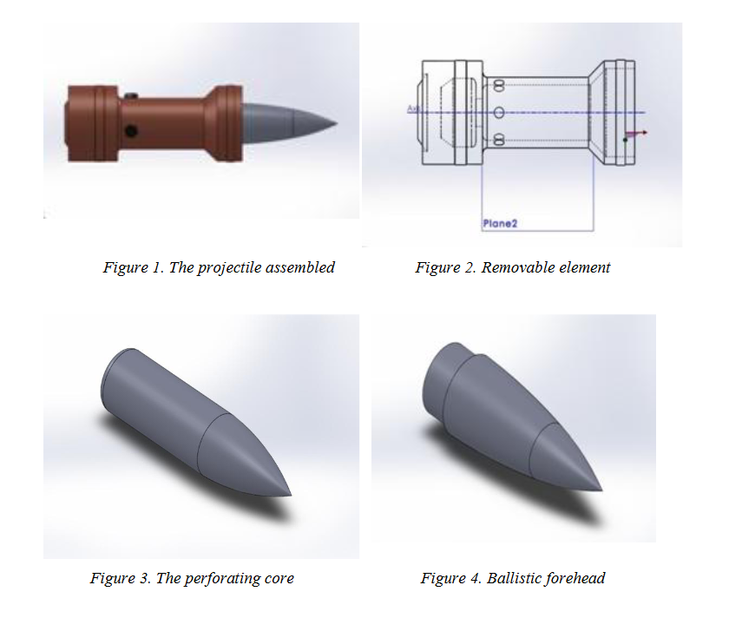
Figure 1 Test case projectile design [2]
The study creates 5 simulations with the projectile travelling at different angles to show the possibility of penetration [2]. The primary focus of the study was to assess the effects of the projectile perforating the armour along with the damage to the projectile when the shot did not perforate.
This was like the student’s simulation as the initial simulation was to assess the damage to the shot on impacting a thick plate of steel. Figure 2 shows the effect this had on the projectile despite the issues discussed in section 3.1. The test case saw a breakup of the shot when impacting the armour at any angle other than 0 degrees. The student used this information to influence their own simulation by changing the angle and thickness of the plate to a head on collision with a 40mm plate with the projectile travelling at 800m/s. This gave the student the opportunity to compare results and assess whether the software had produced an accurate estimate or whether there were parameters that had to be altered.

Secondary Test Cases
Several secondary test cases were considered along with the primary test case. These were simulations of small arms calibre bullets impacting body armour. These cases, while not being a direct comparison, show the fundamentals of simulating ballistic scenarios. These scenarios employ the use of Johnson-Cook damage and plastic models to simulate the deformation and damage to the metal plate. This test case influences the student’s simulation with the primary change being to the material properties of the armour plate. This test case influenced the parameters of the plate as then the effect of the projectile can be compared to evaluate the authenticity of the simulation [3].

Johnson-Cook
The Johnson-Cook model is a commonly used model so simulate different kinds of failure modes with unique equations for ceramic, plastic and damage equations. The most common used in ballistic simulations is the Johnson-Cook damage and plastic. These allow the material to deform and stretch to the point of breaking where the damage parameters remove the excessively damaged nodes allowing for simulations to test penetration and perforation [4].

Analytical and Software Comparison

Initial Simulation
The student began by preparing the simulation. The student designed and assembled the armour plate using Fusion 360, another CAD and CAE software. This was then imported into ANSYS where the material properties of steel and nickel were assigned to the plate and projectile. After the boundary conditions and velocity were applied the mesh was created as shown in figure 2. This mesh was found to be the optimum for analytical results and simulation time with the current set-up. After initial struggles during testing the student assigned an aluminium property to the armour plate. This was to identify whether the material properties were causing the error. The student found that material parameters in the built-in library failed to operate as expected.
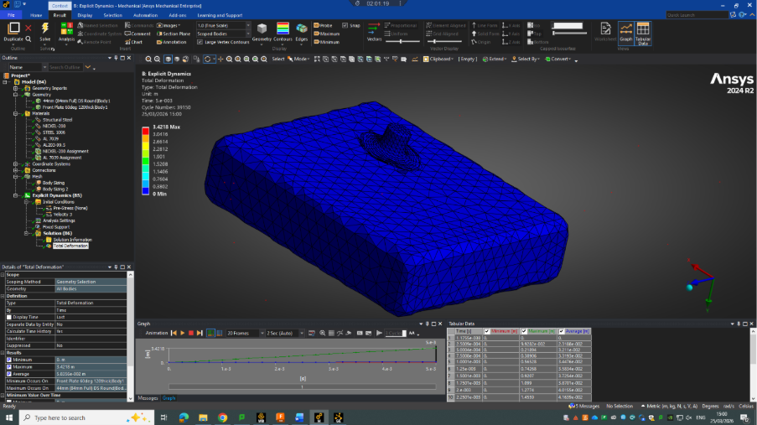
Figure 2 Simulation Failure Due to Material Properties
Figure 1 shows how the projectile deformed, but the plate saw no visible damage despite the projectile impacting at 800m/s. Despite the projectile being made up of a harder material than the armour plate the projectile was deformed while no visible damage could be found to the armour plate. It was then identified that the software was spreading the energy of the projectile through the armour plate and dissipating it instead of using the energy to deform the material. This was due to the lack of Johnson-Cook damage parameters. These values allow for the deformation of the plate and projectile [2].
Along with specific parameters the test case also highlights important boundary conditions that are required for the simulation to take place. Some of these conditions may distort the result from the true value but are required for the simulation to take place.
The student used the test case to identify the error and find a solution which highlights the importance of test cases when using FEA tools.

3.2 Simulation Refinement
The student then changed the design of the scenario by thinning the armour plate and reducing the width. This was to remove the energy dissipation seen in the first attempt. Figure 3 shows the second iteration of the simulation set-up
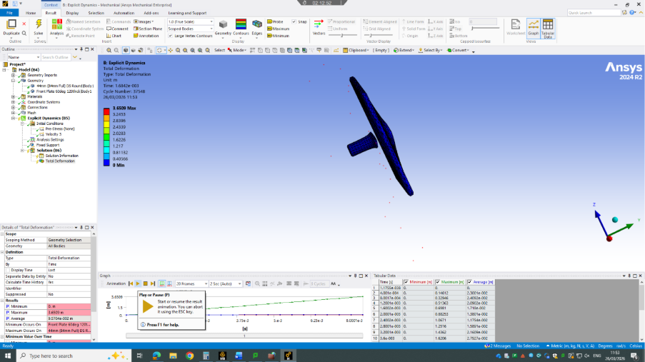
Figure 3 Refined simulation
Despite the refinement there were still issues with the material properties of the armour plate. Again, the aluminium prevents the projectile from perforating the plate despite the expected result to be the opposite. Another investigation into the ANSYS material library showed that the material properties of aluminium were missing parameters allowing for the damage of the plate to be simulated. Several other material parameters were attempted with mixed results. Figure 4 shows how the incorrect material properties can effect the simulations results.
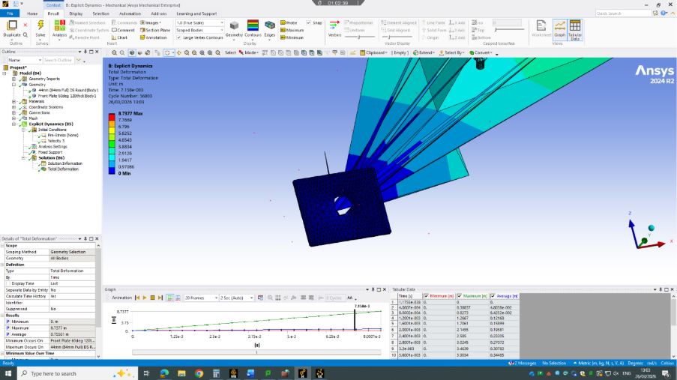
Figure 4 Effect of incorrect material properties
The student found the built-in material library to be useful during the testing phase but several parameters were required in order to achieve the desired result.

Final simulation
The final iteration of the simulation setup saw the student creating material properties from online sources. The student created a profile of 2XXX aluminium alloy which was assigned to the armour plate. The new material showed the expected results when the simulation was tested.
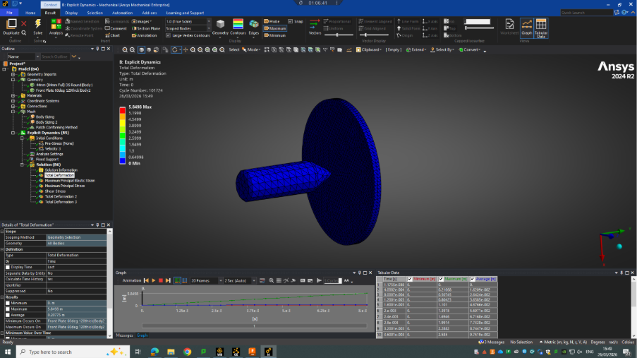
Figure 5 Final simulation configuration
The configuration shown in figure 5 shows the final setup of the simulation. When tested the deformation of the plate and projectile were assessed. The final configuration was influence by the primary and secondary test case meaning both could be compared in the final results.
Figure 6 shows the initial perforation of the plate
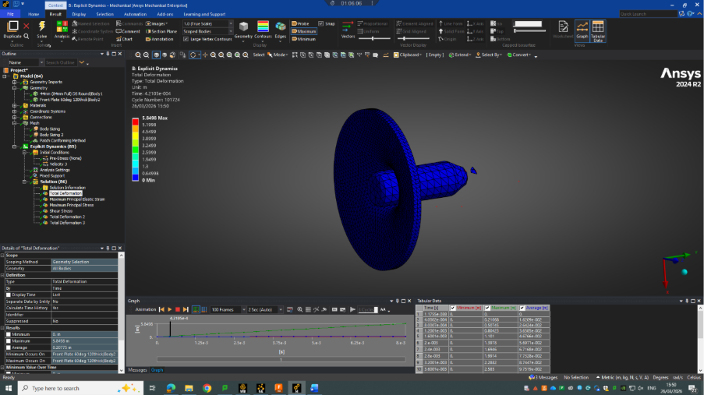
Figure 6 Projectile perforation
This clearly shows the damage to the plate as nodes are removed and detached from the main body of the plate. It also shows the blunting of the projectiles tip after the initial contact. The test case showed a similar trend in results with the difference in mesh size showing a clearer damage model in the test case.
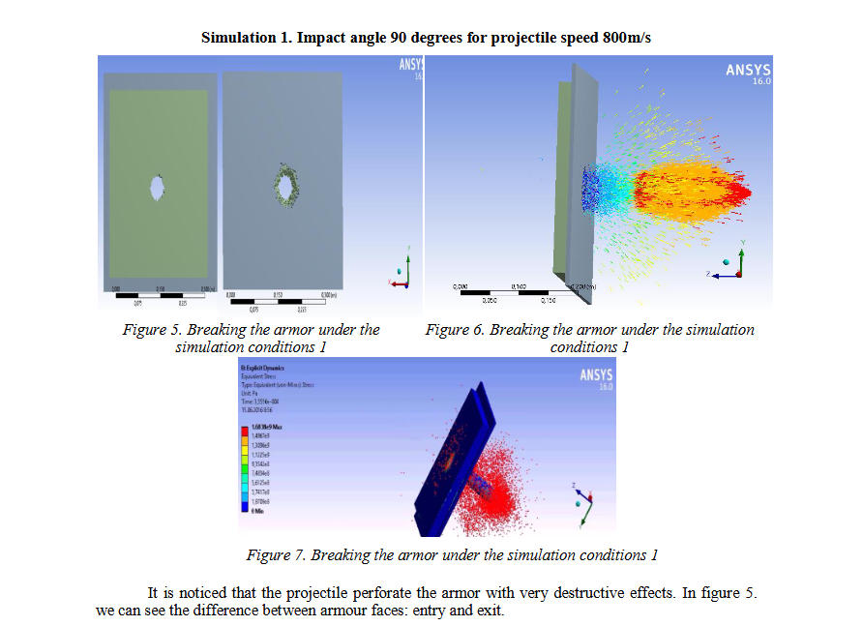
Figure 7 Test case results at 90 degrees [2]

Simulation Results
The results gathered from the final configuration shown in figure 5 showed a similar trend to the test case. To increase the accuracy of the results another simulation was run with a mesh refinement in a local area to assess the nodes in the area of interest. This reduces the load on the software by not using a smaller global mesh size but allows for a deeper analysis in a local area. These results show a similarity to the secondary test case where a smaller projectile impacted a steel plate. The test case used a hex mesh for the plate meaning the deformation shown may be different to this simulation as the different behaviour between the meshes may affect it. Figures 8 and 9 show the technique used and the area targeted.
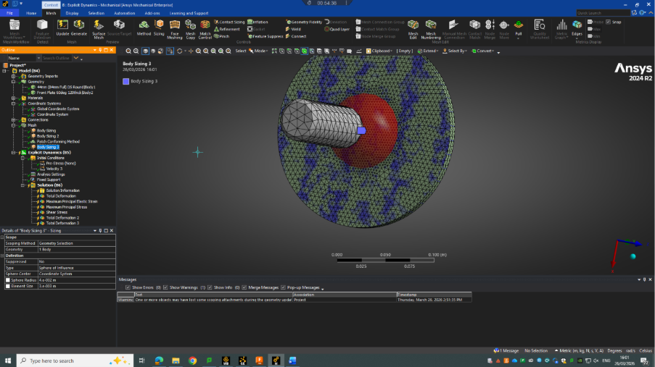
Figure 8 Mesh refinement area
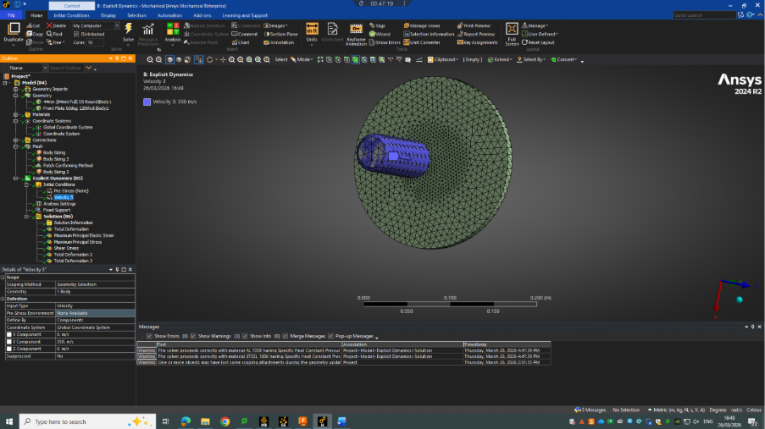
Figure 9 Mesh refinement result
The following results were recorded both the before and after the mesh refinement. This was done so that there could be an assessment on the quality of the mesh and its effect on the results. The comparison is made between each recorded result.
Figure 10 shows the difference between the perforation results with the left side of the figure showing no mesh refinement.
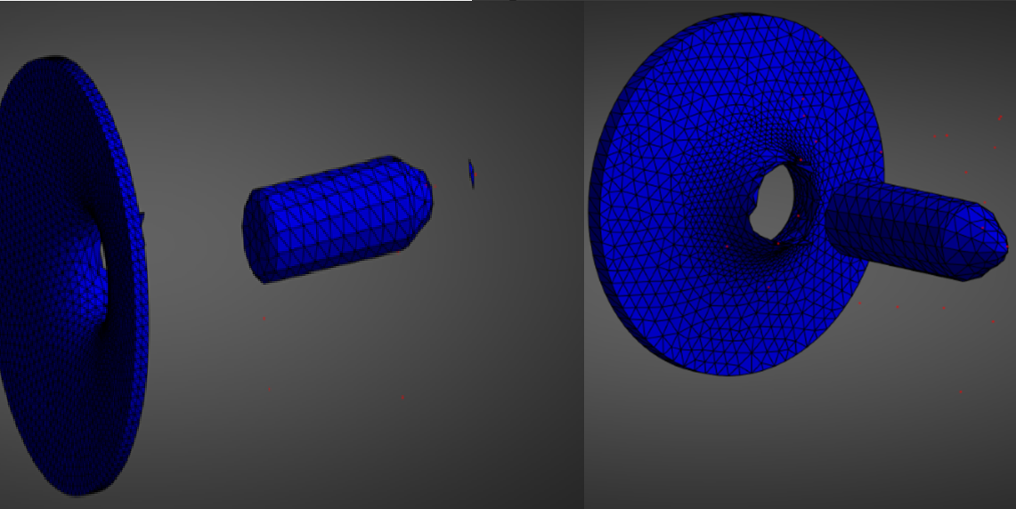
Figure 10 Deformation results comparison
Figure 10 shows how the deformation is better simulated with the mesh refinement. It can be seen that the red nodes in the refined simulation are more abundant showing a more detailed depiction of the spall due to perforation. While these are present in the unrefined result, they are not clear. It can also be seen that the projectile has progressed through the plate with less resistance in the refined model as the tip has not deformed as much compared to the unrefined model. This is due to the damage parameters being translated through the smaller nodes allowing for the deformation and removal prior to the deformation of the projectile. This again shows the importance of mesh size.
Along with deformation, shear, strain and stress were measured to assess the failure mode of the plate. These results show the cause of the damage with the failure areas and the primary regions damaged by the projectile.
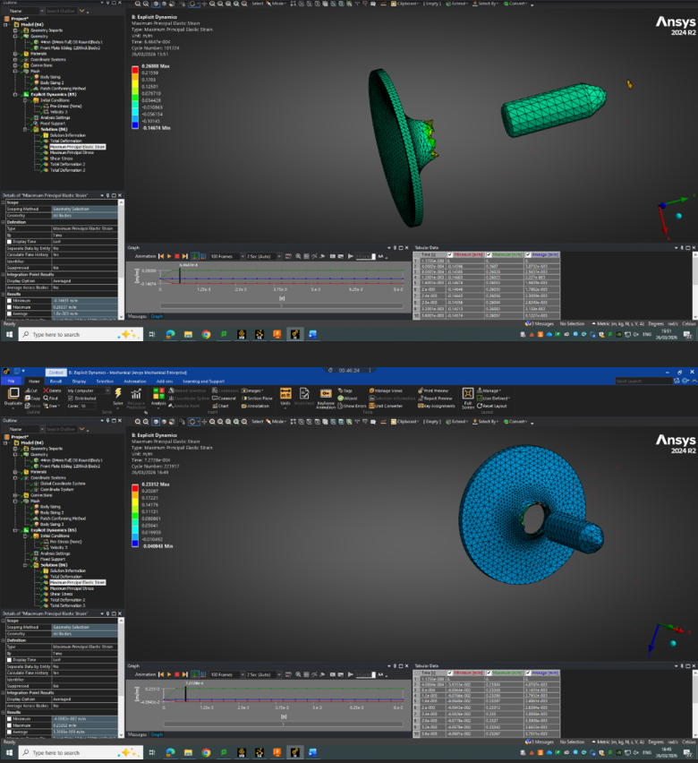
Figure 11 Strain comparison
Figure 11 shows the comparison between the two mesh sets. The maximum value is higher in the unrefined mesh than the refined mesh. This is to be expected as the larger mesh size will have the strain focused in an area with less nodes causing the data to produce a higher maximum. This value in both should not be taken as a 100% accurate result. This is due to the overloading of a single node. A limitation in FEA software. This can cause anomalies which is why the student focused the analysis on the values below the maximum and minimum values. These results show that the failure mode was not caused by strain however several areas were damaged due to the projectiles impact leading to necking prior to tearing. We can see the effect of this around the exit area with the petal shapes created. Strain typically is not the primary cause of deformation as in most situations the metal will remain within the elastic limit however in ballistic simulations the impact point may see excessive strain as the bullet forces its way through the metal causing it to stretch.
Stress was the next result recorded with figure 12 showing the comparison between the two meshes.
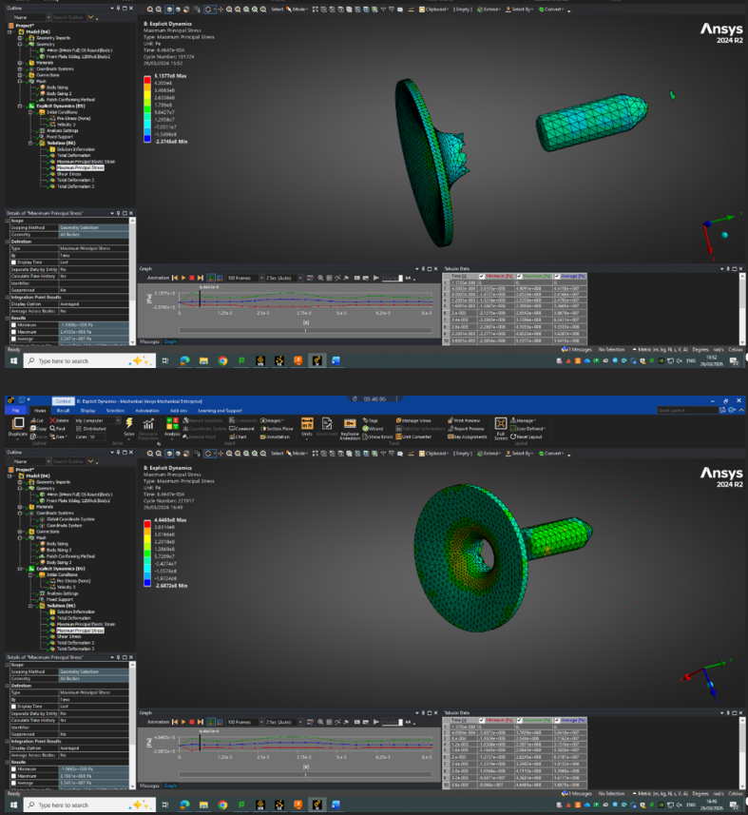
Figure 12 Stress Comparison
The results gathered show the stress focal points. The main compressive area is primarily around the entry point with the exit area showing the necking as mentioned previously. This compressive area is caused by the projectiles impact and while it has an effect on how the plate responds the compressive force will deform the metal but not destroy the nodes. The area outside of the compressive force shows a negative stress value. This is the plate stretching as the projectile forces its way through again showing the necking and petal shape.
The final result recorded was the shear stresses around the entry and exit area.
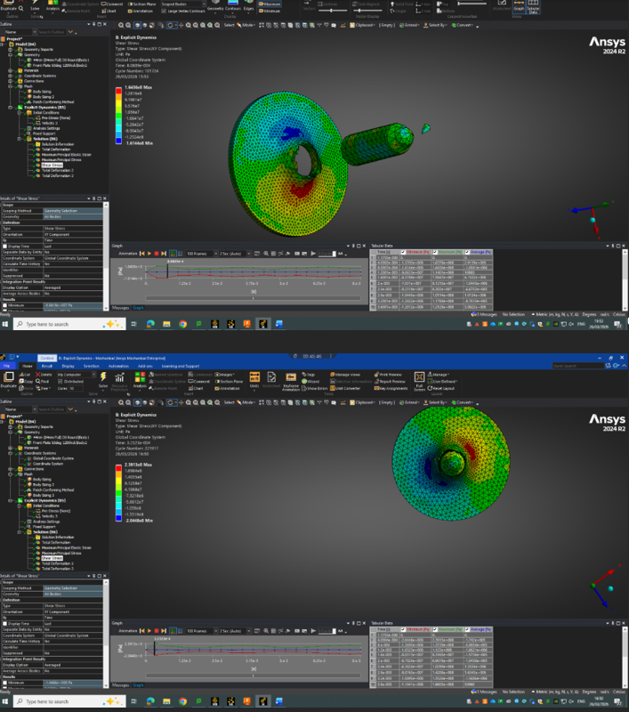
Figure 13 Shear comparison
The shear stress around the entry and exit areas in both mesh types shows a high area of shear stress in the area of strain shown in figure 11. This shows how the real damage to the plate was not caused by linear stress or strain, it was caused by high shear stress. The shear band shown in figure 13 highlights the initial failure area with the difference between the two simulations being the peak shear stress.
In the linear stress and strain the results had similar values but the non-linear shear stress had a larger peak in the refined mesh simulation. The finer mesh allows for more nodes to interact with each other causing more movement across itself until the cracking of the metal and perforation. After the projectile has pass through the plate the petal formation and spall can be seen together where the nodes have been distorted and destroyed.

Conclusions
The results show that the plate fails due to the shear stress around the impact area. The test case used does not analyse the shear stresses, but the visual results show the similarities between the two simulations. The test case was a fundamental part of developing the simulation. The student was able to create a simulation that worked as expected as the results given from the initial simulations could be compared with the test case to identify whether the results were accurate.

Mesh and boundary condition impact

Mesh size
The size of the mesh used determines the accuracy of the results [4]. Figures 8 and 9 show how the mesh can be refined in order to improve the accuracy of the results. However the refinement of the mesh can cause its own problems. Making a mesh too small can cause issues with the excessive simulation times and numerical errors skewing results [5]. The student used a crude mesh in the early simulations to gain faster simulation time to address the issues found. This is allowed for the issues to be addressed quickly rather than use a finer mesh to increase the accuracy of a result that may have an error due to incorrect parameters.
After the use of the crude mesh the student reduced the mesh size globally for both the plate and the projectile to increase the data they could collect from the simulation. This can be seen in figures 10 through 13 as the results gave a reasonable result when compared to the test case. This middle ground of the mesh size allowed for a relatively fast simulation time along with representable results. The software used does limit the mesh malleability as the type of mesh and regional mesh size can be difficult to control.
To address the limited mesh control the student used rounded shapes in the design. This forces the software to use a tetrahedral mesh which is the preferred mesh as it reduces the simulation time and represents the projectile better [4].
After the initial results had been collected the mesh was refined using a local mesh size. This will give more information in the area with the dense mesh. From there the student collected the results showing the difference between them. The difference is caused by the mesh as the interaction between the finer mesh better represents shear stresses compared to the larger mesh.

Boundary Conditions
In FEA software, boundary conditions are tools used to create the interaction between parts. In the student’s simulation they were used to fix the metal plate in space and define the contact between the two parts. The fixed condition prevented the plate from moving on impact from the projectile while the contact boundary determined how the two parts would interact. These conditions are useful tools as they allow for the simplification of the simulation. If the student had not created this condition the simulation would not work as the plate would be pushed by the projectile or not interact with the plate at all.
There are drawbacks to these conditions. By simplifying the simulation with these conditions there can be anomalies in the results [6]. For example, the boundary condition fixing the armour plate in space causes a slight reverberation after impact. This is because the energy travels to the outer edge of the plate and is reflected by the condition. The contact condition used was frictionless meaning that the friction of the interaction was not taken into account. This is severally affects the results. An example would be the true values for deformation as they may be lower due to the energy loss from friction. These conditions while important to determine how the simulation is run also effect the end result. With the simulation of the projectile hitting the plate the error in the results had little effect on the overall assessment of the results. However, despite the lack of effect on the results, it is important to note that boundary conditions can have negative effects on the results.

FEA Software

Applications in OME
FEA analysis has a wide variety of uses in the OME industry. As detailed in this report the software is capable of simulating ballistic scenarios but there are more applications such as the detonation of explosives or how cast explosive cools down [7].

Design and Development
The use of FEA in the design and development of parts and assemblies it common practice in modern engineering. The student found that in the design of the projectile and armour plate they could test the current and improve the design to increase effectiveness. This was done with the original rounded end projectile with the change to a tapered leading to a rounded tip. This increased the spall output from the projectile.
FEA can be used to optimise the design of the parts meaning less material while still retaining functionality and effectiveness [8]. FEA helps to increases confidence in the final design by ensuring components meet performance and safety requirements by proving accurate results.

Advantages
The applications of are varied but in many cases FEA software has allowed for the users to calculate complex simulations faster and to a reasonable degree of accuracy. The computational method has allowed the users to identify a wide range of results about the parts and assemblies they create [3].
These software packages allow the user to create digital prototypes, saving money and time along with the identification of areas for improvement [9]. The creation of digital prototypes reduces the possible waste from creating several physical prototypes along with the time it would take to make these prototypes. By using FEA the user can simulate extreme conditions for the part or assembly meaning safety factors can be tested and potentially improved.
The user can also simulate extreme conditions allowing for the safter factor of the product to be tested the performance assessed. This can help to increase how safe the design in without compromising the overall functionality of the product. The extreme simulations would normally require a trial in order to test the safety factor but with FEA tools the process can be done digitally.
Another advantage of FEA tools is to create a visualisation of the product and the primary areas of interest. This means that the user can show others the visualisation and walk them through the design step by step explaining the reason for each area of the design with the results to reinforce it. This means in industry scenes where engineers must present their findings they can use FEA to create a simulated version of the product in operation along with providing data on the limits of the assembly.

Limitations
There are many limitations to FEA tools. While some are limitations with specific software there are limitations that affect all FEA packages. One of these being the simplification of the conditions the part or assembly will be under.
As seen in this report the use of the frictionless interaction in the simulation allowed for the faster run time however this affects the accuracy of the results.
Another limitation is the control over the meshing of the parts. Depending on the software used the mesh controls can be limiting. The student found the mesh controls in ANSYS to be rigid. When meshing a cuboid part, the software will automatically apply a hex based mesh to the part. Hex meshes, while commonly more accurate than tetrahedral meshes they struggle with complex shapes and simulation time [4]. This limitation can be overcome by changing the design of the part to include a rounded body however this is not always possible. This mesh may struggle to interface with a tetrahedral mesh while also increasing the time it takes to simulated the scenario.
The use of sharp edges in ANSYS causes the simulation to have an increased run time before failing. This is due to the reduced node density at the sharp point. These areas when interacting with other parts are put under stress. This stress can be focused on a limited number of nodes causing the theoretical stress to increase exponentially making the simulation fail. In ballistics simulations this is an issue as most projectiles include the sharp edge for penetration [10]. To remedy these areas of high stress it requires a change in design. This again causes disparity between the physical design and the digital. In some cases, it may not be possible to round off the sharp areas meaning that additional tools may be needed. Smooth Particle Hydrodynamics can be used to model the sharp edge as a fluid but again this increases the time for the simulation.
High energy scenarios become difficult to simulate the shorter the interaction. Modern ballistics will fire projectiles upwards of 1000m/s. These could be large, fast projectiles hitting armour. This type of scenario is difficult to model due to the amount of kinetic energy. Often nodes may be overloaded with energy causing the simulation to slow down. Depending on mesh size this could also cause issues with overloading nodes to make the simulation fail. However sufficiently powerful hardware may be able to simulate a dense mesh scenario with high velocities.
The final limitation the student found was the unexpected peak values from the results. These values are anomalies, but they skew the graph produced by the software. This limitation has a simple fix of changing the scale of the results to identify the peak area and assessing whether the peak is the expected value. Another recommendation would be to train the user for these potential values as an unexperienced user might not realise the issue with their results.

Recommendations
The are many advantages to FEA software along with a number of limitations. Many of these limitations stem from user experience and error while using the software. For example, in ANSYS the general use of the programme is user friendly but the changes to the mesh can be challenging to get a desired mesh. This and many other limitations can be remedied with training on the software. However on more complex FEA tools such as ABAQUS the general use of the programme is not user-friendly meaning often it takes a large amount of experience to gain accurate results as it takes time to learn how to manually manipulate each parameter.
The accuracy of the results depend heavily on correct material models, mesh quality, and realistic boundary conditions, meaning simulations should always be validated against experimental testing or published literature to ensure reliability.

References

[1] | M. Baccouch, Finite Element Methods and Their Applications, 1st ed., London: IntechOpen, 2021.
[2] | I. C. S. O. T. G. I. a. C. P. C. Paul Clinci, “Study on armour-piercing discarding sabot performance in 100mm Naval artillery,” Journal of Physics: Conference, vol. 1297, no. 1, 2019.
[3] | X. Wang and J. Shi, “Validation of Johnson-Cook plasticity and damage model using impact experiment,” International journal of impact engineering, vol. 60, pp. 67-75, 2013.
[4] | “fundamentals-of-fea-meshing-for-structural-analysis,” ANSYS, 2026. [Online]. Available: https://www.ansys.com/blog/fundamentals-of-fea-meshing-for-structural-analysis. [Accessed 08 05 2026].
[5] | “Specifying an Appropriate Element Size for Stress Analysis — Lesson 1,” ANSYS, 2026. [Online]. Available: https://innovationspace.ansys.com/courses/courses/numerically-accurate-results/lessons/specifying-an-appropriate-element-size-for-stress-analysis-lesson-1/. [Accessed 08 05 2026].
[6] | P. D. P. a. V. G. P. P. S. Dahale, “Assessment of Boundary Conditions for FEA of Mounting Bracket Using Co-relation with Experimental Results,” Materials today : proceedings, vol. 5, no. 5, pp. 13290-13300, 2018.
[7] | “What is Finite Element Analysis (FEA)?,” ANSYS, 2026. [Online]. Available: https://www.ansys.com/simulation-topics/what-is-finite-element-analysis. [Accessed 08 05 2026].

Appendices
Whilst Heading 1 to Heading 6 can be used to number headings in the main body of the thesis, Heading styles 7–9 have been modified specifically for lettered appendix headings with Heading 7 having the ‘Appendix’ prefix as shown below.

Ethical approval letter
Click here to insert your ethical approval letter as the first appendix, i.e. Appendix A.

