SAFESTEP AI: AN AI-POWERED WEARABLE AND CARE DASHBOARD FOR FALL PREVENTION IN DEMENTIA CARE HOMES
STUDENT NAME: PASCALINE NONO AMAGNA
STUDENT NUMBER: 2424794

MODULE NAME: CHANGEMAKERS — CREATIVITY AND VALUE CREATION
MODULE CODE: BMHP5014
COMPONENT 2: WRITTEN ASSIGNMENT (POSTER AND PITCH)
UNIVERSITY OF WALES TRINITY SAINT DAVID
SUBMISSION DATE: JULY 18TH, 2026

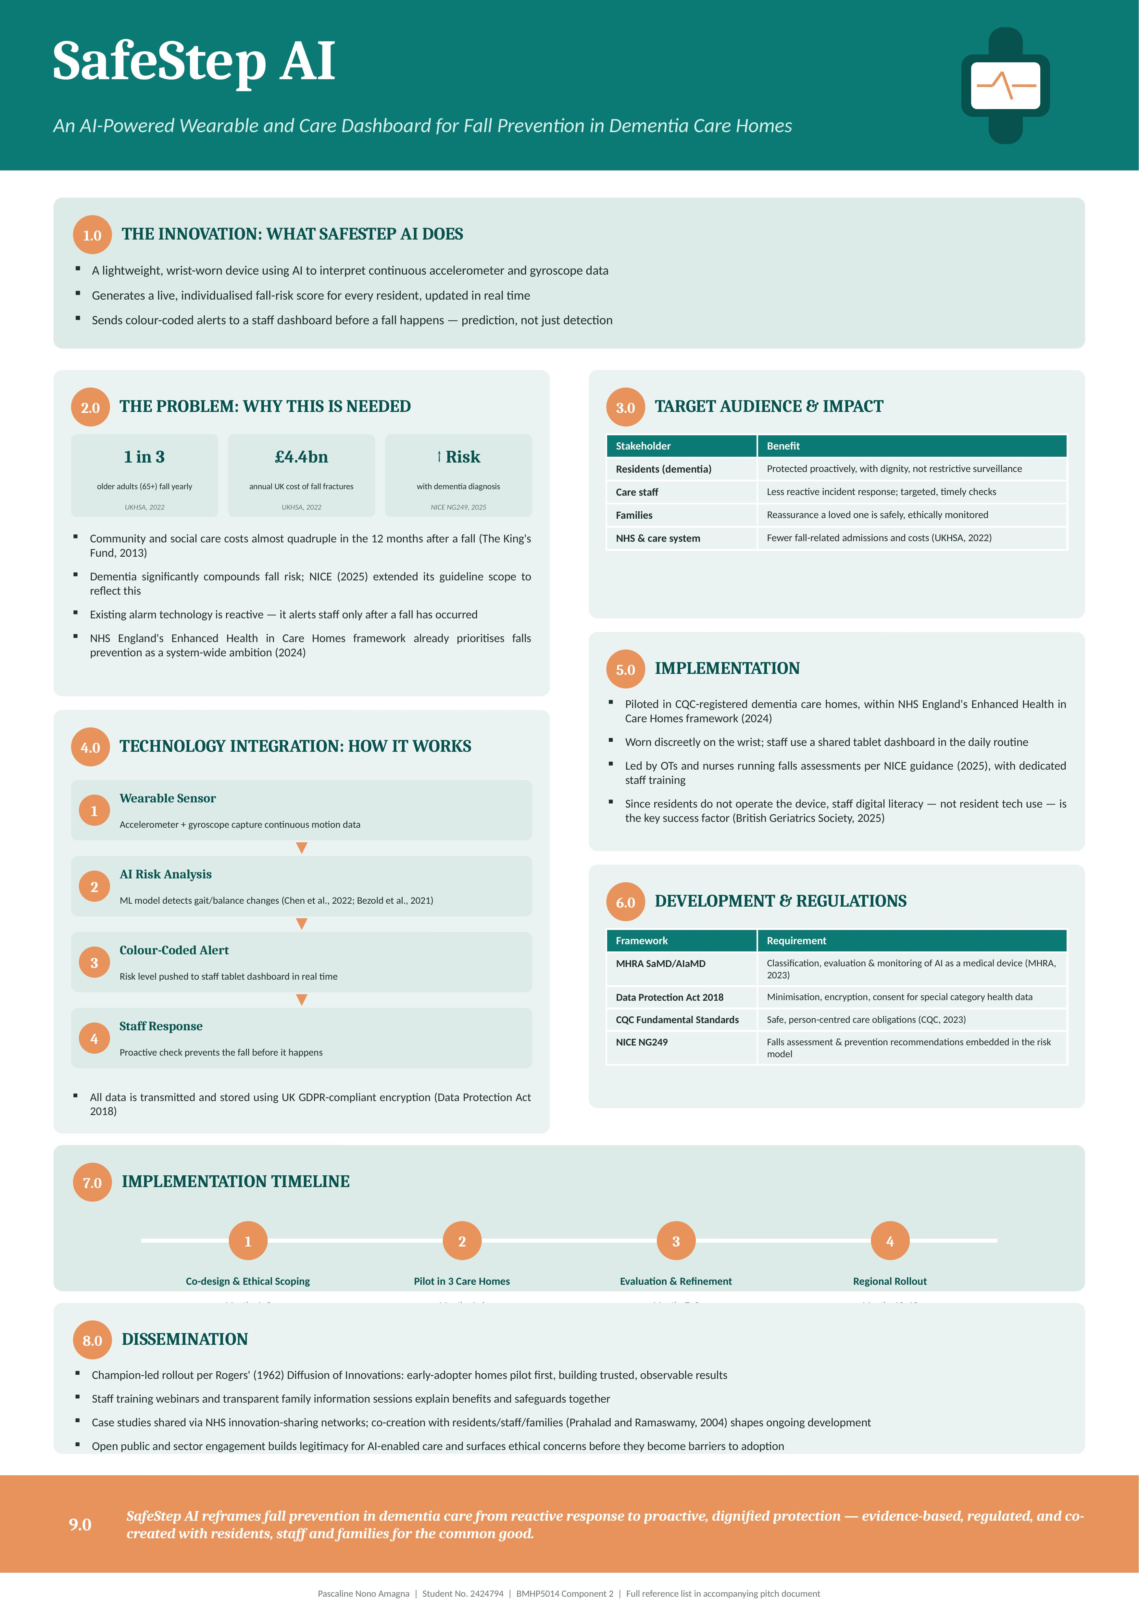

Pitch: SafeStep AI — An AI-Powered Wearable and Care Dashboard for Fall Prevention in Dementia Care Homes
Introduction: A Preventable Crisis in Care Homes
One in three adults aged 65 and older is likely to fall once a year or more, and falls are the biggest source of injury-related harm among older people in the UK (UK Health Security Agency, 2022). Where the fall results in a fragility fracture, the financial costs to the UK are significant at an estimated £4.4 billion per year of which £1.1 billion is attributed to social care (UK Health Security Agency, 2022); in the 12 months after a fall, there is an estimated almost quarter increase in the cost of community and social care (The King's Fund, 2013). These risks are exacerbated by dementia: the updated NICE falls guideline has been focused specifically on this and places dementia in its list of factors that make people more likely to fall (NICE 2025). In hospital settings, NHS England's Enhanced Health in Care Homes framework already places a strong focus on falls prevention (NHS England, 2024), and a fall is not just a fall; it is often the first step towards the loss of independence and confidence. SafeStep AI takes action on this evidence base with an innovation that prevents falls, rather than just catching them 'after the fact'.
The Innovation
SafeStep AI is a lightweight wearable device, powered by artificial intelligence, which calculates a real-time individualised fall-risk score from the continuous gathering of accelerometer and gyroscope data. In contrast to a passive alarm, as previously mentioned, that only comes into play when a fall has already occurred, it is based on the increasing evidence base for sensor-based fall-risk prediction that reveals that wearable inertial sensors can classify higher-risk from lower-risk individuals with some meaningful level of accuracy ( Chen et al., 2022; Bezold et al., 2021). A hearing in real time, as the resident's risk score increases due to subtle changes in gait, balance, or activity, is sent to a colour-coded staff dashboard for a proactive check before a resident's happen. This changes the approach to care from "reactive" to "preventative".
Target Population, Value, and the Common Good
The main beneficiaries will be care home residents who have dementia, who already have an increased fall risk (NICE, 2025) and are often not able to identify their warning signs, e.g., dizziness or tiredness. In addition to residents, SafeStep AI also adds value to care staff time, which is largely spent on responding to incidents, and to families, who feel reassured that their loved one is cared for with dignity, rather than being under watch. Wisely reducing avoidable falls at a system level can alleviate the pressure on an NHS that incurs billions in fall-related costs every year (UK Health Security Agency, 2022) and contribute to the common good in line with this module's ethos of value creation, which demands individual benefit.
Theoretical Underpinning: Innovation and Value Co-Creation
SafeStep AI is based on two complementary theoretical perspectives. First of all, Rogers' (1962) theory of Diffusion of Innovations suggests that innovation is an ongoing social process that is driven by the relative advantage, compatibility, and visibility of the innovation in routine behaviors. This is reflected in the phased approach below, where targeted early adopter care homes receive investment first, as in clinical settings, change is often hard to manage within existing workflows. Second, the concept of value co-creation by Prahalad and Ramaswamy (2004) redirects the attention that may exist in the act of creation of the service from the consumer to the residents, care workers, and families, bringing the focus back toward the latter. In practice, this means that SafeStep AI's development would not be a technocratic, top-down affair, but instead would be led by co-design efforts amongst staff and residents, and for the sake of the common good — not for the sake of innovation.
Policy, Legislation, Regulation, and Professional Services
SafeStep AI, as a device designed to assist in the decision-making process on top of algorithmic risk assessment, would be covered by the Medicines and Healthcare products Regulatory Agency (MHRA) Software and AI as a Medical Device Change Programme, which outlines the principles of classification, evaluation and monitoring of software and AI-based devices once they have been made available on the UK market (MHRA, 2023). The device will also process information regarding the health of individuals with special status, which means the development would also need to adhere to full compliance with the Data Protection Act 2018, including data minimisation, encryption, and consent procedures that are suitable for residents who might not have full capacity. From an operational perspective, all care homes using SafeStep AI are subject to the overarching standards of the Care Quality Commission (CQC), including but not limited to safe care and person-centred practice (Care Quality Commission, 2023). Professional services would, therefore, include people working in a care home as managers, registered nurses, occupational therapists carrying out falls assessments based on NICE guidance (NICE, 2025), and information governance leads who have the duty to ensure that data protection laws are adhered to.
Critical Evaluation: Benefits, Limitations, and Ethical Considerations
The technology based on the detection of falls is promising, but it is not all positive. As aforementioned, there is significant heterogeneity in accuracy, depending on the location of placement of the sensor, the algorithm, and the population being studied ( Chen et al., 2022), and it would therefore be necessary to validate SafeStep AI's risk model locally before full deployment, and not be assumed to be accurate from the beginning. It's also a valid ethical dilemma, where continuous surveillance is juxtaposed with residents' right to autonomy and privacy, especially when residents with dementia are no longer able to give informed consent; this is not something to be taken on a case-by-case basis, but rather, a process of best-interest decision making and open family discussion. Thirdly, the internet is not used by nearly 30% of adults aged over 75 years, and the adoption of the device by residents is not something that needs to be taught to them, however, a barrier to consistent and good quality uptake is care staff digital literacy and the infrastructure of care homes.
Public Involvement and Dissemination
To build the legitimacy of AI-driven care and to detect problems and concerns early on before they can become obstacles to adoption, there is a need for wider public engagement. Dissemination would be along the lines of Rogers' (1962) pathway of adoption: starting with a few “innovator” care homes that would be willing to adopt the technology, followed by the implementation of staff training webinars and family information sessions to inform families about the benefits and safeguards provided. The results and lessons learnt will be communicated via traditional NHS networks and channels for innovation sharing, to allow the innovation to be subject to scrutiny by the wider health sector and the general public, who will ultimately decide whether SafeStep AI is responsibly and sustainably adopted or not.
Conclusion
SafeStep AI is an example of the importance of evidence, ethics, and the co-creation of creativity and added value in health and social care. It focuses on encouraging fall prevention shifts from reactive response to proactive protection and provides a model of innovation that benefits the individual resident and the common good of a care system under continued stress.

References
Bezold, J., Krell-Roesch, J., Eckert, T., Jekauc, D. and Woll, A. (2021) 'Sensor-based fall risk assessment in older adults with or without cognitive impairment: a systematic review', European Review of Aging and Physical Activity, 18, 15.
British Geriatrics Society (2025) NHS Ten Year Health Plan: How It Affects You. London: British Geriatrics Society.
Care Quality Commission (2023). The Fundamental Standards of Care. London: CQC.
Chen, M., Wang, H., Yu, L., Yeung, E.H.K., Luo, J., Tsui, K-L. and Zhao, Y. (2022) 'A systematic review of wearable sensor-based technologies for fall risk assessment in older adults', Sensors, 22(18), 6752.
Data Protection Act 2018, c.12. London: The Stationery Office.
Medicines and Healthcare products Regulatory Agency (2023) Software and AI as a Medical Device Change Programme. London: MHRA.
National Institute for Health and Care Excellence (2025) Falls: Assessment and Prevention in Older People and in People 50 and Over at Higher Risk. NICE Guideline NG249. London: NICE.
NHS England (2024) Providing Proactive Care for People Living in Care Homes — Enhanced Health in Care Homes Framework. London: NHS England.
Prahalad, C.K. and Ramaswamy, V. (2004) 'Co-creation experiences: the next practice in value creation', Journal of Interactive Marketing, 18(3), pp.5–14.
Rogers, E.M. (1962) Diffusion of Innovations. New York: Free Press.
The King's Fund (2013) Exploring System-Wide Costs of Falls in Older People. London: The King's Fund.
UK Health Security Agency (2022) Falls: Applying All Our Health. London: Department of Health and Social Care.

