Manufacturing Process and Material Selection
By Saeid Salimi – 1911294
M4X01163
L4 - Materials and Introduction to manufacturing
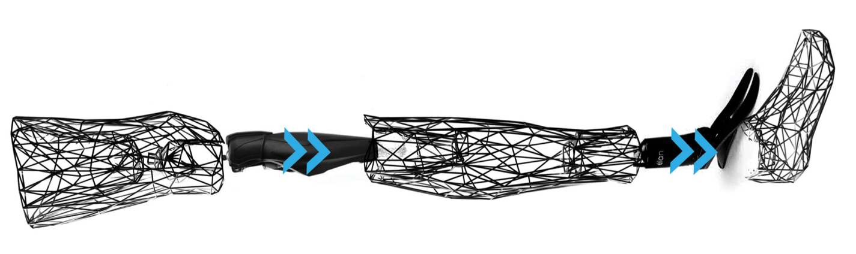
Figure 1 - Titanium artificial leg (Root, 2014)

Table of Contents
1 Introduction 3
2 Standard Leg prosthetics 4
2.1 The use of carbon fibre for prosthesis 5
2.2 The manufacturing process 5
3 Additive manufacturing 6
3.1 Laser sintering 7
3.2 Titanium 7
3.3 The benefit of additive manufacturing 9

1 Introduction
In the medical industry, there is always a benefit when it comes to new processes and new technologies to better an individual’s circumstances ranging from hearing aids, fully functional prostheses or surgical simulation in paediatrics. In this report I will specifically talk about prosthesis as it is an area in which a significant amount of people across the globe can be affected whether that is a genetic defect from birth, or they have been involved in an accident causing them to resort to a prosthesis fitting.
In the medical industry it is important to take into consideration the following things when it comes to designing any type of prosthesis. The location of it is important as some areas would be a lot easier to fit a prosthesis for than others e.g. a simple prosthetic leg would be a lot easier to fit than somebody that needs a full hip replacement.
Another thing that needs to be heavily considered is the strength of the prosthesis fitting against the weight in order to achieve easy functionality and to make sure it is robust enough to last the individual a prolonged period. The adequate strength of material used would factor an acceptable wear rate.
The third area that needs considering is the attachment of the prosthesis. This is just as important as the second point I made, as an individual would want their fitting to fit as flush as possible and as comfortable as possible to make full use of the prosthesis without any issues. Those issues could cause the individual not to take to the fitting, and not use it to its full potential e.g. if there are friction points affecting the comfort of the individual, then it is quite obvious that not enough consideration has been taken in the design concept of the individual’s prosthesis.
The last factor I want to mention is a combination of two things. Materials that are available and also the cost of these materials being used. This area will affect a low funded hospital or if an individual decides to do things privately, they may be short of funding for a more expensive prosthesis available on the market. The cost-effectiveness of the prosthesis will be a deciding factor for final prosthesis produced.
For this report the example of prosthesis I am going to talk about will be a prosthetic leg. There are a lot of deciding factors that come into consideration when creating a leg prosthesis and its implementation into the additive manufacturing sector will be an interesting talking point.

2 Standard Leg prosthetic
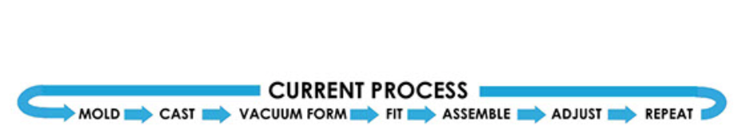
For standard prosthesis, due to its complex mechanics, and factors that need to be considered, the cost and appearance of the leg prosthesis is not very pleasing for an individual with a handicap. The process is in fact a very tedious and time-consuming process, where the individual needs to continue to adjust until fit is as perfect as possible, below is a diagram I will include from a report written by William Root (Root, 2014).
Figure 1 - Current process for prosthetic fitting (Root, 2014)

As the diagram shows, this is a long winded process and considering the sheer number of people around the globe with missing limbs, the process of going about getting a prosthetic limb fitted will take a very long time and would need a big amount of funding and man hours to see it through to the end.

2.1 The use of carbon fiber for prosthesis
The material used to create an artificial leg in this instance is carbon fiber. This is due to carbon fiber having a lot of positive aspects in a material sense due to its durability and strength whilst also being super lightweight. This material is then usually covered with foam and padding to suit the individuals comfort levels or for an aesthetic look, the artificial limb is covered in a plastic same colour as the individual’s skin tone. Going back to the last point in the introduction, the weight of the material used is very important as for the individual, they will be using the prosthetic limb constantly. Having a extra weight to carry around all day will take its toll on an individual’s fitness levels, especially if they don’t come from any sporting or fitness related background. This would then hinder the use of the prosthetic or hinder the individual’s daily routine, where they are not able in fulfilling everything they set out to. Reading what Chris Woodford (Woodford, 2019) mentions how we don’t notice the weight of our natural limbs in comparison to the weight of an artificial one, making the artificial limb as light weight as possible whilst maintaining functionality and strength is the ultimate goal.

2.2 The manufacturing process

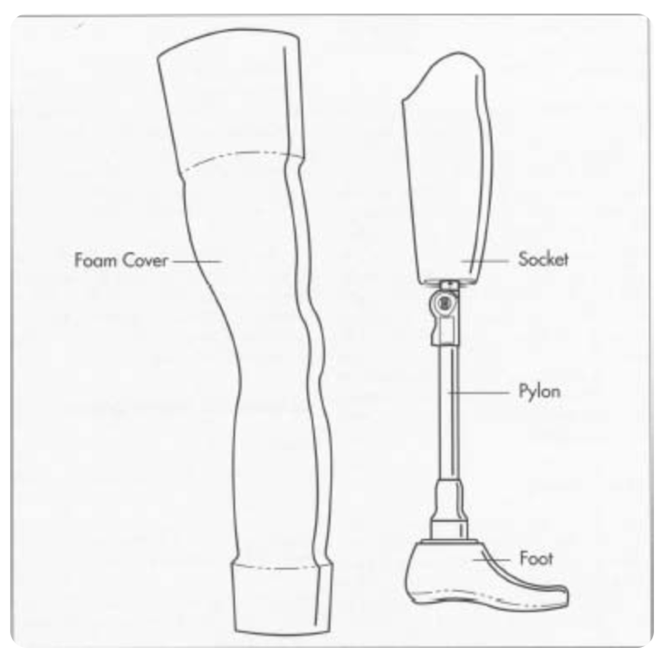
For any prosthesis, they will always be tailored specifically to the individual. This rules out mass production as you can’t have generic fittings to account for everyone’s needs to reach optimum functionality and comfort. Accuracy of the initial impression of the opposite limb is important. This is then followed by a series of measurements made of relevant parts of the body to determine bone and tendon structure. Once all of this is gathered, the prosthetist can now make a plaster cast of the stump, creating an exact duplicate. Following this, a sheet of clear thermoplastic is heated and simply placed over the newly formed cast and inside a vacuum chamber. The air is now sucked out of the chamber, causing the sheet to take the same shape as the cast. This thermoplastic sheet is now the new socket, and the prosthetist can adjust the fit if necessary due to the sheet being transparent. The next process is to make sure the individual needing the prosthesis can walk whilst wearing the test socket, this allows the prosthetist to analyse the individuals gait mechanics and whether they are comfortable enough with the test prosthesis as this is the most important factor to take into consideration. Following any slight adjustments if needed, the permanent socket is now formed via same process as the test socket using polypropylene. The next step is to add the next parts of the artificial limb, made of plastic and using usual plastic forming methods such as vacuum forming or injection moulding. This method consists of forcing molten plastic into a mould and leaving it to cool off, extruding the plastic out through a shaped die. The next piece of the puzzle is to create the pylon, this is usually made of materials such as titanium or aluminium where liquid metal is placed into a steel die of the shape needed. This process is called die casting. The final piece is to get the wooden piece used for the foot to be sized, shaped and drilled into. Once all the pieces are completed, the prosthetist can now fit together all of the components for the individual’s prosthetic leg using the necessary tools e.g. torque wrench and screwdrivers. This is now fitted onto the individual and any final adjustments are made accordingly.
Figure 2 - Showing the different components of a leg prosthesis (Secrest, 2014)

3 Additive manufacturing

3.1 Laser sintering
According to ASTM designation F2792 (Langnau, 2013) laser sintering is defined as a powder bed fusion process used to produce objects, using powdered materials and lasers to fuse/melt the particles together layer by layer, in an enclosed chamber. Usually the products being created via laser sintering are end use products that are robust and complex in nature. The simplicity it offers to create an abnormal object is outstanding. The starting process is a drawn out object on CAD software, in this case a prosthetic leg where the software will use a 3D scan of the individuals opposite limb and exactly replicate this for creation of the prosthetic limb. Once the CAD process is finished, it is then converted into an STL file (standard tessellation format) and inputted into the 3D printer software. The printer will take this STL file and separate the file into slices, the number of slices will take into account the complexity of the object that needs creating. The final part of this process is to just simply press print and watch the printer create the product, layer by layer until completion.

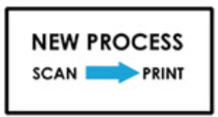

Figure 3 - Additive manufacturing process (Root, 2014)

3.2 Titanium
The use of titanium is heavy across the medical and engineering fields due to its very desirable properties. Whilst competing well with high strength steels, titanium is a lot less dense. Some other properties titanium holds are high resistance to corrosion and also it is biocompatible which proves very useful in the medical industry. Another interesting property titanium holds, explained by (Mota, 2017) is that similar to bone, titanium holds a low young’s modulus. This means that when titanium bears a load, in this instance the load of the individual using their prosthetic leg, the load is evenly distributed between the bone and the prosthetic which results in better gait mechanics for the individual which is a very desirable outcome. For use in laser sintering to create a prosthetic, powdered titanium is layered into the powder matrix and the laser will layer by layer form the prosthetic, showed in the diagram below.

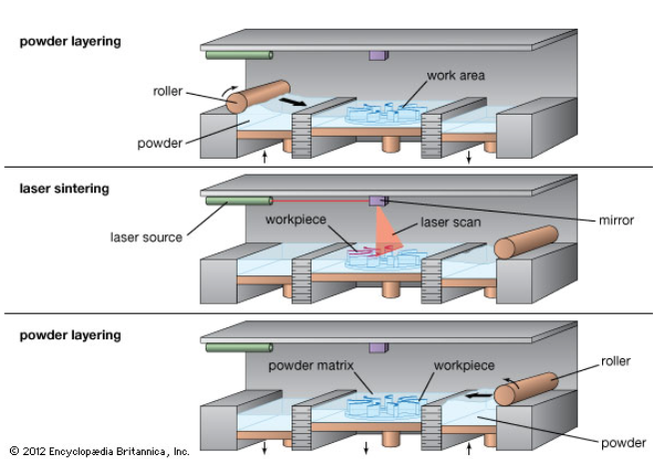

Figure 4 - lASER sintering process (Langnau, 2013)

3.3 The benefit of additive manufacturing

When taking into consideration the man hours and different skillset required to complete a leg prosthesis from scratch using old methods of manufacturing in comparison to new methods of manufacturing, with a much shorter timescale to completion and a lot less craftsmanship needed in order to achieve this, I think that 3D printing far outweighs the old school methods. Laser sintering specifically in the context of leg prosthetics, cuts time needed to create the part along with raw material usage as the loose powder will always be recycled. Once the prosthesis is created, there won’t be any need for any adjustments or post creation curing as the object created will be exactly what was drawn up on the CAD software. This means that any fine tuning of measurements and comfort levels would’ve already been considered before the final print is made. This in my opinion serves for more efficient use of time and materials when comparing to the other process of using thermoplastic sheets in vacuum chambers as the fine tuning of fit needs to be done on a half created object. Another benefit of additive manufacturing is purely the simplicity it offers due to its advanced technological capabilities. Once you scan the limb, the computer software will do the rest and take out any human error that could play a big factor.
I think moving forward not just in the medical industry, but in all industries, laser sintering will serve a great asset in creating everyday objects and products we use at a fast pace and efficient cost.

Bibliography
Langnau, L. (2013). Laser Sintering: What Is It? - Make Parts Fast. [online] Makepartsfast.com. Available at: https://www.makepartsfast.com/laser-sintering/ [Accessed 6 Feb. 2020].
Mota, G.T. (2017). Intimacy Unguarded, Letter to Chris Kraus: Georgia Tatjana Mota. Journal of Visual Art Practice, [online] 16(3), pp.223–225. Available at: https://broncoscholar.library.cpp.edu/bitstream/handle/10211.3/193171/MotaAnissa_LibraryResearchPaper2017.pdf?sequence=1.
Root, W. (2014). Exo Prosthetic Leg. [online] Behance. Available at: https://www.behance.net/gallery/20696469/Exo-Prosthetic-Leg [Accessed 6 Feb. 2020].
Secrest, R. (2014). How artificial limb is made - material, manufacture, making, used, parts, components, structure, procedure. [online] Madehow.com. Available at: http://www.madehow.com/Volume-1/Artificial-Limb.html [Accessed 6 Feb. 2020].
Woodford, C. (2019). Prosthetics: A simple introduction to artificial limbs. [online] Explain that Stuff. Available at: https://www.explainthatstuff.com/prosthetic-artificial-limbs.html [Accessed 6 Feb. 2020].
‌

