EFFECTIVE TEAM WORKING AND COMMUNICATION
Ioanna BAKOGIORGOU (1916883)
GRoup 2
uwtsd

HIGHER EDUCATION FOR THE WORKPLACE

Prof. Akinnseye aluko

Introduction
In this assessment we try to understand the complex process of Communication. What is the relation of sender – receiver and the structure of communication? We take the time to see from closer the three early models of communication and the operations that impact communicators. The methods we could use to make sure that the information we give, decode by receiver in the same way we intend. But how are people using communication effectively in daily life? What is the process (methods) of communication and what kind of skills people need to develop in order to improve communication in personal and professional life? Does communication influence job satisfaction and happiness? Furthermore, how communication works in the workplace and how coworkers communicate between them efficiently are few of the topics we focus and examine through this assignment.
- Communication
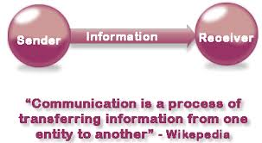
As Maund describes “Communication is the exchange of thoughts, information, or ideas that results in mutual understanding two or more people’’ (Maund et al. 2017, p.47). Similarly, a common online dictionary defines that ‘’The Latin root of “communication” communicare, means “to share” or “to be in relation with.” It further relates to the words “common,” “commune,” and “community,” suggesting an act of “bringing together” (Onlinelibrary.wiley.com, 2008). In simple words, communication is a bridge between human beings in terms of understanding, expressing of feelings, thoughts, ideas and emotions as well.
Figure 1 adapted from Google Image, 2020
- Importance of Communication
Communication undoubtedly is one of the most important life skills in order to build better relationships with others, in workplace, at home, at school and social life. Poor communication can lead to misunderstanding and unpleasant situations.
Good interpersonal communication skills are important for personal and professional development. Furthermore, these skills influence every aspect in people’s life demonstrating the powerful concept of sender – receiver relationships. Strong communicators have developed effective listening skills, verbal and nonverbal communication and critical thinking as well. If people start thinking before talking then they would improve interpersonal relationships. Good communication influences different aspects of people’s life as we can see in the figure below: effective in how we respond to stakeholders, how we make strong decisions, increase consistency in the workflow and so on.
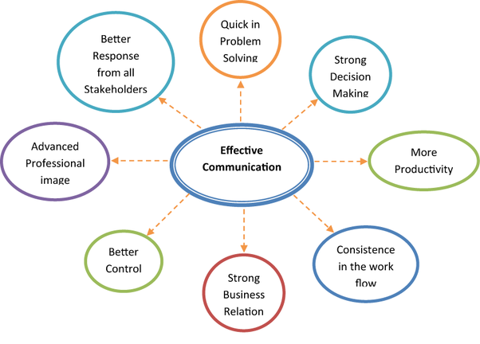
Adapted from blog.smarp.com (2019)
- Effective Communication
People use both verbal and nonverbal communication all of the time. Verbal in forms of words and sounds and nonverbal through body language, facial expression and/or any other form without speech. However, the way we choose to communicate each time creates an idea of us to others. What is important is not only the communication channels we choose every time but also how we use these words, visual channels and so on. The ability to pass across the right message and the capability of the receiver to decrypt this message in the same way can lead to satisfactory communication. Last, the process of effective communication involves good understanding of the context of the message from both sender and receiver.
A good communicator must practice active listening and soliciting feedback. It is necessity for him or her to listen carefully what the other person saying and apply paraphrasing to make sure that he or she understand correctly. As Morgan says “practice makes perfect’’ (2017, Box 2.3, p. 36). We should not take these skills as an easy task. It needs time and effort from individuals and a lot of practice. Firstly, active listening and attention from listener are skills individuals must practice and improve. Secondly, paraphrasing what others said and asking them if it is correct, improves understanding and last, probing questions for better conclusion. Finally, we should consider the feedback we receive to improve relationships and develop communication.
- Methods of communication
We use verbal and nonverbal communication in daily life to connect with others in scholar environments, workplace, at home and to socialize.
A. In verbal communication we use spoken words and sounds to send a message and/or to respond through language. Even though sounds simple and we are probably thinking that we communicate effectively through verbal communication in reality is not that easy. Besides, it requires effective listening skills in order to understand what others are trying to say; to decode the message between the lines.
“Robinson and Robinson (1982) concluded that if speakers are to be consistently efficient at conveying verbally their intended meaning to listeners, they must understand that intended meaning may not be fully conveyed by a message and that many factors can lead to a listener’s failure to understand what a speaker means’’ (Maund et al. 2017, p. 67).
B. On the other hand, nonverbal communication as the authors Ivy & Wahl highlight is “communication other than written or spoken language that creates meaning for someone’’. (Maund et al. 2017, p.69). Body language in the context of facial expressions, posture, movement, the tone of the voice, eye contact and so on fosters and determine nonverbal communication. Therefore, nonverbal communication support individuals verbal communication and helps the flow of the conversation with each other.
Imagine now when a person’s words and body language say something different. The conclusion of the receiver is much more affected by body posture, eye contact and so on. Seemingly the receiver feedback in nonverbal form can influence the flow of the conversation in positive or negative way. Mehrabian’s (1981) seminal research shows that only 7% of verbal cues interpret from the receiver, in contrast to 38% from vocal cues and 55% from body language (Maund et al. 2017, p.50). We should not forget that beyond the content of verbal and nonverbal communication is the relation to others and how we feel about them or a situation each time. How confident we are, what we are thinking, how do we feel and so on. Therefore, we should practice verbal and nonverbal communication equally in all aspects that may relevant to interpersonal relationships, such as feelings, attitudes, emotions, ideas, fears, to build self-confidence as trust into relationships as well.
- Theories of communication
Communication theory is “a field of information theory and mathematics that studies the technical process of information, as well as a field of psychology, sociology, semiotics and anthropology studying interpersonal communication and intrapersonal communication”. (Wikipedia, 28 February 2020). Furthermore, “communication models are systematic representations of the process, which helps people understanding how communication works”.
The very first communication model, the “Mother of all Models” created in 1948 by Elwood Shannon (an engineer) and Warren Weaver (a scientist) is more technological model because of Shannon’s professional. Later, Weaver applied this formula to all aspects of communication in order to achieve effective communication. From this time and after, the model has been recognized as the “Shannon-Weaver Model’’ presented in the figure below. The concept was broken down into key points; the sender, the encoder, the channel, the decoder and the receiver. Noise and feedback were added later.
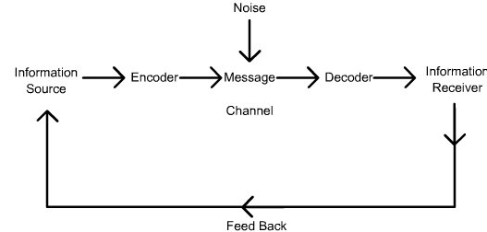
The Shannon-Weaver Model of communication (1949) with the inclusion of feedback to suit the model to human communication (Google image, 2020)

In this model “the sender encodes the message and sends it to the receiver through a technological channel like telephone and telegraph. The sender converts the message into codes understandable to the machine. The message is sent in codes through a medium. The receiver has to decode the message before understanding it and interpreting it. The receptor machine can also act as a decoder in some cases. The channel can have noise and the receiver might not have the capacity to decode which might cause problems in communication process’’ (businesstopia, 2018b).
The inclusion of feedback determines and develop communication between individuals and/or group of people.
The second model, “Schramm’s Model’’ formed in 1954, is based on Shannon-Weaver model. Here, we have the encoding and decoding dynamics in equal important role in effective communication. First, the role of encoding is to put the information into words so the information can easily pass from one individual to another. Second In decoding, the receiver must be able to decode the message in order to complete the communication. And furthermore, the receiver must send a feedback to the sender that he/she received the information. Therefore, the communication is not complete until this happens as we can see in the figure below.
Sender
M↓ ↑M
Receiver
M - Stands for message

This model also suggests that the background of individuals, as the origin, the culture, the current situation is playing a massive role when decoder decode the massage on his own point of view and sometimes lead to misunderstanding. In same way with feedback from the receiver.

Third communication model we are looking at, is David Berlo’s published in 1960 and based in Shannon and Weaver Model. The Sender – Message – Channel – Receiver (SMCR) MODEL focuses in more detail on the factors that affect each of these four components in order to develop more efficient communication.

As we can see in the figure on the next page the model describes the mechanisms before the message sending from the sender and also before the receiver receives the message in four steps. Several factors in this model make the communication more efficient.



Source: businesstopia.com (2018a)

In all these models the communication begins when a person wants to communicate with another person and/or group of people. Therefore, the analysis of each of these factors is extremely useful for effective and efficient operation of communication. Even though feedback was added later, these models do not pay enough attention to feedback, which indeed completes and develops successfully the context of effective communication.
The models help us to analyze what is going wrong in a situation of communication breakdown. Even if they are old, we can still apply them in the analysis of today’s communication which includes texting, messaging, zooming, etc. For example today nonverbal communication in texting and messaging was replaced by the creation of emojis which show emotions. Times have changed and we use new technology to communicate with each other. Nowadays for example we use Zoom, Skype, FaceTime and so on to communicate from distance so people can hear and see us. Even though they are helpful channels especially if we are selling products, our audience cannot test, smell or touch the product. Therefore, we should take in consideration which channel of communication we should use each time.

- How you communicate at your workplace
In my workplace, managers and employees exchange ideas and information hundreds of times every day in order to complete tasks, achieve goals, manage problems and so on. From my experience the outcome of communication is not always the desirable, and the process of communication is far away from simple. It is much easier for most of the people to talk and very difficult to listen to what others have to say.
Working as a team leader for a London-based Meetings & Events company, I need to communicate with my line manager, bookings department, kitchen chef and staff, my team, customers, facilities team etc. several times every day .Working with different kinds of people, from different backgrounds and origins, cultures, personalities and so on I must use different skills, methods to communicate with them. Using written (emails, What’sApp etc.), verbal (on site walkie-talkie) and nonverbal communication as well. From my own point of view, nonverbal communication, body language, facial expression, eye contact, the tone of the voice, active listening etc. have helped me to understand better the information I receive which I need to pass to my team as well.
Very rarely in my workplace people take the time to reflect to their own speaking words and/or nonverbal communication and therefore to ask for feedback. Coworkers want to be listened and to be understood. Also, leaders and managers want to be respected from employees. To achieve both these objectives, managers and employees, need to improve interpersonal skills and effective communication skills.
Two-way communication is primordial so that people understand each other. Improving listening skills, paying attention to what other person is saying, asking questions to make sure you have understood; paraphrasing the content of the message and asking for feedback are the crucial and necessary methods that I can think of. They have helped me indeed improve my skills as a team leader.
I should not forget the influence of nonverbal communication such as facial expression, smiling, appearance (looking clean and tidy, dress code), positive use of words and so on in a workplace communication. It is important to practice and improve these skills. Last, but not less important task is to get to know as much as you can about your audience. This could be helpful in order to deliver your message successfully and get positive feedback.
The practice of these strategies should be adopted from all individuals in a workplace to improve communication and achieve job satisfaction and therefore happiness.
Conclusion
In this assignment we have covered communication, the importance of communication, effective communication relevant to methods and theories of communication. We have also presented three early models of communication; we have examined how they work and their impact to effective communication. We also concluded that even though we use different channels to communicate nowadays the power factors are the same. Last, we observed the group dynamic of communication in the workplace and suggest how we can build strong relations and effectiveness in workplace through communication. We should not forget that times have change and therefore we use different channels to communicate with each other.
Bibliography
Maund, A. et al (2017) Certificate in Higher Education: Skills for the workplace. Student Yearbook. London. Sage publications Ltd
Morgan, P. (2017) The business student’s guide to study and employability. London. Sage publications Ltd
References
Businesstopia (January 2018a). Berlo’s SMCR Model of Communication. Available at: https://www.businesstopia.net/communication/berlo-model-communication. Accessed on May 2020
Businesstopia (January 2018b) Shannon and Weaver Model Of Communication Available at: https://www.businesstopia.net/communication/shannon-and-weaver-model-communication. Accessed on May 2020
Elcomblus.com (2018). Models of communication. Available at: https://elcomblus.com Accessed on May 2020
Onlinelibrary.com (2008). Willey online library. Available at: https://onlinelibrary.wiley.com Accessed on May 2020
Smapr (Dec 13, 2019). Top 5 Communication Skills and How to Improve Them. Available at: https://blog.smarp.com/Top-5-communication-skills-and-how-to-improve-them. Accessed on May 2020
Wikipedia.org (2020). Communication in theory. Available at: https://en.wikipedia.org, Accessed on April 2020

