
Professional career development skills


MORARU ANCA LAVINIA (1909931)
UNIVERSITY OF WALES TRINITY SAINT DAVID
27TH OF NOVEMBER 2020
MODULE: PROFESSIONAL CAREER DEVELOPMENT

Executive Summary
The report is about a professional career development project where the focus is to evaluate the course and what has been learned from it. Apart from this, the report covers my self-assessment with the help of a Personal SWOT Analysis (strengths, weaknesses, opportunities, and threats). After that, the report comes up with the outcomes of learning style questionnaires of visual and auditory learning styles. At last, a detailed Personal Development Plan is a major section of the report, which covers my vision, goals, strengths, potential growth, and development opportunities. At last, it ends with the action plans that would be followed to reach the set SMART Goals.

TABLE OF CONTENTS
Executive Summary 1
Terms of Reference 3
Procedure 3
Introduction 3
Findings 4
Reflections on Completing Lectures 4
Identified SMART Goals 5
Personal SWOT Analysis 6
Gap Analysis 8
Outcomes of Learning Style Questionnaires 8
Relevant Employability Skills to SMART Goals 9
Personal Development Plan (PDP) 11
Conclusion 13
Appendices 15
References/Bibliography 17

Terms of Reference
The main purpose of the report is self-assessment in terms of professional and career development. The report mainly covers the main aspects of the source "professional career development" and self-assessment along with my SMART goals. Specifically, the report addresses things I learned from this course, their application, and the challenges I faced while studying the course. After that, the report addresses my SWOT Analysis and Personal Development Plan (PDP).

Procedure
The procedures that have been compiled to complete this report include;
- Primary research and analysis such as self-assessment and examination
- Secondary research (papers, articles, and books, etc.)
- Reports (i.e., Personal SWOT Analysis) analysis
- Other research activities

Introduction
Professional career development is a process that involves career planning and career management. According to Lejeune, Beausaert, and Raemdonck (2018), human resource management has several elements that include controlling, evaluating, organizing, HR planning, and career development. Companies and organizations devote a substantial part of their resources to these crucial elements, ensuring that all these aspects of career development are implemented effectively towards attaining organizational goals and objectives. In terms of the career development course, the course was a productive study for me as it hugely enhanced my knowledge about professional career development, career planning, and career management. The materials learned from the course helped me to know about the business management field and the process of getting a good job.

Findings

Reflections on Completing Lectures
- Things I Learned During the Course/Lectures
In the first week, I learned about the main conception of professional career development, which explored my interpretation of what it looks like to have a successful career in the 21st century. After that, I learned how to create a personal and professional development vision and identify my professional career goals. Besides this, the course also taught me how to identify the right path for the career that interests me the most and explore different approaches for career development.
Apart from this, I also learned a lot about career growth. For example, I learned the significance of having a professional network. In addition, the course taught me that I must make connections with businesspeople and organizations because it would assist me in finding an ideal career.
- Challenges I Faced and Strategies to Overcome Them
Indeed there were some challenges I faced during lectures. First of all, adopting new things in life is, by nature, a complex action to perform. In Week 2, the lecture was about how to implement learned materials to analyze career strategies. In this aspect, the course focused on exploring how to be consistent learners and how to take advantage of consistent learning for career growth and development. But I found this part of the course a bit challenging. Also, adapting business communication skills were somewhat a challenging thing for me.

- Application of Learning to my Personal Career Development Journey
Things I learned from the professional career development course hugely contributed to my knowledge. It would help me enhance my skills ranging from professional and personal development to acquiring different employability skills. Specifically, the materials learned in the course would be used for career planning help me pursue my ideal career. To my ideal career, I will need to develop my personal as well as professional skills. Because there is always competition among candidates in the labour market, so personal and professional growth and competencies would make me stand out. The significance of having a social and professional network is huge in the current time (Avci, 2020). So, I will use such knowledge to enhance my social and professional network, which will help me easily get a job.
- Follow up Research/Work
Beyond the implementation of what I learned during lectures and my self-assessment, I used secondary research to complete this project.

Identified SMART Goals
Setting SMART Goals is a great approach to plan for a career you want to pursue. By setting SMART Goals, you can create a clear roadmap for how you will reach these goals. Setting SMART Goals can help you decide how to apply your time and resources to make progress (Makarenko, Oliinyk, and Kazakova, 2018). Without having SMART Goals, it could be challenging to determine how to get a particular degree or a job. Because of their significance, the following are the SMART Goals that I have identified during the course and have set to achieve afterwards.
- I am planning to get admission in a professional development course or program and complete it along with my graduation to enhance my knowledge about today's business world.
- I am planning to complete all my assignments this year at least two days before they are due to assist me on how to avoid rushing through work or projects in both personal and professional life.
- To keep me accountable for learning, I would raise my hand at least 3 times in each class to answer the teacher's questions.
- To improve my communication and especially writing skills, I would complete all English Language modules in the writing center, scoring at least 90 percent in each.
- I plan to improve my presentation skills by participating in at least 10 presentation contests before completing my degree.
- I am planning to decrease the time I spend on social to 1.5 hours a day and increase my presence on the internet search to get insights about the corporate world.
- I am planning to attend a college Alumni reunion after my graduation to stay connected with the institute
- I am planning to gain/adopt at least 3 leadership and management skills at the end of this semester

Personal SWOT Analysis
Strengths
- I am efficient in evaluating the problems I face in my personal and educational life, which helps me reach the best solutions.
- I possess strong communication skills especially speaking and listening skills
- I most of the times creatively solve the problems I face in my life
- I have good interpersonal skills, and I am good at leading a team or group of people in a productive and effective way
Weaknesses
- Based on my personal analysis, I sometimes feel mental toughness; even I am not in a stressful situation.
- As compared to my listening and speaking skills, I find myself a bit weak at writing 100% professionally
- I do not have enough practical knowledge about how corporations operate in today's competitive business world.
- I sometimes suffer from intense attention span and bad attention when I work on a complex task
- I lack stress management skills, and I am a bit weak at dealing with some conflicts
Opportunities
- I have an open opportunity to continue my education till getting a doctoral degree, which will help me be on the list of a few and highly qualified people
- I have a potential opportunity to start an article and report writing to enhance my writing skills
- To get admission in a psychology-related course or program to improve my stress management skills
- To adopt problem-solving and innovation skills to further my creativity and conflict resolution skills and competencies.
Threats
- Intense competition in the labour market and continuous increase in it for the fresh graduates
- Increased expenses of colleges and consistent increase in college admission fees
Personal SWOT Analysis is an evaluation used to focus on oneself and the goals one sets to achieve in both personal and professional life (Pluchevckaya, Varlacheva, and Andrienko, 2017). The Personal SWOT Analysis helps me know my strengths and competencies to use them accordingly to achieve my goals. Personal SWOT Analysis would also help me identify any weakness and opportunities I can have. In this way, I would be able to overcome my weaknesses and utilize the opportunities to help myself in the professional career development process. At last, the analysis will enable me to know the critical threats that may come in the way when I make the process.

Gap Analysis
Basically, personal gap analysis is an analysis that would help know additional skills that one need in order to get their ideal job or career. Based on my personal gap analysis, I should possess the skills that would help me succeed in my career as a hotel manager. Particularly, as I am planning to be a hotel manager after the graduation, so I need to acquire the following skills to cover any gap for this particular objective.
- Persistency and determination
- Ability to remain calm in every kind of stressful and challenging situation.
- To be thorough and pay attention to details
- Customer services skills
- Knowledge of HR management and employment law along with business management skills
- Communication, interpersonal, and leadership skills

Outcomes of Learning Style Questionnaires
Different learning styles have varying effects on one's learning and success in both academic and personal life. According to Savickas (2019), students and teachers have heard for more than 30 years that most students learn either visually or auditory. The outcomes that I see as a result of completing the questionnaires of visual and auditory learning styles are;
- First, I have to ensure that I must avoid distractions while learning a new concept or subject, such as business management.
- I have to learn the big picture first and then get close and focused on the main point or subject
- I should make mind concept maps rather than outlines
- I should keep notes of important materials to study them when needed
- I must write my assignments using both academic and business tone to improve my professional writing skills, especially for my professional career. It means that I have to improve my email and report writing skills.

Relevant Employability Skills to SMART Goals
In the current time, companies or organizations are not only looking for employees who possess technical skills or job-related skills and competencies. Instead, every employer in today's business world wants to hire employees or candidates who bring something more than what is required to perform a particular job or duty. According to Wolniak (2017), for a large number of people, a career for life is no longer an option. Instead, people hold jobs with different employers and move across various organizations and even sectors through their professional life. In such cases, skills (i.e. hardworking and communication etc.) that can be used in all types of job are needed. Hence, everyone ranging from students and fresh graduates to senior and expert employees needs to be flexible for working in different patterns and be prepared to avail of any potential opportunity they see during their career or professional life (Denmark, and Klara, 2010). The same applies to me because I have to gain important employability skills to achieve my goals. In short, the most relevant and significant employability skills concerning my goals are;
- Problem-solving skills
Problem-solving is a skill that involves the competency to identify key issues and their implication. This also helps to understand the problems at hand and determine the most effective and most appropriate solutions (Makarenko, Oliinyk, and Kazakova, 2018). For me, problem-solving skills are important because they would help me overcome my weaknesses, such as the weaknesses of feeling stressed. Problem-solving skills are relevant in consideration of my goals because it will help me categorize my problems to solve them effectively. And this would then enable me to manage these problems more effectively. In my professional career, these skills would make me stand out of the rest, too.
- Self-management
Self-management is one of the most important skills for me, especially when it comes to what I have planned to achieve (my goals). Basically, self-management refers to the ability of an individual to perform certain tasks satisfactorily without strong supervision. I am efficient in completing my tasks on time, while self-management skills enable people to delegate tasks to ensure on-time completion. So, these skills will help me enhance my skill of effectively delegating tasks. Self-management skill would also help me motivate myself to do the best I can. Additionally, Lejeune, Beausaert, and Raemdonck (2018) state that self-management can efficiently motivate you to deliver solid work performance, consistently.
- Learning skills
Having strong learning skills means the ability to understand new ideas and methods quickly. It also involves taking on new tasks quickly and adapting to change while continuously enhancing existing knowledge and strengths (Lejeune, Beausaert, and Raemdonck, 2018). This employability skill is important for me because it would help me complete challenging tasks quickly. And this would further assist me in reducing the I need to achieve my goals. In addition, most of my SMART goals are about learning new things by taking admissions in new courses and programs. So, learning skill is an important employability skill in relation to the goals I have set to achieve.

Personal Development Plan (PDP)
Components | Description
Personal Vision | To use me as an example to affect positive attitudes and share my "can do" attitude with whoever comes across my personal and professional life.
Goals | - I plan to get admission to a professional course or program and complete it along with my graduation to enhance my knowledge about today's business world.  - I am planning to complete all my assignments this year at least two days before they are due to assist me on how to avoid rushing through work or projects in both personal and professional life.  - Planning to keep me accountable for learning, I would raise my hand at least 3 times in each class to answer the teacher's questions.  - I am planning to improve my communication and especially writing skills.  - I plan to improve my presentation skills by participating in at least 10 presentation contests before completing my degree.  - I am planning to decrease the time I spend on social to 1.5 hours a day and increase my presence on the internet search to get insights about the corporate world.  - Planning to attend a college alumni reunion after my graduation to stay connected with the institute  - Planning to gain/adopt at least 3 leadership and management skills at the end of this semester
Strengths and Competencies | - Efficiency in evaluating the problems I face in my personal and educational life which helps me reach the best solutions.  - Strong communication skills especially speaking and listening skills  - Ability to creatively solve the problems I face in my life  - Good interpersonal skills, and I am good at leading a team or group of people in a productive and effective way
Development Opportunities | - An open opportunity to continue my education till getting a doctoral degree which will help me be on the list of few and highly qualified people  - To start the article and report writing to enhance my writing skills  - To get admission in a psychology-related course or program to improve my stress management skills  - To adopt problem-solving and innovation skills to further my creativity and conflict resolution skills and competencies
Action Plans | - I would complete all English language modules in the writing center, scoring at least 90 percent in each to improve my communication and especially writing skills.  - I will participate in at least three community programs or campaigns to expand my social network, which will help me get a good job easily.  - I will spend at least 3 hours every Sunday on extra research to know about the current situation of the corporate world and new trends such as job requirements etc.  - I will get an internship during my summer vacations to learn about how companies operate in real.

Conclusion
It has been found that it is a course designed to give students a very clear start on the process of career planning and development. During the lectures, I felt satisfied because every lecture added something new and credible to my knowledge about professional career development. I learned many things from the course, like; what it looks like to have a successful career in the 21st century, create and use a personal and professional development vision, and the importance of networking with people, organizations, and platforms for my professional career. But I faced some challenges where the major one was adapting business communication skills. After that, I found some SMART goals that I aim to achieve in my academic and professional life. Moreover, an in-depth personal SWOT Analysis of mine was a major part, which identified my key strengths, critical weaknesses, potential growth and development opportunities, and threats that may come in the way of my professional career development. Proceeding further, some relevant employability skills concerning my goals are; 1) Problem-solving skills, 2) Self-management, 3) Learning skills. At last, the report comes up with a detailed Personal Development Plan that I will follow to reach my goals. In addition, the PDP also covers my strengths and potential opportunities I can avail of throughout my academic journey and professional career.

Appendices
Appendix 1
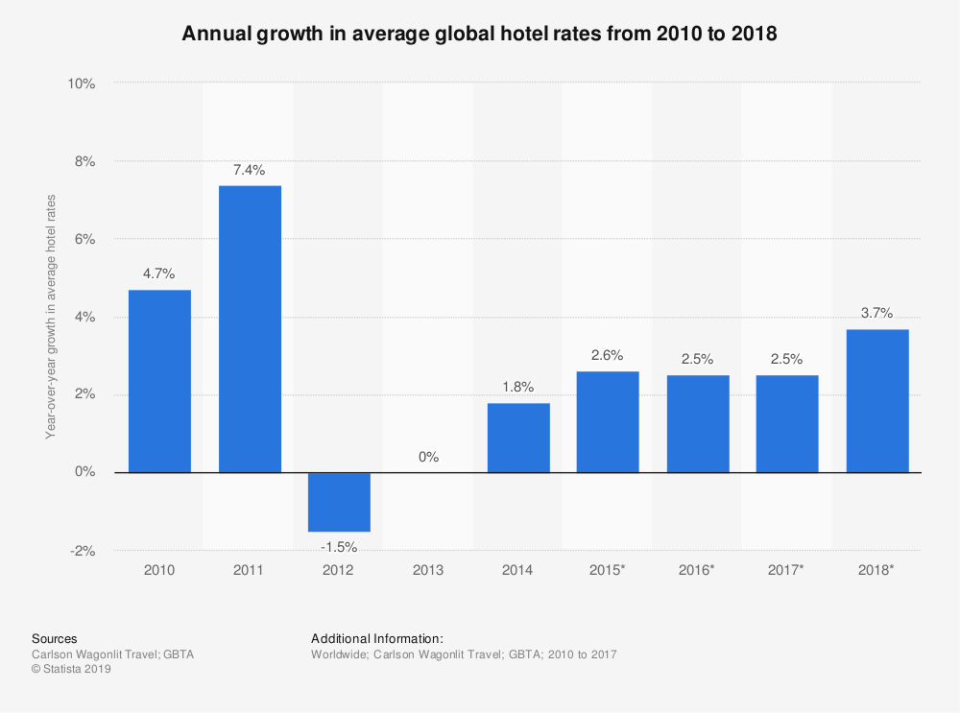
Appendix 2
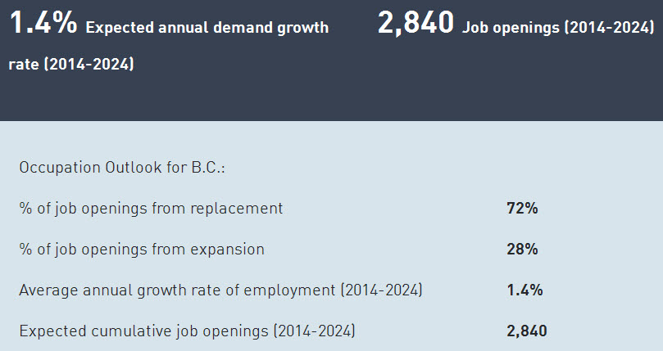

Appendix 3
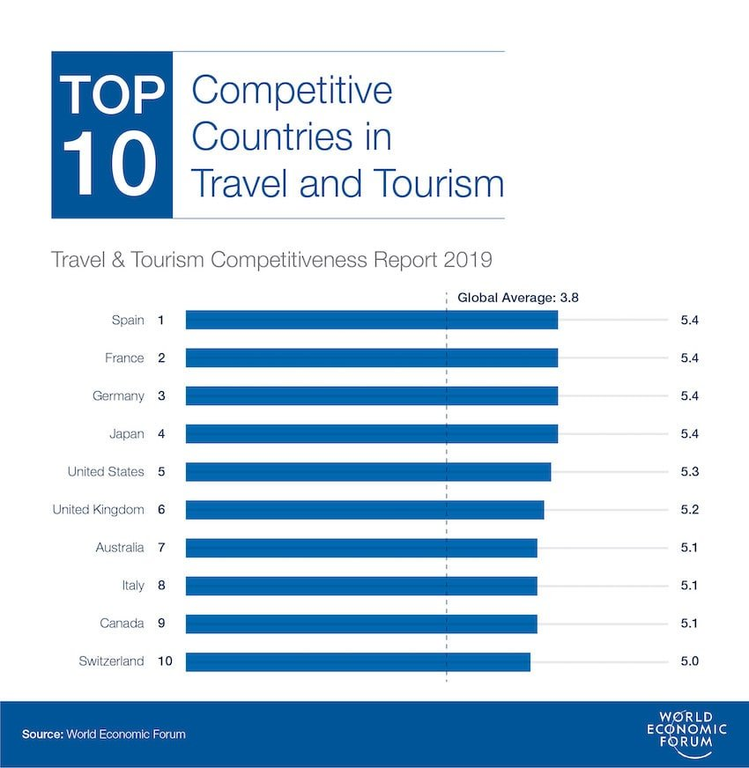
Appendix 4
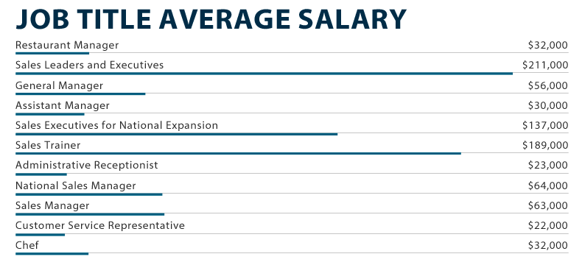

References/Bibliography
Avci, N., 2020. The effects of professional competency and workplace social networking on hotel employees' career success. Anatolia, 31(4), pp.651-661.
Badoer, E., Hollings, Y. and Chester, A., 2020. Professional networking for undergraduate students: a scaffolded approach. Journal of Further and Higher Education, pp.1-14.
Davis, J., Wolff, H.G., Forret, M.L. and Sullivan, S.E., 2020. Networking via LinkedIn: An examination of usage and career benefits. Journal of Vocational Behavior, p.103396.
Denmark, F.L. and Klara, A.M.D., 2010. Women mentors and their effect on educational and professional career development. A handbook for women mentors: Transcending barriers of stereotype, race, and ethnicity, pp.3-20.
Hobbs, R. and Coiro, J., 2016. Everyone learns from everyone: Collaborative and interdisciplinary professional development in digital literacy. Journal of Adolescent & Adult Literacy, 59(6), pp.623-629.
Lejeune, C., Beausaert, S. and Raemdonck, I., 2018. The impact on employees' job performance of exercising self-directed learning within personal development plan practice. The International Journal of Human Resource Management, pp.1-27.
Makarenko, S., Oliinyk, N. and Kazakova, T., 2018. Improving the method approach to the rating evaluation of employees as professional career development. Baltic Journal of Economic Studies, 4(5), pp.179-187.
Pluchevckaya, E.V., Varlacheva, N.V. and Andrienko, O.V., 2017. SWOT-Analysis as a Tool to Achieve a State of Personal Well-Being. The European Proceedings of Social & Behavioural Sciences (EpSBS). Vol. 19: Lifelong Wellbeing in the World (WELLSO 2016).—Nicosia, 2017. 192016, pp.548-553.
Savickas, M., 2019. Career counseling (pp. xvi-194). Washington, DC: American Psychological Association.
Selmer, J. and Leung, A.S., 2002. Career management issues of female business expatriates. Career Development International.
Wolniak, R., 2017. Selected problems of professional career development of employees. Zeszyty Naukowe Wyższej Szkoły Humanitas. Zarządzanie, (2), pp.9-20.
Wright, C.A. and Wright, S.D., 1987. The role of mentors in the career development of young professionals. Family relations, pp.204-208.

