


Underwater Platform Survivability Assessment
Stan Collins
2022429

Supervisor: Gareth Collett
Project submitted as part of the requirements for the award of BEng (Hons) OME

24/07/2025

Declaration of Originality
I, Stan Joseph Collins, declare that I am the sole author of this Project; that all references cited have been consulted; that I have conducted all work of which this is a record, and that the finished work lies within the prescribed word limits.

This work has not previously been accepted as part of any other degree submission.

Signed : 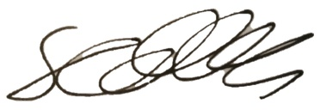

Date : 23rd July 2025

Form of Consent

I, Stan Jospeh Collins, hereby consent that my Project, submitted in candidature for the BEng (Hons) OME degree, if successful, may be made available for inter-library loan or photocopying (subject to the law of copyright), and that the title and abstract may be made available to outside organisations.

Signed: 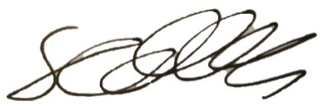

Date: 23rd July 2025

Copyright Acknowledgement

I acknowledge that the copyright of this project report, and any product developed as part of the project, belong to University of Wales Trinity Saint David, Swansea.

Abstract
Explosive Ordnance Disposal (EOD) operators are now beginning to include remotely operated vehicles (ROV) into their toolkits for underwater threats. Due to the complex nature of underwater explosions, the required distance from a charge for the vehicle to survive a blast cannot be determined on charge size alone. The purpose of this report was to establish a method for predicting the blast pressure survivability of an EOD ROV, based on a survived blast in the field, and produce a set of safety distances for a wider array of charges and depths.
To achieve this, a literature review was conducted, and four equations were identified to predict the initial blast pressure. 1D and 3D models were also built in APOLLO Blastsimulator to compare to the equations. The free-field equation found parity in results to the 1D free field model, however the equations considering surface reflections had less consistency. The simulations only considered the initial pressure wave and not secondary bubble pulses.
This report concluded that further work would be required to mature these predictions into established safety distance guidelines, however the equations would suffice as a quick estimation for trial guidance. Validation work would be needed to verify the predictions made in this report, and to expand on the narrow scope of the simulations produced for this report. An explosive trial methodology is described in the final section of this report, which would begin this process of model validation.
Table of Contents
Abstract 3
Acknowledgements 6
1. Introduction 7
1.1. Aims & Objectives 8
1.1.1. Objective 1: Survivability modelling 8
1.1.2. Objective 2: Future work planning 8
1.2. Report Structure 8
2. Underwater Explosions (UNDEX) 9
2.1. UNDEX phenomena 9
2.2. Underwater Blast Predictions 11
3. Research Methodology 14
3.1. Introduction 14
3.2. Research Overview 14
3.2.1. Research Design 14
3.2.2. Research Deliverables 14
3.2.3. Triangulation 14
4. Prediction Methodology 15
4.1. Design 15
4.1.1. First Principal Calculations 15
4.1.2. 1D Simulations 15
4.1.3. 3D Simulations 17
5. Results 18
5.1. Baseline peak pressure 18
5.1.1. 3D models 20
5.2. Safety distance calculations 22
6. Discussion 23
6.1. Baseline Pressure Predictions 23
6.1.1. First principal Calculations 23
6.1.2. 1D Modelling 24
6.1.3. 3D Modelling 24
6.2. Safety Distances 25
6.2.1. Free field – comparing to the 1D model baseline 25
6.2.2. Surface Reflections – comparing to the 3D model baseline 26
7. Conclusions 26
7.1. Conclusions 26
7.2. Future Work 27
7.2.1. Pressure Baseline Trial 27
7.2.2. Additional points for future work 27
7.3. Reflection 28
8. References 28

Figures
Figure 1: Equipment available to EOD/IEDD operators [6]. 7
Figure 2: Illustration of underwater explosion phenomena [13] 9
Figure 3: Underwater Explosion Phenomena [17] 10
Figure 4: Exponential decay of bubble energy and shockwave energy with increasing depth [19] 10
Figure 5: Shock wave time course from 100kg TNT explosion at 25m, using various prediction equations [22] 12
Figure 6: 2D shearing of a block showing Lagrangian (L) and Eulerian (E) meshing [26] 12
Figure 7: Lagrangian vs. ALE description of an UNDEX event: (a) initial FE mesh; (b) ALE mesh at t = 1 ms; (c) Lagrangian mesh at t = 1 ms; (d) details of interface in Lagrangian description [33]. 13
Figure 8: Representation of the 1D model geometry. 17
Figure 9: Example of 3D simulation visualisation of UNDEX event, as the pressure wave passes a point 6m from the detonation using the rigid bottom boundary condition model. 17
Figure 10: Diagram of the 3D simulation layout. 18
Figure 11: Comparison between 1D & 3D free-field models across any array of mesh resolutions. 19
Figure 12: 3D model overpressure results, normalised to the 3D model peak overpressure in figure 11. 20
Figure 13: Pressure wave visualisation from Apollo software of the dense water seabed condition, (left): wave passing x = 5m, (right): wave passing approx. x = 11m. 21
Figure 14: Boxplot detailing the spread of overpressure predictions from all data sources in this report. 22
Figure 15: Distances to match overpressure from 1D modelling prediction, from an array of equations. 23
Figure 16: Distances to match overpressure from 3D modelling prediction, from an array of equations. 23

Tables
Table 1: Formulas for calculating pressure values for underwater TNT explosions [22]. 11
Table 2: UNDEX Blast parameters 14
Table 3: TNT JWL constants and material properties [36] 16
Table 4: P_{max} results from the selected equations. 18
Table 5: Overpressure predictions for a 250g TNT UNDEX blast 21
Table 6: Safety distance predictions based on NEQ & depth. 22

Acknowledgements

As this is my second attempt at getting one of these individual projects right, I feel the need to acknowledge all those who made this time so much easier. My thanks go out to Gareth, for pushing me to make it good and not just okay. My boss David, for his constant well-meaning jokes about my increasing look of dread as the year went on. My Colleague Zac, for sending me daily motivational quotes in the final days. My course-mates Josh, Josh, Anna and Sam, for making me feel better about how late I started putting words on a page. My parents Lisa & Gary, for getting me this opportunity in the first place. My friends Alex and Jamie, for hearing me whine about this for six months. And finally, Avni, for being the most wonderful fiancée, always keeping me topped up on snacks when I needed them, and often when I didn’t.

Introduction
The job of countering underwater explosive (UNDEX) threats has typically fallen to navy personnel. Since World War II, clearance divers have been carrying explosive charges with them into the water and swimming to the targets, often having to trail a firing cable with them, protected only by a wetsuit [1]. While the technology and equipment available to modern divers has advanced since then, the level of protection available to a clearance diver is still generations behind the options for an explosive ordnance disposal (EOD) operator on land.
Options for remote engagement of targets on land have been standard since the introduction of the wheelbarrow robot in the 1970s [2] and have continued to be developed into systems with the capability of autonomously navigating through challenging environments [3] and neutralising threats remotely, keeping the EOD operator out of danger.
The full suite of typically available equipment for on land EOD operations can be seen in Figure 1. While the active materials section is fairly ubiquitous between the land and ocean domain, the EOD diver community has fallen behind in the protection and remotely operated vehicle (ROV) sections.
In recent years, wider industry has begun to develop solutions on this area. The maturity of the underwater ROV technology has advanced to the point where vehicles can provide suitable alternatives to sending a diver to face the threat, with several countries introducing ROVs into their Navy fleets for EOD purposes [4] [5]. These vehicles cross the full depth range of typical EOD operations, from crawlers for ship hulls and surf zones, to free flying ROVs for open water.

Figure 1: Equipment available to EOD/IEDD operators [6].
EOD operations can be conducted in a wide array of operating conditions. Unexploded ordnance (UXO) is typically found on the seafloor, but the presence of buoyant mine and limpet mines means the point of detonation could be anywhere from the sea floor to the water’s surface [7]. The refraction and superposition of blast waves underwater (Figure 3) means that safety distances cannot be calculated purely from distance but must also consider the position of the charge and the ROV relative to hard surfaces and boundaries [8].
This research aims to provide a baseline survivability assessment of an EOD ROV and begin work to develop safety distances for the vehicle across an array of charges.

Aims & Objectives
The main project aim is to evaluate the survivability of an ROV currently being used to support EOD operations. For various reasons, it may be beneficial to leave the ROV in the water during a blast, and so a deeper understanding of the required safety distances is required. This can be broken down into a few goals as follows:

Objective 1: Survivability modelling
Based on the available data from practical testing, a limit for the max blast pressure the vehicle could survive will be estimated. This will be conducted using calculations from first principals using established equations identified in a literature review and using modelling software. Using this baseline pressure, safety distances from a set of charge weights (NEQs) will be developed and will be of use in the planning for future trials work to validate these findings.

Objective 2: Future work planning
Once values are obtained from the modelling, trials planning will begin to evaluate the minimum distance the ROV should be from a blast, based on the maximum observed pressure and impulse. The results from this work will help validate the modelling work done in this report, establishing if it is appropriate to expand it into a deeper study. This will likely fall under future work.

Report Structure
This project will be divided into three parts. Firstly, a literature review will be conducted to outline the current prediction methodology for calculating underwater blast and damage. Calculations will be made using an array of prediction formulae, providing estimations for safety distances for the vehicle.
The next stage of the report will summarise the simulation work done to compare to the first principal calculations. Modelling of UNDEX blasts in a variety of situations was conducted, to provide alternative predictions for the peak pressure observed during each blast.
A selection of these predictions will be used to calculate safety distances from a range of target NEQs, considering the effects of depth on the predictions. This will again be done through publicly available equations and computer simulations.
Finally, the last section of the report will summarise future trials work being designed to validate or disprove these predictions, which should allow for safety distances for the vehicle to be established.

Underwater Explosions (UNDEX)

UNDEX phenomena
As has been well documented in many literature reviews on the topic, explosive events underwater have markedly different characteristics to those on land. After the initial detonation, the event can be defined as two distinct phases: the initial shock wave, and an oscillating bubble phase [9]. The initial blast wave decays exponentially, resulting in a detonative event with a higher peak incident pressure, but much smaller impulse than the same blast above water [10].
The superheated gas generated by the detonation expands until the pressure from the water exceeds the gas pressure, collapsing the bubble and creating another shock wave, called a bubble pulse, as in Figure 2 [11]. This collapse continues until the bubble reaches it smallest size, defined by the volume of its gaseous products, before growing outwards again. This cycle continues until the bubble expends all of the available energy, at which point the cycle stops and the bubble size remains constant [12].
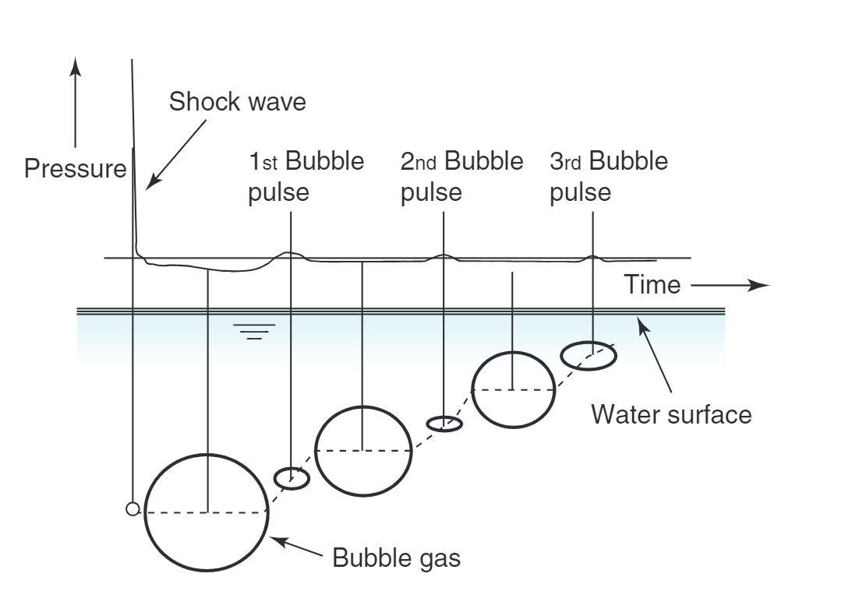
Figure 2: Illustration of underwater explosion phenomena [13]
The bubble produced by the initial detonation will migrate over time. If left in the free field, the bubble will migrate towards the surface. However, when near a hard surface, the bubble will migrate towards the surface, collapsing against it and producing damage through the Monroe effect, similar to a shaped charge [14]. This jetting effect can be the most destructive element of an UNDEX event due to the localised loading of the jet, highlighting the importance of understanding the geometry of any underwater blast [15].
The mechanisms for underwater explosions are not limited to these two effects. If detonation occurs under a vessel, the gas void generated can cause a ship to break under it’s own unsupported weight. A large plume of water can be observed during many UNDEX events as the gas bubble reaches the surface. Surface reflections of pressure waves produce a bulk cavitation region, as in Figure 3 [16].
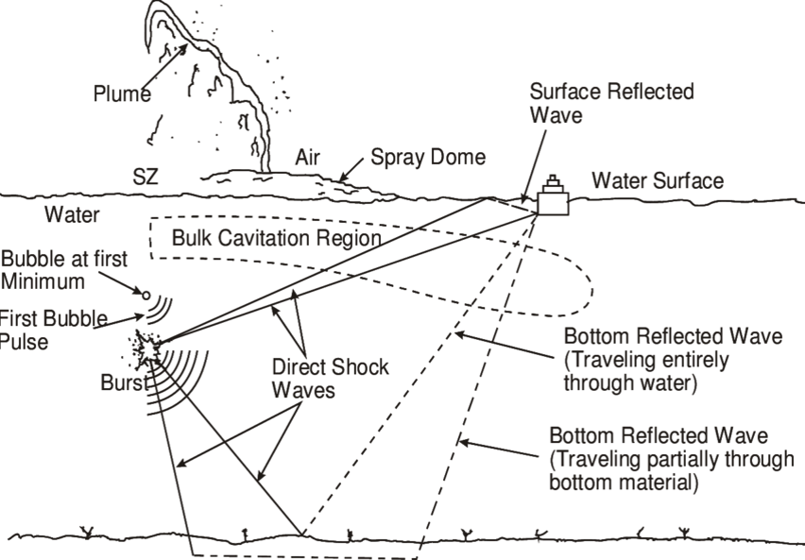
Figure 3: Underwater Explosion Phenomena [17]
Important to note is that as depth increases, the water pressure also increase, which studies have shown to result in peak overpressure and shock wave energy decreases [18]. In simulations, it has been shown that the positive overpressure of the shockwave, the maximum bubble size, bubble energy and bubble period all decrease with depth [19], as in Figure 4.
Figure 4: Exponential decay of bubble energy and shockwave energy with increasing depth [19]

Underwater Blast Predictions
Accurate predictions for the mechanics and properties of underwater explosions have been in development since the 1940’s [10] [9], where the first equations for UNDEX predictions were developed. While there was been refinement of these initial equations, they are still being used as the underlying principles of modern blast prediction [20]. This can be done analytically and produce results in line with experimental data [21].
Table 1: Formulas for calculating pressure values for underwater TNT explosions [22].
Author, Year | Pressure equations | Remarks, constants
R. Cole, 1948 [10] | $$p_{max}=52.3{\left(\frac{\sqrt[3]{m}}{r}\right)}^{1.13}$$  $$p\left(t\right)= p_{max}e^{-\frac{t}{θ}}$$  $$θ=0.093\sqrt[3]{m}{\left(\frac{\sqrt[3]{m}}{r}\right)}^{-0.22}$$ | Derived from results of TNT tests on charges weighing 70 – 136 kg
W. Stiepanow et al. 1966 [23] | $$θ=0.1\sqrt[3]{m}{\left(\frac{\sqrt[3]{m}}{r}\right)}^{-0.24}$$ | Time contact given by W. Stiepanow
W. Stiepanow et al. 1966 [23] | $$p_{max}=52{\left(\frac{\sqrt[3]{m}}{r}\right)}^{1.19}$$  $$p\left(t\right)= p_{max}e^{-\frac{t}{θ}}$$  $$θ=0.07\sqrt[3]{m}{\left(\frac{\sqrt[3]{m}}{r}\right)}^{-0.17}$$ | $$0.05 ≤ \frac{\sqrt[3]{m}}{r} ≤4$$  R. Cole formulas with J. S. Nawagin corrections
W. Stiepanow et al. 1966 [23] | $$p_{max}=44{\left(\frac{\sqrt[3]{m}}{r}\right)}^{1.5}$$  $$p\left(t\right)= p_{max}e^{-\frac{t}{θ}}$$ | $$6< \frac{r}{\sqrt[3]{\frac{3m}{4πρ_{TNT}}}}<12$$  $$θ<t< \left(5-10\right)θ$$
A.H. Keil, 1961 [24] | $$p\left(t\right)=K1∙{\left(\frac{\sqrt[3]{m}}{r}\right)}^{A1}∙e^{-\frac{t}{θ}}$$  $$θ=K2∙\sqrt[3]{m}{\left(\frac{\sqrt[3]{m}}{r}\right)}^{A2}$$
  Relations given for various explosives proposed by:
  W.D Reid | A.H. Keil | Rajendran & Narasimhan | Ming at al.
  K1 = 52.12 | K1 = 148.93 | K1 = 52.16 | K1 = 29.9
  A1 = 1.18 | A1 = 1.13 | A1 = 1.13 | A1 = 1.81
  K2 = 0.092 | K2 = 0.085 | K2 = 0.058 | K2 = 0.058
  A2 = -0.185 | A2 = -0.22 | A2 = -0.22 | A2 = -0.22
Geers & Hunter, 2002 [13] | $$p_{max}=P_{C }{\left(\frac{a_{c}}{r}\right)}^{1+A}f\left({\left(\frac{a_{c}}{r}\right)}^{B}\frac{v_{c}t}{a_{c}}\right)$$  $$p\left(t\right)= p_{max}e^{-\frac{t}{θ}}$$ | $\sqrt[3]{\frac{3m}{4πρ_{TNT}}}= a_{c}$ for spherical charges
  Formula given by Geers & Hunter for pressure waveform proposed by:
  R. Cole | T.E. Farley & H.G Snay | R.S. Price
  Pc = 1.42 | Pc = 1.45 | Pc = 1.67
  vc = 0.992 | vc = 1.24 | vc = 1.01
  A = 0.13 | A = 0.13 | A = 0.18
  B = 0.18 | B = 0.23 | B = 0.185

However, a review of formulas for predicting UNDEX primary blast characteristics (Table 1) produces an array of equations, which result in an array of predictions for peak pressure, impulse and time history [22], with the main differences coming in the form of the constants applied to R. Cole’s initial equations. Figure 5 illustrates the differences in peak pressure between a selection of different prediction equations. The discrepancies between these predictions are attributed to the data sets used to produce the models. Cole experimented primarily between 70 and 136 kg of explosive [10], whereas Geers and Hunter used data gathered at depths of 76 to 152m on a range of 0.2 to 5.4 kg [13].
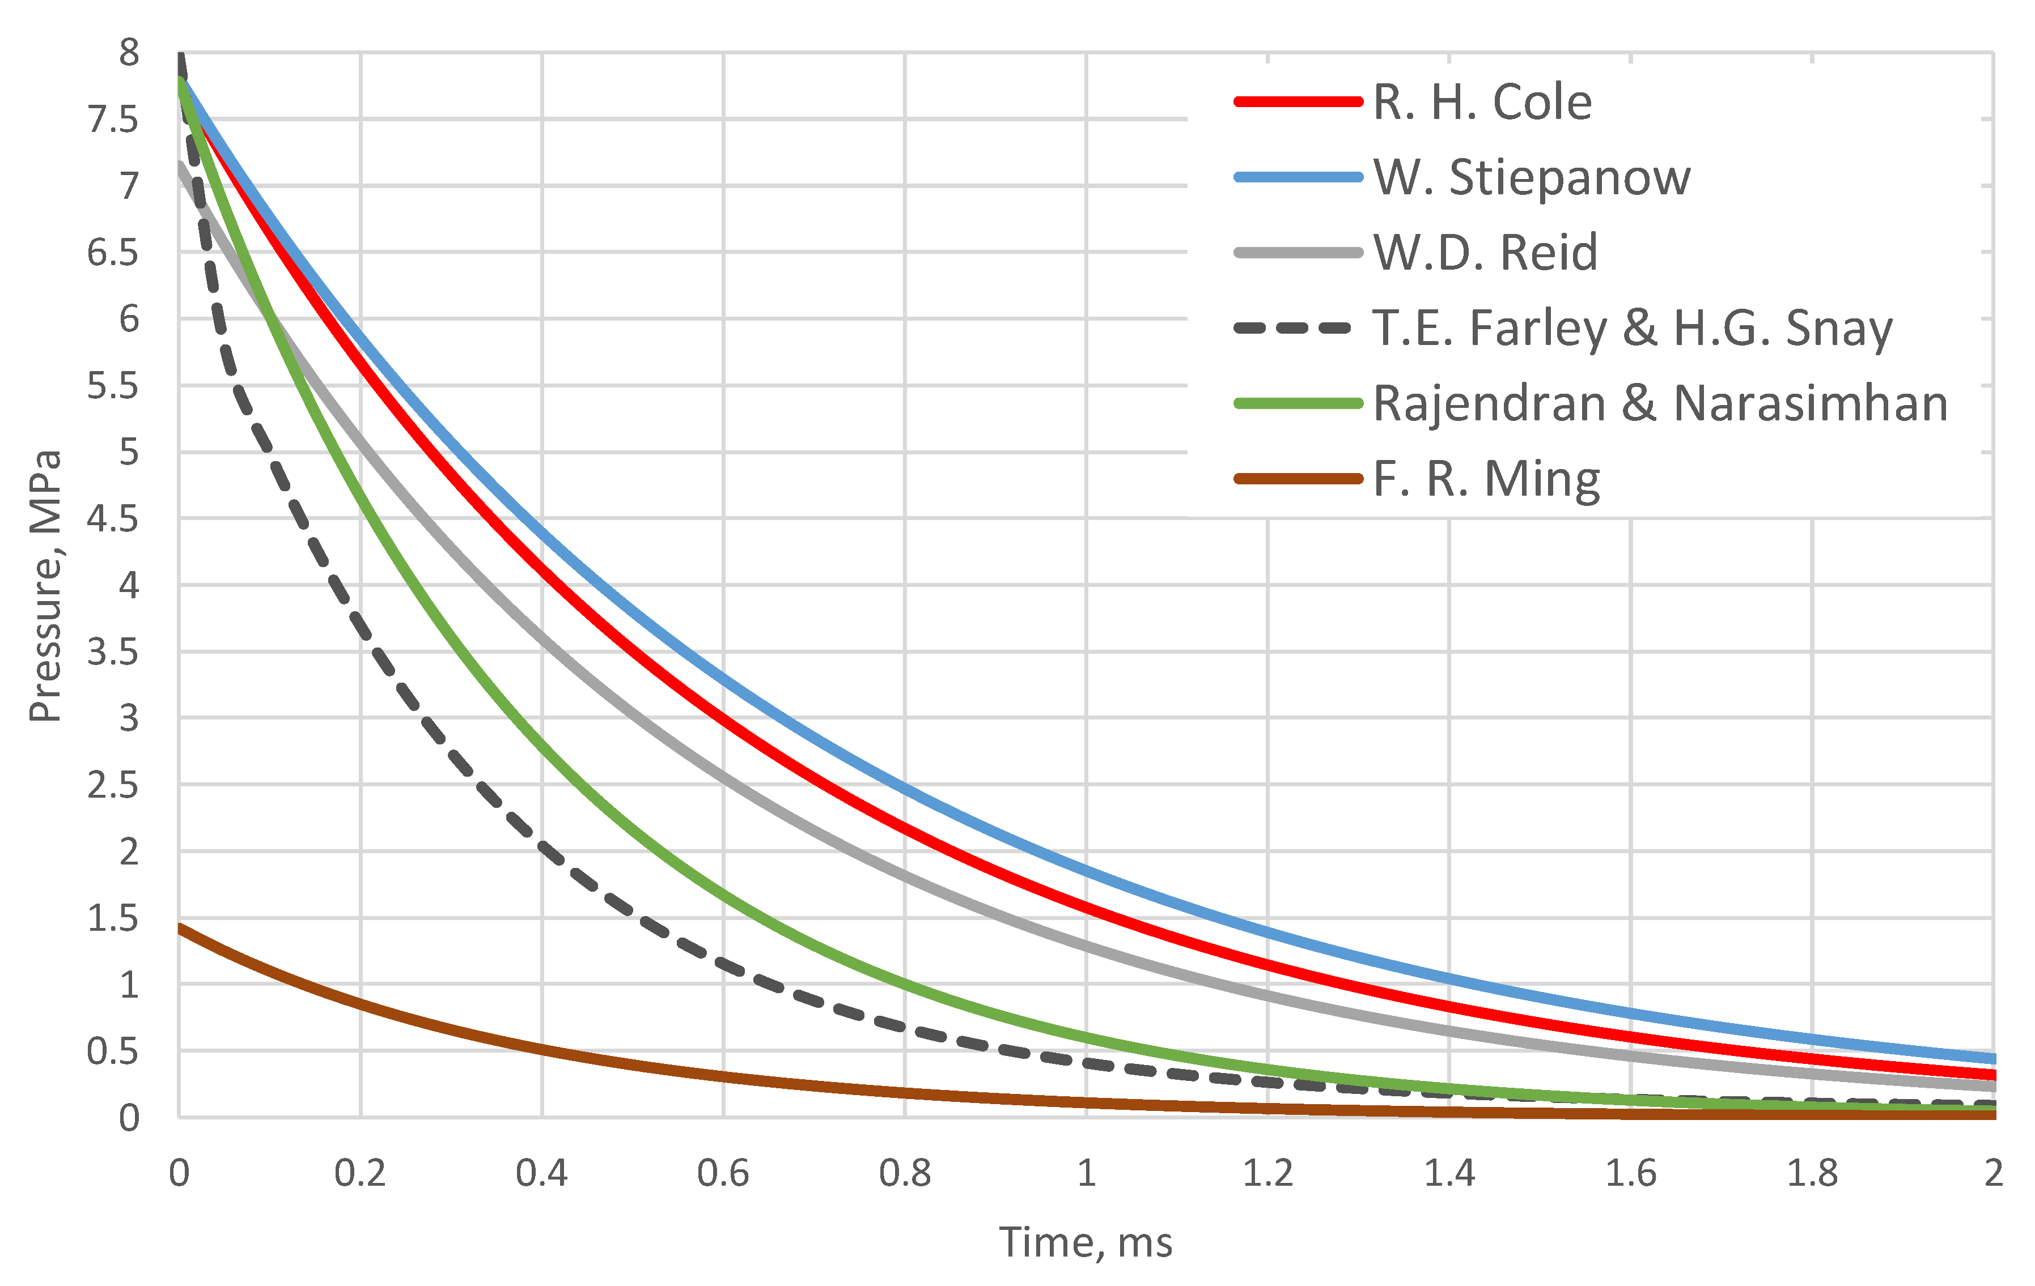
Figure 5: Shock wave time course from 100kg TNT explosion at 25m, using various prediction equations [22]
Advanced UNDEX blast prediction is typically done using computer simulations, where effects of blast are modelled using methods such as finite element method (FEA), finite volume method (FVM) and smoothed particle hydrodynamics (SPH) [20]. Of particular interest is the survivability of underwater structures, where the computer simulations can provide estimates for cumulative pressure history of a structure [12], vibration estimates [11] and damage predictions [25].
Typically, models investigating the water response only use an Eulerian mesh approach, whereas for structural analysis a Lagrangian mesh in required [20]. An Eulerian model measures the properties of the flow by accessing a fixed point in space, and letting the flow move through it. The Lagrangian approach describes the motion of the flow, deforming the mesh as the space distorts, as in Figure 6.
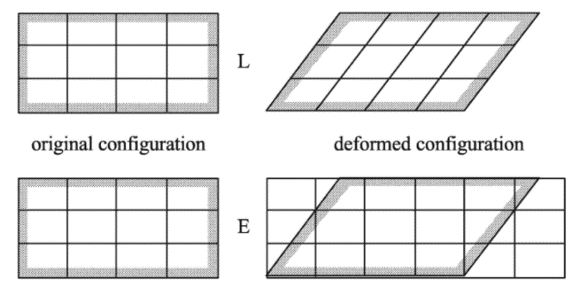
Figure 6: 2D shearing of a block showing Lagrangian (L) and Eulerian (E) meshing [26]
Both these model descriptions have inherent flaws however when applied to UNDEX simulations. Eulerian modelling can incur large computational costs and complex algorithms to model fluid-structure interactions. The spatial modelling must be large enough to encapsulate the entire measurable effected area, which can result in reduced mesh density if node limit is a limiting factor. The boundary conditions of the material may not line up with the boundaries of each element, and so applying boundary conditions becomes more complex [27]. On the other hand, Lagrangian modelling not allowing mass to pass between each element means that extreme element distortion, which can easily lead to a model crash [28]. This is particularly of issue when modelling damage from the bubble jet.
Given UNDEX modelling typically requires some combination of both fluid and structural analysis, a combined mesh approach has been adopted by many of the publicly available papers on the topic, often referred to as the arbitrary Lagrangian-Eulerian (ALE) method [29] [30] [31] [32] . This technique allows for allocating certain areas of a model to be either Lagrangian or Eulerian descriptions, the switching between the two methods when required, or the continuous remeshing of a model as a simulation progresses. This allows for far greater distortions than a typical Lagrangian model, while maintaining a higher resolution than a purely Eulerian mesh [33]. This difference is best illustrated by Figure 7, where sections b and c capture an explosive event at t = 1 ms in an ALE mesh and a Lagrangian mesh respectively.
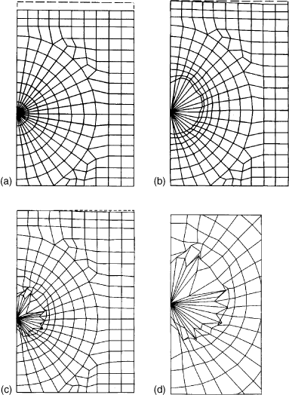
Figure 7: Lagrangian vs. ALE description of an UNDEX event: (a) initial FE mesh; (b) ALE mesh at t = 1 ms; (c) Lagrangian mesh at t = 1 ms; (d) details of interface in Lagrangian description [33].

Research Methodology

Introduction
On a recent energetic trial, an EOD ROV survived an UNDEX event while at reasonably close range from the blast. The ROV experienced the blast without incident, suggesting that this blast wave could be considered within the survivability parameters of the vehicle. While no pressure reading was taken during the event, the parameters of the charge were known, and predictions of the experienced overpressure can be extrapolated from this data.
Obtaining this overpressure would provide the vehicle with a baseline survivable pressure, from which proper safety distances can be extrapolated for various charges in a variety of locations, such as increases in depth or NEQ. This baseline figure can provide wider context for the vehicle survivability, and be used in future work assessing specific EOD-based scenarios.
Due to the breadth of options available for UNDEX blast predictions, this report will act as a review to compare some of the various prediction methods for the blast, and analyse how these differences in predictions affect the recommended safety distances.

Research Overview

Research Design
The first stage of this research is to predict the pressure experienced by the vehicle in the blast, to provide a baseline of survivability. While no pressure measurements were taken during that event, the depth of the charge, the NEQ were known, as well as the distance from the charge. Based on this information, predictions for the observed pressure can be made, using first principal calculations and software simulations. Table 2 outlines the details of the survived blast:
Table 2: UNDEX Blast parameters
Explosive | NEQ (g) | Range from ROV (m) | Depth (m) | Seabed type
TNT | 250 | 12 | 20 | Sediment

The scope of the modelling is limited to the water response to the UNDEX event. Structural and individual component responses of the ROV could be assessed in future simulations, and will be mentioned later in the future work section. As only the water response is required for the pressure prediction, the modelling will be conducted using an Eulerian description.

Research Deliverables
Pressure values will be calculated from existing experimental data to obtain a baseline for the limits of the ROV. This will be done through numerical calculations, 1D modelling and 3D modelling. The required safety distance from the charge will then be calculated in a variety of operating conditions.
The specific outputs of this report will be a set of maximum pressure values, which can be used as a comparison point for future trials work (as laid out in the future work section of this report), and an associated set of safety distances linked to specific charge NEQs and depths. This work is considered to be a pilot study, and will require further work to mature the confidence in these predictions

Triangulation
As will be mentioned throughout this report, various sections of the prediction methodology are unvalidated, or based on very few data points. An additional project could be produced to analyse these predictions once additional data points have been generated, or by comparing it to existing UNDEX modelling predictions. This project aims to provide guidance for future practical work, which will be expanded in the future work section of this report, which could also be used to validate or disprove these predictions.

Prediction Methodology

Design

First Principal Calculations
First, the scope of the predictions must be identified. For the initial first principal calculations, the charge is considered to be in the free-field, without interference or reflections. The charge is assumed to be a bare sphere of TNT, without considerations of confinement or depth.
For this project, the vehicle is assumed to be beyond the range where the explosive gas bubble would migrate towards it. The initial bubble radius can be calculated using equation 1 [10]. A charge of 250 g TNT would produce a bubble radius of 70 cm, well below the range where a vehicle would typically be situated. At 12 m range (over 17 bubble radii), it is assumed the bubble would instead migrate towards the surface, or another hard boundary condition.
$$\begin{aligned}b=k_{b}\sqrt[3]{\frac{W}{h+10}} \#\left(1\right)\end{aligned}$$
Further, the bubble pulse pressure waves are ignored at this time. Given the discrepancy in energy between the initial pressure wave and subsequent bubble pulses (53% to 13% of the initial detonation energy [34]), it is assumed that if the vehicle can survive the initial pressure wave, then it can withstand the following pulses. This assumption is consistent with those found in the methodology for warship strength assessments [22].
The initial prediction for the peak overpressure will be calculated using the equations in Table 1, using R. Cole’s equation and W. Steipanow’s interpretation of the constants. Surface reflection is considered by Cole using two separate alternatives to his initial equation, which are also included in the predictions for comparison to the 3D models.

1D Simulations
Peak pressure experienced at set distances underwater can be simulated by various methods. The simplest method is to reduce to problem down to a one-dimensional analysis, modelling the pressure wave passing through the water column.
As with the first principal calculations, the scope of the modelling is limited to the water response to the UNDEX event. Structural and component response of the ROV could be assessed later, and will be mentioned later in the future work section.
To conduct the modelling (both 1D and 3D), this report uses APOLLO Blastsimulator (referred to as Apollo throughout this report). As only the water response is required for the pressure prediction, the modelling will be conducted using a compressible, inviscid fluid Eulerian description, as in equation 2:
$$\left\{\begin{aligned}∂_{t}ρ+ ∇∙Q=0, \\ ∂_{t}Q+ ∇∙\left(u⊗Q\right)+ ∇P=ρf, \\ δ_{t}E+ ∇∙\left(u(E+P\right))= ρf∙u+ ρΦ_{v}\end{aligned} \right. (2)$$
Where ρ is density, u is velocity, P is pressure, Q is momentum (ρu), f is the mass external force and $Φ_{v}$ is a mass heat transfer source term. The volumetric total energy, E, is defined as:
$$\begin{aligned}E= ρ\left(\frac{u^{2}}{2}+ ∈\left(P,ρ\right)\right) \#\left(3\right)\end{aligned}$$
Where $∈\left(P,ρ\right)$ is the internal energy, which is determined by the equations of state.
For the model, equations of state (EOS) for the explosive and water are required. The behaviour of the explosive cannot be modelled with traditional plastic/elastic models, and as such requires it’s own equation of state to model the detonation and generation of the blast wave. The most commonly used expression to model high explosives (and the method used in this model) is the Jones-Wilkins-Lee (JWL) EOS:
$$\begin{aligned}P=A\left(1- \frac{ω}{R_{1}ν}\right)e^{-R_{1}ν}+B\left(1- \frac{ω}{R_{2}ν}\right)e^{{-R}_{2}ν}+ \frac{ωE}{ν} \#\left(4\right)\end{aligned}$$
Where $A, B, R_{1}, R_{2}$ and ω are user-defined material constants, $ν$ is the ratio of the initial density to the current density (${ρ_{0}}/ρ$) and E is the internal specific energy [35]. Table 3 shows each constant used in the above equation.
Table 3: TNT JWL constants and material properties [36]
Density (kg/m³) | Detonation wave speed (m/sec) | A (MPa) | B (MPa) | ω | R1 | R2 | Detonation Energy Density (ρd) (J/kg)
1630 | 6930 | 373800 | 3747 | 0.3 | 4.15 | 0.95 | 3680000
For the water, the Tait equation of state is used, as in equation (5) [37].
$$\begin{aligned}V= V_{o}-C\log\left(\frac{B+P}{B+ P_{0}}\right) \#\left(5\right)\end{aligned}$$
Where V is the specific volume of the water, V₀ is the specific volume at which P = P₀, P = hydrostatic pressure and B & C are functions of temperature. The water was modelled as fresh water at 20°C degrees. Values for the equation 5 were filled using pre-sets in the Apollo software.
For the 1D simulations, the following assumptions were implemented into the models:
- All charges will be assumed to detonate perfectly from the centre of the charge. The charge is modelled as a perfect sphere of TNT. This is to simplify the model. Consideration into non ideal detonations or low-order detonations are discussed in the future work section, as well as discussions on alternate charge shapes.
- Speed of sound is not altered from the default. This is due to speed of arrival not being of concern to the research, especially in the 1D model.
- Bubble effects are to be ignored during the simulations. Vehicle placement will be beyond the range of potential damage via UNDEX bubble migration. Only peak incident pressure will be calculated. This enables comparisons to be drawn between this modelling and the equations for free-field UNDEX events.
- No surface reflections are included in this modelling. The 1D model does not have the capability to include surface reflections, and so all blasts are considered to be floating a significant distance from either the seabed or water surface.
- The pressure gauge is at the same depth as the charge. Due to the simplicity of the 1D model, the gauge must be in line with the charge. A representation of the model can be seen in Figure 8. There is no visualisation of the 1D results, as the system only outputs text files in 1D models.

G1
12m
Figure 8: Representation of the 1D model geometry.

3D Simulations
To model the surface reflections from the seabed, a more complex model is required. The jump to 3D modelling introduces a new variable in the bottom boundary condition and material properties. The seabed in the trial was sandy, and ideally this would the seabed condition chosen for the modelling. However, there are no validated seabed material properties built into the system, and so a more novel approach was required.
Rather than model the seabed as a new, solid material without validation, the seabed could be kept as water, but with the density changed to reflect the conditions of the seabed sediment. This ‘dense water’ seabed condition will be compared to a rigid boundary seabed condition, and a free-field boundary, where the seabed is effectively more water. For the ‘dense water’ seabed, the material conditions are based on the properties of saturated sand, and use a density of 1900 kg/m³, and a speed of sound of 1720 ms⁻¹.
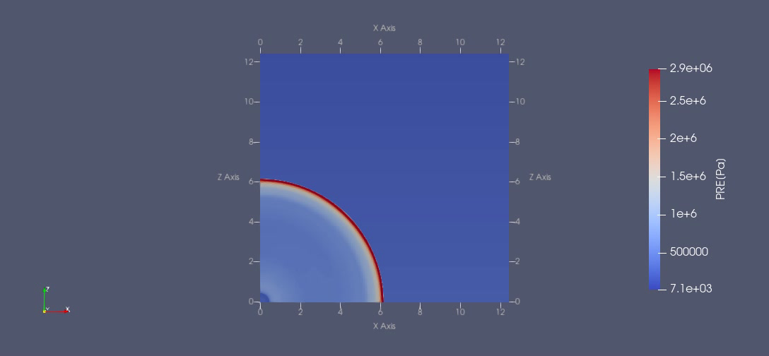
Figure 9: Example of 3D simulation visualisation of UNDEX event, as the pressure wave passes a point 6m from the detonation using the rigid bottom boundary condition model.
The addition of the extra dimensions allows for a supplementary element of analysis regarding safety distance from the charge – relative hight from the charge. All other prediction methods mentioned thus far measure the peak pressure at the same depth as the charge, however the 3D modelling allows for changing the elevation of the pressure gauges, while keeping the slant range from the charge consistent. A schematic of the experimental set up can be seen in Figure 10. The charge is modelled as being placed in contact with the seabed, with gauges placed at every 5-degree interval, all at 12 m range from the TNT. A visualisation of the software output can be seen in Figure 9.
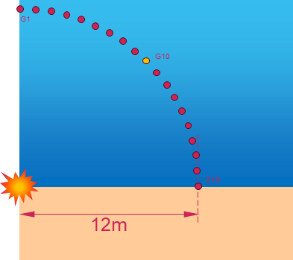
Figure 10: Diagram of the 3D simulation layout.

Results

Baseline peak pressure
The first stage of building the safety distances is to predict the baseline of vehicle survivability. This is initially done by using peak pressure equations established by Cole and Swisdak [20]:
$$\begin{aligned}P_{m}=k{\left(\frac{m^{\frac{1}{3}}}{R}\right)}^{∝} \#\left(6\right)\end{aligned}$$
Where Pm is peak incident pressure, m is explosive mass and R is range. K and α are empirical constants specific to the explosive material. For TNT, these values are K = 52.30 & α = 1.13 [9].
Using the information of the survived blast, a pressure of 1.87 MPa can be calculated, based on a range of 12m. However, the initial blast was while the charge was on the seabed, and so superposition and reflection also should be considered. If the ground was assumed to be perfectly rigid, reflecting the entire energy of wave, then the charge mass is effectively doubled [10], producing a peak observed pressure of 2.67 MPa. However, work conducted by Cole measuring peak reflected pressure waves on sandy mud seabed conditions found an increase of 10% was more consistent [10]. This would produce a value of 2.05 MPa.
As outlined in Table 1, there are other interpretations of Cole’s pressure equations, in particular in relation to the values for constants K & α. W. Stiepanow et al. [23] identifies these as K = 52, and α = 1.19, which produces a peak pressure of 1.58 MPa. Table 4 summarises all of the numerical predictions for the max observed pressure.
Table 4: P_{max} results from the selected equations.
Prediction # | Author | Equation | P_{max}
1 | R. Cole | $$52.3{\left(\frac{m^{\frac{1}{3}}}{R}\right)}^{1.13}$$ | 1.87 MPa
2 | R. Cole (Rigid Seabed) | $$52.3{\left(\frac{{(2×m)}^{\frac{1}{3}}}{R}\right)}^{1.13}$$ | 2.67 MPa
3 | R. Cole (Adjusted) | $$1.1 ×52.3{\left(\frac{m^{\frac{1}{3}}}{R}\right)}^{1.13}$$ | 2.05 MPa
4 | W. Stiepanow et. al. | $$52{\left(\frac{m^{\frac{1}{3}}}{R}\right)}^{1.19}$$ | 1.58 MPa

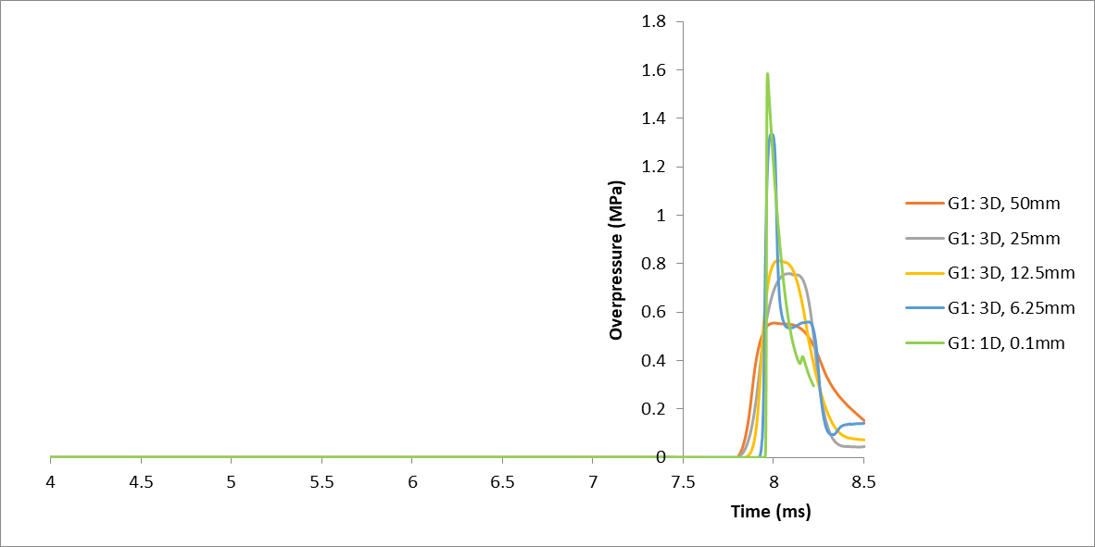
The next stage is to repeat this prediction with simulated modelling. Taking the initial conditions as the same as the previous section, a 1D model can be built and the blast simulated, as illustrated in Figure 11. The model output a peak pressure of 1.58 MPa. Using this figure as a baseline point of comparison, the mesh resolution of the 3D model can be assessed before the full suite of simulations are run. Due to the increasing complexity of the model, computational time increases massively for the 3D model (0.7 hours for a single 1D model compared to 9 hours for highest resolution 3D model), and so mesh resolution had to be dramatically reduced. As seen in figure 11, a mesh resolution of 6.25mm produced the closest response to the 1D simulation in terms of peak overpressure and the impulse of the blast wave. As such, 6.25mm mesh resolution is used throughout the remaining 3D testing.
1.58MPa
Figure 11: Comparison between 1D & 3D free-field models across any array of mesh resolutions.
Using this mesh resolution, a variety of 3D models were produced to make predictions with seabed reflections included in the prediction. As there was no preset ground condition built into the modelling software, three separate modelling conditions were used for the seabed: a rigid boundary, salt water (effectively acting as a free field simulation), and dense water.

3D models
As seen in figure 12, when comparing the 3D models, a few notable trends can be identified. Both the rigid and all water seabed conditions follow the same pattern, with the gauge at 45° to the charge (Gauge 10) producing the lowest peak over-pressure, before beginning to rise as the gauges approach the boundary. Considering gauges 0 to 10, all three model results are proportioned as expected. The free field ‘all water’ model produced the lowest pressures, as it is without surface reflection, while the rigid boundary with ideal surface reflections produced the highest values (a full 36% increase on the Gauge 0 value from the dense water model).
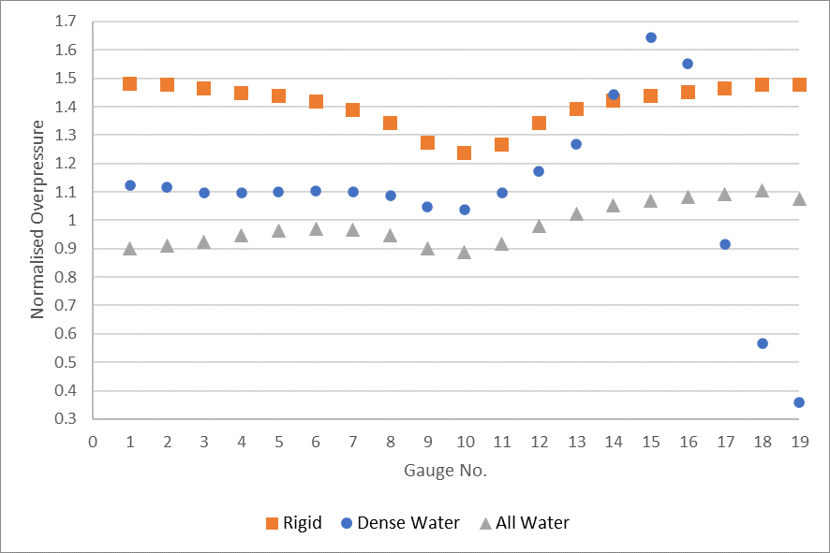
Figure 12: 3D model overpressure results, normalised to the 3D model peak overpressure in figure 11.
Where the models begin to differentiate is gauges 11 – 19, where the dense water model fully separates from the arc of the rigid and all water models. Guage 15 produces a peak overpressure of 2.19 MPa, a full 68% increase on the 1.33 MPa observed in the 3D free field simulation. Gauges 17, 18 and 19 all show dramatically reduced overpressure compared to the rigid and all water models. In particular, the gauge at the boundary condition, Gauge 19, produced a very low overpressure of only 0.48 MPa. This overpressure is equivalent to a charge mass of 12.6g on TNT when calculated using equation 6.
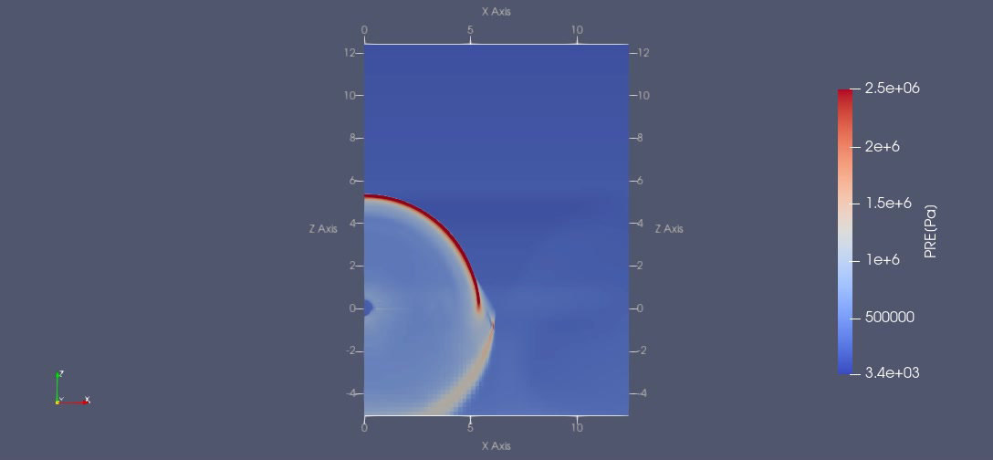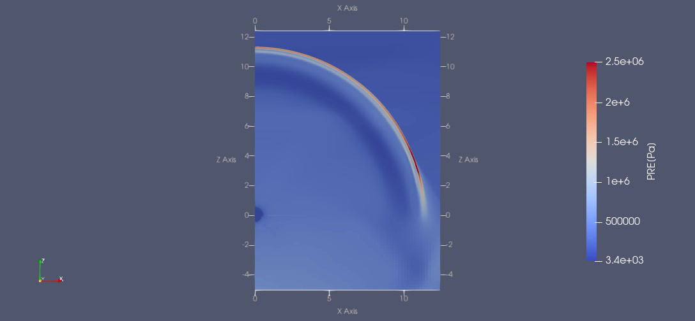
Figure 13: Pressure wave visualisation from Apollo software of the dense water seabed condition, (left): wave passing x = 5m, (right): wave passing approx. x = 11m.

When assessing the visualisations of the dense water simulation, a clear focusing of the peak pressure across the front of the blast wave can be observed. Figure 13 demonstrates that the blast wave initially was an even distribution of pressure across the blast front, before transitioning to the uneven dispersal of pressure values seen in Figure 12. This result would suggest that distance from the target and relative height from the target cannot be considered separately in determining where is the safest place to place a vehicle from an UNDEX event.
Table 5 captures every prediction of the observed overpressure of the initial blast as outlined in research methodology section of this report. Ignoring the minimum of the dense water model, all results fall within a 1.01 MPa range. If averages are taken for all the 3D results across the 19 gauges, this range reduces further to 0.85 MPa. When considering every max pressure prediction from every gauge in every simulation, the Interquartile range for this data set is 0.54 MPa, visualised in figure 14). This is, relative to the predicted pressures, rather large.
Table 5: Overpressure predictions for a 250g TNT UNDEX blast
Prediction method | Overpressure (MPa)
Prediction method | Min | Max
R. Cole | 1.86
R. Cole (Rigid seabed) | 2.67
R. Cole (Adjusted value) | 2.05
W. Stiepanow | 1.58
1D Model | 1.58
3D Model (Free field) | 1.33
3D Model (Rigid boundary) | 1.64 | 1.97
3D Model (Dense water) | 0.48 | 2.19
3D Model (All water) | 1.18 | 1.47

Figure 14: Boxplot detailing the spread of overpressure predictions from all data sources in this report.

Safety distance calculations
Given the discrepancies between the various overpressure prediction methods, it is worth considering establishing an array of safety distances, relative to each prediction of overpressure. Using 1D modelling as in the previous section, predictions of larger NEQs and increasing depth were produced. This was done by taking the pressure prediction in the 1D model (1.58 MPa) and calculating the distance where the gauge experiences that pressure again against the new charge. The average value across the 19 gauges for the dense water model is used as a reference for the 3D section. Table 6 collects the distances to match each baseline pressure from the new 1D models, comparing a 10 kg and 100 kg NEQ of TNT, at depths 20 m and 300 m.
Table 6: Safety distance predictions based on NEQ & depth.
Charge Mass (kg) | Depth (m) | Distance to match overpressure (m)
Charge Mass (kg) | Depth (m) | 1D Model | 3D Model
10 | 20 | 41.2 | 44.7
10 | 300 | 41.1 | 44.5
100 | 20 | 88.7 | 105.3
100 | 300 | 88.4 | 104.9

Most notable from Table 6 is the incredibly small discrepancy between the two depth extremes. Only 10cm separates a 10kg blast at 20m depth and 300m using the 1D simulation as a baseline. Even using the most extreme example, comparing the 100kg charge to the 3D model, only results in a difference of 40cm.
When using the numerical prediction methods outlined in section 5.1, predictions can make for distances to match overpressure for a wider array of charge NEQs, as in Figures 15 & 16. These equations do not factor in depth, however as identified in Table 6, the effect is minimal on the distance calculations. When comparing to the 1D model prediction of the 10 kg charge mass in Table 6, the distances ranges from 40.6 m from W. Steipanow to 60.0 m for the Rigid seabed version of R. Cole’s equation. It must be considered that two of the four equations used in the numerical predictions factor in surface reflections, whereas the 1D model only considered free field, so only the blue R. Cole and W. Stiepanow plots should be compared to the 1D prediction.

Figure 15: Distances to match overpressure from 1D modelling prediction, from an array of equations.

Figure 16: Distances to match overpressure from 3D modelling prediction, from an array of equations.

Discussion

Baseline Pressure Predictions

First principal Calculations
The results from the initial calculations can be broken down into two sections: with and without considerations of surface reflections. When assessing the free-field predictions, prediction of 1.86 and 1.58 MPa were made using the unchanged R. Cole and W. Steipanow equations respectively. Given the range of NEQs Cole was using to make that initial equation, and that Steipanow prediction matches the validated 1D model, this report concludes that the Steipanow constants should be used when making free-field predictions for TNT in the future.
Considering the simulations including surface reflections, the two equations both use alterations of R. Cole’s equation, which has just been identified as the equation with potential inaccuracy when considering a charge of this NEQ. The two equations consider two drastically different seabed conditions, namely rock and sediment. As such, the two values are best compared to the later 3D models, rather than each other.
When assessing which prediction is best representative of the blast observed by the EOD ROV, and so the value to carry forward into the blast predictions, the W. Steipanow prediction was chosen. While it does not address any surface reflections, it does match a verified prediction in the 1D free field prediction, giving it a degree of secondary validation lacking in the other predictions. It is worth noting that the best way to assess these predictions would be recreating the blast with actual pressure gauges, but that will be discussed in the conclusion.
As outlined in the methodology, there are a number of key assumptions made in this section which must be addressed. The initial set of pressure predictions (section 5.1) are derived from equations without reference to depth. Figure 4 graphically demonstrates that depth has a limiting effect on almost all underwater explosive properties, and so ignoring it clearly reduces the accuracy of the results. However, Table 6 illustrates how little depth impacted the safety distances produced by the modelling, and so it may be that in shallower conditions these predictions are still valid.
The calculations also only reference the initial blast and not the subsequent bubble pulses. When operating in a free-field, where incident overpressure is the only damage mechanism of concern, this would provide a valid prediction, however it does not consider reflected pressure waves or superposition of waves from the bubble pulses, which under certain circumstances could be an issue.

1D Modelling
This modelling method obviously abstracted the explosive event down to its most fundamental component, and as such ignores all other considerations. While depth is considered, making it an improvement on the initial first principal calculations, the model is again in a free-field, not accounting for any reflections. It is worth noting that this stage of analysis (1D simulations in the APOLLO program) has the highest level of confidence of all of the predictive methods used, due to the historical validation of the model from past trials work.
The 1D model produced the 2nd lowest estimate for the free-field peak overpressure, only higher than the initial free-field 3D model, which was of much lower resolution. It was the same value as the W. Stiepanow prediction, which might suggest that this set of equation constants produces the highest accuracy of prediction for this scale of charge in a free-field environment at this depth.

3D Modelling
In the initial free field modelling comparison to determine the meshing requirement, the 3D models all showed reduced peak pressure when compared to the 1D model. This is indicative of Eulerian models with reduced resolution, as shown by the fact that as the mesh size decreased, the peak pressure got closer to the 1D prediction. The 6.5 mm mesh size was the smallest achievable mesh given the available computational power and timeframe, with each simulation lasting 9 hours. It can be theorised that with a higher resolution, the peak pressure could increase and eventually reach parity with the 1D model.
The addition of the extra dimensions allowed for a separate element of analysis, namely observing how relative hight from the target affected peak overpressure. Depending on the model chosen, the lowest observed overpressure it either at the 45° from the surface boundary, or at the boundary itself. The large discrepancy between the other models and the dense water model at the material boundary requires further investigation to determine the cause of this reduction. Given each model only had a single simulation to pull data from, it would be inappropriate to pull conclusions over which is the more accurate prediction. Proper validation work using practical data would be the best means of assessing this discrepancy.
The difference between the two 3D models with considerations of surface reflection (rigid boundary and dense water) is stark and suggests an issue with one of the two models. The distinct drop of overpressure at the boundary between fresh water and the seabed in the dense water model could be caused by the pressure wave travelling through the seabed (best seen in left visualisation in Figure 13), or by blast wave reflection superposition. However, if the effect was superposition, the change in pressure across the blast wave front would be expected to be seen on the rigid seabed model as well, which it is not.
The 3D models were the only simulation to include considerations of pressure wave reflections. While in isolation this would increase the confidence in these results, the increased number of variables introduces numerous elements of uncertainties. The materials chosen for the seabed were not validated for UNDEX simulations, and so the confidence in these results is limited until validation work can be conducted. Similarly, the dense water model predicted that resting on the seabed would result in the lowest observed overpressure, however the model is not validated for ground shock or shock wave travelling through the seabed before ‘reflecting’ out of the material (as in figure 3).

Safety Distances
When discussing safety distances, the first observable conclusion is the minimal effect depth has on the predictions. The difference between the same charge at 20 m and 300 m is minuscule, suggesting that in future work if a quick estimation of pressure or distance is required, then depth can effectively be ignored, as in the numerical equations outlined early in this section. When assessing the 1D modelling results in Table 6, the gap between the safety distances when referring to the 1D and 3D models is quite significant with the 100 kg charge, highlighting potential effect of factoring in surface reflections into the calculations.

Free field – comparing to the 1D model baseline
Where the baseline pressure value is taken from the 1D model, the predicted safety distances are lower than when using the 3D model baseline. The difference between the two baseline predictions increases notably with NEQ, jumping from an 8.5% increase at 10 kg to a 18.7% increase at 100 kg. The slope of that increase with NEQ cannot be plotted from only these two data points, and so more analysis would be required to expand on these initial findings.
Comparing the two free-field numerical equations for blast pressure (R. Cole & W. Steipanow), as plotted in Figure 15, shows that W. Steipanow’s predictions are a closer match to the 1D model than R Cole, a finding consistent with the results in Table 6. There is a 12m difference between the R. Cole prediction of a 100 kg charge and the 1D modelling, which suggests that it may not be suitable for predictions of free-field blasts moving forward. This report recommends using the K. Steipanow equation for TNT blast calculations in future, where modelling solutions are not available.

Surface Reflections – comparing to the 3D model baseline
It is worth considering that in this section, free-field 1D modelling is being compared to a baseline pressure prediction from a 3D model with surface reflections, and so there will be inherent inaccuracy with this section of comparison. However, it does give an indication of how the safety distances increase when surface reflection is considered into the initial pressure value. This is most pronounced with the larger charge, with a full 20m difference between the two predictions.
Of the two numerical equations that consider surface reflections, Cole (adjusted) maps to the 1D model predictions fairly well, which was to be expected this the initial baseline pressure was taken from the 3D dense water model, and both the model and the equation are supposed to represent a sediment seabed condition. If the rigid seabed 3D model was used as the source for the pressure in this modelling, then it would be expected that the Cole (Rigid) would produce results more inline with the 1D model safety distance. The discrepancy between the two equations as the NEQ of the charge increased illustrates the requirement to know the seabed condition before a predictive equation or model is chosen. Rather than choosing a specific equation or model as the basis for all future safety distance calculations, this report instead recommends that both these equations be kept on and chosen between when specifics about the UNDEX scenario are clarified.
All of the predictions for safety distance provided in this report should be given a safety factor if considered into the planning of explosive trials. The exact safety factor would need to be determined through further analysis, as it is likely to be proportional to the NEQ. As it stands, the are too few data points regarding the damage limit of the vehicle to draw conclusions regarding safety factors.

Conclusions

Conclusions
This report provides an array of potential safety distances for an EOD ROV. Based on the confidence in these prediction methodologies, this report estimates that the 1D software modelling simulations provides the best prediction methodology for free-field UNDEX events. The 3D models used in this report give an indication of pressure changes when a seabed is present in the calculations, but further work is required to fully mature these predictions into usable safety distances. The 3D models also indicate that distance from the target and relative height from the target cannot be considered separately in determining where is the safest place to place a vehicle from an UNDEX event.
The equations established in this report can provide an initial estimation for the required distance the EOD ROV must be from a charge to survive an UNDEX event. In particular, the identified equation for free-field UNDEX blast closely aligns to the validated 1D model, and so can be used with some confidence in prediction work. It is worth noting that the predictions made in this report cover a relatively small range of ocean depths, and additional work would be needed to assess if the accuracy of these equations holds up as the depth increases. Figure 4 would indicated that when a charge reaches 2000 m depth, the shock wave at 1 m will have reduced in energy by ~ 5%.
The limited number of simulations run for each variation of the 3D models further reduces the confidence in these predictions. Additional runs of each model would help establish if some of the observed patterns and outlying results, such as the pressure drop-off at the surface boundary in the dense water model, are valid UNDEX phenomena or just errors in the model.
Without validation, in the form of experimental data or a previously validated 3D model, the predictions made in this report are to be considered preliminary research for a deeper assessment of the scenarios discussed in this report. The following future work section outlines a methodology for beginning that validation work, through an explosive trial.

Future Work

Pressure Baseline Trial
The most glaring acknowledgement throughout this research has been the scarcity of data. In particular, the safety distance calculations rely on a single data point where the ROV survived a blast, where no blast pressure data was recorded. Therefore, all the safety distances discussed in this report are themselves based on an estimation of what the vehicle experienced in that initial blast.
Without this baseline measurement, the only way to assess the pressure predictions made in this report is to compare them to validated models. The only validated model available during this work was a 1D free-field simulation, which cannot fully represent the experience of the vehicle for the many reasons already discussed in this report. As such, the obvious first stage for future work is to recreate this blast, or better yet conduct a series of experiments build around testing the vehicle to destruction.
The simplest way to test this would be identifying the component most susceptible to damage from the blast pressure wave, likely any components with internal pockets of air such as a camera, and test these components individually to destruction. A pressure gauge could be placed at same depth and distance from a blast to capture the pressure experienced by the component. While this would identify the breaking limit of that component on its own, it ignores several other factors in underwater damage.
Based on the research done on underwater structure and vehicle survivability; vibrations, pressure time history, impulse and pressure reflections are all key in understanding underwater response to shock. The frame of most ROVs are hollow by design, allowing easy access to internal components for maintenance. This hollow frame could allow for superposition of pressure waves as they are reflected internally inside the structure. As such, tests might be more accurate if the entire vehicle could be tested to destruction, although the cost implication would need to be considered. To this point on cost, each detonation test with a vehicle would require a new vehicle, as an accumulation of stress fractures could lower the pressure at which the system fails, incurring heavy costs.

Additional points for future work
Further, the 3D models of the seabed were unvalidated for UNDEX simulations. The material properties chosen for the analysis were picked to reflect typical seabed material compositions EOD teams could encounter, but the accuracy of the results would require further analysis and likely additional validation work based on explosive trials. This could allow for expansion into considerations into ground shock, something that was not able to be included in the scope of the study. The models could also be expanded to include the bubble pressure waves, which also were not included due to the scope of the project.
Another critical element of an UXO disposal was not addressed in this study, namely that of height from the seabed. All 3D models assumed the charge was in contact with the seabed, however this may not always be the case. On land, where there is a height of burst from the ground, a Mach stem effect can be developed as the pressure wave moves as a flat edge rather than a curve, and this effect could impact safety distances if the ROV were to be sat on the seabed. Additionally, no consideration was taken into the effect of partial of full burial of a charge. If the target is legacy UXO, the charge may have been in place for years or even decades, and so many have become covered in marine life or buried in ocean sediment.
All explosives in this report were modelled as spherical charges of TNT, and future work could also explore the difference in safety distance depending on shape of charge, determining how the safety distance changes depending on the charge orientation. This would be particularly of interest regarding shaped charges, a tool regularly used in underwater EOD.
An increasing priority of underwater EOD is the transition to deflagration rather than detonation of a charge, causing a low order response in the munition [38]. The energetic response in such a scenario is reduced, which provides additional safety to surrounding infrastructure and marine life. Work could be undertaken to simulate the vehicles response to these explosive events, however it is safer to assume an article will detonate, and so the worst-case safety distance would likely always be assumed.

Reflection
If this report were to be repeated or reattempted, a different methodology would be advisable. The lack of validated models for the 3D models impacted the conclusions that could be drawn from those sections of modelling, so a more thorough exploration into this section could have yielded improved results. Finding additional data from similar firings could have been used as an initial validation method, or the project could have pivoted to providing that data through a small trial. Additional focus could also have been put into surface reflections from the surface, something that was not able to be addressed in this report due to time constraints.
A not insignificant amount of time was spend attempting 2D simulations on ANSYS Autodyne, which ultimately produced no usable data. With hindsight, this effort should have been stopped sooner, and placed in maturing the confidence in the 1D & 3D models. A 2D model would however be useful in comparing to the 1D and 3D models, as it could run both free-field and surface reflection models, allowing direct comparisons to be made to all the other models used in this report.

References

[1] | R. Hoole, “The Clearance Diver,” Royal Navy Clearance Divers Association, 2022. [Online]. Available: https://www.rncda.com/history-cd/. [Accessed 16 June 2025].
[2] | D. Lisle, “Making Safe: The dirty history of a bomb disposal robot,” Security Dialogue, vol. 51, no. 2-3, 2019.
[3] | DSTL, “New robots lead the way in bomb disposal innovation,” Ministry of Defence, 5 Feburary 2025. [Online]. Available: https://www.gov.uk/government/news/new-robots-lead-the-way-in-bomb-disposal-innovation. [Accessed 17 May 2025].
[4] | VideoRay , “Case Study: US Navy,” Blue Halo, 2025. [Online]. Available: https://videoray.com/wp-content/uploads/VRBH-CaseStudy-EOD-Rev1.0.1.pdf. [Accessed 23 May 2025].
[5] | N. Gain, “Belgian Navy’s EOD capabilities enhanced with Exail R7 ROVs,” Naval News, 2 April 2024. [Online]. Available: https://www.navalnews.com/naval-news/2024/04/belgian-navys-eod-capabilities-enhanced-with-exail-r7-rovs/. [Accessed 4 Feburary 2025].
[6] | EOD COE, “EOD/IEDD Equipment Catalogue,” EOD COE, 2025. [Online]. Available: https://www.eodcoe.org/en/technology-dept/eod-equipment-database/. [Accessed 9 March 2025].
[7] | J. Crimmins, “Mine Warfare and Submarines,” Navy Institute Proceedings , vol. 120, no. 10, 1994.
[8] | R. Barrett, “Guidelines for the Safe Use of Explosives Under Water,” Energy Institute, 1970.
[9] | M. Swisdak, “Explosion Effects and Properties. Part II. Explosion Effects in Water,” Naval Surface Weapons Centre, 1978.
[10] | R. H. Cole, Underwater Explosions, Dover Publications, 1948.
[11] | H. Matos, M. Galuska, C. Javier, S. Kishore, J. LeBlanc and A. Shukla, “A review of underwater shock and fluid–structure,” Flow, vol. 4, no. 10, 2024.
[12] | Y. Shin, “Ship shock modeling and simulation for far-field underwater explosion,” Computer & Structures, vol. 82, no. 23-26, pp. 2211-2219, 2004.
[13] | T. Geers and K. Hunter, “An integrated wave-effects model for an underwater explosion bubble,” Journal of the Acoustical Society of America, vol. 111, no. 4, pp. 1584-1601, 2002.
[14] | T. B. Benjamin and A. T. Ellis, “The Collapse of Cavitation Bubbles and the Pressures thereby Produced against Solid Boundaries,” Philosophical Transactions of the Royal Society of London. Series A, Mathematical and Physical Sciences, vol. 260, pp. 221-240, 1966.
[15] | C. Javier, M. Galuska, M. Papa, J. LeBlanc, H. Matos and A. Shulka, “Underwater explosive bubble interaction with an adjacent submerged structure,” Journal of Fluids and Structures, vol. 100, 2021.
[16] | A. H. Keil, “The Response of Ships to Underwater Explosions,” Department of the Navy, 961.
[17] | F. Costanzo, “Underwater Explosion Phenomena,” Naval Surface Warfare Centre, 2015.
[18] | Y. Gao, S. Wang, J. Zhang, X. Jia, C. Liang and F. Ma, “Effects of underwater explosion depth on shock wave overpressure and energy,” Physics of Fluids, vol. 34, no. 3, 2022.
[19] | J. Yue, X. Wu and C. Huang, “Scaling Law of deep-sea trinitrotoluene (TNT) explosion,” Acta Mechanica Sinica, vol. 40, p. 123280, 2024.
[20] | F. Vannucchi, “Survey on Experimental and Numerical Approaches to Model Underwater Explosions,” Journal od Marine Science and Engineering, vol. 7, no. 1, 2018.
[21] | J. Li and J. Rong, “Experimental and numerical investigation of the dynamic response of structures subjected to underwater explosion,” European Journal of Mechanics - B/Fluids, vol. 32, pp. 59-69, 2012.
[22] | R. Kicinski and Szturomski, “Pressure Wave Caused by Trinitrotoluene (TNT) Underwater Explosion—Short Review,” Applied Sciences, vol. 10, no. 10, 2020.
[23] | W. Stiepanow, P. Sipilin, J. Nawagin and W. Pankratow, Tłoczenie Wybuchowe (Stamping with an Explosion—In Polish), Warsaw: Wydawnictwa Naukowo—Techniczne, 1966.
[24] | A. Keil, “Introduction to Underwater Explosion Research,” Norfol Naval Ship Yard, 1956.
[25] | A. Zhang, L. Zeng, X. Cheng, S. Wang and Y. Chen, “The evaluation method of total damage to ship in underwater explosion,” Applied Ocean Research , vol. 33, no. 4, pp. 240-251, 2011.
[26] | T. Belytschko, W. Liu, B. Moran and K. Elkhoday, Nonlinear Finite Elements for Continua and Structures, Chichester: John Wiley & Sons, 2014.
[27] | A. Zhang, P. Sun, F. Ming and A. Colagrossi, “Smoothed particle hydrodynamics and its applications in fluid-structure interactions,” Journal of Hydrodynamics, vol. 29, no. 2, pp. 187-216, 2017.
[28] | T. Belytschko, W. Liu, B. Moran and K. Elkhodary, Nonlinear Finite Elements For Continua And Structures, Wiley, 2014.
[29] | Z. Yu, B. Ni, Q. Wu, Z. Wang, P. Liu and Y. Xue, “Numerical Simulation of Icebreaking by Underwater-Explosion Bubbles and Compressed-Gas Bubbles Based on the ALE Method,” Journal of Marine Science and Engineering, vol. 12, no. 1, 2023.
[30] | J. Kim and H. Shin, “Application of the ALE technique for underwater explosion analysis of a submarine liquefied oxygen tank,” Ocean Engineering, vol. 35, no. 8-9, pp. 812-822, 2008.
[31] | A. Pishevar and R. Amirifar, “An adaptive ALE method for underwater explosion simulations including cavitation,” Shock Waves, vol. 20, pp. 42-439, 2010.
[32] | R. Lohner, L. Li, O. Soto and J. Baum, “An arbitrary Lagrangian–Eulerian method for fluid–structure interactions due to underwater explosions,” International Journal of Numerical Methods for Heat & Fluid Flow, vol. 33, no. 6, 2023.
[33] | J. Donea, A. Huerta, J. Ponthot and A. Rodriguez-Ferran, “Part 1. Fundamentals,” in Arbitrary Lagrangian–Eulerian Methods, Wiley, 2004.
[34] | Y. Gao, S. Wang, J. Zhang, X. Jia and Z. Sheng, “Influence of water depth on the peak overpressure and energy of the secondary pressure wave of underwater explosions,” Ocean Engineering, vol. 293, 2024.
[35] | R. Menikoff, “JWL Equation of State,” Los Alamos National Laboratory, 2017.
[36] | R. Tiwari, T. Chakraborty and V. Matsagar, “Dynamic Analysis of Curved Tunnels Subjected to Internal Blast Loading,” Advances in Structural Engineering, pp. 405-415, 2014.
[37] | V. Verveyko, M. Verveyko, Y. Melikhov and G. Melnikov, “Perspectives of Applicability and Validity of Tait Equation for Liquids,” International Journal of Thermophysics, vol. 35, pp. 2158-2165, 2014.
[38] | R. Alford, R. Hazael and R. Critchley, “Using the combustion continuum to distinguish between explosive material and explosive article reactions for a unified scale in ordnance disposal categorization,” Journal of Energetic Materials, 2025.
[39] | O. Yapar and P. Basu, “Fluid-structure interaction simulation of the effects of underwater explosion on submerged structures,” Finite Elements in Analysis and Design, vol. 199, 2022.

