Tamanna Sultana
Cv
1912525
BMHP5015
CHLOE HARRIS
Portfolio.
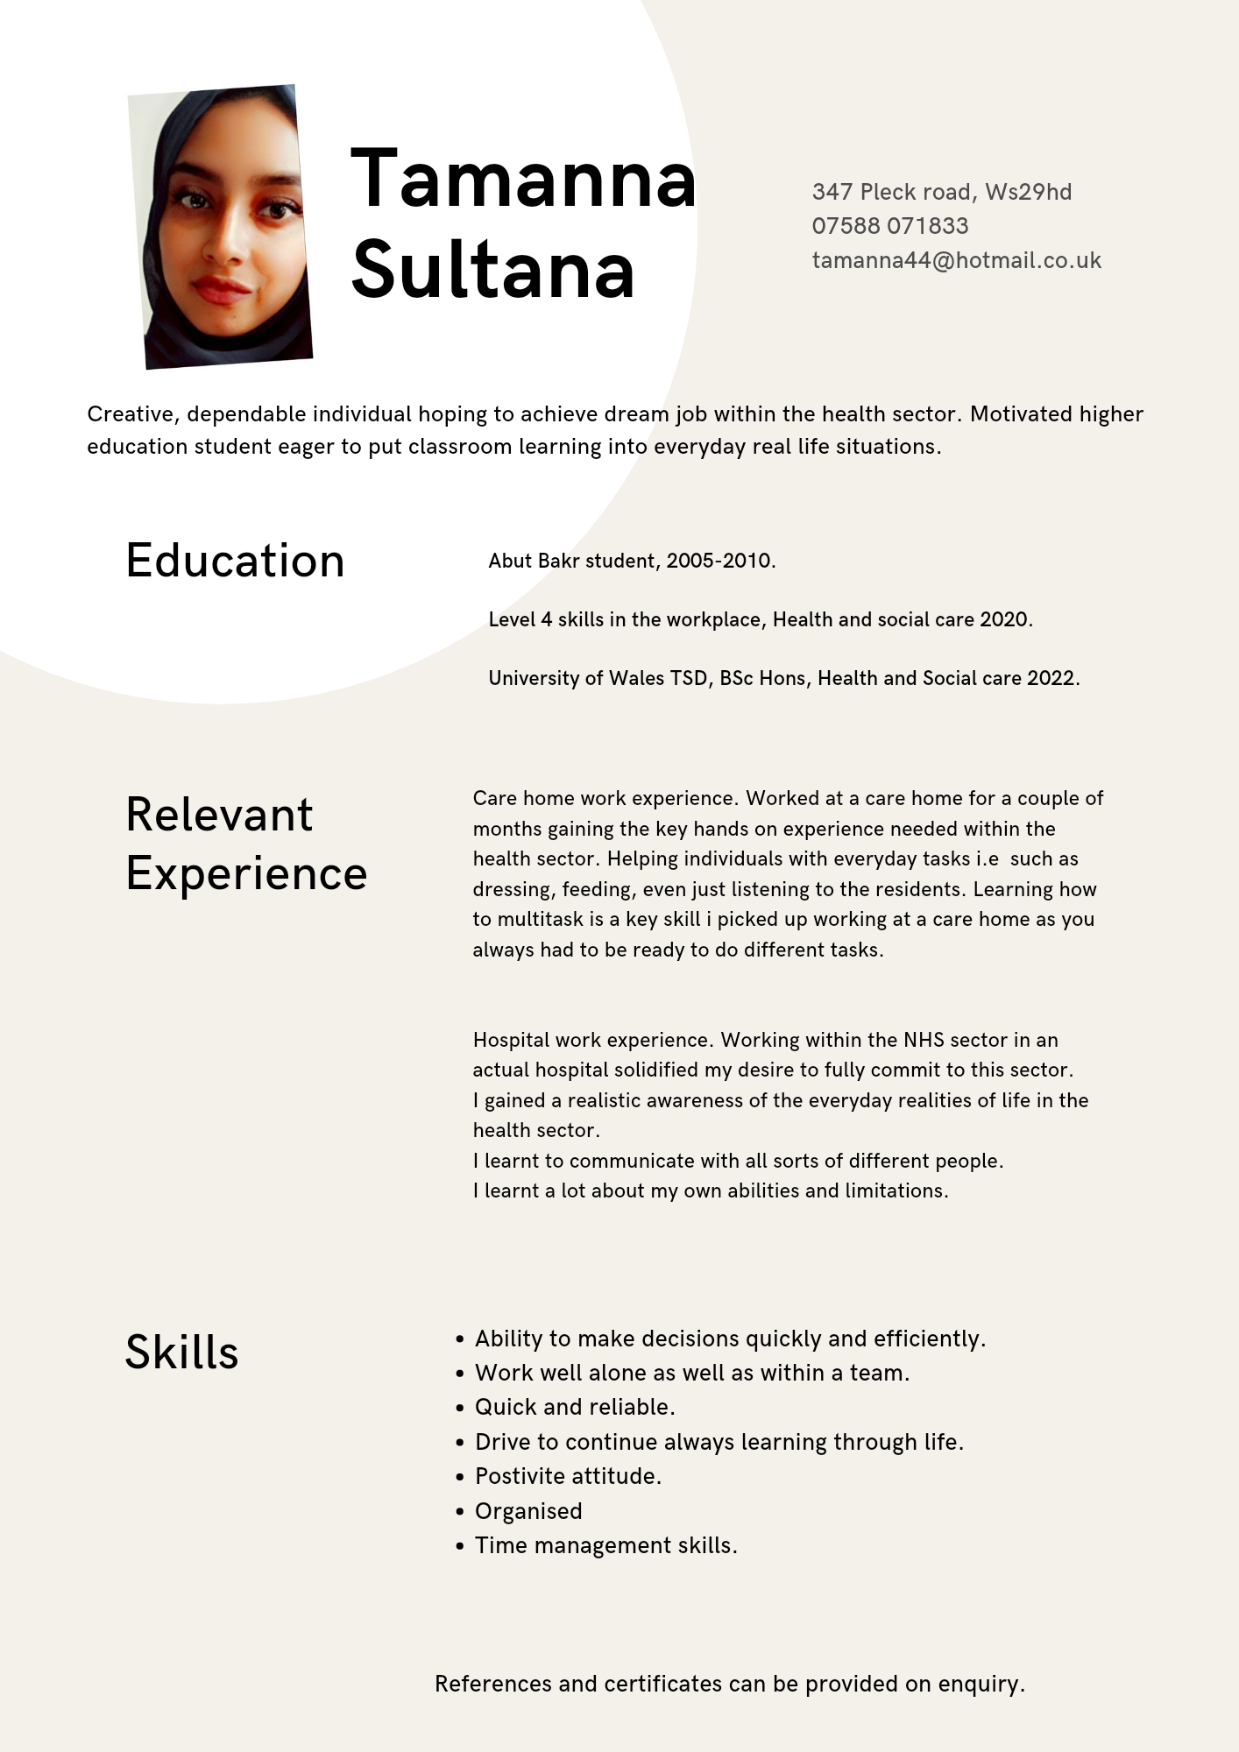

COVER LETTER.

Tamanna Sultana
07588071833
Tamanna44@hotmail.co.uk

Dr. Mr Khan
Chief of Staff and General Physician
Birmingham hospital

November 14, 2021
RE: Full time nurse.

Dear Mr. Khan

I am writing with the intention of expressing my interest in an announcement you have made regarding the position of Full Time Nurse at Birmingham hospital. So, I am applying to avail this smart opportunity and to become a part of your hospital as a nurse. I have reviewed the job description, and now I am so excited and energised to see how well my overall knowledge, skills, and experience level fits your hospital and requirements and needs. Therefore, I am encouraged to get this employment because, as I visited the website of your company, I believe that your primary mission and culture fit with overall experience and what I can offer you as a professional nurse.

I have an excellent background, as in the past I offered all-inclusive services to old age people, bringing improvement to their quality of life. I know that the healthcare sector is evolving with fast pace and health care professionals are anticipated to have the skills and knowledge needed to serve patients by working in a technical and fast-paced clinical environment. I have experience as a specialist in healing patients’ wounds and changing bandages. Through my kind and compassionate character, I establish close relationships with patients and their family members. I believe all these aspects of my personality make my profile suitable for this position at your hospital. Similarly, my experience is also proven in interpersonal care and treatment, and a capacity for collaboration with consistent and constant pace. During my previous positions, I always focused on strengthening my decision-making and problem solving skills while ensuring detail and accuracy.

All the above facts make me a great candidate and thus I would like to be a part of your hospital, as it is my preferred healthcare organisation for serving patients. I want to serve the patients with old age and mental health conditions because my feeling is that this area has the strong potential to lead me directly to the most emotionally fulfilling professional career. By getting this position, I will have the chance to assist mental health and well being of people. As the nursing management in the future, majoring in family, I intend to work in the clinical setting to help vulnerable people in the future by assuming an administrative and leadership role.

As a promoter of evidence-based practice, I intend to champion for a setting that enhances critical thinking and clinical inquiry besides incorporating the best evidence in the nursing management profession. It is my dream to witness the incorporation of best evidence by health professionals in their routine practice. I am looking forward to having this position at your well-recognised healthcare organisation to bring significant changes to the healthcare sector.

Having this job is my passion and on the basis of my study and experience, I can say that I am a good candidate for the position. I am sure I will be a professional carer and will be able to provide assistance to the most vulnerable people in our society.

My excitement level is high due to the idea of ​​being a part of your establishment where i will be able to contribute my talent to it. I hope you will consider my profile and contact me as soon to continue discussing how my overall persona and my work knowledge and experience fit into the Nurse position. I believe, I could become a valuable asset for your organisation.

Thanks for your valuable time and attention.

Sincerely,

Tamanna Sultana

Proposal for a Documentary on Hand Hygiene
Introduction
Hospital based infections are very common and hence, presents a serious public health problem because it actually shows the quality of care of the healthcare setting (Srigley et al., 2018). Nosocomial infection (NI), also called hospital infection (HI) or healthcare-related infection is known as that infection that the patient acquires in relation to the care received during medical treatment and that was not present in the moment of initiating contact with health care (Abelairas & Dopico, 2017). The spread of the microorganisms responsible for NI can occur through the hands of healthcare personnel, other people who are in contact with patients, or surfaces located in their vicinity.
Approximately 2,000,000 hospital infections occur annually in the United States, involving 5 to 10% of hospitalized patients, causing approximately 90,000 deaths and a cost ranging from $ 4.5 to $ 7 trillion annually (Magill et al., 2018). Therefore, it is confirmed that hand hygiene is a public health problem in hospitals, since they mean a high social and economic cost, which causes side effects such as the decrease of possibilities in the use of beds for patients with other pathologies; therefore, epidemiological surveillance is necessary and fundamental, in the prevention and control of IH and to reduce morbidity and mortality from IH, as well as the reduction of costs. It affects 1 in 10 patients who have been admitted to a hospital, so there have always been fears of admitting a patient for any event.
The objective of the proposed documentary is to contribute to the implementation of hand hygiene measures as a safe and permanent practice in the daily actions of health professionals in order to disseminate and promote hand hygiene.
Importance of hand hygiene
Qushmaq et al. (2018) stressed the importance of hygiene of professionals' hands with soap and water or rubbing with alcohol during patient care. They evaluated the effect of an intervention to encourage hand hygiene and to investigate the risk factors for non-adherence in the ICU. Hand hygiene compliance increased from 38.4% to 54.5% with the study. Handwashing with soap and water remained around 30% while rubbing with alcohol increased from 5.4% to 21.7%. It is believed that handwashing with soap and water is one of the most effective and cheapest ways to prevent infectious diseases, which are the leading cause of infant mortality. This measure could reduce almost half of the deaths and avoid a quarter of deaths from acute respiratory infections. According to Qushmaq et al. (2018), hygiene in health services reduces the risk of acquiring nosocomial infections, however, there is multiple evidence that shows that the correct use of hygiene measures reduces morbidity and mortality due to nosocomial infections since the 19th century.
It is necessary to spread this simple and effective method to the population to maintain their health, that of their relatives and save lives. Health personnel must take into account the five moments in which hand hygiene must be carried out:
- Before direct contact with the patient;
- Before performing an aseptic task or manipulating an invasive device, despite the use of gloves;
- After contact with the environment of the patient and the healthcare environment
In this way, hand hygiene fulfills two fundamental purposes: that of protecting the patient and the health worker. It is for these reasons that it must be done in two moments: before and after care. The indication above is present at moments one and two, that is, when there is a risk of transmission of microorganisms to the patient, so the patient is specifically protected.
Objective of the Documentary
"Direct contact" was defined as any procedure that implied the direct relationship of the health worker's hand with the skin and / or mucous membranes of a patient and "hygiene opportunity" as any situation in which hand hygiene is indicated, be it whatever the recommended technique (routine washing, antiseptic, surgical or use of alcohol-based products). The published literature on the success of hand hygiene promotion campaigns is abundant; however, the studies are methodologically not very powerful. There is a need of comprehensive documentary that further encourage health professionals and common people to practice hand hygiene.
In order to disseminate the importance of hand hygiene, especially in clinics and healthcare settings, it is quite relevant and appropriate to produce a documentary on the topic. This documentary would be an effective piece of information for health professionals continuous training and for providing awareness about the importance of hand hygiene to the health professionals.

References
Allegranzi, B., & Pittet, D. (2017). Promotion Strategy. Hand hygiene: a handbook for medical
professionals, 9, 230.
Magill, S. S., O’Leary, E., Janelle, S. J., Thompson, D. L., Dumyati, G., Nadle, J. & Ray, S.
M. (2018). Changes in prevalence of health care–associated infections in US hospitals. New England Journal of Medicine, 379(18), 1732-1744.
Qushmaq, I. A., Heels-Ansdell, D., Cook, D., Loeb, M. & Meade, M. (2018). Hand
hygiene in intensive care unit: prospective observations if clinical practice. Pol Arch Med., 118 (10): 543-7
Srigley, A., Lightfoot, D., Fernie, G., Gardam, M. & Muller, P. (2013). Hand hygiene monitoring
technology: protocol for a systematic review. Systematic Reviews, 2:101

