University of Wales Trinity Saint David
London

MARKETING FUNDAMENTALS
(LCBB4004)

ADIDAS BLOG

Submitted to: Submitted by:
Tushara Balendran Nadya Zarankova
1914056

Table of Contents

BACKGROUND OF ADIDAS 3
PRODUCT 4
Footwears: 4
Apparel: 4
Sports Equipment: 5
Accessories: 5
FEATURES OF ADIDAS PRODUCT 7
PRICE 7
PLACE 8
PROMOTION 10
REFERENCES 14

BACKGROUND OF ADIDAS
Adidas AG is a German Global organisation which is established and located in Herzogenaurach, Germany. The company produce footwear, apparel, sport equipment and accessories. Adidas is one of the largest producers of sportswear in Europe and 2nd largest around the globe after Nike. It is the parent organisation of Adidas Group which includes the sportswear corporation Reebok, 8.33% of the German sports team Bayern München and the Austrian fitness tech giant Runtastic. Three streaks are the identification symbol of Adidas, which is featured as a branding aid on the footwear and apparel of the brand.

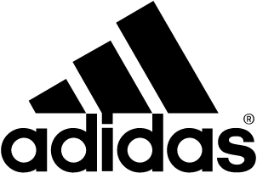
Adidas logo

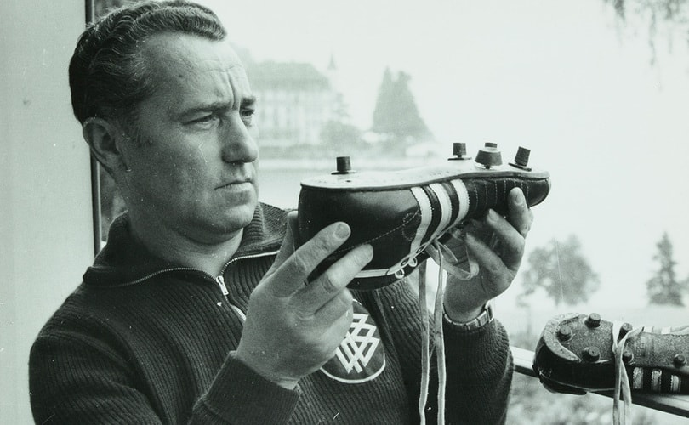
The word Adidas is an abbreviation from the name of Adolf (Adi) Dassler, who is the founder of the company. Since the first World War, he started making footwears. The American track-and-field champion Jesse Owens wore sneakers which were apparently a present at the Olympic Games in Berlin in 1936 by the founder of Adidas, Adi Dassler. Owens medal-winning accomplishments increased the fame of Dassler’s company around the planet.

Adidas expanded rapidly during the 1950s and in 1963, the company launch production of soccer footballs. After 4 years, Adidas started producing clothing.

PRODUCT

Footwears:
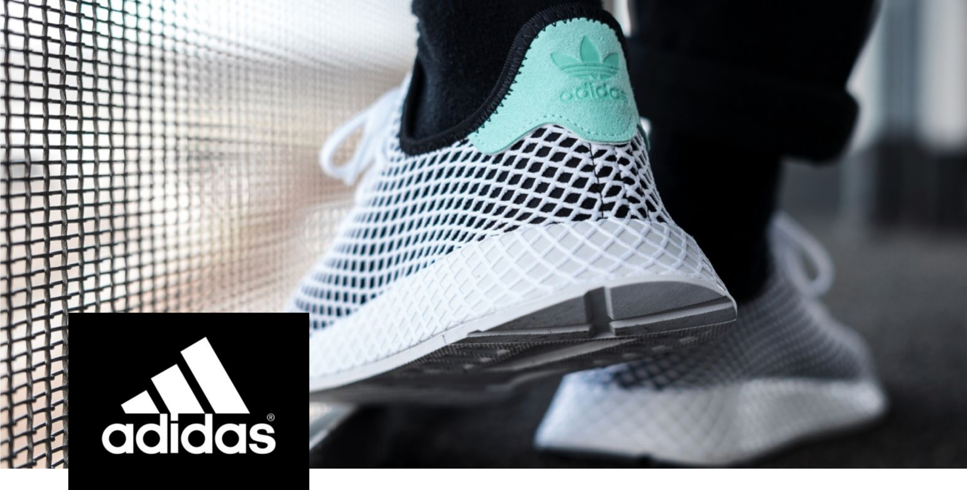
Our company is most famous for the production of sport shoes and footwear. Adidas produce aerodynamic varieties of shoes such as Tennis, Cricket, Basketball, Baseball, golf, gymnastics, Ice hockey and so on. The moto of our business is to provide a comfortable experience to the customers during different physical sport activities. Adidas company also produce a range of fashionable and good-looking shoes.

Apparel:
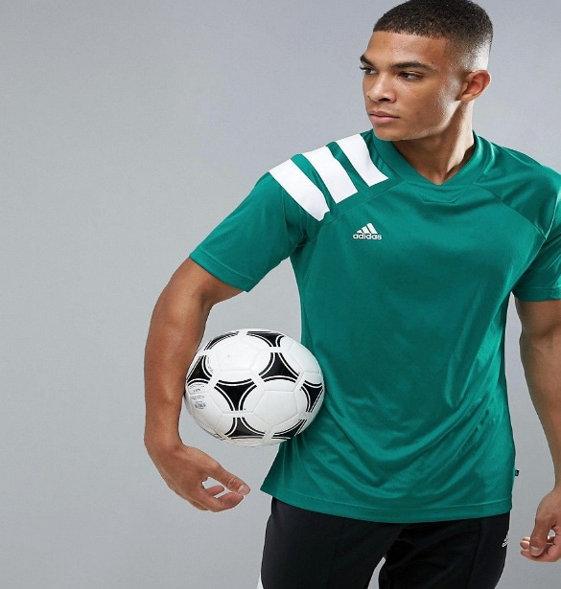
Football products and the related facilities have historically remained one of Adidas primary concerns. In the global supply of uniforms for football players, Adidas continues to be a major supplier. Adidas produce referee uniforms which are utilized by several nations including competitions in the global tournaments. Our company produces various sportswear like T-shirts, jackets, shorts and many more, and kits for various sports such as Tennis, Cricket, Basketball, Baseball, golf, gymnastics, Ice hockey etc. We offer to our customers outdoor wear, waterproof jackets, trousers and hiking clothing.

Sports Equipment:
Adidas company provide sports equipment and plays an important role in the market. The range of equipment is: jerseys, boxing gloves, leg and head protectors and many more.

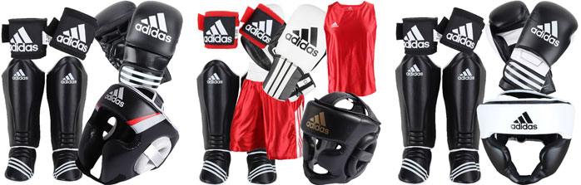

Accessories:
Slide-style sandals, watches, sunglasses, luggage bags, baseball caps, and socks are also designed and manufactured by our company which aims to have a constantly developing range of products in the sportswear market. Adidas also has a variety of branded deodorants, fragrances, shaving cream and ointments for men and women. In mid-August 2014, Adidas revealed they will be releasing a new Fit Smart wristband, worth of around 150-170 British Pounds. The wristband can match the miCoach app from Adidas, which serves as a fitness instructor.

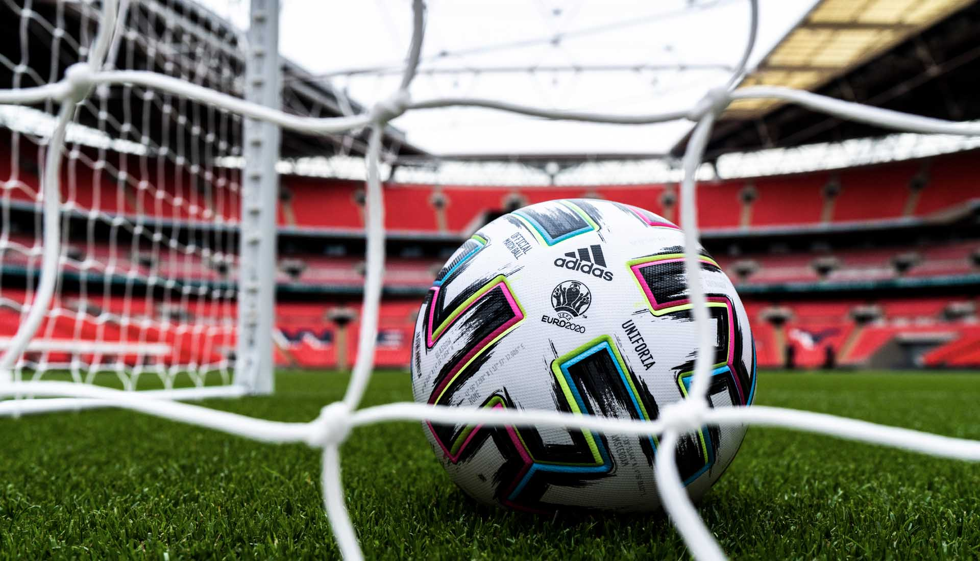

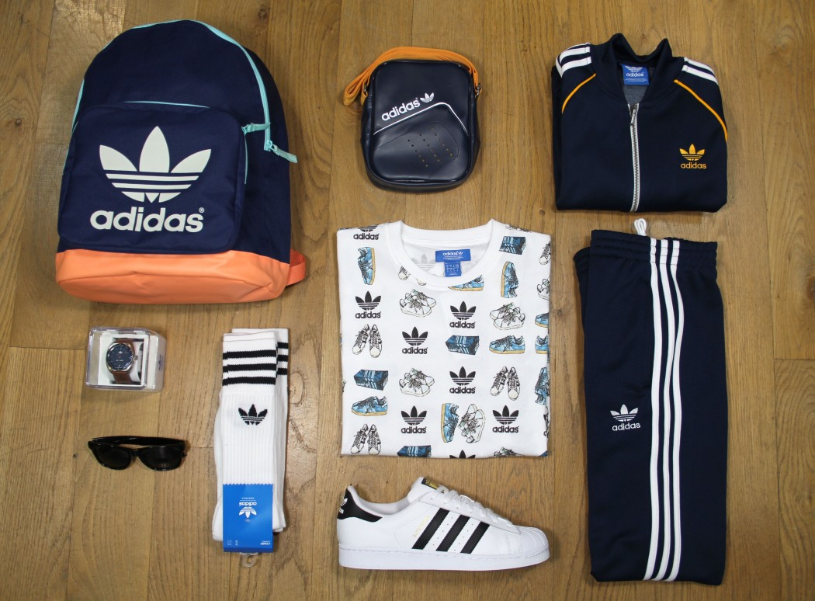

FEATURES OF ADIDAS PRODUCT
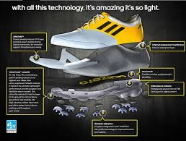
High level of comfort with emphasis on relaxation with padding is something that all athletic trainers want in general. Proper padding also helps to avoid adverse effects on the joints. The product is the most recent breakthrough in training padding. Adidas, for instance, has created a midsole containing thousands of tiny pellets of power which store and release additional power while moving. In the performance of the footwear, Adidas slogan, "We strive to help you perform your best," is clearly defined.

PRICE
In our company we strive to keep the price of our products low so we can be competitive in the market and at the same time to keep the high quality of production. In order to be able to keep our prices low it is necessary for our products to have a low production cost. Therefore, our production centers have been relocated to Asia where the production costs are relatively low but the quality remains at the same time in high level. Thanks to our competitive pricing strategy the price of our products is lower in comparison with our main rivals from Nike and Puma. Here are some examples:
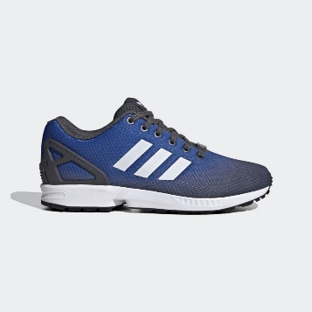
ZX FLUX SHOES £44.97

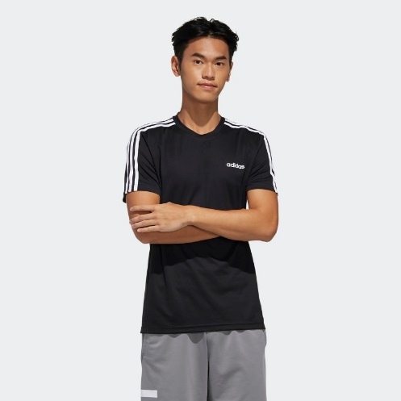
DESIGNED 2 MOVE 3-STRIPES T-SHIRT £15.96

PLACE

Adidas has shops in more than 160 countries as in US, China, Canada, and Russia.


Portland, OR 97217, USA

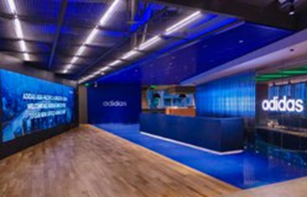
Xuhui District, Shanghai, China


Street Krylatskaya, b.155, Moscow, Russia

In UK we sell our products in existing outlets across London, Manchester, Liverpool and almost every city in the country. We have presence in all shopping centers and many showrooms in the UK. Adidas is in partnership with other big retail companies as Sport Direct, JD Sports and TK Maxx who selling our products.
Our business organisation sells its products and services through online websites. The company has its own official website www. Adidas.com. As the company's 2018 annual report noted: "The digital revolution is transforming the way our customers act as well as the ways the company operates and functions fundamentally”. Advancement in technology has helped the company to speed up the creation of direct connections and interactions with the potential customers.

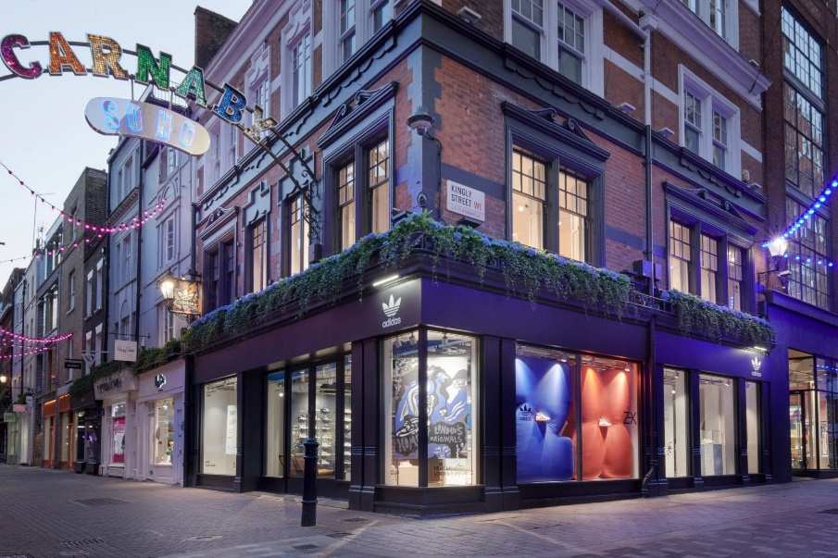

Adidas, Carnaby Street, London

PROMOTION
Celebrity branding or sponsorship of celebrities is a type of promotional campaign or business plan that utilizes the popularity or social standing of a star to advertise products, company or services. Utilizing stars in advertising has a variety of benefits. Famous stars also function best since they attract a big interest effortlessly. Advertising stars create brand recognition, and they construct it much quicker than conventional forms of advertising. Brand knowledge tests the proportion of individuals who are associated with a specific brand.
When it came to products partnering, Adidas is definitely a genius. Our company developed incredible infrastructure of distinct cultures, artistic backgrounds, and talents. After the launch of the hit hip-hop song My Adidas and Walk This Way, the culture of hip-hop sneakers was created and Adidas jumped over to the music sector. This prepared the path for more deals with Adidas and much more excitement and demand for the brand of the three stripes. There are various football players that support and promotes the company and its brand. Lionel Messi is one of the celebrities who promote our products. His profile on Twitter is operated by Adidas. Messi has a lifelong arrangement with the company, which is expected to make him higher than 10 million British Pounds annually. James Rodriguez is another football player who advertise Adidas and when he appeared in the World Cup Championship 2014, then the image of the company really thrived. Adidas become most famous brand for football footwear as Rodriguez won the Golden Boot trophy for achieving the most goals in the competition.
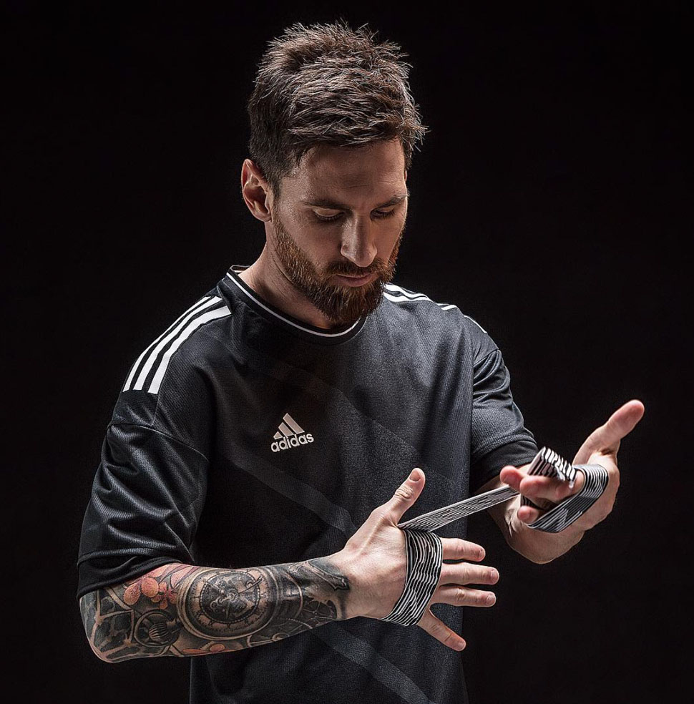
Picture: Lionel Messy

Adidas is using various marketing channels in order to provide the proper information to the customers across the globe. With the help of the advertisement our company informing the potential customers about the various offers, promotions, new arrivals, and many other important information. Using TV channels, magazines, and online platforms we announce our seasonal sells, and reduced price of promotional products. Adidas also collaborate with other famous brands as Prada to promote company products to wider auditory.

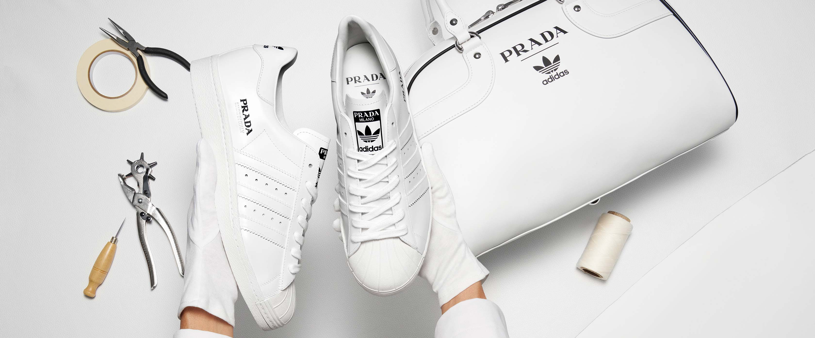
Picture: Adidas 2019

With the use of visual and graphic content we are engaging and attracting large number of customers. As people spend most of their time on various popular social media channels such as Instagram, Facebook, You-tube and many more, we start actively to promote our products there.
Our customers can find attractive promotions and new arrivals on the links bellow:
https://www.facebook.com/adidasUK/?brand_redir=182162001806727
https://www.instagram.com/adidasoriginas/?hl=en

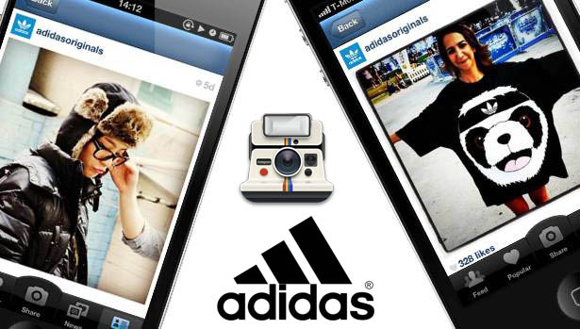
Adidas Originals Now Live on Instagram

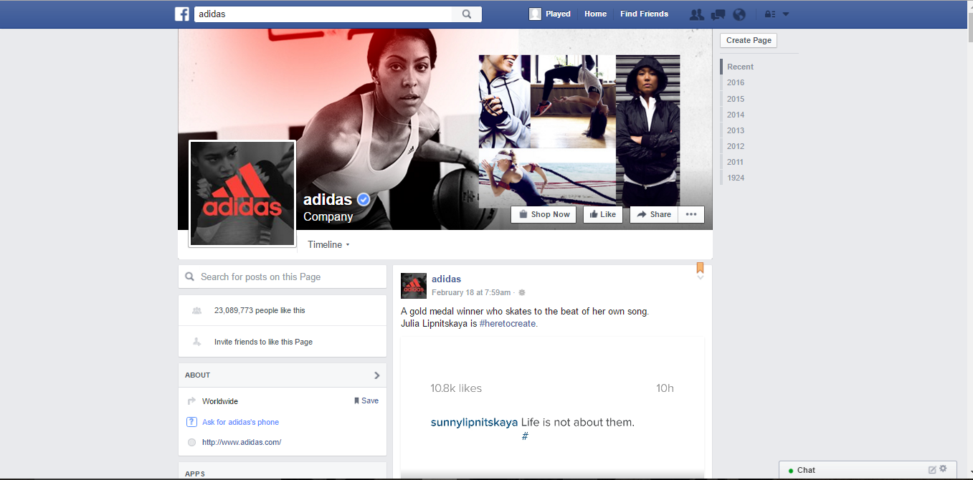
facebook.com/adidasUK/

Adidas using email marketing to maintain contact with its regular customers, and sending emails to them regarding current activities taking place, promotions, prices and etc. Use of digital ways to inform and attract people regarding what we are offering is one of the cost-effective strategies where within few minutes we would be able to reach large number of customers. With the use of the tagline “Impossible is nothing” we are engaging our customers.

REFERENCES

Books & Journals

Ang, C. and Rusli, H., 2018. The impact of marketing mix 4ps and consumer behavior toward purchase decision of adidas products. iBuss Management, 6(2).

Hisrich, R.D. and Ramadani, V., 2017. Entrepreneurial marketing mix. In Effective Entrepreneurial Management (pp. 75-99). Springer, Cham.

Alipour, M. and Sabzikaran, E., 2018. Investigating the Effect of Brand Authenticity on the Importance of Brand and the Desire to Buy (Case Study: ADIDAS Brand). American Journal of Business, Economics and Management. 6(1). p.1.

Online
Adidas 2020.[online. Available through: <https://dobetter.esade.edu/en/adidas-research> ]

Adidas logo 2020.[online. Available through: <https://logos-world.net/adidas-logo/>]

History of Adidas 2018. [online. Available through: <https://www.designboom.com/design/adi-dasslers-first-shoes-an-exhibition-by-adidas/>]

Aichner, T., Shaltoni, A.M., Grosso, C., Forza, C., Haag, A., Haag, L., Briem, A.K., Betten, T., Held, M., Wehner, D. and Baumann, M., 2019. The Impact of Perceived Advertising Creativity on Behavioural Intentions and Quality Perceptions in Mass Customization. https://www.researchgate.net/profile/Thomas_Aichner/publication/334124574_The_Impact_of_Perceived_Advertising_Creativity_on_Behavioural_Intentions_and_Quality_Perceptions_in_Mass_Customization/links/5d1b748fa6fdcc2462ba66cb/The-Impact-of-Perceived-Advertising-Creativity-on-Behavioural-Intentions-and-Quality-Perceptions-in-Mass-Customization.pdf [Accessed: 14/12/2020].

Signoroni, S.A., 2018. The final kick in the battle between Adidas and Shoe Branding Europe. Journal of Intellectual Property Law & Practice, 13(11), pp.847-849. https://academic.oup.com/jiplp/article-abstract/13/11/847/5136355 [Accessed: 14/12/2020].

