

INTERNATIONAL BUSINESS COMMUNICATIONS
CROSS-CULTURAL BUSINESS COMMUNICATION

1) International BC
BABM
Lecturer. Afzal Munna
2) Ivan Sendrev (2235334)

Table of Contents
Introduction 4
Main Body 4
Conclusion 12
Reference List 13

List of Figures
Figure 1: Primark Logo 4
Figure 2: Shiseido Logo 5
Figure 3: Hofstede’s Cultural Dimensions 7
Figure 4: Edward Hall’s High-Context vs. Low-Context Communication Model 9

Introduction
International business communication is a very important part of today’s globalised economy since it allows successful cooperation between different culturally diverse teams. As companies become more global, it becomes more important to understand and adapt to different ways of communication for projects to run smoothly, to build relationships, and to be successful. This essay analyses the collaboration between a UK based multinational retail company Primark and a Japanese cosmetics and skincare brand, Shiseido. To develop and market the products, the two firms have joined forces with employees from UK and Japan. Considering the cultural distance between these nations, it is predicted that barriers in communication are inevitable and likely to have an impact on project results without proper management. The purpose of this essay is to compare and evaluate these differences in communication style between UK and Japanese teams by looking at Hofstede’s Cultural Dimensions and Hall’s High Context and Low Context Communication Theory. The essay also explores with the help of critical analysis how cultural differences affect how people interact in the workplace; the potential sources of misunderstanding and how it can be addressed.

Main Body
Background / Organisational Context
Located in the UK, Primark is a leading international clothing retailer which is a leader in the fashion industry (Primark, 2024). It has 460 stores globally and continues to expand, a flat organisational structure that encourages efficiency, fast decision making and open communication. As a part of its value driven retailing strategy, expansion by Primark is by rapid turnover of inventory and global market expansion, with more interest in the Asian market using partnerships and sourcing operations. Unlike many UK-based companies however, the communication style of the company is also an extension of typical UK business culture – direct, task focused, informal but through clarity, individual responsibility and quick feedback loops, particularly the latter in project environments.


Figure 1: Primark Logo
(Source: Primark, 2025)
One of the oldest and most prestigious beauty companies in Japan and with strong interests in Asia, North America and Europe, Shiseido was founded in 1872 (Shiseido, 2025). The internal culture of Shiseido is rooted in deep Japanese values of harmonic (wa), Sankei imbued in high-context, indirect, communicant hierarchical structure, and setting up long term relationships. For instance, their communication is more individualistic and fast paced, while they are slow and collective in their decision making, must remain formal, subtle, and depend on non-verbal cues, very different indeed to Primark’s. Shiseido launches global reach of global reach of Tokyo, New York, Paris through the basis of international collaboration to a specific brand (Shiseido, 2025).


Figure 2: Shiseido Logo
(Source: Shiseido, 2025)
In the collaboration with Shiseido, Primark and Shiseido has been working on a joint venture to develop an affordable, eco-friendly skincare line aimed at the environmentally conscious millennials and Gen Z consumers. Primark gives its network of thousands of stores and its product strategy of offering affordable product, and Shiseido provides its heritage of research excellence, quality of product, and innovation in skincare. Integrated cross border product teams, branding and marketing campaigns are crucial in many parts of the partnership (Sudirjo, 2023).
Though the cultural difference between the UK and Japan is big, it is important to understand both countries’ communication style to avoid project failure. Misalignment among expectations, communication tone or style of feedback can undermine teams’ collaborative, innovative and trusting habits. Therefore, intercultural awareness stops being an added skill and becomes strategically necessary for international ventures such as the Primark–Shiseido partnership.
Theoretical Framework
This essay draws on key intercultural theories used to structure a lens to evaluate communication differences between UK and Japanese team. Hofstede’s Cultural Dimensions Theory is amongst the most widely used framework for figuring out how national culture affects the values in the workplace (Żemojtel-Piotrowska and Piotrowski, 2023). Specifically, when considering the UK-Japan business relationship, four of the dimensions are relevant.
A term to classify the degree to which people put more value in individual goals than in group interests is Individualism vs. Collectivism. Individualism is a high score for the UK, meaning we favour personal autonomy and direct communication (Dabiriyan Tehrani and Yamini, 2022). On the contrary, Japan prefers to be collective and has a tendency toward group harmony, indirect communication, and consensus-upon-decisions.
Power Distance concerns itself with dealing with inequalities in power and authority. The UK has low power distance, which writes down that organisational structures are flatter and that managers communicate openly with employees (Dabiriyan Tehrani and Yamini, 2022). The difference is that the power distance in Japan is quite high, so there is a formal hierarchy, and one must respect the authority of someone. It affects how much and when the employees express their opinions.
The behaviour associated with Uncertainty Avoidance is the degree of threat people wish to avoid when the situation is uncertain. So, while Japan scores high, that means preferring structured communication and careful planning, and the UK is rather comfortable with ambiguity and flexibility.
Masculinity vs. Femininity is a discussion of the cultural focus on achievement verses cooperation (Hsu et al., 2021). Although both cultures are masculine, Japan’s adherence to status and perseverance is far greater than that of the UK, whose emphasis is result oriented.
Hall’s High Context vs Low Context Communication Theory also points out that Japan is a high context culture that relies on implicit message, non-verbal cues and shared understanding for sense of communication (Yang, Hou and Arth, 2021). On the other hand, the UK is a low context culture promoting explicit direct, and transparent communication.
Combined, these theories provide useful information about how cultural values can affect on communication style and workplace behaviour, which are basis for the latter comparison between Primark and Shiseido.
Critical Comparison of Communication Styles
Apply theories to compare communication differences between Primark (UK) and Shiseido (Japan):
A. Using Hofstede
Hofstede’s Cultural Dimensions offer a strong structural foundation to scaffold the understanding of communication differences between Primark (UK) and Shiseido (Japan). This dimension is particularly relevant for the Individualism vs. Collectivism dimension. Finding themselves in a very individualistic UK environment, Primark allows employees to be much more open, talk freely, express their own opinions and take ownership of tasks. On the contrary, Shiseido is Japan’s collectivism culture where communication is indirect, and group harmony is the most important. Due to the unity and the need for no conflict, Japanese team members may be afraid to criticise an idea, project or way of working and instead choose to show their opposition passively or nonverbally (Drabble and Holloway, 2023). This gap can be a source of miscommunications as UK team members do not actually sort out indirect conversations as a lack of clarity or commitment.
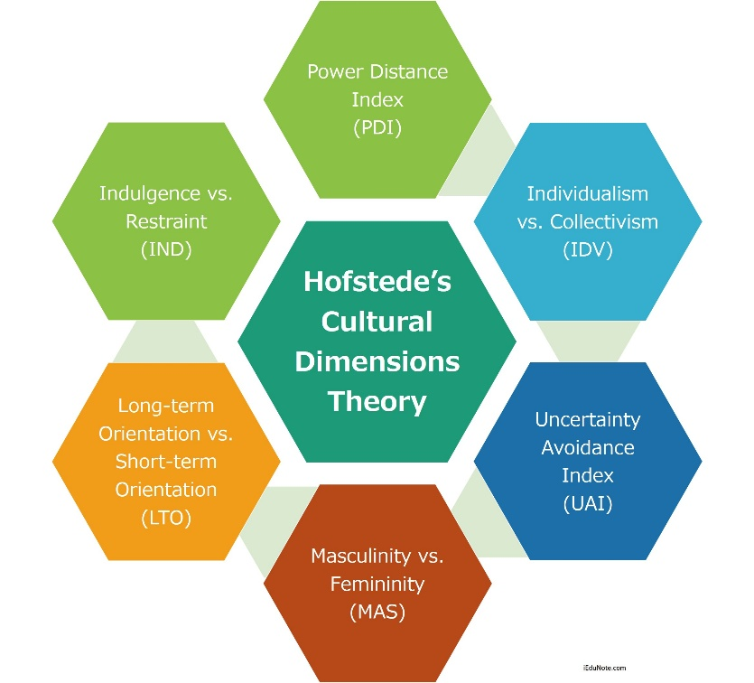

Figure 3: Hofstede’s Cultural Dimensions
(Source: iEduNote, 2025)
There are also stark contrasts on the dimension of Power Distance. Primark has a relatively flat organisational structure that allows junior staff to be able to easily communicate with senior management. Making decisions is typically shared and is aimed at efficiency and openness. In line with Japan’s extremely high-power distance, Shiseido follows a more hierarchical structure with the communication generally being in one direction, from above down. Central pieces of respect for seniority and formal channels and junior employees are less likely to voice challenges of authority openly. This can cause delay in decision making and affect the spontaneity in cross cultural meetings with Primark staff.
For Uncertainty Avoidance, Japanese culture is very high, matching Shiseido’s preference for planning down to the last detail, mitigating risk, and formalised communication protocols (Santini, 2023). UK culture, and by extension Primark, shows greater tolerance for ambiguity, encouraging flexible and adaptive communication. British UK employees may find prolonged planning inefficient, and Japanese UK employees may perceive rapid decision making has been risky or careless.
B. Using Hall’s High/Low Context
According to Hall’s High-Context and Low-Context Communication Theory, Hall addresses how having a communicative style such as Primark (UK) versus Shiseido (Japan) in a collaborative business environment. Hall claims that Japan is a high context culture where a lot of communication is delivered in context, non-verbal cues, shared values and the implicit understanding. With that, the UK is low context as compared to the other cultures as the messages are relayed clearly, explicitly, and several other assumptions.
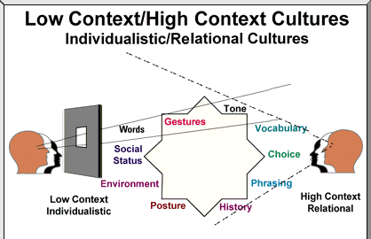

Figure 4: Edward Hall’s High-Context vs. Low-Context Communication Model
(Source: Yang, Hou and Arth, 2021)
In Shiseido, employees are likely to communicate disagreement or hesitation using vague or indirect expressions and relying on the tone, pauses, or silence of a conversation to convey meaning (Stone, 2023). The premise behind this communication is in the Japanese notion of group harmony and avoidance of confrontation. On the other hand, UK’s low context culture manifests through Primark’s employees being trained to speak to one another in straight and direct manner. Feedback is usually provided openly and directly, either written or in meetings, kind or critical, but rarely or not at all with subtlety.
Contrasting with these styles, for example in emails, UK team members are used to clear action points, deadlines, and direct requests from co-workers. However, in doing so, Shiseido’s emails might be more formal, indirect and polite, being less direct in their instructions to support respect and deference. A UK manager might not realise that a vagueness by a Japanese colleague could be interpreted as evasiveness or indecisiveness, while a Japanese counterpart would feel too blunt and aggressive from a UK manager.
In UK team meetings, people may be assertive in meetings, given the need to be as assertive as possible and so resolve issues as quickly as possible without thinking (Paterson, 2022). While Japanese team members may tend not to speak up real time, in front of senior staff team members may be more inclined to reflect, consult their team before offering a response (Badrinarayanan, V., 2024). The contingency here can cause the Japanese to perceive the UK’s assertiveness as disrespectful and disrupting to hierarchy, and the UK side can come away with misperceptions of disengagement or lack of initiative.
Communication Challenges & Potential Misunderstandings
Issues of communication arise in the form of cross-cultural collaborations between Primark and Shiseido due to the major difference in the expectations and interpretations in relating to the businesses from different cultural perspectives. Indirect versus direct communication styles is one of the main causes of problems. In Japanese high context communication, a polite “yes” could mean affirmation but in no way agreement (Arakaki, 2022). In group settings, this is often used at Shiseido to support harmony, and not to create confrontation. Primark’s UK team, with its low context culture is also prone to interpret the same thing of full commitment to a proposal (Tyler and Vachhani, 2021). At the end, this can be very frustrating when expected actions are not taken, destroying trust and delaying project progress.
Feedback styles also differ dramatically. Direct feedback is also acceptable to UK professionals to of giving and receiving it as a means of improvement (Mogea, 2023). On the other hand, Shiseido employees may not easily dispense critical feedback in the open, particularly in group but especially to superiors, because of pride in social harmony. Thus, UK managers may regard the Japanese managers as being not transparent or not assertive and vice versa from Japanese employees’ viewpoint UK style may be too insensitive and too confrontational. Such misalignment can affect the performance review, brainstorming sessions, and team dynamics; therefore, it affects collaboration effectiveness.
The final barrier is hierarchical decision-making at Shiseido. This is because Japan has a high-power distance, and even simple decisions may have to be approved by the senior level with deep internal consultation (Nkando, 2021). However, because Primark tends to have a flatter hierarchy, decision making is correspondingly quicker with greater delegation of authority. These differences can result in delays: the UK team perceives the Japanese side as being slow and bureaucratic, the Japanese team considers the UK’s speed as hasty and a lack of respect for protocol. Friction in those cases can have a large impact on timelines since timelines are time sensitive with product launches or marketing campaigns.
Also, a large attributive role in the Japanese communication is put-on non-verbal cues and silence (Mendonça, Ercan and Asenbaum, 2022). Shiseido employees may use gestures, pauses or body language to express disagreement or not ready to say something. The UK’s teams on the other hand favour lots of verbal expressiveness and fast response. By its use of silence to reflect or avoid confrontation, UK staff may be missing the point of how the Japanese use silence as an acknowledgement or to avoid confrontation entirely. Failing to properly reconcile these cultural gaps can give rise to miscommunication, frustration or overlooked strategic advantages, all reasons to make the Primark/Shiseido alliance culturally sensitive and adapted in the way it communicates to one another.
Strategies to Improve Cross-Cultural Communication
A set of targeted strategies will have to be implemented to ensure effective communication between Primark and Shiseido to solve the communication challenges. Firstly, both team’s cultural training programmes including Japanese and Britain communication styles, values and business etiquette should be a mandatory for each people (Aririguzoh, 2022). It can also reduce misinterpretations of indirect messages, like the Japanese ‘yes,’ and even help to clarify this indirect message. Secondly, hybrid communication protocols, e.g., agreed meeting structures, shared glossary of key terms, and clear follow up actions, bridge the gap between high and low context style making it clear for both sides (Neumayr et al., 2021). Third is engaging intercultural consultants or appointing cultural liaisons to each team to real time interpret cultural cues and intervene in case of misunderstandings (Zhao and Stiles, 2024). These professionals can meet conflict resolution and feedback processes in tandem with both cultures’ preferences. Finally, it’s important to engage in promoting empathy, patience and flexibility as the core values in the partnership. A trusting relationship and therefore an effective long-term collaboration will be created through encouraging UK staff to be more accepting of silences or hierarchical processes or vice versa encourage Japanese colleagues to be more used to direct feedback and faster decision-making cycles.

Conclusion
With globalisation of business becoming the norm, effective cross-cultural communication is key to the success of international collaborations. However, the alliance between Primark and Shiseido underscores the challenge of different styles of communication (which derive from national cultural values) on the dynamics of the team, making decision, or the working efficiency of the project. And the results of this analysis suggest that although the UK values individualism, direct communication, and low power distance, Japan values collectivism, indirect expression, and hierarchical structure. Conflicts can occur because of difference in cultural backgrounds like – misinterpreted agreement, inconsistent feedback styles, gap in the framework of the expected response time or level of formality in the response. Yet, when these differences are viewed through the lenses of intercultural frameworks such as Hofstede’s Dimensions and Hall’s Context Theory, the organisations are better placed to understand and manage them. However, enhancing cultural intelligence among team members, and as a result, team inclusion, through training, adaptive protocols, and empathic leadership, is not only beneficial, but it is necessary. If businesses are to do any global projects, they must invest in the intercultural competence as the strategic asset, as the projects are becoming more and more complex.

Reference List
Arakaki, T., 2022. Promoting the Use of Okinawan by New Speakers: An Analysis of Honorific Choices in the Family Domain. Languages, 8(1), p.12.
Aririguzoh, S., 2022. Communication competencies, culture and SDGs: effective processes to cross-cultural communication. Humanities and Social Sciences Communications, 9(1), pp.1-11.
Badrinarayanan, V., 2024. Trust building strategies for virtual leaders in the post pandemic era. Project Leadership and Society, 5, p.100126.
Dabiriyan Tehrani, H. and Yamini, S., 2022. Gender differences concerning the horizontal and vertical individualism and collectivism: A meta-analysis. Psychological Studies, 67(1), pp.11-27.
Drabble, D. and Holloway, R., 2023. Under the surface and far apart: hidden discord in global virtual teams (Doctoral dissertation, Royal Holloway, University of London).
Hsu, N., Badura, K.L., Newman, D.A. and Speach, M.E.P., 2021. Gender, “masculinity,” and “femininity”: A meta-analytic review of gender differences in agency and communion. Psychological Bulletin, 147(10), p.987.
iEduNote, 2025. Hofstede’s Cultural Dimensions Theory. Available at: https://www.iedunote.com/hofstedes-cultural-dimensions-theory. [Accessed on: 17.03.2025]
Mendonça, R.F., Ercan, S.A. and Asenbaum, H., 2022. More than words: A multidimensional approach to deliberative democracy. Political Studies, 70(1), pp.153-172.
Mogea, T., 2023. Cross-Cultural Communication Barriers in Organizations. CENDEKIA: Jurnal Ilmu Sosial, Bahasa dan Pendidikan, 3(2), pp.20-33.
Neumayr, T., Saatci, B., Rintel, S., Klokmose, C.N. and Augstein, M., 2021. What was hybrid? a systematic review of hybrid collaboration and meetings research. arXiv preprint arXiv:2111.06172.
Nkando, M., 2021. Perceived effects of power distance on organizational change in a multicultural organization. Walden University.
Paterson, R.J., 2022. The assertiveness workbook: How to express your ideas and stand up for yourself at work and in relationships. New Harbinger Publications.
Primark, 2025. About Us. Available at: https://corporate.primark.com/en-us/a/about-us/who-we-are. [Accessed on: 24.03.2025]
Santini, A., 2023. Western cosmetics in the online Chinese market: Adaptation strategies and the case of Rilastil.
Shiseido, 2025. About the Brand. Available at: https://www.shiseido.com/us/en/150th-anniversary/ [Accessed on: 17.03.2025]
Stone, W.R., 2023. The Art of Effective Communication: Unlocking Your Potential. BornIncredible. com.
Sudirjo, F., 2023. Marketing strategy in improving product competitiveness in the global market. Journal of Contemporary Administration and Management (ADMAN), 1(2), pp.63-69.
Tyler, M. and Vachhani, S., 2021. Chasing rainbows? A recognition-based critique of Primark’s precarious commitment to inclusion. Organization, 28(2), pp.247-265.
Yang, X., Hou, J. and Arth, Z.W., 2021. Communicating in a proper way: How people from high-/low-context culture choose their media for communication. International Communication Gazette, 83(3), pp.238-259.
Żemojtel-Piotrowska, M. and Piotrowski, J., 2023. Hofstede’s cultural dimensions theory. In Encyclopedia of sexual psychology and behavior (pp. 1-4). Cham: Springer International Publishing.
Zhao, X. and Stiles, D.R., 2024. Stuck in Limbo: how sensemaking discrepancy over strategy-related performance leads to disjointed collaboration in an international joint venture. Asia Pacific Journal of Management, 41(2), pp.903-945.

