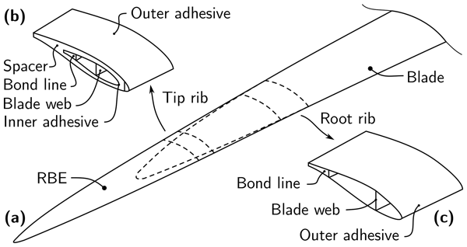
(Rosemeier M, Saathoff M, 2020)

Designing a wind turbine blade: Structural Design

Oksana Gomzjakova | ACMA 6010 Structural & Fluid Analysis | 11.12.2020

Contents
1. Abstract 2
2. Introduction 3
3. Topology Optimization 5
4. Optimization of the blade in Design Studio. 6
5. Conclusion 19
References 20

Abstract
Composites used for construction of blades are crucial for the proper functioning of wind turbines as the wind turbine blade sustains wind loading during its operation. Due to increasing size of the blades, it is important to use the composite materials in a most sufficient way to obtain the material strength and reduce the weight (Young W, Wu W, 2011). The purpose of this report is composite structural optimization of the blade using finite element analysis (FEA) interfacing with Design Studio. This study develops on how it would be possible to increase the strength of the blade by changing the arrangements of fibres without changing properties and weight. With the aid of visualisation interface, the geometric model of the blade can be constructed by only few data inputs. Based on the numerical stress analysis of the wind turbine blade, a simple iterative method was proposed to design the structure of the composite blade.

Introduction
As the size of wind turbines continue to enhance, it becomes increasingly important to ensure that they are as structurally efficient as possible to meet the main purpose of the wind turbine, which involves wind energy can be a cost-effective source for power generation (Jureczko M, Pawlak M, Mezyk A, 2005). Aerodynamic and structural optimization has become a subject of considerable interest. It involves determination of the geometry of an aerodynamic configuration that meets certain objectives subject to constraints. The structural design of the blade contains almost two aspects- one is the section of the blade structure, and another is section layer material selection and arrangement, and calculating the thickness of layers (Zheng Y, Zhao R, Liu H, 2014), as well as fiber direction.
The aim of this report is to optimize the structure to minimize the mass of the skin while displacement is a constraint.
FEA has been demonstrated as a powerful approach which can handle analysis of laminated composite structures.
FEA includes three stages:
- Pre-processing (includes defining of geometry, types of elements, material properties, meshing, defining the boundary conditions etc)
- Solution/Analysis
- Postprocessing (contour plots)
(Lake, 2020)

The pre-processing includes data input, while post-processing presents the results in a form of deformed shapes and contour maps (Edwar G, Beshay G ED M, Maalawi K Y, 2020)

A baseline model generated in Solidworks was exported in Design Studio, where material properties have been altered. Then there was the layers thicknesses and the angles of the fibres optimized to achieve a certain stiffness whilst the mass was minimalized.
The created model of the blade consists of 7516 elements, 15334 nodes and 45150 DOF

The results are obtained from Notepad:
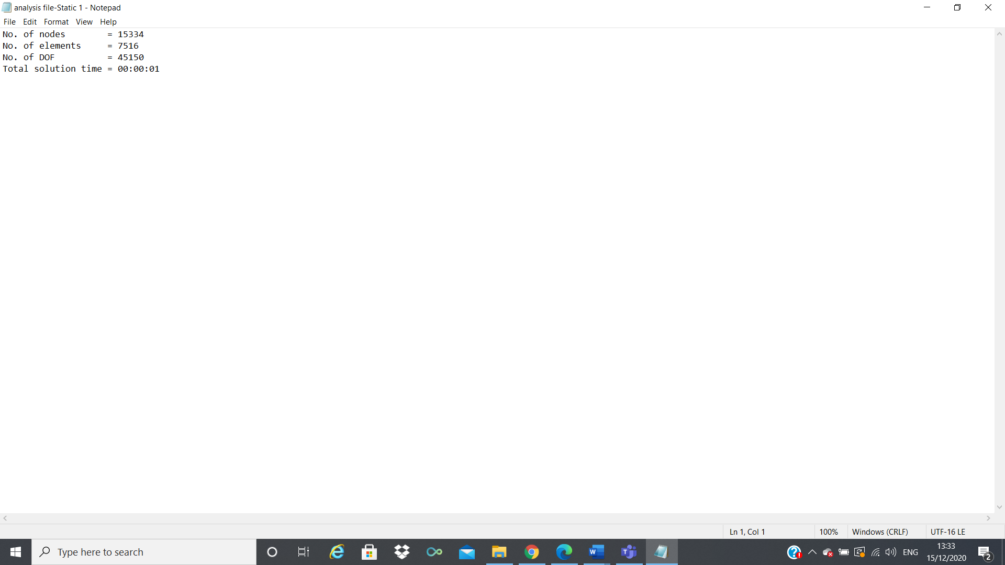

Topology Optimization
Topology optimization (TO) is a mathematical method, a process which optimizes material layout and structure within a given 3D geometrical design space using a defined set of requirements. The goal is to maximize the performance of the system by mathematically modelling and optimizing external forces, boundary condition and constraints. Moreover, conventional topology optimization uses finite element method to evaluate the design performance against defined criteria (Wang Z, Suikera S J, Hofmeyer H, Twan van Hooff, Blocken B, 2020).
The conventional TO formulation uses a finite element method to evaluate the design performance. The design is optimized using either gradient based mathematical programming techniques such as optimality criteria algorithm and the method of moving asymptotes or non-gradient based algorithms such as genetic algorithms (Chapman, 1994)
For such an optimization process, the three main elements are: design variables, the cost function, and the constraints.
The design domain is broken into finite elements, which are used for both structural analysis and to create a mesh, which represents the structural system. As the optimization develops, the shape of the boundaries is changed in order to meet the design objective (reduce mass) and constraint (displacement). (Warshawsky, 2015)
The stages the blade has been optimized in this report do include:
- Creating a model
- Defining the material properties
- Inputting a load
- Solving the problem and interpreting the results

Optimization of the blade in Design Studio.

The simulation run has been implemented in Solidworks to see the result of deformation:
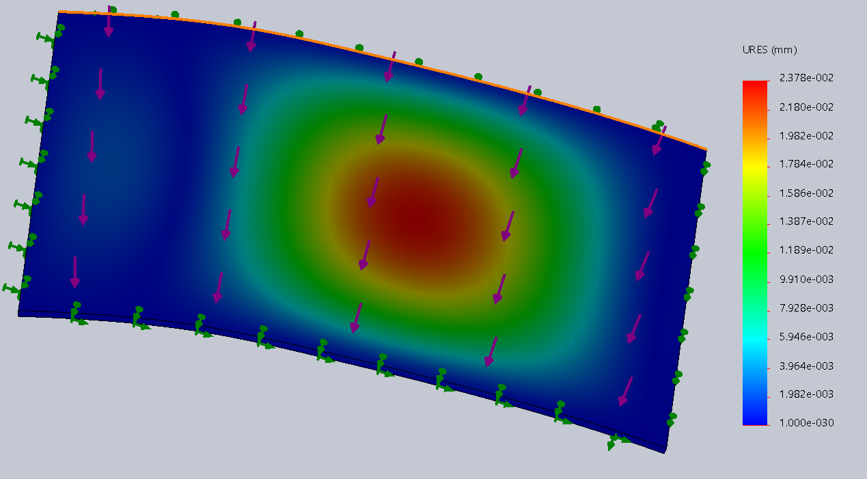
And with stress applied:
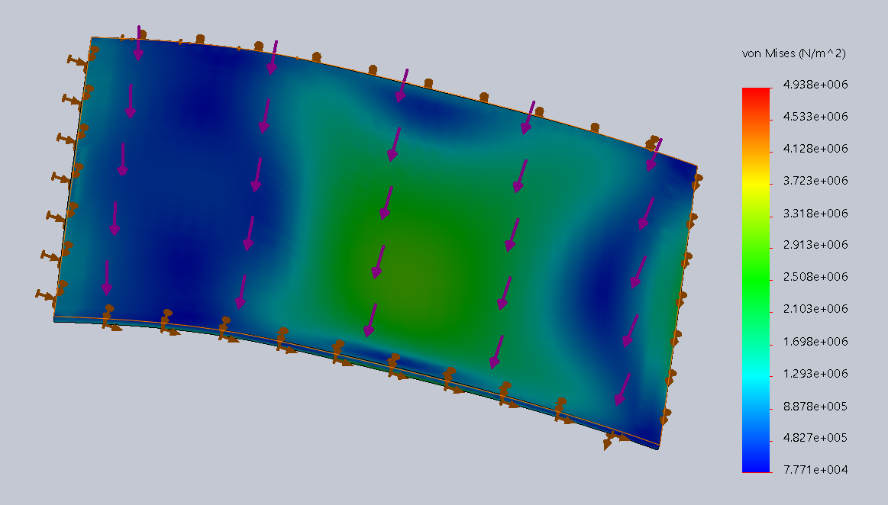
This model has been exported as a Nastran file.

Material properties, element type and thickness of each layer are to be defined. To define the material, go to materials in analysis, select new in material and go to MAT 8. Call the material as “unidirectional”. Enter the values which are given in the task.
This shows the orientation of E1 direction for each element:
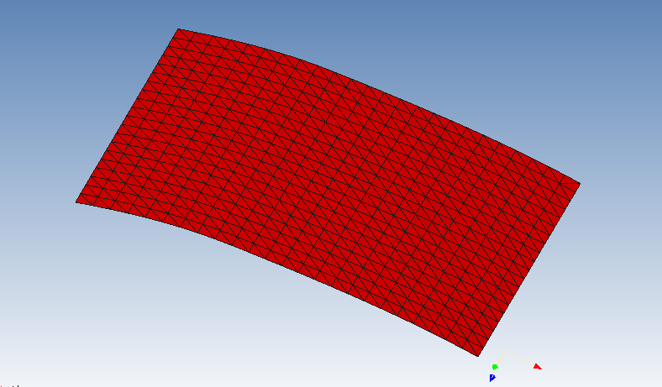
Fiber orientation:
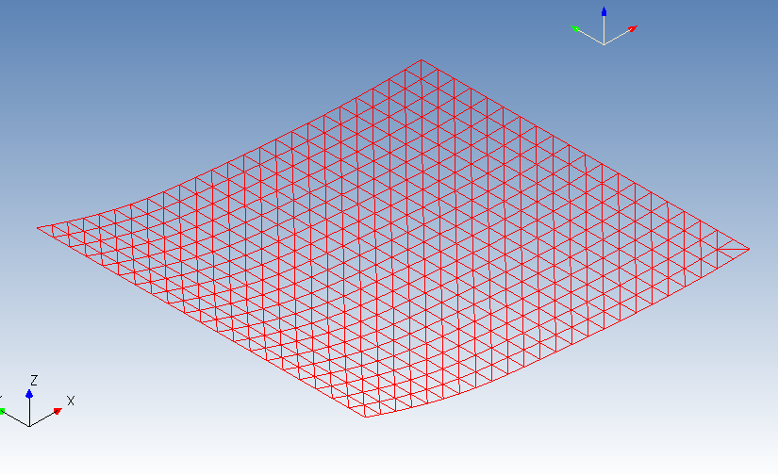
Elements:
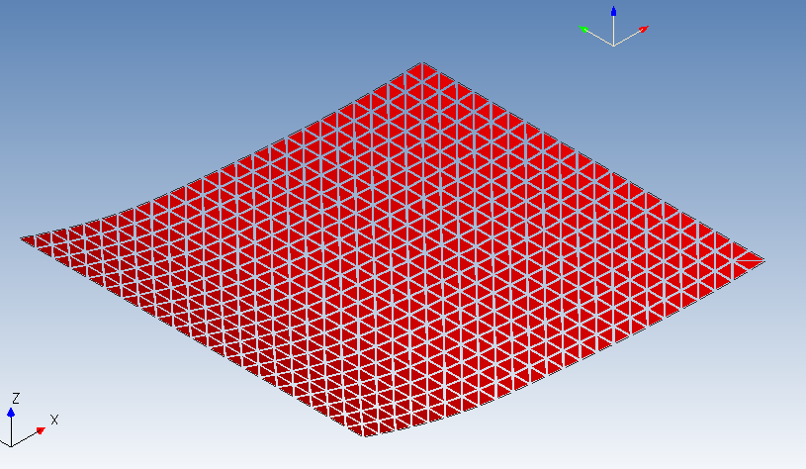
Nodes:
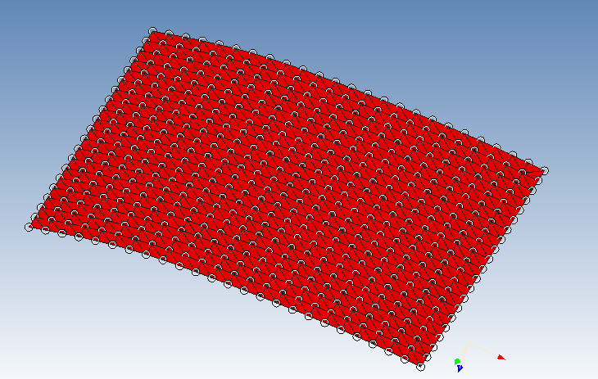

Note that by default the vectors for the elements align in the global x direction, this corresponds to 0 degrees. However, we have assumed that 0 degrees is along the y axis, therefore we must align the elements in the y direction.
For that select all elements then go modify, change 2d elements theta. Select next and choose use vector. Pick two grids of the screen to define the vector that you want to be 0 degrees for these elements.
Next step was to make up a laminate which consists of the unidirectional material, that has been just defined. For this we go to group properties in analysis. Here PCOMP/PCOMPG as a type have been selected and thickness been changed.
Now that our new PCOMP has been defined we need to move the elements from the PSHELL that we defined in Solidworks to the PCOMP that we have just defined. For this go to elements in analysis and select all elements then modify it.
After modify change elements group and go next. Select PCOMP that you have just created.
We can now assess this composite structure and compare it to the original solid structure. To compare with the original solid structure, go to genesis and single analysis.
GENESIS>SINGLE ANALYSIS
Apply the load of 200 N as a UDL on the whole surface of the skin plate.
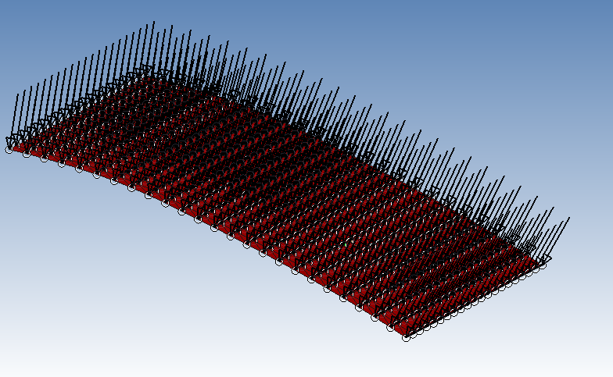

Load applied and bottom 4 edges are fixed
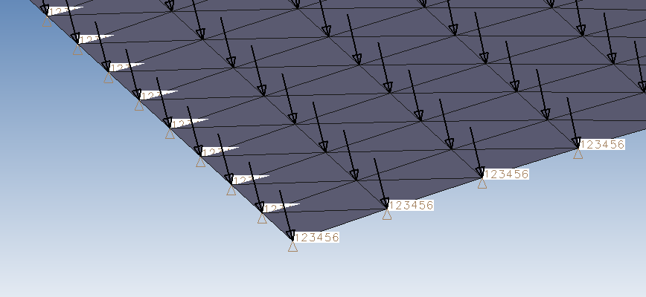
Material and load applied in Design studio:
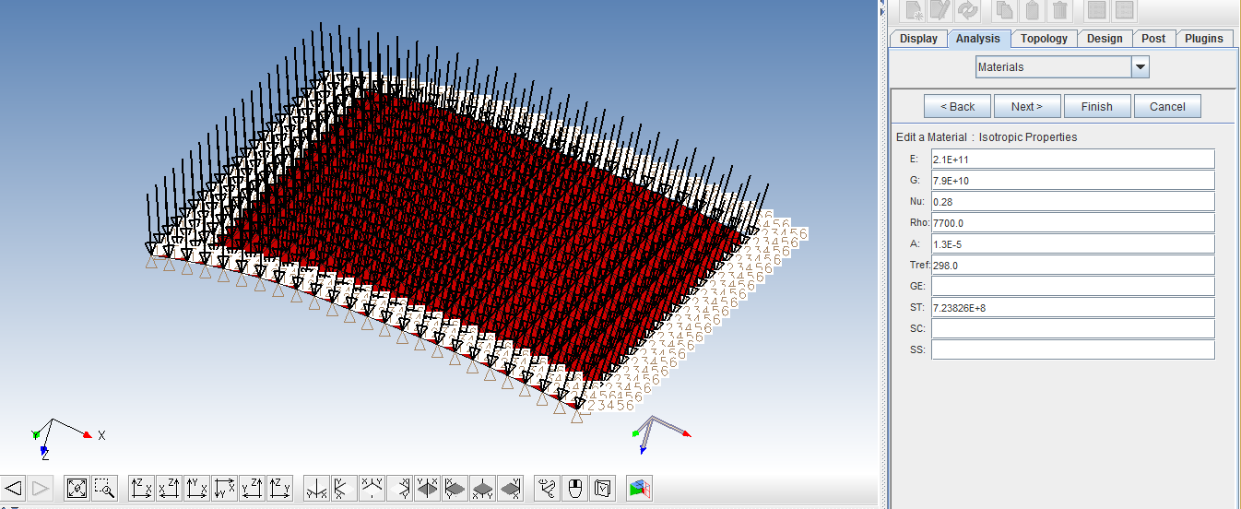
To know the volume and mass of the product, select elements in analysis. Select the comment calculate mass and volume. Then optimize it.
ANALYSIS>ELEMENTS>SELECT ALL>CALCULATE MASS/VOLUME

Then the model was saved in new folder Optimized.
The objective was set up. Next step is to set up our constraint. Displacement as constraint has been set.
Then design variables were set up so that the thickness of each orientation can be between 0.1mm . For this select new in design variables and name your variable L1THK as it wil represent the variable for the thickness for plies in the first orientation. Give initial value as 1e-3 and lower value as 0.2e_3 and upper value as 3e-3 ad finish.
We are now going to attach the above design variables to the PCOMP that we created. For that attachment first select sizing in design and highlight your pcomp and modify point the thickness of layer one to L1THK point the other layers to their appropriate design variables.
The maximum number of cycles allowed to 30 was increased
GENESIS>OPTIMISE
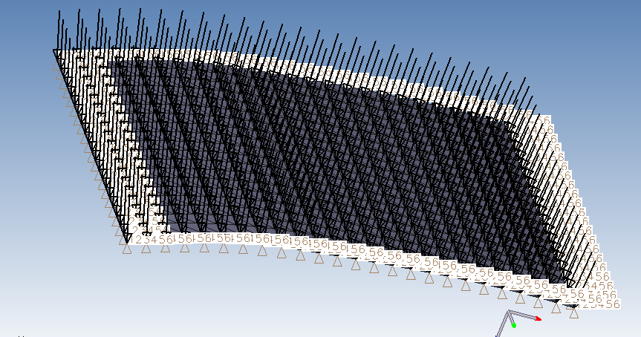

The mass of the material that designed in Design studio:
Now compare the mass variation between the original material and the optimized material structure that could withstand the actual load that was applied before. The constrain was the deformation should be in the limit of 0.2 mm so that the wind turbine blade can withstand the force the hit on the blade. The mass reduction was achieved through the fiber orientation combination and count of the fibers at each orientation angle of fibers placed.
In design studio environment designed the full structure with the specified orientation of composite material and applied the required constrains of fixed portions and load portion and then run the optimization process. Now we get the process environment like this,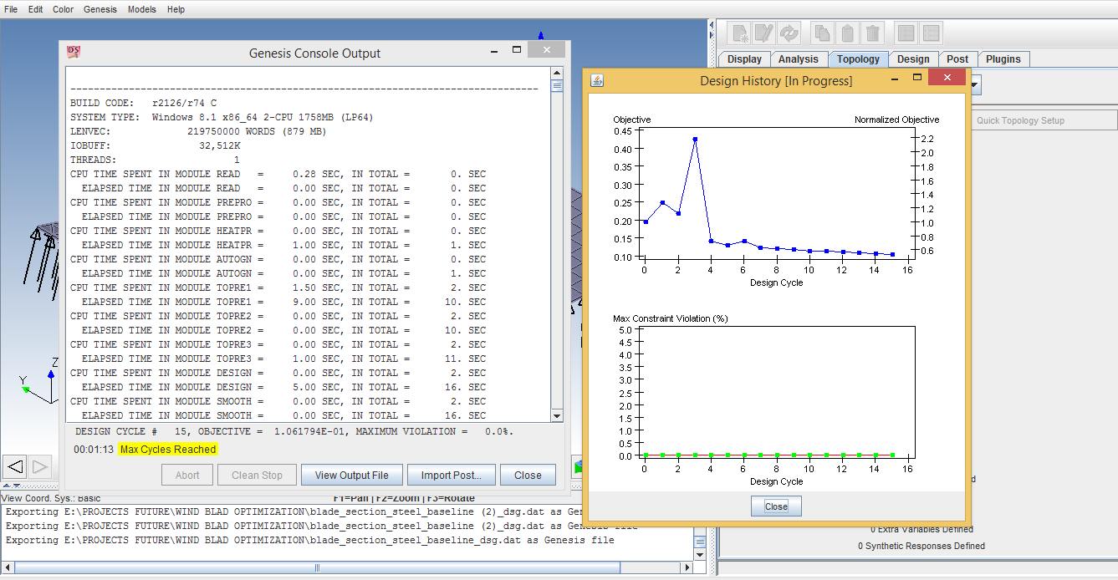

From the analysis we get the graph plot which defines the cycles of the process and its objective comparison, here the clear visible of plotted graph: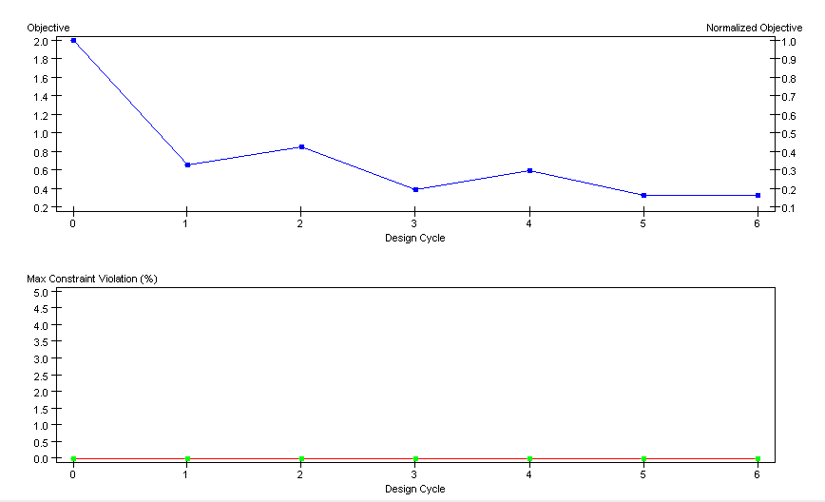

The final output of the optimization process will exicute in graphical and numerical also,
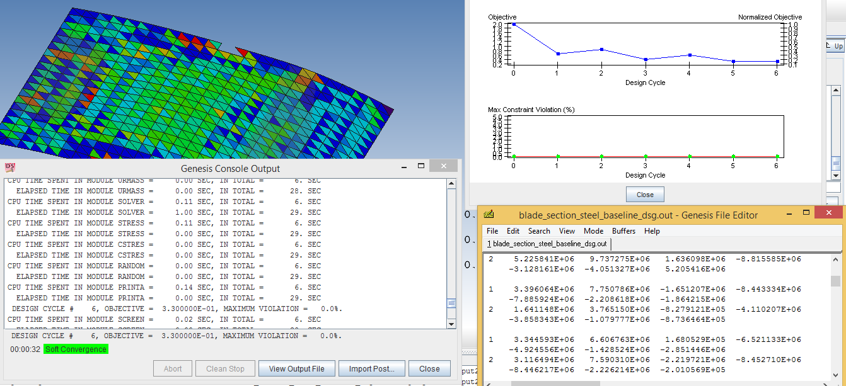
The load applied with respect to the iterations in step by step are plotted in the upcoming graph, 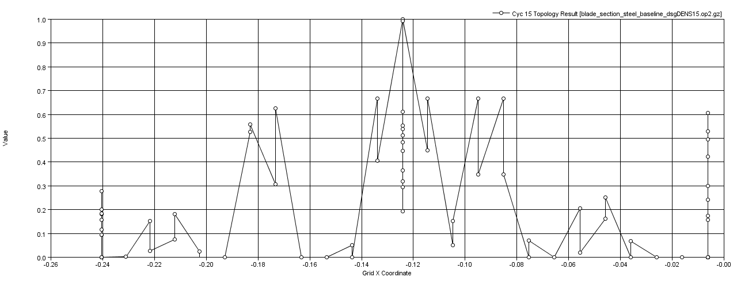

Next step was IMPORT POST> , displacement for the last design cycle was confirmed. POST>DEFORM/COLOR MESH> deform your mesh using the results from the last cycle:
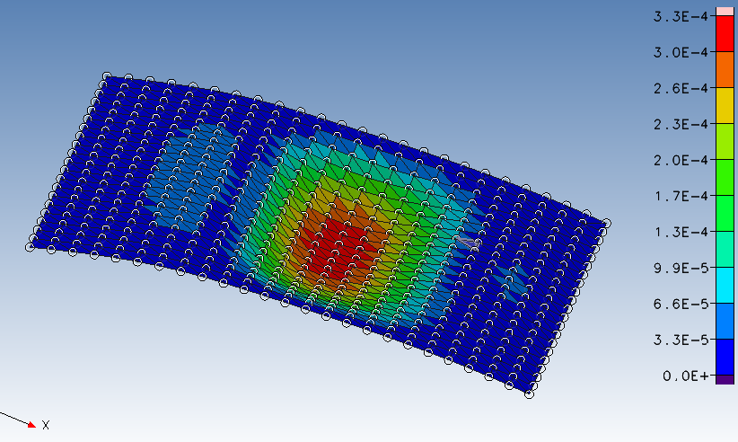
So, genesis has added thickness to each orientation to meet the displacement target and minimize the mass. To see how genesis has achieved this we can view how the variables have changed.
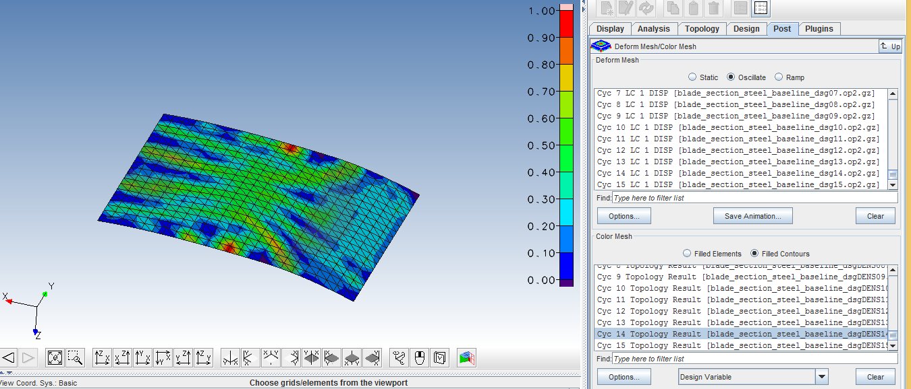

The next step was FILE>IMPORT>DESIGN HISTORY RESULTS – read the file in and curve was added
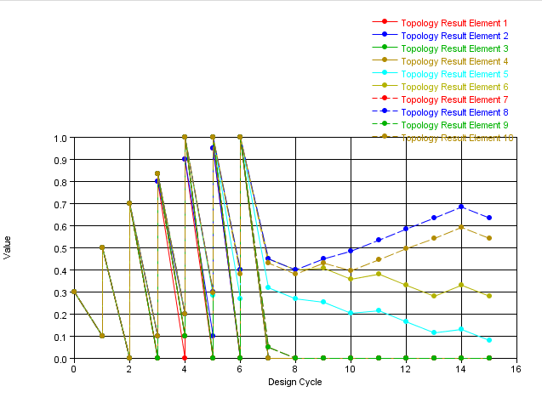

Now the mass properties in solidworks and design studio have been compared:
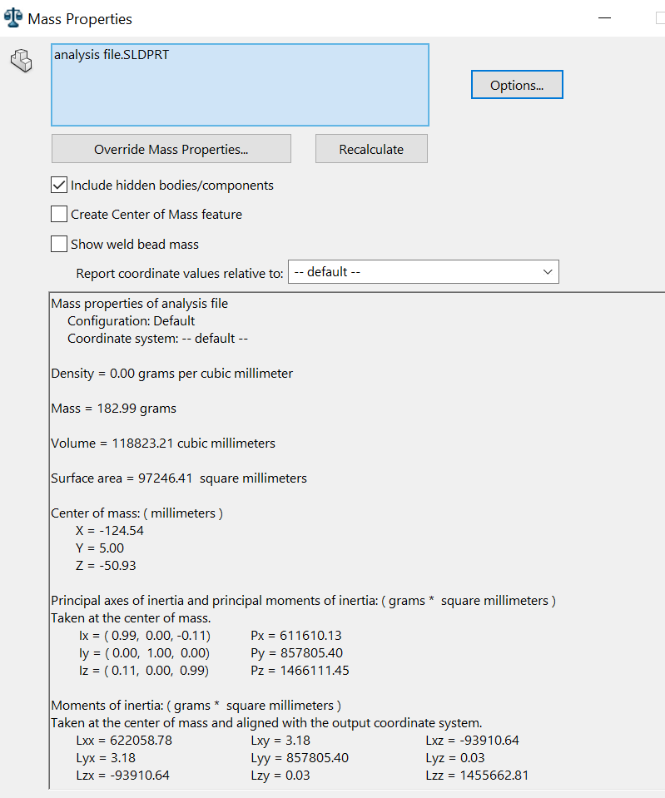

From the process of optimization, we get a different kind of results outputs and their result is as following:
Software | Thickness | Deflection | Mass | Load
Solidworks | 2.5 mm | 0.5mm | 182.99 grams | 200 N
Design studio | 2.5mm | 0.18mm | 100 grams | 200 N
By comparing the mass variation between the original and optimized model, it is seen that reduction in mass does not affects the actual load that was applied. The constrain was the deformation should be in the limit of 0.2mm, so the wind turbine blade can withstand the force it hits on the blade. The mass reduction was achieved through the combination of fiber orientations and count of the fibers at each orientation angle of fibers placed.

From the process of optimization, we get a different kind of results and outputs:
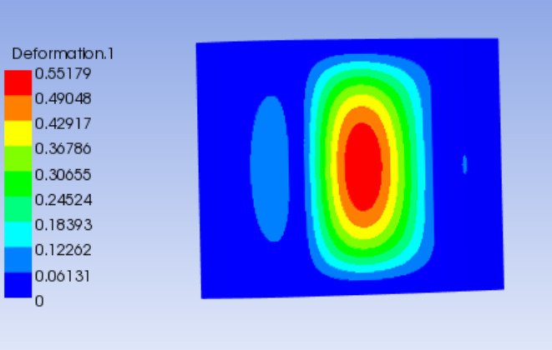
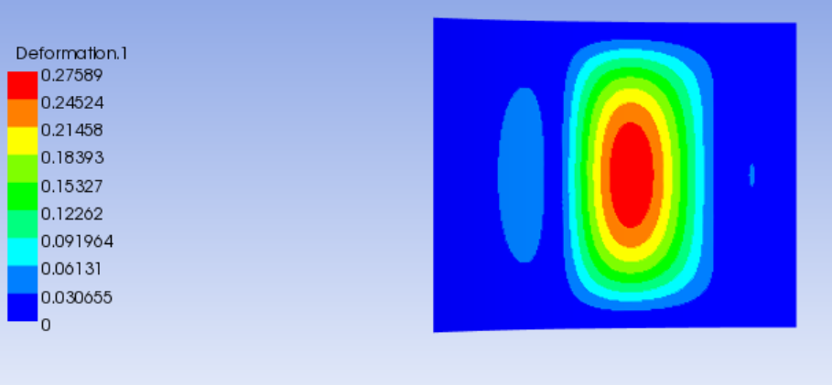
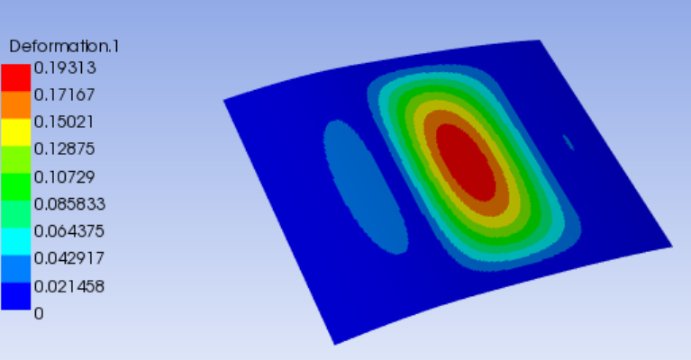

Optimization problem summary is shown below:
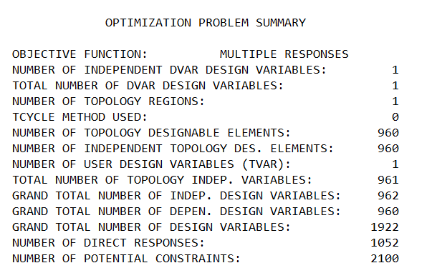

Conclusion
A wind turbine blade geometry constructing interface was optimized in the study case to facilitate the stress and deformation analysis using Design Studio. To optimize suitable mass properties at the same load sustain, the orientations of the fiber in the composite material have been considered as a parameter. These parameters are the fiber at 0°, 45°, 90°, -90° and -45°. From these combinations it was obtained, the 45° and -45° combination takes most of the part and the other plies rolls miner parts, so it was achieved a greater strength with less mass of the blade.
Based on the maximum principal stress failure criterion, the composite blade skin can be determined under a specified safety factor. A uniform stress loading on the blade can be derived with this design methodology. By using the optimization analysis in Design Studio, it was achieved a greater reduction in mass but at the same operation properties. Results showed that the optimization process led to significant decrease of mass, while properties of composite material have not been changed, and whilst the displacement was a constraint.

References
Chapman, C. D., 1994. STRUCTURAL TOPOLOGY OPTIMIZATION, MASSACHUSETTS: s.n.
Edwar G, Beshay G ED M, Maalawi K Y, 2020. Structural Optimization of Wind Turbine Blades for Improved Dynamic Performance. In: Design Optimization of Wind Energy Conversion Systems with Applications. s.l.:s.n.
Jureczko M, Pawlak M, Mezyk A, 2005. Optimisation of wind turbine blades. Journal of Materials Processing Technology, Volume 167, pp. 463-471.
Lake, K., 2020. Creating a CAE FE model, s.l.: s.n.
Rosemeier M, Saathoff M, 2020. Assessment of a rotor blade extension retrofit as a supplement to the lifetime extension of wind turbines. Wind Energy Science, Volume 5, pp. 897-909.
Wang Z, Suikera S J, Hofmeyer H, Twan van Hooff, Blocken B, 2020. Coupled aerostructural shape and topology optimization of horizontal-axis wind turbine rotor blades. Energy Conversion and Management, Volume 212.
Warshawsky, L. B., 2015. Practical application of topology optimization to the design of, Iowa: s.n.
Young W, Wu W, 2011. Optimization of the skin thickness distribution in the composite wind turbine blade. s.l., IEEE, pp. 62-66.
Zheng Y, Zhao R, Liu H, 2014. Optimization Method for Girder of Wind Turbine Blade, Lanzhou: s.n.

