

EXAMINATIONS 2013 / 2014 Semester 2- Resit
ARHOLIADAU 2013/ 2014

FACULTY OF: APPLIED DESIGN AND ENGINEERING
SCHOOL OF APPLIED COMPUTING

NAME OF COURSE/PROGRAMME: | HND /BSc/BEng Networks
YEAR OR LEVEL: | Year 2
NAME OF MODULE/UNIT/EXAM PAPER: | Local Area Networks
MODULE NO: | M2X8625/ M2X8521/ M5X8930
DATE OF EXAMINATION:

EXAMINATION TIMES:

START TIME:

FINISH TIME:

TIME ALLOWED:

INSTRUCTIONS TO CANDIDATES:

Answer 3 out of 4 questions.

Candidates are not permitted to bring calculators, dictionaries; text books/case studies or any other reference materials into the exam room.

QUESTION ONE

- Compare Router physical interface and Subinterface. [6 marks]

- Define a VLAN Trunk and what problem does it solve? [5 Marks]

- Refer to the network shown in figure 1. Identify RSTP port types and explain them. [14 Marks]

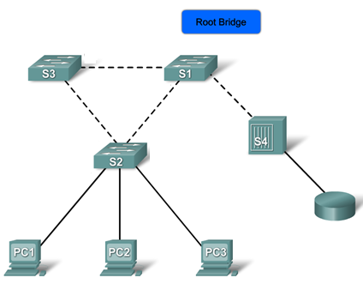

Figure 1

QUESTION TWO

- With aid of a network diagram explain PVST+? [13 Marks]

- A switch can be configured in either server, client, or transparent mode. These modes differ in how they are used to manage and advertise VTP domains and VLANs. Complete the table below based on the mode and operation. [12 Marks]

 | VTP Server | VTP Client | VTP Transparent
Description

Respond to VTP advertisements?
Global VLAN configuration preserved on restart?
Update other VTP enabled switches?

QUESTION THREE

- With aid of a network diagram explain the Hierarchical network model. [15 Marks]

- What are the restrictions on implementing EtherChannel? [10 Marks]

QUESTION FOUR

- Explain the Data, Default, Native and Management VLANs. [16 Marks]

- Refer to the network shown in figure 2, PC1 is not able to communicate with PC3. Identify the issue and write down the commands to troubleshoot the issue. [4 marks]
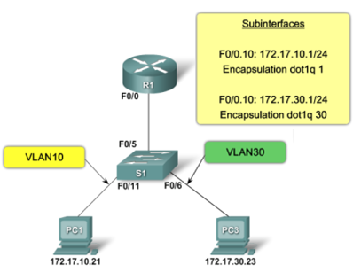
Figure 2

- With aid of an appropriate network diagram explain traditional Inter-VLAN routing [5 marks]

