Semiotic Analysis
by Seren Trodden
(Word count 463)

Student Number: 2201099
BA Design Crafts
Tutor: Julia Lockheart

Submission date:
Submission ID:
File name:

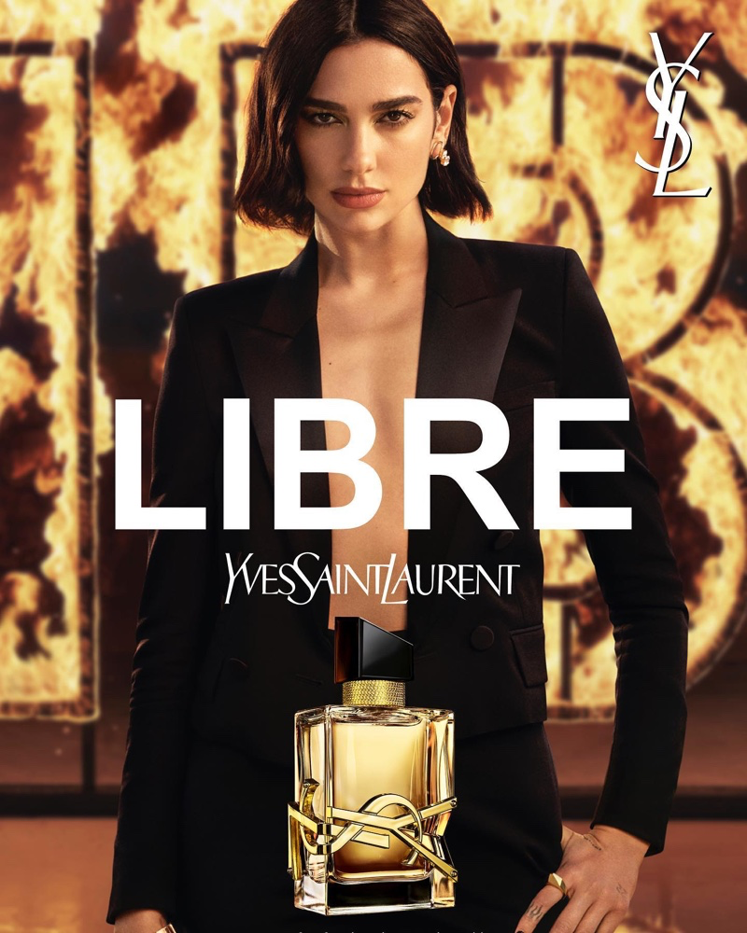

Fig.1 Dua Lipa

This advertisement is selling a brand of perfume called Libre by Yves Saint Laurent (YSL), using the famous singer Dua Lipa. The word ‘libre’ meaning ‘free’ in French is placed in big bold white text right in the middle. Yves Saint Laurent’s name and the YSL brand logo are used in several different places across the image, in the middle, the top right corner, behind Dua Lipa, where it is on fire, and on the perfume bottle. A minimal colour palette is used of warm tones with black, making the advert eye-catching and classic in its simplicity. The bottle is rectangular in shape, mirrored by Dua Lipa’s sharply tailored suit jacket.

We understand that as a singer Dua Lipa must have confidence to perform, therefore having her represent the perfume implies that the product will give us confidence as well. The name Libre tells us that this perfume can be liberating and empowering for the wearer. Dua Lipa looks directly at the camera with calm confidence, telling us that this perfume can potentially enhance our own attitude, offering the possibility of becoming the most confident version of ourselves. Several of Vance Packard’s “eight hidden needs” are suggested here, such as “reassurance of worth” (Packard, 1957).

‘’the color white include purity, innocence, cleanliness’’(Cherry, 2023) The name of the perfume is placed centrally in white, as this is the most important information that the advertisement must convey to the customer if they are to make a purchase. The YSL name and logo are the next messages, to tell us the perfume is by this famous brand. This lettering is also white, but smaller and understated compared with the perfume name, emphasising the class and confidence of the brand. Dua Lipa is behind the writing in full focus, drawing you into the advert, as they use this famous figure to connect with you.

Colours consist of warmly lit skin tones, with black clothing against a flaming background to make the subject pop out. Dua Lipa wears a plain black suit, matching the lid of the perfume bottle, while the writing behind is on fire, matching the liquid inside the bottle, a possible comment on the qualities of the perfume. “It is true to say that colour is subjective and emotional. It is often the most volatile element of a project” (Adams, 2017). We could interpret the colours as saying that this beautiful woman represents the bottle, while the flaming background is the perfume inside. Use of fire can suggest danger, but here it is used to imply power and confidence. Black is often used for sorrow, but here it implies singularity and independence (Chapman, 2021).

Fire as a symbol within most cultures represents many different ideas but all similar outcomes such as power, divinity, destruction and a force to be respected, giving the brand status elevation above other brands (Building Beautiful Souls Inc., 2023). This could imply that once the customer uses the product the perfume transforms them into a much more confident person, as if you where becoming Dua Lipa herself.

Bibliography:

Adams, S. (2017) The Designer’s Dictionary of Color. [UK edition] Abrams.

Building Beautiful Souls Inc. (2023) Fire, Creation, Destruction, Transformation. Available at: https://www.buildingbeautifulsouls.com/symbols-meanings/five-elements-symbolic-meaning/fire-element-symbolic-meaning/ (Accessed: 27 November 2023).

Chapman, C. (2021) Color Theory for Designers, Part 1: The Meaning of Color. Available at: https://www.smashingmagazine.com/2010/01/color-theory-for-designers-part-1-the-meaning-of-color/#:~:text=Black%20is%20the%20strongest%20of,mourning%20in%20many%20Western%20countries. (Accessed: 27th November 2023).

Cherry, K. (20230 The meaning of the color white. Available at: https://www.verywellmind.com/color-psychology-white-2795822#:~:text=The%20color%20white%20has%20a,emptiness%2C%20simplicity%2C%20and%20minimalism. (Accessed: 27th November 2023).

Packard, V. (1957) The Hidden Persuaders. Cardinal Edition [UK edition] London: Pelican Books.

Table of content:
Figure 1: Dua Lipa

Elizabeth, J. (2022) Dua Lipa Glows for Yves Saint Laurent Libre Le Parfum. Available at: https://www.fashiongonerogue.com/yves-saint-laurent-libre-le-parfum-campaign-dua-lipa/ (Accessed: 25th November 2023).

