Assignment Title: Menu Engineering
Student Name: Marian Bogdan Staicu
Student ID:2234128
Module Name: Food & Beverages Operations
Module Code: BMIH4002
Lecturer: Ffion Cumberpatch
Word Count: 403 words

Part 1

Restaurant Concept
Hotel Trinity is a four-star city centre hotel created with the purpose of providing people with authentic Italian cuisine and taste. Italian food is popular for its simplicity, quality, affordability, taste and variety (Boffey, 2019). The concept of a restaurant is based on these factors, as the popularity of Italian food is already booming. In addition, the regional variation of Italian cuisine and dishes are more diverse, even if they seem similar. Furthermore, Italian cuisine also comes with a wealth of tradition and history, which also has a strong underlying connection with tourism (Jones, 2023). Therefore, the purpose is to make people eat elegant and tasty Italian food, making them taste travel.

Target Audience
Italian cuisine is considered traditional, simple and genuine, yet made with few and flavourful authentic ingredients. The cuisine is continuously becoming a part of the British culinary landscape (Giuffrida, 2023). The main targeted audience of the restaurant will be those looking for comfort food, along with those in search of the balanced and healthy Mediterranean diet and quality ingredients. In this manner, the purpose is to make food a big part of the food culture. Therefore, the purpose is to target all those people, irrespective of their age or any other demographic characteristics, looking for an appetite for quality. It is undeniable that Italian food will continue to increase in popularity, and consumers are also becoming wiser regarding true Italian food.

Reasoning behind Menu Choices
The menu choices for the restaurant have been selected in such a manner as to fulfil the essence of Italian cuisine. The fondness of British consumers for high-quality Italian produce is nothing new (Secondi et al., 2020). Therefore, the focus is on making a difference by offering food that might be easy and convenient but also versatile and tasty at the same time. The figure below shows some of the most popular Italian dishes in the UK.
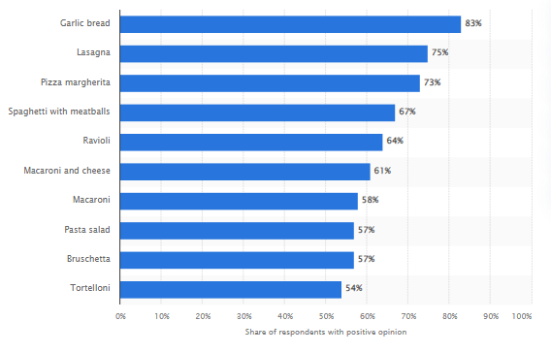
Figure 1: Popular Italian Dishes in the UK
Source: Statista (2023)
Another major preference, in this regard, is to cater to the need of people with diverse dietary preferences. For this purpose, the restaurant especially focuses on the inclusion of those dishes which are also suitable to be consumed by those that prefer a vegetarian or vegan lifestyle. In this manner, the emphasis is on inducing the sense of exploring Italian cuisine among people, irrespective of their dietary preferences.

Part 2

Menu

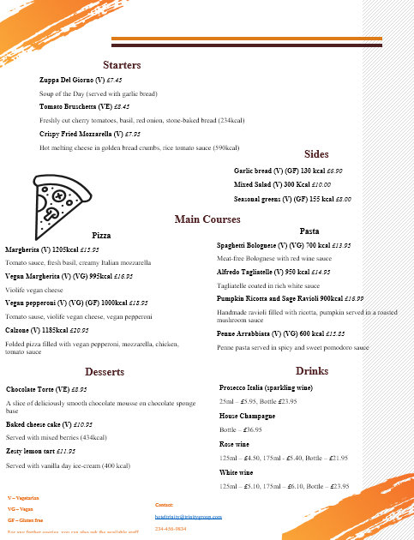

References
Amore, 2023. Mi Amore Italian restaurant Menu. [online] Mi Amore Italian Restaurant Aberdeen. Available at: [Accessed 3 Jun. 2023].
Ask Italian, 2023. Ask Italian Menu. [online] Ask Italian. Available at: [Accessed 3 Jun. 2023].
Barandblock, 2023. [online] Meat-free, moreish menu - bar + block. Available at: [Accessed 3 Jun. 2023].
Boffey, D., 2019. Italian is loved, but most Europeans favour their own country's food, survey finds. [online] The Guardian. Available at: [Accessed 3 Jun. 2023].
Giuffrida, A., 2023. Italian academic cooks up controversy with the claim Carbonara is a US dish. [online] The Guardian. Available at: [Accessed 3 Jun. 2023].
Jones, T., 2023. If there's one thing Italians won't stomach, it's dishing the dirt on their cuisine. [online] The Guardian. Available at: [Accessed 3 Jun. 2023].
Prezzo, 2023. Prezzo gluten free autumn 22 tier 3 no price . [online] Prezzo. Available at: [Accessed 3 Jun. 2023].
Ristorante Da Vinci, 2023. Ristorante Da Vinci Menu. [online] Ristorante . Available at: [Accessed 3 Jun. 2023].
Secondi, L., Principato, L. and Mattia, G., 2020. Can digital solutions help in the minimization of out-of-home waste? An analysis from the client and business perspective. British Food Journal, 122(5), pp.1341-1359.
Statista, 2023. GB: Most popular Italian dishes 2022. [online] Statista. Available at: [Accessed 3 Jun. 2023].

