
APPENDIX GA36c

LEVEL 6 ASSESSMENT SPECIFICATION

Student name: | Robert Humphrey | Student ID number: | 1600949
Programme:
Module: | Advanced Training Methods
Module code: | SHSS6089 | Contribution to Overall Module Assessment (%): | 50%
Lecturer: | Geraint Forster | Internal Verifier: | David Gardner
Assignment Title: | Review Article | Word count (or equivalent): | 2,500 words
Submission deadline: | 3PM 19/03/2021 | Return date of provisional marks & written feedback: | 16/04/2021
Submission method: | All written assessments, where practical and possible, must be submitted via Turnitin unless otherwise instructed by the Lecturer. (Please DO NOT put this assessment specification into Turnitin or it will match many similarities with other students’ submissions.)  Alternative submission method (if applicable):  Late submission of the assessment will result in a late penalty mark. Penalties for late submission: Up to one week late, maximum mark of 40%. Over one week late, 0%. Only the Extenuating Circumstances Panel may approve a change to submission dates.
Academic honesty / referencing: | Academic honesty is required. In the main body of your submission you must give credit to authors on whose research and ideas your work is based. Append to your submission a reference list that indicates the books, articles, etc. that you have used, cited or quoted in order to complete this assessment.

Module Learning Outcomes
(from module syllabus)
- Critically evaluate the effectiveness of a range of recent advanced training methods.

- Integrate advanced training methods effectively into a training programme.

- Use technology effectively to enhance training outcomes and monitoring.

TASK DESCRIPTION

Scenario

This assignment requires you to implement and evaluate the effectiveness of one of the advanced training methods studied in this module. This implementation can involve either working with client who you can safely work with (in person or remotely), or implementing it into your own training. You must choose a different training methodology to the one used in assignment 1.

You must also evaluate the role that technology can play in supporting this training method.

Task
Having integrated the advanced training method into the training of an individual for a suitable period of time, write an evaluative report outlining the effectiveness of the training method in achieving the desired goals, and the usefulness of technology in monitoring progress.

Include the following in the report:

- A profile of the client including results of any testing conducted;
- A rationale for the inclusion of this particular advanced training method in the training programme of the client;
- A summary of the training programme prescribed to the client;
- Details and evaluation of any technology used within the programme;
- A critical evaluation of the effectiveness of your intervention, using evidence-based research to support your opinions.

GUIDANCE FOR Students IN THE COMPLETION OF TASKS

Student FEEDBACK FORM

This section details the extent to which the assessment criteria are demonstrated by you, which in turn determines your mark. The marks available for each category of skill are shown. Lecturers will use the space provided to comment on the achievement of the task(s), including those areas in which you have performed well and areas that would benefit from development/improvement.

Generic Assessment Criteria | Marks available | Marks  awarded
1. Engagement with Literature Skills  . | 25
2. Knowledge and Understanding Skills | 25
3. Cognitive and Intellectual Skills | 20
4. Practical Application Skills | 20
5. Transferable Skills for Life and Professional Practice | 10

Assessment Mark (Assessment marks are subject to ratification at the Exam Board. These comments and marks are to give feedback on module work and are for guidance only until they are confirmed. ) | Late Submission Penalties (tick if appropriate) |  | %
 | Up to 1 week late (40% Max) |  | %
 | Over 1 week late (0%) |  | %

The effects of High Intensity Interval Training on running and cycling endurance

Athlete profile

The athlete is a 24 year old male and weighs 94.2kg with a stature of 177cm. The athlete competes in recreational triathlons at a standard level, with sprint and Olympic distance being the main discipline. The athlete is training for an Ironman in Wales that is due to take place in September 2021. He trains 5 days a week with an average duration of 1.5 hours per day. The athlete runs an average of 20-30km a week, with a variation of terrain. He does 70-100km of cycling a week and 5km of swimming a week, however due to the COVID-19 restrictions, is unable to train in pools due to leisure centres not being open and the weather is currently too cold to swim in the sea. The athlete would normally take part in a triathlon event once per month on average although he has not taken part in an event since March 2020 due to COVID-19.

The goal that the athlete wants to achieve, is to be able to complete a 5km run in less than 20 minutes. To be able to apprehend this goal, muscular endurance training and High Intensity Interval (HIIT) training would show great benefits to help increase aerobic capacity which will lead to an improvement in cardiovascular fitness (Eddy et al., 1977). In addition, this will also help the athlete lose weight which will make the client lighter, thus help them run faster due to carrying less excess weight. A secondary goal the client has is to be able to increase their current Functional Threshold Power (FTP) score. Due to the similarity of both goals, HIIT training on the bike would be highly beneficial to help achieve their goals. Before the programme was completed, the time the athlete scored for their 5km was 23:33 and their FTP score was 227. The client is a student, studying at the University of Wales Trinity Saint David with a part time job as a gym instructor and swim teacher. Tests were completed by conducting a 5km and a 20 minute FTP test before and after the HIIT training programme. Each test was completed a week apart due to their current training schedule to avoid any complication that may impact their results. All data was collected using the Strava (2021) fitness app while using a 735xt Garmin watch. A Garmin heart rate monitor was used to collect heart rate data. FTP testing was completed on a Watt Bike Pro both times with data collected via the Watt Bike App.

Rationale
The purpose of this study is to identify whether HIIT training helps increase cardiovascular output performance for running and cycling. It is known that aerobic exercise has a number of benefits for the high risk populations, including weight loss when HIIT training is applied (Shiraev and Barclay, 2012). HIIT training includes exercising repeatedly at a high intensity for a duration of 30 seconds to several minutes following a 1-5 minutes of recovery (recovery depends of exercise duration). American College of Sport Medicine, (2014) described HIIT training as “type of training which involves repeated bouts of high intensity effort followed by varied recovery times” It was also stated by (Haskell et al., 2017) that regular endurance training helps improve overall physical fitness and recovery rate with American College of Sports medicine (2009) suggesting that adults aged 18 – 65 should endure 150 minutes of moderate activity, or 75 minutes of high levels of intensity each week. It has been known that HIIT training, shows greater performance efficiency when compared to low intensity continuous training which is the most world widely used within the recreational population. Within this programme, a variation of Sprint Interval training which is a sub-category of High Intensity Interval Training which was described by Weston et al. (2014) as short “all out” intense exercise, followed by a short rest at a low-intensity to be able to recover between each set.
HIIT training also has the ability to greater increase VO2 max peak when compared to moderate intensity exercise (Ito., 2019). Xie et al., (2016) explain that increasing an athlete’s peak VO2 has the potential to improve “aerobic capacity and promote cardiac rehabilitation.” Helgerud et al., (2007) stated that VO2 max is one of the main factors when determining aerobic and endurance performance. A study performed by Milanovich stated that the combination of HIIT and continuous levels of endurance exercise has shown benefits to help improve an individual’s VO2, however VO2max showed a greater increase when following a HIIT-specific training programme when compared to moderate effort in endurance exercise.

A study by Kohn et al.,(2011) examined the physiological and skeletal muscle adaptations in eighteen well‐trained endurance runners who took part in a 6 week HIIT programme. The findings showed no changes in the athlete’s maximal oxygen consumption, muscle fibre type and capillary supply. However, it was shown that a change in Lactate dehydrogenase (LDH) increased in homogenate. This study shows that HIIT training in endurance runners shows no adaptations in muscle oxidative capacity, however, an increase in LDH activity was seen mostly in type IIa muscle fibres.

shown that training programmes that include long, continuous exercises have the ability to improve the VO2 max of the individual (Eddy et al., 1977) however, further research has shown that experiencing high intensity exercise with repeated short intervals also has the ability to have an increase in VO2max outcome of the athlete (Cocks et al., 2013).
It is also known that applying SIT training has the ability to improve cardiorespiratory fitness, as Gillen et al., (2016) stated that enduring a maximal effort of 20 seconds of sprints, along side a 10 minute training programme three times a week, over a period of 6 weeks, produced improvements within the cardiorespiratory performance. Another study by Gibala et al., (2006), had also stated that SIT has the ability to increase efficiency and performance in aerobic power and metabolic function which is achieved with endurance training, with Xie et al. (2016) also stating increased VO2 peak has the ability to improve “aerobic capacity and promote cardiac rehabilitation”.

When using SIT as a method of HIIT, an increase in VO2 max and maximal aerobic performance will occur (Sloth et al., 2013). Therefore, athletes who compete in endurance sports (such as a marathon) would gain great benefits if using SIT training as an increase in VO2 max will help increase performance within aerobic capacity (University of California, 2019). A study by Gibala et al., (2005) identified that Sprint Interval training in time trial cyclists with a distance of 2km- 40km led to an improvement in performance of 3.5% to 10.1%. This could also suggest that the use of the SIT training method could help increase a runner’s overall time and performance.

Training Programme
The training programme that was created for the client was influenced by Buchheit and Laursen (2020). It was suggested that the individual performs at maximal intensity for a duration of 20s with a recovery time of up to 2 minutes with a 6-10 repetition within each set as this will greatly stress the anaerobic system. The training programme created also fits in to their current training programme and will replace their current programme for a 6 week duration. Within the sessions there is a mixture of sprint intervals on the bike and Sprint interval hill sprints. The main structure of the programme involves variation on timed sprints that are performed on both the bike and when running. The cycling aspect of the training method uses their current FTP to calculate effort measured in WATTS for the athlete with a time variation of 1 minute to 3 seconds of total max effort. The running application of the programme includes hill sprints with a time variation of 1 minute maximal effort, to 20 seconds of maximal effort with a recovery period between each set. Good discipline and repetition of the same programme each week for 6 weeks must be followed to ensure accurate results.

Table 1: Showing the Training programme for the client
 | Cardio Training | Strength Training/stretching
Monday | Cycling  1. Warm Up 20 Minutes Single Leg Drills.  20 min @ 130-245 W  Zone 1-Zone 2  2. Ramp down in 4 steps  1. 2 minutes seated high resistance  2 min @ 261-293 W  Zone 3  2. 2 minutes seated with added resistance  2 min @ 261-293 W  Zone 3  3. 2 minutes standing with same resistance  2 min @ 261-293 W  Zone 3  4. 1 minutes seated mid resistance / high cadence  1 min @ 261-293 W  Zone 3  3. Recovery  5 min @ 163-196 W  Zone 1-Zone 2  4. Ramp down in 4 steps  1. 2 minutes seated high resistance  2 min @ 261-293 W  Zone 3  2. 2 minutes seated with added resistance  2 min @ 261-293 W  Zone 3  3. 2 minutes standing with same resistance  2 min @ 261-293 W  Zone 3  4. 1 minutes seated mid resistance / high cadence  1 min @ 261-293 W  Zone 3  5. Recovery  5 min @ 163-196 W  Zone 1-Zone 2  6. Ramp down in 4 steps  1. 2 minutes seated high resistance  2 min @ 261-293 W  Zone 3  2. 2 minutes seated with added resistance  2 min @ 261-293 W  Zone 3  3. 2 minutes standing with same resistance  2 min @ 261-293 W  Zone 3  4. 1 minutes seated mid resistance / high cadence  1 min @ 261-293 W  Zone 3  7. Cool Down  10 min @ 130-196 W  Zone 1-Zone 2 | 30 min @ 4-6 RPE  Use Resistance band around knees or ankles for all exercises, redo all exercises below x2 times, take your time hold good form and technique and keep the movement controlled, YouTube video: https://www.youtube.com/watch?v=GwPe0JwYbrA 12 Glute Bridges. 6 (Each Side) Single Leg Glute Bridge with other leg elivated. 6 (Each Side) Side-Lying Abduction (Straight leg up and down). 10 (Each Side) Pelvic Drop's. 6 (Each Side) Single Leg Dead-lift. 6 (Each Side) Single Leg Squat. 5 (Each Side) Side Bridge. 12 Low Sumo Squat.
Tuesday | Running  1. Warm up  10 min @ 10:14 min/mi  Zone 2  Easy jog + stretching and 2 x 10's strides.  2. Repeat 10 times  1. 1 Mins Hard  1 min @ 07:27 min/mi  Zone 5b  2. 1 Mins Easy  1 min @ 10:56-20:29 min/mi  Zone 1  Walk / jog on recovery, get the HR down and breathing under control for the next effort.  3. Recovery Jog  5 min @ 10:14 min/mi  Zone 2  4. 10 Mins Tempo Effort  10 min @ 08:22 min/mi  Zone 4  Focus on holding a steady / comfortable pace with good running form.  5. Cool Down  5 min @ 10:56 min/mi  Zone 1
Wednesday | Running  1. Active  45 min @ 126 bpm  Zone 1: Recovery  Pre-Activity Comments: Aim to hold HR under or around 150bpm | Strength / Activation  15 min @ 6-8 RPE  Warm Up - Find a large area like studio / hall or hallway. 2 Minutes jogging up and down or in circle with high knees, heel flick and run drills --- 20 x High Knee Walking Lunge --- 10 x Walking Inchworm With Press Up --- 6 x YOGA Flow --- 5 x Bear Crawl Up / Down --- 3 Way Lunge (Front / Side / Back) repeat 6 rotations --- A Running Skip --- B Running Skip ---Stretching If Needed.
Thursday | Cycling  1.Warm up  10 min @ 163 W  Zone 1  2. Repeat 10 times  1. Hard  0:30 @ 359 W  Zone 5  2. Easy  0:30 @ 196 W  Zone 2  3. Recovery  5 min @ 212 W  Zone 2  4. Repeat 10 times  1. Hard  0:30 @ 359 W  Zone 5  2. Easy  0:30 @ 196 W  Zone 2  5. Recovery  5 min @ 212 W  Zone 2  6. Repeat 10 times  1. Hard  0:30 @ 359 W  Zone 5  2. Easy  0:30 @ 196 W  Zone 2  7. Recovery  5 min @ 212 W  Zone 2 | Stretch and Flexibility routine (15 minutes)
Friday | CYCLING  Warm up  20 min @ 147 W  Zone 1  Ramp up in 5 steps  Burst @ 100% FTP  40 sec @ 326 W  Zone 4  Tempo 70.3 Effort  4 min @ 277 W  Zone 3  Burst @ 100% FTP  40 sec @ 326 W  Zone 4  Tempo 70.3 Effort  4 min @ 277 W  Zone 3  Burst @ 100% FTP  40 sec @ 326 W  Zone 4  Recovery  3 min @ 179 W  Zone 1  Ramp up in 5 steps  Burst @ 100% FTP  40 sec @ 326 W  Zone 4  Tempo 70.3 Effort  4 min @ 277 W  Zone 3  Burst @ 100% FTP  40 sec @ 326 W  Zone 4  Tempo 70.3 Effort  4 min @ 277 W  Zone 3  Burst @ 100% FTP  40 sec @ 326 W  Zone 4  Recovery  3 min @ 179 W  Zone 1  Ramp up in 5 steps  Burst @ 100% FTP  40 sec @ 326 W  Zone 4  Tempo 70.3 Effort  4 min @ 277 W  Zone 3  Burst @ 100% FTP  40 sec @ 326 W  Zone 4  Tempo 70.3 Effort  4 min @ 277 W  Zone 3  Burst @ 100% FTP  40 sec @ 326 W  Zone 4  Recovery  3 min @ 179 W  Zone 1  Ramp up in 5 steps  Burst @ 100% FTP  40 sec @ 326 W  Zone 4  Tempo 70.3 Effort  4 min @ 277 W  Zone 3  Burst @ 100% FTP  40 sec @ 326 W  Zone 4  Tempo 70.3 Effort  4 min @ 277 W  Zone 3  Burst @ 100% FTP  40 sec @ 326 W  Zone 4  Recovery  3 min @ 179 W  Zone 1  Ramp up in 5 steps  Burst @ 100% FTP  40 sec @ 326 W  Zone 4  Tempo 70.3 Effort  4 min @ 277 W  Zone 3  Burst @ 100% FTP  40 sec @ 326 W  Zone 4  Tempo 70.3 Effort  4 min @ 277 W  Zone 3  Burst @ 100% FTP  40 sec @ 326 W  Zone 4  Cool Down  10 min @ 147 W  Zone 1
Saturday | 1 minute HIIT Intervals (Running)  Warm up  10 min @ 80-140 bpm  Zone 1: Recovery-Zone 2: Aerobic  Repeat 3 times  Warm Up Strides  20 sec @ 170-190 bpm  Zone 5C: Anaerobic Capacity  Easy Stride Recovery  1 min @ 80-140 bpm  Zone 1: Recovery-Zone 2: Aerobic  Repeat 6 times  Hard  1 min @ 190-200 bpm  Zone 5C: Anaerobic Capacity  Easy  2 min @ 80-150 bpm  Zone 1: Recovery-Zone 4: SubThreshold  Cool Down  10 min @ 80-150 bpm  Zone 1: Recovery-Zone 4: SubThreshold | Session  This quick session can be completed after a run. Complete the circuit below three times, with 30-seconds rest between exercises and two-minutes rest between sets.  30-second plank  30-second side planks (each side)  30-second bridge  20 mountain climbers (count one each time your feet swap positions)  20 Russian twists with a medicine ball  30-second balance on each leg (make it harder with a balance board).
Sunday | A 2hr ride at 65-70%FTP RPE 6 MHR% 70%. with a self selected rest complete 10x2min high cadence reps @105rpm or above. (NB works best on flat or down hill sections.) | Stretch all key cycling and running muscles (full body) + some foam rolling if sore / tender.  Videos.  8 Key Stretches - https://www.youtube.com/watch?v=6Ksc8N_k-FA  Stretches for Cyclists -  https://www.youtube.com/watch?v=V6hc-NAsYeo  Foam Rolling -  https://www.youtube.com/watch?v=mNswIIhUEko

The programme shown in Table 1 includes 4 HIIT sessions per week to help maximise the benefits of HIIT and to utilise its effectiveness. The sessions will be predominately focusing on 10 minute tempo efforts with some shorter bursts at an FTP of 227 as this is good to break up the effort, mimic the outdoor rolling roads and provide an improved physiological training response. Other HIIT sessions include strength training, with a certain amount of repetition of short and maximal efforts with the goal to increase neuromuscular recruitment and maximum specific strength. This training programme is to be completed 6 times, which makes the programme last 6 weeks with progress being monitored. Prior to beginning the programme, a 5KM running time will be completed with average kilometre splits being recorded together with the average heart rate throughout the test with the total time being noted. Two days after the 5km test has been completed, an FTP test will be completed to show a baseline on the client’s current FTP.

Technology Used

The technology that was used during testing was a Garmin Forerunner 735xt sports watch together with the Strava (2021) app to log in the results of the testing and to analyse the client’s performance through their 5km run which also allows pace analysis, split times and heart rate as seen in figures 1 and 3 below. A Garmin HR runner monitor and a triathlon HR monitor using the Strava app as seen in figure 2, 4. The Garmin watch was worn by the client to keep record of the distance covered, overall time and splits per km. FTP testing was conducted on a Watt Bike using the Watt Bike App with the use of the Garmin Heart Rate Monitor. Figures 5 and 6 show the results of FTP testing pre and post completion of the programme with the inclusion of average Heart Rate.
Figure 1 – Showing heart rate and time splits data from a 5km run before starting the programme

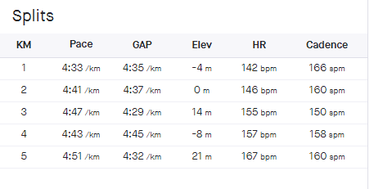
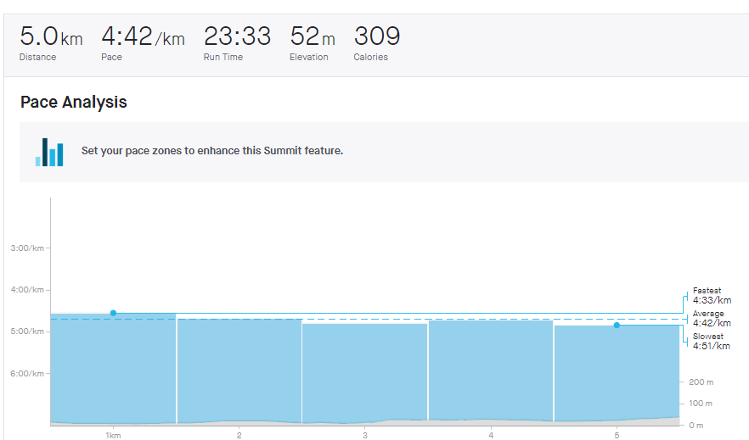

Figure 2 – Data showing the heart rate zones before the 6 week programme for the 5km run

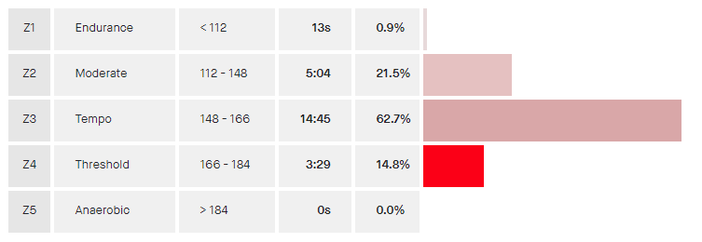
Average BPM 155

Figure 3 – Shows the results of the 5km run after completion of the programme.

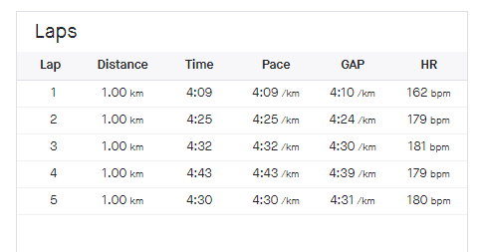
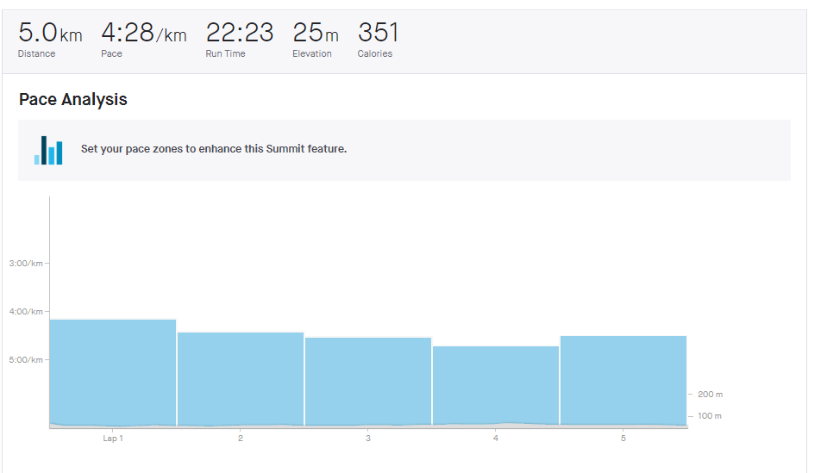
Figure 4 – Data showing the heart rate zones after completion of the 5km run

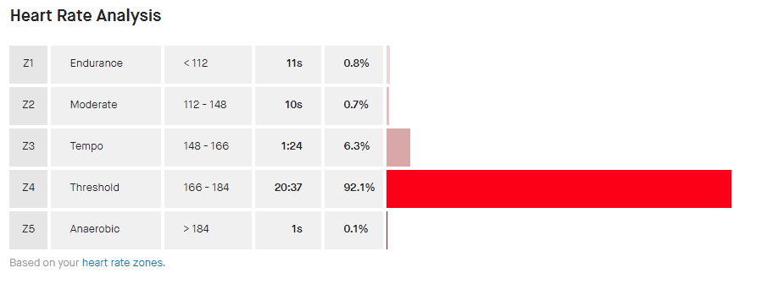
Average BPM 179

Figure 5 – Data showing the the heart rate zones and results prior from completion of the of the HIIT training sessions.

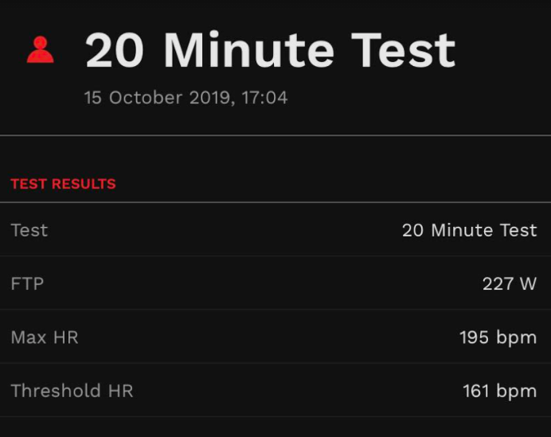

Figure 6 – Data showing the he heart rate zones and heart rate for the FTP test following the completion of the HIIT training sessions.

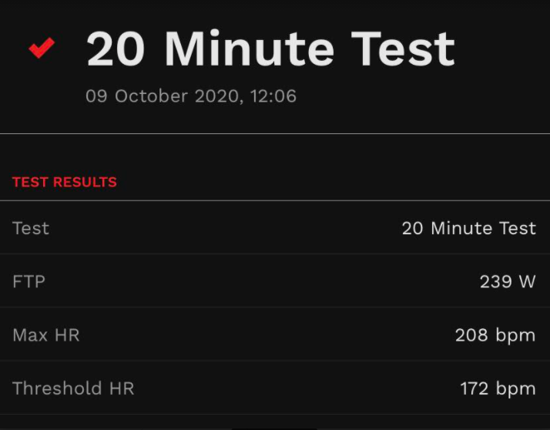

Critical Analysis
Upon comparison of figures 1,2 and 3,4 the 5km running time showed to decrease by 5% with a total time of 23:33 minutes to 22:23 minutes after completion of the 6 week HIIT programme that is specifically looking at Sprint Interval Training (SIT). The same results show from looking at figures 5 and 6 with the FTP increasing by 5.3% with an average heart rate recorded at 161bpm (Beats Per Minute) pre testing, and an average 172bpm post completion of the 6 week programme, thus being able to work harder without compromising performance and efficiency with a greater average heart rate.

The results shown support the point made by Astorino et al., (2012) that implementing HIIT training significantly increases VO2max and power output in active men and women. This also has the potential to improve maximal aerobic performance, as the results produced by the athlete after completing the 6 week programme proves this theory. After completion of the programme, in stages the client found some aspects of the HIIT training physically and mentally stressful, however, the client was determined to finish each day to their highest level. This is fairly common for athletes who endure HIIT training as it can become off putting after a few weeks into a programme as a study by Foster et al., (2015) found that HIIT training over a period of a 8-week training period, showed that enjoyment decreased by untrained adults.

When looking at figures 2, 4, 5 and 6, it is clear to see that average heart rate increases when testing after completing the 6 week programme. The 5km average heart rate was shown at 155bpm before the programme whereas after completion of the HIIT programme, average bpm was shown to be 179. This shows that the client is able to work harder and faster when enduring greater stress levels on the cardiovascular system. However, the results shown to contradict studies performed by Conraads et al., (2016) and Loennechen et al., (2007) as they stated that there is no difference in peak heart rate with both methods of exercise of interval training and continuous training. The reasoning to this may be down to technology issues and human error when collecting data and due to the current restrictions of the study due to COVID-19. A repeat of the test may be beneficial when limitations have been lifted and no restrictions/ obstacles are in the way.
Looking at the data collected, figures 2,4 5 and 6 shows that there are clear differences in heart rate zones of the athlete from the beginning of the programme, to the end. In the 5km run, it shows that the client was 62.7% in zone 3 pre –intervention and 92.1% in zone 4 post – intervention which states the athlete managed to sustain a greater average heart rate with an increased speed. The FTP test didn’t follow the same result as pre-intervention was shown 100% in zone 4, as well as the post – intervention which was also shown be in 100% in zone 4.

It is clear to see that training with the inclusion of HIIT and Sprint Interval Training (a method of HIIT), has shown to give great effect on improving the client’s FTP score with an increase of 5.3% as well as their 5km running time with a decrease in 5% in their time. A change in the client’s average heart rate differs as their average heart rate increases after completion of their 6 week HIIT programme. However, some limitations and restriction have been effect with the application of the programme due to COVID-19. However, protocol of the tests may be accounted to human error of the client when setting up the test. Without such limitations, a greater number of participants would give more credible results with the ability to conduct testing with a tester present.

Throughout the programme, the client did enjoy the majority of the programme and felt stronger and lighter after the HIIT programme was completed. However, once the client got halfway thought the programme, signs of fatigue came to the client and he was close to dismissal of the programme but, despite this he carried on. Greater motivation came when the client noticed improvements in their performance and was feeling less fatigued further into the programme. To conclude, by looking at the results it is clear to see that SIT has improved the client’s overall fitness in both running and cycling with a decrease in both 5k running time and an increase in their current FTP score. Therefore, inclusion of these training methods has the capability to improve their overall fitness and improve their current VO2 Max.
Word count - 2441

Reference

ACSM, 2014. “ACSM’s Guidelines for Exercise Testing and Prescription”, 7th Edition. Medicine & Science in Sports & Exercise.

BUCHHEIT, M. and LAURSEN, P., 2020. High-Intensity Interval Training: “The key strategy to maintain fitness during periods of reduced activity”. HIIT Science, [online] Available at: <https://hiitscience.com/high-intensity-interval-training-the-key-strategy-to-maintain-fitness-during-periods-of-reduced-activity/> [Accessed 12 March 2021].
BURGOMASTER, K., HIGHES, S., HEIGENHAUSER, G., BREADWELL, S. and GIBALA, M., 2005. “Six sessions of sprint interval training increases muscle oxidative potential and cycle endurance capacity in humans”. Journal of Applied Physiology, 98(6), pp.1985-1990.
COCKS, M., SHAW, C., SHEPERD, S., Fisher, J., RANASINGHE, A., BARKER, T., TIPTON, K. and WAGENMAKERS, A., 2013. “Sprint interval and endurance training are equally effective in increasing muscle microvascular density and eNOS content in sedentary males”. The Journal of Physiology, 591(3), pp.641-656.
CONRAADS, V., PATTYN, N., DE MAEYER, C., BECKERS, P., COECKELBERGHS, E., CORNELISSEN, V., DENOLLET, J., FREDRIX, G., GOETSCHALCKX, K., HOYMANS, V., POSSEMIERS, N., SCHEPERS, D., SHIVALKAR, B., VOIGT, J., VAN CRAENENBROECK, E. and VANHEES, L., 2015. “Aerobic interval training and continuous training equally improve aerobic exercise capacity in patients with coronary artery disease”: The SAINTEX-CAD study. International Journal of Cardiology, 179, pp.203-210.
EDDY, D., SPARKS, K. and ADELIZI, D., 1977. “The effects of continuous and interval training in women and men”. European Journal of Applied Physiology and Occupational Physiology, 37(2), pp.83-92.
FARLAND, C., SCHUTTE, J., FOSTER, C., PORCARI, J., DOBERSTEIN, S., HARBIN, M., GUIDOTTI, F., ROBERTS, B. and TUURI, A., 2015. “The Effects of High Intensity Interval Training versus Steady State Training on Aerobic and Anaerobic Capacity”. Medicine & Science in Sports & Exercise, 47(5S), p.133.
Garmin.com. 2021. Garmin | United Kingdom | Home. [online] Available at: <https://www.garmin.com/en-GB/> [Accessed 6 March 2021].
GIBALA, M., LITTLE, J., VAN ESSEN, M., WILKIN, G., BURGOMASTER, K., SAFDAR, A., RAHA, S. and TARNOPOLSKY, M., 2006. “Short-term sprint intervalversustraditional endurance training: similar initial adaptations in human skeletal muscle and exercise performance”. The Journal of Physiology, 575(3), pp.901-911.
GILLEN, J., MARTIN, B., MACINNIS, M., SKELLY, L., TARNOPOLSKY, M. and GIBALA, M., 2016. “Twelve Weeks of Sprint Interval Training Improves Indices of Cardiometabolic Health Similar to Traditional Endurance Training despite a Five-Fold Lower Exercise Volume and Time Commitment”. PLOS ONE, 11(4), p.e0154075.
HASKELL, W., LEE, I., PATE, R., POWELL, K., BLAIR, S., FRANKLIN, B., MACERA, C., HEATH, G., THOMPSON, P. and BAUMAN, A., 2007. “Physical Activity and Public Health”. Medicine & Science in Sports & Exercise, 39(8), pp.1423-1434.
HELGERUD, J., HØYDAL, K., WANG, E., KARLSEN, T., BERG, P., BJERKAAS, M., SIMONSEN, T., HELGESEN, C., HJORTH, N., BACH, R. and HOFF, J., 2007. “Aerobic High-Intensity Intervals Improve V˙O2max More Than Moderate Training”. Medicine & Science in Sports & Exercise, 39(4), pp.665-671.
ITO, S., 2019. “High-intensity interval training for health benefits and care of cardiac diseases - The key to an efficient exercise protocol”. World Journal of Cardiology, 11(7), pp.171-188.
KOHN, T. A, ESSEN-GUSTAVSSON, B, & MYBURGH, K. H. (2011). “Specific muscle adaptations in type II fibers after high‐intensity interval training of well‐trained runners”. Scandinavian Journal of Medicine & Science in Sports, 21(6), 765–772.

SHIRAEV, T., & BARCLAY, G. (2012). Evidence based exercise: “Clinical benefits of high intensity interval training”. Australian Family Physician, 41(12), 960–962.

SLOTH, M., SLOTH, D., OVERGAARD, K. and DALGAS, U., 2013. “Effects of sprint interval training on VO2maxand aerobic exercise performance”: A systematic review and meta-analysis. Scandinavian Journal of Medicine & Science in Sports, 23(6), pp.e341-e352.
Strava.com. 2021. Strava. [online] Available at: <https://www.strava.com/dashboard> [Accessed 8th March 2021].
UC DAVIS HEALTH, S., 2021. “VO2max and Oxygen Consumption” | UC Davis Sports Medicine. [online] Health.ucdavis.edu. Available at: <https://health.ucdavis.edu/sportsmedicine/resources/vo2description.html> [Accessed 8th March 2021].
WATSON, S., ALLEN, B. and GRANT, J., 2016. “A Clinical Review of Return-to-Play Considerations After Anterior Shoulder Dislocation”. Sports Health: A Multidisciplinary Approach, 8(4), pp.336-341.
WEASTON, K., WESLOFF, U. and COOMBES, J., 2014. “High-intensity interval training in patients with lifestyle-induced cardiometabolic disease”: a systematic review and meta-analysis. British Journal of Sports Medicine, 48(16), pp.1227-1234.
WISLOFF, U., STOYLEN, A., LOENNECHEN, J., BRUVOLD, M., ROGNMO, Ø., HARAM, P., TJONNA, A., HELGERUD, J., SLORDAHL, S., LEE, S., VIDEM, V., BYE, A., SMITH, G., NAJJA, S., ELLINGSEN, Ø. and SKJAERPE, T., 2007. “Superior Cardiovascular Effect of Aerobic Interval Training Versus Moderate Continuous Training in Heart Failure Patients”. Circulation, 115(24), pp.3086-3094.
XIE, B., YAN, X., CAI, X. and LI, J., 2017. “Effects of High-Intensity Interval Training on Aerobic Capacity in Cardiac Patients”: A Systematic Review with Meta-Analysis. BioMed Research International, 2017, pp.1-16.

