Abstract

Students require motivation to succeed academically. (Allahqoli et al., 2019). Without adequate motivation, student performance declines, learning is unrewarding (Green & Kelso, 2006) and failure, anxiety and pessimism can result. (Allahqoli et al., 2019; Ryan & Deci, 2020).
Research has moved from deficit-based to phenomenological in nature (Svinicki & Vogler, 2012) and theories most helpful for understanding motivation include attribution theory and Self-Determination Theory (SDT). Identifying factors that increase or decrease motivation in students is important, the aim of this research is to interpret using thematic analysis, the factors influencing students’ motivation to apply for and maintain engagement with a university degree program. Interpretations led to specific themes being found important to students’ motivation. These were Self-determination, Attributions, Relatedness, Goal orientation and Teaching.

Introduction

Motivation is an internal process that brings about goal directed behaviours that can be consistently maintained, subject to outside influences. (Svinicki & Vogler, 2012; Allahqoli et al., 2019; Green & Kelso, 2006)
Two types of motivation are described across all theories.
Intrinsic motivation is internal; activities are undertaken for personal satisfaction, enjoyment, interest or curiosity (Lepper, 1988; Dev, 1997). Intrinsic motivation has been consistently shown to correlate with better academic performance. (Ryan & Deci, 2020; Taylor et al., 2014; Froiland and Worrel, 2016).
Extrinsic motivation involves behaviours undertaken in order to obtain rewards or avoid punishments (Lepper. 1988; Dev, 1997; Ryan & Deci, 2020). Four sub-types of extrinsic motivation are described by Ryan and Deci (2000) in their SDT Taxonomy of Motivation, as per the table below.

SDT assumes an inbuilt propensity for growth and integration leading to learning, competence and integration along with relatedness to others (Svinicki & Vogler, 2012; Ryan & Deci, 2020; Eccles & Wigfield, 2002; Hebb, 1955; White, 1959; deCharms, 1968) and recognises these as motivational influencers. However, this propensity is not automatic, but requires three fundamental basic psychological needs (across all cultures) to be met, namely autonomy, competence and relatedness.

Autonomy is feeling in control of what we do and our achievements (Ryan & Deci, 2020). Interesting and valuable experiences support autonomy whereas it is undermined by external factors such as positive or negative consequences (Ryan & Deci, 2020; Guay, 2021). Competence relates to a sense of self-efficacy and confidence in growth and skills. Relatedness involves connections with others. Caring and respect support relatedness. If these needs are not met, then levels of motivation can be damaged (Ryan & Deci, 2020). Cameron and Pierce (1994) support this idea with their research showing that external controls and negative feedback hinder intrinsic motivation. The more autonomy that students have the more their motivation is internalised (Eccles & Wigfield, 2002). The above table describes the process of external to internal regulation.

A meta-analysis (Howard et al., 2021) showed intrinsic motivation correlates highly to student success. Wentzel notes that student goals are important to understand motivations, personal goals can be autonomous or controlled. Autonomous goals increase wellness whilst controlled goals decrease wellness (Wentzel, 2000).

Attribution theory (Weiner, 1992) notes that people explain the past through allocating causes for past events and those attributions then affect motivation in the future. Attributions are phenomenological and will settle within three dimensions: Locus (Is the cause internal or external for the individual?), Stability (Does the cause change over time?), Controllability (Can the cause be changed by internal or external sources?) (Perry & Hamm, 2017). Weiner (2015) identified skill, effort, difficulty of the task and luck were the most important attributions in achievement.

Teacher support increases motivation (Eccles & Wigfield, 2002; Allahqoli et al, 2019; Green & Kelso, 2006). The passion, skills and ability of teachers increase student motivation. Research by Afzal et al., (2010) shows six important sources for motivation in students; “Rejection of alternative options (extrinsic), Self-exploration (intrinsic), Career and qualifications (extrinsic), Social enjoyment (extrinsic), Social pressure (extrinsic), altruism (extrinsic).” In his study the first, third and fifth sources enhanced academic achievement. The second and the sixth source enhanced intrinsic motivation. Sheehy, (1977) also noted that “marker experiences” can increase motivation in older students.

Research question

What factors have an influence on university students’ motivation to apply for, and maintain engagement with a university degree program?

Method
Participants

There were four participants.
- Sarah, female, 32 years old, BSc Psychology student.
- Alex, male, 20 years old, BA Applied Computing student.
- Mark, male, 45 years old, BA Construction and the Built Environment student.
- Emily, female, 22 years old, BSc Psychology student.
Participants were chosen by their designation of being willing to take part in research during their university applications within the last 2 years. Emails were sent including an outline of the purpose of the study and the focus group was set up. Those who provided responses and could attend on the specific day and time at the provided location became part of the focus group.

Data Collection

A researcher created a semi-structured interview to explore motivation in the focus group. Ten open-ended questions with additional prompts were used to obtain specific examples from the focus group over the course of 60 minutes. This was audio recorded and after completion the researcher transcribed the information verbatim for data analysis. Pseudonyms were used for anonymity purposes and identifying factors were removed from the final transcript. The transcript was provided to students to analyse for the purpose of this report.

Data Analysis

Thematic analysis using a six-phase framework (Braun & Clarke, 2006) was used to analyse the transcript to interpret themes and patterns within the data. The transcript was repeatedly read in order to ensure familiarity with the data. In the margin of the table both comments and codes were used to condense the size of the data into more meaningful codes. These codes were then looked through to interpret themes and patterns in the data. Statements made by the participants were reviewed to ensure their relevance as an individual or shared opinion. The data was then reviews, themes modified and cutting and pasting of data to support the themes being developed. Data was then considered to ensure that it supported the themes. The themes were then defined, and a list of themes and sub-themes was created.

Results

What factors have an influence on university students’ motivation to apply for, and maintain engagement with a university degree program? A thematic analysis (Braun & Clarke, 2006) was conducted on a focus group transcript. 5 major themes were interpreted as per the table below.

Themes | Sub-themes | Supporting quotes
Self-Determination (SDT) | Positive Intrinsic Motivation  Positive Extrinsic Motivation  Autonomy  Negative Intrinsic Motivation  Negative Extrinsic Motivation  Self-efficacy. | Line 72 “I like the idea of learning more” – Alex  Line 106 “I want to do something for me” – Sarah  Line 118 “I just want a better life for me and for the girls” – Sarah  Line 474 “For me it’s literally just my kids.” – Sarah  Line 74 “I got to choose the course” – Alex  Line 237 “The parts of my studies I enjoy the most are when I get to sit in a room for hours on end just me and my computer” – Alex  Line 505 “So I thought I wouldn’ be clever enough to get on to the course” – Mark  Line 590 “I’ve had to work a bit harder on other things.” – Emily  Line 528 – 529 “worked at a variety of different places different retail shops and that just wasn’t me” – Emily  Line 715 – 717 “it was quite difficult for me to engage in lots of social activities and then also feel up for going to university” – Alex  Line 133 – 134 “I thought pursuing a psychology degree would allow me to understand what I am “like”” – Emily  Line 324 – 327 “the motivation to carry on just came from me understanding and making peace with the fact that I didn’ know it all at that point.” – Mark
Attribution | Controllability  Internal Locus  Marker Experiences. | Line 54 – 57 “I feel like studying computing can help me get a better job” – Alex  Line 568 – 569 “he saw the enjoyment I got from ICT when I was in school, and sort of let me do that. He let me choose my own course.” – Alex  Line 119 – 121 “I didn’t have much growing up and I’m not moaning about it or nothing, but like I want to show them that their mam is determined to provide them with things that I didn’t have when I was young.” – Sarah  Line 56 - 57 “studying computing can help me get a better job” – Alex  Line 99 – 100 “I never would have thought about uni if I hadn’ na done this” – Mark  Line 33 “force you” – Mark
Relatedness | Peer support  Relatedness to others | Line 195 “sounds so interesting!” – Sarah  Line 88 “what happened, if you don’t mind me asking?” – Sarah  Line 224 “I really enjoy interacting with people.” – Sarah  Line 260 – 261 “it’s just nice – really nice – to see other people” – Mark
Goal Orientation | Short-term goals  Long-term goals  Work/life balance. | Line 178 “I guess finish the course and do well” – Alex  Line 163 “get to the end of the month” – Mark  Line 167 “Be the boss,” – Mark  Line 179 “have my own game development studio” – Alex  Line 734 “I’ve got me kids and my wife an’ we try an’ do as much as we can in the evenings, so I don’t give all my time up for uni” – Mark  Line 737 “it is quite literally just routine.” - Sarah
Teaching | Positive Teacher  Negative Teacher | Line 341 – 342 “He just loved talking about personality and it made it so so interesting.” – Emily  Line 423 “I enjoyed because the lecturer was alright” – Alex  Line 435-436 “had some lecturers that have been really monotone, you know, and its hard to sit there for 2 or 3 hours” – Alex  Line 211-212 “I’ve been allocated to a supervisor who specialises in, like, health psych and I’m not very sure about how into that I am.” – Sarah

Discussion

Theme 1: Self-Determination

Through applying thematic analysis to the data a prominent theme is Self-Determination, this theme was further divided into the sub-themes of Positive Intrinsic Motivation, Positive Extrinsic Motivation, Autonomy, Negative Intrinsic Motivation, Negative Extrinsic Motivation and Self-efficacy. See quotes in table.

Theme 1.1 Positive Intrinsic Motivation.

Multiple participants were interpreted as enjoying learning and wanting to do something for themselves.

Theme 1.2 Positive Extrinsic Motivation.

Sarah expressed a want to complete the course to give her children a better life and Alex wanted to increase his income.

Theme 1.3 Autonomy.

Autonomy increases motivation and Alex was able to choose his own course and his enjoyment was when he was able to do things by himself.

Theme 1.4 Negative Intrinsic motivation.

This was interpreted through Mark’s thought about his inadequacy and Emily found she had to work harder in subjects she did not enjoy.

Theme 1.5 Negative Extrinsic Motivation.

Emily discovered retail work did not suit her and Alex found social activities negatively impacted his ability to go to university.

Theme 1.6 Self-Efficacy

Emily wanted to increase her self-efficacy by understand her self better and Mark increased his self-efficacy by understanding that he didn’t know it all and made peace with that.

Theme 2 Attribution

Attributions were interpreted as causative for increasing motivation.

Theme 2.1 Controllability

Alex knew that studying computing could assist him in getting a better job and his father let him choose his course, Alex had motivation from the control the choice gave him.

Theme 2.2 Internal Locus

Sarah’s locus of control was internal and she was determined to provide her children with things that she did not have when she was young. Alex’s internal locus was his belief in studying enabling him to get a better job.

Theme 2.3 Marker experiences

Marker experiences increase motivation, Marks attributions regarding his accident show that he was motivated to make the change.

Theme 3 Relatedness

Relatedness can increase motivation through peer or other interaction.

Theme 3.1 Peer Support

In interpreting the data it seemed that all participants were supporting each other and this may have increased their motivation to participate.

Theme 3.2 Relatedness to others

This was interpreted from participants enjoying interacting with others.

Theme 4 Goal Orientation

Short and long-term goals can increase motivation provided that the work/life balance is maintained.

Theme 4.1 Short-term goals

All participants showed motivation for short-term goals.

Theme 4.2 Long-term goals

Mark and Alex had clear long-term goals whilst Sarah and Emily were still unsure about their futures.

Theme 4.3 Work/life Balance

Routine and family interaction were the most important interpretations regarding work/life balance.

Theme 5 Teaching

Teacher attributes can have positive or negative impacts on motivation, 2 participants noted positive impact and 2 noted negative.

Theme 5.1 Positive Teacher

The skills and passion of teachers increased motivation via making the subject more interesting.

Theme 5.2 Negative Teacher

Lecturers without positive energy or whose knowledge the student was uncertain about decreased motivation.

Conclusion

The thematic analysis interpretations show that as per the introduction the main themes correspond to current research regarding motivation. Intrinsic and Extrinsic motivation, the need for autonomy, the attributions interpreted and the relatedness to peers and others, goal orientations and teaching were all factors that impacted the participants motivations.

References

Afzal, H., Ali, I., Khan, M. A., & Hamid, K. (2010). A Study of University Students’ Motivation and Its Relationship with Their Academic Performance. International Journal of Business and Management, 5(4). https://doi.org/10.5539/ijbm.v5n4p80
Allahqoli, L., Nithyanantham, V., Rahmani, A., Allahveisi, A., Gheshlagh, R. G., Fallahi, A., & Nemat-Shahrbabaki, B. (2019). Exploring the factors affecting the motivation for learning from the perspective of public health students: A qualitative study. Journal of Mind and Medical Sciences, 6(2), 319–326. https://doi.org/10.22543/7674.62.p319326
Braun, V., & Clarke, V. (2006). Using thematic analysis in psychology. Qualitative Research in Psychology, 3(2), 77–101. https://doi.org/10.1191/1478088706qp063oa
Cameron, J., & Pierce, W. D. (1994). Reinforcement, Reward, and Intrinsic Motivation: A Meta-Analysis. Review of Educational Research, 64(3), 363–423. https://doi.org/10.3102/00346543064003363
deCharms, R. (1968). Personal causation : the internal affective determinants of behavior. --. http://ci.nii.ac.jp/ncid/BA03594266
Eccles, J. S., & Wigfield, A. (2002). Motivational beliefs, values, and goals. Annual Review of Psychology, 53(1), 109–132. https://doi.org/10.1146/annurev.psych.53.100901.135153
Froiland, J. M., & Worrell, F. C. (2016). INTRINSIC MOTIVATION, LEARNING GOALS, ENGAGEMENT, AND ACHIEVEMENT IN A DIVERSE HIGH SCHOOL. Psychology in the Schools, 53(3), 321–336. https://doi.org/10.1002/pits.21901
Green, T. M., & Kelso, C. M. (2006). Factors that affect motivation among adult learners. Journal of College Teaching & Learning, 3(4). https://doi.org/10.19030/tlc.v3i4.1729
Guay, F. (2021). Applying Self-Determination Theory to Education: regulations types, psychological needs, and autonomy supporting Behaviors. Canadian Journal of School Psychology, 37(1), 75–92. https://doi.org/10.1177/08295735211055355
Hebb, D. O. (1955). Drives and the C. N. S. (conceptual nervous system). Psychological Review, 62(4), 243–254. https://doi.org/10.1037/h0041823
Howard, J. L., Bureau, J. S., Guay, F., Chong, J., & Ryan, R. M. (2021). Student Motivation and Associated Outcomes: A Meta-Analysis from Self-Determination Theory. Perspectives on Psychological Science, 16(6), 1300–1323. https://doi.org/10.1177/1745691620966789
Lepper, M. R. (1988). Motivational considerations in the study of instruction. Cognition and Instruction, 5(4), 289–309. https://doi.org/10.1207/s1532690xci0504_3
Perry, R. P., & Hamm, J. M. (2017). An attribution perspective on competence and motivation: Theory and treatment interventions. Handbook of Competence and Motivation: Theory and Application, 61–84. https://psycnet.apa.org/record/2017-17591-005
Ryan, R. M., & Deci, E. L. (2020). Intrinsic and extrinsic motivation from a self-determination theory perspective: Definitions, theory, practices, and future directions. Contemporary Educational Psychology, 61, 101860. https://doi.org/10.1016/j.cedpsych.2020.101860
Sheehy, G. (1977). Passages: Predictable Crises of Adult Life. Bantam.
Svinicki, M. D., & Vogler, J. S. (2012). Motivation and Learning: Modern Theories. In Springer eBooks (pp. 2336–2339). https://doi.org/10.1007/978-1-4419-1428-6_392
Taylor, G., Jungert, T., Mageau, G. A., Schattke, K., Dedic, H., Rosenfield, S., & Koestner, R. (2014). A self-determination theory approach to predicting school achievement over time: the unique role of intrinsic motivation. Contemporary Educational Psychology, 39(4), 342–358. https://doi.org/10.1016/j.cedpsych.2014.08.002
Weiner, B. (1992). Human Motivation: Metaphors, Theories, and research. https://ci.nii.ac.jp/ncid/BA14309532
Weiner, B. (2015). Principles for a theory of student motivation and their application within an attributional framework. Ucla. https://www.academia.edu/17370042/Principles_for_a_theory_of_student_motivation_and_their_application_within_an_attributional_framework
Wentzel, K. R. (2000). What Is It That I’m Trying to Achieve? Classroom Goals from a Content Perspective. Contemporary Educational Psychology, 25(1), 105–115. https://doi.org/10.1006/ceps.1999.1021
White, R. W. (1959). Motivation reconsidered: The concept of competence. Psychological Review, 66(5), 297–333. https://doi.org/10.1037/h0040934

Appendices
Consent form

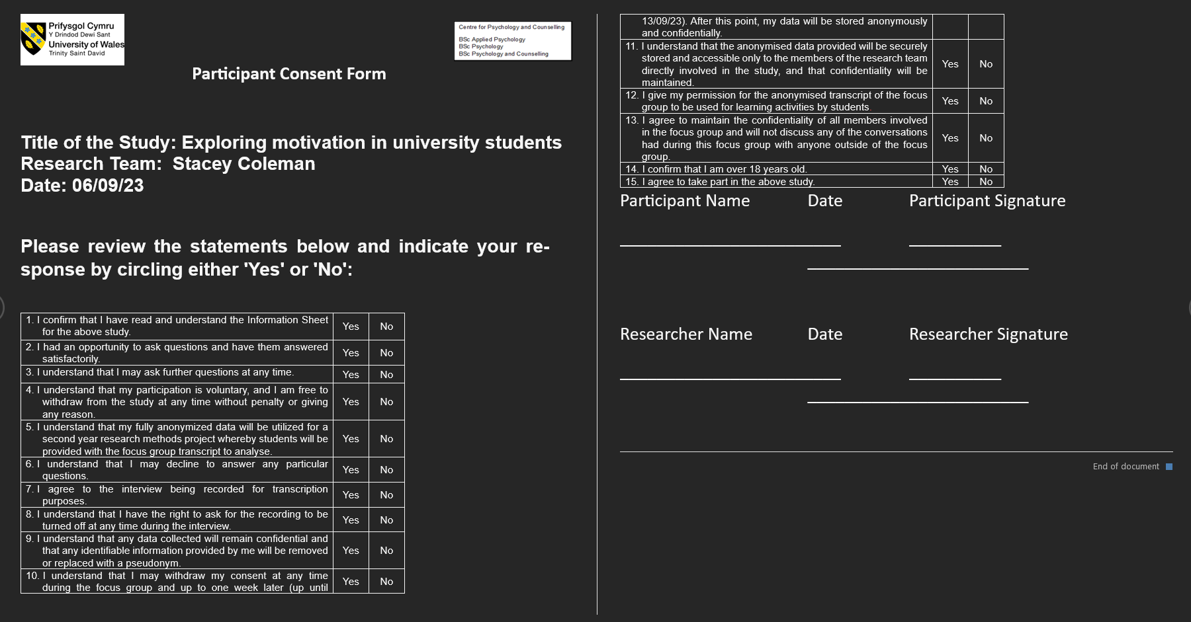

Debrief Form

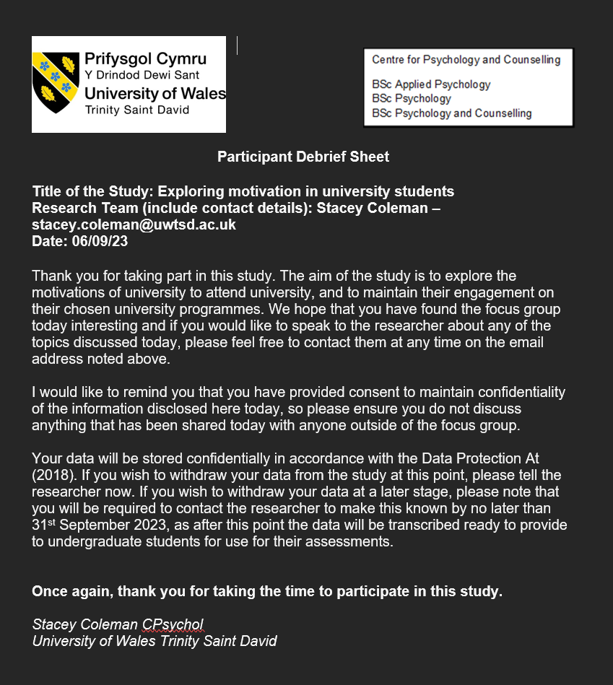

Transcript 

