Individual Report: Marketing Fundamentals

External Analysis & Evaluation

Name: Victoria Grigoras
Student ID: 2234531
Module name: Marketing Fundamentals (LCBB4004)
Lecturer: Tushara Balendran
University of Wales, Trinity Saint David
Word Counts: 3000-3500
Table of Contents
Introduction 3
Analysis and Discussion 3
PESTLE Framework 4
PORTER’s Five Forces 7
SWOT Analysis 9
Recommendation 11
Conclusion 13
References 14

Introduction
The study aims to explore and analyse various aspects of Unilever, one of the world's leading consumer goods companies. The study will provide a comprehensive analysis of Unilever's business model, including its strengths, weaknesses, opportunities, and threats. This will involve conducting a PESTLE analysis to examine the impact of various external factors on the company's operations, as well as Porter's Five Forces analysis to assess the competitiveness of the industry. Furthermore, the study will conduct a SWOT analysis to evaluate the internal factors that influence Unilever's performance. Based on the analysis, the study will provide recommendations for Unilever to improve its business operations and maintain its competitive edge. Overall, the study seeks to provide insights into the strategies and practices of a successful multinational corporation in the consumer goods industry.

Analysis and Discussion
Unilever, the multinational conglomerate of consumer goods, is a British-Dutch enterprise with headquarters in London and Rotterdam. The present company was formed in 1929 when the Netherlands margarine maker Margarine Unite joined with the British soap giant Lever Brothers (UNILEVER, 2023). Unilever dominates the fast-moving consumer goods industry with its wide range of food, beverages, cleaning products, and personal care products. Among the many well-known brands that the company produces are Knorr, Lipton, Dove, Axe, Hellmann's, and Magnum.
Unilever employs more than 155,000 workers in 190 countries (Kpoku, 2021). The company is committed to sustainability and has ambitious goals to improve world health and reduce its environmental footprint. In recent years, Unilever has garnered attention for its commitment to environmental and social responsibility. The group's efforts to reduce plastic waste, mitigate climate change, and promote gender equality have been widely acclaimed.

PESTLE Framework
The external macroenvironmental elements that have an impact on a company's operations may be examined with the use of pestle analysis. A quick PESTLE study of Unilever is as follows:
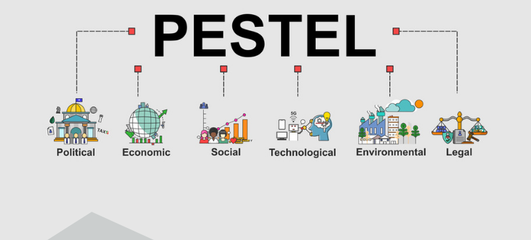
Figure 1: Pestle Framework
(Source: Cheng, 2021)

Political Factors:
As Unilever operates in several nations across the world, the political atmosphere in those locations is crucial to its success. Government policy, legislation, trade agreements, and tax regulations are all examples of political factors that might influence Unilever. Unilever's operations in the UK and Europe might be impacted by Brexit due to changes in trade agreements and laws (Cheng, 2021). Alterations in tax legislation might potentially have an impact on the company's bottom line. Please elaborate in less than 200 words. Brexit, or the United Kingdom's vote to leave the European Union, may have an impact on many facets of Unilever's company. Trade pacts and limitations have been called into question. If the UK and the EU are unable to negotiate a trade agreement, Unilever might see an increase in costs and a decrease in profits as a result of tariffs and other trade barriers. Any changes to the regulations controlling product safety, labelling, and marketing might result in the company incurring more compliance costs (Tiscini, et al., 2020).
The bottom line of Unilever might be negatively affected by things like a shift in tax legislation. The UK government has threatened to adopt new tax policies to make up for money lost due to Brexit, which might result in higher taxes for businesses operating in the UK. This may increase Unilever's operating costs and reduce the company's profit.
Economic Factors:
Unilever is significantly impacted by both national and international economic conditions. When people lose confidence in the economy, they tend to reduce their spending on things that aren't strictly necessary. This may have a negative impact on economic growth and consumer spending. Unilever's profit line might take a hit if this happens, particularly for their more costly products.
Unilever's bottom line might take a hit if inflation puts upward pressure on production costs. Inflation that drives up the cost of essential inputs like raw materials, electricity, and transportation might hurt the company's bottom line. The impact on company might worsen if this causes prices for consumers to rise.
With an increase of more than eight billion euros from the previous year, Unilever Group global sales reached over 60.07 billion euros in 2022 (Statista, 2023).
Changes in the currency rate might have an impact on Unilever's bottom line. As it operates on a global scale, Unilever deals in several currencies. Changes in exchange rates might affect the bottom line because of their influence on the value of sales and expenses (Tomić, and Schneider, 2020). It's possible that an increase in the value of the US dollar might reduce the value of foreign currency profits, while a drop in the value of the euro could drive up the price of importing raw materials.
Social Factors:
As it makes mass-market consumer goods, Unilever must respond rapidly to changes in consumer preferences. As individuals have become more health conscious, they have also shown a greater demand for improved dietary options. Considering this shift, Unilever has decreased the quantity of sugar and salt in its products and boosted their R&D spending on new healthier alternatives.
Similarly, Unilever has made steps to address diversity and environmental issues because it values doing the right thing (Iglesias, et al., 2023). The company has adopted environmentally responsible practises for sourcing its raw materials. Unilever has pledged to reach gender parity in the workplace as part of its efforts to encourage diversity and inclusion.
Unilever has also responded to changing consumer preferences by expanding its product line. The company has responded to the growing number of customers who identify as vegan or vegetarian by expanding its selection of suitable dishes.
Unilever has seen a rise in brand loyalty and trust as a result of the company's efforts to be socially responsible and responsive to changing customer preferences. The company's commitment to sustainability and diversity and inclusion is highly valued by customers, which bodes well for the firm's growth and success in the future.

Technological Factors:
The sustained prosperity of Unilever depends heavily on technical development. The company has infused technology into every facet, from production and supply chain management to marketing and product development. With the use of big data analytics, Unilever can learn more about its consumers' needs and preferences. Its state-of-the-art technology has allowed the company to examine vast volumes of data, identify patterns, and make informed decisions about product strategy, marketing, and supply chain optimisation.
Unilever is also investing in research and development to find new technologies that will allow it to produce greener products. The company has invested much in R&D to produce more environmentally friendly packaging options, such as using recyclable materials and less plastic (Neves, et al., 2020). Unilever is exploring options like bioplastics to provide more environmentally friendly and functional packaging.
In addition, Unilever is using technology to enhance its supply chain operations, which include tracking and tracing products, managing stock levels, and arranging for efficient delivery. With RFID tags and data analytics, Unilever has been able to improve supply chain efficiency, reduce waste, and provide better customer experience.
Legal Factors:
Legal issues pose serious risks to Unilever's operations and earnings due to the company's exposure to complex and ever-evolving regulatory systems in many areas throughout the world. The regulation of commercial speech is an issue of paramount importance. Unilever must comply with a wide variety of labelling, advertising, and marketing regulations across the world (UNILEVER, 2023). Any violations of these guidelines may result in monetary fines, legal action, and damage to the company's reputation.
The legal protection of Unilever's intellectual property is another consideration. Patented and trademarked inventions are crucial to the company's strategy of differentiation. Yet, losing money and market share due to infringement of these assets by a third party is a real possibility. Because of this, Unilever must be on high alert to avoid having its intellectual property stolen. When it comes to food law, Unilever is just as serious as everyone else. The company must follow all applicable rules for food safety, quality, and labelling, which may differ from market to market (Lähteenmäki-Uutela, et al., 2021). Failure to comply with regulations may result in product recalls, legal action, and damage to the company's reputation.
Environmental Factors:
Unilever puts a high value on environmental concerns due to its dependence on natural resources. Climate change, resource depletion, and improper waste management are three major environmental risks that might have an impact on Unilever's business, bottom line, and public image.
Unilever has ambitious environmental goals as part of its sustainable business strategy, including reducing its environmental effect and promoting sustainable sourcing and production. To source all of its agricultural raw materials by 2023, the company plans to cut water consumption and greenhouse gas emissions, improve biodiversity, and use other sustainable practises.
In addition to sourcing raw materials from sustainable sources, Unilever is trying to lower its greenhouse gas emissions throughout the whole value chain. By 2030, the company plans to reduce its emissions of greenhouse gases by 50 percent from its 2005 levels (UNILEVER, 2023). The goal is to reduce emissions across the supply chain, from manufacturing to shipping to receiving. Unilever's goal is to have a completely waste-free value chain by the year 2030.

Overall, the dynamic nature of the global economy means that Unilever confronts stiff competition across the globe (UNILEVER, 2023). The company's future is dependent on its capacity to rapidly adjust to shifts in the economy and in consumer preferences. Although facing several challenges, Unilever is projected to continue growing and prospering because to the company's strong brand equity, innovative products, and sustainable practises.

PORTER’s Five Forces
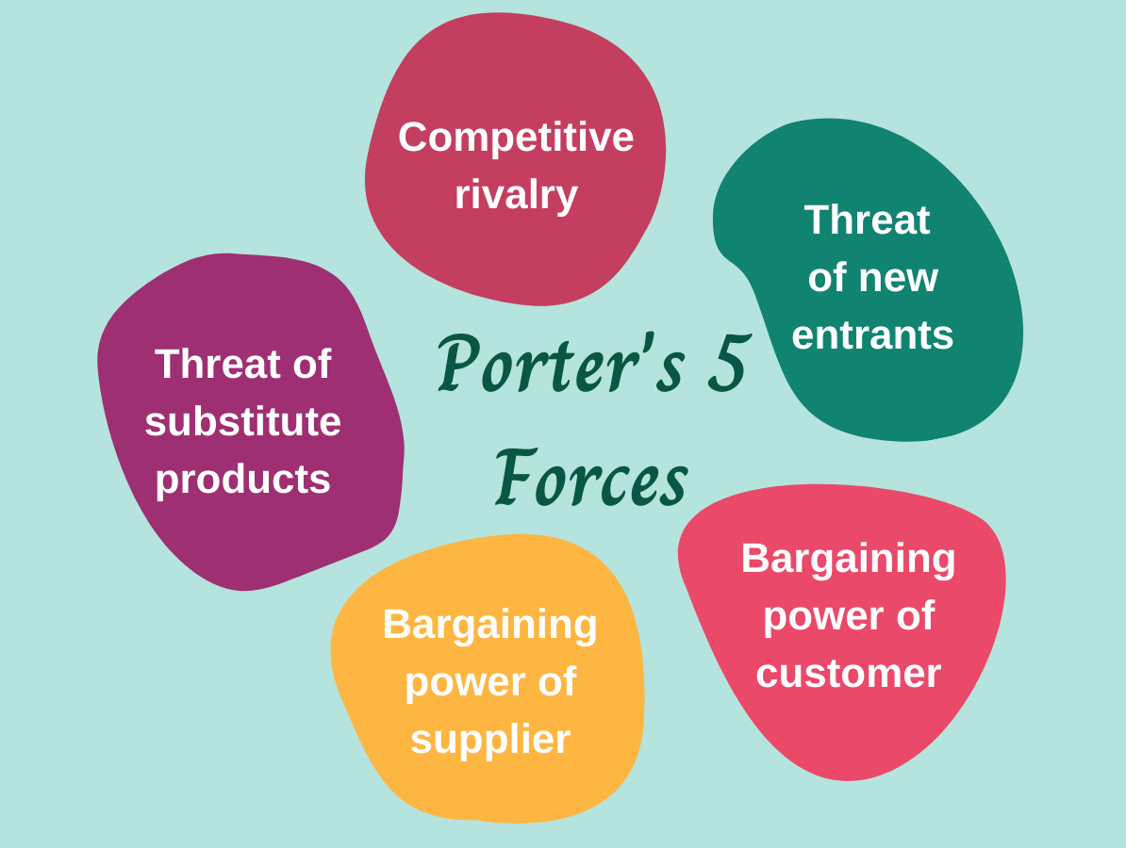
Figure 2: Porter’s Five Forces
(Source: Björkdahl, 2020)
The competitive environment in which a firm operates may be evaluated with the help of Porter's Five Forces. The following are taken into consideration in Unilever's Five Forces Analysis:
Threat of New Entrants:
As a result of the many challenging barriers to entry, the market for consumer goods is subject to a low degree of competition from emerging businesses. Established companies such as Unilever already have a strong presence in the market, which makes competition particularly tough across the industry (Björkdahl, 2020). This is not an easy industry to enter into because of the significant initial expenses connected with producing new items, constructing new facilities, and launching new marketing efforts. In addition, there are severe laws that have been put in place for the industry. These regulations include criteria pertaining to product quality, safety, and labelling. This indicates that new rivals are less of a danger to Unilever's present market domination than they were previously thought to be.
Bargaining Power of Suppliers:
Unilever has a significant amount of reliance on its suppliers for the procurement of important components such as palm oil, soybeans, and cocoa (Zu Ermgassen, et al., 2021). Suppliers are in a strong position to negotiate due to the limited number of available alternatives and the high costs associated with switching. Supply chains have a tendency to have a geographical concentration, with a few numbers of suppliers supplying a significant share of the market. Unilever has implemented processes for sustainable procurement in order to reduce its reliance on specific suppliers and to mitigate the risks associated with the supply chain.
The Bargaining Power of Buyers:
The customer base for Unilever includes not just end users but also distributors and merchants. Because of the cutthroat nature of competition in the consumer products industry and the variety of available alternatives, purchasers have a significant amount of bargaining power. Retailers and wholesalers have significant bargaining influence with their suppliers when it comes to price and conditions negotiations because of their ability to negotiate (CFI, 2023). Customers of Unilever, on the other hand, have a more difficult time haggling over costs since the firm offers a wider choice of products, its brands are well recognised, and the corporation is dedicated to innovation. These three factors work together to achieve this result.
The threat of Substitutes:
The consumer goods industry is especially susceptible to the threat posed by substitutes because of the abundance of competing items and brands available in the market. Unilever has competition from a broad range of businesses, some of which are major multinational corporations while others are locally based companies. These competitors provide customers products that are comparable to those that Unilever sells for personal care and the home (Dubey, 2022). Brand recognition, investment on research and development, and environmental activities are some of the things that set Unilever apart from its competitors and decrease the risk of cheaper imitations.
The intensity of Competitive Rivalry:
In the industry of consumer goods, there is many well-established businesses, all of which are fighting against one another for a share of the market. Unilever faces competition not just from multinational corporations such as Procter & Gamble and Nestle but also from local businesses operating in each area. In order to differentiate its products and services from those of its rivals and to maintain its dominating share of the market, Unilever has made significant investments in sustainable sourcing, marketing campaigns, and product innovation (UNILEVER, 2023).
Unilever operates in an industry that is notoriously cut-throat, which means that the company faces serious challenges as well as exciting new opportunities for expansion. The dedication of the firm to environmental responsibility, technological advancement, and increased brand recognition all contribute to the mitigation of risks brought on by competitors, consumers, and suppliers, so setting the stage for the company's continued and sustained success. By maintaining its commitment to sustainable sourcing, product development, and marketing across the board, Unilever can preserve its edge over its competitors and continue to grow its presence in the international consumer goods business.

SWOT Analysis
The Strengths, Weaknesses, Opportunities, and Threats (SWOT) analysis is a typical tool used by businesses to evaluate themselves. In a nutshell, this is Unilever's SWOT analysis:
Strengths:
Products offered by Unilever range from food and drink to household cleaners, reflecting the company's own diversity (UNILEVER, 2023). The diversity of the firm's assets reduces its vulnerability to declines in any one market or product type.
Dove, Lipton tea, and Hellmann's mayonnaise are just a few of Unilever's well recognised brands that help to establish the corporation as a global powerhouse. The company's name recognition has helped them attract new customers and maintain existing ones.
The size and depth of Unilever's distribution network contribute to the company's success in reaching consumers throughout the world. The company's supply chain management system and distribution network work together to guarantee on-time product delivery.
Unilever is committed to environmentally responsible business practises and has ambitious ambitions to reduce its environmental footprint. Customers that care about the environment tend to have a positive impression of the firm because of its dedication to sustainability.
Weaknesses:
The United States, Canada, and Europe are the company's three largest revenue generators. The company is especially vulnerable to recessions in certain regions because of how dependent it is on their economies.
Although you may find Unilever products in practically every nation, the company's presence is considerably lower in countries with emerging economies (Salvato, et al., 2020). The company's limited presence in these regions makes it challenging for it to seize expansion opportunities.
Unilever's product recalls have harmed the corporation financially and publicly.
The markets in which Unilever operates are saturated with competitors from all over the world.
Opportunities:
Unilever has the potential to expand its presence into growth markets. The company has a chance to gain market share by focusing on what it does well: developing and distributing products.
Through strategic mergers and acquisitions, Unilever can maintain its rapid growth (Prado Perez, 2020). The company is considering acquiring comparable businesses in order to expand its product line and reach new markets.
Unilever might leverage the growing popularity of online shopping by offering its products and services via this channel.
Unilever can meet the demands of shoppers for new and improved products because to the company's commitment to R&D.
Threats:
Unilever's bottom line and product demand are both susceptible to economic uncertainty.
Political instability in any of the countries in which Unilever operates might affect the company's normal operations.
In the markets where it operates, Unilever faces tough competition from both multinational corporations and local firms.
Unilever's product demand might be impacted by changes in consumer preferences (Mazikana, 2023). The company's survival depends on its ability to innovate new goods and services that satisfy consumer needs.
Unilever's product range, brand recognition, and dedication to sustainability are all notable strengths. The company, however, faces challenges such as a concentration on mature markets, a dearth of a local presence in new nations, and fierce competition. Although Unilever looks to development opportunities in new countries, e-commerce, and product innovation to produce growth, it must be vigilant against threats including economic volatility, political instability, and shifting customer preferences.

Recommendation
To keep up with the ever-changing consumer products market, Unilever must prioritise research and development, global growth, and targeted mergers and acquisitions. Unilever can expand its company and adapt to the requirements of customers all around the globe if it prioritises sustainable sourcing, digital marketing, diversity, partnerships, an efficient supply chain, and staff development. Here are some suggestions for Unilever based on their PESTLE and SWOT analyses:
Innovation: Investment in R&D and new products is essential if Unilever is to maintain its lead in the market (Iglesias, et al., 2023). Environmentally friendly packaging and healthier food alternatives are only two examples of how the corporation might benefit from pursuing new technology and developing new goods.
Market expansion: Unilever should investigate potential development avenues in emerging markets (Björkdahl, 2020). Growth opportunities are greatest in emerging economies like China, India, and Brazil; thus, the corporation should prioritise expanding its presence there.
Mergers and acquisitions: Unilever might improve its product offering and gain market share via mergers and acquisitions (Zu Ermgassen, et al., 2021). By acquiring market-leading businesses, Unilever can strengthen its position in the marketplace and attract a wider range of consumers.
Sustainability: Environmental responsibility and responsible business practises should remain top priorities for Unilever. Companies may boost their brand image and attract environmentally and socially conscientious customers by being transparent about their efforts to lessen their environmental impact (Kpoku, 2021).
Employee engagement: A robust and competent team is essential to Unilever's success; thus, the company should place a premium on employee engagement and retention. This may be accomplished by providing enticing pay and perks, potential for advancement, and a pleasant place to work (Salvato, et al., 2020).
Digital marketing: Unilever must prioritise digital marketing methods if it wants to expand its customer base and keep its current customers interested. The firm can promote its goods and interact with its consumers more effectively via social media and influencer marketing.
Cost optimization: Profitability may be increased at Unilever by giving more attention to optimising costs and streamlining operations. Supply chain management and manufacturing procedures are two areas where costs may be lowered without sacrificing quality that the organisation should investigate (Tiscini, et al., 2020).
Diversification: Unilever must broaden its product offering so that it is less dependent on any one market segment. As a result, the business is better able to weather economic downturns and adapt to shifting customer tastes.
Strategic partnerships: To increase productivity while decreasing expenses, Unilever should form strategic alliances with suppliers, distributors, and retailers. The company's environmental objectives may be further advanced via supplier collaboration aimed at enhancing sustainability practises.
Crisis Management: Unilever should have a crisis management strategy in place to deal with unexpected situations (Stanca, and Tarbujaru, 2022). In order to keep operations running smoothly, it may be necessary to take precautions like recalling products and notifying customers as soon as possible.
Sustainable sourcing: Unilever should maintain its commitment to sustainable sourcing techniques in order to lessen its negative impact on the environment and enhance its standing as a good corporate citizen. Some examples of this kind of action include spending money on environmentally friendly agricultural methods, decreasing water use, and expanding the use of renewable energy.
Digital marketing: To expand its customer base and enhance its relationship with existing customers, Unilever should place a greater emphasis on digital marketing. To reach its target audience, businesses are increasingly turning to digital mediums including social media, smartphone applications, and the web.
Diversification: Unilever should think about expanding into new product categories and expanding into new markets to lessen its reliance on any one area. In order to reach a wider audience, businesses may diversify into related fields or provide goods with novel formulations or components (Tomić, and Schneider, 2020).
Partnerships: Unilever should form strategic alliances with other corporations to pool resources and expertise (Cheng, 2021). To co-create new goods or reach new markets, corporations may form partnerships with both new and existing players in the industry.
Supply chain efficiency: It is crucial for businesses like Unilever to save costs and provide better service to their customers. Logistics optimisation may also include cutting down on waste and enhancing stock control.
Employee development: Investment in employee training and education may help companies like Unilever recruit and retain talented workers. Programs that help workers become more invested in their jobs and advance in their careers are examples of this.

Conclusion
The products produced by Unilever, a global company, include food and drink, cleaning products, personal care goods, and more. The company has been operational for almost 90 years, and throughout that period it has grown to become a world powerhouse in the fast consumer products sector. Unilever is known for producing several well-known brands, including Axe, Dove, Knorr, Lipton, and Magnum, among many more. The company operates in more than 190 countries throughout the globe, giving it a substantial presence in both developed and emerging markets. Unilever has ambitious goals, including reducing its negative effects on the environment and improving people's lives all around the world. By doing so, the company is moving closer to its sustainable living strategy's aims of reducing carbon emissions, eliminating garbage, and enhancing the quality of life for millions of people.

References
Björkdahl, J., 2020. Strategies for digitalization in manufacturing firms. California Management Review, 62(4), pp.17-36.
CFI, 2023, “Bargaining Power of Suppliers”, Available at: https://corporatefinanceinstitute.com/resources/management/bargaining-power-of-suppliers/ [Accessed on 2nd April 2023]
Cheng, Y., 2021, February. Analysis on the Opportunities and Challenges of Unilever’s Differentiated Competition by Using SWOT and PEST. In 6th International Conference on Economics, Management, Law and Education (EMLE 2020) (pp. 280-284). Atlantis Press.
Dubey, A., 2022. Understanding the consumer: A comparison of buying behaviour among consumers of Hindustan Unilever and Patanjali products. Applied Marketing Analytics, 7(3), pp.276-287.
Iglesias, O., Mingione, M., Ind, N. and Markovic, S., 2023. How to build a conscientious corporate brand together with business partners: A case study of Unilever. Industrial Marketing Management, 109, pp.1-13.
Kpoku, O.K., 2021. Positive and negative influence of globalization on international business actors’ activity (on materials of Unilever Group) (Doctoral dissertation).
Lähteenmäki-Uutela, A., Marimuthu, S.B. and Meijer, N., 2021. Regulations on insects as food and feed: a global comparison. Journal of Insects as Food and Feed, 7(5), pp.849-856.
Mazikana, A.T., 2023. Significance of Social Factors in the Marketing of Fast-Moving Consumer Goods. A Case of Unilever. A Case of Unilever (March 7, 2023).
Neves, A.C., Moyne, M.M., Eyre, C. and Casey, B.P., 2020. Acceptability and societal impact of the introduction of bioplastics as novel environmentally friendly packaging materials in Ireland. Clean Technologies, 2(1), p.9.
Prado Perez, S., 2020. Sustainability Discourse in the Fast-Moving Consumer Goods Sector–A comparison between Procter & Gamble and Unilever.
Salvato, C., Sargiacomo, M., Amore, M.D. and Minichilli, A., 2020. Natural disasters as a source of entrepreneurial opportunity: Family business resilience after an earthquake. Strategic Entrepreneurship Journal, 14(4), pp.594-615.
Stanca, I. and Tarbujaru, T., 2022. Crisis management: What COVID-19 taught the world. Logos Universality Mentality Education Novelty: Economics & Administrative Sciences, 7(1), pp.01-18.
Statista, 2023, “Revenue of Unilever Group worldwide from 2007 to 2022”, Available at: https://www.statista.com/statistics/269190/global-revenue-of-the-unilever-group-since-2007/ [Accessed on 2nd April 2023]
Tiscini, R., Testarmata, S., Ciaburri, M. and Ferrari, E., 2020. The blockchain as a sustainable business model innovation. Management Decision.
Tomić, T. and Schneider, D.R., 2020. Circular economy in waste management–Socio-economic effect of changes in waste management system structure. Journal of environmental management, 267, p.110564.
UNILEVER, 2023, “Advertising and marketing”, Available at: https://www.unilever.com/planet-and-society/responsible-business/advertising-and-marketing/ [Accessed on 2nd April 2023]
UNILEVER, 2023, “Clean Home. Clean Planet. Clean Future.”, Available at: https://www.unilever.com/brands/home-care/clean-future/ [Accessed on 2nd April 2023]
UNILEVER, 2023, “Strategy and goals”, Available at: https://www.unilever.com/planet-and-society/waste-free-world/strategy-and-goals/ [Accessed on 2nd April 2023]
UNILEVER, 2023, “We are Unilever”, Available at: https://www.unilever.com/our-company/ [Accessed on 2nd April 2023]
Zu Ermgassen, E.K., Lima, M.G.B., Bellfield, H., Dontenville, A., Gardner, T., Godar, J., Heilmayr, R., Indenbaum, R.A., Dos Reis, T.N., Ribeiro, V. and Meyfroidt, P., 2021. Addressing indirect sourcing in zero deforestation commodity supply chains. AgriRxiv, (2022), p.20210399227.

