

Student Name: Nidhi Radadiya

Student ID: 2434257

Module Name: Strategic Management

Module Code: LCMB7003

Lecturer’s Name: Amare Desta

Work Count: 5436

Term 2

Table of Content
Introduction 8
1. Selection of Organisation and Target Market 9
1.1 Selected Organisation 9
1.2 Rationale for Organisational Selection 10
1.3 Selected Target Market 12
1.4 Rationale for Target Market Selection 13
2. Comprehensive Strategic Analysis 15
2.1 PESTLE Analysis of the Indian Coffee Shop Market 15
2.2 Political Factors 16
2.3 Economic Factors 17
2.4 Social Factors 17
2.5 Technological Factors 18
2.6 Legal Factors 19
2.7 Environmental Factors 21
2.8 Competitive Landscape and Generic Strategies 22
2.9 Critical Evaluation of Analytical Tools 26
3. Strategy Development and Formulation 28
3.1 Selected Suitable Market Entry Method 28
3.2 Strategic Models Underpinning Market Entry 30
3.2.1 Eclectic Paradigm (OLI Framework) 30
3.2.2 Uppsala Internationalisation Model 31
3.3 Competitive Strategy for the Indian Market 31
3.3.1 Best-Cost Provider Strategy 31
3.3.2 Experiential Differentiation and Category Priming 32
3.4 Leveraging Innovation and Dynamic Capabilities 34
3.4.1 Innovation-Led Competitive Advantage 34
3.4.2 Dynamic Capabilities Perspective 35
3.5 Cross-Cultural and Network Strategy 36
3.6 Risk Mitigation and Sustainability Integration 37
3.6.1 Risk Mitigation 37
3.6.2 Sustainable Competitive Advantage 38
3.7 Strategic Fit with Organisational Objectives 39
4. Performance Evaluation Framework 39
4.1 Rationale for Selecting the Balanced Scorecard and Triple Bottom Line 39
4.2 Balanced Scorecard Design for the Expansion Initiative 41
4.2.1 Financial Perspective 41
4.2.2 Customer Perspective 43
4.2.3 Internal Business Process Perspective 44
4.2.4 Learning and Growth Perspective 45
4.3 Integrating the Triple Bottom Line into Performance Measurement 47
4.3.1 Economic Sustainability 47
4.3.2 Social Sustainability 47
4.3.3 Environmental Sustainability 49
4.4 Linking Balanced Scorecard and Triple Bottom Line 50
4.5 Practical Application and Monitoring of KPIs 51
4.6 Critical Evaluation of the Framework 52
5. Conclusion and Recommendations 53
5.1 Conclusion 53
5.2 Recommendations 54
References 55

List of Tables

Table 1:PESTLE Analysis of India for the Coffee Shop Market 15
Table 2: Generic Competitive Strategies in the Indian Coffee Shop Market 22
Table 3: Critical Evaluation of the Framework 52

List of Figures
Figure 1: Dutch Bros Coffee 8
Figure 2: Dutch Bros Corporate Overview 9
Figure 3: Revenue Growth Performance Trend 10
Figure 4: Drive-Thru Customer Experience 10
Figure 5: Revenue and Earnings Growth 11
Figure 6: India Coffee Market Growth 12
Figure 7: India Branded Coffee Market 13
Figure 8: India Coffee Retail Growth 14
Figure 9: India Beverage Market Structure 14
Figure 10: India Food Safety Regulation 16
Figure 11: India GST Tax Framework 16
Figure 12: India Coffee Market Growth 17
Figure 13: India Coffee Consumption Growth 18
Figure 14: Cafés as Innovation Hubs 19
Figure 15: India Coffee Business Regulations 20
Figure 16: Sustainable Coffee Farming Practices in India 21
Figure 17: International Coffee Brands India 24
Figure 18: Coffee Pricing in India 24
Figure 19: Traditional Indian Coffee Brand 25
Figure 20: Cost-Efficient Coffee Operations 26
Figure 21: Porter’s generic strategies 27
Figure 22: Foreign Direct Investment 28
Figure 23: Joint Ventures in FDI 29
Figure 24: Advantages of Shared Ownership 29
Figure 25: Ownership–Location–Internalisation 30
Figure 26: Uppsala Internationalisation Model 31
Figure 27: Best-Cost Provider Strategy 32
Figure 28: Experience-Based Competitive Differentiation 32
Figure 29: Experiential Café Brand Engagement 33
Figure 30: Innovation-Driven Beverage Menu 34
Figure 31: Dynamic Capabilities Perspective 35
Figure 32: Cross Cultural Communication 36
Figure 33: Local Supplier Network Building 37
Figure 34: Local Sourcing Risk Mitigation 37
Figure 35: Sustainable Competitive Advantage 38
Figure 36: Dutch Bros Marketing Strategy 39
Figure 37: Balanced Scorecard 40
Figure 38: Triple Bottom Line 40
Figure 39: Market-specific revenue growth 41
Figure 40: Tracking Sales Revenue and Growth Rates 42
Figure 41: Customer satisfaction scores 43
Figure 42: Post-purchase surveys 43
Figure 43: Order processing time 44
Figure 44: Value proposition 45
Figure 45: Barista Training 46
Figure 46: Economic Performance Monitoring Dashboard 47
Figure 47: Social Sustainability KPI Framework 48
Figure 48: Coffee Supply Chain Emissions 49
Figure 49: Balanced Scorecard - TBL Integration 50
Figure 50: Triple-Layer Business Model Canvas 51
Figure 51: Dashboard-based reporting systems 52

Introduction
This report evaluates how Dutch Bros Coffee can expand internationally to the market of urban specialty coffee shops in India by using strategic analysis, entry -mode theory, competitive strategy models as well as performance measurement frameworks. The research has firstly substantiated the choice of the Dutch Bros and India as a high-growth target market with the basis of the changing consumer lifestyle, the appeal of the high coffee quality, and the spread of online cafe culture. The study then proceeds to analyse India's external environment through a PESTLE analysis and also formulates an entry strategy that is compatible with organisational objectives using internationalisation theories, such as the OLI framework and the Uppsala model. The competitive advantage is explained in terms of a best-cost and experiential differentiation strategy, with the support of competence of innovation and dynamic capabilities. Finally, a report suggests adopting a combined framework of Balanced Scorecard and Triple Bottom Line performance measurement to track the key success indicators, reduce risks and development of sustainable growth.
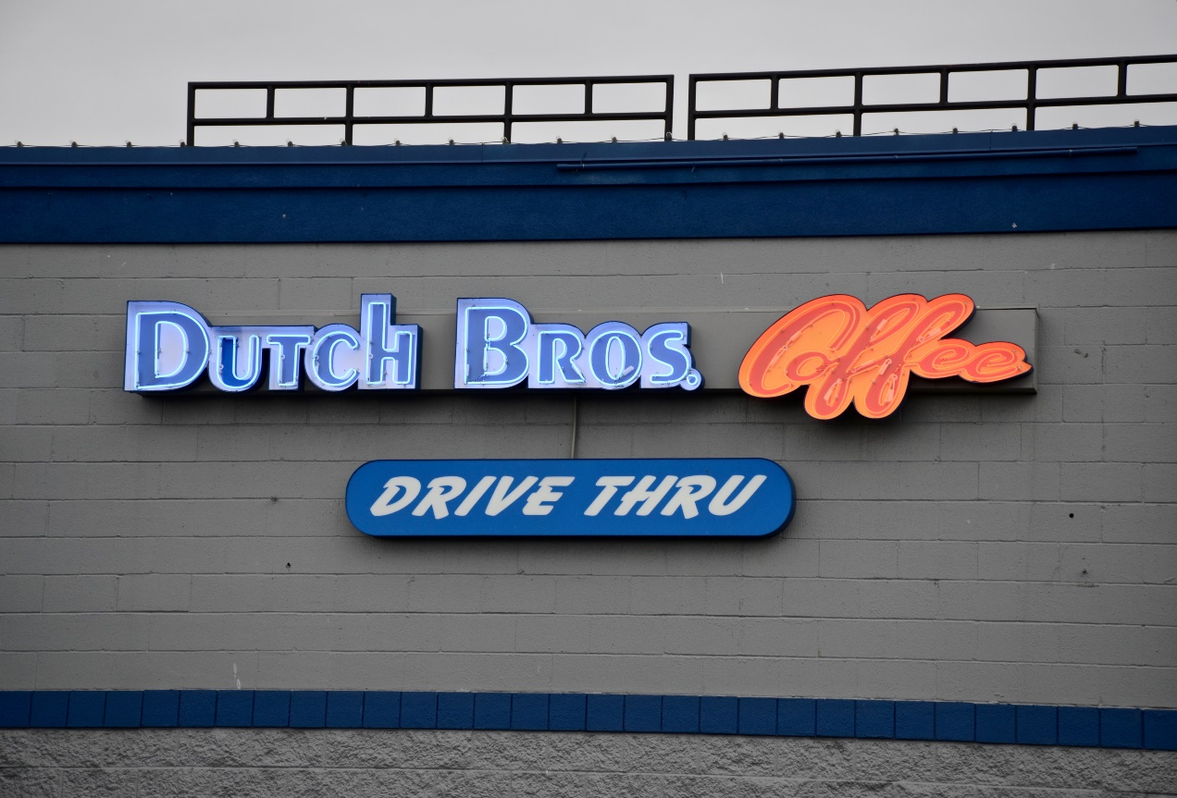
Figure 1: Dutch Bros Coffee

1. Selection of Organisation and Target Market

1.1 Selected Organisation
The organisation that will be the focus of this study is the Dutch Bros Coffee specialty coffee chain that is rapidly growing with original roots in the US. Founded in 1992 by brothers Dane and Travis Boersma, Dutch Bros has grown from a single pushcart to a publicly traded company on the New York Stock Exchange and with the ticker symbol BROS, where more than 1,000 drive-thru-focused stores are spread across 24 states. The brand is well known because of its speed driven service model, higher degree of beverage customisation and a strong community centric culture (Stern, 2020).
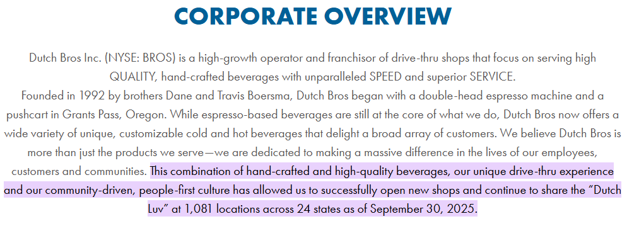
Figure 2: Dutch Bros Corporate Overview
Its menu offerings include espresso-style coffee standards, the company’s patented DUTCH FAVES ™, and their self-brand Nederland snack energy flavors, covering a wide range of tastes. Its smart use of privately-owned Arabica beans and creative flavor blends strongly put the brand in the high-end-but-affordable specialty coffee niche (Xu, 2023). In addition, strong financial performance supports this positioning, and revenues approach USD 1.537 billion in 2025 a confirmation of continuing double-digit growth (Statista, 2025; Wu, 2023).
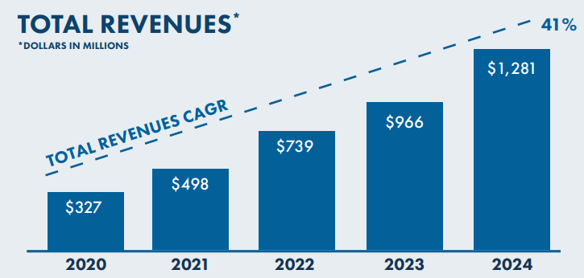
Figure 3: Revenue Growth Performance Trend

1.2 Rationale for Organisational Selection
Dutch Bros Coffee was chosen because of its exceptional growth, differentiated business model, and proof of marketing effectiveness within the specialty coffee sector. When compared to conventional employees and cafe competitors, Dutch Bros focuses on drive-thru convenience and highly personalised customer interaction which in turn creates a unique type of service experience to improve customer loyalty (Xu, 2023).
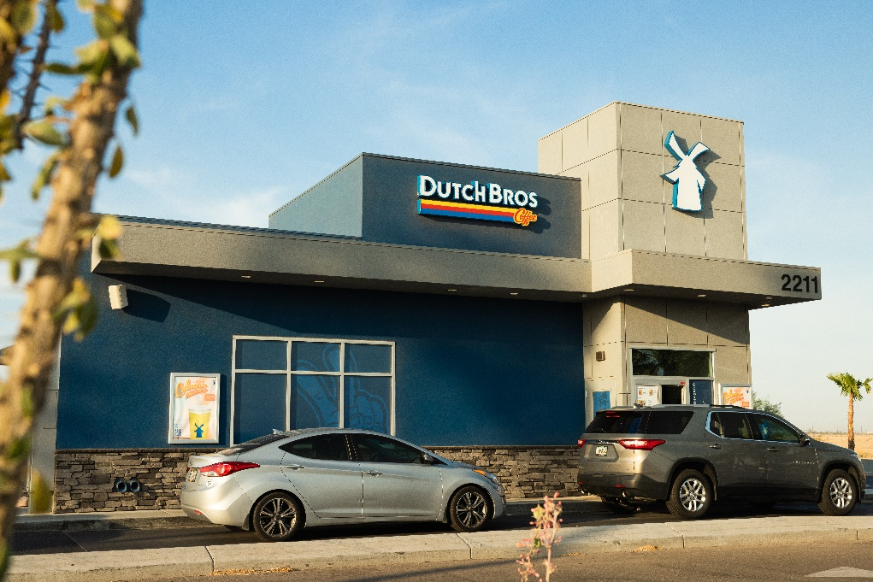
Figure 4: Drive-Thru Customer Experience
The company has shown its ability to grow rapidly in revenue in the short term, and its ability to grow revenue will result in USD69.38 billion in 2023 changing to USD69.537 billion in 2025, explaining its scalability and financial strength in a competitive global market (Statista, 2025). The literature and business reports reveal that Dutch Broshas successfully managed to leverage the brand communities, the level of employee participation, and experiential marketing to induce the repeat buying (Stern, 2024). Investment-based studies have identified Dutch Bros as a high-potential company compared to established giants in the same category of companies such as Starbucks and Luckin Coffee, but mainly because of its innovative product mix and operational efficiency (Wu, 2023). Consequently, Dutch Bros is a good organization for the analyses of opportunities for international market expansion.
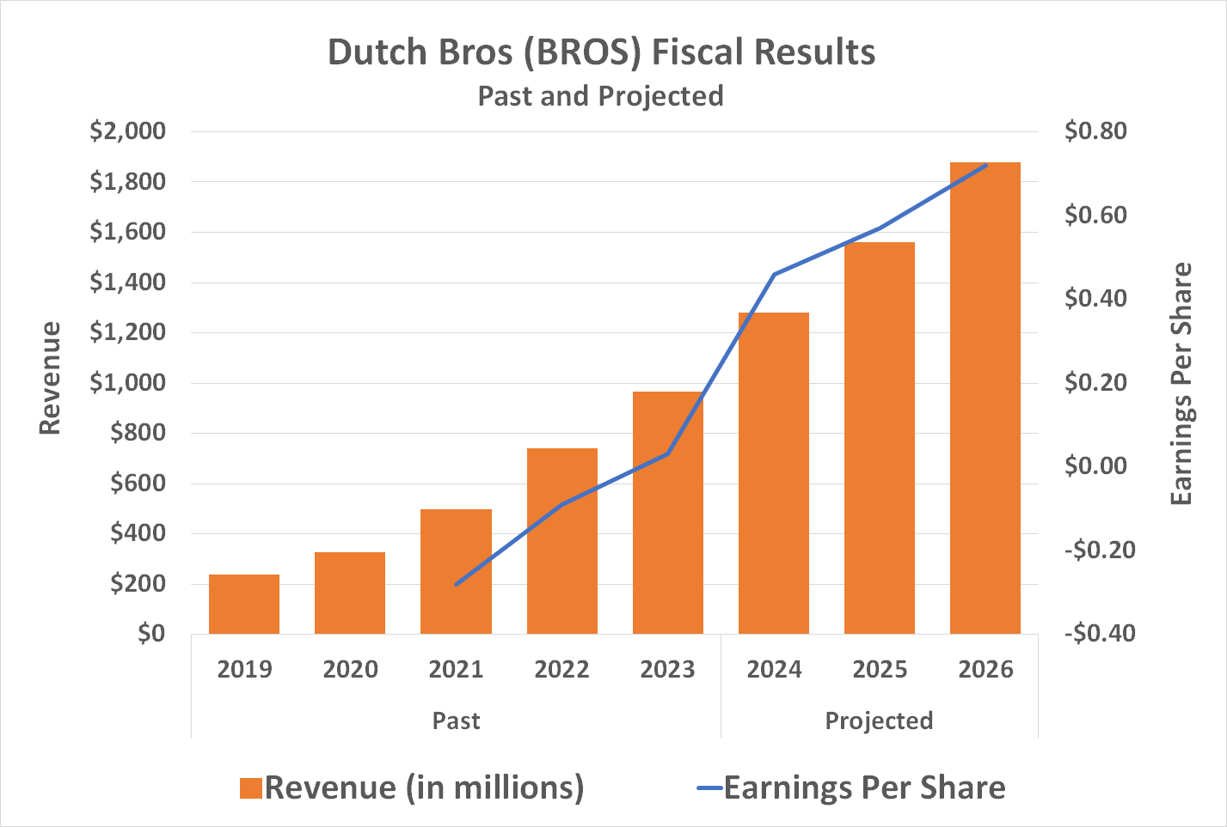
Figure 5: Revenue and Earnings Growth

1.3 Selected Target Market
The proposed target market is the operator of urban specialty coffee shops in India, specifically targeting millennial/generation Z consumers who are based in or near Tier-1 cities, both metropolitan and emerging. The industry is projected to have reached an estimated USD 601.5million in the year 2024, and it is projected to grow to nearly USD 961.5million by 2030, and this represents a strong market momentum (Mukherjee Pipil, 2025).
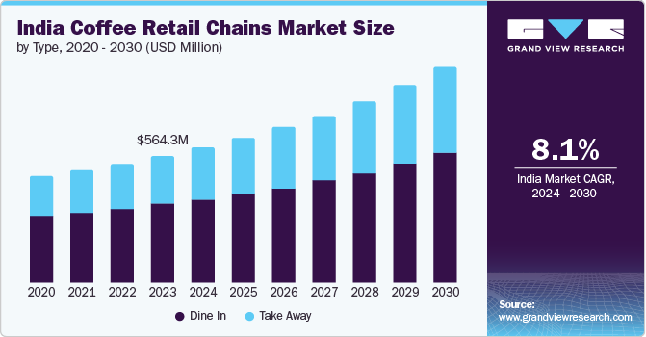
Figure 6: India Coffee Market Growth
Among young urban consumers, cafes are increasingly seen as social places that are conducive to work, studies and leisure activities, and so the demand for premium beverages, customization and experiential consumption intensifies (Farouqi et al., 2025).
The market is characterized by the rapid growth of international brands - Starbucks and Tim Hortons - concurrent with strong domestic companies - Blue Tokai and Third Wave Coffee. Chain coffee shops have a market share of more than 48%, which testifies to a strong acceptance of branded offerings as well as technology enabled service models (Mukherjee Pipil, 2025).
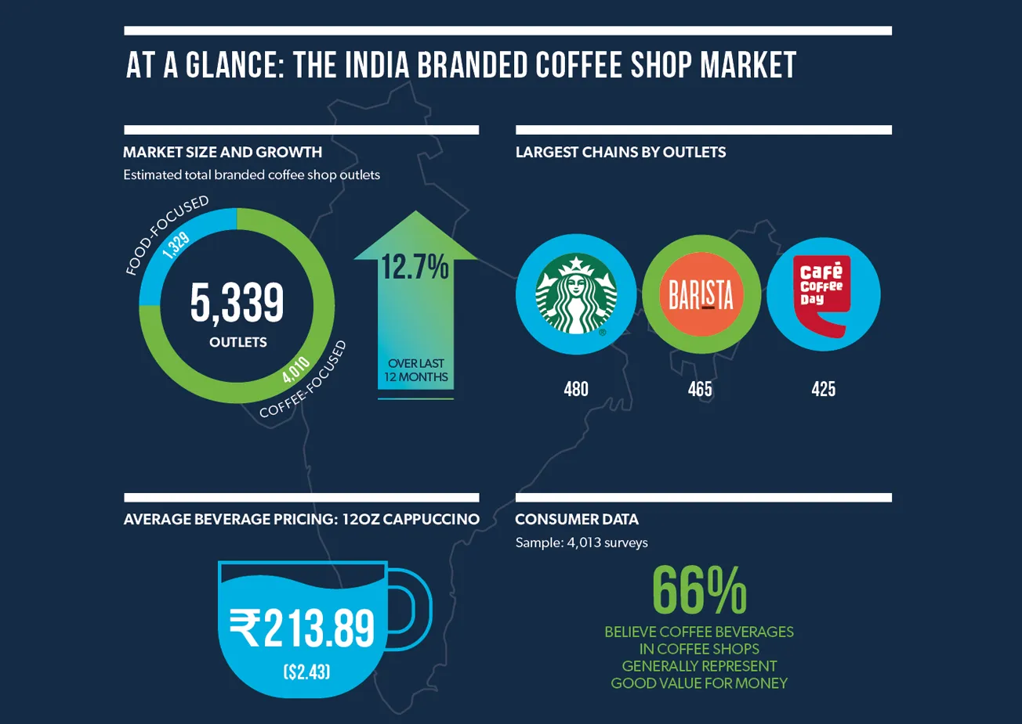
Figure 7: India Branded Coffee Market

1.4 Rationale for Target Market Selection
The target market has been identified as India because of its huge growth potential, consumer changing lifestyles and rising specialty coffee experience. These increased disposable incomes, urbanisation as well as exposure to international cafe cultures have all spurred the increased trend of coffee consumption amongst the younger age groups especially in metropolitan regions (Mukherjee Pipil, 2025). Empirical research indicates that the customer experience and customization, as well as the brand engagement, have a strong impact on the revisit intention in urban specialty coffee shops, which should be closely related to the experiential and personalised service approach adopted by Dutch Bros (Farouqi et al., 2025).
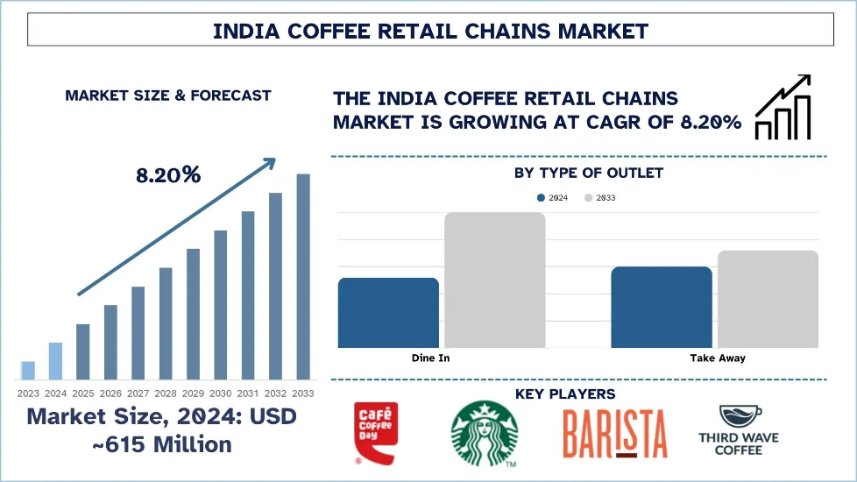
Figure 8: India Coffee Retail Growth
Additionally, the digitalisation of food and beverage services through delivery and loyalty applications, which swiftly made it, create favourable conditions for a brand that is seen characterised by strong operational speed as well as continuous innovation with menu. Structural analyses of the global coffee industry further reveals the growing prospects of new markets like India in the long run as the demand for specialty coffee is not limited to the traditional western markets (Bobadilla et al., 2024). These converging factors altogether make India a proven strategic market for the internationalization of the newly acquired Dutch Bros.
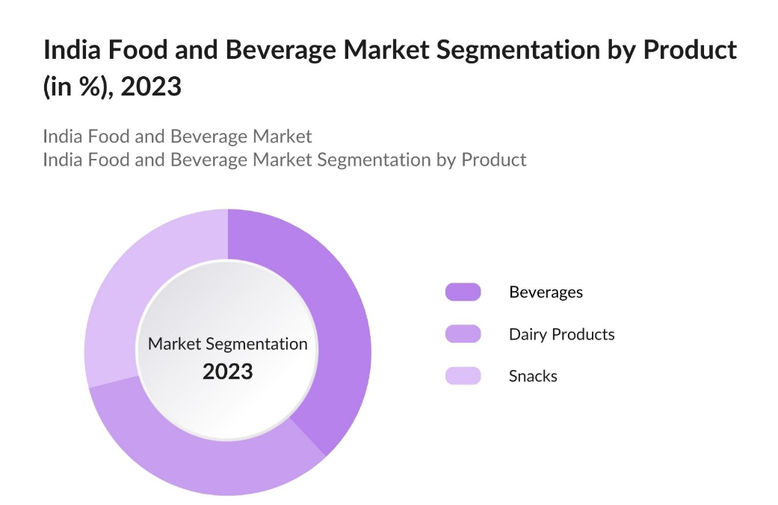
Figure 9: India Beverage Market Structure

2. Comprehensive Strategic Analysis

2.1 PESTLE Analysis of the Indian Coffee Shop Market
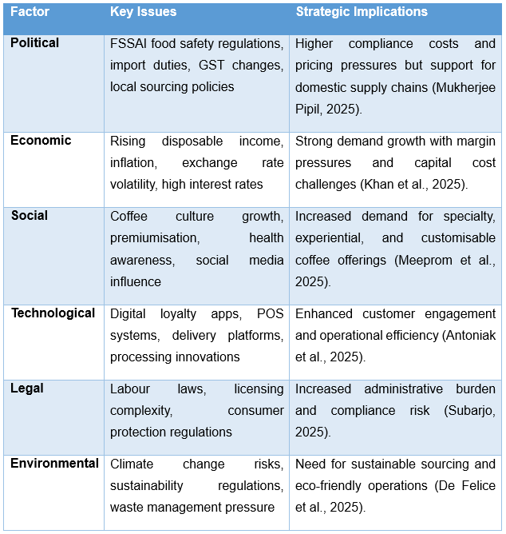
Table 1:PESTLE Analysis of India for the Coffee Shop Market
(Source: Developed by Author)

2.2 Political Factors
The political drivers of the Indian coffee shop market are significant, mostly when it comes to regulatory regulation and trade policy. Compliance with the Food Safety and Standards Authority of India (FSSAI) requirements implies the constant investment of the means of quality assurance and hygiene measures, thus increasing the cost of operations of both domestic and foreign market participants (Mukherjee Pipil, 2025).
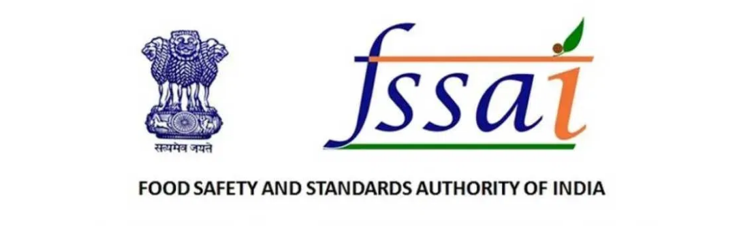
Figure 10: India Food Safety Regulation
In addition, high import duty on equipment for coffee, syrups, and specialty beans have direct impacts on coffee cost structure, especially for brands that depend on imports. Goods and Services Tax (GST) rates also affect the pricing of menus in a price discriminating market where small increments can have an impact on demand. However, government encouragement for local sourcing helps to support Indian coffee farmers and increase the resilience of a supply chain, but may limit the access to certain international blends (De Felice et al., 2025).
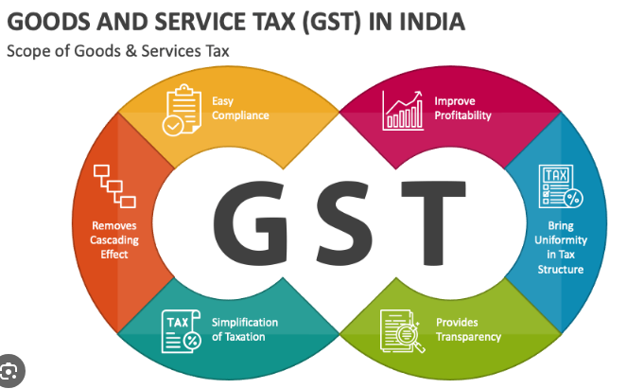
Figure 11: India GST Tax Framework

2.3 Economic Factors
The economic situations in India are very akin to both providing considerable opportunities and confronting great challenges to the operators of coffee shop businesses. The rising income of the growing urban middle class has led to an increase in both the demand of the high experience of out-of-home coffee, especially in Tier 1 and Tier 2 types of urban centres (Khan et al., 2025). However, the inflationary forces affecting the major inputs like milk, sugar, coffee beans, energy, and labour have reduced the profit margins forcing brands to balance between price and premium positioning closely. Besides, the exchange-rate volatility also impacts the price of imported equipment and ingredients, and high rates of interest raise the price of aggressive expansion policies taken by large chains (Mukherjee Pipil, 2025).
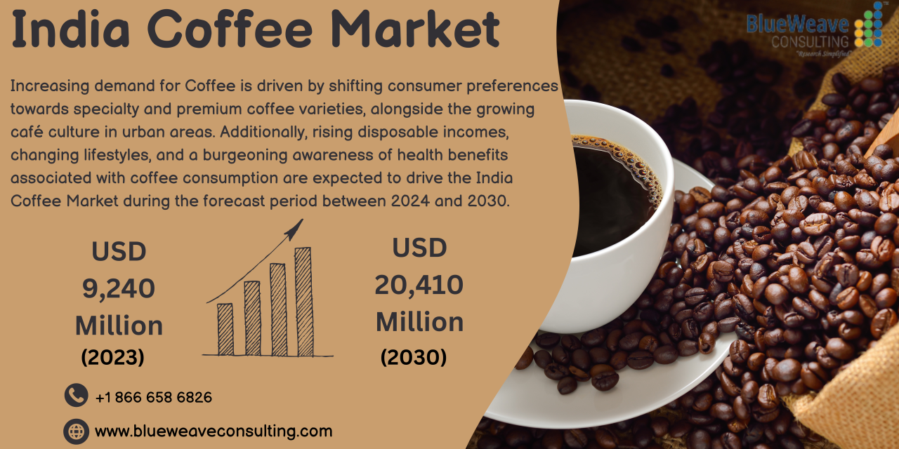
Figure 12: India Coffee Market Growth

2.4 Social Factors
The change in social trends forms a major driving force for expansion in India's coffee shop segment. Evidently, a discernible cultural transition can be observed, in which traditional tea consumption is gradually replaced by coffee, especially in Generation Z and millennial cohorts who consider cafes to be 'third spaces' for social interaction, academic pursuits and remote work (Meeprom et al., 2025). The concomitant processes of premiumisation and increased health consciousness have increased the demand for specialty, organic and ethically sourced coffee varieties, as well as low sugar and functional beverage alternatives. Rapid urbanisation has expanded the customer base in both metropolitan and emerging urban centres, while the omnipresent effects of social media has hastened the absorption of Western Cafe culture and empowered aesthetically pleasing, "Instagrammable" store designs (Farouqi et al., 2025).
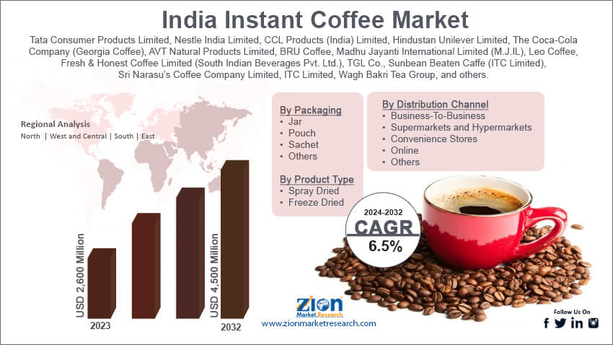
Figure 13: India Coffee Consumption Growth

2.5 Technological Factors
One of the elements of competitiveness in the Indian coffee shop market is the use of technology. Mobile applications, loyalty programmes, and in-built point-of-sale systems enable digital transformation to increase customer engagement and efficiency (Antoniak et al., 2025). These developments have increased market penetration opportunities that are no longer limited to the physical footfall due to the growth of food delivery companies, such as Zomato and Swiggy. Moreover, innovative technologies in coffee processing (automated roasting and climate-resistant drying) generate some uniform flavour profile and quality features that cannot be afforded in the specialty coffee segment (Bobadilla et al., 2024).
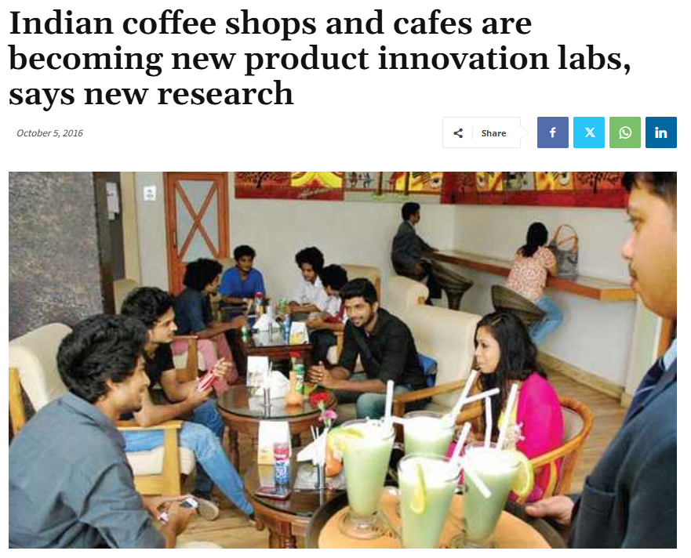
Figure 14: Cafés as Innovation Hubs

2.6 Legal Factors
Legal compliance is a tough task in view of complex regulatory regime in India. Coffee shop operators are bound by labour laws like the Code on Wages Act, and the Plantation Labour Act for wage systems, deciding social security contributions, and workplace safety mandates (Subarjo, 2025). Moreover, the setting up of new outlets requires acquisition of myriad National and State level licences, such as food safety, fire safety, and municipal authorisation, thereby prolonging the operational timelines and increasing the administrative expenses. In addition, strict legislation in the respective field of consumer protection and advertising require that transparency and ethical risk is applied in marketing acts, which are crucial to ensuring that brand credibility is preserved (Mukherjee Pipil, 2025).
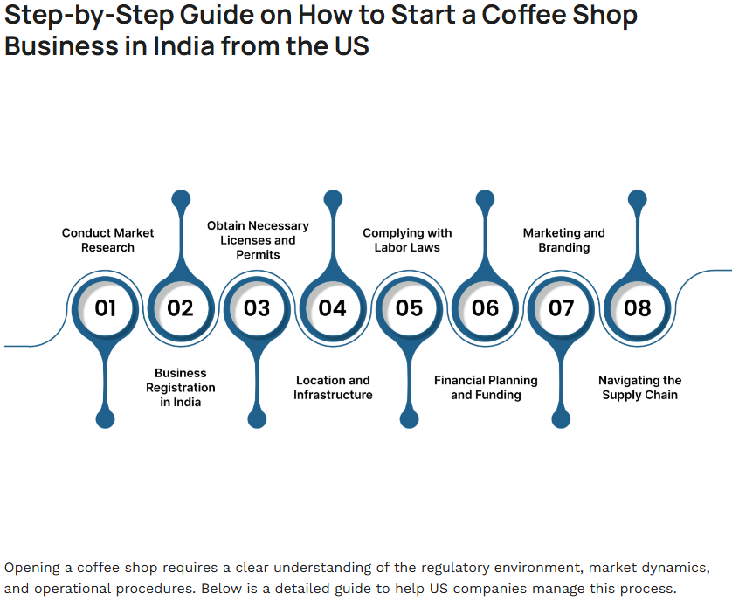
Figure 15: India Coffee Business Regulations

2.7 Environmental Factors
The issue of environmental sustainability has also assumed a special importance in Indian coffee industry. Unpredictable rain and increasing temperatures in the coffee-producing areas like Karnataka and Kerala have been created by climate representatively, thus posing a threat to production volumes and the quality of beans (De Felice et al., 2025). Sustainability laws in the international arena such as EU Deforestation Regulation requires companies to report deforestation-free supply chains. Furthermore, the growing pressure to reduce plastic waste and improve water management has made the brands shift towards environmentally friendly packaging and responsible business operations. This has led to increase in more than 60 per cent coffee consumers considering environmental responsibility in buying coffee, making sustainability not only a competitive requirement but also a discretion (De Felice et al., 2025).
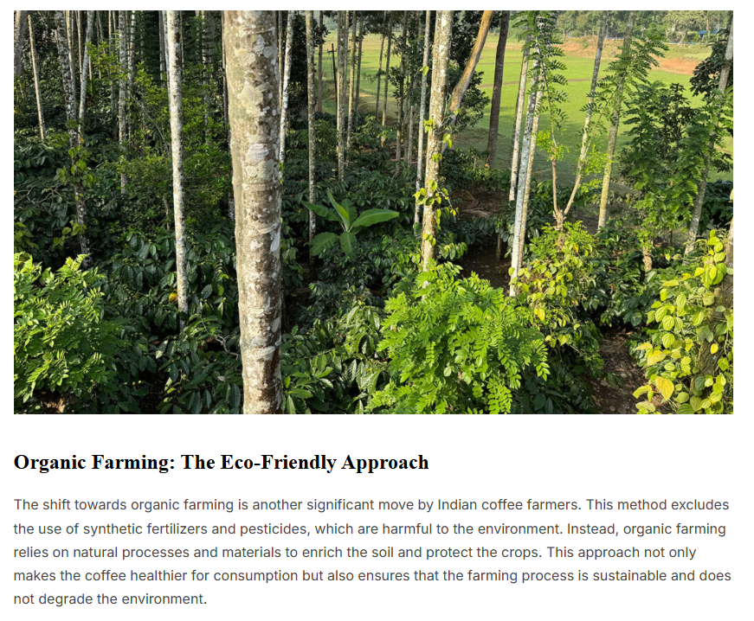
Figure 16: Sustainable Coffee Farming Practices in India

2.8 Competitive Landscape and Generic Strategies
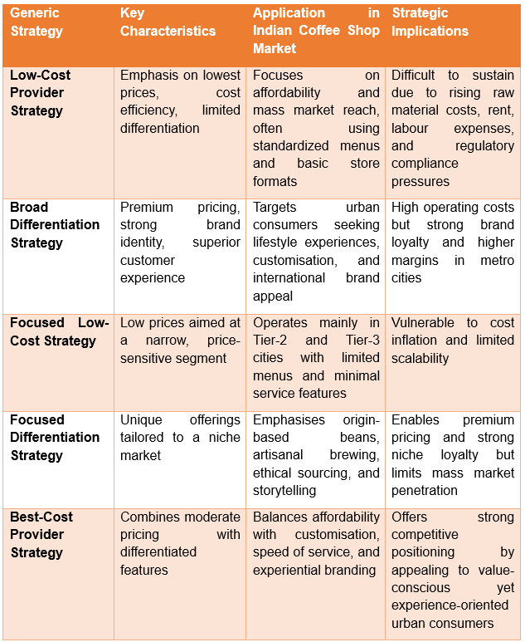
Table 2: Generic Competitive Strategies in the Indian Coffee Shop Market
(Source: Developed by Author)
The Indian coffee shop market is very competitive thus skilled by the presence of both international brands and strong local chains rendering positioning itself as a critical success factor. International players like Starbucks, Costa coffee and Tim Hortons mostly adopt broad differentiation strategies that focus on premium store ambience, global brand identity, customization and experiential consumption. These brands are directed towards urban consumers from the middle and upper income classes who link coffee consumption with lifestyles, social standing and leisure opportunities. Research shows that such experiential and customer-centric differentiation has been found to significantly increase customer satisfaction and revisit intentions in urban specialty coffee markets, especially among millennials and consumers of Generation Z (Meeprom et al., 2025).
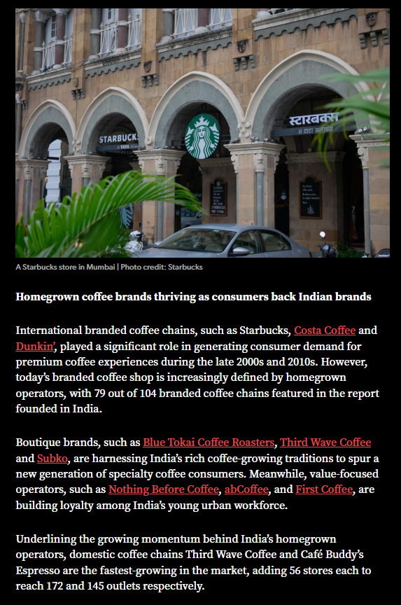
Figure 17: International Coffee Brands India
Conversely, low cost provider strategy is mainly used by mass market and legacy operators as is the case with Café Coffee Day which focuses on low cost and rampant availability. However, this strategy has increasingly found itself a challenge to sustainability due to the continued rise in input costs namely coffee beans, milk, labour and rental costs and an increment in the cost of regulatory compliance in the Indian food and beverage industry. Resultantly, price-based competition alone causes the firms to face a threat of eroding their marginal and long term financial flow.
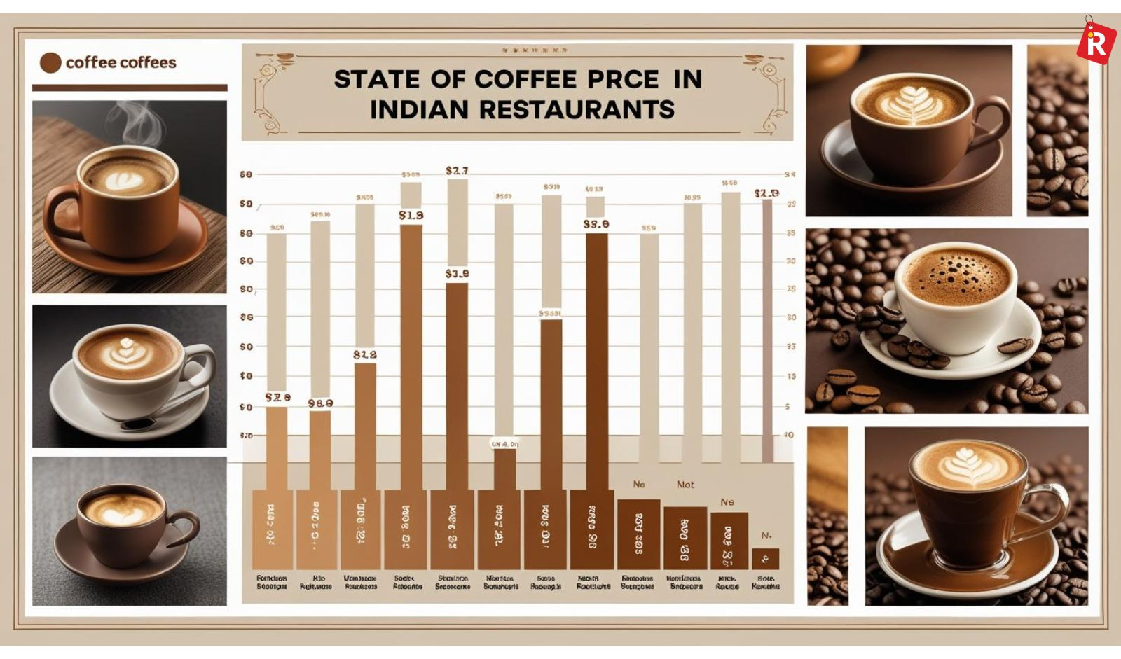
Figure 18: Coffee Pricing in India
Focused low cost strategies are mostly used by smaller regional operators who tend to target highly price sensitive consumers operating within Tier-2 and Tier-3 urban centres, and these operators tend to rely on constrained menu choices and rudimentary forms of service. In a contrasting way, focused differentiation strategies are pursued by niche brands such as Blue Tokai and Third Wave Coffee, which focus on a particular origin-based sourcing, artisanal brewing techniques, transparency and ethical supply chains. These brands appeal to niche consumers who play to a perceived authenticity and higher quality, thereby allowing them to charge a higher price and lead to strong brand loyalty.
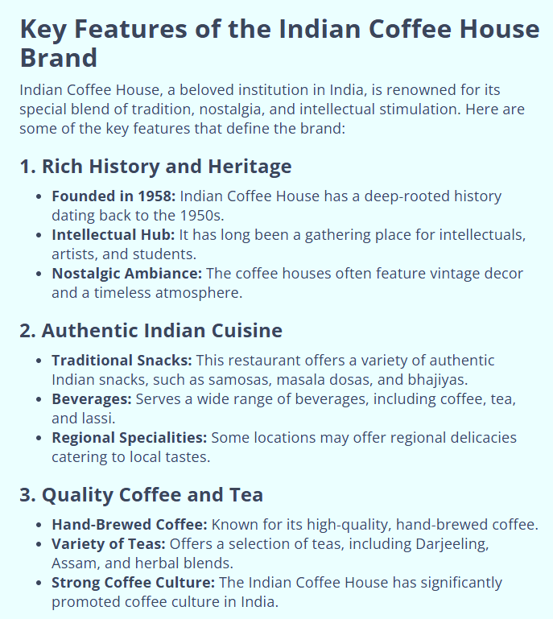
Figure 19: Traditional Indian Coffee Brand
In this competitive environment, best-cost provider strategy becomes the most feasible to the firms like Dutch Bros. With a combination of moderate prices with great differentiation in terms of speed of service, high levels of customization of beverages and a youthful community based brand-culture the Dutch Bros will be able to appeal to a large population of urban consumers. Investment and marketing strategies analyses have shown that this kind of hybrid positioning enables firms to compromise on low-cost and the quality of experience, which helps to avoid pressure in competition and develops sustainable growth in new markets (Xu, 2023; Wu, 2023).
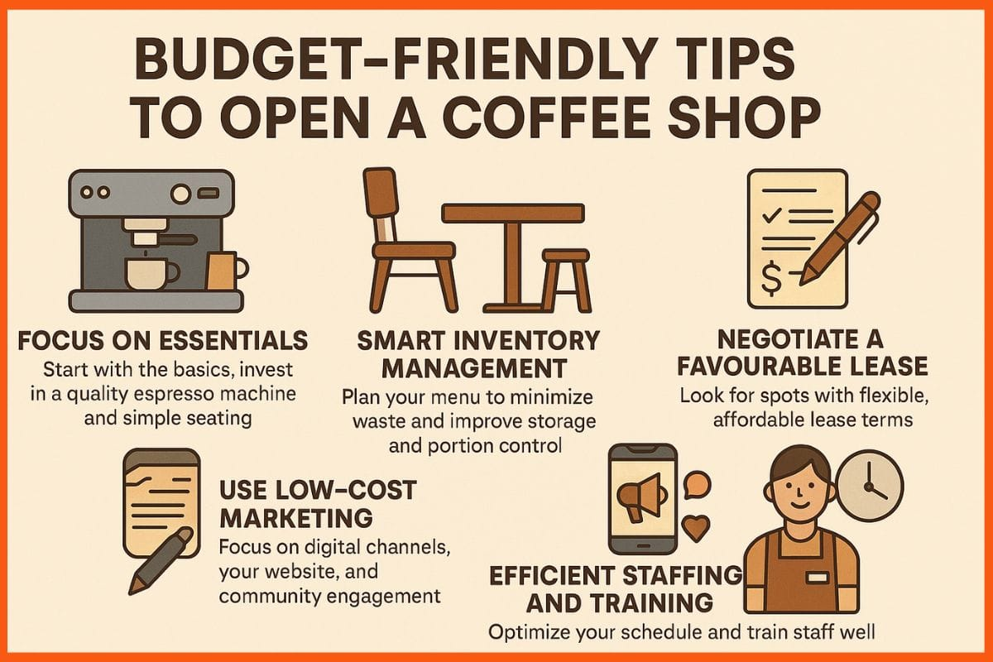
Figure 20: Cost-Efficient Coffee Operations

2.9 Critical Evaluation of Analytical Tools
The PESTLE framework, on the other hand, proves useful in providing a structured synopsis of macro - environmental forces that determine the marketing condition of the Indian coffee shop market and thereby in facilitating the identification of strategic risks and opportunities. Nevertheless, its static character is the limitation of its ability to capture rapid market swings and interdependencies among things, especially in a dynamic emerging economy.
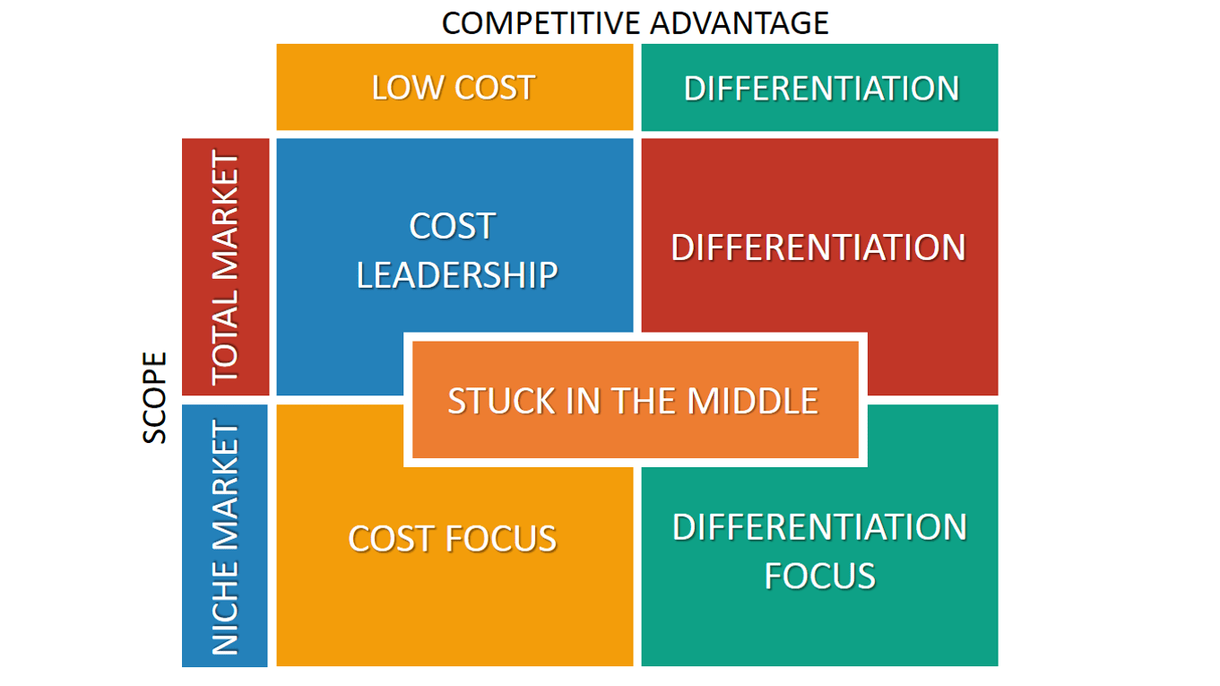
Figure 21: Porter’s generic strategies
On the same note, the generic strategies offered by Porter can be considered to have useful understanding of competitive positioning but can oversimplify the hybrid strategies that are quite often used in the modern services industries. At Indian level where the preference of consumers keep changing and emerging digitalization is breaking traditional strategic lines, companies often end up integrating both differentiation and cost effectiveness at the same time. In turn, strategy clarity can be observed as the contribution of these tools, but they should be complemented with schemes that would refer to the dynamic capabilities and customer experience to make the strategic decision-making more robust (Vu et al., 2025).

3. Strategy Development and Formulation

3.1 Selected Suitable Market Entry Method
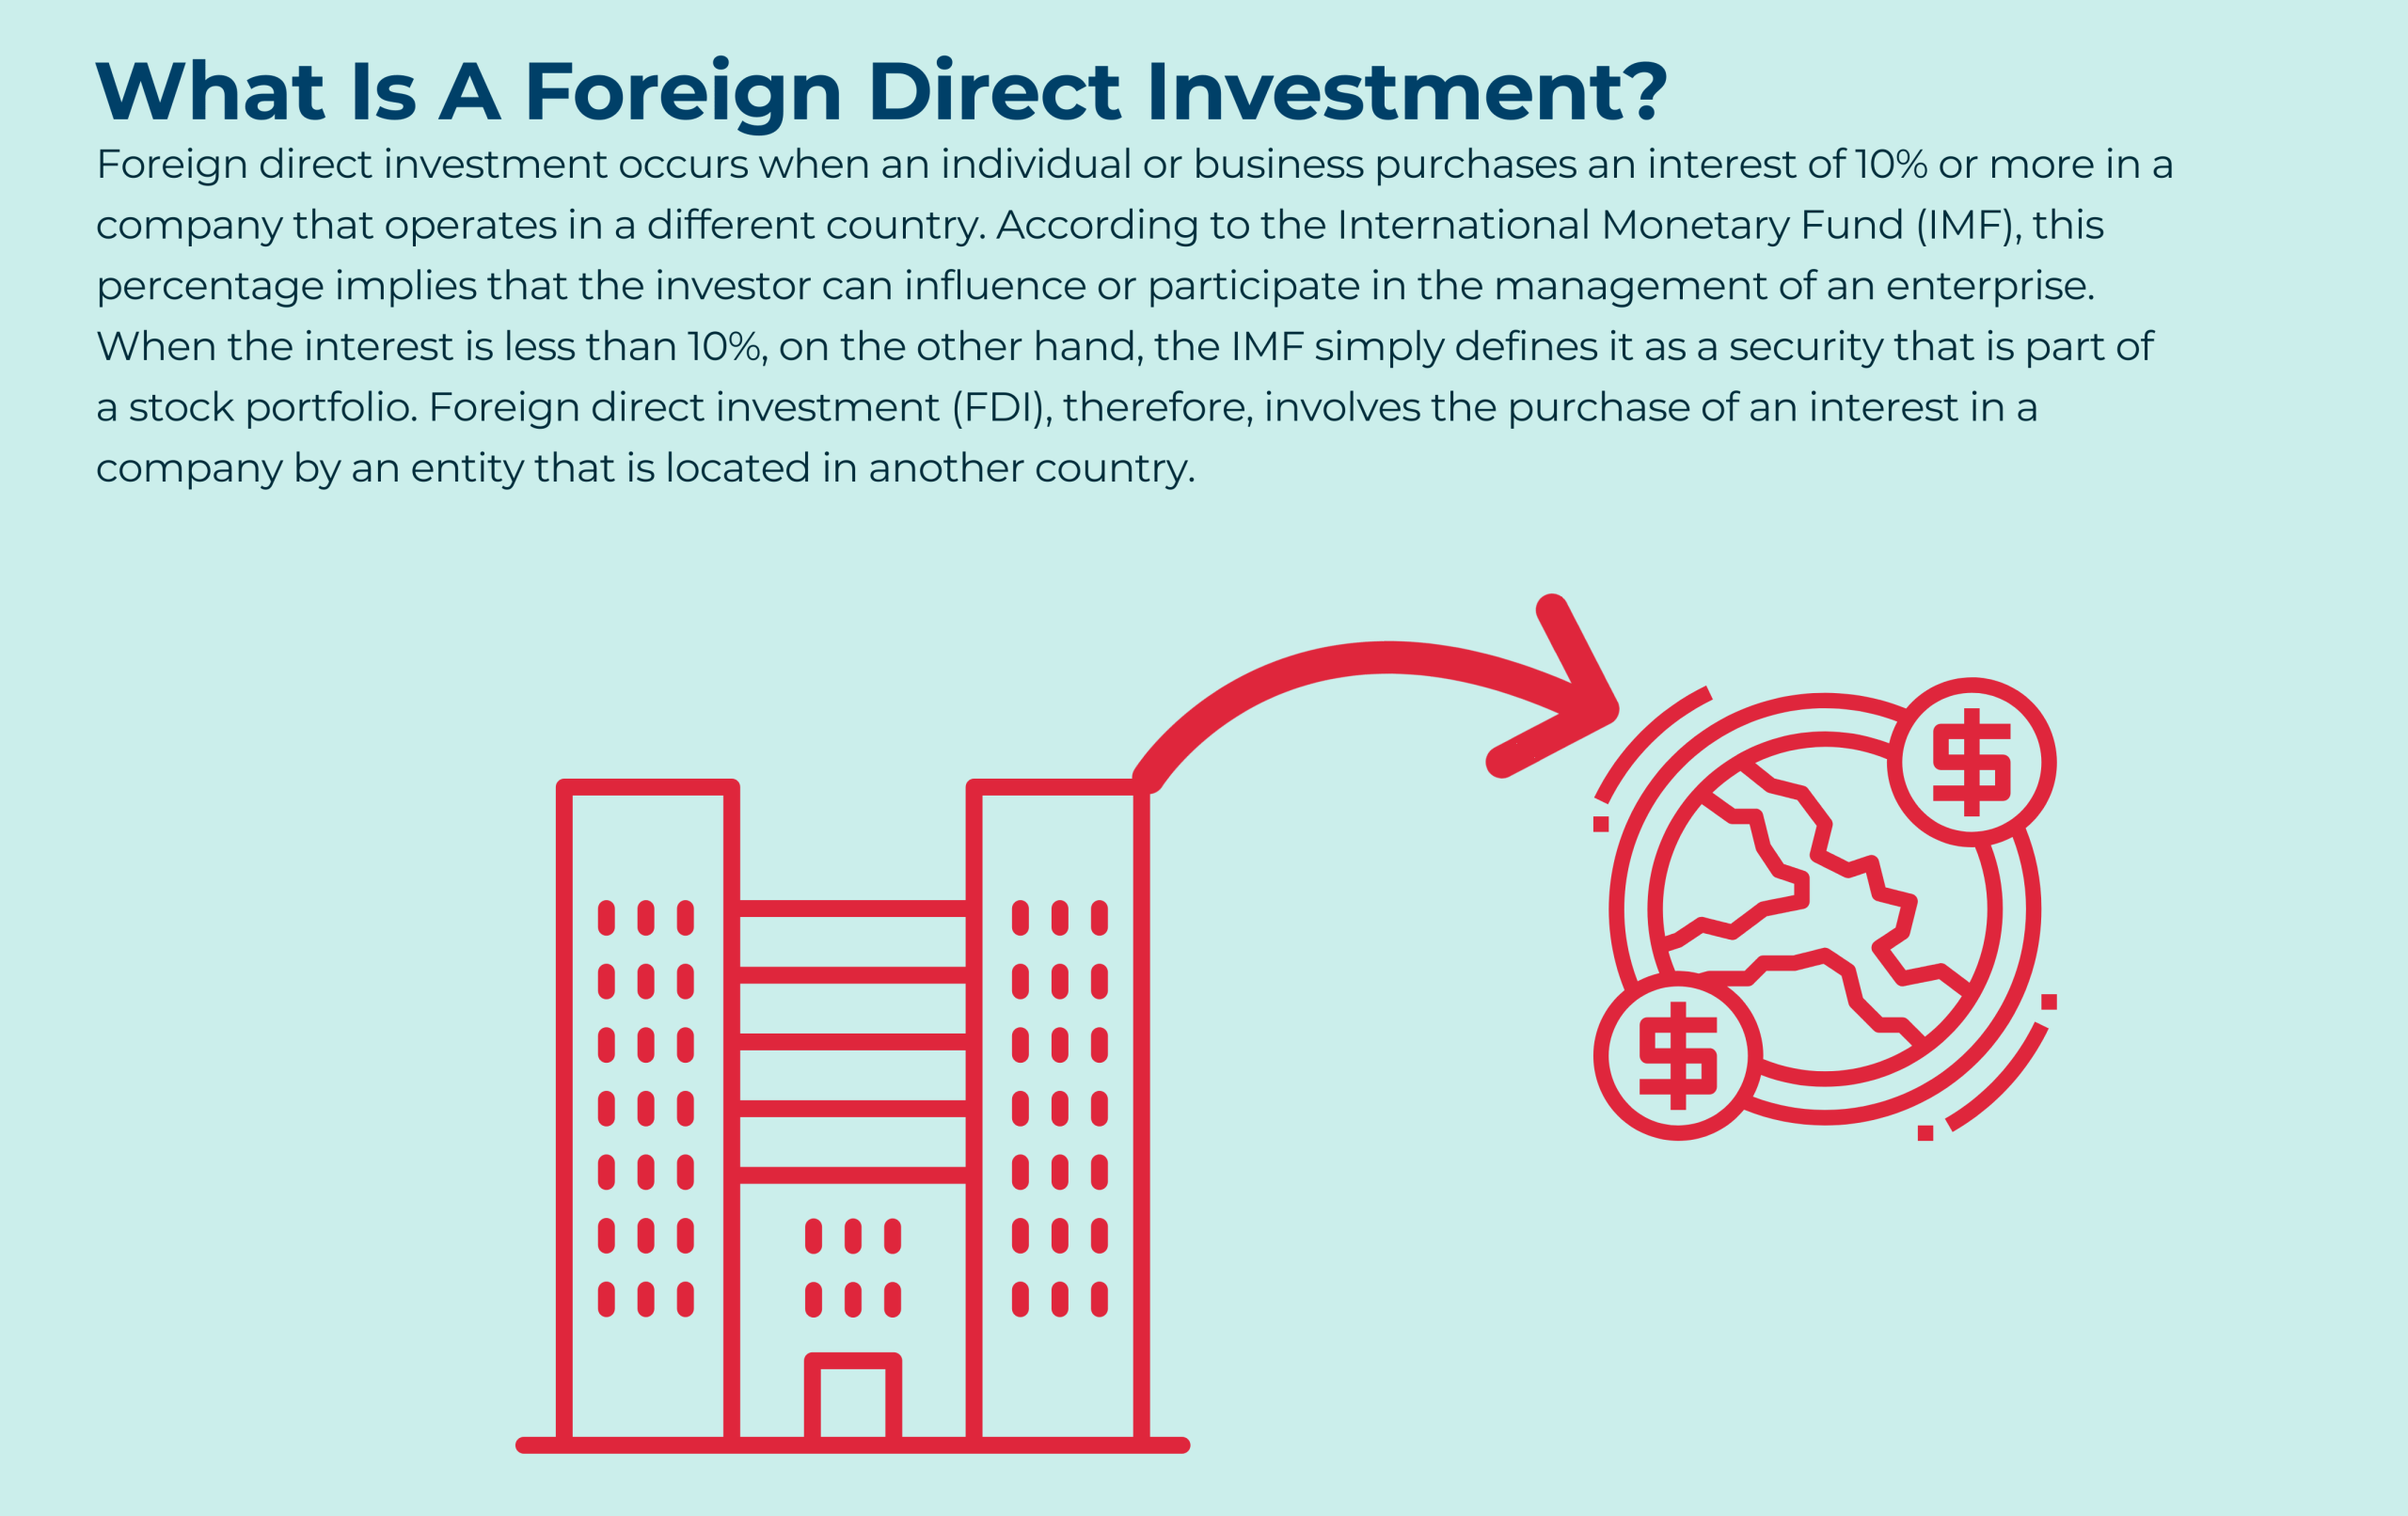
Figure 22: Foreign Direct Investment
The best market entry strategy for Dutch Bros Coffee India is through joint venture based foreign direct investment (FDI), with a local strategic partner. Joint ventures are widely recognized as effective entry strategies in emerging markets based on the fact that they reduce many culture and regulation risks while the same time offering access to essential local market knowledge and distribution networks (Kostruba et al., 2025). India's complex regulatory environment, rigorous licensing requirements and fiercely competitive domestic competition make being 100 percent owner a risky proposition during the initial phase of entry to the market.
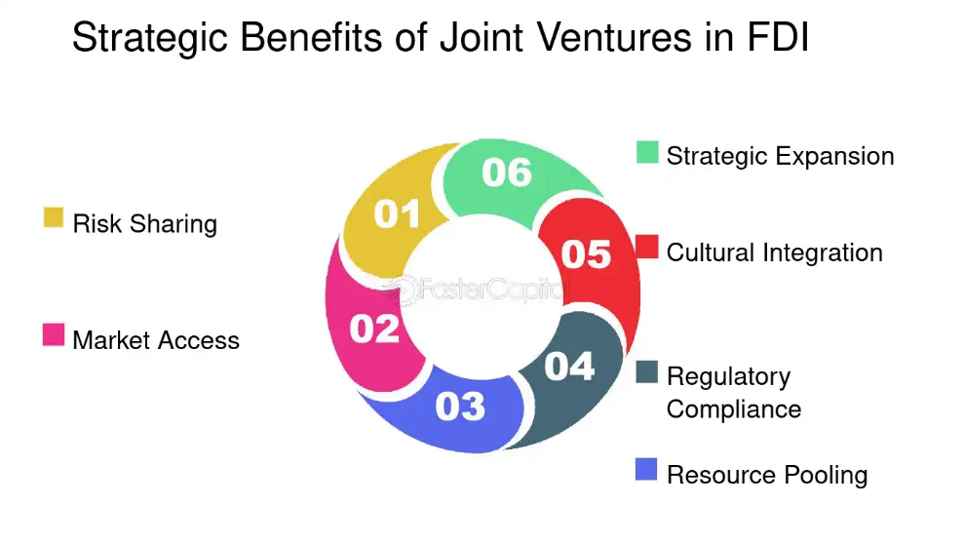
Figure 23: Joint Ventures in FDI
FDI-backed joint ventures are in line with the internationalisation theory, which argues that firms venturing in market environments that are institutionally intricate gain advantages of mutual ownership arrangements that soak up control and risk (Maurseth et al., 2025). A local partner will make it easier to select sites, localise supply chains, adhere to labour laws, and incorporate digital platforms, thus making it easy to adopt time-to-market and increase legitimacy. This approach will allow Dutch Bros to maintain strategic brand identity and product development control and at the same time through partner strengths, individualise the offering to the needs of the Indian consumers.
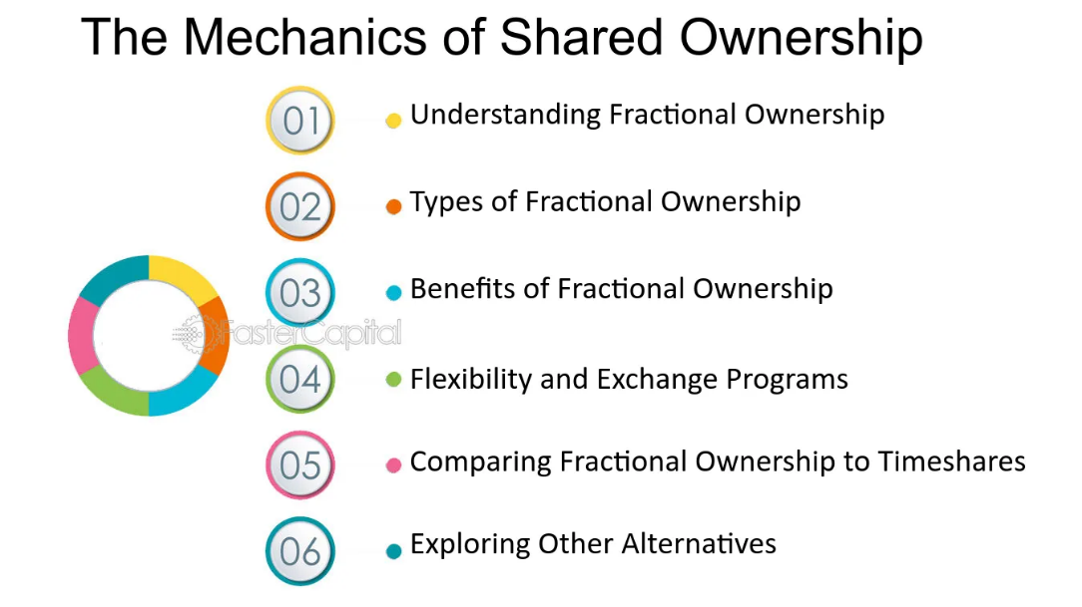
Figure 24: Advantages of Shared Ownership

3.2 Strategic Models Underpinning Market Entry

3.2.1 Eclectic Paradigm (OLI Framework)
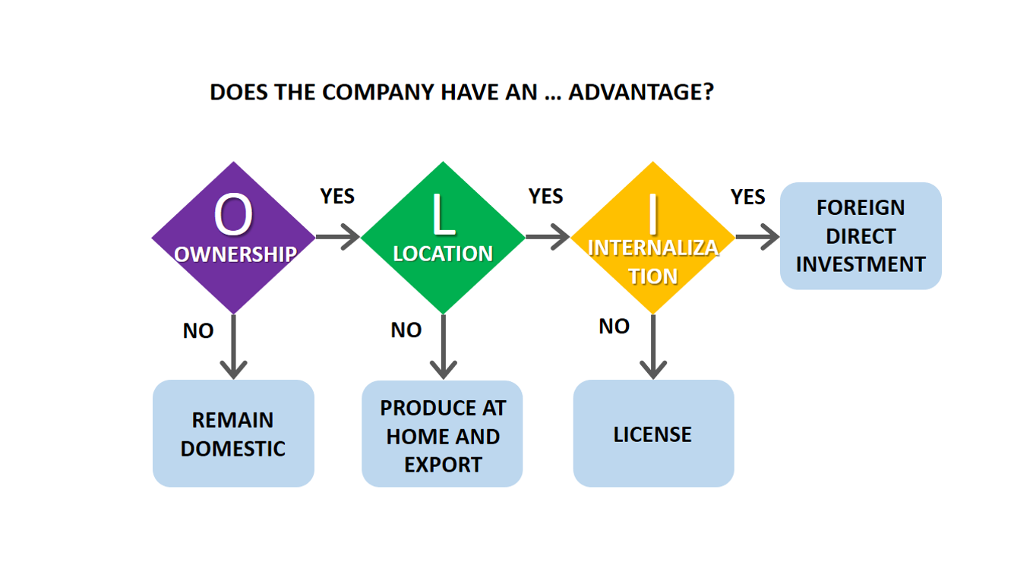
Figure 25: Ownership–Location–Internalisation
The Eclectic Paradigm (Ownership-Location-Internalisation) offers a good theoretical basis for the decision on market entry by Dutch Bros. Ownership advantages include: strong brand culture, differentiated menu with customizable beverages, proprietary energy drinks, and an experience-based service model (Xu, 2023). Location advantages are provided by India's burgeoning urban middle class, rising cafe culture and specialty coffee demand. Internalisation advantages achieved by partial ownership that allows for Dutch Bros to protect brand standards and share operational risk through a joint venture (Maurseth et al.,2025).

3.2.2 Uppsala Internationalisation Model
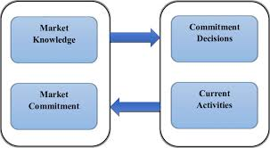
Figure 26: Uppsala Internationalisation Model
The Uppsala Model is based on the premise of the internationalisation of firms that occur in a gradual manner in which they enter culturally distant markets via the modes of entry with lower risk levels before increasing commitment. A joint venture is in line with this reasoning, as it allows Dutch Bros to gain the experience in the market before it expands to scale. Empirical studies also indicate that the presence of knowledge of foreign market entry can positively affect the international performance by combining it with the effective network performance and reasonable decisions in selecting the market (Martin Martin et al., 2022). Such a gradual solution reduces the risk of uncertainty even as it encourages a long-term growth which is sustainable.

3.3 Competitive Strategy for the Indian Market

3.3.1 Best-Cost Provider Strategy
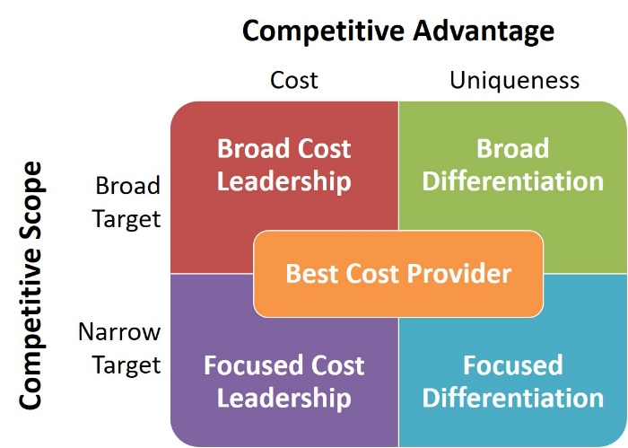
Figure 27: Best-Cost Provider Strategy
In the context of the Indian specialty coffee market, Dutch Bros is recommended to have a best-cost provider strategy incorporating synthesis of moderate pricing and significant differentiation. This strategy takes advantage of the dual consumer demand of premium consumer experiences and price sensitivity, with the latter being more pronounced than it is in Western markets. There are empirical evidence that best-cost approaches are an effective strategy to compromise the value and differentiation so that firms can compete with premium international brands as well as strong domestic competition (Farida & Setiawan, 2022).
The concept can allow Dutch Bros to offer personalised specialty drinks, high-energy beverages and strong service culture at prices that urban millennials and Gen Z consumers can easily afford.

3.3.2 Experiential Differentiation and Category Priming
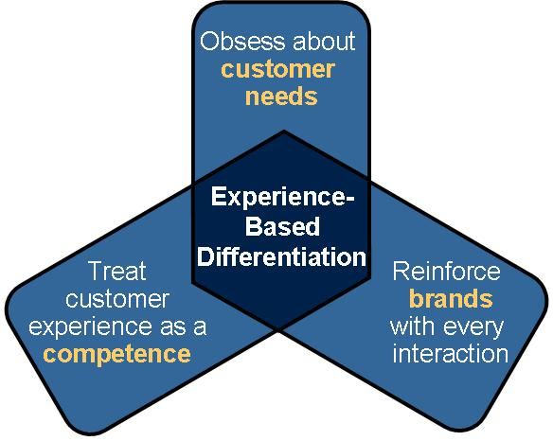
Figure 28: Experience-Based Competitive Differentiation
Informed by category priming theory, Dutch Bros should base its competitive advantage in experiential differentiation. First impressions, in terms of digital and physical entry, have a powerful role in building brand image and make first positioning extremely consequential (Aversa et al., 2022). Consequently, Dutch Bros should aspire to establish itself as a high energy, youth-oriented and community-driven brand to differentiate itself from traditional environments of a cafe setting.

Figure 29: Experiential Café Brand Engagement
It is possible to attain this by incorporating the use of visually dynamic store design, by creating drive-thru formats to match the trends in the Indian traffic, by establishing the culture of music-focused brand, and enhancing the customer experience through the use of digital medium. Evidence shows that experiential marketing has significant positive effects on customer satisfaction levels and their willingness to visit the same location again within the scope of coffee drinking (Meeprom et al., 2025).

3.4 Leveraging Innovation and Dynamic Capabilities

3.4.1 Innovation-Led Competitive Advantage
Innovation is a key building block supporting the sustainable competitive advantage in service - oriented sectors. Dutch Bros may take advantage of developments in how they design menus, use the Internet, and optimize a process to improve over competing firms. The combination of mobile ordering systems, loyalty applications and data-driven personalization mechanisms gives a boost to operational efficiency and strengthens customer engagement (Antoniak et 노선, 2025).
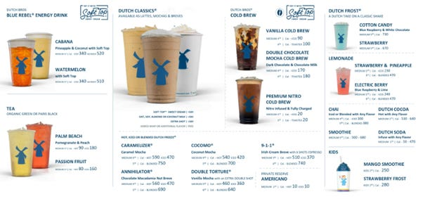
Figure 30: Innovation-Driven Beverage Menu
The empirical observations show that both innovation and performance have a reciprocal reinforcing relationship, thus, helping firms maintain a competitive edge in highly competitive markets (Farida & Setiawan, 2022).

3.4.2 Dynamic Capabilities Perspective
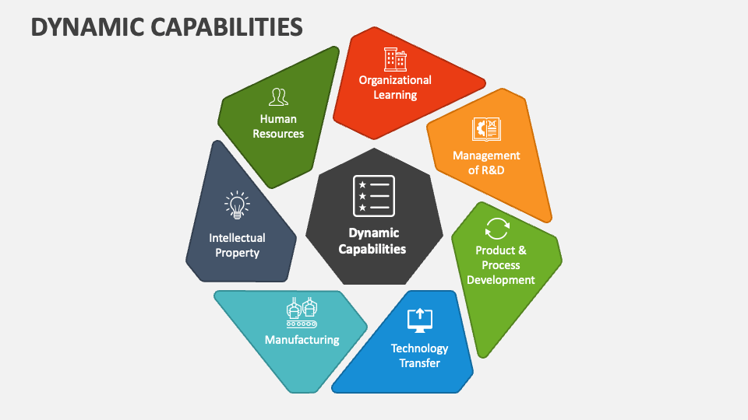
Figure 31: Dynamic Capabilities Perspective
The dynamic capabilities framework emphasises a firm's ability to identify opportunities and then mobilise the resources needed to seize those opportunities and reconfigure the operational assets in line with changing environmental contingencies. This analytical lens is especially relevant in the setting of the emerging economies like India, where the nature of consumer preferences is characterised by rapid and iterative evolution. Empirical studies of coffee related tourism and experiential consumption can also highlight the importance of adaptive responsiveness and market sense capabilities for achieving sustainable competitive advantage (Vu et al., 2025).
In light of these theoretical and empirical insights, the Dutch Bros are recommended to continue to perfect flavour profiles, moderate sweetness levels, and continue expanding non-coffee beverage options according to local palates, which will ensure the continuity of the brand's integrity.

3.5 Cross-Cultural and Network Strategy
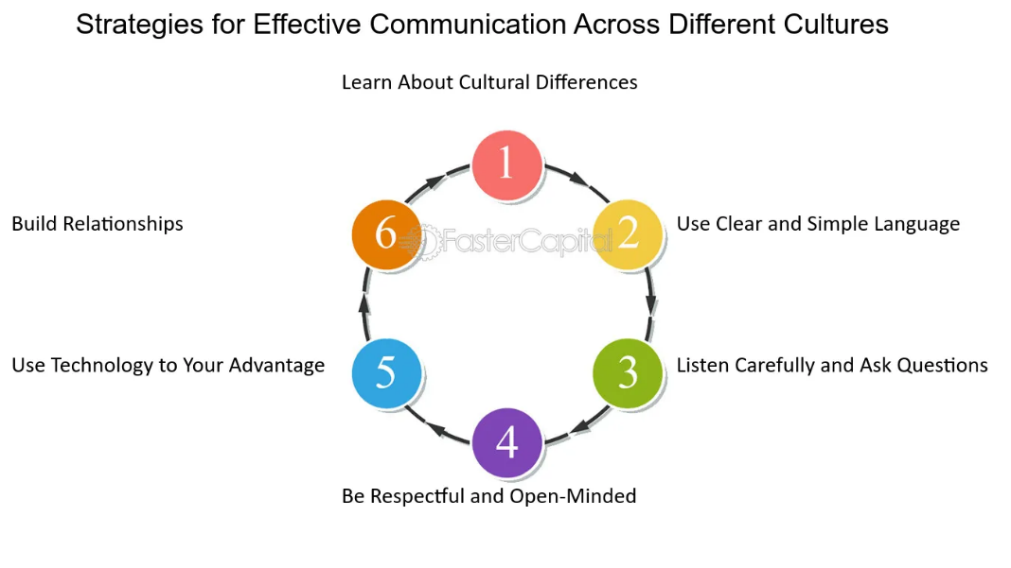
Figure 32: Cross Cultural Communication
There is need to adapt to culture in a developing economy. The cross cultural strategy theory reiterates the necessity of balancing the globality of the brand with the responsiveness of the local culture. In India, consumers are highly culturally diverse in various regions, which demand such a strategy as flexible menu localisation and marketing communication (Su’udiah, 2025).
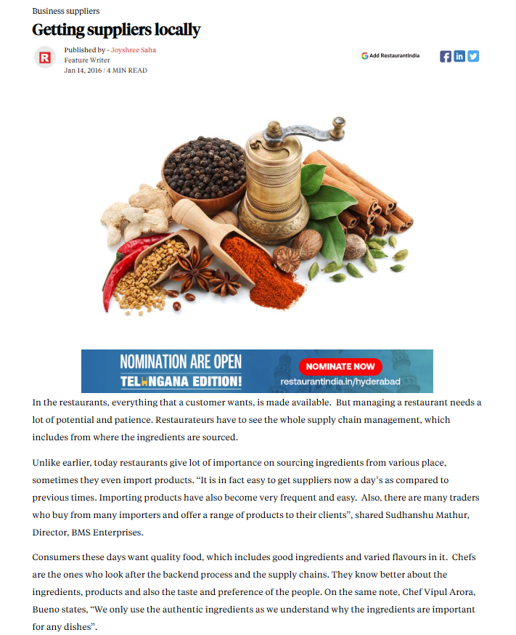
Figure 33: Local Supplier Network Building
Establishing local networks with suppliers, delivery platforms, influencers and real estate developers is an indicator of both legitimacy and efficiency. Empirical evidence has shown that network capability mediates the link that exists between foreign market entry knowledge and international performance, thus making partnerships a strategic imperative, rather than an optional consideration (Martín Martin et al., 2022).

3.6 Risk Mitigation and Sustainability Integration

3.6.1 Risk Mitigation
The more serious risk measures include the complexity of regulations, inflationary pressures on cost, cultural misfit, and the need to be sustainable. A joint venture structure can reduce regulatory and cultural uncertainty whereas a gradual outlet growth policy can reduce financial risks. The use of locally available inputs in procurement is used to mitigate the volatility of exchange-rate and reduces the dependence on the imports made globally.
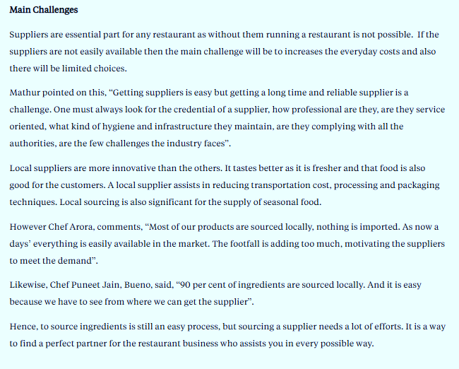
Figure 34: Local Sourcing Risk Mitigation

3.6.2 Sustainable Competitive Advantage
Integration of sustainability considerations into the core strategic framework is imperative. Research literature on the notion of sustainable competitive advantage underscores the centrality of technological innovation, knowledge management and organisational agility in attaining long term organizational success (Satar et al., 2024). Additionally, practices that are aimed at sustainability improve brand credibility amongst environmentally conscious consumers.
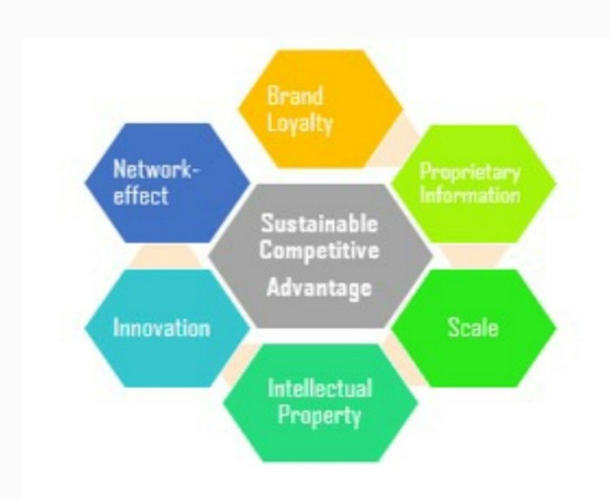
Figure 35: Sustainable Competitive Advantage
The scholarly sources confirm the notion that sustainability-oriented differentiation is becoming the cornerstone of competitive edge in consumer-facing industries, and among the younger generations, in particular (Gunawan et al., 2025). Therefore, Dutch Bros must focus on sourcing and packaging in an ethical manner, recyclability, and water-efficient operations to match the changing consumer values.

3.7 Strategic Fit with Organisational Objectives
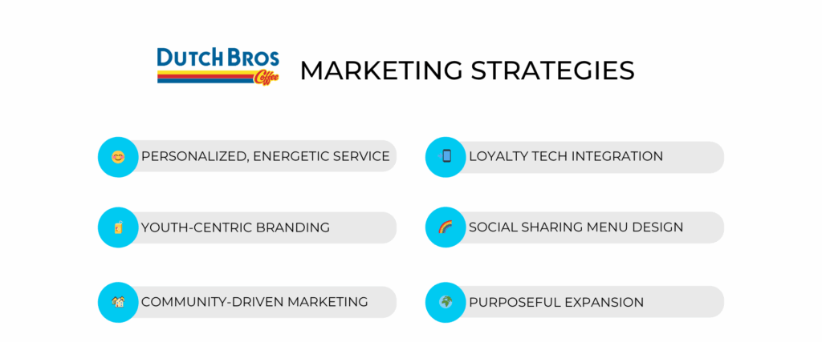
Figure 36: Dutch Bros Marketing Strategy
The strategy being considered is very conducive to the organisational objectives of Dutch Bros, relative to its growth, brand expansion, and experiential leadership. A joint venture based entry allows for quick but controlled penetration of a market and a best cost experiential differentiation approach allows for customer acquisition and loyalty. Innovation, sustainability, and cultural adaptation are the combined factors supporting the firm's competitive positioning in the Indian dynamic coffee market.

4. Performance Evaluation Framework

4.1 Rationale for Selecting the Balanced Scorecard and Triple Bottom Line
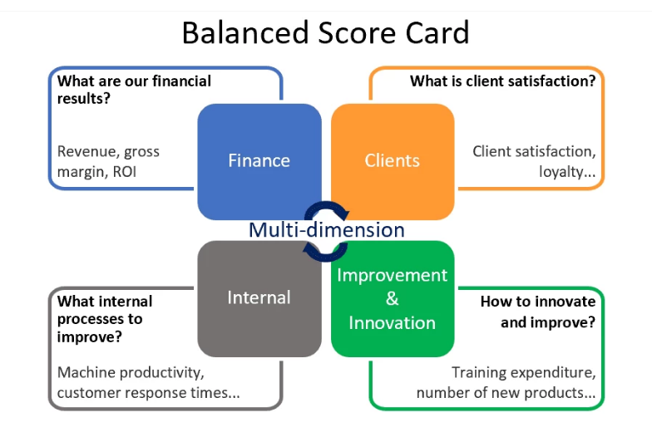
Figure 37: Balanced Scorecard
The Balanced Scorecard was initially designed to counter shortcomings of the purely fiscal performance measurement thus, integrating both financial and non-financial measures of performance to confirm that the business operations are in line with the strategic goals. The framework evaluates performance in four perspectives namely financial; customer; internal business processes; and learning and growth (Madsen, 2025). Practical research supports the view that the Balanced Scorecard makes it easier to focus on strategy, supplements the quality of decision-making, and improves operational performance, especially in complex and competitive markets (Ta et al., 2022).
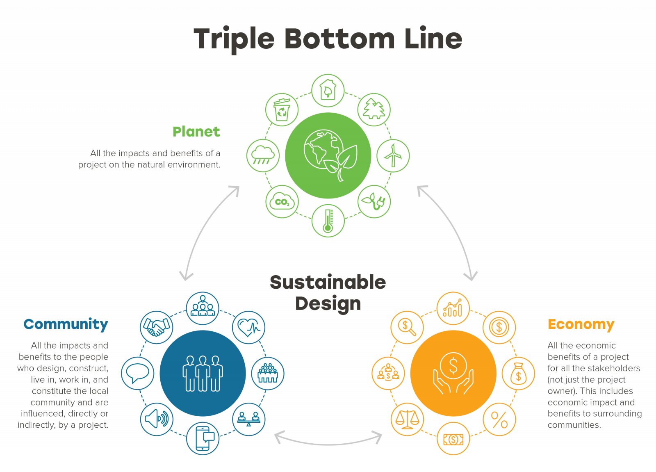
Figure 38: Triple Bottom Line
Nevertheless, the Balanced Scorecard, alone, may fail to adequately capture the sustainability and ethical elements that are becoming of increasing importance in global supply chains for coffee. The Triple Bottom Line framework thus addresses this shortfall in that it evaluates performance on economic, social and environmental aspects. Scholars believe that organisations working in emerging markets have to integrate the principles of TBL if they are to attain long-term growth, legitimacy, and stakeholder trust (Bhatti et al, 2025). Consequently, the combination of the BSC and the TBL provides a comprehensive performance evaluation framework that balances profitability and responsibility and sustainability.

4.2 Balanced Scorecard Design for the Expansion Initiative

4.2.1 Financial Perspective
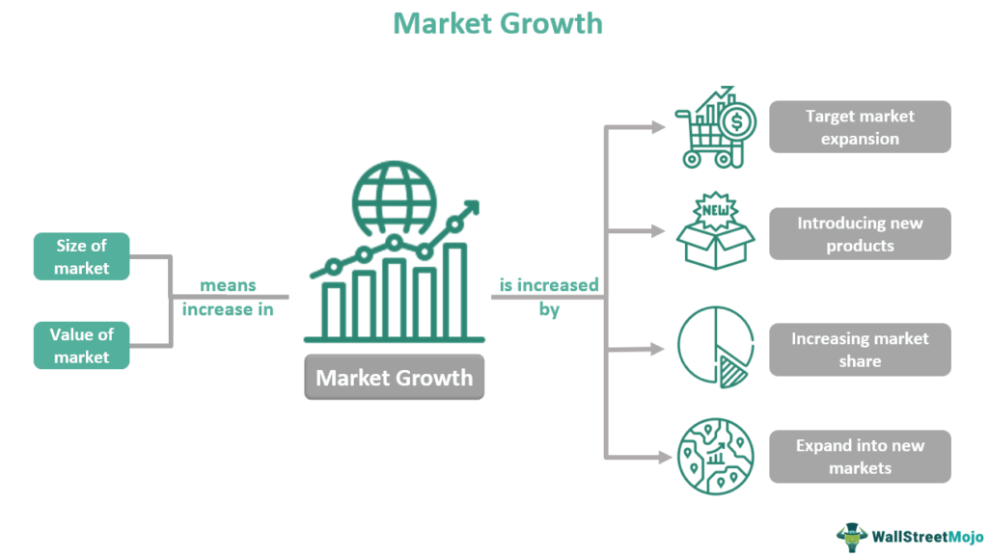
Figure 39: Market-specific revenue growth
The financial aspect analyses the ability of an expansion program to increase shareholder value and a long term financial sustainability. The indicators of major performance should focus on increasing revenue, cost reduction, and productivity of capital. In the case of Dutch 3 Dutch Bros, the metrics that are needed to measure financial success of Dutch Bros operations in India are market-specific revenue development, average revenue per outlet as well as operating margin. These KPIs indicate the ability of the organisation to create demand and be in control of the inflation pressures related to labour, rent and raw materials.
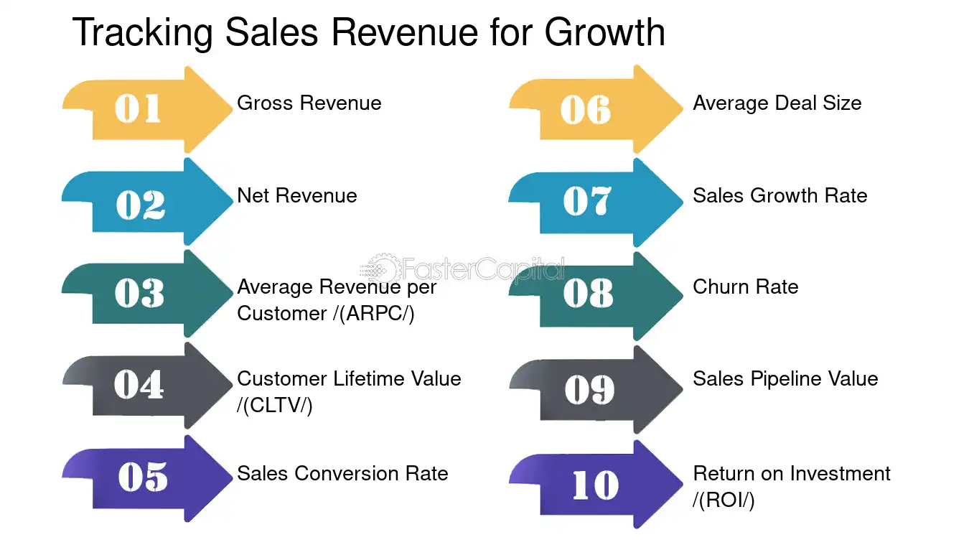
Figure 40: Tracking Sales Revenue and Growth Rates
For example, monitoring of outlet level revenue from Tier - 1 Metropolitan areas like Bengaluru and Mumbai allows managerial entities to compare performance with domestic benchmarks and calibrate pricing mechanism. Empirical evidence suggests that financial key performance indicators appear to be important, but they should be interpreted in the context of non-financial indicators to reduce the risks of short-termism (Madsen, 2025). Consequently, the framework of Balanced Scorecard ensures that financial results are considered the product of successful strategy implementation and not as isolated goals.

4.2.2 Customer Perspective
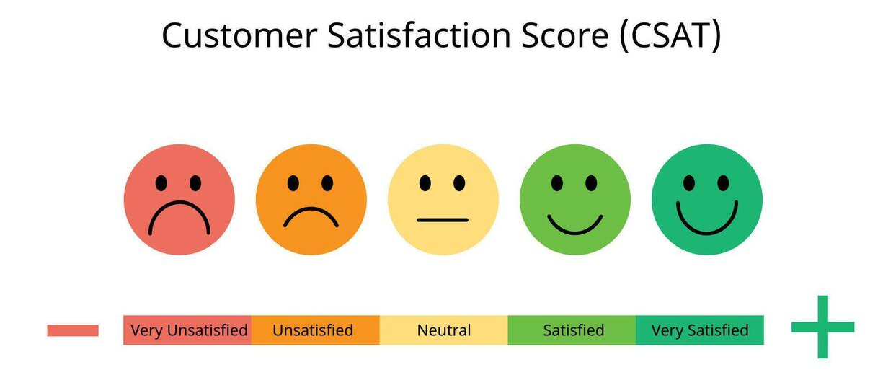
Figure 41: Customer satisfaction scores
The customer perspective is an analysis of the ability of the organization to create value to the target market. The experiential, brand experience, and perceived value are the main aspects that shape consumer expectations when it comes to the Indian specialty coffee market; the relevant key performance indicator would include customer satisfaction levels, the frequency of a repeat purchase, brand awareness, and online presence factors, including the use of loyalty apps.

Figure 42: Post-purchase surveys
An illustrative example can be provided as examination of revisit intention and satisfaction through post purchase postcards that provides information on resonance of Dutch Bros experiential differentiation strategy amongst Indians. Empirical studies show that customer experience is one of the decisive factors in building a loyal customer base and a long-term profit scenario in coffee consumption contexts (Meeprom et al., 2025). By bringing such metrics under the same roof, the Balanced Scorecard supports the process of continually monitoring the performance of the customer, thus ensuring that; service innovations and localization initiatives are translated into empirically measurable outcomes.

4.2.3 Internal Business Process Perspective
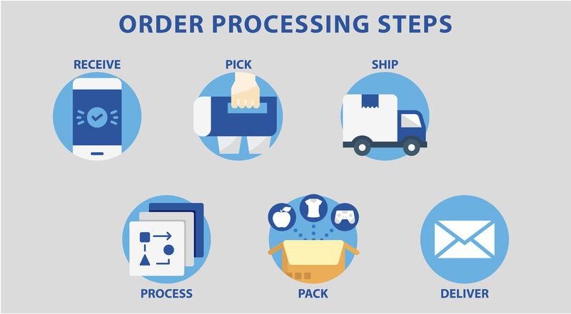
Figure 43: Order processing time
The internal process approach focuses on the operational efficiency and process excellence which promotes the best customer and financial processes. With the expansion of Dutch Bros, the most salient key performance indicators would include order processing time, supply-chain reliability, inventory turnover, as well as adherence to the set food-safety criteria. These measures commit specific importance to the context of the Indian situation, where the regulatory complexities and uneven infrastructure situations impose a burden on the service uniformity.
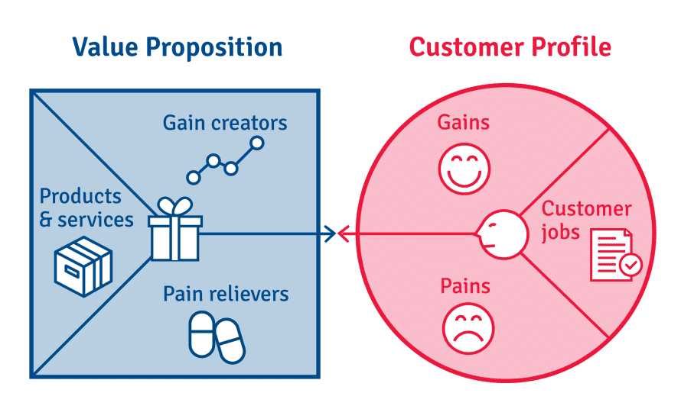
Figure 44: Value proposition
As an example, the usage of average service intervals monitoring in drive-thru-adapted outlets belongs to the preservation of speed-related value proposition of the brand. Empirical investigations into the implementation of Balanced Scorecard have found out that improvement of internal process works as leading indicators for subsequent financial performance (Ta et al., 2022). Accordingly, this approach allows the proactive identification of operational bottlenecks before they have a detrimental effect on customer satisfaction or profitability.

4.2.4 Learning and Growth Perspective
The learning and growth perspective covers ability of the organisation to innovate, develop its employees and agility in the organisation. Among the key performance indicators, there are the hours spent on employee training, staff retention rates, adoption of innovation, and development of digital capability. In the service-oriented sectors, employee engagement has a direct impact on the service quality and brand experience.
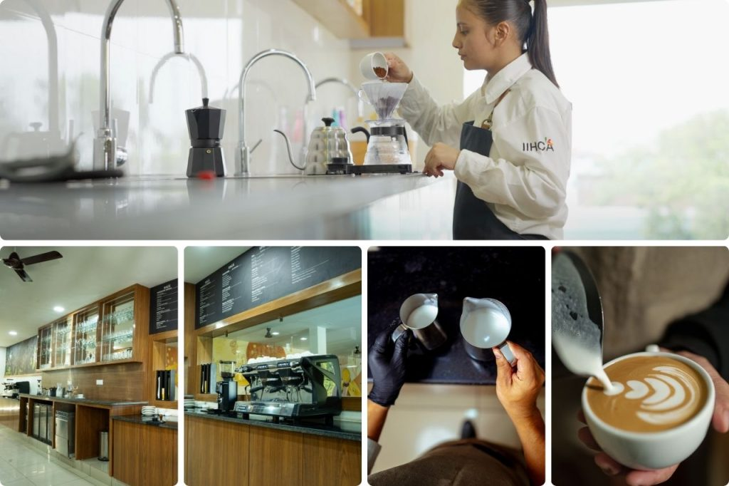
Figure 45: Barista Training
For example, tracking the completion rates of barista training programs helps with consistent delivery of service and culturicide outlet activity across outlets being established. Academic research underlines the significance of learning-oriented performance measures for allowing to keep competitive edge in dynamic markets (Madsen, 2025). This view is the basis of Dutch Bros's long-term adaptability because it can ensure that human capital and technological capabilities evolve with changing market demands.

4.3 Integrating the Triple Bottom Line into Performance Measurement

4.3.1 Economic Sustainability
The economic sustainability under the TBL system is much similar to the financial view of the Balanced Scorecard although economic sustainability focuses on creation of long-term value instead of profit maximisation; short-term. The ratio of local sourcing, the long-term association of a supplier and returns on sustainable investments are the key performance indicators to assess the economic resilience.
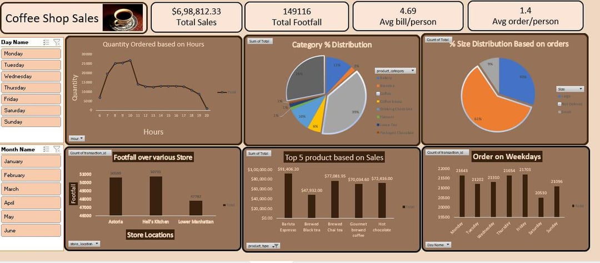
Figure 46: Economic Performance Monitoring Dashboard
In particular, increasing the share of locally disposed ingredients mitigates the risk of exposure to exchange rate volatility and at the same time facilitates and supports domestic suppliers. Empirical evidence suggest that economic sustainable practices make businesses more stable and competitive in emerging economies (Jali et al., 2025). Consequently, economic sustainability metrics strengthen financial key performance indicators (KPIs) and encourage long-term growth.

4.3.2 Social Sustainability
Social sustainability evaluates the role that the organisation plays on the workers, societies and society, in general. The relevant KPIs are fair wages, indices of employee welfare, local community programmes, and generation of jobs within the locality. These indicators are invaluable in the world of India where the labour standards and social equity issues are vital issues as far as the organisational legitimacy is concerned.
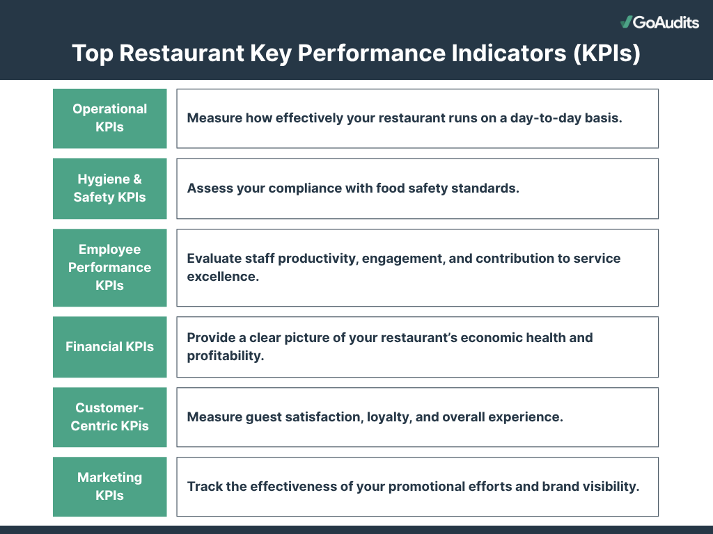
Figure 47: Social Sustainability KPI Framework
For example, an evaluation of an adherence to the labour laws and an employee satisfaction guarantees an ethical method of work and keeps the turnover under control. Empirical research has shown that socially responsible practices have a positive impact on organisational reputation and employee performance (Bhatti et al., 2025). Incorporation of social key performance indicators in the performance framework ensures success of the expansion is not judged only in terms of financial results.

4.3.3 Environmental Sustainability
The problem of the environmental sustainability gets even greater relevance in the coffee industry as a direct effect of climate-related risks and disruptions, which impact supply chains. Some of the critical key performance indicators include the amount of carbon footprint per retail outlet, water -use efficiency, recycling rates of waste, and compliance to sustainable sourcing. The supply chains of coffee are becoming more questioned in terms of deforestation, water usage and emissions.
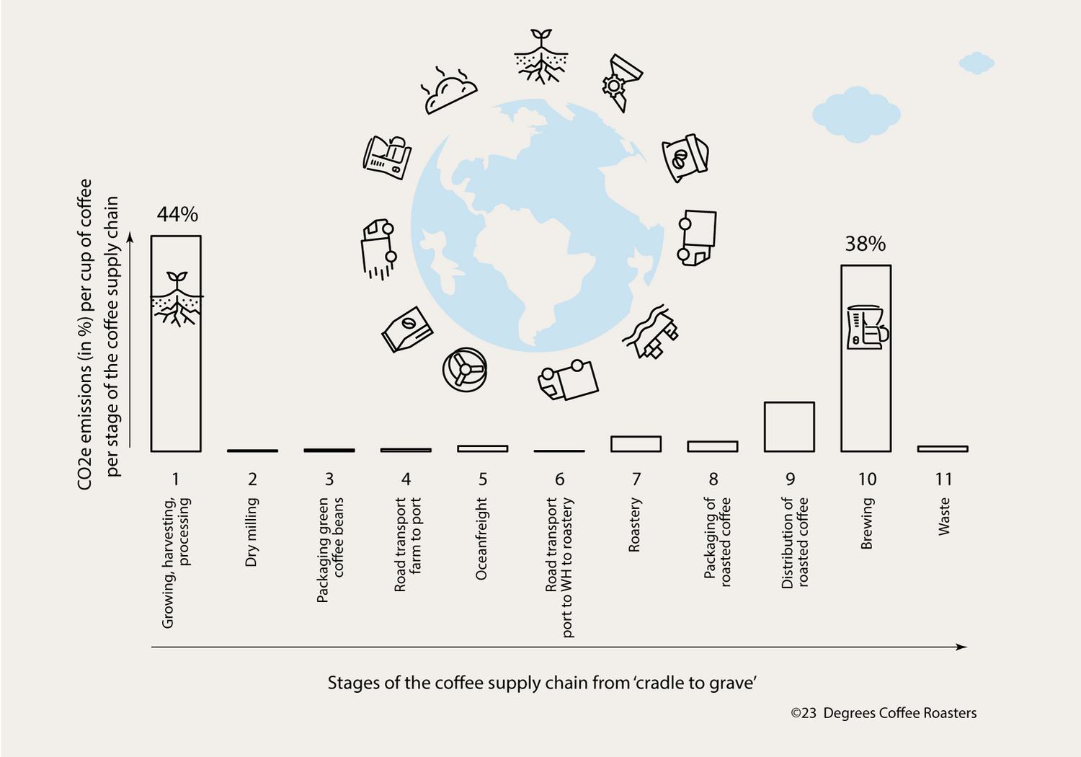
Figure 48: Coffee Supply Chain Emissions
For example, water usage in beverage preparation and cleaning processes allows for operational efficiency and environmental stewardship. Empirical case study research based on the coffee industry shows that green sourcing and operations enhance brand credibility and long-term performance (Proença et al., 2022). As such, environmental KPIs provide quantifiable evidence of the organisation's commitment to meeting sustainability.

4.4 Linking Balanced Scorecard and Triple Bottom Line
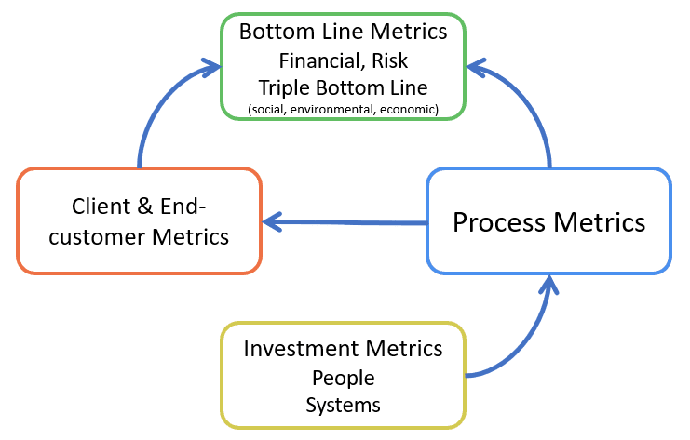
Figure 49: Balanced Scorecard - TBL Integration
The combination of the Balanced Scorecard framework and Triple Bottom Line paradigm creates a performance evaluation system, which has strategic alignment and is sustainability-focused. The economic sustainability goals, the internal processes, and the learning and growth dimensions align the financial and customer perspective with the objectives of social responsibility, thus, through employee development. The scholars argue that such a combination helps to convert sustainability goals into operational indicators that would also address the strategic-implementation gap (Bhatti et al., 2025).
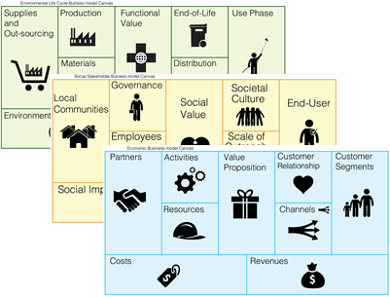
Figure 50: Triple-Layer Business Model Canvas
The Triple-Layer Business Model Canvas, which is applied to the analysis and research of the coffee sector, further facilitates this integrated approach by demonstrating simultaneous value creation along three dimensions of economy, society, and the environment (Kurniasari et al., 2025). This supports the suitability of using a combined BSC-TBL framework to evaluate Dutch Bros expansion initiative.

4.5 Practical Application and Monitoring of KPIs
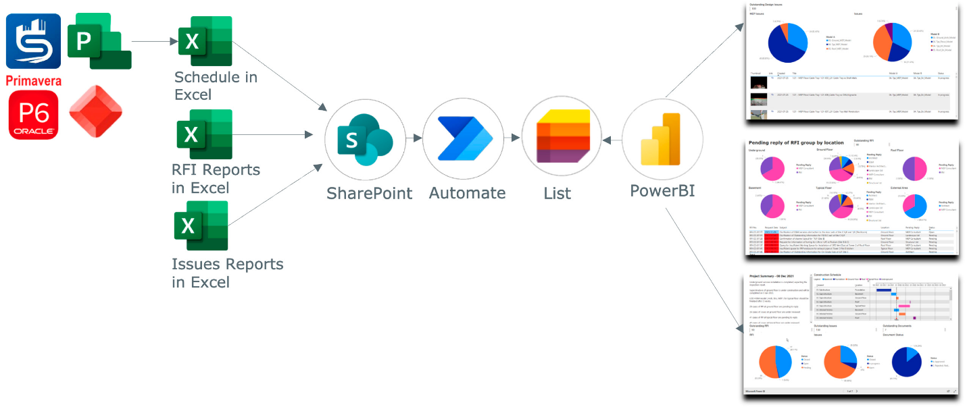
Figure 51: Dashboard-based reporting systems
To provide the efficacy, key performance indicators should be evaluated quarterly with the help of dashboard-based reporting systems that integrate financial, operation, and sustainability indicators. The supervisory agencies are supposed to specify the areas of performance variations and documentation of the corrective measures to be taken to restore the aberrantes promptly. To illustrate this a reduction in customer satisfaction indices may trigger additional staff-level training intercession or an overhauling of the service procedures.
Researches about Balanced Score Card implementation highlight that ongoing monitoring and managerial commitment are vital in determining the success of its implementation process (Ta et al., 2022). Consequently, the framework needs to be incorporated into strategic review processes and not considered as a stand-alone reporting instrument.

4.6 Critical Evaluation of the Framework
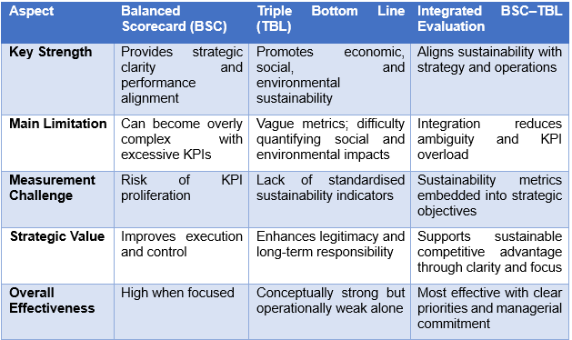
Table 3: Critical Evaluation of the Framework
Even though the Balanced Scorecard is clear in terms of strategy, critics argue that its effectiveness can be undermined should too many key performance indicators be included. Similarly, the Triple Bottom Line has been criticized as having inaccurate measurement benchmarks and an inherent obstacle in quantifying the social and environmental impacts (Bhatti et al., 2025). However, incorporation of both frameworks can overcome the mentioned gaps by harmonizing the sustainability indicators with the strategic plans and the operational procedures.
Empirical evidence suggests that organisations where performance measurement has been combined with innovation, knowledge management and organisational agility are more likely to achieve a sustainable competitive advantage (Satar et al., 2024). Consequently, despite its limitations, the integrated BSC-TBL framework has proven very effective in those situations where it is implemented with clear priorities and managerial commitment.

5. Conclusion and Recommendations

5.1 Conclusion
Finally, the suggested performance evaluation framework that combines the Balanced Scorecard with the Triple Bottom Line provides a holistic and strategic approach to measure the success and performance of the expansion process of Dutch Bros Coffee into the Indian specialty coffee market. The framework has financial, customer, internal process, learning and growth, economic, social and environmental sustainability measures which makes the short-term financial performance consistent with establishment of long-term value and responsible business practices adoption. This kind of integrated approach enables ongoing monitoring of performance, promotes the use of evidence based decision making, and enhances strategic alignment at all levels in the organization. Furthermore, it addresses the unique challenges that go along with working in an emerging market by incorporating sustainability, stakeholder requirements and operational effectiveness into measurable key performance indicators. Subsequently, the framework does not only check the success of expansion but also strengthens the ability of Dutch Bros to build a sustainable competitive advantage, increase brand legitimacy, and boost resilient growth in the Indian market.

5.2 Recommendations
- Develop and implement a combined KPI dashboard to review Balanced Scorecard and Triple Bottom Line indicators in real time.
- Prioritise the measures of customer experience and brand engagement to increase loyalty in urban Indian markets.
- In order for the quality of service to remain consistent and in line with the cultural values of the organization, a greater allocation of resources for the training and development of employees should be a priority.
- Economic and environmentally sustainable alternatives at consumer level can be improved through strengthening of local sourcing practices and by establishing strong and cooperative working relationships with suppliers.
- There should be regular sustainability audits in place to systematically measure and track social and environmental performance criteria.
- KPI reviews and refinements done on a quarterly basis will help to ensure that the KPI continues to align with strategic objectives and is responsive to changing market dynamics.

References

Antoniak, M., Szymkowiak, A., Borusiak, B. and Borović, D. (2025) Coffee and Tea Marketing Journal, Vol. 2 No. 1. London: Coffee & Tea Market Research Institute. Available at: https://www.researchgate.net/publication/393096259
Aversa, P., Huyghe, A. and Bonadio, G. (2022) ‘First impressions stick: Market entry strategies and category priming in the digital domain’, Journal of Management Studies. Available at: https://onlinelibrary.wiley.com/doi/10.1111/joms.12712
Bhatti, A.A., Shaikh, J.R., Shamsi, M.I. and Shamim, K. (2025) ‘Triple bottom-line: A critical review and need for strategic renewal’, Pakistan Business Review, 27(1), pp. 1–28. https://doi.org/10.22555/pbr.v27i1.1368. Available at: https://www.researchgate.net/publication/393743998_Triple_Bottom-Line_A_Critical_Review_and_Need_for_Strategic_Renewal
Bobadilla, L.G., Campos Trigoso, J.A., Bustos Chavez, M.P., Rituay Trujillo, P.A. and Oliva, M. (2024) ‘Structural analysis of the future of the coffee industry in the Amazonas region using a MICMAC approach’, Heliyon, 10(7), e27827. Available at: https://www.sciencedirect.com/science/article/pii/S2405844024038581
De Felice, F., Rehman, M., Petrillo, A. and Baffo, I. (2025) ‘Decoding the coffee supply chain: A systematic review of stakeholders, sustainability opportunities, and challenges’, Sustainable Futures, 10, 101105. Available at: https://www.sciencedirect.com/science/article/pii/S2666188825006690
Farida, I. and Setiawan, D. (2022) ‘Business strategies and competitive advantage: The role of performance and innovation’, Journal of Open Innovation: Technology, Market, and Complexity, 8(3), 163. https://doi.org/10.3390/joitmc8030163. Available at: https://www.researchgate.net/publication/363561015_Business_Strategies_and_Competitive_Advantage_The_Role_of_Performance_and_Innovation
Farouqi, M.F., Hanafi, M.H., Shahril, A.M., Gaffar, V. and Rahman, A.R.A. (2025) ‘Exploring the coffee shop experience: The impact of customer experience on revisit intentions in urban specialty coffee shops’, Journal of Nusantara Studies, 10(2), pp. 417–448. https://doi.org/10.24200/jonus.vol10iss2pp417-448. Available at: https://www.researchgate.net/publication/394189669
Gunawan, A., Dewayana, S.S., Suryadi, K. and Anne Marie, I. (2025) ‘Sustainable competitive advantage in creative SMEs: A systematic bibliometric review of scholar literature’, Multidisciplinary Reviews, 9(2), 2026065. https://doi.org/10.31893/multirev.2026065. Available at: https://www.researchgate.net/publication/396145549_Sustainable_competitive_advantage_in_creative_SMEs_A_systematic_bibliometric_review_of_scholar_literature
Jali, N.P., Doorasamy, M. and Gregory, V. (2025) ‘Triple bottom line’s elements, sustainability and growth of small manufacturing enterprises in an emerging economy’, International Journal of Applied Research in Business and Management, 6(2). https://doi.org/10.51137/wrp.ijarbm.2025.njtt.45825
Khan, W., Sainger, G., Siddiqui, M.S. and Mateen, B. (2025) ‘Percolating insights: A study on coffee purchase behaviour in an emerging economy’, British Food Journal, 127(10), pp. 3895–3909. Available at: https://www.emerald.com/insight/content/doi/10.1108/BFJ-01-2025-1271589/full/html
Kostruba, A.V. and Kostruba, O. (2025) ‘Strategies for companies to enter international markets: Literature review and conceptualization’, Danube, 16(2), pp. 154–175. https://doi.org/10.2478/danb-2025-0008. Available at: https://www.researchgate.net/publication/394191007_Strategies_for_Companies_to_Enter_International_Markets_Literature_Review_and_Conceptualization
Kurniasari, F., Madepo, M.A. and Naím, A. (2025) ‘Enhancing sustainable business practices: Triple-layer business model canvas analysis of SEGITIGA Coffee’, International Economics and Business Conference (IECON), Vol. 3 No. 1, pp. 401–415.
Madsen, D.Ø. (2025) ‘Balanced scorecard: History, implementation, and impact’, Encyclopedia, 5(1), p. 39. https://doi.org/10.3390/encyclopedia5010039. Available at: https://www.researchgate.net/publication/389984126_Balanced_Scorecard_History_Implementation_and_Impact
Martín Martín, O., Chetty, S. and Bai, W. (2022) ‘Foreign market entry knowledge and international performance: The mediating role of international market selection and network capability’, Journal of World Business, 57(2), 101266. Available at: https://www.sciencedirect.com/science/article/pii/S1090951621000746
Maurseth, P.B., Masso, J. and Holmen, R.B. (2025) ‘FDI and trade for foreign market entry: Theory and evidence from Estonia’, Baltic Journal of Economics, 25(1). Available at: https://www.tandfonline.com/doi/full/10.1080/1406099X.2025.2463863
Meeprom, S. and Kokkhangplu, A. (2025) ‘Customer experience and satisfaction in coffee consumption: An experiential marketing perspective’, Cogent Business & Management, 12(1). Available at: https://www.tandfonline.com/doi/full/10.1080/23311975.2025.2450296
Mukherjee, D.P. and Siya, P. (2025) Analysing India’s competitive edge in the coffee industry. SSRN Electronic Journal. https://doi.org/10.2139/ssrn.5267241. Available at: https://www.researchgate.net/publication/392052084_Analysing_India's_Competitive_Edge_In_The_Coffee_Industry
Proença, J.F., Torres, A.C., Marta, B., Silva, D.S., Fuly, G. and Pinto, H.L. (2022) ‘Sustainability in the coffee supply chain and purchasing policies: A case study research’, Sustainability, 14(1), 459. https://doi.org/10.3390/su14010459. Available at: https://www.mdpi.com/2071-1050/14/1/459
Satar, A., Al Musadieq, M., Hutahayan, B. and Solimun (2025) ‘Creating a sustainable competitive advantage: The roles of technological innovation, knowledge management, and organizational agility’, Journal of Entrepreneurship, 44(3), pp. 11–23. Available at: https://onlinelibrary.wiley.com/doi/10.1002/joe.22280
Statista (2025) Revenue of Dutch Bros from 2020 to 2025 (in million U.S. dollars). Available at: https://www.statista.com/
Stern, G. (2020) Dutch Bros Coffee: A staple in the West and growing fast despite the pandemic. Forbes, 1 December. Available at: https://www.forbes.com/sites/garystern/2020/12/01/dutch-bros-coffee-a-staple-in-the-west-and-growing-fast-despite-the-pandemic/
Stern, G. (2024) Dutch Bros expanding faster than you can say iced coffee. Forbes, 18 December. Available at: https://www.forbes.com/sites/garystern/2024/12/18/dutch-bros-expanding-faster-than-you-can-say-iced-coffee/
Su’udiah, V. (2025) ‘Navigating cross-cultural business strategies: The impact of globalization on international market entry in emerging economies’, Indonesian Interdisciplinary Journal of Sharia Economics, 8(2), pp. 4053–4078. https://doi.org/10.31538/iijse.v8i2.6366. Available at: https://www.e-journal.uac.ac.id/index.php/iijse/article/view/6366
Subarjo, I.M. (2025) ‘Analysis of factors affecting the supply of cafe service industry in Pekanbaru City’, Global Insights in Management and Economic Research, 1(1), pp. 6–11. https://doi.org/10.53905/Gimer.v1i01.2. Available at: https://www.researchgate.net/publication/393641926
Ta, T.T., Doan, T.N., Tran, H.N., Dam, T.A. and Pham, T.M.Q. (2022) ‘Factors affecting the application of balanced scorecard to enhance operational efficiency of listed companies: The case of Vietnam’, Cogent Business & Management, 9(1). Available at: https://www.tandfonline.com/doi/full/10.1080/23311975.2022.2149146
Vu, O.T.K., Alonso, A.D., Carrillo, B., Velasquez, S., Buitrago Solis, M.A., Nayak, N.P., Nguyen, C., Cáceres Gutiérrez, J.P., Gonzalez Alandia, B.E. and Nguyen, N.M. (2025) ‘Understanding coffee tourism development through the dynamic capabilities lens: A qualitative cross-national exploration’, Tourism Recreation Research. Available at: https://www.tandfonline.com/doi/full/10.1080/02508281.2025.2513358
Wu, Y. (2023) ‘Coffee industry investment analysis based on indicators: Evidence from Dutch Bros, Starbucks and Luckin Coffee’, Highlights in Business Economics and Management, 7, pp. 36–41. https://doi.org/10.54097/hbem.v7i.6822. Available at: https://www.researchgate.net/publication/369876693
Xu, W. (2023) ‘Analysis of Dutch Bros marketing strategies’, Advances in Economics, Management and Political Sciences, 18(1), pp. 263–268. https://doi.org/10.54254/2754-1169/18/20230081. Available at: https://www.researchgate.net/publication/373896272

