
University of Wales Trinity Saint David
School of Engineering
BEng Motorsport Engineering (Hons) - Year 3

Title of Report

Analytical Assessment of Engine Internal Components

Module Name and Code

Contemporary Powertrain Design – ACHA6006
Student Name & Number

Justin Elliott - 2404771
Submission Date

16/03/2025

2324 Words

University of Wales Trinity Saint David
2024-2025
Contents
Table of Figures 4
Introduction 1
Task 1: Ford EcoBoost 1.6 GDTi Engine Components 2
1.1: Engine Specifications 2
1.2: Connecting Rod at Midpoint 3
1.2.1: Conrod Force 3
1.2.2: Fatigue Safety Factor 4
1.2.3: Goodman Diagram 5
1.3: Gudgeon Pin at Point A 6
1.3.1: Resultant Stress 7
1.3.2: Fatigue Safety Factor 7
1.3.3: Goodman Diagram 8
1.4: Connecting Rod Bolt 9
1.4.1: Fatigue Safety Factor 9
1.4.2: Goodman Diagram 10
1.5: Original Components Analysis 11
Task 2: Ford EcoBoost 1.6 GDTi Engine Connecting Rod Bolts to 9000 RPM 12
2.1: Fatigue Safety Factor 12
2.2: Goodman Diagram 12
Task 3: Ford EcoBoost 1.6 GDTi Engine Components Redesigns 13
3.1: Material 13
3.1.1: Ti-6Al-4V (Grade 5) Titanium Alloy 14
3.1.2: C350 Maraging Steel 15
3.1.3: Inconel 718 Sprint Temper Goodmand Diagram 16
3.2: Surface Finishes 17
3.2.1: Nitriding 17
3.3: Geometry/Design 18
Task 4: Ford EcoBoost 1.6 GDTi Crankshaft Configurations Instantaneous Torques 19
4.1: Flat Plane 19
4.1.1: Torque Inertia Per RPM 19
4.1.2: Torque Inertia Per Cylinder 20
4.1.3 Crank Torque Per Cylinder 21
4.2: Cross Plane 22
4.2.1: Torque Inertia Per Cylinder 22
4.3: Comparison 23
4.3.1: Torque Inertia 23
4.3.2: Gas Torque 24
Conclusion 25
References 26

Table of Figures
Figure 1: Ford EcoBoost 1.6 GDTI Demo Engine (Dana60Cummins, 2011) 2
Figure 2: Conrod Force Per 1000 RPM Graph 3
Figure 3: Connecting Rod Goodman Diagram 5
Figure 4: Gudgeon Pin Diagram Depicting Point A (Harrison, 2025) 6
Figure 5: Gudgeon Pin Resultant Stress Per 1000 RPM Graph 7
Figure 6: Gudgeon Pin Goodman Diagram 8
Figure 7: Original Conrod Bolt Goodman Diagram 10
Figure 8: Original Conrod Bolt With RPM Extension Goodman Diagram 12
Figure 9: Ti-6AI-4V Titanium Alloy Conrod Bolt Goodman Diagram 14
Figure 10: C350 Maraging Steel Conrod Bolt Goodman Diagram 15
Figure 11: Inconel 718 Sprint Temper Conrod Bolt Goodman Diagram 16
Figure 12: Residual Compressive Stress from Nitriding vs Distances From Surface Graph (Hearn, 1997) 17
Figure 13: Flat Plane Torque Inertia per 1000 RPM Graph 19
Figure 14: Flat Plane Torque Inertia Per Cylinder Graph 20
Figure 15: Flat Plane Crank Torque Per Cylinder Graph 21
Figure 16: Cross Plane Torque Inertia Per Cylinder Graph 22
Figure 17: Flat and Cross Plane Torque Inertia Comparison Graph 23
Figure 18: Flat and Cross Plane Gas Torque Comparison Graph 24

Introduction
This report examines the forces, stresses, and Fatigue Safety Factor (FSF) experienced by the midpoint of the connecting rod (conrod), the gudgeon pin at point A, and the connecting rod bolts, in a Ford EcoBoost 1.6L engine. Goodman diagrams are used to assess the fatigue performance of these parts, with a critical evaluation of life expectancy and potential overengineering.
To simulate the design of the engine being modified, the engine's RPM range is increased to 9000 RPM through interpolation of pressure data. The new forces and stresses on the conrod bolts are recalculated, and their FSF values reassessed to determine the impact on component performance and durability.
Furthermore, based on the findings, multiple redesigns of the conrod bolts are proposed to restore or improve their safety factor under the extended RPM range. Finally, instantaneous torque calculations for both standard (flat-plane) and cross-plane crankshaft configurations are performed, with a discussion on their differences and suitability for various applications.
Finally, concluding comments are made about the findings of this report, with an evaluation of the report overall, as well as ideas to expand on this report included.

Task 1: Ford EcoBoost 1.6 GDTi Engine Components
Using the engine specifications given, the forces of the piston, conrod, Gudgeon Pin and Conrod Bolts were calculated using MATLAB.

1.1: Engine Specifications
The Ford EcoBoost 1.6 Litre GDTI, seen in figure 1, is a 16-Valve DOHC, transversely mounted, Inline 4 Cylinder Turbocharged DI Petrol Engine. Part of the Ford Sigma engine family and with a maximum RPM of 6000, it’s power and torque output is 110 KW and 240 Nm @ 1600-4000 RPM respectively. (Ford, n.d)
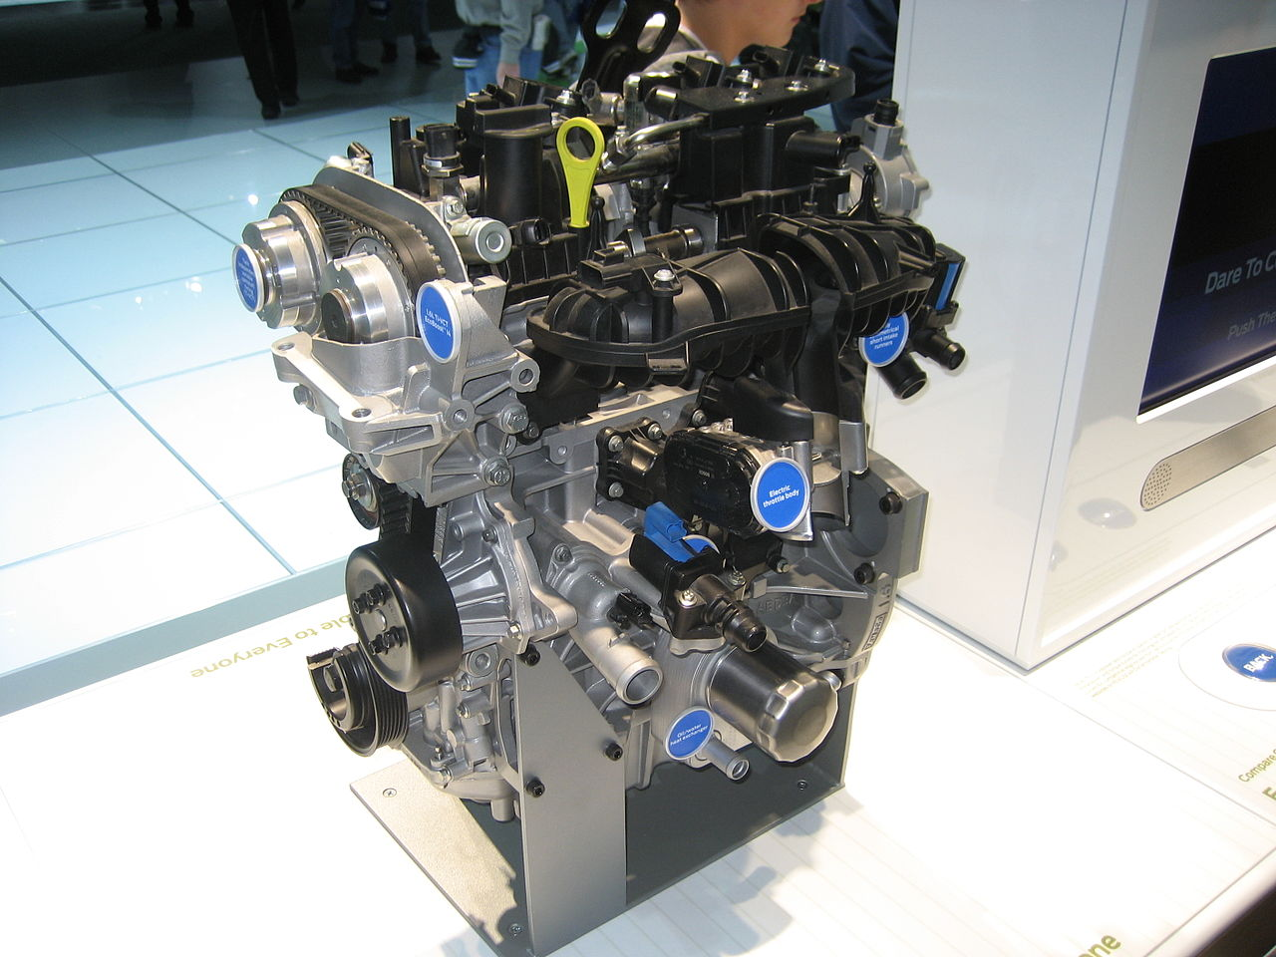
Figure 1: Ford EcoBoost 1.6 GDTI Demo Engine (Dana60Cummins, 2011)

1.2: Connecting Rod at Midpoint

1.2.1: Conrod Force
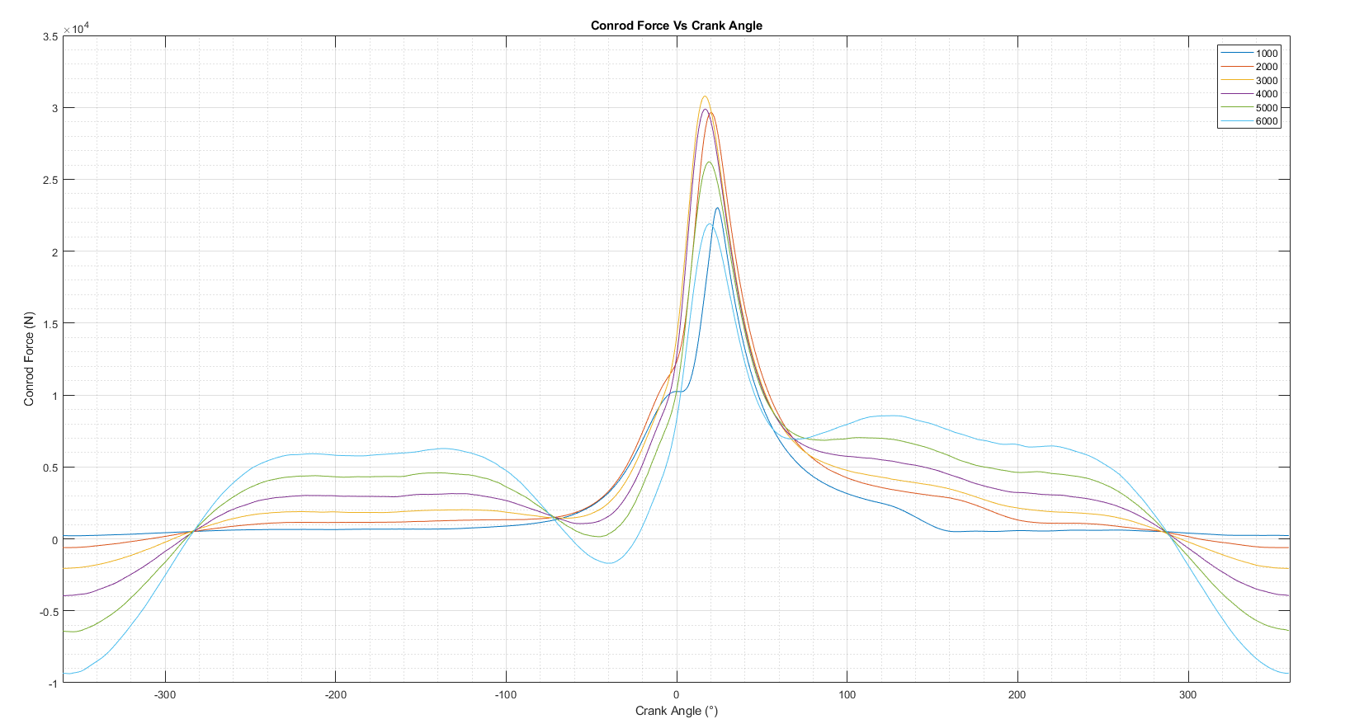
Figure 2 shows the force in Newtons on the conrod vs Crank Angle in degrees for each 1000 RPM interval.
Figure 2: Conrod Force Per 1000 RPM Graph

1.2.2: Fatigue Safety Factor
More and Merlyn describe the component fatigue safety factor (FSF) as “the factor of safety (FOS) with respect to a fatigue failure at a given design life.” (More & Merlyn, 2020) The maximum Factor of Safety for a component or part is 15 (unitless) and Fatigue Safety Factor values less than one indicate failure before the design life is reached.” (More & Merlyn, 2020) A components FSF should be at least 2 for infinite fatigue design meaning the component is designed to withstand an infinite number of cycles without failure.
A component’s FSF can be calculated using the following equation:
$FSF=\frac{1}{\left(\frac{S_{alt}}{S_{e}}+\frac{S_{mean}}{S_{ult}}\right)}$ (1)
$$FSF=Fatigue Safety Factor$$
$$S_{alt}=Alternating Stress$$
$$S_{e}=Endurance Limit$$
$$S_{mean}=Mean Stress$$
$$S_{ult}=Ultimate Tensile Stress (UTS)$$

(Ansys Innovation Courses, n.d)

After running the MATLAB script, the original OEM conrod FSF was calculated to be 2.1077. This is within the typical range for an automotive road car engine conrod FSF.

1.2.3: Goodman Diagram
“The Goodman diagram is a more useful presentation of the fatigue life test, as compared to the prior method “stress-life.” It is used to predict the fatigue life at a given stress ratio (alternating and mean stresses), based on the material properties (ultimate strength, S_{ut}, and endurance strength, S_{e}). It considers the specimen’s geometry and surface condition.” (Farhat, 2021)
The conrod stresses were then used to plot a goodman diagram to visually present the calculated data, seen in Figure 3.
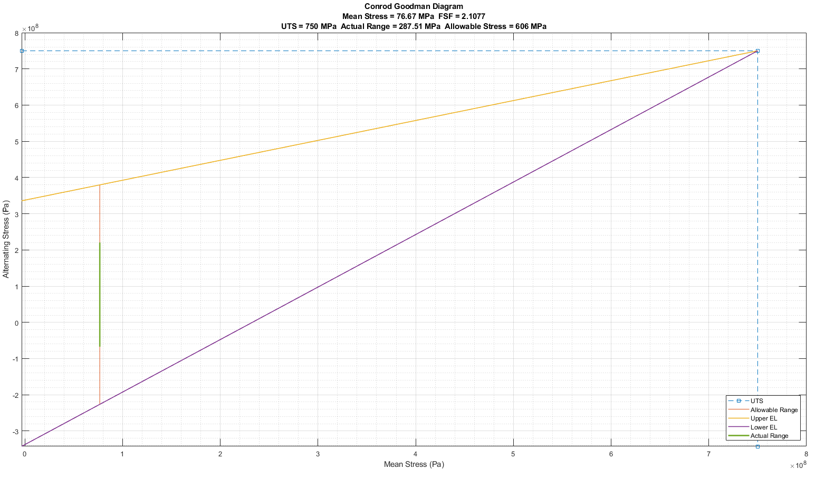
Figure 3: Connecting Rod Goodman Diagram

1.3: Gudgeon Pin at Point A
Next, the Gudgeon Pin FSF was calculated at Point A, in Figure 4 below, and a Goodman Diagram plotted.
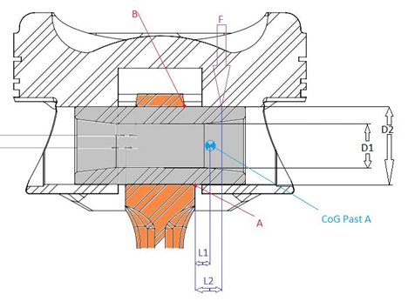
Figure 4: Gudgeon Pin Diagram Depicting Point A (Harrison, 2025)

1.3.1: Resultant Stress
The resultant stress was also calculated using the forces acting on the Gudgeon Pin, in MATLAB.
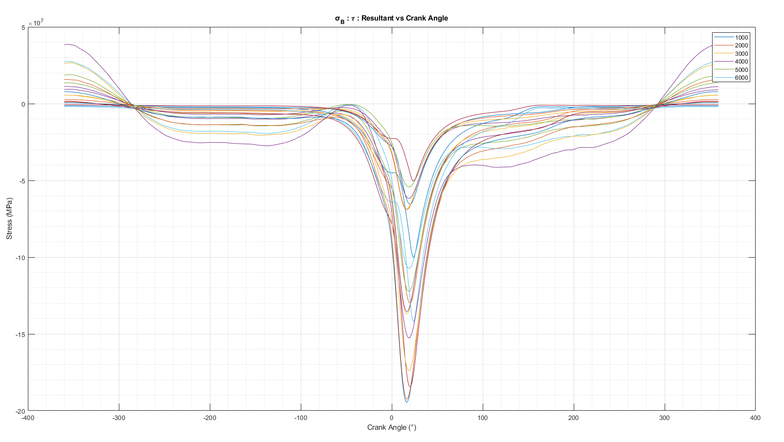
Figure 5: Gudgeon Pin Resultant Stress Per 1000 RPM Graph

1.3.2: Fatigue Safety Factor
The FSF of the original gudgeon pin was calculated to be 4.1626. This is an exceedingly high value and shows that the component is over engineered.

1.3.3: Goodman Diagram
A Goodman Diagram, seen in the Figure below, was produced in MATLAB.
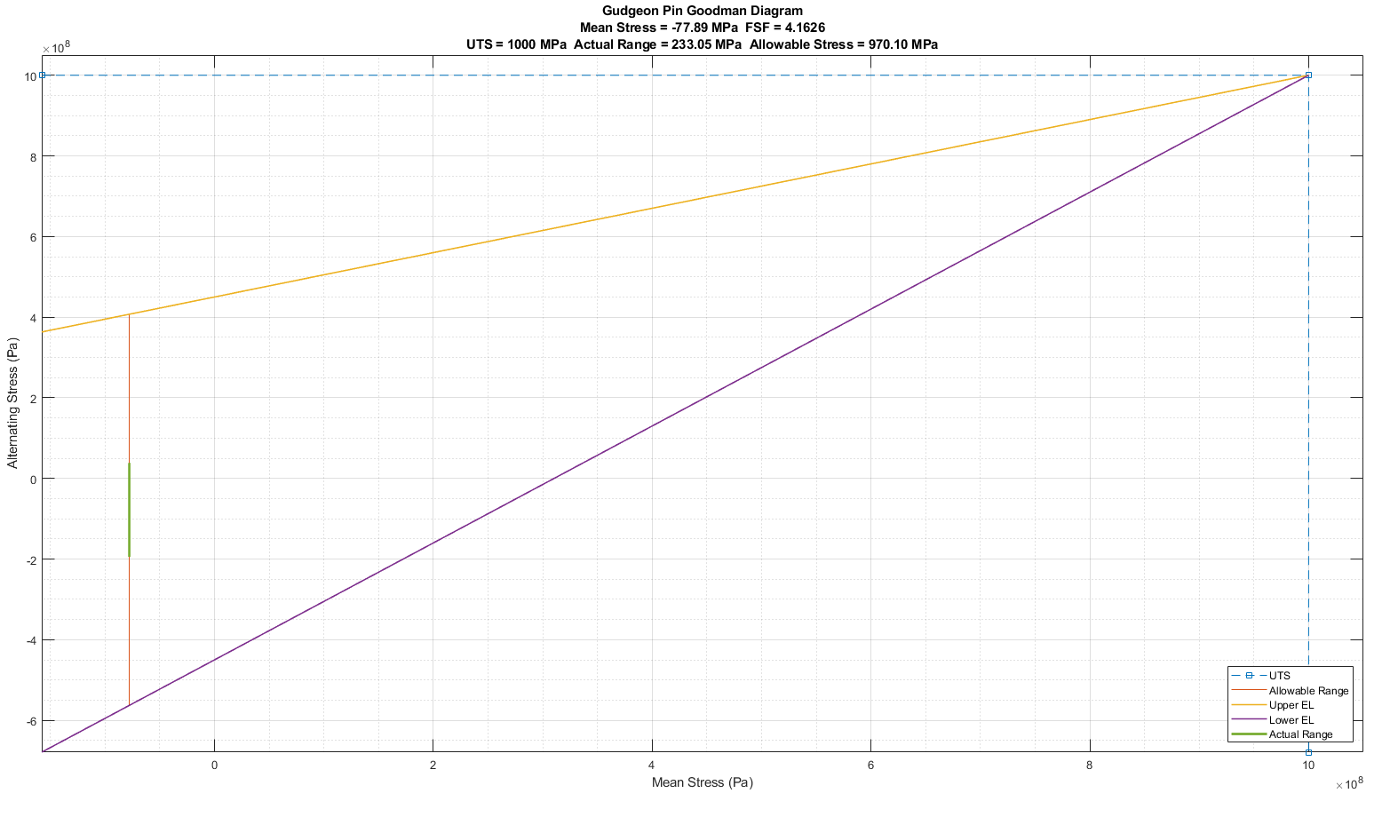
Figure 6: Gudgeon Pin Goodman Diagram

1.4: Connecting Rod Bolt
Connecting rod bolts are among the most important fasteners in an engine, as they secure the rotating assembly. If a rod bolt fails, it can result in catastrophic engine failure. One of the most crucial joints in the engine is where the two halves of the connecting rod meet, and the rod bolts must endure significant tension forces during each crankshaft rotation. (Automotive Racing Products, 2023)
As the crankshaft rotates, the big end of the connecting rod momentarily becomes oval-shaped, causing the rod bolts to flex. When the crankshaft continues rotating, the rod returns to its original shape. Due to these alternating tension loads and cyclic bending, it is essential to use fasteners capable of exerting a clamping force that exceeds the loads imposed on the joint. Beyond selecting rod bolts with sufficient strength to manage the extreme cyclic stress, proper installation and tightening are critical. (Automotive Racing Products, 2023)

1.4.1: Fatigue Safety Factor
The FSF of the original OEM conrod bolt was calculated to be 2.5076. This is beyond the typical required FSF of engine components, suggesting the part is over engineered.

1.4.2: Goodman Diagram
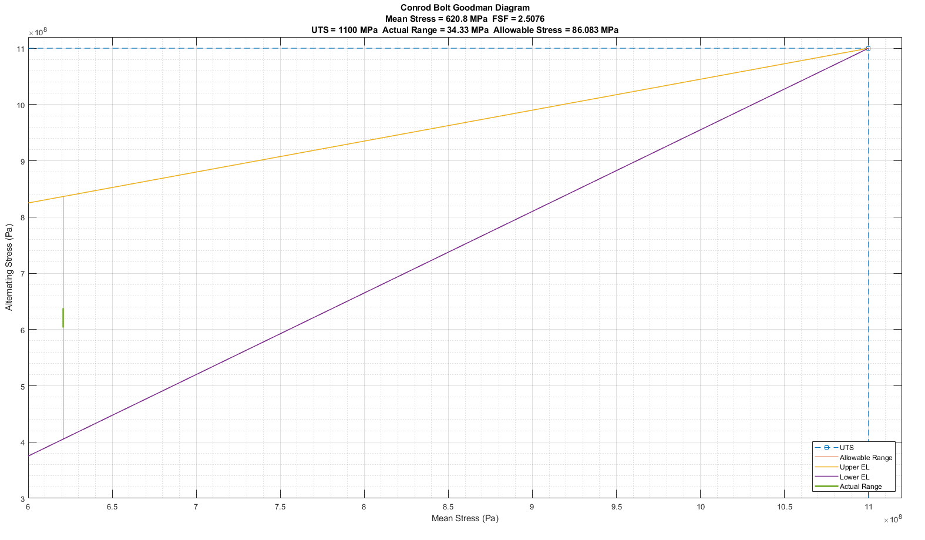
Figure 7 below shows the Goodman Diagram for the standard conrod Bolt.
Figure 7: Original Conrod Bolt Goodman Diagram

1.5: Original Components Analysis
Ford EcoBoost 1.6L GDTi is an engine designed for road car use. The over engineering of the original OEM components could be for reliability, especially after very high milage and running time with potentially below adequate levels of maintenance such as regular engine oil changes.
Also, due to Ford being a mass manufacturer, these parts might have been designed for multipurpose use in a range of different engines/engine models with higher power and torque outputs resulting in higher forces and stress on the internal components. This would lower the production cost, time and complexity of engines for Ford.

Task 2: Ford EcoBoost 1.6 GDTi Engine Connecting Rod Bolts to 9000 RPM
To simulate the engines maximum speed being increased to 9000 RPM, the MATLAB code for the conrod bolts was edited to extend the RPM range to 9000 RPM in 1000 RPM steps. The given cylinder pressure data was then extended to the new maximum RPM by using linear interpolation and extrapolation.

2.1: Fatigue Safety Factor
The extended data was then used to calculate the conrod bolts new FSF of 0.4633. This decreased UTS at 9000 RPM will increase the amount of fatigue the bolts experience due to cyclic loading, reducing there lifespan significantly. The FSF of below 1 indicates that the bolts will fail prematurely which will most likely cause major damage to the engine.

2.2: Goodman Diagram
Figure 8 shows the Goodmand Diagram for the Original Conrod Bolt after extending the RPM range to 9000.
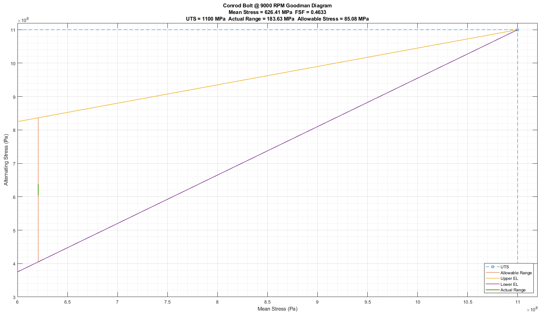
Figure 8: Original Conrod Bolt With RPM Extension Goodman Diagram

Task 3: Ford EcoBoost 1.6 GDTi Engine Components Redesigns
To improve the FSF of the conrod bolts to prevent failure at the extended RPM, the conrod bolts were redesigned by adjusting the bolts values in the MATLAB script.

3.1: Material
The table below compares the various materials tested for redesigning the conrod bolt to withstand the increased forces at the extended RPM range to 9000 RPM. Red signifies the calculated FSF is below 1, Yellow signifies the FSF is above 1 and Green above 2.
Material | Treatment | Description | UTS | Mean Stress (MPa) | FSF
Ti-6Al-4V (Grade 5) Titanium Alloy | - | Alpha-beta alloy | 1000 | 583.21 | 0.408
Original | - | OEM Steel | 1100 | 620.80 | 0.463
Nimonic 115 Superalloy | - | Nickel-Chromium Based Alloy | 1300 | 550.81 | 0.733
C350 Maraging Steel | - | 12% Cobalt, 4.8% Molybdenum | 2412 | 1357.69 | 1.032
C350 Maraging Steel | Nitriding | 12% Cobalt, 4.8% Molybdenum | 2612 | 1357.69 | 1.357
Inconel 718 | Spring Temper + Annealed + Aged | Expensive | 3900 | 1287.94 | 2.583
Inconel 718 | Sprint Temper | Very Expensive,  Special Tooling | 5100 | 1165.87 | 3.849
Figure 9: Table of Conrod Bolts Materials Redesigns

3.1.1: Ti-6Al-4V (Grade 5) Titanium Alloy
Figure 9 shows the Goodman Diagram for the Conrod Bolt using Ti-6Al-4V Titanium Alloy. It is the most widely used high strength titanium and is an alpha-beta alloy. (Smiths High Performance, 2023)
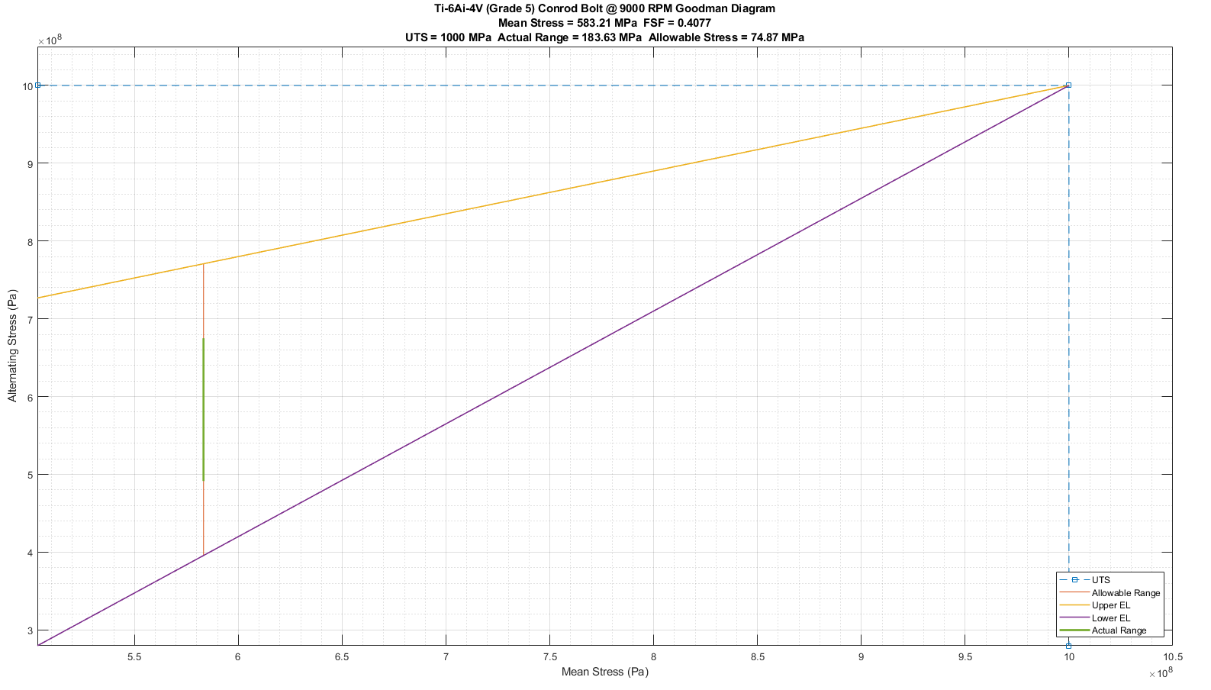
Figure 9: Ti-6AI-4V Titanium Alloy Conrod Bolt Goodman Diagram

3.1.2: C350 Maraging Steel
C350 Maraging Steel is a high strength steel alloy for high performance motorsport components containing 12% cobalt and 4.8% Molybdenum. Typically, the higher the alloy content of the steel, the higher the cost of the base material. (Smiths High Performance, 2023)

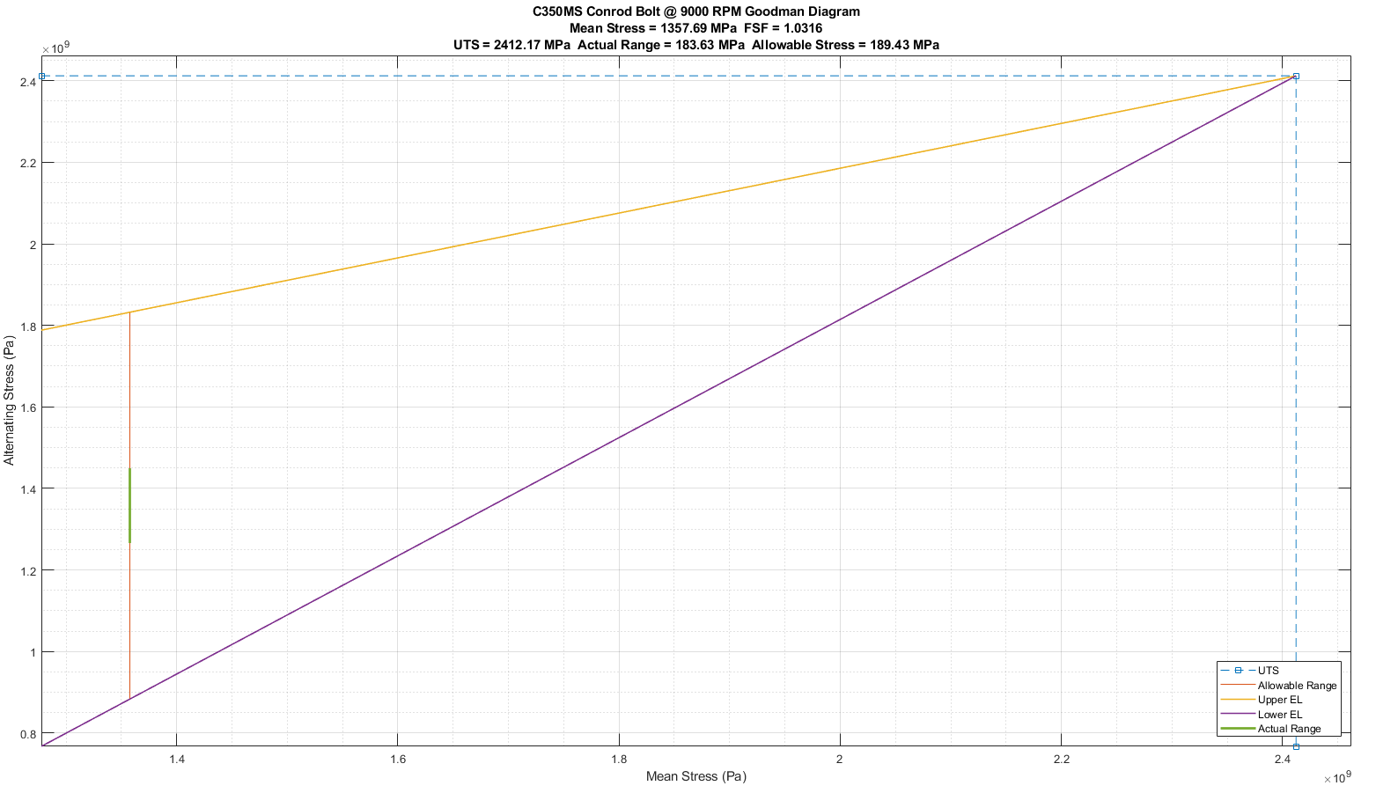
Figure 10: C350 Maraging Steel Conrod Bolt Goodman Diagram

3.1.3: Inconel 718 Sprint Temper Goodmand Diagram
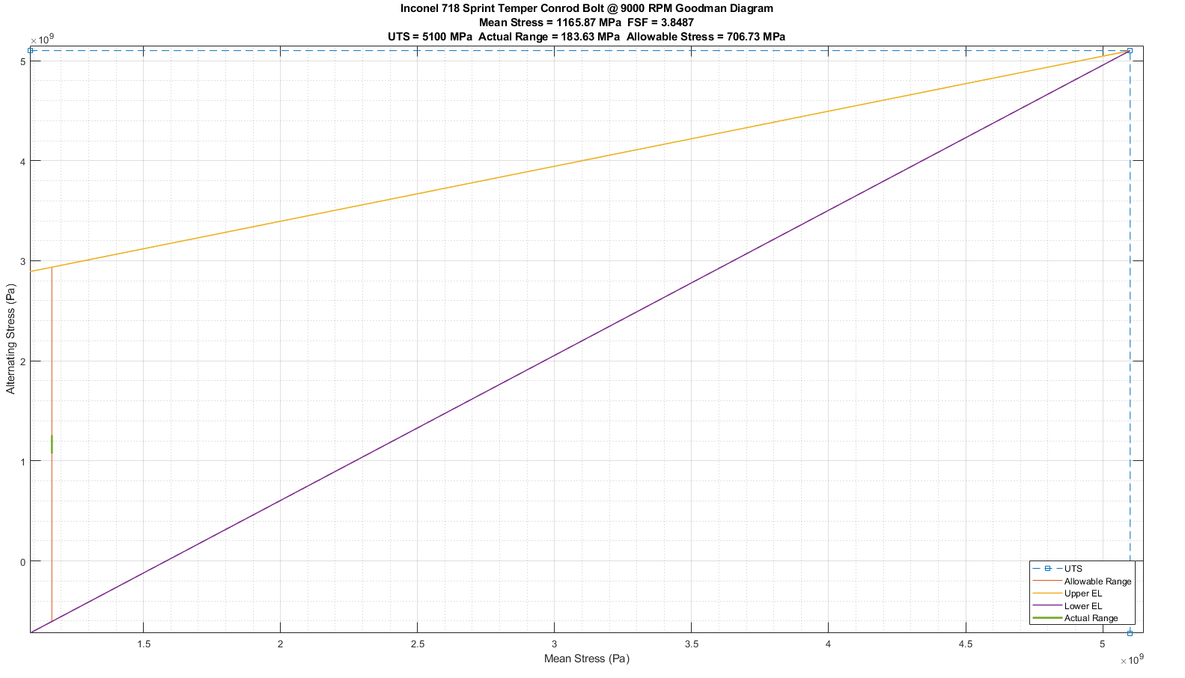
Inconel 718 is a high strength super alloy with excellent yield strength. It is a precipitation-hard enable nickel based alloy designed to display exceptionally high creep-rupture, tensile and yield properties at temperatures up to 1300°F. (Smiths High Performance, 2023) Figure 11 shows the Goodman Diagram for the Conrod Bolt.
Figure 11: Inconel 718 Sprint Temper Conrod Bolt Goodman Diagram

3.2: Surface Finishes
Many types of surface finishing are available to metal which can improve the materials properties. These include but are not limited to Shot Peening, Nitriding, Polishing and Carburising.

3.2.1: Nitriding
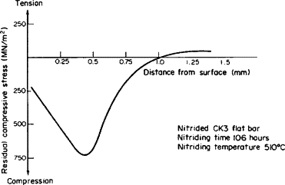
Nitriding is a heat treatment process in which certain alloy steels are exposed to an ammonia atmosphere at approximately 550 °C for durations ranging from 10 to 100 hours. This leads to the formation of nitrides on the steel’s surface, causing a slight volumetric expansion. The underlying core material resists this expansion, generating significant residual compressive stresses. The resulting hardened surface layer, typically around 0.5 mm thick, enhances resistance to stress concentrations such as surface notches. This combination of increased hardness and high residual compressive stresses significantly improves the fatigue life of nitrided components compared to the untreated material. Minimal distortion or warping is produced by the nitriding process and no quenching is required. (Hearn, 1997)
Figure 12: Residual Compressive Stress from Nitriding vs Distances From Surface Graph (Hearn, 1997)
Plasma nitriding is relatively safe for the environment, with energy consumption being reduced by around 56% compared to gas nitriding and uses significantly less process gas, resulting in lower emissions of harmful gases. Furthermore, the Nitriding process can be a costly process to run based on batch processing and long cycle times compared to other types of heat treatments, however this depends on the type of nitriding.

3.3: Geometry/Design
The geometry of the bolts could also be redesigned to increase the bolts factor of safety such as rolling the threads or increasing the amount of wasted shank.

Task 4: Ford EcoBoost 1.6 GDTi Crankshaft Configurations Instantaneous Torques
To find if a cross plane crankshaft configuration was more suitable to the higher RPM, the instantaneous torques were calculated for both the standard flat plane and the alternate cross plane at each 1000 RPM interval and each cylinder.

4.1: Flat Plane
The standard crankshaft configuration in the Ford Ecoboost 1.6L engine is a Flat-Plane design.

4.1.1: Torque Inertia Per RPM

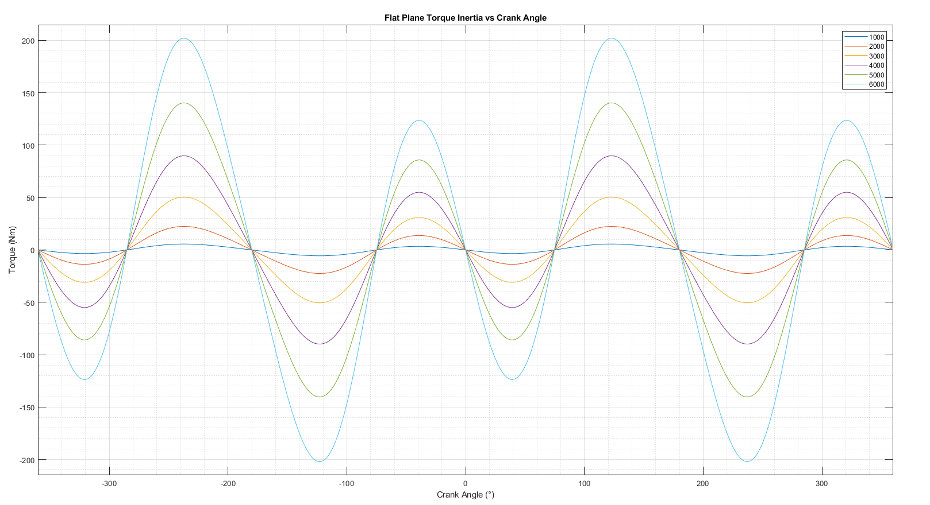
Figure 13: Flat Plane Torque Inertia per 1000 RPM Graph

4.1.2: Torque Inertia Per Cylinder
Figure 14 below presents the flat plane crankshaft torque inertia per cylinder.
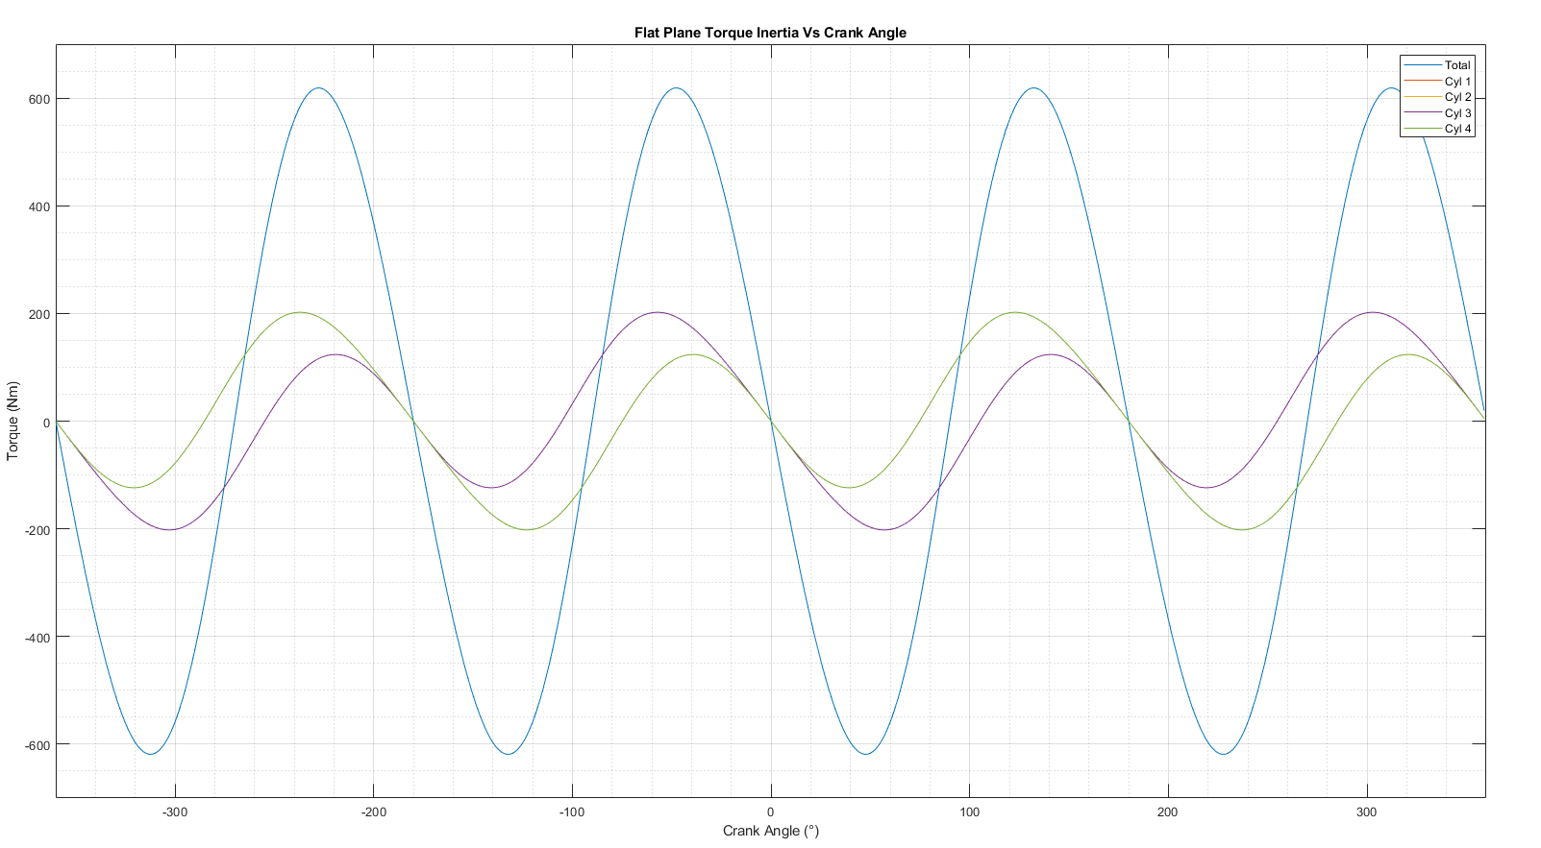
Figure 14: Flat Plane Torque Inertia Per Cylinder Graph

4.1.3 Crank Torque Per Cylinder
Figure 15 shows the Flat Plane Crank Torque per cylinder.
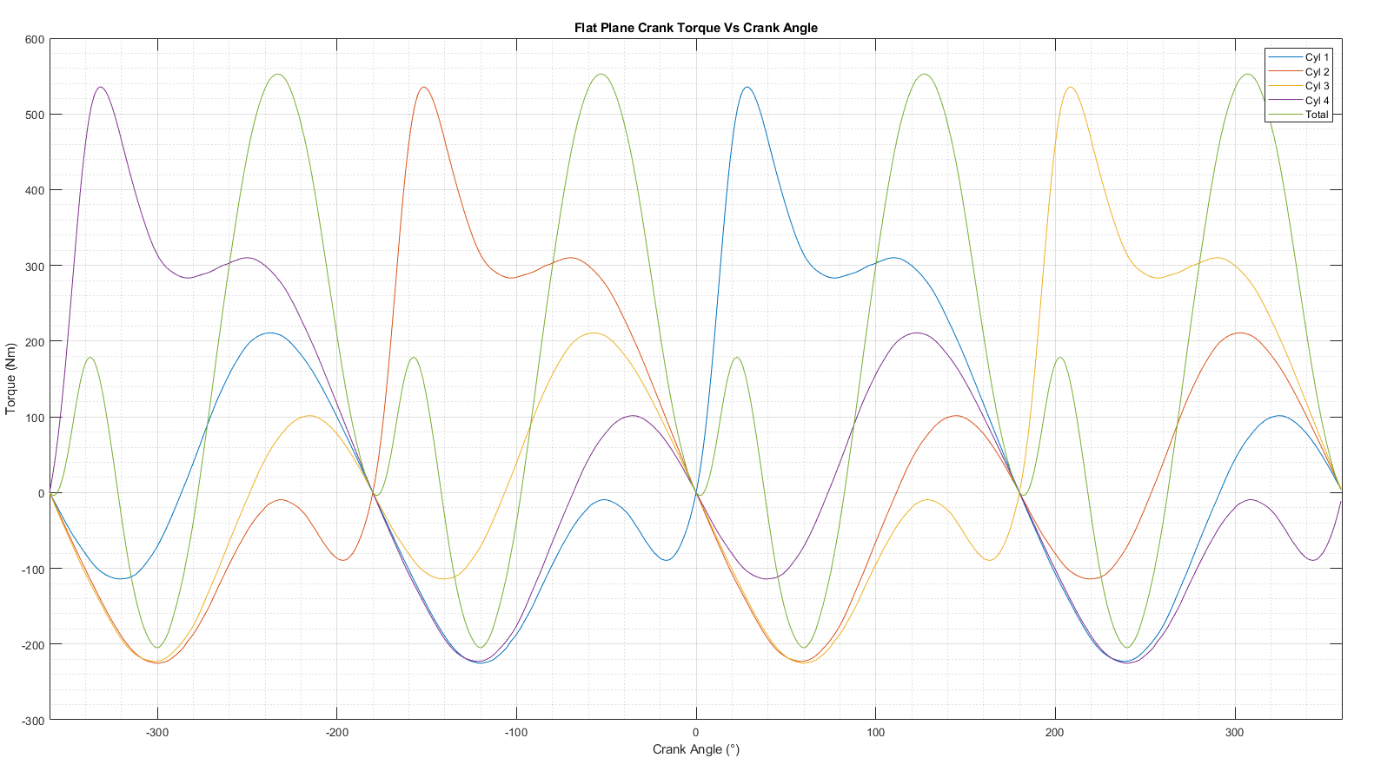
Figure 15: Flat Plane Crank Torque Per Cylinder Graph

4.2: Cross Plane
To compare the two crankshaft configurations, the torque inertia per cylinder using a Cross Plane was calculated and presented in Figure 16.

4.2.1: Torque Inertia Per Cylinder
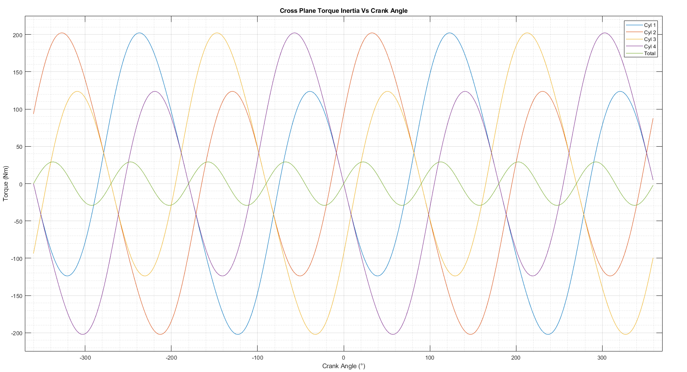
Figure 16: Cross Plane Torque Inertia Per Cylinder Graph

4.3: Comparison
Bothe the flat-plane and cross-plane are then compared.

4.3.1: Torque Inertia
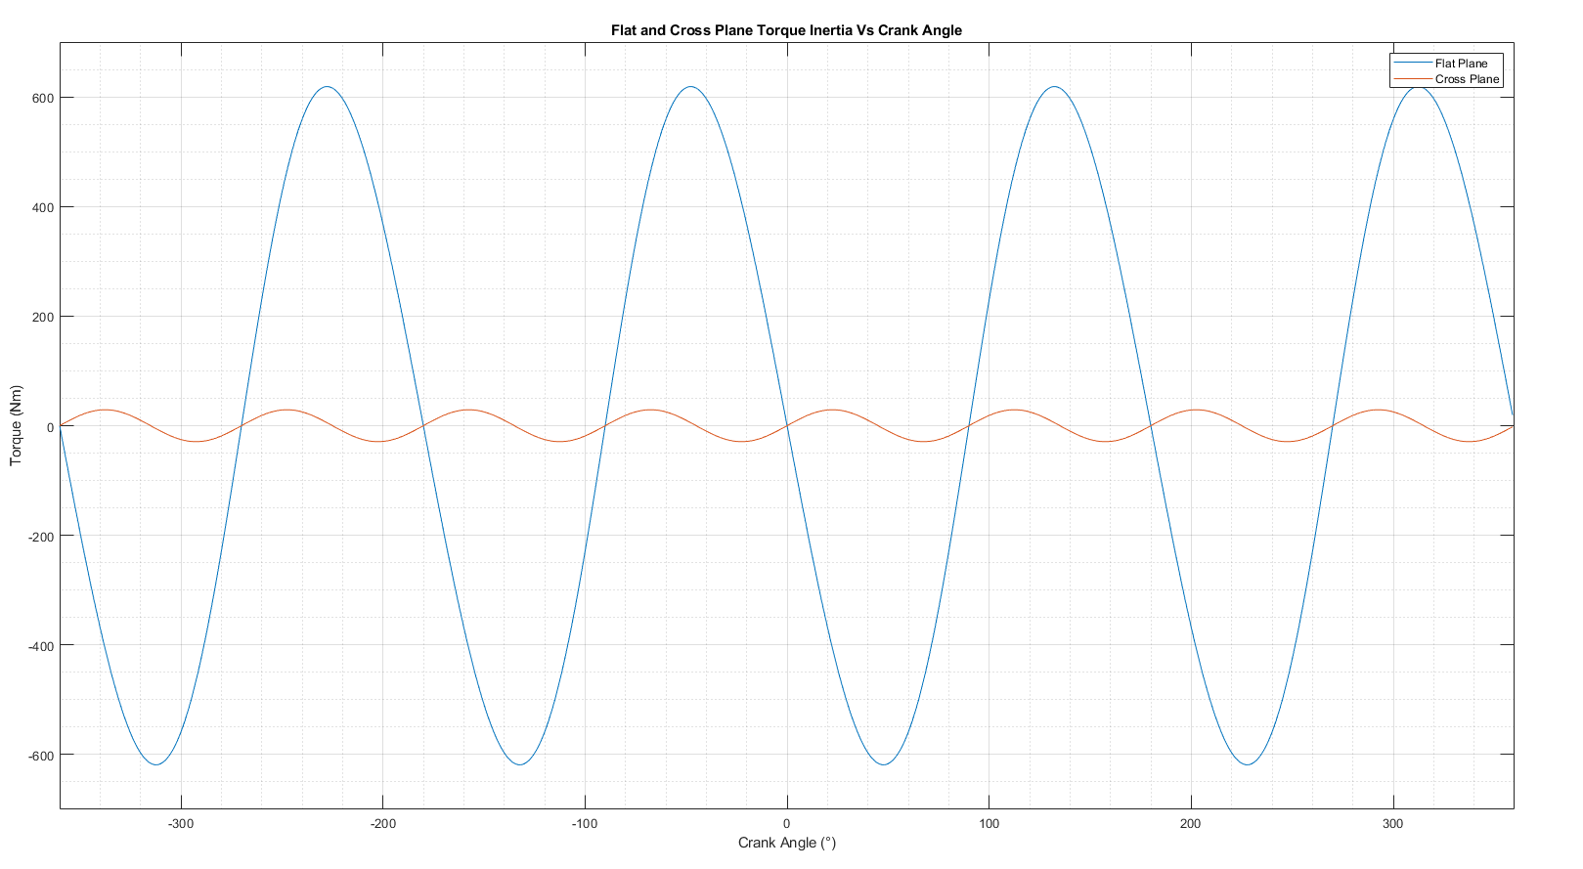
Figure 17 shows the calculated flat and cross plane torque inertia. As can be seen, significantly more torque inertia is produced from the flat plane compared to the cross plane.
Figure 17: Flat and Cross Plane Torque Inertia Comparison Graph

4.3.2: Gas Torque
Figure 18 below compares the gas torque for a flat plane and a cross plane crankshaft. The flat plane torque is consistent across the crank angle range. In comparison, the cross plane shows higher peak torque as well as being inconsistent across the piston cycle.
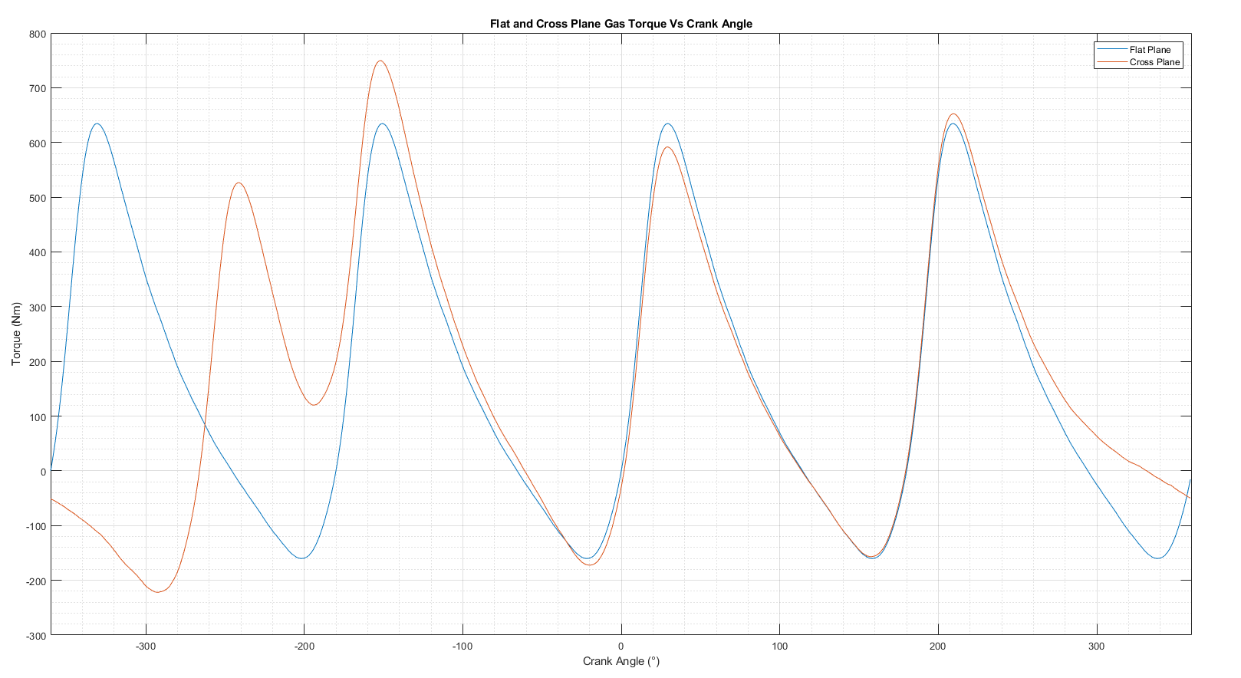
Figure 18: Flat and Cross Plane Gas Torque Comparison Graph

From the calculated data the standard, flat-plane crankshaft seems better suited for the higher RPM due to its lower rotating mass and better balance at high RPM.

Conclusion
In conclusion, the original selected components are over engineered for the forces applied to them, up to the standard maximum RPM of 6000. Furthermore, when extending the maximum RPM to 9000 and interpolating the pressure data, the conrod bolt FSF falls below 1 FSF. This means it will fail prematurely, before 1 lifetime.
The best suited material to redesign the conrod bolt for the extended RPM range was found to be Inconel 718 with spring tempering, annealing and aging, as the FSF was increased to above the original FSF at 9000 RPM as well as being cheaper and easier to manufacture parts from than Inconel 718 with sprint tampering.
After reviewing and comparing the calculated data, the best suited crankshaft configuration for the extended RPM range was the flat plane crankshaft configuration due to its lower rotating mass and better balance at high RPM.
A possible inaccuracy within the calculations was using extrapolation to extend the data beyond the given range, as this may introduce inaccuracies if the trend does not follow a linear pattern beyond the known values.
To expand on this report, the Gudgeon pin FSF at 900 RPM could be calculated and CR14 Titanium Alloy used to improve the FSF if required as this is a commonly used high performing material used for Gudgeon pins, and it has a UTS 100 MPa higher than the original steel pin UTS. Likewise, for the Conrod, 7086 Ultimate Aluminium Alloy could be used with a surface finish to gain superior structural performance compared to the original steel. Finally, the geometry of the conrod bolt could be changed to increase the FSF further.

References
Ansys Innovation Courses, n.d. Calculating Fatigue Factor of Safety in Workbench, Canonsburg: Ansys, Inc..
Ansys, Inc., 2024 R2. Granta EduPack. Canonsburg: s.n.
Automotive Racing Products, 2023. ARP 2023 Catalog. Ventura(California): s.n.
ChatGPT, n.d. s.l.: OpenAI.
Dana60Cummins, 2011. Ford Ecoboost 1.6 GDTi Demo Engine. s.l.:Dana60Cummins, CC0, via Wikimedia Commons.
Farhat, H., 2021. Operation, Maintenance, and Repair of Land-Based Gas Turbines. Rome: Roma Tre University.
Ford, n.d. Specification Details Data Sheets Ford. [Online]
Available at: https://www.ford.co.uk/content/dam/guxeu/uk/documents/home/experience-ford/about-ford/ford-component-sales/specification-details-data-sheets/16-ecoboost-np.pdf
[Accessed 16 03 2025].
Harrison, A., 2025. 1600 Sigma Pressure Data.xlsx. Swansea: UWTSD.
Harrison, A., 2025. Complete 1600 EcoBoost Engine Specifications.pdf. Swansea: UWTSD.
Harrison, A., 2025. Contemporary Powertrain_25.url. Swansea: UWTSD.
Hearn, E., 1997. Mechanics of Materials 2. 3 ed. s.l.:s.n.
Jelaska, D., n.d. Fatigue safety factor general formula proposition for the prestressed components subjected to arbitrary CA stress cycling process, Boškovića: University of Split-FESB.
Jweeg, M. J., Resan, K. K. & Najm, A. A. N., 2014. Improving Fatigue Life of Bolt Adapter of Prosthetic SACH Foot. Journal of Engineering, 20(3), pp. 1-10.
Mathworks, n.d. MATLAB. s.l.:Mathworks.
More, V. S. & Merlyn, C. K. V., 2020. Fatigue Life, Fatigue Damage, Fatigue Factor of Safety, Fatigue Sensitivity, Biaxiality Indication and Equivalent Stress of a Radial Connecting Rod. International Research Journal of Engineering and Technology (IRJET), 7(9), pp. 1-4.
Mylsamy, S. & Subramanyan, N., 2023. Fatigue failure prediction through factor of safety and stress concentration in a malfunctioned AISI 4140 automotive crankshaft. Materials Research Express.
Smiths High Performance, 2023. Technical Datasheets. Biggleswade(Bedordshire): s.n.
University of Portland, n.d. Fail-Safe and Safe-Life Designs And Factor of Safety, Portland: University of Portland.
University of Wales Trinity Saint David, n.d. University of Wales Trinity Saint David. [Online]
Available at: https://en.wikipedia.org/wiki/File:TSDLogo.png
[Accessed 17 10 2024].

