

EDUCATION
IN ACTION
ECAP5008
Portfolio

Contents page

- Introduction
- Placement Form
- Arrangement with lecturer
- Approaching the placement setting
- DBS
- Attendance Letter
- Task 1 – Sports Day
- Task 2 – Reading
- Task 3 – Five’s
- Task 4 - Avocado
- Task 5 – Money
- Reflective Piece

Introduction

This placement was attended at Milford Haven Community Primary School where I was placed with year 1 pupils aged 5 and 6 years old. On this placement I went between all of the three year 1 classes so I could assist the teachers as they needed. Classes were mixed with boys and girls and different learning abilities.

Placement Form

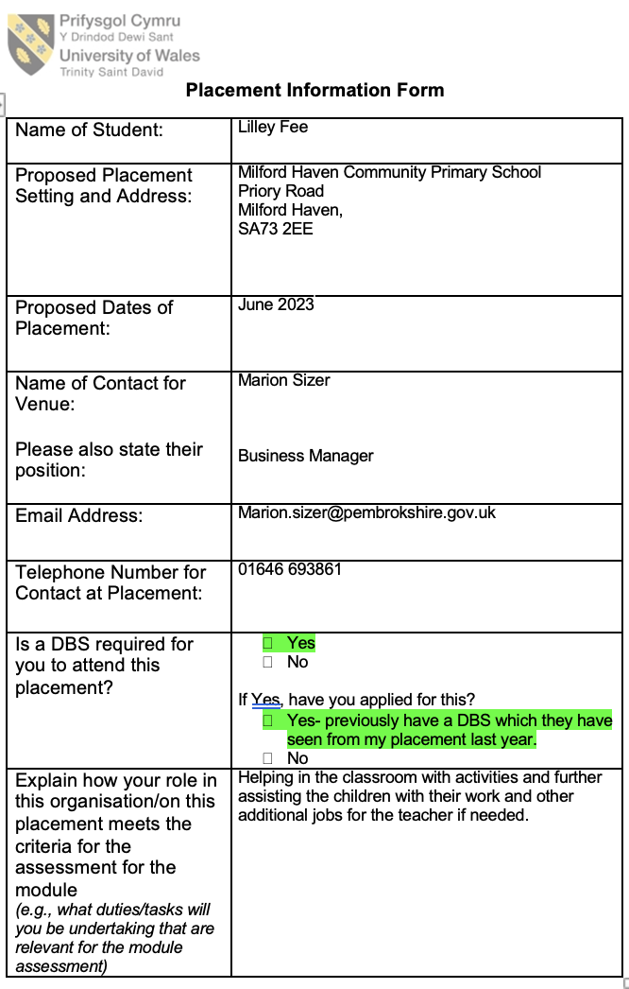

Arrangment with
Lecturer

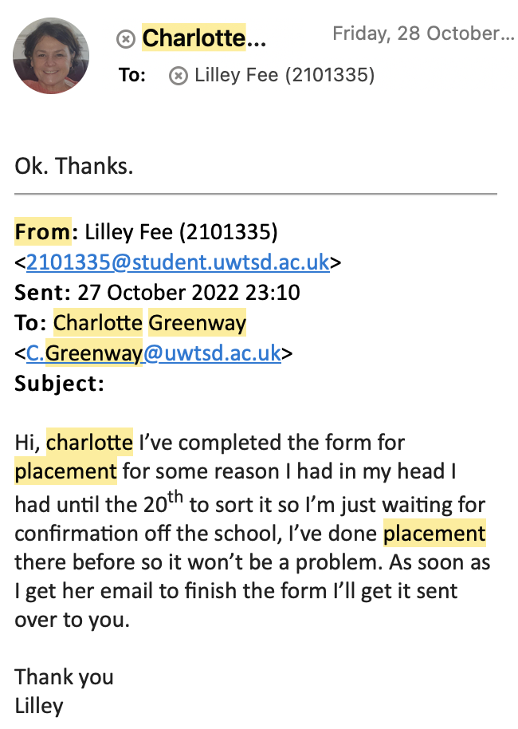

Approaching the Placement

All arrangement regarding the placement was made over the phone and in person.

DBS

The school already have my DBS on file due to attending a previous placement their when I was in college.

Attendance letter

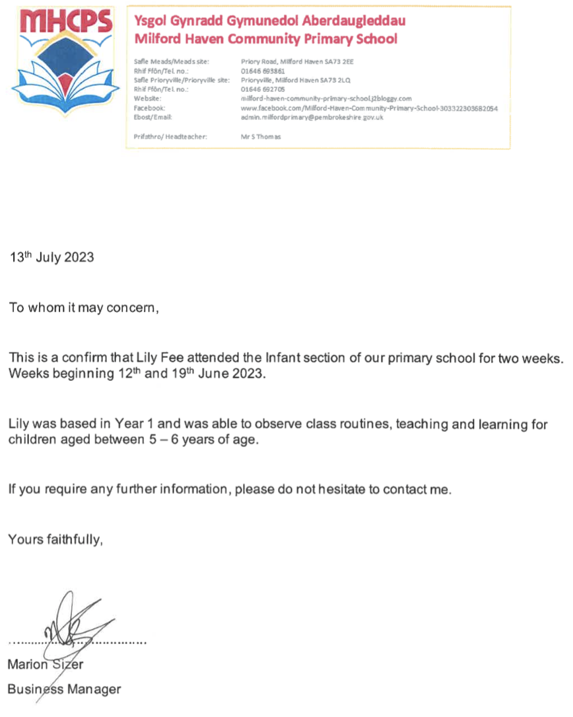

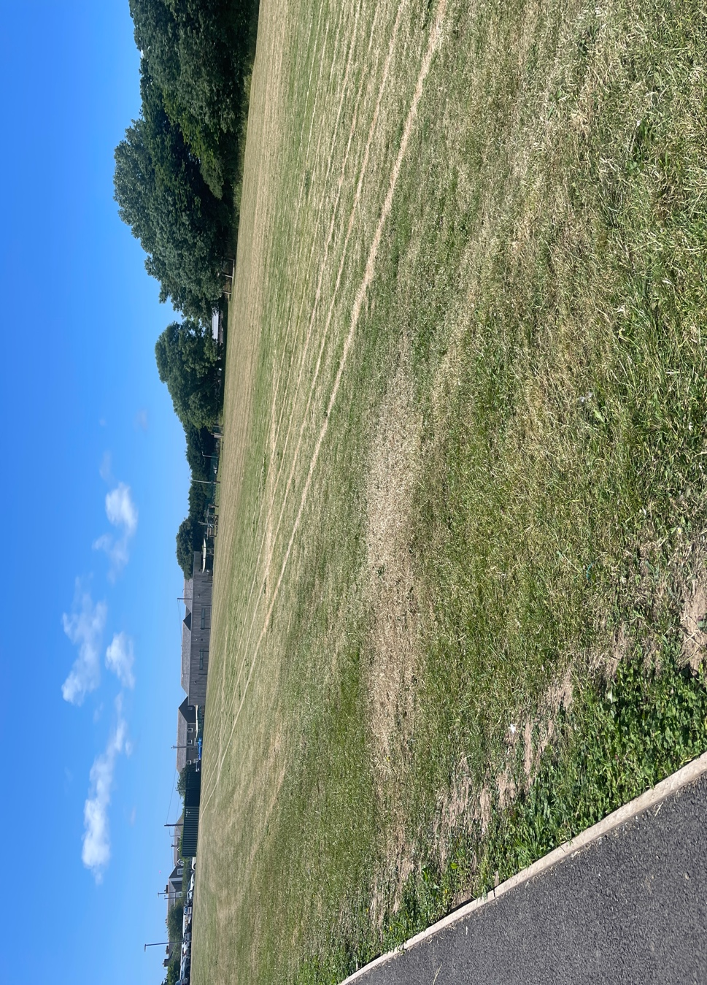
Task 1 – Sports Day

This is the school field. On my second day of placement, it was Sports day! On sports day I sat with the children and assisted them to be arranged into their groups and showing them where to go when it was time for their race. As it was over 20 degrees on this day we done water trips with the children along with them bringing their bottles with them. We also made sure they were under the gazebos and had sun cream top ups along with making sure their hats were on. After all the races had finished the children done a parade around the field and then met their parents to purchase ice creams, ice lolly’s, cold drinks, and hot dogs.

Task 2- Reading

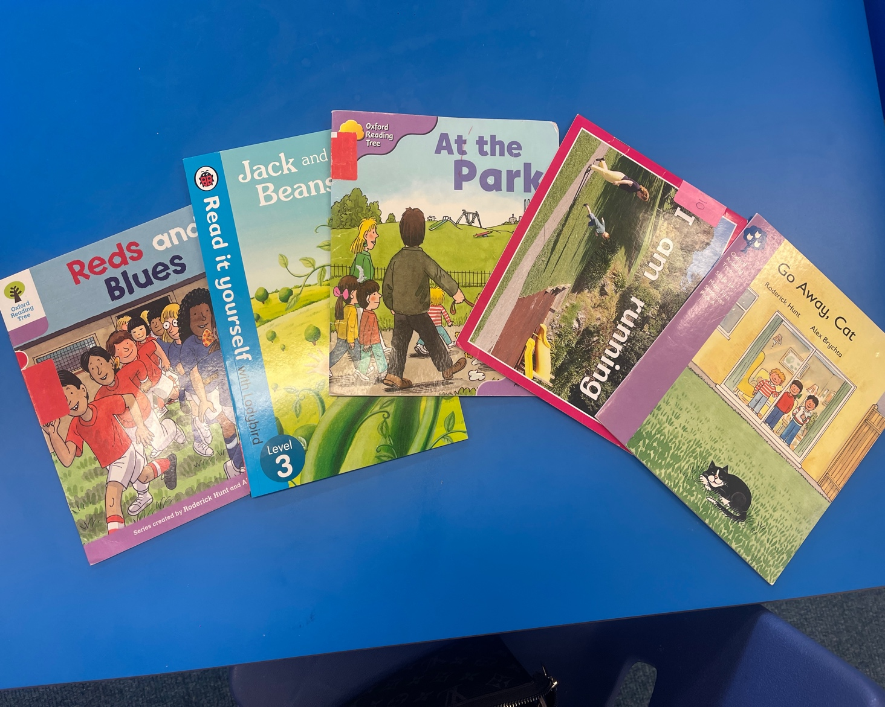

Nearly every day on my placement I assisted the children with reading. Most of the children finished their books in one sitting some range from 8 – 16 pages and then some of the other children’s books go to 24 pages. They are banded in colour for abilities. They have a mix of pictures to help the children when they’re stuck with the words. Majority of the children were able to break down the words and sound them out when they were difficult. Along with solo reading to me we also did group reading with around 7 children and me where we would all take it in turns to read to each other and everyone would listen. We would also all read aloud at the same time and use the pictures to talk among us.

Task 3 – Five’s

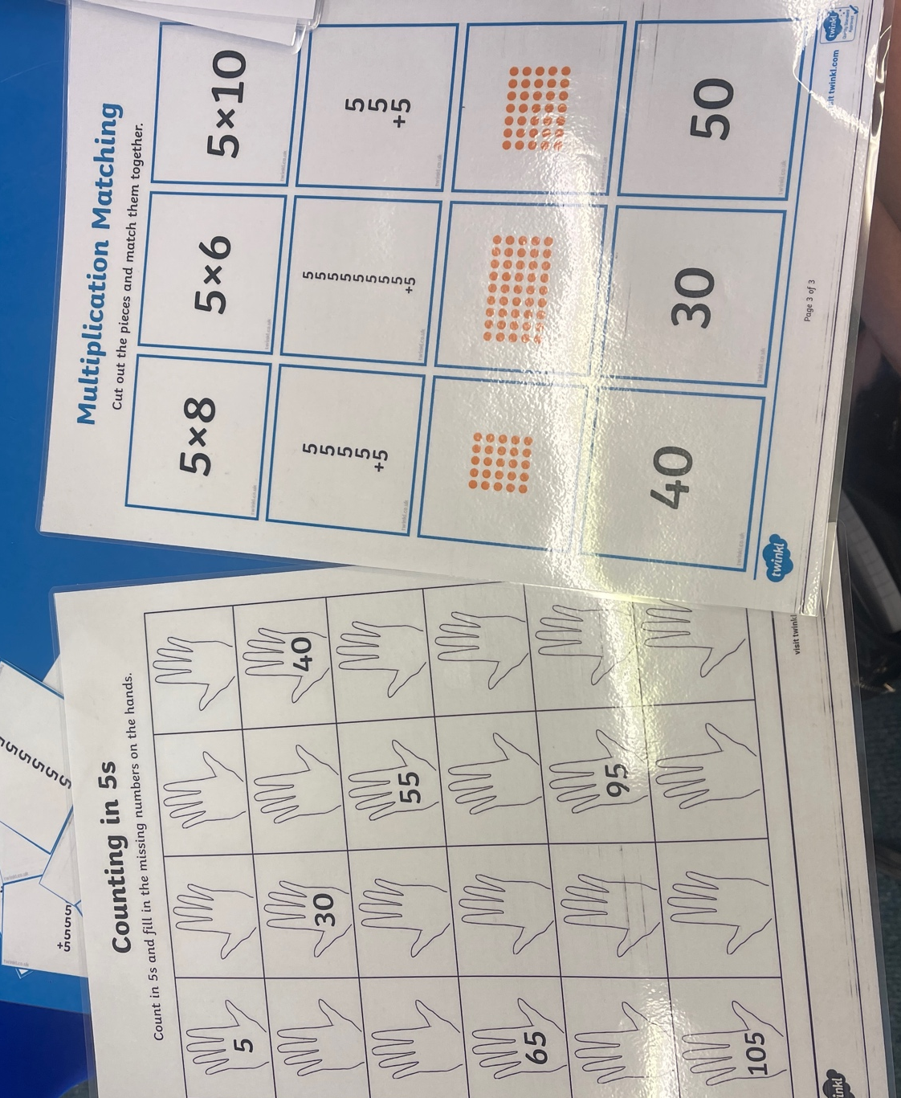

Over the 2 weeks that I was in the school they were practicing hard on their five times tables and also their ten’s. They would use the multiplication matching sheet cut them out and try to match them back up. They would also then follow the counting in 5’s sheets with their own hands to see how they count their fingers in fives. The children really enjoyed using these sheets along with the 100 square grids to use their finger to count along. Some of the children would need assisting but they all tried so hard to be able to count in 5’s.

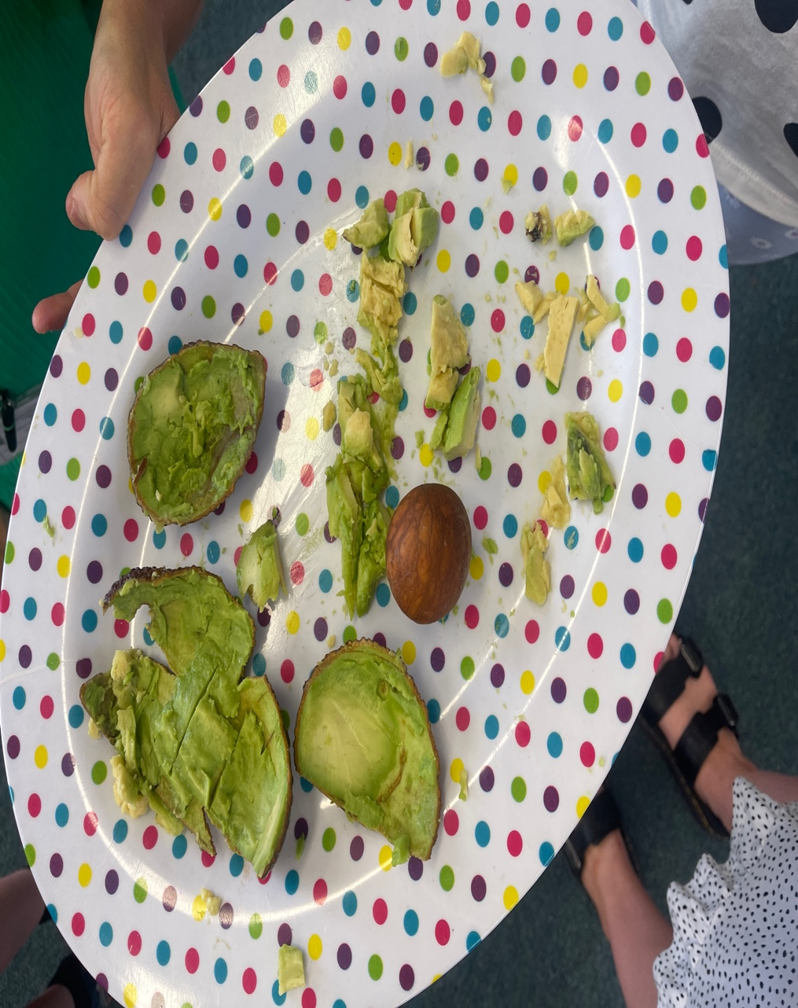
Task 4 - Avocado

This session come about when Mrs Quant was reading a book about an avocado baby to the children. They had recently been learning about the difference between fruit and vegetables the children said that the avocado was a fruit as it had a stone which was correct. The teacher then said she would bring in an avocado for the children to try. There were mixed reviews of the taste of the avocado, but they all loved sitting in a big circle and passing it around to feel the texture of it. Majority of the class said it was squishy and had a rough textured skin. Although a lot of the children were unsure whether or not to taste the avocado there was only 2 children who didn’t want to try it because they already knew they didn’t like it from home. It was wonderful that the children all tried it even though they were unsure.

Task 5 – Money

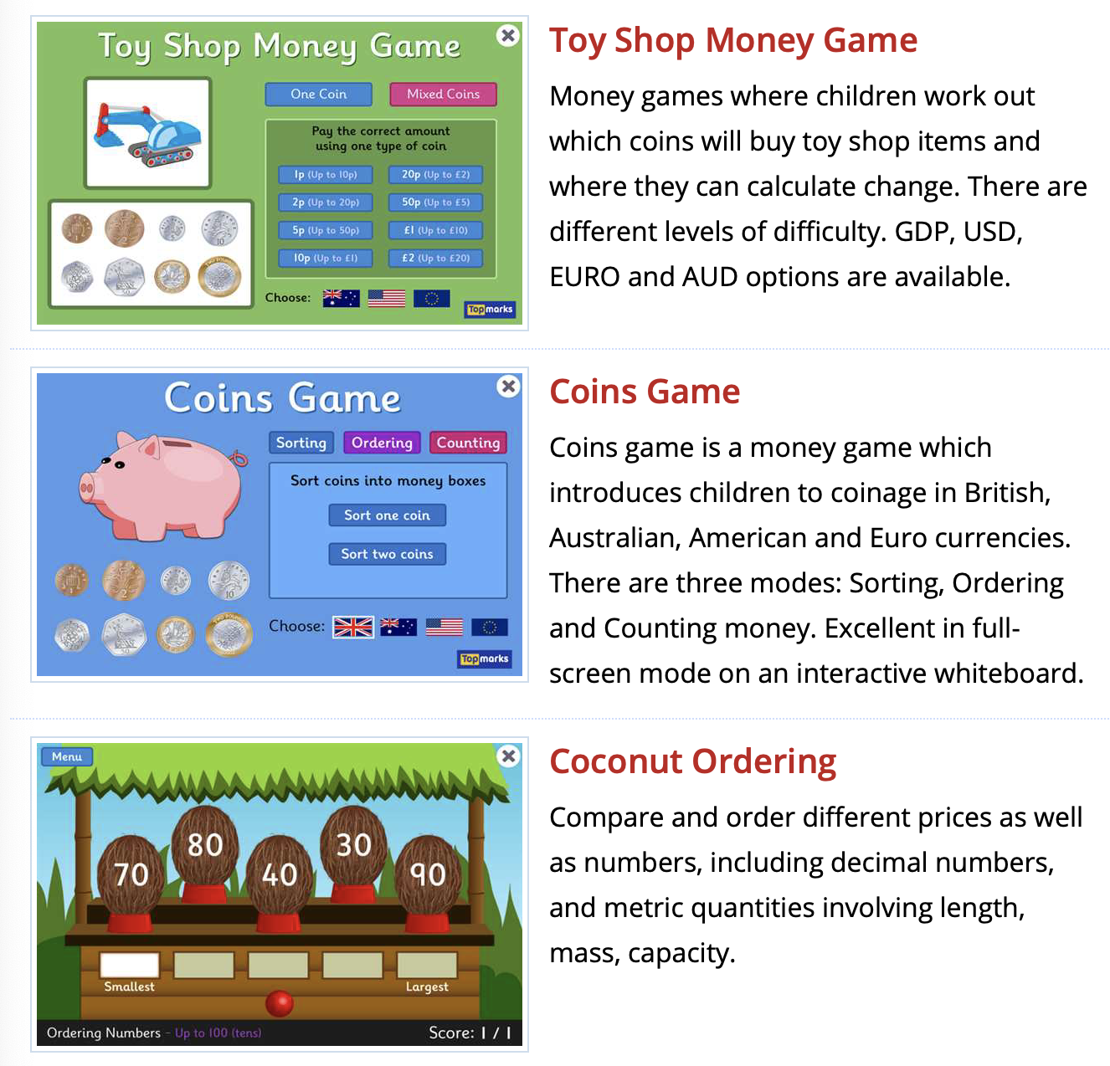

In the school the children were learning what types of money there is, they had a play shop in classroom where they could pretend to pay for things with the right money. They also would use money in their 30x5 which is 30 minutes of exercise 5 times a week, if they did x amount of push ups they would receive pretend money. After using all the physical tasks with money, they would then play money games on the ipad’s. They would play the coin game where you can sort mixed coins, order the coins from littlest value to biggest and vice versa and count the coins. They also used the toy shop game where they would put money forward for what they want to buy and also the coconut ordering which could be number in a certain times table that they need to find in a mix of numbers or ordering the numbers. The children use the ipads at least once a day and take photos of their task to be sent to their parents.

Reflective Piece

The 2-week placement in Milford Haven Community Primary School really benefitted me with my studies. It helped me observe the children and think about all the modules that we have completed to be able to see it in action. Before I started the placement I thought I was going to be in the upper school but being down with the younger children was a lovely change. I didn’t know a lot of things before going to this placement as last time I was with the older children around aged 10. Whereas this time the 5–6-year-olds are only in their second year of compulsory school. All the children were so loving, and I really didn’t except to settle in there as well as I did. What I didn’t know before is that it’s now compulsory for them to brush their teeth at least once in the school day, so our classes done them after lunch before they had their milk. I also didn’t realise that they had home readers and spelling tests that young either I thought it was when they moved to the upper school in year three.

Majority of everything I had done on this placement was new to me dealing with squabbles in the playground, listening to readers, leading a task, helping the children learn their spellings, assisting them on the ipads, attending the sports day as part of the school not a family spectator was all new to me and helped me gain so much confidence. It was lovely to feel as though I was part of the team and not just there for 2 weeks on placement.

One thing that surprised me is how much the children are so grown up for only 5 and 6 years old. They would listen to the teachers, including me and as soon as the teachers clapped they would copy, if one of them was upset over something little the teacher would give them a little cuddle and remind them that it’s only a little problem that can be sorted and they didn’t need to cry, and they would stop. For such little children they were so well behaved, only once in my two weeks one of the children had to stand outside with the teacher while everyone else was playing because they wouldn’t do their work. Another thing that surprised me was how well the children listen in the playground. When play time is over the teacher rings the bell once and the children have to freeze and then when the bell is rung for the second time they then walk to their specified lines, which really surprised me at how well this was completed every day.

As the children were so little there wasn’t really anything that was challenging as all the children got on well they would show so much love to each other and the adults in the class. It really was a lovely environment. It was really satisfying to know the children would come to me and ask for help or they would ask questions about university and when they get older how they would like to go to university, and they loved to give hugs which was so adorable.

The only problems I was faced with was children falling in the playground or arguing with each other from children in year 2. I feel like I delt with this appropriately with bringing the injured child to a teacher who could then take them to clean them up and fill in the accident book and then the children who had fallen out I would confront the problems, they would then apologise to each other and they would then go off and play with each other again so I do feel like I would 100% tackle the problem the same way again.

The emotions I felt were majority so warming when I was in the school the teachers and children were so welcoming and it was actually quite sad to be leaving the school after only being there for 2 weeks it flew by, and I would love to hopefully return back there in the future, and I am so grateful that they even considered me to complete my placement there.

