

Part 1. A CRITICAL EXPLORORATION OF THE PURPOSE, CONTENT AND FORMAT OF A CRITICAL LITERATURE REVIEW FOR DOCTORAL RESEARCH.
Part 2. ANNOTATED BIBLIOGRAPHY(SNAPSHORT)
Part 3. PRELIMINARY LITERATURE REVIEW ON WHAT TECHNOLOGY STRATEGIES ARE USED WITHIN THE UK IT TELECOMS INDUSTRY.

DBA CANDIDATE:
Jones Fonchin

Critical Literature Review for Doctoral Research

Module Lead: Dr Emma Roberts
Part 1.
Introduction:
The literature review is a critical and vital element of the research process and will normally come after the choice of topic. According to Paré et al. (2016), the literature review plays an important part in progressing knowledge, providing supporting evidence to practices and acting as a guide in developing new theories and future research. The choice of research topic and the literature review process will help shape the entire research through to design and methodology. The literature review therefore serves as a guide to the researcher by enabling a synthesis of the existing literature around their topic of interest. Booth et al. (2016) identifies different types of literature reviews; critical review, integrative review, literature review, mapping reviews and many others however the focus on this paper will on the literature review. The focus of this paper will therefore be to provide a critical review and analysis of the purpose, content, structure and significance of the literature review with some additional recommendations for future researchers.
Critical review of the purpose and content of a literature review
What is a Literature Review?
Over the last decades, researchers are beginning to recognise the significance of the literature review in social and management sciences. The reason for this is due to the rapid increase in the volume of research being conducted using diverse methods and techniques, Payne, S. et al (2021). According to Efrat & Ravid (2018), the literature review can be described as a logical review of the extant literature surrounding the researcher’s topic of interest. Wisker (2015) describes this as that part of the research where the researcher engages with different theoretical and conceptual frameworks and position the contributions of their research with the ongoing debates and epistemological assumptions surrounding their existing topic. As cited by Booth et. al (2016), Fink (2005) defines this as a methodical, transparent, clear and replicable approach used in identifying, evaluating and breaking down the extant literature produced by researchers and practitioners at large. Creswell (2014) comments the literature review is the process of positioning and summarising different research conducted around a specific topic. According to Greetham (2021), the literature review provides an opportunity to critically analyse and evaluate the methods, assumptions and conclusions found in the literature, through the review and analyses of concepts and finally summarising these different ideas to bring out new insight and ideas to the problem. Machi, (2022), defines the literature review as different views presented in a logical manner which provide comprehensive context and background evidence about the current knowledge of a topic being researched. From the various definitions discussed above, certain commonalities exist amongst these definitions such as the literature review is a process; it involves summarising different views from different researchers in a logical approach and involves bringing out new insights on the topic
The aim of the literature review is therefore to provide a direction for future research either as a separate artifact or embedded artifact through a detailed analysis of the existing literature, reviewing theories, concepts, current knowledge, and methodologies with the objective of identifying gaps in the current studies and with a goal of filling these existing gaps and adding new knowledge to the area of interest. Wisker (2015) commented that a good literature review should provide clarity of the theoretical lens used for the research work and how it aligns to existing literature and ongoing discussions in the field. Lenart and Berdanier (2020) further described the literature review as an “inverted triangle” where the researcher starts from the general themes surrounding the problem and narrows down the focus to the main specifics which they want to focus their attention to including the audience.
This therefore leaves one with the question of, if a research topic adds no new knowledge to the existing field, is it therefore worthwhile carrying on with the topic?
Purpose and Content of a Literature Review
Different schools of thoughts and scholars have shared different views about the purpose and content of a literature and its structure. There is no right or wrong answer to this but it all depends on the research type, research questions underpinned by the philosophical and epistemological stand point of the researcher in relation the study (Machi, 2022). The purpose could be easily understood and explained as why should one do a literature review in the first place? Creswell, (2014) identifies three purpose of the literature review; a) sharing the results of research work already carried out in the area of focus of the researcher; b) It helps to position the study in relation to the ongoing discussions on the existing literature with the objective of filling in gaps and expanding on the current literature; and finally c) it helps to provide a structure through which the researcher can compare the results of their findings with those of others in the field.
Greetham (2021) agrees with Crewell (2014) that purpose of a literature review is provide the researcher with the opportunity to locate the gap in the existing body of knowledge and but goes further to add that it is an opportunity for the researcher to make an original contribution to the topic. It is therefore by identifying gaps that a researcher can therefore make an original contribution to the study. Another purpose of the review is for the readers to be able to see the rationale, significance and relevancy of the researchers work in relation to other existing research. The review structure and content should therefore bring meaningful insight to the research question by showing the position of the research in relation to other studies and a clear justification of the choice and methods used in the study (Greetham, 2021). Haynes & Hunsley (2021) go further to add that apart from providing the necessary context of the research, the purpose of the review is also for the researcher to select what the focus, goals and methods of the research will be.
According to Efrat & Ravid (2018), they considered the purpose of a literature review under three main categories namely; 1) to help set the context of the research by providing clarity on definitions, conceptual framework, key researchers in the field; 2) they help to inform the research design and methodology with a number of benefits such as helping the researcher to be more focused and ensuring that the researcher carries out a robust research which is reliable and valid. And finally, 3) another purpose of the literature review is to identify areas of future research through the identification of gaps as well as convincing the readers these gaps exist in the literature (Lenart & Berdanier, 2020).
Lenart and Berdanier (2020) further discuss four purposes of the literature review process in addition to the identification of gaps in the literature which are; to enable the researcher gain credibility through a well-crafted, synthesised and articulated literature review; it enables the readers to be able to interpret and recognise the full worth of the researchers findings; the review enables the researcher to visualize their potential audiences and therefore able to meet their needs; and finally the fifth purpose of the review is to guide the choice of language used by the researcher. They also explain the literature review process goes through three key steps involving the researcher communicating their motivation, locating their work within a particular area of the literature and breaking down relevant studies and findings relevant to the area of research (Lenart & Berdanier, pg.11, 2020)
Although literature reviews are conducted using different approaches, they all have a common theme and feature as identified by Payne, S. et al. (pg.9, 2021) such as a focused question to address, selection parameters, database searches, data analysis, findings, and discussion of research outcomes
Booth, et al (2016) explains that the purpose of a literature review is to help analyse, summaries and synthesis evidence from research to help provide clarity on what is known or not know about the research question. By carrying out a good synthesis also helps to validate whether the research findings are consistent across the various studies. Furthermore synthesizing the literature properly also brings out any weaknesses and limitations in the evidences and methods used to conduct the research.
Conclusions and Recommendations
The literature review is therefore critical and plays a key role in the research project by analysing and synthesising the existing research to identify gaps and focus the study to filling these gaps. The literature review helps the researcher to be able to position their research in relation to the existing works already carried out of the problem. It enables the researcher to extract the most relevant information and making the right judgments on the quality of the evidence to include in their research. The content of the literature review therefore include an analysis of the different views, discourses, theories and concepts about the topic of interest presented in a logical manner and adhering to some protocols. Writing a good literature review therefore provides a sound basis for the research work to be carried out as the design and methodology will emerge for the literature alongside the research questions to be answered.

References
Andrew Booth, Anthea Sutton and Diana Papaioannou (2016) Systematic Approaches to a successful literature review, (2nd edn.). Thousand Okas, CA:Sage.
Bryan, Greetham,. (2021). How to write your literature review. Red Globe Press.
Catherine G., P., Berdanier, & Joshua, B. Lenart, (2020). So, you have to write a literature review : a guided workbook for engineers (1st edn.). John Wiley & Sons, Inc.
Creswell, J. W. (2014). Research design: Qualitative, Quantitative and Mixed Method Approaches (4th edn.). Thousand Oaks, CA: Sage.
Haynes, S.N. and Hunsley, J., (2021). Writing dissertations and theses in psychology: a student's guide for success. New York. Routledge.
Machi, A., Lawrence (2022). The literature review: six steps to success. (4th edn.). Thousand Oaks, California: Corwin.
Pare, G., Tate, M., Johnstone, D. and Kitsiou, S., (2016). Contextualizing the twin concepts of systematicity and transparency in information systems literature reviews. European journal of information systems, 25(6), pp. 493-508.
Sheila, Payne; Nancy, Preston and Helen, Aveyard (2021). A post-graduate’s guide to doing a literature review in health and social care (Second edition.). Open University Press.

Part 2

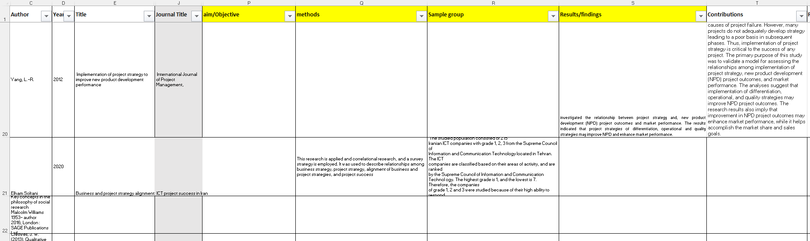

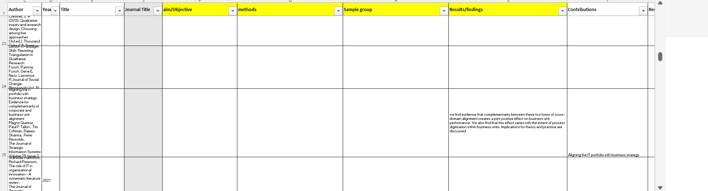

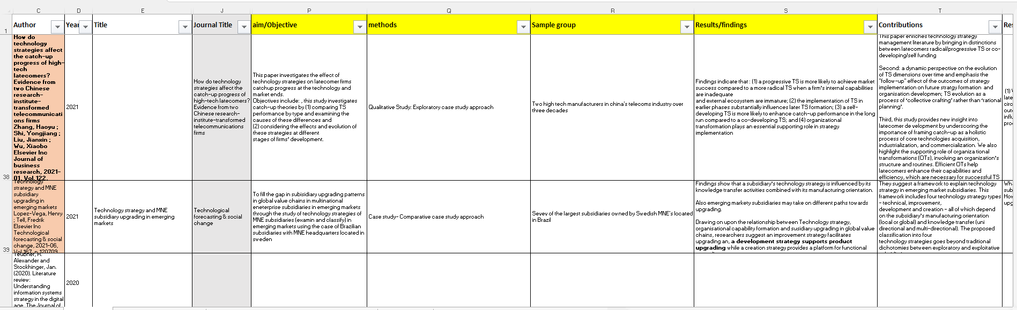

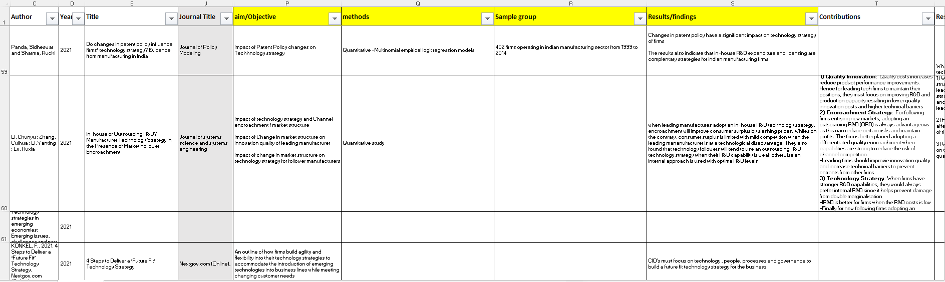

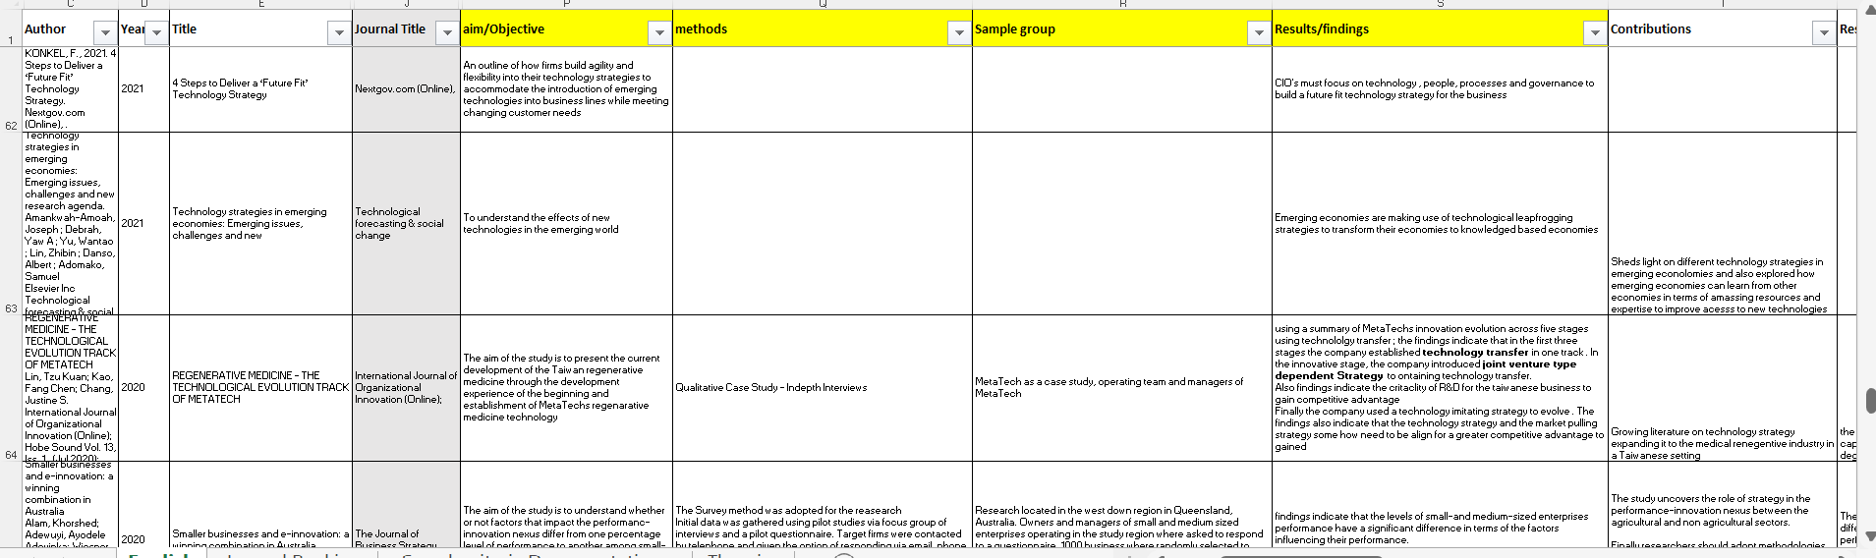

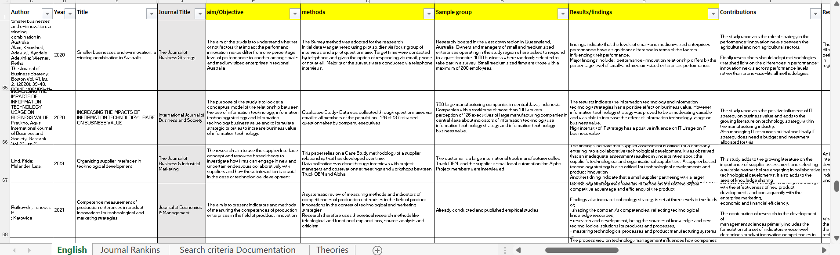

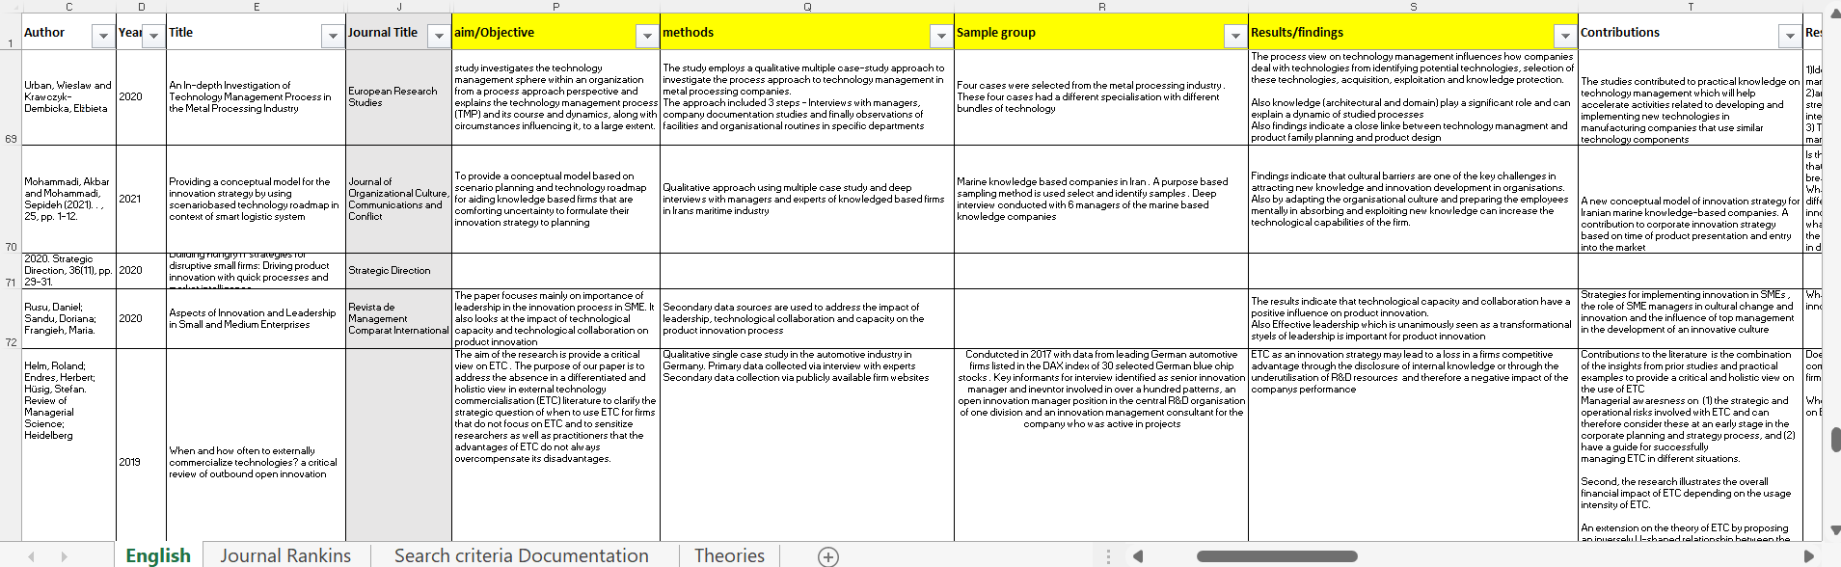

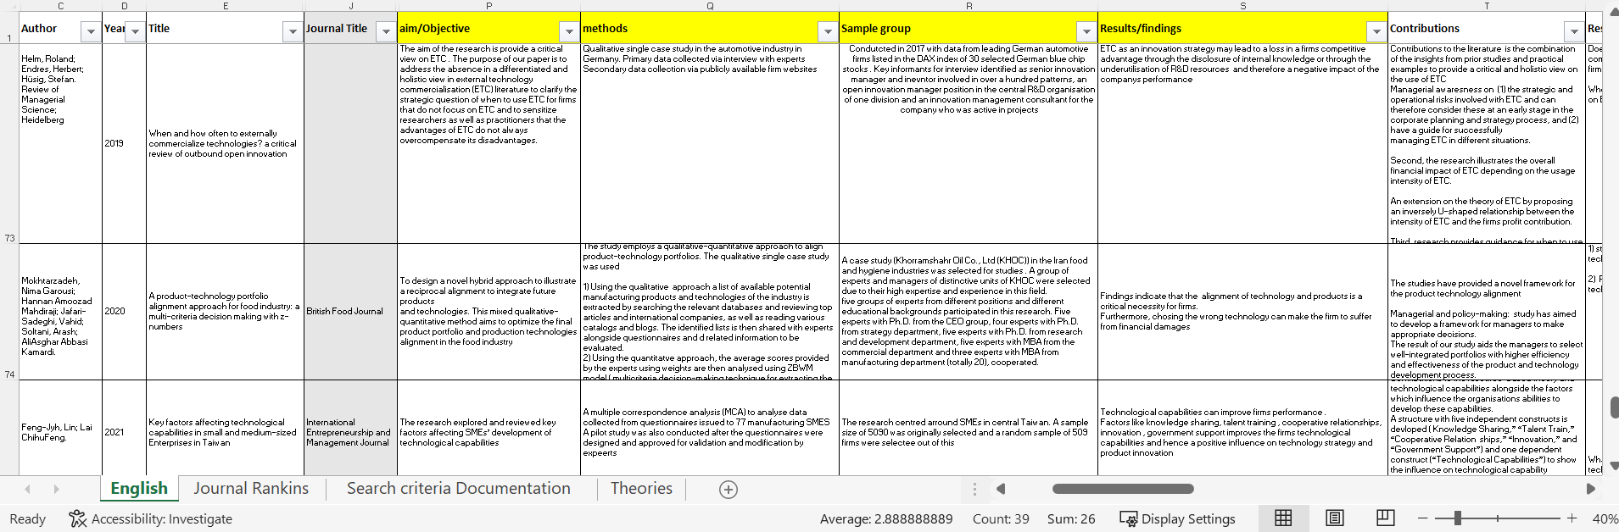

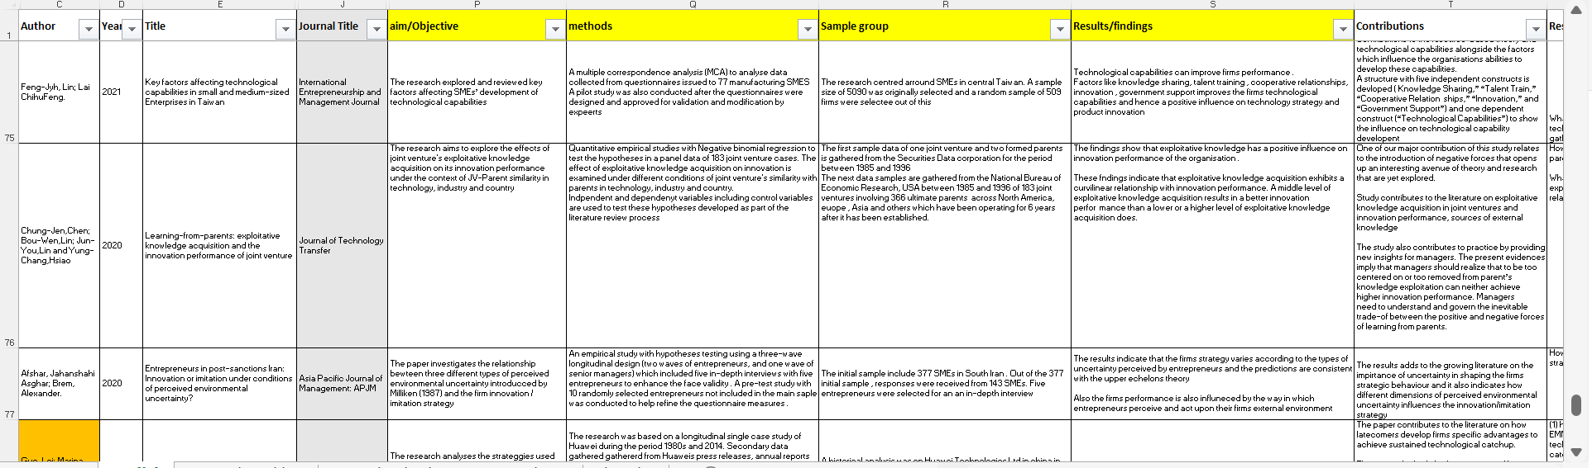

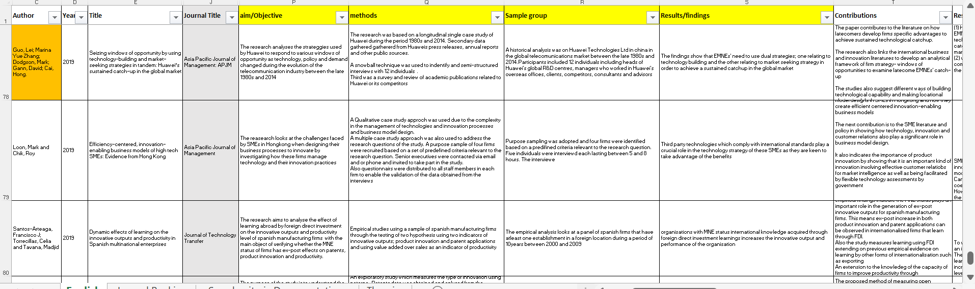

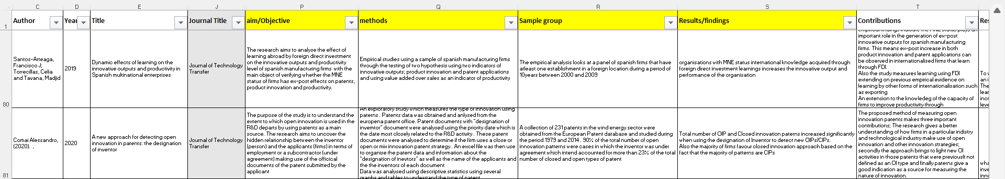

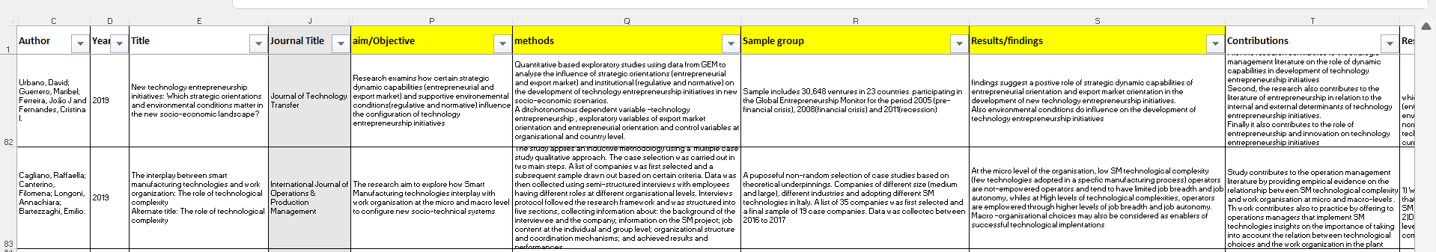

Part 3

1. Introduction
Technology strategy (TS) decisions is one of the biggest challenges affecting millions of IT executives when undergoing large scale IT transformation projects and product. Strategy looks to answer the question of why some companies have a greater competitive advantage and outperform the others. Management scholars have used different concepts like the resource-based view, organisational capability theories, opportunity-based views, actor-network theories, knowledge-based views, and many others to address this issue. However, as pointed out by Furr (2021), very few of these models have directly addressed the use of technology to create and capture value which is a critical and vital activity at the heart of strategy. Due to the rise in technological changes, firms are under increased pressure with rising complexities in customer needs, resource challenges and high expectation on quality (Helm et al. 2019). Technology strategy therefore enables the organisation to gain competitive advantages driven from technological innovations, (Lopez-Vega and Tell, 2021).
Product innovation is vital for the future growth of organisations and for them to remain competitive. However, only a few firms have shown this ability to progressively innovate their product base especially when it comes to market changing innovations (Winby and Worley, 2014 cited by Brand et al. (2021). One of the possible challenges with product innovation is deciding on what approach to take. Product innovation tends to follow either an exploitation approach or an exploration approach or a mixed of both approaches. Product exploitation and exploration approaches are therefore considered the key driving forces in innovation literature and allow the company to gain competitive advantage (March 1991 cited by Kahn & Candi, 2021)
Digital technologies like artificial learning (AI), machine learning (ML), cloud computing, data analytics and the internet of things (IOT) provide companies with greater opportunities to develop and scale their product offerings more efficiently and with less costs (Pesch et al., 2021). Despite the significance of digital product innovations to businesses, little research has addressed which organisational factors influence digital product innovations (Pesch et al., 2021). With the changes in the digital economy firms are facing challenges brought about by more transparency in innovation of technologies (Li, Zhang et al. 2021) and increase speed, product innovation, technology usage, quality, and price (Azeem et al. 2021)
Research has also indicated that human factors like organisational culture, senior management support, and communication and team composition are significant factors which influence product development performance (Brown and Eisenhardt, 1995, cited by Marion & Fixson, 2021).
Telecommunication companies are rapidly innovating from traditional telco companies offering mobiles and voice to technology companies hence the significance of technology strategy can be easily observed in this industry.

Aim
The aim of this research is to critically evaluate and analyse what information technology strategies (ITS) are being used by UK IT executives in the telecoms industry and its implications on product innovations.
Several studies have investigated the influence of ITS on organisational performance, business strategy alignment, product innovation, IT investment decision making (Stanislav and Richard, 2021; Elham, S. 2018; Street et al., 2018, Queiroz, M. et al., 2020; Mamonov and Peterson, 2021). However, despite the significance of ITS, research in the area for UK telecoms industry compared to other industries and disciplines still needs further investigation. Technology strategy requires a clear communication from management as well as resources and capabilities to manage the transformation process.

Objectives
In-order to achieve this, the objectives are:
To undertake an extensive literature review on the IT technology strategies used within the UK telecoms industry.
To identify and evaluate the factors affecting these strategies
Development of recommendations for the application of these strategies
This research presents a case study on one of the UK leading telecoms company Vodafone. The UK telecoms industry is currently undergoing a major transformation from traditional Telco to technology companies and has therefore become a global focus across the industry.

2. Theoretical background and Literature Review

Introduction

In this section we discuss and introduce the concept of technology strategy and some the underlying conceptual frameworks driving Technology strategy. In the subsections, the various factors which influence technology strategy and product innovation are also discussed and analysed with reference to the research question.

2.1. Technology Strategy as a Concept

When one talks of technology, the first thing that comes to mine are the tangible elements like microprocessor chips, hardware, infrastructure, smart gadgets like phones, tablets, laptops and so forth. However, a combination of these technologies put together in today’s world is now giving rise to a completely new kind of technologies referred to as digital technologies, smart technologies and the like with great capabilities which integrate in every aspect of our daily life, impacting different organisational domains and used widely across different works of life in medicine, engineering, agriculture, e-commerce, product innovation and the like (Furr, 2021). Over the past decades large organisations have increased their spending on information technology, however this increase is not reflected in productivity or customer satisfaction experience (Konkel, 2021). With many companies trying to integrate technology together with business management using various tools and methods to choose the relevant technologies to achieve strategic objectives of competitiveness, continuous focus on technology strategy is therefore important as it’s the only approach they can use to achieve their goals (Mokhtarzadeh et al., 2020). According to Mokhtarzadeh et al., (2020, p.3)

“the purpose of the technology strategy concept is to provide a broad and comprehensive approach to achieve organizational goals through the benefits of technological capabilities in a competitive environment”

Based on the view of Mokhtarzadeh et al, technology strategy as a concept is seen as a systematic process which serves as a guide to organisations to follow in implementation and taking actions on technological decisions. The link between technology and strategy continuous to be an issue in recent years (Mokhtarzadeh et al., 2020). Several organisations are finding it increasing difficult and challenging to select what technologies they need to include in their portfolio possible due to number of reasons such as a lack of technology strategy and product strategy including a technology and product roadmap.

Urban & Krawczyk-Dembicka, (2020) looked at technology strategy as a concept within technology management (TM) while others have looked at technology strategy as a concept in its own rights. If one is to look at technology strategy from the perspective of TM, this will be more from the strategic view of TM. According to the strategic view Urban & Krawczyk-Dembicka (2020, p.4) define technology strategy

“as a long-term vision for managing technology that sets a consistent decision-making pattern to foster the creation and exploitation of knowledge to attain superior competitiveness”.

Organisations are now faced with challenging decisions on how to invest, integrate and leverage these new technologies within their organisations to gain competitive advantage and to innovate their product base. Despite the benefits of having a clear technology strategy and management approach, there are still ongoing questions about the link to business performance. Urban & Krawczyk-Dembicka (2020) go further to argue that having a balance internal and external technology sourcing strategy thus have a positive impact on the organisations performance and an organisation can therefore gain competitive advantage by leveraging external technology sourcing whiles ensuring the right balance of knowledge as exists within the organisation from technological, domain and architectural knowledge. The findings of Urban & Krawczyk-Dembicka indicate that TM influences product planning and product design and the process view of TM influences how the organisations deal with technology from the identification process, selection, acquisition, exploitation and through to knowledge protection. Building on their findings and seeing technology strategy as a process, one supports the view that technology strategy influences every element of the organisation and product innovation. In another study by Furr (2021) on technology entrepreneurship, the findings also indicated that different domains technology management, evolutionary economics, entrepreneurship, and strategy in dynamic environments have contributed to the meaning of technology strategy. Technology entrepreneurship is also understood be the interface between innovation and entrepreneurship (Urbano, D. et al., 2019). Furr, (2021, p.2) defined technology strategy from the perspective of an entrepreneur in which technology strategy and entrepreneurship is defined as a

“entrepreneurial action to apply a technology to achieve some end, often an economic or social end. Thus, in the sense that technology entrepreneurship is the action of applying technology to create new value, and perhaps capture it as well, then technology strategy, as an umbrella concept incorporating technology entrepreneurship, can be defined as a firm’s strategy for creating and capturing value with technology as well as the firm’s strategy in a world shaped and reshaped by technology”

Urbano, D. et al., (2019) agree with the definition of Furr (2021) by adding that innovation leads to the creation of ideas, products, and services while entrepreneurship is about identifying and taking advantage of business opportunities aimed at bringing about socio-economic values.

Panda and Sharma (2021) added that technology strategy is also influenced by changes in patent policy which also has an impact on organisational choices. Panda and Sharma (2021) described technology strategy as the “acquisition, development and exploitation” of these technologies for the benefit of the organisation. Zhang et al. (2021) added that technology strategies are “procedures” and shape how organisations go about acquiring, managing, and exploiting new technical knowledge and abilities. Mohammadi & Mohammadi (2021) described this as the path used by companies to define which technologies to deploy and set aside.

When organisations make technology strategy decisions, they are faced with several options such as decisions on in house manufacturing, external sourcing, licensing, or more in-house R&D and or a mixture of these options and so on. Panda and Sharma therefore supported the view that such decisions are driven by the transaction costs theory. The transaction costs theory (make or buy decision) asserts that a firm can developed technology in house through its own R&D process or purchase technology externally depended on the costs. Building on this, one can therefore agree with Panda and Sharma, that this is also likely to be the case in the UK Telecoms industry.

Li et al. (2021) examined the impact of technology strategy and channel encroachment and discovered that when leading manufacturers adopt an in-house R&D technology strategy, encroachment will improve consumer surplus by slashing prices and on the contrary limit consumer surplus when organisation lack the technical abilities. Their findings also indicate technology followers will tend to use an outsourcing R&D technology strategy when their R&D capability is weak otherwise an internal approach is used with optima R&D levels.

Furr (2021) also argued that with the rapid growth of emerging technologies firms now need to formulate their strategies taking these technologies into consideration. Furr and Eggers (2021) also argued that technology strategy is somehow influenced by the theory of uncertainty through the innovation phase. They argued that as the degree of behavioural biases increases so does the level of uncertainty increase which can have a degree of influence on the innovation process. Products with shorter life cycles forces firms to innovate constantly and therefore adding more uncertainty due to these rapid changes (Panda and Sharma, 2021). Afshar & Brem (2020) add that during the time of uncertainty some firms respond by either using an imitative approach to their competitors most successful products or an innovative strategy by launching new products and services. The organisations strategy is therefore influenced by managements perception of the environmental uncertainties facing the business which are consistent with predictions of the upper echelons theory (Hembrick & Mason, 1984 cited by Afshar & Brem ,2020). The upper echelons theory postulates that executive’s perception and interpretation of the environment will influence the actions taken by the executives. Similarly, the organisations technology strategy will be influenced by how senior management perceives and interprets the challenges facing the organisation which intend will have an influence on the product innovation activity within the organisation. Mohammadi & Mohammadi (2021) add that due to the challenges and complexities in today’s economy firms are forced to compete for new product offerings and products with a shorter life span. Konkel, (2021) argued further that in other for senior IT executives to build future ready technology strategies which allows the firm to constantly adapt, meet customer needs, attract new opportunities, and deliver disruptive innovations, they must focus on building on four IT competencies: technology, people, processes, and governance.

According to Rutkowski, P., (2021) the companies technology strategy forms part of its overall strategy and thus include several other technological systems like databases, industrial systems, technological processes, and products. They argued that with the new paradigm shift in organisations coming from the perspective of marketing resources, organisational resources and technological knowledge being very critical for the value of the business, this has therefore given rise to a new taught process in how organisations formulate their technology strategy. Based on this, organisations set technology strategy at three different levels in the areas of; organisational competencies indicating technical knowledge resources; research and development as the critical source of knowledge and product innovation; and gaining control in the technological process and product manufacturing as a competitive tool. Rutkowski, P., (2021, p.10) went further to discuss that

“in the area of technological strategy, core competencies reflect the well-established technological knowledge resources at the disposal of the company, necessary for its efficient functioning, and at the same time determine the possibility of establishing strategic units. The level of core technological and market competences is usually assessed by a given company. However, it should be remembered that a change in their scope and intensity results in the necessity to acquire and spend significant resources”.

Analysing the above definitions of TS, what is unique about them is that they all talk about acquiring and exploiting these technologies for competitive advantage and they all agree about the challenges of resources involved in defining these strategies. Based on the arguments and discussions above Urbano et al. (2019) identify two main streams of debates which are centred around how and when the organisation takes advantage of opportunities. The first debate is linked to the impact of organisational level resources and capabilities on technological and innovative developments. whiles the other stream of the debate focused on the environmental level looking at the influence of environmental conditions on technological innovations and performance. Both streams of literature have been the basis for the development of the conceptual framework used for this research on technology strategy. One can say that the technology strategy of the organisation is influenced by these socio-technical factors which intend impacts the organisations product innovation.

2.2. Capability based Technology Strategies.
Researchers have now come to the agreement that technological capabilities are the major drivers for firm’s competitiveness (Zhang et al., 2021). Technological capabilities are key resources for the organisation providing it with the unique knowledge, skills, and abilities to participate in more significant activities to achieve competitive advantage (Lin and Lai, 2020). The building of organisational technological capability can take the form of technology transfer and knowledge spill overs during which the organisation increases its knowledge base in scope and depth (Guo et al.,2019). However, there are several challenges which organisations face in the process of trying to achieve this ranging from both micro to macro levels and other socio-technical factors. Technological capabilities allow firms to focus on more strategic activities as these firms possess unique skills and resources which gives them competitive advantages and improves the firm’s profitability and performance (Feng-Jyh & Chihufeng, 2021). Developing technological capabilities is therefore important for organisations as it breeds new products and services through innovation and increases the market share of the organisation. To develop capabilities, organisations therefore need to acquire the right knowledge which Feng-Jyh & Chihufeng (2021) rightly pointed out could be a challenge for SMEs. Feng-Jyh & Chihufeng (2021) identified several factors that could influence the ability of the organisation to develop technological capabilities which included the sharing of knowledge, skills training, collaborative partnerships, innovation, and government support. They argued those resources are critical for any organisation to develop the right capabilities to innovate and compete in this dynamic environment. One can therefore say that, similarly these factors will also influence the organisation’s technology strategy as the strategy defines how the organisation will develop these technological capabilities and what technologies to harness to drive future competitiveness and product innovation. Through knowledge, organisations can gain further insight about customer journeys and can use this to develop on the firm’s capabilities. Barney (1991) cited by Urbano et. Al., (2019) added that organisations can gain sustainable competitive advantage by having resources (assets and capabilities) that cannot be copied and not tangible. Based on the philosophy of Barney, Urbano et al identified the strategic orientation of an organisation as an important organisational dynamic capability as it describes the philosophical unpinning of how business is conducted with reference values, beliefs, and objectives. Organisational culture is therefore shaping the way capabilities are developed and hence an impact to is technological strategic setting. Amankwah-Amoah et al. (2021) added that countries are now using technological knowledge to transform from traditional agricultural economies to knowledge-based economies. One can therefore argue that knowledge and transformation capabilities are critical and vital resources for technology strategy.
Traditionally, research has looked at IT strategy as subordinate to business strategies, researchers have now been able to acknowledge the fact that IT strategy in its own rights is responsible for driving business change and should therefore be treated in its own rights (Chen et al. 2010 as cited by Teubner, & Stockhinger, J. 2020). TS is sometimes understood to be the process of how firms go about gaining knowledge and abilities, Ford (1998) as cited by Zhang et al. (2021). It could also be deemed in the light of the organisations views on product innovation and providing value for money to customers through sustainable development (Lopez-Vega and Tell, 2021). Technology strategy as a concept has been around for some time and measured from various dimensions like “technology leader versus technology follower”, degree of “technological diversification”, technology sourcing strategy (internal or external sourcing) and “product exploration versus product exploitation strategies” (Pavitt, 1990 cited by Lopez-Vega and Tell, 2021).
Prior studies on TS have used different measures such as the ability of the organisation to integrate technological knowledge, product innovation, organisational capabilities, and manufacturing orientation through the organisation, (Zhang et al. 2021, Lopez-Vega and Tell, 2021) but one thing is certain, these strategies all require resources, and the organisation needs to be capable to manage the transformation process. During the product innovation process, knowledge is created throughout the various phases (Marion & Fixson, 2021). Organisations capable of integrating external knowledge with their local technological efforts are able to improve their TS such as innovation, R&D, internal versus external sourcing (Panda and Sharma, 2021). Knowledge is therefore a key resource for the organisation to gain competitive advantage and build organisational capabilities. The combination of the organisations skills that are used in gaining technical knowledge to improve business performance and drive innovation is what is referred to as the technological capacity of the firm (Rusu et al., 2020). According to the knowledge-based view (KBV) of the organisation, knowledge is deemed as a key resource and the creation and combination of knowledge is therefore critical to the innovation efforts (Galunic and Rodan, 1998; Henderson and Clark, 1990; Quintane, Mitch Casselman, Sebastian Reiche, and Nylund, 2011 cited by Marion & Fixson, 2021). The findings of Santos-Arteaga et al. (2019) also indicate that for organisations with MNE status, international knowledge acquired through foreign direct investment learnings increases the innovative output and performance of the organisation. Similarly, Zhang et al. (2021) supports the resource challenges by adding that having a co-developing strategy with other organisations could assist firms late in the technology race gain knowledge quicker and improve internal capabilities faster.
TS based on capability focuses on two key capabilities; resource-based capability theory (RBC) and organisational based capability theory (OBC) (Lopez-Vega and Tell, 2021). Teubner, & Stockhinger (2020) commented that research on IT capabilities have deep rooting on the resource-based theory of the firm first introduced by Barney, (1991) postulating that the resources available to an organisation are critical for its performance. RBC postulate that the organisations resources and capabilities will determine the ease with which competitors can copy its value-generating capabilities (Barney, 1991; Grant, 1991). The resource-based theory also argues that organisations possess different resources and capabilities which gives them the opportunity to create competitive advantage. Loon & Chik (2019) add that whiles these resources and capabilities differ from between organisations, the most critical ones observed in technology driven SMEs are the acquisition of technology and its application and innovation management. Therefore, an organisation’s ability to manage these resources and capabilities gives them an opportunity to fully utilise their technological and non-technological resources for a greater competitive advantage. Managing technological resources is therefore linked to the organisations technology strategy and has implications for product innovation.
Park and Mithas (2020) on the other hand argue that, though there are benefits using resource-based theory and transaction cost economics view to define the strategy setting, there are still limitations to these approaches as they do not address elements of complexity involve in formulating strategy and system complexities. Kahn & Candi, (2021) argued that when it comes to innovation, the size of the firm and product offering influences the innovation strategy and the impact on performance. They revealed that large firms will take on an exploration approach since they had more resources while small firms will tend to follow an exploitation approach since these involved fewer resources.
OCB theory focuses on both the operational capabilities aspect of the organisation and the dynamic capabilities. Operational capabilities focus on routines to manage day to day operations whiles dynamic capabilities are more about the firm’s ability to manage change within its environment. Considering the above two theories, one can argue that the TS choices defined by senior executives in the telecoms industry are geared towards a resource-based capability approach which has a positive impact towards product innovation by the organisation. Parkers and Mithas, (2020) add that organisational capabilities need to work together for a better competitive firm performance through their analysis of six dimensions of organisational capabilities; “information analytics, leadership, strategic planning, customer focus, human resource focus and process management” capabilities. Parker and Mithas (2020) also agree with Lopez-Vega and Tell, (2021) in terms of the significance and importance of embedding and integrating knowledge into the business processes and operational aspects of the organisation.

2.3 Conclusion

Through the review of the literature, several themes have been identified on what technology strategy means as concept, different dimensions of TS such as exploratory, exploitative, progressive, radical and capability base theories. All these themes have now helped to refine the research question through the identification of a possible gap in technological partnership strategy which should provide another insight and possibly has a more significant impact as form of technology strategy. Through the literature, two key conceptual models have been identified; actor-network conceptual framework and the resource-based theory which will be used a guide to the research work going forward.

References
Amankwah-Amoah, Joseph; Debrah, Yaw A ; Yu, Wantao ; Lin, Zhibin ; Danso, Albert and Adomako, Samuel (2021). Technology strategies in emerging economies: Emerging issues, challenges and new research agenda. Technological forecasting & social change, 170, pp. 120881.
Azeem, Muhammad; Ahmed, Munir; Haider, Sajid and Sajjad, Muhammad (2021). Expanding competitive advantage through organizational culture, knowledge sharing and organizational innovation. Technology in Society, 66, pp.101635
Bedford, Denise A. D & Kucharska, Wioleta (2020). Relating Information Culture to Information Policies and Management Strategies. IGI Global.
Brand, M., Tiberius, V., BICAN, P.M. and BREM, A., (2021). Agility as an innovation driver: towards an agile front end of innovation framework. Review of Managerial Science, 15(1), pp. 157-187.
Building hungry IT strategies for disruptive small firms: Driving product innovation with quick processes and market intelligence. (2020). Strategic Direction, 36(11), pp. 29-31.
Bryman, A. (2004), Quantity and Quality in Social Research, Routledge, New York: USA.
Chung-Jen,Chen; Bou-Wen,Lin; Jun-You,Lin and Yung-Chang,Hsiao (2020). Learning-from-parents: exploitative knowledge acquisition and the innovation performance of joint venture. Journal of Technology Transfer, 45(1), pp. 228-258.
Cohen, L.; Manion, L. and Morrison, K. (2007), Research Methods in Education, 6th edn, Routledge, New York: USA
Comai Alessandro, (2020). A new approach for detecting open innovation in patents: the designation of inventor. Journal of Technology Transfer, 45(6), pp. 1797-1822.
Creswell, J. W. (2014). Research design: Qualitative, Quantitative and Mixed Method Approaches (4th ed.). Thousand Oaks, CA: Sage.
Denscombe, M (2010), The Good Research Guide: for small scale social research projects, 4th edn, McGraw-Hill, New York

Eva, Martínez-Caro, Cegarra-Navarro, J. Gabriel., & Alfonso-Ruiz, F. Javier. (2020). Digital technologies and firm performance: The role of digital organisational culture. Technological Forecasting & Social Change, 154, pp.119962
Feng-Jyh, Lin and Lai ChihuFeng, (2021). Key factors affecting technological capabilities in small and medium-sized Enterprises in Taiwan. International Entrepreneurship and Management Journal, 17(1), pp. 131-143.
Furr, N.R., (2021). Technology Entrepreneurship, Technology Strategy, and Uncertainty. New York: Oxford University Press.
Guo, Lei; Marina Yue Zhang; Dodgson, Mark; Gann, David and Cai, Hong, (2019). Seizing windows of opportunity by using technology-building and market-seeking strategies in tandem: Huawei’s sustained catch-up in the global market: APJM. Asia Pacific Journal of Management, 36(3), pp. 849-879.
Helm, Roland; Endres, Herbert and Hüsig, Stefan (2019). When and how often to externally commercialize technologies? a critical review of outbound open innovation. Review of Managerial Science, 13(2), pp. 327-345.
Husam Barham, Marina Dabic, Tugrul Daim and Dara Shifrer (2020). The role of management support for the implementation of open innovation practices in firms. Technology in. Society, 63, pp. 101282.

Jian Qin, Bo van der Rhee, Venugopal Venkataraman and Taher Ahmadi, (2021). The impact of IT infrastructure capability on NPD performance: The roles of market knowledge and innovation process formality.Journal of Business Research, 133, pp.252-264.
Kahn, Kenneth, B. & Candi, Marina. (2021). Investigating the relationship between innovation strategy and performance. Journal of Business Research, 132, pp.56–66.
Ko, Chen; Cheng-Hao Steve; Liu, Gordon; Nguyen, Bang and Takeda, Sachiko. (2020). IT-based product innovation strategies for small firms. Information Technology & People (West Linn, Or.), 33(6), p1489–1514.
Konkel, Frank, (2021). 4 Steps to Deliver a ‘Future Fit’ Technology Strategy. Nextgov.com (Online).
Liu, Yexin ; Wu, Weiwei and Wang, Yan (2020). The Impacts of Technology Management on Product Innovation: The Role of Technological Capability. IEEE Access, 8, p.210722–21073.
Lind, Frida and Melander, Lisa (2019). Organizing supplier interfaces in technological development. The Journal of Business & Industrial Marketing, 34(5), pp. 1131-1142.
Loon, Mark and Chik, Roy, (2019). Efficiency-centered, innovation-enabling business models of high tech SMEs: Evidence from Hong Kong: APJM. Asia Pacific Journal of Management, 36(1), pp. 87-111.
Lopez-Vega, Henry and Tell, Fredrik (2021). Technology strategy and MNE subsidiary upgrading in emerging markets. Technological forecasting & social change, 67, pp.120709
Ma, Q., Wu, W. and Liu, Y., (2021). The Fit between Technology Management and Technological Capability and Its Impact on New Product Development Performance. Sustainability, 13(19), pp. 10956.
Malmqvist Johan, Hellberg, K., Gunvie, M., Rose, R. and Shevlin, M., (2019). Conducting the Pilot Study: A Neglected Part of the Research Process? Methodological Findings Supporting the Importance of Piloting in Qualitative Research Studies. International Journal of Qualitative Methods, 18.
Marion, Tucker, J.and Fixson, Sebastian. K. (2021). The Transformation of the Innovation Process: How Digital Tools are Changing Work, Collaboration, and Organizations in New Product Development. The Journal of Product Innovation Management, 38(1), pp.192–215
Maxwell, J.A. (2005), Qualitative research design: An interactive approach, 2nd ed, Thousand Oaks, CA: Sage.
Mohammadi, Akbar and Mohammadi, Sepideh (2021). Providing a conceptual model for the innovation strategy by using scenariobased technology roadmap in context of smart logistic system. Journal of Organizational Culture, Communications and Conflict, 25, pp. 1-12.
Mokhtarzadeh, Nima Garousi; Hannan Amoozad Mahdiraji; Jafari-Sadeghi, Vahid; Soltani, Arash and AliAsghar Abbasi Kamardi (2020). A product-technology portfolio alignment approach for food industry: a multi-criteria decision making with z-numbers. British Food Journal, 122(12), pp. 3947-3967.
Pan Fagerlin, and Wang, Yueqi (2020). Top managers’ communication efforts as response to tensions in product innovation: an attention-based view. Baltic Journal of Management, 15(1), pp.21–45
Panda, Sukanya and Rath, Santanu Kumar (2021). Information technology capability, knowledge management capability, and organizational agility: The role of environmental factors. Journal of Management & Organization, 27(1), pp.148–174.
Panda, Sidheswar and Sharma, Ruchi (2021). Do changes in patent policy influence firms’ technology strategy? Evidence from manufacturing in India. Journal of policy modeling, 43(2), pp. 362-375.
Park, Youngki and Mithas, Sunil (2020). Organized Complexity of Digital Business Strategy: A Configurational Perspective. MIS Quarterly, 44(1), 85–127.
Pesch, Endres, H., and Bouncken, R. B. (2021). Digital product innovation management: Balancing stability and fluidity through formalization. The Journal of Product Innovation Management, 38(6), pp.726–744.
Rusu, Daniel; Sandu, Doriana and Frangieh, Maria (2020). Aspects of Innovation and Leadership in Small and Medium Enterprises. Revista de Management Comparat International, 21(5), pp. 659-673.
Rutkowski, Ireneusz.P., (2021). Competence measurement of production enterprises in product innovations for technological and marketing strategies. Journal of Economics & Management, 43, pp. 110-130.
Santos-Arteaga, Francisco J; Torrecillas, Celia and Tavana, Madjid (2019). Dynamic effects of learning on the innovative outputs and productivity in Spanish multinational enterprises. Journal of Technology Transfer, 44(1), pp. 97-131.
Sońta-Drączkowska, E. and Mrożewski, M. (2020) ‘Exploring the Role of Project Management in Product Development of New Technology-Based Firms’, Project Management Journal, 51(3), pp. 294–311
Teubner, R. Alexander and Stockhinger, Jan. (2020). Literature review: Understanding information systems strategy in the digital age. The Journal of Strategic Information Systems, 29(4).
Urban, Wieslaw and Krawczyk-Dembicka, Elżbieta (2020). An In-depth Investigation of Technology Management Process in the Metal Processing Industry. European Research Studies, 23 (1), pp. 115-136.
Urbano, David; Guerrero, Maribel; Ferreira, João J and Fernandes, Cristina I., (2019). New technology entrepreneurship initiatives: Which strategic orientations and environmental conditions matter in the new socio-economic landscape? Journal of Technology Transfer, 44(5), pp. 1577-1602.
Wang, H., Feng, J., Zhang, H. and Li, X., (2020). The effect of digital transformation strategy on performance: The moderating role of cognitive conflict. International Journal of Conflict Management, 31(3), pp. 441-462.

