BMSW5102
Developing Relationships and Workplace Achievement

Task 2

Report

Name of student: Petru Parasca
Student number: 2123010
Name of institute: University of Wales
Lecturer/s: Dr. Doreen Nyaa Amundam

Table of Contents
Introduction 3
Component 1 4
1. What are the benefits of developing individual staff members to “UWTSD”? 4
2. How can training and development be used to manage an individual’s expectations in respect of personal development in “UWTSD”? 6
3. Critically evaluate the development vehicles available to an organisation appropriate to the development needs of the individual 9
Component 2: SMART & PDP 12
SMART 12
SWOT Analysis 13
Personal Development Plan 14
Conclusion 15
References 16
Appendix 18
Interview 18

Introduction
The report is referred to in "UWTSD" as the specialist HR manager. This article is founded on employee development and working relationships in the group. The benefits of personal growth within the organisation will be covered first in the report. "UWTSD" will be used as an example to show the training and development options for managing individual expectations. The organisation's overall view of the development drivers will be presented at the conclusion along with a critical evaluation. The University of Wales Trinity Saint David is a multi-campus university. The university will look into how each individual's actions can improve their performance overall as well as how they interact with others at work (Roman et al., 2021).
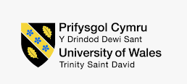
Figure: “UWTSD” (Saks, 2022).

Component 1

1. What are the benefits of developing individual staff members to “UWTSD”?
The following are some of the benefits of developing individual employees at a university like "UWTSD":
Enhancements to Performance
Because each person learns differently through various actions, developing in "UWTSD" will result in improved performance. Additionally, better individual learning will result in better employee development. The nine-field grid, which provides a visual orientation that can include valuation and appraisal information, can also be used by managers to allow workers to view their current and projected performance during performance reviews. This will also produce the best outcomes, enabling the university to outperform its rivals in the market (Saks, 2022).
Improved approach to unforeseen circumstances
With their newly acquired skills from the development process, employees will present the best solutions during the brainstorming. When it comes to taking the best possible actions in high-stakes market situations, "UWTSD" will do so for the least amount of money and effort. As a result, the employees will be more effective in achieving the university's goals and objectives (Chanana, 2021). Employers adore it because continuing education is frequently more effective than hiring new personnel. Many managers raise those efficiencies to the next level by using era to enhance pass-education projects. Many employees spend because it enables them to diversify their skill sets (Saks, 2022).
More effective cultural development
Through the growth of each employee, the university culture at "UWTSD" will be best for everyone. The organisational goals will be more clearly defined and the staff members' ability to understand organisational policy will improve. They will act in accordance with the objectives and organisational policies as a result. This behaviour improvement will assist the university in fostering the best working relationships among the staff members, where they will be kind to one another in "UWTSD" (Riyanto et al., 2021).
Greater Creativity and Responsibility
The employees of "UWTSD" will become more motivated and committed to achieving the goals and objectives of the organisation through the development of individual staff members. Similar to any other strategic objective, training must be approached (Saks, 2022). For both the business and the person receiving education to successfully implement a programme, effective coaches, a follow-up evaluation, and a method to get results are necessary. Find a way to integrate training into business daily life and business workplace. The employees will concentrate on more creative actions through the online channel founded on the organisation's objectives and objects (Yousf, et al, 2021).
Greater Employee Engagement and Response
The individual staff member development in "UWTSD" encourages employees to become more engaged with the process and the managers. Since they will feel more motivated and like they are an essential part of the organisation, they will respond more readily to the commands and actions of upper-level management. Who is satisfied and who is not is revealed by how well the employees perform. This brings up the expectation of keeping up with the organisation's process advancement. When the organisation achieves its goals and objectives, this will lead to the best results possible along with the highest level of efficiency (Roman et al., 2021).

2. How can training and development be used to manage an individual’s expectations in respect of personal development in “UWTSD”?
An essential component of the HR in a university like "UWTSD" is the process of training and expansion. The HR department and managers need to put forth their best efforts in this area or task so that the workers can produce the best outcomes. Additionally, it can help people manage their prospects for their own personal growth. These are the habits it accomplishes this (Ababneh, 2021)
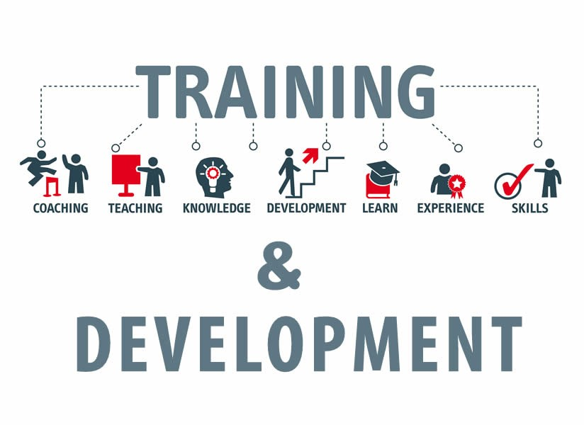
Figure: Training and Development (Saks, 2022).
Continuous Communication
The employees will be more open with the managers as long as nonstop communication is done over the drill and expansion process in "UWTSD." When workers express their needs and opinions to managers and leaders, the best results will result. This will guarantee that the needs are met, the opinions are examined and taken into account, and the expectations of the employee are managed (Ababneh, 2021)

Boosting Confidence
During the training and development process, when the employee is strongly engaged and developed, employee trust in "UWTSD" increases. A possible confidence boost for workers is also raised by the skill development of the workforce. The university will support the workers in becoming the best versions of themselves and communicating effectively with the process where their expectations will be realised by this personal growth, which will assure the best motivations of the employees (Chanana, 2021).
Expectation Clarification
The training and development process, in which they are closely watched for their activities in "UWTSD," helps to make the expectations of the staff more clear. This enables the managers to keep tabs on the workers' wants and needs, enabling the managers to take the best possible action inside the university to satisfy the employees' expectations (Saks, 2022).
Employee Development Methods
Coaching
Giving an employee advice and guidance from a more skilled or experienced person is known as coaching. Coaching aims to assist employees develop new skills, perform better, and elevate the calibre of their careers. Coaching has the following characteristics: it is customised and customised, it has a clear business goal, and it is typically carried out one-on-one over time (Saks, 2022).
Mentoring
Through structured or informal programmes, mentors match employees with varying levels of expertise with more seasoned co-workers. Formal mentoring schemes is especially for women and people of colour, may enhance performance and the work environment while reducing attrition and enhancing hiring (Roman et al., 2021).

Individual development plans
To increase the speed of employee learning, organisations might also use a character development plan. This report defines the intentions, learning objectives, and support needed to help a worker meet specified developmental goals. Plans for personal growth that include experiential learning, symbolic involvement, and adult learning approaches may be advantageous (Roman et al., 2021).
The 9-box grid
A method for determining each employee's level of current and future organisational contribution is the nine-container grid. As a method for evaluating a university's talent pool and identifying possible leaders, the grid is often used in succession planning. When using the information from the grid, managers may also design individual growth plans (Saks, 2022).
Cross-training
It involves preparing people to do tasks that aren't typically part of their job account. The lesson of go-education may be ongoing and planned, or it might be a quick or ad hoc fix. Although move-training seldom results in a quick raise, it does demonstrate a worker's eagerness to learn new skills. The capacity to use a variety of skills may also help him or her become eligible for further professional growth (Saks, 2022).

3. Critically evaluate the development vehicles available to an organisation appropriate to the development needs of the individual
Motivation, leadership management, engagement, and other key development tools are among "UWTSD"'s core development tools. These raise the issue of the organisation's personnel properly developing. This raises the issue of organisational development requirements being met in the area where the business achieves the greatest market outcomes. Below are those mentioned:
Motivation
One of the most crucial aspects of any university is motivation, and "UWTSD" provides the finest motivation for workers. Employees are motivated in a variety of ways by the university, both good and bad. The top performer receives both intrinsic and extrinsic benefits, including bonuses, accolades, promotions, and others. It allows HR professionals to build on the corporate culture—which is separate from technical skills and knowledge—that an employee already has rather than beginning from scratch. Typically, furthering an individual's development is more likely to be beneficial in bringing human assets to an organisation than education or onboarding freshly hired personnel could be (Saks, 2022).
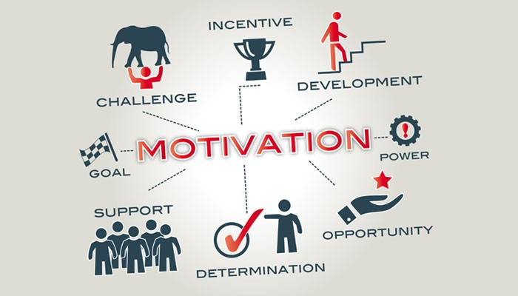
Figure: Motivation (Raza, et al, 2021)

In order for the underperforming workers to become more productive in the future, the university offers help to them. Although it may be done well, workforce development does need the organisation to spend money, time, and effort. However, in the long term, those investments will more than pay for themselves. If an employee seems to be acting inappropriately, the person may face negative motivational measures including task punishment, demotion, and others. This leads to the optimal growth of both the organisation and the people (Riyanto et al., 2021).
Leadership Management
The leaders are very operative, and "UWTSD" develops the greatest leaders with efficient controlling to guarantee the best outcome. The managers and leaders are highly capable and kind, and they have no trouble establishing rapport with the staff members. As a consequence, there is more effective communication between the organisation and the staff, who get greater attention.
Better task communication from the leaders will inspire the staff more, which will improve their performance. The abilities of the workers will also be improved, and they will be more motivated to contribute to the growth of the university and secure its aims and objectives. With the leaders' trust, the workers will also grow more effectively, and the leaders will motivate them to work more for the business, which will lead to the best marketplace activities
Engagement
The most crucial factor in a university like "UWTSD" where the goal is to produce the greatest outcomes with the workforce is employee engagement. With constant contact and emotional exchange on the part of the organisation, the workers will advance further. "UWTSD" has the highest level of employee engagement and greatest performance. Employee development is essentially described as a strategic tool for an organisation's long-term growth, productivity, and capacity to hold closely to important personnel (Yousf et al., 2021).

Employee improvement methods might be time-consuming for businesses, difficult for employees, and questionably expensive for each event if major roadblocks go undiscovered. Workers are concerned that their companies do not provide enough opportunity for professional and skill development. Additionally, this improves employee learning while fostering the finest possible degree of growth for competitive advantages. Employees will interact more effectively and waste less time thanks to the organisation's implementation of the best workplace engagement approach and best corporate culture initiatives. The procedure will eventually provide the greatest outcomes, and the workers' performance will increase (Chanana, 2021).

Component 2: SMART & PDP

SMART
SMART objectives combine the qualities of being precise, measurable, attainable, relevant, and time-bound. Based on their success, the university gives its personnel more inspiring incentives.
Specific
Here, I need to be clear about the kind of objective I need to accomplish with UWTSD's recently hired staff members. Here, certain details like whom and what I should work with to accomplish the objective must be maintained. The goal's mission statement needs to be this particular.
Measurable
What measurements I'll use to gauge success will be decided in this section. Measurable is crucial to achieving the objective since it helps make it more real. It is my responsibility as the HR manager of "UWTSD" to utilise this section correctly (Yousf et al., 2021).
Achievable
This section assesses the significance of the objective and what I can do to increase the objective's viability. However, to achieve this, it could call for new abilities, a changing environment, and a new mentality (Kristanto et al., 2020).
Relevant
The pertinent portion of a SMART objective focuses on how large corporate goals were built with particular logic. The business and university goals should be pertinent to one another in this situation. In order to receive a better and timelier response from newly hired personnel, it is my responsibility as an HR manager to keep the system and them relevant.
Time-Bound– Each job and objective should have a deadline and be fulfilled by that time. Giving a target date for delivery is quite important in the context of the university and its purpose. This method is referred to as time-bound (Kshatriya, 2018)

SWOT Analysis
SWOT Analysis
Strengths  - According to Baier et al. (2022)'s SWOT analysis, I have a strength in that newly hired workers may receive the opportunity to access a wealth of internal knowledge.  - Using technologies in "I" will promote the development of technical expertise and corporate expansion | Weaknesses  - I have certain weaknesses. A problem for the "UWTSD" firm might be improper upkeep.  - I could be unable to run their operations because I don't have properly trained competent workers.  - The drawback for me and the staff at "UWTSD" may be the absence of rivals or an unorganised scenario.
Opportunities  - Using a variety of technology phrases and tools may be a fantastic benefit for newly hired workers to boost their career growth, I've discovered.  - I have discovered that using the right business strategy may preserve the professional balance of the employee.  - I've discovered that workers may benefit much from the various university activities in terms of experiencing various business moods. | Threats  - The new leadership may put me in danger, and they periodically may go off course.  - Highly qualified and seasoned workers may pose a danger to freshly hired workers; I've discovered (Fontaine, 2018).  - The newly hired workers may be in danger if I handle HR in a disorganised manner (Chadwick et al., 2018).

Personal Development Plan
Focus Area | Where now | Will be | How known | Activity | Resources | Time | Reward
Creating training plan | increasing | Leadership and communication abilities. | SMART objectives may be examined. | Group activities and experiences | many business paperwork and papers | after a year
Following training plan | Perhaps better can | keep the situation stable under any circumstance (Petrakis et al., 2021) | With the use of a SWOT analysis | Self-practice | Members of my group | after 2 year | Net running gear.
Maintaining | Maintain all of business personnel in good condition. | All the teams and activities can be effectively managed by me. | via self-practices | Collaboration and more effort | My colleagues | after 3 year

Conclusion
The debate has led to the conclusion that "UWTSD" has been highly successful in appropriately managing the workforce, where the university has successfully motivated and inspired the workforce. The business might also benefit from tight communication and oversight, where the demands of the workers can be better met. This will increase workers' productivity, and the business will succeed in more effectively attaining its aims and objectives. Additionally, the business has excellent leadership, which encourages people to perform at their highest levels, outperform all rivals, and satisfy students to the fullest extent possible. (Kshatriya, 2018)

References
Ababneh, O.M.A., (2021). How do green HRM practices affect employees’ green behaviors? The role of employee engagement and personality attributes. Journal of Environmental Planning and Management, 64(7), pp.1204-1226.
Ali Ababneh, O.M., Awwad, A.S. and Abu-Haija, A., (2021). The association between green human resources practices and employee engagement with environmental initiatives in hotels: The moderation effect of perceived transformational leadership. Journal of Human Resources in Hospitality & Tourism, 20(3), pp.390-416.
Baier, M.S., Lockl, J., Röglinger, M. and Weidlich, R., (2022). Success factors of process digitalization projects–insights from an exploratory study. Business Process Management Journal.
Chadwick, A. and Leigh, J.A., (2018). Identifying and developing clinical leadership in relation to transition’: in. Transition to nursing practice: from student to registered nurse, pp.116-133.
Chanana, N., (2021). Employee engagement practices during COVID‐19 lockdown. Journal of public affairs, 21(4), p.e2508. MU
Fontaine, S.J., (2018). The role of reflective practice in professional development. The Veterinary Nurse, 9(7), pp.340-347.
Hurtienne, M.W., Hurtienne, L.E. and Kempen, M., (2022). Employee engagement: Emerging insight of the millennial manufacturing workforce. Human Resource Development Quarterly, 33(2), pp.137-156.
Kristanto, T., Hadiansyah, W.M., Nasrullah, M., Amalia, A., Anggraini, E.Y. and Firmansyah, A., (2020). Strategi Pemasaran Digital Dalam Peningkatan Penerimaan Mahasiswa Baru Menggunakan Analisis SWOT. MULTINETICS, 6(2), pp.128-133.
Kshatriya, S., (2018). A case study of empowerment: Linking adult training to employment through innovative learning approaches. International Journal of Research in Social Sciences, 8(7), pp.44-75.
Petrakis, E.G., Kontochristos, I. and Rastsinskagia, K., (2021), May. Fi-SWoT: Secure Federated Service Oriented Architecture for the Semantic Internet of Things. In International Conference on Advanced Information Networking and Applications (pp. 200-214). Springer, Cham.
Raza, A., Farrukh, M., Iqbal, M.K., Farhan, M. and Wu, Y., (2021). Corporate social responsibility and employees' voluntary pro‐environmental behavior: The role of organisational pride and employee engagement. Corporate Social Responsibility and Environmental Management, 28(3), pp.1104-1116.
Riyanto, S., Endri, E. and Herlisha, N., (2021). Effect of work motivation and job satisfaction on employee performance: Mediating role of employee engagement. Problems and Perspectives in Management, 19(3), p.162.
Rožman, M. and Štrukelj, T., (2021). Organisational climate components and their impact on work engagement of employees in medium-sized organisations. Economic Research-Ekonomska Istraživanja, 34(1), pp.775-806.
Saks, A.M., (2022). Caring human resources management and employee engagement. Human Resource Management Review, 32(3), p.100835.
Wu, J., Inoue, Y., Filo, K. and Sato, M., (2022). Creating shared value and sport employees’ job performance: The mediating effect of work engagement. European Sport Management Quarterly, 22(2), pp.272-291.
Yousf, A. and Khurshid, S., (2021). Impact of employer branding on employee commitment: employee engagement as a mediator. Vision, p.09722629211013608.

Appendix

Interview
Interviewer: Good morning, everyone, and thank you for joining us today. We have the pleasure of speaking with the staff members of UWTSD to discuss the benefits of developing individual staff members for the university. Let's begin by introducing ourselves.
Interviewee 1: Thank you for having us- I am Jane, a faculty member in the School of Education. I believe that with their newly acquired skills from the development process, employees will present the best solutions during the brainstorming. I think that when it comes to taking the best possible actions in high-stakes market situations, "UWTSD" will do so for the least amount of money and effort. I think that As a result, the employees will be more effective in achieving the university's goals and objectives
Interviewee 2: Hi, I'm Mark, a senior researcher in the Department of Computer Science. I believe that through the growth of each employee, the university culture at "UWTSD" will be best for everyone. I think that the organisational goals will be more clearly defined and the staff members' ability to understand organisational policy will improve. They will act in accordance with the objectives and organisational policies as a result.
Interviewee 3: And I'm Sarah, a librarian at UWTSD. Happy to be here- I believe that the employees will be more open with the managers as long as nonstop communication is done over the drill and expansion process in "UWTSD." I think that when workers express their needs and opinions to managers and leaders, the best results will result. I think that this will guarantee that the needs are met, the opinions are examined and taken into account, and the expectations of the employee are managed (Ababneh, 2021)
Interviewer: Those are fantastic initiatives that truly demonstrate UWTSD's commitment to staff development. You may go now.

