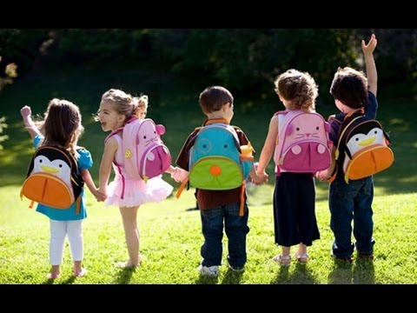
(source: HelloDoktor, 2017)
Transition handbook for early years.
Starting big school…

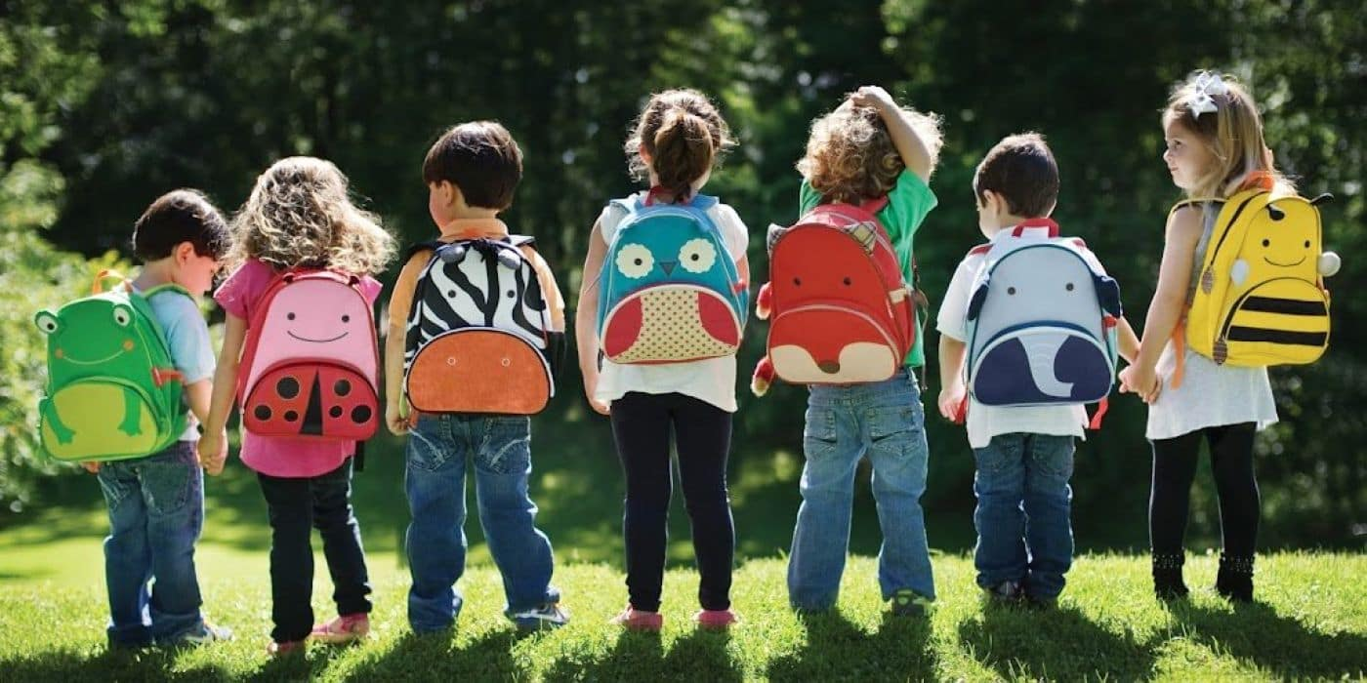
(source: HelloDoktor, 2017)

Contents page
Page 1-introduction
Page 2-Theorists- on how they are linked to transition
Page 5-Open days- the benefits of holding them
Page 7- Home visits and planning
Page 8- planning
Page 9- Observation
Page 10-reporting and communication
Page 11- report sheets
Page 13- safe guarding and the aim
Page 14-reference list

Michelle roberts
1706015
EAEE5003/C

Word count 410 page 1
Introduction
This booklet is going into detail of what transition is and why it is important to get it correct, and as practitioners what we can do to make the process smooth and successful for children aged 3 years and above, but not forgetting parents and practitioners who also have a key role in the transition phase. And how communication between them both is vital. Although this was challenged by Gwernan-Jones, Ruth, et al (2015) explaining the negative relationship of both parent and teacher, but this is proved more likely to be with children showing social, emotional and behavioural difficulties. Van Stone, B. (2013) suggests that as a practitioner you have the day to day relationship with the child, your aim is to build the trust between you both, so if the child has any problems they will feel comfortable enough to come to you and work through them.
Throughout the booklet there will be different examples 0f activities, theories and methods, giving more detail of their importance’s. Discussing the role of the practitioner and the importance of their involvement with parent/guardian. Most of if not all can help with transition, it can be incorporated with most changes that a child will experience in school. It gives them a good step in stone to deal with separation and change in later years, for example, Moving from one classroom to another. It is a substantial change for a child moving from a familiar routine and environment to another. Harper, L. (2016).
Drake (2006) suggests that as practitioners we now need to make this process exciting and fun for the children, focusing on listening to the individuals need of the child, building that close relationship and trust between the key worker and the parent. Milteer, R., & Ginsburg, K. (2012) agrees with Drake (2006) and continues to high light the following:
-Communication is key as children may discuss any worries at home. but also, our duty to show how the child has been in school to the parent/guardian. This can be done through a report system, newsletters or a one to one visit.
-Planning Making children feeling safe in their setting, As Montessori believes we should be giving them the sense of security, a home from home feel. (Lillard, 2013). Building that trust barrier, how can we do this? but remembering some children come from a more

Word count 197 page 2
trouble back ground or have learning difficulties and will find transitioning more challenging. Further support needed.
-Children’s development looking at the child’s holistic needs, physical, emotional, relational and intellectual needs. And according to Fane, J., MacDougall, C. et ol (2016) Also making sure their health and wellbeing is considered too.
Theorist
Here are some of the theorists and what they believe transition means to the child and all who are involved,
According to Croner-I (no date) starting school is a big milestone for children. This also offers exciting opportunities, but it does not come without its challenges. Not only for the child but also for the parents, they can experience anxiety and can get emotional at times. Brooker (2008) believes that a successful transition will result in having a more confident child, being able to handle new experiences. Dunlop (2007) agrees, if we can get the transition right in the foundation phase then it sets them up to handle transition better in later years. Something to always remember that not all children cope with transition in the same way, Bronfenbrenner theory on transition is described as ‘ecological system’ this has five stages. Here is a diagram below:
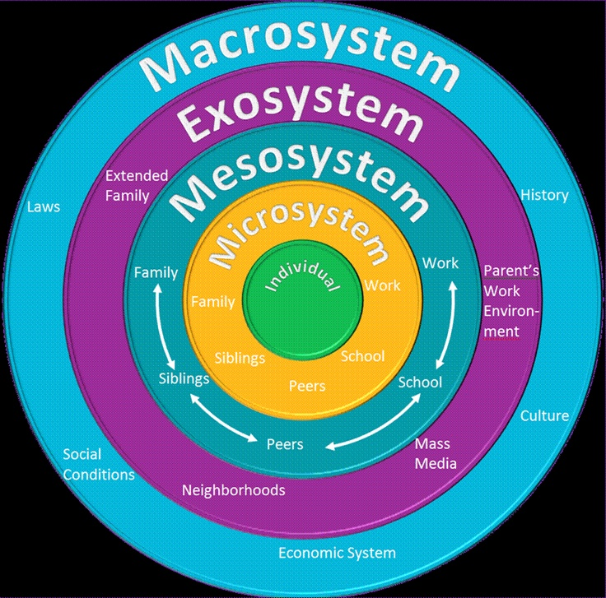
Word count 354 page 3 (source: Marie, 2017)
Based in the middle will be the child. Working away from the centre shows those who are closest to the child and has the most influence on them, working its way out to the people and environment not so close, but all will have an impact on the child some way or another. David (2007) Shows Bronfenbrenner beliefs that because children have different up bringing’s, their influences from their immediate carers are different, not every child has a positive influence in their lives. Bronfenbrenner found that in 1940’s-1950’s an experiment was undertaken, and it found that a child who comes from a divorced family lacks cognitive, social and biological skills, this was compared to a child having their two parents together. He believes it is about the environment that they are brought up in. and the effects this has on the child.
Bowlby (1969) shows, the different type of relationship a child will have with its mother. Below you will see a diagram and shows on the left, if a child is loved, feels safe and secure and has a positive relationship with its mother, how the child will be confident to explore further. An experiment was conducted by Bowlby on a large group of children back in 1936 to 1939, and discovered after doing test, children who had been separated from their mothers before the age of 5 years, were more likely to show less emotion and be involved in more criminal activities. This shows if a child comes from a disadvantaged background that does not have the ‘go to’ figure in their lives, Transition is going to be a challenge for them. Also, he high light’s that the first 5 years of the child’s life is the most valuable time to build that secure relationship with its mother. Not just using her as a food source, the child looks for the love and security that it needs. (O’Connor 2013).
Bowlby’s theory, ‘the secure base’. (Benson and Haith, 2009). Here below is an example of a diagram showing Bowlby’s attachment theory, taken from simply Psychology (2007).
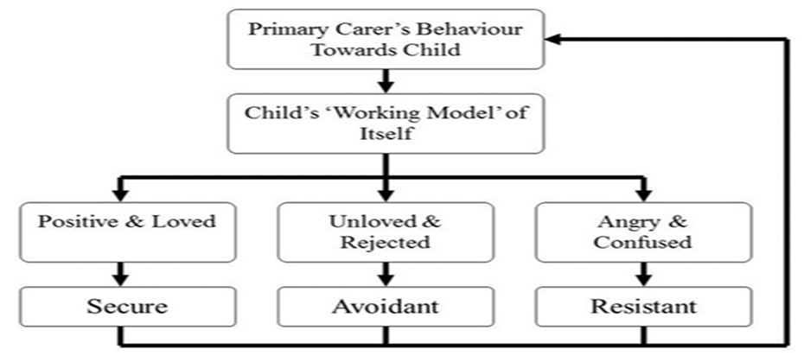
(source: Simply psychology, 2007)
Word count 271 Page 4
Below is a diagram of Maslows (1943) high racquet of the child’s needs, second from the bottom is the safety need previously been mentioned with Bowlby theory, imagine if the child does not have that, they could not possible be able to build on their self-esteem, confidence or form relationships with others. So, when we look at a child coming into a new setting (like school) how will we expect them to manage with such a big change?
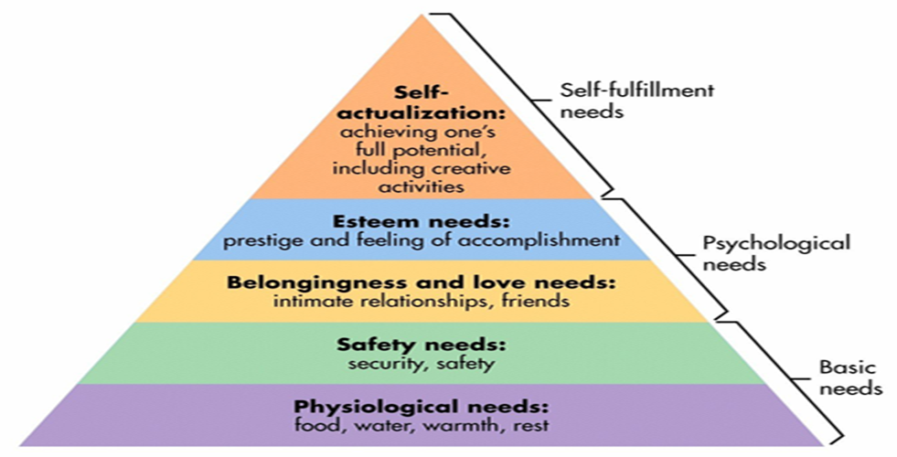
(source: Simply psychology, 2007)

Sourced from Wallborn (2014) Bandura theory ties into Bronfenbrenner’s ecological system but Bandura believes that we learn by copying, after an experiment was contacted by Bandura called ‘bobo doll’, it found that the children copied what the adult was doing to the doll. This proved both Negative and positive behaviour. if the child in its home environment seeing negative behaviour, they are going to copy that kind of behaviour and that will be normal to them, and during the transition phase this will make them feel vulnerable because they are lacking in having emotional skills. (O’Connor, 2013). On comparison to Maslows diagram, a child who has a positive, loving and secure up bringing gives them a better step to build confidence and self-esteem. which in return will make transition a more manageable process. Bandura believes that observational learning is the most important learning method Louw (1998:60). However, this is challenged by Skinners Theory, Shaffer (2008) explained that skinner believes you learn by consequences, you have your own mind to make choices based on the reward or punishment, if a child gets rewarded for bad behaviour they will continue to
Word count 316 page 5
display that kind of behaviour, Skinner put this down to the child memory. So, this is where as a practitioner, we need to focus on the good behaviour, giving rewards and praise where needed and be a good role model to the children.

Open days
Below are five reasons and the benefits for having an open day at the early years setting to help with transition, it gives us time with parents/guardian and child, getting to know them and their families. their culture and their beliefs. this session will take place over a number of weeks prior to the child starting school. This will help the children to become comfortable and more confident in their new surroundings, which will lead onto them being able to leave their parent/guardian to come to school, the aim is become that go to person mentioned earlier in the booklet, more known as Bowlby’s theory.
Points as follows:

- It gives the practitioner the opportunities to meet the children and parents,
- For any questions or worries to be discussed
- If there are any allergies or any other health issues with the child
- If there are any strong beliefs with in the family
- Any safe guarding issues involving the child (Very important)
- Know their names
- For the child to see their environment/setting,
- Children can familiarise themselves with their surrounding
- Be introduced to the key workers
- Know and what to expect on their first day
- Gain confidence
- Children feel safe with having their guardian in the same room (at the beginning)
- For the parent to see the child’s new setting,
- parents like to visualise where the children are
- be able to have conversations about what they have done during the day
- they gain confidence their child will be happy
- Meet other children that will be in the same class,
- Not all children have socialised before, due to their up bringing’s
Word count 245 page 6
- They lack self-confidence to interact with others
- Gives them confidence
- Teaches them to share and engage with others
- To develop new skills
- Gives parents chance to talk with each other,
- Make friends
- Getting to know other families
- Socialising
- Discuss between each other their worries. (Realise they are not the only parent anxious)
- Giving themselves a bit of reassurance.
Above are supported and sourced from Cadima, Doumen, et ol. (2015), Eduction.com (2009), Harper, L. (2016), Denham, S., Bassett, A., et ol. (2012).
According to the BBC (2015) when the parent/guardian comes to the open day they are looking at everything, they will have their own checklist in their minds.
Looking at the art work around the class- shows what children have been learning.
Having a feel for the atmosphere- is it happy, sad, friendly or even chaotic

Home visits
The Key for school leaders (2017) state ‘The statutory framework for Early years foundation stage (EYFS) does not refer to home visits.’ However, it continues to say ‘While home visits are not statutory, they do reflect good practice. This is not something all schools can give but if they can it is highly recommended; A visit will take place during the summer term if starting in September and you will be recommended to go in pairs. One can go through paper work and the other can spend time interacting with the child, many forms can be exchanged on this visit;
• Permission slips
• Settling procedures
• Questionnaire.
• reports
Word count 298 page 7
The questionnaire with have questions such as;
• Does your child have any learning difficulties?
• Does the parent/guardian have any concerns?
• What is the child’s first language?
• Any family beliefs/traditions?
• Safe guarding questions
It will be clear that what the parents bring to the open day and what we can offer at school, can be adapted to a home visit. The only drawback is the child not seeing their new class, where to hang their coat and even where they will be having lunch. The aim of both is the same. what The Key for school leaders (2017) show is the advantage of seeing a child in its own surrounding, you will see the children relaxed and happier to engage.

Planning
The Department for children, schools and families (2009) believe Effective Early Years practitioners will organise the time, space and activities in the daily routine to reflect the overall combination which best supports children’s well-being and learning. There is more behind just setting up activities and leaving the children to explore them for themselves. Although Montessori encourages freedom of play as this enhances creative learning (cited in Lillard, 2013). Practitioners need to look deeper into the needs of the child and what will they gain from that activity. Play is important in their wellbeing and social development, helping with learning and building their confidence, but it also shows that if a child has the influence of a skilled parent/guardian this can enhance their progress too. The department of children, schools and families (2009) Quote,
the best outcomes for children’s learning occur where most of the activity within a child’s day is a mixture of: child-initiated play, actively supported by adults focused learning, with adults guiding the learning through playful, rich experiential activities.
(Department of children, schools and families, 2009:7)

Word count 222 page 8
Although adult interaction is needed, there are positives and negatives of both, too little will mean the activity will become very repetitive and the child will just play with no learning, too much will result in the child being deprived of learning, but it does give them independence and space.
So, planning an activity is crucial, thinking on how the practitioner can engage with the new children. Circle time is a good one to start with, this gets all the children together, getting to know names of other children, it opens discussions between one another (have they got a sibling, any pets etc) and interacting, this encourages their language, listening and confidence skills. Building on their personal social and emotional development (department of education, 2017, 7) making them feel there are being listened to. Introducing puppets and stories are exciting and fun, but observation is key, are the children engaging with you, are they losing interest and getting restless, and being able to notice these signs will make a good practitioner, adapting to the mood of the children. Remembering the expected time for a child three year and above is about 5 to 7 minutes. Even if it is one child, remembering they are all different in their own ways. And then act appropriately, give that added support where needed. (Kimberly, 2015).

Word count 25 page 9
Observation
Below is a form for each child, to be filled in as part as their settling in process, highlighting any concerns you may have.
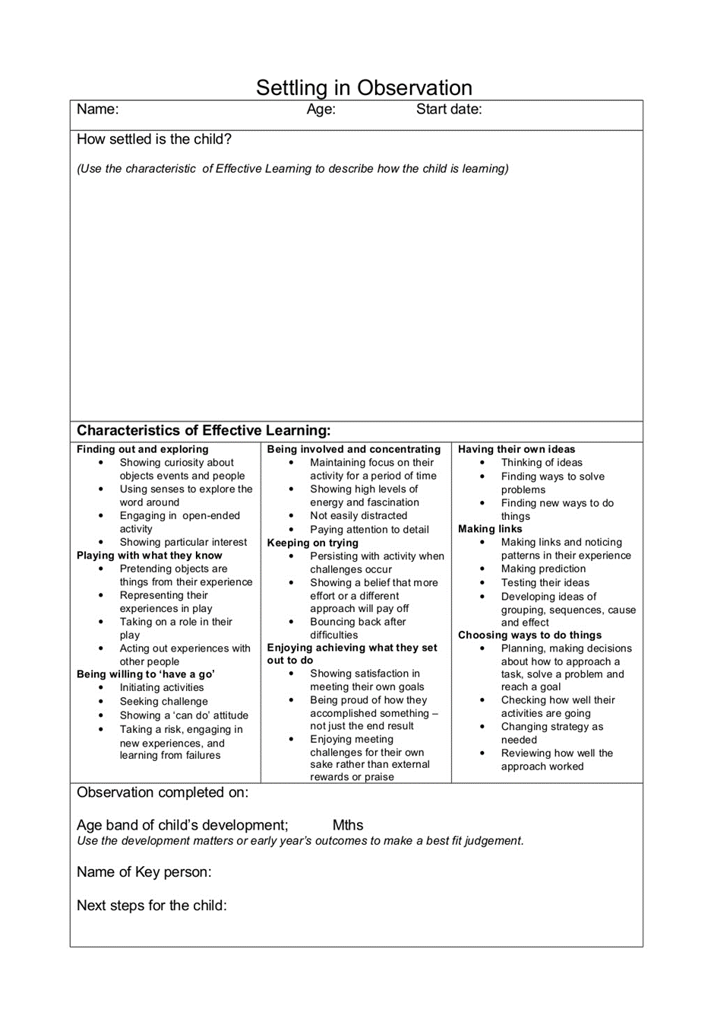
Word count 301 Page 10 (Sources: Slide share, 2015)

Report and communication between parents
Open communication between the practitioner and the parent/guardian is very important. It is remembering the needs of the child. It is important that a positive relationship is formed between the parent/guardian from the very start. It is the practitioner care to report any worries or concerns they have with the parent/guardian. The child could need extra care in certain areas of their development, if the parent/guardian is aware of this then they can both work together, coming up with strategies both at home and at school to help improve the developmental area. (Early years the organisation for young children, 2007)
The form below covering all the children’s needs and how they are developing, this will then be shown and discussed with the parents/guardian. Action will then be taken appropriately.
This is not the only we communicate together, a face to face meeting can be help, some parents/guardians may find it more reassuring talking directly to the practitioner. Just needing just reassurance at times that there is nothing to worry about, and equally, some parents are happy to communicate through paper system. but the form is a good template to follow to discuss the issues.
Having that support from the parent gets it off to a good start, having them continues support at home too. Helping to make the transition stage go smooth. Parents can offer to read with the children, having books about school, getting them involved in putting out their school uniform, having an input in what to put in their lunch box etc. It is all about making them excited, not frightened. It is all about working together, Both the practitioner and the parent/guardian want the child happy, because a happy child will engage more and learn more. And that is the aim of all involved with the child.

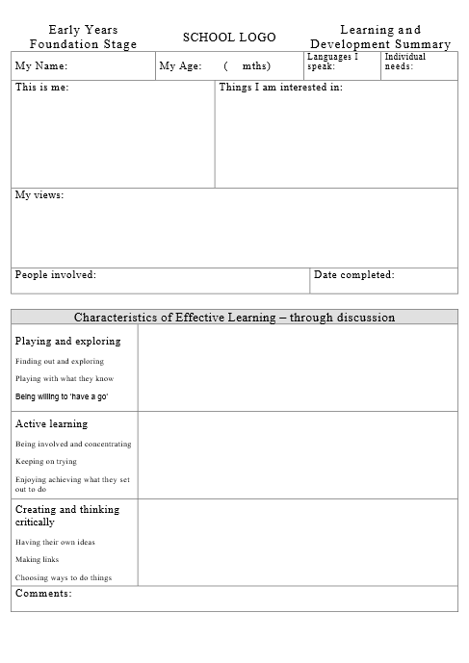
(source: Reception End of Year Report Format, no date)
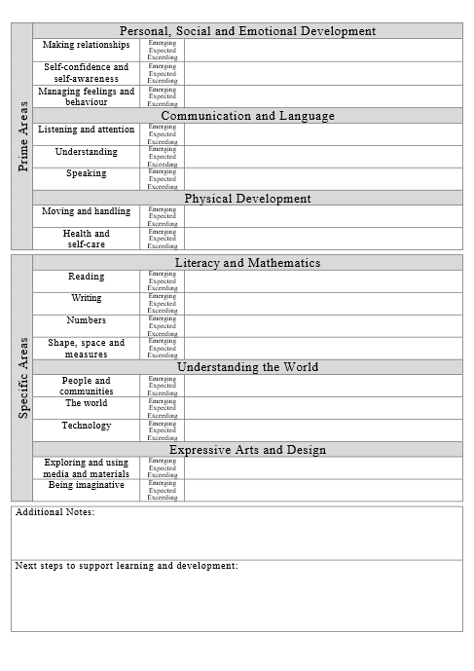
(source: Reception End of Year Report Format, no date)
Word count 380 page 13
Safe guarding
Children need to be protected, this could be, being protected from a family member and that is something the practitioner in the school needs to be aware of, and all involved with that child. For whatever reason, if the child does not have contact and needs to stay away from a certain individual, our role is to respect that wish and protect the child coming to harm with them. The child will only be given to the specified names highlighted on the form that the main carer would have filled in on one of our open days. This will be kept up to date at all time, and accessible to any new/temporary practitioners that may be with that child. (NSPCC, no date)
Another role of the practitioner is to be aware of the health of the children, again it is protecting their needs. Noticing emotional abuse or neglected. Knowing the signs and what they mean. If there is a change in a child’s behaviour and pattern, have they started to be late? their personal hygiene is not what it used to be? Are they looking for food because they are hungry? But please remember this could be their normal behaviour from the start there may not of be a change. And as a practitioner it is what we do with the information. Log it, report it (follow the settings safe guarding procedures) and where needed it may be suitable to speak with the parent/guardian. It is not to be ignored. It is our duty of care to protect the well fare of the children. As from a learning point of view this will have an impact on the emotional and cognitive development, as highlight at the beginning of this article in Maslow’s diagram. (Baginsky, 2008, 7-8).
Aim
The aim of the booklet highlights throughout, the need of the children, but not every child has the same learning abilities when they start school. Due to their home lives having affected on their development. Some positive and some negative. The use of the theorists in the booklet prove this. We as practitioners need to give the children the best start in early years, and by making the transition process as enjoyable and exciting will give them a good step in later years.

Page 14
Reference list

BBC. (November 2015) ‘Making the most of open days' http://www.bbc.co.uk/schools/parents/open_days/ [accessed: 17th November 2017].
Baginsky, M. (2008) safeguarding children and schools. Great Britain: Jessica Kingsley.
Benson, B. J and Haith, M., M. Social and Emotional Development in Infancy and Early Childhood
Brooker, L. (2008) supporting transition in early years. England.
Cadima, Doumen, Verschueren, and Buyse. (2015). Child engagement in the transition to school: Contributions of self-regulation, teacher–child relationships and classroom climate. Early Childhood Research Quarterly, 32, pp. 1-12.
Croner-I, (no date) ‘managing transition in early years provisions’ https://app.croneri.co.uk/features-articales/managing-transtion-early-years-provisions [accessed: 18th November 2017].
David, R. Shaffer, K.K. (2007) Developmental Psychology. (6th ed) Wadswoth.
David, R. Shaffer, K.K. (2007) Developmental Psychology. (8th ed) Wadswoth: Linda Schreiber.
Department for children , (2009) ‘Learning, playing and interacting’ https://www.foundationyears.org.uk/wpcontent/uploads/2011/10/Learning_Playing_Interacting.pdf [accessed: 23rd November 2017].
Denham, S., Bassett, A., & Zinsser, H. (2012). Early Childhood Teachers as Socializers of Young Children’s Emotional Competence. Early Childhood Education Journal, 40(3), pp. 137-143.
Drake, J. (2006) ‘Nursery world’ https://www.nurseyworld.co.uk/nursery-world/news/1080194/transitionsetting [accessed: 22nd November].
Dunlop, A.W, Fabian, H. (2007) informing transitions in the early years. England.
Early years the organisation for young children. (2007) ‘A Guide for parents’ http://www.early-years.org/parents/docs/settle-in.pdf [accessed 28th November2017].
Education.com, (2009) ‘communication between parents, child, and teachers’ https://www.Education.com/reference/article/comunication-parent-child-teacher/ [Accessed: om 23rd November].
Fane, J., MacDougall, C., Redmond, G., Jovanovic, J., & Ward, P. (2016). Young Children's Health and Wellbeing Across the Transition to School: A Critical Interpretive Synthesis. Children Australia, 41(2), pp. 126-140.
Gwernan-Jones, Ruth, Moore, Darren A., Garside, Ruth, Richardson, Michelle, Thompson-Coon, Jo, Rogers, Morwenna, . . . Ford, Tamsin. (2015). ADHD, Parent Perspectives and Parent-Teacher Relationships: Grounds for Conflict. British Journal of Special Education, 42(3), pp. 279-300.
Harper, L. (2016). Supporting Young Children’s Transitions to School: Recommendations for Families. Early Childhood Education Journal, 44(6), pp. 653-659.
HelloDoktor, (2017) ‘How to keep your child safe at school’ http://hellodoktor.com/health-centre/child-health/keep-child-safe-school/ [Accessed: 21st November 2017].
Kimberly, (2015). ‘Top 10 tips about circle time’ http://www.earlyyearscareers.com/eyc/latest-news/ten-top-tips-about-circle-time/ [accessed: 28th November 2017].
Lillard, Angeline S., 2013. Playful Learning and Montessori Education: American Journal of Play, 5(2), pp.157–186.
Louw, D. A, (1998) Human Development. (2nd ed). South Africa: Pearson.
Marie, S. (2017) ‘Bronfenbrenner’s Bioecological approach. Diagram of Bronfenbrenner’s Bioecological approach’ http://www,suemarie.info/2017/10/Brinfenbrenners-bioecological-approach.mtml [Accessed: 18th November 2017].
McLeod, S. A. (2007). ‘Bowlby's attachment theory’ http://www.simplypsychology.org/bowlby.html [accessed 27th November 2017].
McLeod, S. A. (2017). ‘Maslow's hierarchy of needs’ http://www.simplypsychology.org/Bowlby.html [accessed 27th November 2017].
Milteer, R., & Ginsburg, K. (2012). The Importance of Play in Promoting Healthy Child Development and Maintaining Strong Parent-Child Bond: Focus on Children in Poverty. Pediatrics, 129(1), pp. 204-13.
NSPCC, (no date) ‘Safeguarding children’ https://www.foundationyears.org.uk/wp-content/uploads/2011/10/Learning_Playing_Interacting.pdf [accessed 28th November 2017].
O’Connor, A. (2013) Understanding transition in early years. (2nd ed).
Slide share, (2015) observation sheets. https://www.slideshare.net/earlyyearscareers/settling-in-observation-sheet
Teaching resources. (no date) ‘Reception End of Year Report Format’ https://www.tes.com/teaching-resource/reception-end-of-year-report-format-6340036 [accessed: 28th November].
The key for school leaders (2017) ‘Home visits in the EYFS’ https://schoolleaders.thekeysupport.com/pupils-and-parents/engaging-parents-and-carers/building-relationships-with-parents/home-visits-eyfs/ [accessed 23rd November 2017].
Van Stone, B. (2013). Creating a Positive Classroom Environment: Teach, 11, pp. 23.
Wallborn, F. (2014) Religion in personality theory. (1st ed).

