Conservation Plan

Dylan samuel

2119913

1. Introduction

1.1 Purpose of the Conservation Plan
This Conservation Plan, also referred to as a Heritage Management Plan, has been prepared to support the conservation, management, and future development of the Mynachlog Fawr farmstead. The plan provides a clear and structured approach to understanding the historic environment of the site and to managing change in a way that protects and enhances its heritage value. It follows recognised heritage management principles used within the UK conservation and construction sectors and is informed by best practice guidance for the care and management of historic buildings.
The main aim of this plan is to ensure that the historic buildings and their setting at Mynachlog Fawr are fully understood before any conservation, repair, or development works are undertaken. By identifying the elements of the site that are of significance and explaining why they are important, the plan supports informed and balanced decision-making during the proposed conversion of the farmstead into The Strata Florida Centre. This includes providing guidance on appropriate repair techniques, alterations, new uses, and long-term maintenance.
In addition, the plan seeks to manage change in a controlled and sustainable manner. Although adaptation is necessary to secure a viable future for the buildings, it is important that any changes do not negatively impact their historic, architectural, archaeological, or cultural significance. This Conservation Plan therefore acts as a practical decision-making tool, helping owners, designers, contractors, and other stakeholders to assess potential impacts and to identify suitable mitigation measures where risks to the site’s significance may occur.

1.2 Site Location and Context
Mynachlog Fawr farmstead is located in rural Ceredigion, West Wales, directly beside the ruins of the 12th‑century Cistercian Abbey of Strata Florida. The abbey is internationally recognised as one of the most important monastic sites in Wales and has strong links to Welsh history, learning, and culture. The surrounding landscape is quiet, rural, and largely unchanged, which adds to the historic character and setting of the site.
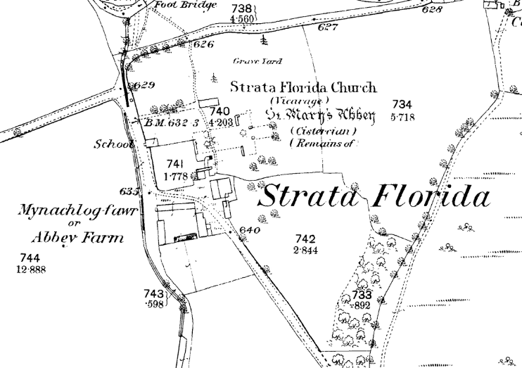
The farmstead forms part of the wider historic monastic landscape. Historically, farms such as Mynachlog Fawr would have supported the abbey through agriculture and land management. This close physical and historical relationship greatly increases the heritage value of the farmstead.

(“About- Strata Florida”)

1.3 Vision for The Strata Florida Centre

In 2016, the Strata Florida Trust (SFT) acquired Mynachlog Fawr with a long‑term vision to create The Strata Florida Centre. The centre aims to celebrate Welsh heritage, history, language, and culture, while also supporting education, research, and community engagement. The University of Wales Trinity Saint David (UWTSD) is working in partnership with SFT to support this vision, starting with accurate scanning and modelling of the buildings.
For this vision to be successful, the historic buildings must be carefully conserved and adapted in a sensitive manner. This Conservation Plan helps to ensure that development does not harm the site’s significance and instead enhances understanding and appreciation of its heritage.

2. Understanding the Heritage Assets

2.1 Overview of the Heritage Assets
The heritage assets at Mynachlog Fawr consist of a traditional Welsh farmstead that has developed over several centuries. Although much of the visible fabric is likely post‑medieval, the site may contain earlier elements connected to the medieval abbey and its agricultural activities.
“Part of the Grade II* listed Mynachlog Fawr farmhouse was originally built in the sixteenth century out of the remains of the Abbey’s refectory, as a gentry house, out of parts of the monastic buildings, as a residence. It was then rebuilt as a mansion in 1670-80. The ground floor contains a panelled parlour containing features of its gentry past, including a late 17th century panel painting and painted ceilings. There is also a 17th century staircase, and a large kitchen, which preserves fittings from its use as a Welsh tenant farmhouse in the 19th and 20th centuries.” (“About- Strata Florida”)
The main heritage assets include:
The Farmhouse (Mynachlog Fawr): A historic domestic building constructed using traditional materials and methods. The farmhouse reflects vernacular Welsh architecture and rural living.
Agricultural Buildings: A group of barns, byres, and outbuildings that supported farming activity. These buildings demonstrate how the site functioned as a working farm.
Setting and Landscape: The surrounding fields, historic routes, and visual connections to Strata Florida Abbey. The setting is a key part of the site’s significance and must be considered alongside the buildings.
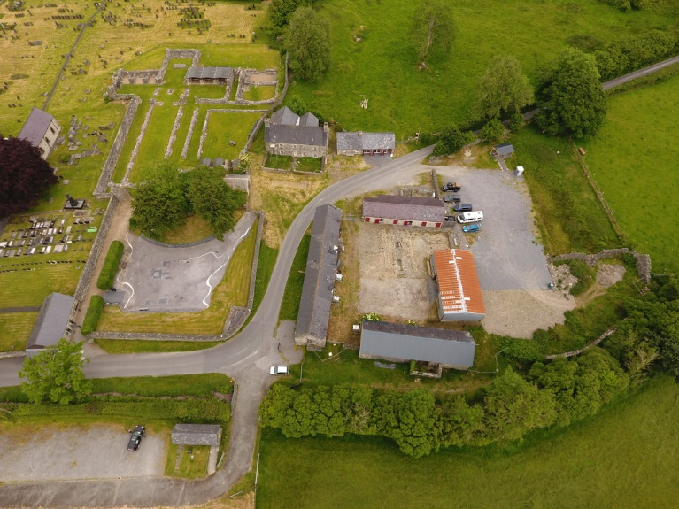

(“About- Strata Florida”)

2.2 Architectural Character and Construction
The buildings at Mynachlog Fawr are typical of historic rural farmsteads in West Wales. They are mainly constructed using locally sourced materials, which helps them blend into the surrounding landscape.
Key architectural features include:
Rubble stone masonry walls built with lime mortar, Traditional roof coverings, such as slate, Simple building forms designed for practical agricultural use, Evidence of repairs, extensions, and alterations over time. These characteristics show how the site evolved in response to changing needs while retaining its historic character.

3. Assessment of Significance

3.1 Statement of Significance

Mynachlog Fawr is a heritage asset of high significance due to its strong historical, architectural, archaeological, and cultural connections to Strata Florida Abbey and the wider Welsh landscape. Its importance lies not only in the individual buildings but also in their relationship with each other and their setting.
Understanding this significance is essential, as it allows informed decisions to be made about conservation and development, ensuring that the site’s heritage value is not lost.

3.2 Historic Significance

The historic significance of Mynachlog Fawr comes from its close association with Strata Florida Abbey. Founded in the 12th century, the abbey played a major role in Welsh religious life, learning, and politics. Farms like Mynachlog Fawr would have supported the abbey through food production and land management.
Following the Dissolution of the Monasteries, the continued use of the site as a farm demonstrates continuity in land use. This provides valuable evidence of how monastic landscapes were adapted and reused over time.

3.3 Architectural Significance
Architecturally, Mynachlog Fawr is significant as a good example of a traditional Welsh farmstead. The use of local stone, simple construction techniques, and functional design reflects vernacular building traditions.
The survival of original fabric and historic features adds to the building’s authenticity. Even later alterations are important, as they help tell the story of how the site has changed and been used over time.

3.4 Archaeological Significance
There is potential for archaeological remains both above and below ground. These may include earlier building phases, foundations, or features linked to monastic agriculture.
Any ground disturbance has the potential to damage these remains, making archaeological assessment an important part of the conservation process

3.5 Cultural and Social Significance
Strata Florida is deeply connected to Welsh cultural identity, language, and history. Mynachlog Fawr contributes to this cultural landscape and has value to local communities, historians, academics, and visitors.
The site also has educational value, particularly through its future role as part of The Strata Florida Centre.

4. Stakeholders: Who the Site Is Important To

The heritage assets at Mynachlog Fawr are important to a range of stakeholders:
Local communities, who value the site as part of their historic environment
Strata Florida Trust, as owners and custodians of the site
UWTSD, through its involvement in education, research, and heritage practice
Heritage bodies, such as Cadw, due to the site’s national importance
Visitors and tourists, who engage with Welsh history and culture
Future generations, who will inherit the site and its significance

Understanding stakeholder interests helps ensure that conservation decisions are balanced and inclusive.

5. Issues, Risks, and Vulnerabilities

5.1 Physical Risks
Historic buildings are vulnerable to deterioration if they are not properly maintained. Key risks include:
Weathering of stonework and mortar
Water ingress due to roof defects or poor drainage
Structural movement caused by age or ground conditions

5.2 Environmental Risks
Environmental factors also pose a threat to the site:
Increased rainfall linked to climate change
Growth of vegetation on walls and roofs
Damp conditions affecting historic fabric

5.3 Development and Use Risks
The proposed change of use introduces additional risks:
Loss of historic character through insensitive alterations
Damage from increased visitor numbers
Installation of modern services impacting historic fabric

5.4 Management Risks
Poor management can also affect significance:
Lack of long‑term maintenance planning
Inadequate understanding of the site’s heritage value
Use of inappropriate materials or techniques during repairs

6. Conservation Management Policies

6.1 Conservation Principles
All conservation work should follow established principles:
Minimum intervention – only carry out work that is necessary
Like‑for‑like repair – use matching materials and methods
Reversibility – new work should be reversible where possible
Respect for significance – protect what makes the site important

6.2 Policies for Built Fabric

Carry out detailed surveys and condition assessments before work begins

Repair historic fabric rather than replacing it

Avoid unnecessary alterations to original features

Integrate modern services discreetly

6.3 Policies for Setting and Landscape

Protect key views between the farmstead and the abbey

Retain historic field patterns and boundaries

Ensure new work fits the rural character of the site

6.4 Archaeological Policies

Preserve archaeological remains in situ where possible

Carry out archaeological assessment before ground works

Properly record and archive any discoveries

6.5 Use and Interpretation Policies

Ensure new uses are compatible with the buildings

Provide interpretation to explain the site’s history

Promote Welsh language and cultural heritage

6.6 Risk Mitigation Measures

Implement a planned maintenance programme

Monitor building condition regularly

Ensure work is carried out by appropriately skilled professionals

7. Implementation and Review

This Conservation Plan should be used throughout the project lifecycle. It should be reviewed and updated as new information becomes available from surveys, research, and building investigations.

8. Conclusion

Mynachlog Fawr is a heritage asset of significant historic, architectural, and cultural value. Its careful conservation is essential to the success of The Strata Florida Centre. By understanding its significance, identifying risks, and applying clear conservation policies, the site can be protected while allowing sensitive change. This approach ensures that Mynachlog Fawr will continue to contribute to Welsh heritage and education for future generations.

