


INtegrating project

Iestyn Evans
Integrating project ACHA4008| 2305862@student.uwtsd.ac.uk



Introduction
Within this report I will be exploring the spike prime v3 kit. The kit is designed to help teach programatic thinking and problem solving skills within a STEM(Science Technology Engineering and mathematic) setting. Robotics is a important area of stem and can be used to teach a lot of the key ideas and thought processes which are used in stem industrys which if taught at a young age can have a strong impact on an individuals problem solving and thinking skills while also ushering people towards the quickly growing and rapidly expanding world of stem.
To explore the spike prime v3 kit as a team we have been assigned the task of solving a maze using the spike prime kit to do this we have had to explore maze solving algorithims and motor based drive bases for the spike prime v3 kit.

Table of Contents
Iestyn Evans 1
2
Introduction 2
key project areas 4
Code development 4
Mechanical design 5
research 6
Project planning stages 7
requirements 7
design 7
implimentation 7
conclusion 8

key project areas

Code development
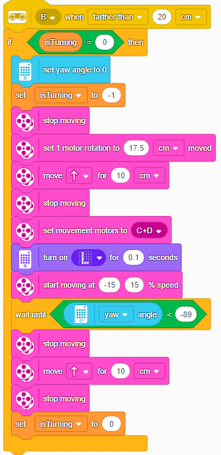
As during this project we are usingthe spike prime v3 development kit we had 2 choices for developing our code base we could either use the scratch block based coding or python we decided to use scratch as this would allow us to have a more rapid development and iteration cycle greatly increasing improving development times and also allowing us to have a more concise code base as the code blocks within scratch enabled us to have a clearer code base. We also needed to process the sensor data within the code to do this we monitored the yaw for the spike prime v3 kit at all times as this allowed us to respond to any updates in the kits position and adjust while on the fly the below code snippet demonstrates this within pa our code the below snippet uses the distance sensors to track if the spike prime v3 kit is paralel to a wall at any time and if it is not it will rotate to stay on path as we used the pledge algorithim monitoring our relative distance from the current path was a key piece of data that we needed.

Mechanical design
While building the vehicle we used various resources in optimising our vehicle to solve mazes we also had to have multiple sensors to input data from the world around the robot to the robots internal code to allow the algorithim to programatically solve the maze. We also used insperation from other vehicles and engineering design choices from a myriad of similar projects. We also followed some of the design ideas from the lego spike prime v3 website however as the spike prime wheelbase was not specifically design for maze solving projects we had to make some adjustsments with adding additional sensors allowing us to retrieve data from the world to allow the robot to accurately traverse the maze. We also needed to make changes to the vehicles wheel base as the broad wheelbase of the original kit did not allow for an accurate enough turning radius to navigate the maze. The below image of our maze solving robot demonstrates both the range sensors and the narrower wheelbase we had installed in our spike prime v3 kit however we believed that in future designs we would have had a singular drive shaft-based system allowing for more precise control of the vehicle and allowing for a greater level of torque allowing our spike prime v3 kit to traverse a wider span of terrains. The below image also includes the force sensor this was used to detect when the spike prime had hit an obstacle however shortly after taking this photo, we added a broader actuation area for the pressure sensor as it allowed for more accurate detection of obstacles while also allowing for minimal changes within the code which saved us time within the development process.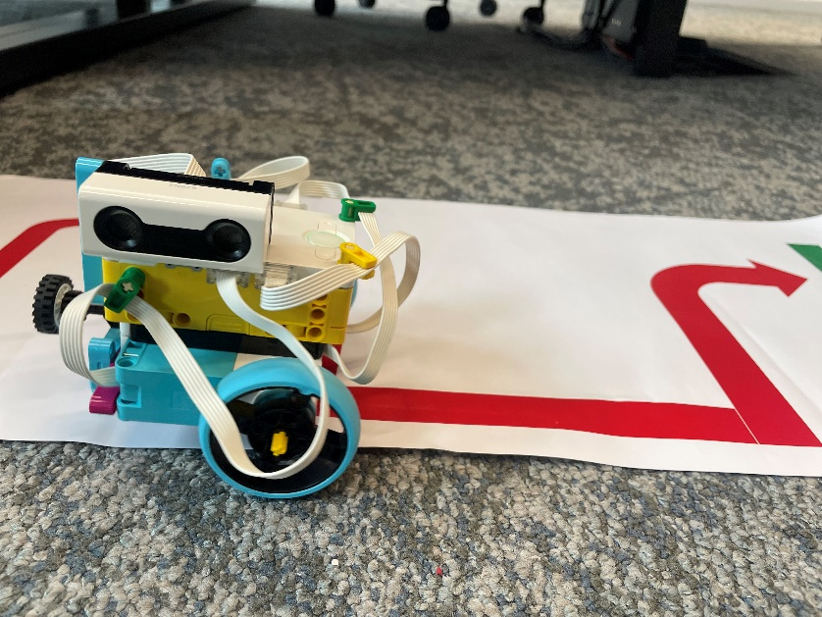

research
During development our key areas of research focused around the code , algorithims and vehicle design for research into code we used github and the offical spike prime documentation. During our research we also discovered alternative ways of implimenting code within the spike prime as the spike prime allows flashing with custom firmware such as pybricks which allows for a fully featured version of micro python which allows for a wider code base as micro python has far more features than legos base version of python included with the spike primes. Pybricks also enables a much faster development cycle as they allow the use of traditional ide’s. However we unfortunatley could not use pybricks as installing custom firmware on the universitys devices is strictly prohibited.
During our research into the spike prime v3 kit and its use in maze solving algorithims we discovered the pledge maze solving algorithim which allowed us to solve the maze using programatic instruction. The pledge maze solving algorithim uses ideas from the hand on wall algorithim which typically struggles with dealing with any obstacles within the maze the pledge algorithim named after john pledge of exeter if the robot repeats a loop around one wall 4 times it will drive itself forwards to escape any obstacles and then will return to the hand on wall style of maze solving.

Project planning stages

requirements
The main requirements for the project were to path-find along a pre defined route and to then solve a maze once we had received these guidelines we needed to start developing and designing a way to complete these tasks as they both used the same sensors we needed to have individual code bases for each task allowing us to use each of the sensors for different aspects of each of the task.

design
During our design process we went through multiple iterations of our design most of which had similar designs however the key change that netted us the most improvement with our design was narrowing the wheelbase which allowed us to have a better control of the steering systems.

implimentation
Our final implimentation took many stages of iteration before we were finally certain it was the right fit for the task. The below image is our final implimentation of our spike prime v3 kit traversing the path for the challenge it is using the color sensor that is on the bottom of the spike prime to guide it along the path to have it consistently follow the route we had it iterate through the path 1 inch at a time as this made it less likely to lose the path.
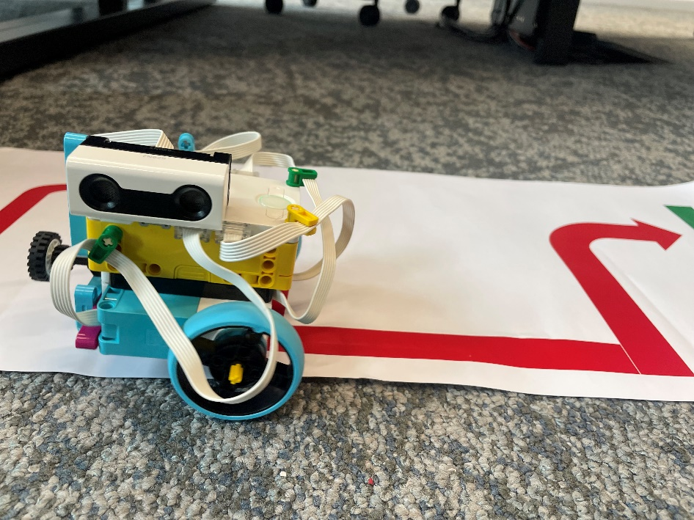

conclusion
To conclude this essay I think it is important to highlight the importance of kits like the spike prime and there importance in introducing the younger generations to the world of stem having access to kits like this from a young age can massively improve the likelyhood of a child pursuing stem while also learning a vast myriad of skills that if they do not end up in the stem industry can still massively benefit their problem solving and programatic thinking skills. During this project myself and my team have learnt a lot about how to design and iterate within a team setting and the importance of having multiple view points on one task this is another strong aspect of the spike prime v3 as it can be assigned to a group to improve interpersonal and team building skills while also learning how to program. The spike prime also has a lot of functionality beyond what myself and my group have explored which I believe can help in developing skills and helping people into the STEM industry

