  BA Business Management  Dissertation  LCBB6000  Lecturer: Dr Eric Osei  Analysing the causes of high employee turnover and proposals for prevention: A Case of Restaurant Fig and Olives and Forage Bakery | Ivaylo Todorov  Student ID: 2132919
Abstract
Hospitality companies in the UK are currently facing significant employee turnover. Research has shown that the high level of employee turnover in the sector is mainly due to the decision made by employees to leave the sector or change their job. This case study aims to analyse the causes of high employee turnover and proposals for prevention. Based on a review of the literature on the causes of staff turnover, approaches to reduce employee turnover and strategies for long-term employee retention, the causes of high staff turnover in the hospitality sector, the approaches and strategies that have the strongest impact on reducing turnover and long-term employee retention were identified. The analysis of the study showed that the main causes of high staff turnover, approaches to reduce employee turnover, and strategies for long-term retention in the hospitality sector are related to Salary, Work-life balance, and Growth opportunities. The results indicate that companies in the hospitality sector should primarily focus their efforts on building and improving company strategies and the conditions offered to their employees in these three areas. Further research is needed to identify other influencing factors, and further studies on the combined impact of factors on employee turnover in the hospitality sector.

Table of Contents

List of Tables … i
List of Figures … i
Chapter 1: Introduction … 1
1.1. Overview … 1
1.2. Background and Problems statement … 1
1.3. Aim of research … 3
1.4. Research objectives … 3
1.5. Research Questions … 3
1.6. Significance/rationale of the study … 3
1.6.1. Benefits to Industry … 3
1.6.2. Academy benefits … 3
1.7. Methodology … 4
1.8. Structure of the dissertation … 4
Chapter 2: Literature review … 5
2.1. Introduction … 5
2.2. Hospitality Sector … 5
2.3. Employee Retention … 5
2.4. Employee Turnover … 6
2.5. Employee turnover in the hospitality industry … 7
2.6. Relationship between employee turnover and performance … 10
2.7. Obstacles to High Employee Turnover … 11
2.7.1. Job satisfaction … 11
2.7.2. Recruitment … 12
2.7.3. Work/life balance … 12
2.8. Strategies for preventing high employee turnover … 12
2.8.1. Wages and benefits strategy … 12
2.8.2. Flexible work time strategy … 12
2.8.3 Diversity strategy … 13
2.8.4. Sustainable growth … 13
2.9. Theoretical Framework of employee turnover … 13
2.10. Chapter Summary … 14
Chapter 3: Methodology … 15
3.1. Research Philosophy … 15
3.2. Research Approach … 16
3.3. Research Methods … 16
3.4. Research Strategies … 16
3.5. Time Horizon … 17
3.6. Data Collection and Data Analysis … 17
3.7. Ethical Consideration … 17
3.8. Chapter Summary … 18
Chapter 4: Findings and Discussion … 19
4.1. Introduction … 19
4.2. Findings … 19
4.2.1. Reasons leading to employee turnover … 19
4.2.2. Approaches to reduce employee turnover … 20
4.2.3. Strategy for retaining staff over a long period of time … 20
4.3. Discussion … 21
4.4. Chapter summary … 23
Chapter 5: Conclusion and Recommendation … 24
5.1. Introduction … 24
5.2. Conclusion … 24
5.3. Limitations … 24
5.4. Recommendations … 25
6. References … 26

List of Tables

Table 1. Reasons leading to employee turnover … 19
Table 2. Approaches to reduce employee turnover … 20
Table 3. Strategy for retaining staff over a long period of time … 21

List of Figures

Figure 1. Average UK turnover rate (Jan 2022–Dec 2023) …8
Figure 2. UK turnover by industry (Jan 2022–Dec 2023) … 9
Figure 3. UK tenure by industry (Jan–Dec 2023) … 10
Figure 4. The conceptual framework … 14
Figure 5. Saunder’s Research Onion method … 15

Chapter 1 Introduction
1.1. Overview
Employee retention and turnover are important organisational management issues that have a big impact on competitiveness and productivity. These essential characteristics of modern businesses are examined in this dissertation. It begins with a summary of employee turnover and its effects before exploring the causes of this phenomenon. Establishing successful retention strategies requires an understanding of the underlying causes. A deductive method and accredited secondary quantitative data will be analysed and used. Based on the collected data, the confirmed or rejected hypotheses, a strategy will be proposed to reduce staff turnover and retain it for a long period of time in the considered case: A Case of Restaurant Fig and Olives and Forage Bakery. Employee loyalty, job satisfaction, and job performance are all known to be significantly impacted by engagement activities (Meswantri & Ilyas 2018).
1.2. Background and Problems statement
The general problem is the high turnover rate of employees in the hospitality sector. “The average turnover - or churn - for UK workers is 34%. Three in ten UK employees leave to join another organisation each year” (GOV, 2023). Hospitality has the highest employee turnover (Jan 2022–Dec 2023)- 40.7% (CIPD, 2024).
It is not known what the reasons are for attracting and retaining staff for a longer period.
Citing McAllister (2022) "The number of employees in the hospitality industry is approaching pre-pandemic levels, but high staff turnover in the sector remains a major cause for concern for employers". The total number of employees in 2022 increased by 21.7% compared to 2021. Pay also increased by 6% for restaurant employees. On the one hand, this shows that pay was not sufficient to attract and retain staff. On the other hand, despite the increase in pay, 6% of restaurant staff leave each month. This shows that financial remuneration is one of the factors for attracting and retaining staff. According to McAllister, there is also a change in the development of the composition of the workforce. The number of workers from outside the EU increased to 17.9 in 2022, while in 2019 it was 11%. The level of British nationals working in the sector has also changed, rising by 10% (from 44.8% to 55.8%) over the same period. EU workers in the sector accounted for 26.3% of the workforce in 2022, compared to 35.9% in 2021 and 43.2% in 2019 (McAllister, 2022). Brexit is also a reason for this turnover.
Based on Portes (2020), over the past two decades, the number of EU citizens living in the UK has doubled. EU citizens in the UK number over 3.6 million, or 1 in 5 who left the UK live in the UK. Before the Brexit vote, EU migration reached 200,000, and before Covid-19, this figure decreased to 1/4. Changing economic trends, legal relations between the EU and the UK, psychological factors and uncertainty about the future affect the departure of EU citizens and their attraction and settlement in the UK. As a result of this uncertainty, they are forced to return to their homeland or seek a safer and more secure life in another European country (Portes, 2020).
In addition to Brexit, Covid-19 has also caused an outflow of EU citizens, and therefore employees (from EU, UK citizens and other expatriates) in the restaurant sector. Referring to Ramuni (2021) hospitality and restaurants, they are one of the most affected industries in the UK by Covid-19. Before the pandemic, the level of job vacancies was lower compared to 2020. However, the number of occupied positions in the sector in June 2021 was 11% lower than in February 2020. In April 2020, nearly 1,650,000 employees in the industry were on leave, decreasing to under 590,000 employees by the end of May 2021. This data shows the large number of employees on whom Covid-19 has had a direct impact, and they have been temporarily or permanently unemployed. As a result of reduced income or lack thereof, the financial situation of employees is deteriorating. As a result, employees in this sector are forced to retrain and seek employment in more secure economic sectors (Ramuni, 2021).
The subsequent inflation after Covid-19 also has a direct impact on restaurants and bakeries. The inflation rate has increased significantly over the last 3 years (2021-2024). Referring to the Office for National Statistics (2025), the lowest average level for this period was recorded in 2021- 2.5%, the highest in 2022- 7.9%, and in October it even reached a level of 9.8%. The average inflation rate in 2024 is 3.3% (CPIT, 2025). Due to high inflation and to maintain their business, restaurants and bakeries are forced to implement various strategies. Increasing the prices of the products offered is one of them. Another strategy is to reduce costs, which includes reducing working hours, and this includes staff salaries and/or staff reductions.
As a result of these factors, the hospitality industry, of which restaurants and bakeries are a part, remains the most affected. On the one hand, the outflow of labour from the EU due to Brexit, the uncertainty about health and the workplace, and retraining for better and safer work caused by Covid, and the increase in prices, the reduction of working hours/wages and staff cuts due to inflation are only some of the reasons leading to the essence of the problem - shortage and high turnover of staff in restaurants and bakeries. On the other hand, because of these factors and the uncertain economic environment, additional reasons are created for increasing staff turnover - lack of work life balance, long shifts, lack of recognition, lack of career development, bad line management, no rewards etc. As a result of this problem, the questions arise how to attract and retain staff for a long period of time? What are the reasons for staff turnover? What are the ways to reduce employee turnover? What prevents employee turnover?
1.3. Aim of research
The aim of the research is to attract and retain staff over a long period of time using a case study methodology.
1.4. Research objectives
Determine the reasons for high turnover of employees.
Explore the factors that attract and retain employees for a long period.
Explore the strategy for retaining staff over a long period of time.
1.5. Research Questions
The research questions of the study are:
1. What are the reasons leading to employee turnover?
2. What are the approaches to reduce employee turnover?
3. What are the practices for retaining staff over a long period of time?
1.6. Significance/rationale of the study
1.6.1. Benefits to Industry
This study can help expanding and better understanding GOV's (2023) strategy for retaining of employees for long period. The study improves the understanding of employee turnover, research on voluntary exit rates, and reveals patterns associated with engagement programs, clarifying the need to adapt retention tactics. Taking this holistic view can help businesses develop lasting engagement skills, to improve the conditions offered, to reduce or temporarily prevent staff turnover.
1.6.2. Academy benefits
This study can expand Luecke’s (2002) arguments in terms of understanding of employers for employee turnover. When conducting the study and analysing the data, it is possible to find new unexplored reasons for staff turnover as well as those for their long-term retention. On the other hand, it is possible to identify reasons that in previous studies represented a negligible percentage, but to date indicate a greater or significant impact.
1.7. Methodology
In the initial step of the dissertation, the topic, aim and objectives are defined. Accredited articles, books, research papers, etc. related to staff turnover and long-term employee retention will be searched, researched, analysed and used.
Deductive method will be used - in particular Saunder’s Onion research method. The data that will be analysed and used is secondary data. 2 hypotheses will be presented, which will be proven or rejected based on secondary data. To collect, analyse and present the collected quantitative data, I will use programs such as Excel and SPSS (Saunders, 2012). Data will only be searched and used from reliable and accredited sources such as the University's online library, Google Scholar, UK Government websites, etc. Based on the collected data, conclusions will be drawn about the main reasons for staff leaving the workplace in the restaurant business (including bakeries) and proposals will be made for the preparation of strategies for staff retention for a long period of time.

1.8. Structure of the dissertation
Chapter 2 is the Literature Review- Secondary data will be collected and reviewed from accredited literature that is related to the topic of the study to establish research proposals or discover factors that are already having a greater impact compared to the past. Chapter 3 covers the methodology. This part of the dissertation shows the method that will be used to achieve the objectives of the study- deductive method - more specifically Saunder’s Onion research method. Chapter 4 is the research findings and discussion. Secondary data will be analysed using Excel and or SPSS software. Chapter 5 covers conclusions and recommendations. In this chapter, you will know the conclusions of the analyses, the strategy proposal and the possible.

Chapter 2 Literature review
2.1. Introduction
Concerns about employee turnover and retention have attracted significant attention from experts. The research has primarily focused on determining the factors that influence an individual's decision to stay or quit an organisation, identifying the elements that lead to employee turnover in hospitality industry, relationship between employee turnover and performance, obstacles to high employee turnover, strategies for preventing high employee turnover.
2.2. Hospitality Sector
According to Report linker (2024), businesses that offer services related to the creation, food and beverage of customers fall within the scope of the hospitality market. These include hotels and resorts, bars and nightclubs, pubs and restaurants, travel agencies, and agencies for planning and managing events such as conferences, weddings, corporate events, etc (Reportlinker, 2024).
The United Kingdom possesses one of the most vibrant and varied hospitality industries globally. The British pub serves as both a landmark and a communal hub. Restaurants and bakeries are globally acknowledged as among the finest, while nightclubs attract consumers from across the entire world. The UK hospitality industry comprises approximately 143,000 enterprises, employing around 1.8 million workers (UKhospitality, 2024). In 2019, the gross value added generated by the hospitality sector was £40.4 billion (UKhospitality, 2024). In addition to generating employment and supporting the economy, the hospitality sector is essential to the structure of communities nationwide, offering inviting environments for people to meet up, entertain, relax and socialise (Kwarteng, 2023).
UK Hospitality (2024) notes that the hospitality sector plays an important role in the country's economy and provides a large part of the population's jobs. As the third largest employer in the country, the hospitality sector provides jobs for nearly 3.5 million. On the other hand, the sector's contribution to the country's economy is approximately £93 billion per year. £7 billion in investment in 2022, £20 billion in total and £54 billion in tax revenue have been realized for this year in the sector (UKhospitality, 2024).
2.3. Employee Retention
Referring to the CIPD (2025) the negative impact of employee turnover is influenced by long-term employee retention. It is necessary for the organization to understand why staff leave, and on the other hand, it is necessary to create and implement strategies for staff retention (CIPD, 2025).
Das and Baruah (2013) note that employee retention refers to the practice of motivating employees to stay in the organisation for an extended duration. It is a process that motivates employees to stay with the organisation for the longest duration possible or until the project's completion. Retaining key employees in an organization affects the long-term success and effectiveness of the organization, good relationships between staff, customer satisfaction, and increased sales (Das, 2013).
Singh (2019) notes that preventing talented employees from leaving is the main reason for promoting and retaining employees for a long period of time in the company. Singh also notes that "employee retention" basically involves the undertaking and implementation of various measures by the company to achieve the specified goal (Singh, 2019).
Employee retention refers to the various strategies employed to maintain employees within an organisation over a long period of time (Francis, 2014).
2.4. Employee Turnover
The term "employee turnover" is commonly used in business organisations. Although numerous studies have addressed this topic, limited research has focused on identifying the causes and primary factors of turnover, as well as recommending practical strategies that managers can implement to retain employees and improve organisational effectiveness and productivity, valid for any organization.
The employees are the engine of any organisation. Approximately fifteen percent of the workforce plans to depart, which is likely to lead to actual turnover if preventative measures are not implemented. Retaining employees is more cost-effective than recruiting, training, and integrating new personnel. Management should implement programs that determine the reasons for staff turnover and identify the factors that attract and keep them within the organisation (Mamun, 2017).
Some authors define staff turnover as voluntary or involuntary, avoidable and unavoidable turnover. Voluntary turnover is defined as the employee leaving the organization of his or her own free will (Noe, 2006). Another definition of voluntary turnover states that voluntary turnover reflects the employee's free decision to leave the organization and change jobs (Egan, 2004). Voluntary turnover is an employee's decision, but it can be influenced by both internal factors - dissatisfaction, lack of motivation, discomfort, and external factors - conflicts with colleagues and management, stress at work, lack of balance between personal life and work, a better offer from another company, etc. Voluntary turnover can be predicted to a certain extent and can be influenced and reduced by applying various strategies (Mano, 2004). Involuntary turnover is defined as cases when the employer decides to terminate the employment relationship between the company and the employee. These cases may include dismissal, termination of the contract after the trial period, completion of the project, reduction of staff, reduction of employee capacity, etc. (Chiu, 2003). In these cases, the company has direct control over employee turnover. In the event of retirement or death, employee turnover is considered involuntary, but the company has no direct control. Involuntary turnover is also considered when the employee leaves the company due to personal health problems or to take care of a sick family member. Therefore, employees are forced to leave. In this case, the company and the employees have no control (Martin, 2004).
Avoidable turnover refers to employee departures that an organisation can prevent or decrease by enhancing recruitment, assessment, and motivation practices (Luecke, 2002). Any business organisation has to determine whether voluntary turnover has been managed appropriately. This confirmation is essential, as it will prompt the necessary initiatives to improve employee retention. The employee turnover can be managed, influenced, and increases the expenses of the company (Weisberg, 2002). A comprehensive model for understanding the turnover process does not currently exist. A range of factors is utilised to assess the causes of employee turnover. It encompasses personal factors, job content factors, working environment factors, and external factors. Unavoidable turnover is caused by employee’s choices that exceed an employer's influence, such as relocating. A significant percentage of turnover results from recruitment errors, many of which can be prevented. Organisations have implemented specific measures when selecting and assessing prospective employees. Therefore, establishing accurate criteria and building a good strategy for staff selection will affect turnover (Chiu, 2002).
Increased employee turnover results in the loss of talent, and when specific skills are limited, recruitment can incur significant expenses. However, low employee turnover may hinder the infusion of innovative concepts into the company. However, particularly in contexts where skills are limited, recruitment expenses are high, or employers face challenging vacancies, turnover is likely to pose significant issues. Employees possessing in-demand or specialised abilities, or those who have cultivated robust relationships with clients, will be more advantageous to employers and consequently more detrimental for a business to lose, especially if they transition to a direct opponent (CIPD, 2024).
2.5. Employee turnover in the hospitality industry
The UK hospitality sector is comprised of approximately 143,000 businesses, employs around 1.8 million people and, in 2019, generated £40.4 billion in Gross Value Added (GOV, 2023). In addition to creating jobs and improving the economy, hospitality is essential to communities across the nation because it offers an inviting atmosphere for people to socialise (GOV, 2023). The median turnover among UK employees is 34%. That divides into 27.4% who transition to a different company and 6.6% who are unemployed for a year later, potentially due to education, retirement, or illness, for instance. Approximately two-thirds of employees continue with their current company year after year. Thirty percent of UK employees transition into a different employer annually (CIPD, 2024).

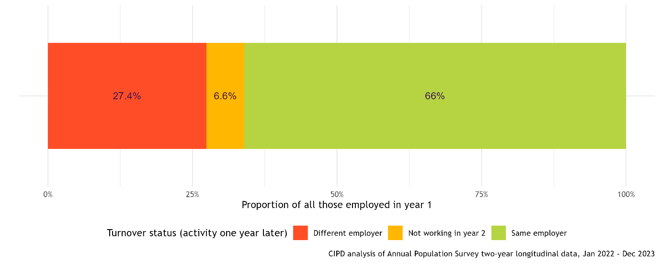 (CIPD, 2024)
Figure 1. Average UK turnover rate (Jan 2022–Dec 2023)

Hospitality has the highest employee turnover (Jan 2022–Dec 2023)- 40.7%. Staff turnover rates range from 25% in the public administration and the military to 52% in the hospitality industry.

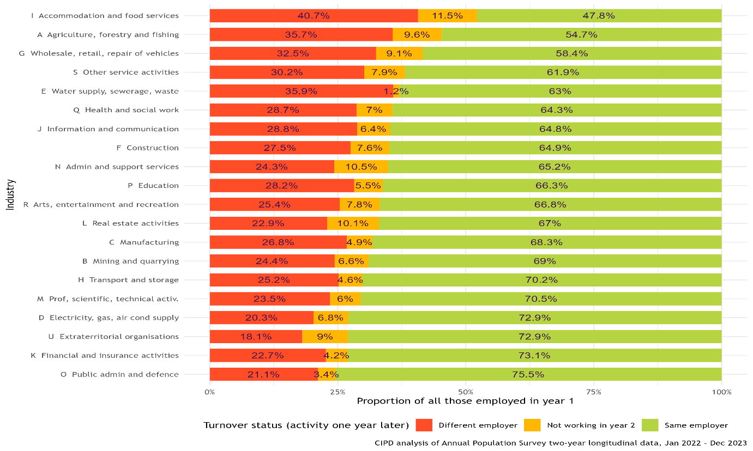 (CIPD, 2024)
Figure 2. UK turnover by industry (Jan 2022–Dec 2023)

Tenure is a comparable comparative tool to staff turnover. This indicates the duration of an individual's employment with an organisation. Turnover elucidates the rate of employee departures, whereas tenure provides insight into the broader workforce dynamics. The predominant duration of service ranges from two to five years. Tenure may also be categorised by industry. The percentage of staff members with a tenure of under 12 months has returned to the pre-pandemic rate of approximately 16%. It reached a peak of 18% in early 2022. More than one-third of workers in the hospitality sector have held their positions for less than one year.

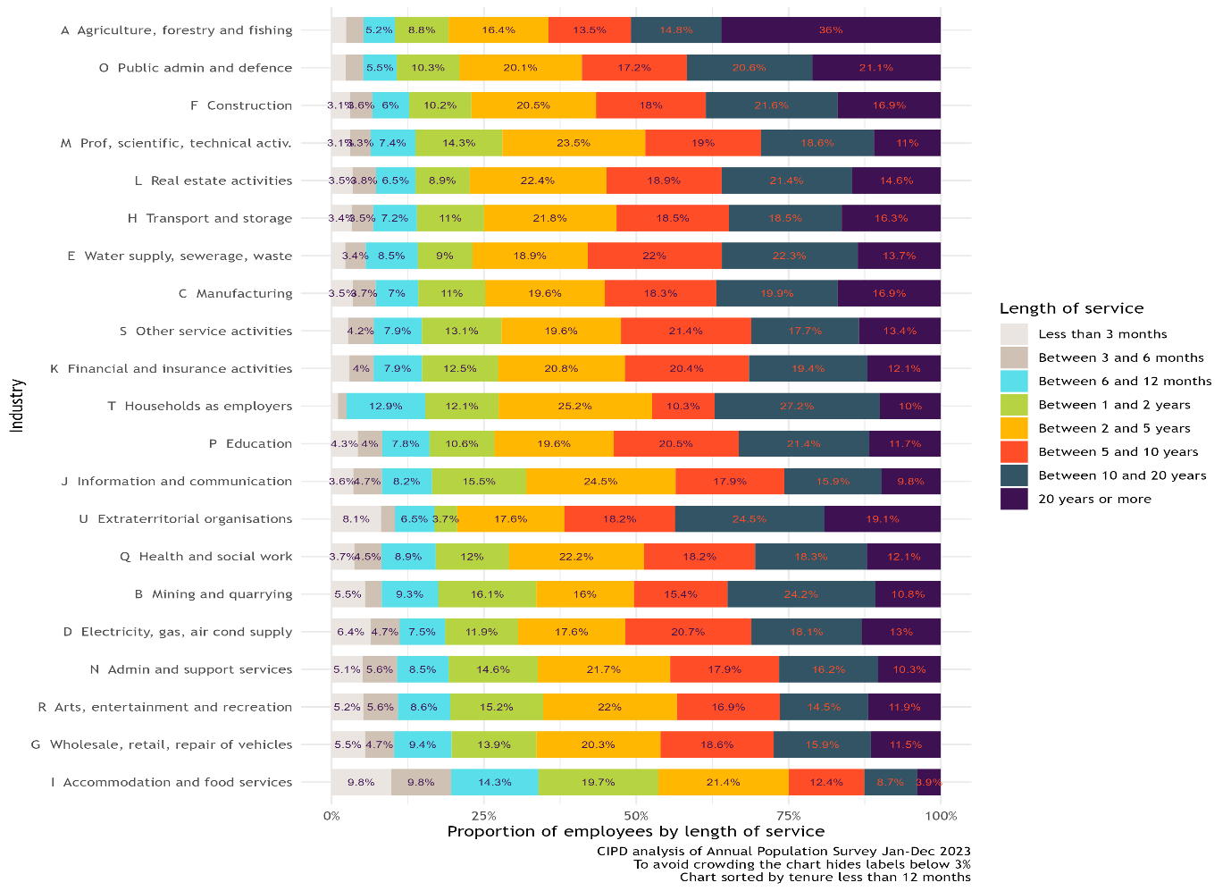 (CIPD, 2024)
Figure 3. UK tenure by industry (Jan–Dec 2023)

According to Ghani et al. (2022) the primary reason of increased employee turnover in the hospitality sector is the industry's seasonal dynamics. In the hospitality sector, managers generally hire staff in accordance with seasonal variations. Furthermore, the hospitality sector significantly overlooks economic and social sustainability practices, potentially resulting in adverse employee attitudes and intention(Ghani, et al., 2022).
2.6. Relationship between employee turnover and performance
Jun and Eckardt (2025) notes that employee turnover has a negative correlation with training. It follows that in the absence of training, i.e. development of employee qualities, the probability of staff turnover increases. Therefore, when training is conducted, employees will be more qualified and will be able to meet the needs of the company. On the other hand, employees will be more satisfied with their work and will be more attached to the company, knowing that the company values ​​them and continuously invests in their development (Jun, 2025). According to Frenkel and Barel’s (2016) social exchange theory, employees may reciprocate the valuable benefits received from their employer by remaining with the organisation. If employees recognise the value of training and feel compelled to reciprocate the organization's investment, they may exhibit increased commitment and exert greater effort in their work (Frenkel, 2016). On the other hand, a body of research indicates that training can raise employee turnover levels. Trevor (2001) notes the positive relationship between training and increasing turnover, as it will increase his skills and knowledge. Ultimately, enhanced proficiency through training may lead employees to increase their turnover plans and prefer higher-paying employment opportunities (Trevor, 2001). Modern conditions allow employees to be more mobile and work in more remote locations. In combination with the accumulated professional experience and acquisition of new skills after training, employees can be more competitive in the labour market and look for an employer who will offer them better compensation and social benefits (Gault, 2010). Job satisfaction exerted a considerable adverse effect on the decision to leave the hospitality sector. This indicates that employees with low satisfaction with their jobs were inclined to quit the industry. Moreover, individuals content with their jobs were also content with their careers and unlikely to resign, whereas employees dissatisfied with their careers were prone to exit the industry. Furthermore, a positive correlation existed between negative moods and the intention to exit the industry. This outcome indicates that individuals experiencing anger and anxiety were predisposed to exit the industry. Consequently, individuals who experienced support and care from their organisation exhibited reduced feelings of frustration and anxiety in the workplace, more likely to express job satisfaction (Zientara, 2022).
2.7. Obstacles to High Employee Turnover
2.7.1. Job satisfaction
The findings demonstrate that career satisfaction substantially impacted the intention to depart from the hospitality sector, aligning with research indicating that career satisfaction affects the intention to leave an occupation or organisation/ industry. The analysis indicated a negative correlation between job satisfaction and the intention to quit or change the industry (Zientara, 2022). Therefore, employees who are satisfied with their work, their workplace and their career tend to stay in the organization for a long period. On the other hand, those who are not satisfied will probably have an intention to change. This intention can be triggered both by a change in job position within the organization (applying for another job position, promotion, change of work department), and by a change in the organization.

2.7.2. Recruitment
Advanced recruitment and selection processes, along with the essential function of sustainability practices, facilitate the identification of the appropriate candidate and enhance the probability of organisational retention. Research indicates a positive correlation between optimal recruitment practices and organisational performance. They assist the company in attaining favourable outcomes and enhancing the quality of its products and services. Hiring and retaining top employees reduces the expenses associated with recruiting unsuitable candidates, who often depart from the organisation after a short period (Ghani, et al., 2022).
2.7.3. Work/life balance
According to Ghani et al. (2022) in the hospitality sector, employees typically lack balance between their professional and personal lives. These employees, due to their inadequate work/life balance, encounter conflicts both at work and in their personal lives. The majority of employees leave due to a lack of opportunities to engage in sustainable growth between their personal and professional lives. The equilibrium between work and personal life is influenced by factors including insufficient working hours, inadequate holiday policies, an excessive workload, and the absence of support systems in the workplace. Ensuring accurate working hours, an 8-hour workday, a clear policy for the use of annual leave, and providing support are some of the factors that an organization can change to improve work-life balance. This will improve employee satisfaction and reduce the intention to leave, which will also reduce high staff turnover.
2.8. Strategies for preventing high employee turnover
2.8.1. Wages and benefits strategy
Wages and benefits have emerged as the paramount factor in employer branding for attracting and retain candidates, despite significant variations across sectors. 33% have enhanced compensation and benefits to be more competitive in the past year. Benefits and wages have ascended from second to first position in respondents' rankings of the most critical elements of employer branding for attracting candidates. Nonetheless, only 42% prioritise compensation and benefits as their primary attractors, with significant disparities observed across organisations and sectors (CIPD, 2022).
2.8.2. Flexible work time strategy
More than two-thirds promote certain vacancies as available for flexible working arrangements. A greater proportion of organisations this year (2022: 30%; 2021: 24%) indicate that advertising positions with a variety of hours is one of their most successful strategies for attracting and retain employees. Nonetheless, there has been minimal alteration in the percentage of advertising positions available for flexible working arrangements. Twenty percent of organisations promote all job vacancies as available for flexible working, while an additional 49% offer this option for select positions (CIPD, 2022).
2.8.3. Diversity strategy
Approximately 61% of organisations possess a formal diversity strategy (2021: 62%; 2020: 52%), with a notable prevalence in corporations, the governmental sector, and non-profit organisations (public sector: 86%; non-profits: 72%; private sector: 54%) Organisations are particularly motivated to implement strategies to attract and retain workers of all ages, encompassing under-represented groups and the long-term unemployed, including by eliminating particular standards from job requirements (CIPD, 2022).
2.8.4. Sustainable growth
Development in the career, along with professional and personal development opportunities, and additionally financial growth, constitutes sustainable growth prospects for employees. Career growth or development refers to a structured approach employed by companies or organisations to assess the availability of employees who possess the requisite skills and qualifications for the job. It is the process of establishing a continuous system that improves the skills and knowledge of employees. For the success of the hospitality sector career advancement and growth prospects are essential (Ghani, et al., 2022).
2.9. Theoretical Framework of employee turnover
According to Saunders et al. (2007), “A conceptual framework indicates how the researcher views the concept involved in a study, especially the relationship among concepts”.
The creation of a conceptual model commences with an exhaustive literature review. Consequently, researchers have established a conceptual framework that delineates the causes and influencing factors of employee turnover, alongside effective retention strategies to mitigate turnover rates. Informed by prior theoretical literature and the necessity for further investigation, the following research framework is proposed for this study.
The conceptual framework is as follows, based on the literatures reviewed:

Figure 4. The conceptual framework

2.10. Chapter Summary
In summary, it can be stated that the hospitality industry is one of the industries with a high rate of staff turnover. The relationship between performance and turnover is proportional. Staff selection, job satisfaction and work-life balance play a major role. To identify and analyse the causes of staff turnover in the hospitality sector, to build and propose a proper strategy for retaining staff for a long period of time, this study will use Saunder’s Onion research method.

Chapter 3 Methodology
The study used Saunder’s Research Onion method. The method consists of several layers shown on Figure 5. The research onion, introduced by Saunder’s, is a framework that facilitates the organisation of research and the systematic development of research design through its sequential layers. The research onion model was predominantly formulated for business studies (Saunders, 2007). This method was chosen and used in this study because it is comprehensive and wide-ranging. Saunder's method allows for working with secondary data for a specific period, as used. It also provides different approaches depending on the study, including deductive, which was used in this study. A wide range of strategies are available. The Case Study used is one of the eight proposed and included by Saunder. On the other hand, Saunder provides 5 different philosophies, the one used in this case being interpretivism.
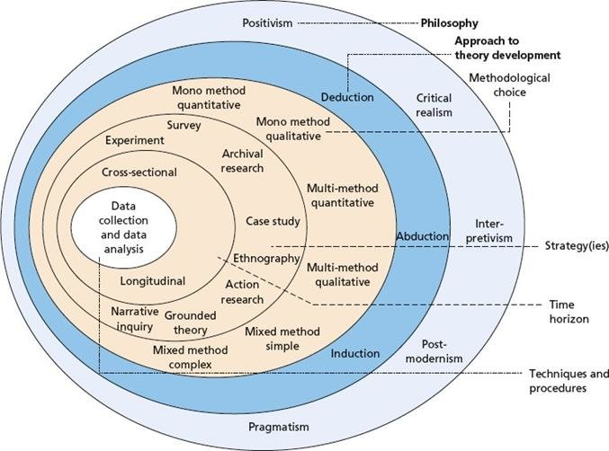
(Researchgate, 2024)
Figure 5. Saunder’s Research Onion method

3.1. Research Philosophy
It includes the beliefs or assumptions regarding the methods of data collection, analysis, and application. Saunder’s method includes the following philosophies: Positivism, Critical Realism, Postmodernism, Pragmatism, and Interpretivism. The study used Interpretivism. Interpretivism accentuates the impact of social and cultural factors on individuals. These factors can influence the decision to leave/stay with the company by the employee (Ghani, et al., 2022). Factors influencing employee decisions can be job satisfaction, career development, pay and benefits, work/life balance, work environment. On the other hand, they can influence the company when developing strategies for hiring, retaining for a long period of time or firing employees (CIPD, 2022). The company's strategy for retaining employees for a long period of time can be built based on the influence of salary and benefits, personal and professional development of employees, additional bonuses, improving work/life balance (CIPD, 2025).
3.2. Research Approach
Relates to the strategies or methodologies applied to theory development; specifically, whether the emphasis is on evaluating existing theories or constructing a new theory. The Research Approach are Deductive, Inductive and Abductive. Deductive begins with a theory, formulate hypotheses or propositions based on the theory, and gather and analyse data to assess the theory. A deductive method is used in this study, particularly the Saunder's Onion research method (Saunders, 2007). This study begins with an approved, current, relevant and existing theory related to the hospitality sector (GOV, 2023), the reasons for high staff turnover in this sector (CIPD, 2025), methods and strategies for retaining staff for a long period of time (Mamun, 2017), followed by the formulation of a question- RQ1,RQ2 and RQ3 subsequent data collection to support the case study.
3.3. Research Methods
The research methods used by Saunder (2007) are single method quantitative or qualitative, multi method quantitative or qualitative, and mixed method quantitative or qualitative. The type of data used for this study is quantitative secondary data. Secondary quantitative data is already existing data collected by another person/people, government or scientific organizations, etc. This data is expressed in numbers (UKhospitality, 2024), percentages (CIPD, 2024), and figures (CIPD, 2024), etc. are used to display them. The data is collected from government websites GOV.UK, scientific articles, accredited information sites- Google Scholar, Statista.
3.4. Research Strategies
Research strategy is based on the aim of the study how the research is to be conducted. Types of research Strategies are Survey, Experimental research, Archival research, Action research, Ethnography, Grounded theory, Narrative Inquiry and Case Study (Saunders, 2007). A case study is a comprehensive examination of a singular subject, such as an individual, a collective, an organization, or a specific event, or issue. This research involves analyzing the subject to obtain a comprehensive understanding of issues (Saunders, 2012). This case study followed a mixed-method approach and performed a literature review of previously published studies. This study employs a systematic methodology to examine organizational surveys, books, academic articles, and research studies. The primary objective was to achieve an in-depth understanding of the topic- Analysing the causes of high employee turnover and proposals for prevention, by methodically engaging in the existing literature. The research was conducted in order, beginning with the determination of the research objective- RO1, RO2, RO3 and aim- to attract and retain staff over a long period of time using a case study methodology. This covered an analysis of retaining staff strategies, the factors influencing employee turnover (CIPD, 2025), and the effectiveness of different retention initiatives in United Kingdom (Ghani, et al., 2022). Following selecting the sources, they were refined by applying reliable resources, and other pertinent databases within the discipline.
3.5. Time Horizon
This layer explores the length of time of the research. Longitudinal, involving repeated data collection over an extended duration for comparative analysis. Cross-sectional study includes data collection at a specific moment (Saunders, 2012). A cross-sectional time horizon was used for this study. The time framework is appropriate for this study because it examines a specific problem- the causes of high employee turnover for a specific period.

3.6. Data Collection and Data Analysis
This part of the Saunder’s method is related with methods and techniques incorporate data collection and analysis, including the application of primary and secondary data, preparation of interviews, selection of samples, formulation of questionnaire content etc (Saunders, 2007). Data in the study was only searched and used from reliable and accredited sources such as the University's online library, Google Scholar, UK Government websites, etc. To collect, analyse and present the collected quantitative data, was used program such as Excel and/or SPSS.
3.7. Ethical Consideration
During the preparation of the study, the ethical principles of anonymity, confidentiality, impartial data analysis, correct reporting of results, correct use and citation of sources, etc. was observed. Expand to include Confidentiality, acknowledgement of intellectual property of authors (cited, referenced), completed ethics forms and followed the guideline of UWTSD. The data used are for academic purposes and the final document was protected securely.

3.8. Chapter Summary
The research onion, introduced by Saunders et al. (2012), is a framework that facilitates the organisation of research and the systematic development of research design through its sequential layers. The research onion model was predominantly formulated for business studies. The Sauder Method was used to prepare this study, which include the philosophy of Interpretivism, a deductive method for collecting secondary data, which was analysed and processed with Excel, respecting all ethical principles.

Chapter 4 Findings and Discussion
4.1. Introduction
The Findings and Discussion chapter presents the findings of the collected quantitative secondary data related to the aim of the dissertation: to attract and retain staff over a long period of time using a case study methodology. The data are summarized and presented in tables and graphs for easier and clearer systematization, reading and visualization. The Excel program was used to create the tables. Also, findings related to the collected data from the literature review and indicated in the tables, in addition to the research questions and objectives of this dissertation, are discussed, interpreted and presented.
4.2. Findings
4.2.1. Reasons leading to employee turnover
After the study and the use of accredited secondary data, the following reasons for staff turnover were identified in Table 1: Low Payment, Work life balance, Lack of Benefits, Recruitment Process, Lack of Growth opportunities, Family commitments.

 | Reasons leading to employee turnover
Secondary source | Low Payment | Lack of Work life balance | Lack of Benefits | Recruitment Process | Lack of Growth opportunities | Family commitments
Ghani, B. et al. | xx | xx |  | xx | xx
Gordan, T. | xx | xx |  |  | xx
Timsina, S. | xx | xx | xx |  |  | xx
(Ghani, et al., 2022), (Gordon, 2019), (Timsina, 2024)
Table 1. Reasons leading to employee turnover

The majority of the authors indicate the following two reasons noted in Table 1 Low payment and Lack of work-life balance as the main ones in making the decision by employees to leave the company. Growth opportunities are indicated as a factor with medium influence in making such a decision. The factors Lack benefits and Family commitments have a minor influence on staff turnover.

4.2.2. Approaches to reduce employee turnover
The results of the study show that the main approaches influencing and reducing staff turnover in the hospitality sector indicated by the authors are Job satisfaction, Recruitment, Work/life balance and Payment.

 | Approaches to reduce employee turnover
Secondary source | Job satisfaction | Recruitment | Work/life balance | Payment
Ghani, B. et al. |  | xx | xx | xx
Zientara, S. | Xx |  | xx | xx
Das, B. | Xx |  |  | xx
(Ghani, et al., 2022), (Das, 2013), (Zientara, 2022)
Table 2. Approaches to reduce employee turnover
Majority of the authors indicate that Payment has the strongest influence on employee turnover and on the decision of employees to stay in the company for a long period of time. The study found that the reasons Job satisfaction and Work/life balance have an average influence, with 2/3 of the authors indicating them as a valid reason for reducing staff turnover. Recruitment has a minor influence. However, Recruitment is among the reasons that affect the reduction of staff turnover.

4.2.3. Strategy for retaining staff over a long period of time
The results of the study (Table 3) show that the main strategies influencing employee retention for a long period of time in the company in the hospitality sector are Wages and benefits strategy, Flexible work time strategy, Sustainable growth strategy, Diversity strategy, Recruiting suitable employee strategy, Job satisfaction strategy.

 | Strategy for retaining staff over a long period of time
Secondary source | Wages  and benefits strategy | Flexible work time strategy | Sustainable growth strategy | Diversity strategy | Recruiting suitable employee strategy | Job satisfaction strategy
Ghani, B. et al. | xx | Xx | xx |  | xx | xx
CIPD | xx | Xx | xx | xx
Mamun and Hasan | xx | Xx |  |  | xx | xx
(Ghani, et al., 2022), (CIPD, 2022), (Mamun, 2017)
Table 3. Strategy for retaining staff over a long period of time

Majorities of the authors indicate that Wages and benefits strategy, and Flexible work time strategy have the strongest influence on employee turnover and long-term retention. The study found that the strategies Sustainable growth, Recruiting suitable employees, and Job satisfaction have an average influence, with 2/3 of the authors indicating them as a reason for staff retention. Diversity strategy has a minor influence.
4.3. Discussion
The purpose of this study was to analyse the causes of high employee turnover and provide suggestions for prevention in the hospitality industry. The study investigated and analysed the causes of high employee turnover, approaches to reduce employee turnover, and strategies for retaining staff for a long period of time. To achieve this goal, the questions of the causes leading to employee turnover, approaches to reduce turnover, and practices for retaining staff for a long period of time were examined.
The majority of the researched authors point out that in the hospitality sector the reasons leading to staff turnover are Low payment and Lack of work-life balance (Ghani, et al., 2022), (Gordon, 2019), (Timsina, 2024). These reasons can be defined as the main reasons for determining the hospitality sector as the sector with the highest employee turnover rate. Hospitality has the highest employee turnover (Jan 2022–Dec 2023)- 40.7% (CIPD, 2024). On the one hand, this can lead to longer work shifts so that employees can receive better pay. On the other hand, long work shifts, hours and days of overtime can lead to a deterioration in work-life balance. These reasons can be combined with other reasons that have less influence on the employees' decision to leave the company. The following reasons were identified as having a medium and minor impact: Lack of Benefits, Recruitment Process, Growth opportunities, Family commitments (Ghani, et al., 2022), (Timsina, 2024), (Gordon, 2019). The study shows that in the absence of career development opportunities, respectively, in pay, employees are influenced and decide to leave the company. Increasing pay and receiving benefits is related to increasing qualifications and opportunities that the company provides, and in their absence, some employees may leave the company (Ghani, et al., 2022). The recruitment process and family commitments have a minor influence. The recruitment process has a weak influence, because the research, interview and selection of employees may have been conducted well, but this does not guarantee that the employee will remain in the company (Ghani, et al., 2022). Although with a minor influence, the study found that unavoidable family reasons/commitments such as moving the family to another city, caring for a child, caring for a sick family member (Timsina, 2024). The study showed that, despite its major, medium or minor influence, each reason can lead to staff turnover both independently and in combination with other influencing reasons.
The study shows that the approach indicated by the majority of the surveyed authors, which has a major impact on reducing staff turnover in the hospitality sector, is salary (Ghani, et al., 2022), (Zientara, 2022), (Das, 2013). Every employee starts work expecting his efforts to be rewarded with a certain salary, and salary is the way in which each employee covers expenses and needs (Ghani, et al., 2022). Salary is an incentive not only to satisfy the employee's needs, but also to increase his standard of living (Das, 2013). This in turn leads to the other two reasons that the study found to have a significant impact on reducing employee turnover: Job satisfaction and work-life balance. Appropriate payment that meets the employee's expectations shows the appreciation of the efforts he makes in the company. This leads to satisfaction in the employee and job satisfaction leads to a decrease in the desire to leave the workplace (Ghani, et al., 2022). Based on the findings in this study on the causes of high employee turnover, it can be noted that job satisfaction and salary approaches can influence the other approach that has a significant impact on reducing turnover, the work-life balance approach. Ensuring work-life balance for company employees will also increase employee satisfaction (Zientara, 2022).
The study showed that the main strategies used for staff retention are Wages and benefits strategy and Flexible work time strategy. The wage and benefits strategy can be associated with stimulating employees to stay in the company for a long period of time, as depending on the duration they will receive a salary increase, material or non-material bonuses, additional benefits (Mamun, 2017). This strategy can also be associated with Flexible work time strategies by providing employees with an additional day off or holiday as a benefit. The implementation of a flexible work time strategy, on the one hand, supports the planning of work shifts and the workflow (CIPD, 2022). On the other hand, flexible working hours contribute to the work-life balance of employees by helping them to combine family and work obligations (Ghani, et al., 2022). Work-life balance and regulated and flexible working hours, as well as a smooth workflow, can also have an impact on the Job Satisfaction strategy. This strategy, as well as the Sustainable growth strategy (Ghani, et al., 2022) and the Recruiting suitable employee strategy (Mamun, 2017), are indicated as strategies with a medium impact on employee retention over a long period of time. Implementing a strategy for the correct selection of employees can have an impact on retention, such as hiring employees with an interest in the work and an attitude to developing skills and knowledge (Ghani, et al., 2022). This can have a positive impact on both the employee and the company and can increase employee retention and reduce the company's costs for hiring and initial training of new employees. The sustainable growth strategy can be related to career development, increasing wages, improving qualifications (Ghani, et al., 2022). On the one hand, the implementation of this strategy by the company can have a positive effect by offering its employees salary growth, various internal and external training to improve skills and knowledge leading to promotion. On the other hand, the effect can be negative if the company has a limited budget and can train a certain number of employees. Also, when reaching the maximum salary that the company can afford, the company may lose competitiveness and fail to retain employees. The effect of improving qualifications may also be negative, the employee could use the opportunity to search a better position in another company.
4.4. Chapter summary
Analysing the causes of employee turnover is essential for companies in the hospitality sector. The results of this study show some important reasons leading to employee turnover as well as approaches to reduce this turnover. The impact of these factors and approaches can be as major, medium and minor. Analysing and understanding in depth these reasons and approaches will help companies make the right selection and more effective implementation of the strategy. Strategies for retaining staff for a long period of time can be implemented both independently and in combination. Based on the findings of the study, it can be summarized that in order to build and implement a strategy for retaining employees over a long period of time, companies need to understand the reasons leading to staff turnover and be familiar with approaches to reducing employee turnover.

Chapter 5 Conclusion and Recommendation
5.1. Introduction
Analysing the causes of employee turnover and implementing strategies to reduce turnover and retain employees for a long period of time are essential for companies in the hospitality sector.
5.2. Conclusion
This case study investigated, analysed and synthesized accredited secondary data related to the causes of high employee turnover, approaches to reduce turnover and strategies for long-term employee retention in the hospitality sector. It was concluded that an in-depth understanding of the causes of turnover and approaches to reduce turnover could help companies develop and implement or improve the implemented strategy for long-term employee retention. The findings of this case study show that the main causes of high employee turnover in the sector are related to Low Payment (Ghani, et al., 2022), Lack of Work life balance (Timsina, 2024), and Lack of Growth opportunities (Gordon, 2019). Approaches to reduce turnover also correspond mainly to Job satisfaction, Work/life balance and Payment (Ghani, et al., 2022). The findings report that based on the indicators of employee turnover and employee turnover reduction, the most influential are Wages and benefits strategy (Ghani, et al., 2022), Flexible work time strategy (CIPD, 2022), Sustainable growth strategy and Job satisfaction strategy (Mamun, 2017). Leaving or staying for a long period of time in the company is a decision made primarily by the employee. The case study statistics show that Recruitment has an impact on turnover, approach and strategy, but this impact is minor. This study clearly showed the main causes of high staff turnover in the hospitality sector but also raised the question of the correlation between the different causes of high staff turnover, as well as the mixing of different approaches to reduce turnover and combining strategies for retaining staff for a long period of time.
5.3. Limitations
There were limitations in the preparation of the case study. The imposed limit of words used in the study limits the in-depth and comprehensive use of a wider volume of information. This necessitates the use of a limited number of studies and articles, which leads to gaps in the literature review. Limited time on the other hand hinders the collection of primary data. The lack of primary data is also a limitation, as it would have provided more accurate and up-to-date information related to the study. Another limitation is the wide scope of the concept of employee retention and strategies, as each author defines them from a different perspective. On the other hand, the authors consider each of the investigated reasons individually. There is a lack of research on the interactions and dependencies between the individual reasons and how they influence the employee's decision when combined.
5.4. Recommendations
The study contributed in two ways. First, it reviewed the literature to identify the causes of high employee turnover and proposed approaches to reduce turnover in the hospitality industry. Second, the study suggests effective strategies for retaining employees over a long period of time. These strategies can be used by managers in the hospitality industry. Managers can also use this study as a basis for future in-depth research and data collection from departing employees as well as long-term employees to develop or adapt their strategies for long-term employee retention. The case study can also be used as a source of information for the creation or implementation of internal company rules related to working time, work break, and holiday policies. In addition, the study provides a basis for future research and for testing proposals for retaining employees for a long period of time in the hospitality industry. The study can also be used as a starting point for more in-depth studies related to the topic by examining factors with less influence, as well as for changing academic rules when writing a dissertation.
In conclusion, this case study identified the main reasons for high staff turnover such as Low Payment and Lack of Work life balance, approaches to reduce staff turnover such as Payment, Job satisfaction and Work life balance, and made a proposal for strategies for long-term staff retention in the hospitality sector.

References

Chiu, R. K., Luk, V. M. & Tang, T. L., 2002. Retaining and Motivating Employees. Personnel Review, 31(4), pp. 402-431.
Chiu, R. L. V. a. T. T., 2003. Retaining and Motivating Employees. Personnel Review, 31(4), pp. 402-431.
CIPD, 2022. RESOURCING AND TALENT PLANNING REPORT, LONDON: CIPD.
CIPD, 2024. Benchmarking employee turnover. [Online]
Available at: https://www.cipd.org/uk/views-and-insights/thought-leadership/cipd-voice/benchmarking-employee-turnover/
CIPD, 2024. Benchmarking employee turnover: What are the latest trends and insights?. [Online]
Available at: https://www.cipd.org/uk/views-and-insights/thought-leadership/cipd-voice/benchmarking-employee-turnover/
[Accessed 19 2 2025].
CIPD, 2025. Employee turnover and retention. [Online]
Available at: https://www.cipd.org/uk/knowledge/factsheets/turnover-retention-factsheet/
[Accessed 10 2 2025].
CPIT, 2025. inflation and price indices. [Online]
Available at: https://www.ons.gov.uk/economy/inflationandpriceindices/timeseries/l55o/mm23
[Accessed 30 1 2025].
Das, B. L. a. B. M., 2013. Employee Retention: A Review of Literature. Journal of Business and Management, 14(2), pp. 08-16.
Egan, T., Yang, B. & and Bartlett, K., 2004. The effects of organizational learning culture and job satisfaction on motivation to transfer learning and turnover intention. Human Resource Development Quarterly, 15(3), pp. 279-301.
Francis, A., 2014. Human resource management practices and employee retention in Nigeria’s manufacturing industries. International Journal of Scientific & Engineering Research, 5(2), pp. 1741-1754.
Frenkel, S. J. a. B. T., 2016. How training and promotion opportunities, career expectations, and two dimensions of organizational justice explain discretionary work effort. Human Performance, 29(1), pp. 16-32.
Gault, J. L. E. a. D. M., 2010. Effects of business internships on job marketability: the employers' perspective. 52(1), pp. 76-88.
Ghani, B. et al., 2022. Challenges and Strategies for Employee Retention in the Hospitality Industry: A Review.. Sustainability, 14(5), pp. 1-26.
Gordon, T. T. S. a. S., 2019. The impact of coworker support and organizational embeddedness on turnover intention among restaurant. Journal of Human Resources in Hospitality & Tourism, pp. 394-423.
GOV, 2023. Hospitality strategy: reopening, recovery, resilience. [Online]
Available at: https://www.gov.uk/government/publications/hospitality-strategy-reopening-recovery-resilience/hospitality-strategy-reopening-recovery-resilience
Jerez, M., 2023. The Effect of Waiters’ Occupational Identity on Employee Turnover Within The Context of Michelin-Starred Restaurants. Journal of Hospitality & Tourism Research, 47(7), pp. 1215-1243.
Jun, M. a. E. R., 2025. Training and employee turnover: A social exchange perspective. BRQ Business Research Quarterly, 28(1), pp. 304-323.
Kwarteng, K. a. S. P., 2023. Hospitality strategy: reopening, recovery, resilience. [Online]
Available at: https://www.gov.uk/government/publications/hospitality-strategy-reopening-recovery-resilience/hospitality-strategy-reopening-recovery-resilience
Luecke, R., 2002. Hiring and Keeping the Best People. Boston: Harvard Business School Publishing.
Mamun, C. A. a. H. N., 2017. Factors affecting employee turnover and sound retention strategies in business. Problems and Perspectives in Management, 15(1), pp. 63-71.
Mano, R. & and Shay, S., 2004. Job search modes and Turnover. Career Development International,, 9(5), pp. 442-446.
Martin, R. & and Martin, A., 2004. Employment Relations in Central and Eastern Europe in 2002: Towards EU Accession. Industrial Relations Journal, 34(5), pp. 498-509.
McAllister, J., 2022. High rates of hospitality staff turnover persist as headcounts rise. [Online]
Available at: https://www.restaurantonline.co.uk/Article/2022/08/02/high-rates-of-hospitality-staff-turnover-persist-as-headcounts-rise/
[Accessed 2025 1 26].
Meswantri, M. &. I. A., 2018. Determinant of Employee Engagement and Its Implications on Employee Performance. International Review of Management and Marketing, 8(3), pp. 36-44.
Noe, R., Hollenbeck, J. & Gerhart, B. a. W. P., 2006. Human Resources Management Gaining a Competitive. 4 ed. New York: McGraw Hill.
Portes, J., 2020. A radical departure: Migration and mobility between the UK and EU. [Online]
Available at: https://www.epc.eu/content/PDF/2020/11_A_radical_departure.pdf
[Accessed 28 1 2025].
Ramuni, L., 2021. Coronavirus and its impact on UK hospitality: January 2020 to June 2021. [Online]
Available at: https://www.ons.gov.uk/businessindustryandtrade/business/activitysizeandlocation/articles/coronavirusanditsimpactonukhospitality/january2020tojune2021#toc
[Accessed 28 1 2025].
Reportlinker, 2024. United Kingdom Hospitality Market Size. [Online]
Available at: https://www.reportlinker.com/market-report/Hospitality/501857/Hospitality?term=hospitality%20market&matchtype=p&loc_interest=&loc_physical=9045530&utm_group=standard&utm_term=hospitality%20market&utm_campaign=ppc&utm_source=google_ads&utm_medium=paid_ads&
Researchgate, 2024. Saunders Research Onion. [Online]
Available at: https://www.researchgate.net/figure/Saunders-et-als-Research-Onion-30_fig2_349316382
[Accessed 7 3 2025].
Saunders, M. a. L. P., 2012. Doing research in business and management : an essential guide to planning your project. Harlow: Financial Times Prentice Hall..
Saunders, M. L. P. a. T. A., 2007. Research Methods for Business Students. Harlow: FT Prentice Hall. .
Singh, D., 2019. A literature review on employee retention with focus on recent trends. International Journal of Scientific Research in Science and Technology, 6(1), pp. 425-431.
Timsina, S., 2024. Employee Turnover and Engagement Programs for Retention. [Online]
Available at: https://urn.fi/URN:NBN:fi:amk-202404166713
[Accessed 13 11 2024].
Trevor, C. О., 2001. Interactions among actual ease-of-movement determinants and job satisfaction in the prediction of voluntary turnover. Academy of Management Journal, 44(4), pp. 621-638.
UKhospitality, 2024. The economic impact of hospitality in the UK. [Online]
Available at: https://www.ukhospitality.org.uk/media-centre/facts-and-stats/
Weisberg, J. a. K. A., 2002. Gender and turnover: A re-examination of the impact of sex on intent and actual job changes. Human Relations, 46(8), pp. 987-1006.
Zientara, P. A.-M. J. &. B. M., 2022. Factors Affecting Hospitality Workers’ Intention to Leave the Industry during the Coronavirus Pandemic. Evidence from the UK. Journal of Quality Assurance in Hospitality & Tourism, 25(4), p. 874–907.
Zientara, P. A.-M. J. a. B. M., 2022. Factors Affecting Hospitality Workers’ Intention to Leave the Industry during the Coronavirus Pandemic. Evidence from the UK. Journal of Quality Assurance in Hospitality & Tourism, 25(4), p. 874–907.

