Portfolio
ECIE5002 Numbers Count
2109160 Charlotte Teed

Table of Contents

Blog 1 3
References 5
Blog 2 6
References ……………………………………………………………………………………………………………………………………….8
Numeracy Resource………………………………………………………………………………………………………………………….9
Reference ………………………………………………………………………………………………………………………………………10
Video …………………………………………………………………………………………………………………………………………….11
Evaluation ……………………………………………………………………………………………………………………………………….12
References………………………………………………………………………………………………………………………………………13
Reflection……………………………………………………………………………………………………………………………………….15
References……………………………………………………………………………………………………………………………………….18


Blog 1
Suck at Maths?
Why it doesn’t matter if you live in the UK.
(Brooks, 2015)
The current Prime Minister, Rishi Sunak made headlines recently for his plans to make ‘some form of Maths mandatary in England for students up to 18 years old’ (Gov.uk, 2023). As sensational as this sounds for the U.K it isn’t unusual worldwide. Dr Hogden et al at King’s College London found that out of 24 countries studied, only 6 had no requirement for maths to be studied after the age of 16 (J Hogden, 2010) and who was included in those 6? You guessed it, not only the U.K, but countries with strong British affiliations like Australia and Ireland (J Hogden, 2010). Having studied Economics at Oxford, Sunak recognises that the ability to read statistics, and basic numeracy are skills needed for life (Gov.uk, 2023).
The other day, I decided to put this to the test. How much of our everyday lives do we use numeracy for? I was astounded! (The table I created is one and how to read it another by the way!)
Action | Link to Numeracy
Switch off alarm & check time | Time
Switching on TV | Digital / Co-ordinates
Watching the weather | Co-ordinates, numbers for temperature
Shower | Reading temperature / ratio of shower gel
Make coffee | Measuring / temperature / ratio
Make instant porridge | Measuring / time
(National Numeracy, 2023)
I hadn’t even made it out of the house before I realised that the table itself could take over this blog! But it’s a great example of how we take for granted the daily activities that connect with numeracy and that we value the importance of this subject and embrace it for the next generation
Haven’t we been here before though?
In 1982, Cockcroft published a report commissioned by the Secretary of State which highlighted the importance of making Maths relevant (Cockcroft, 1982). Has this happened? It’s doubtful considering that 49% of us who are eligible to work in the UK only have primary school age mathematical capabilities (National Numeracy, 2022). Sunak’s announcement made countless headlines, criticizing his choice of prioritizing Maths in his first speech of 2023 whilst seeming to put the current cost of living crisis further down the list (The Post, 2023).
Given that the Cockcroft report was published by the government 41 years ago, and the need for it was identified as early as 1977 have things really changed (Cockcroft, 1982)? It still seems fine in our society to admit that you are terrible at Maths (The Guardian, 2018). We seem to have created and accepted a culture of innumeracy (The Guardian, 2018). Figures taken from National Numeracy see a divide in numerical literacy according to social status which would perpetuate the problem of the ‘rich getting richer’. Saying that, National Numeracy also indicated that even the higher classes have no qualms about admitting a weakness here (National Numeracy, 2023). In addition to this, in 2015, Brewin highlighted the fact that additional provision is provided in schools as a matter of course for dyslexia, but the social acceptance of underachievement in Maths could be detrimental in a pupil suffering from dyscalculia from getting the extra help that they need (The Guardian, 2018). We need to completely change the narrative for the next generation. As the digital age takes hold, Maths will dominate requirements for work and everyday living. Perhaps we need to look at re-branding!
Tell me what you think and subscribe theoverthinkingteacher.com

References
Brooks, 2015. Dating Fails on the Autism Spectrum. [Art].
Cockcroft, D. W. H., 1982. Education England.org.uk. [Online]
Available at: http://www.educationengland.org.uk/documents/cockcroft/cockcroft1982.html
[Accessed 2023].
Gov.uk, 2023. Prime Minister sets ambition of maths to 18 in speech. [Online]
Available at: https://www.gov.uk/government/news/prime-minister-sets-ambition-of-maths-to-18-in-speech
[Accessed 23 January 2023].
Gov.uk, 2023. The Rt Hon Rishi Sunak MP. [Online]
Available at: https://www.gov.uk/government/people/rishi-sunak
[Accessed January 2023].
J Hogden, D. P. L. S. G. R., 2010. Is the UK an Outlier?. [Online]
Available at: https://www.nuffieldfoundation.org/wp-content/uploads/2019/12/Is-the-UK-an-Outlier_Nuffield-Foundation_v_FINAL.pdf
National Numeracy, 2022. Nation turns to numeracy to help count the cost of living this winter. [Online]
Available at: https://www.nationalnumeracy.org.uk/news/numeracy-help-cost-living-winter
National Numeracy, 2023. Why is Numeracy Important?. [Online]
Available at: https://www.nationalnumeracy.org.uk/what-numeracy/why-numeracy-important
The Guardian, 2018. British people often boast about being ‘bad at maths’. Here’s why that causes genuine harm. [Online]
Available at: https://www.theguardian.com/education/shortcuts/2018/sep/12/british-people-often-boast-about-being-bad-at-maths-heres-why-that-causes-genuine-harm
The Post, 2023. How Rishi Sunak unleashed the anti-maths philistines. [Online]
Available at: https://unherd.com/thepost/how-rishi-sunak-unleashed-the-anti-maths-philistines/
Yates, K., 2023. As a mathematician, I fear Rishi Sunak’s plan for compulsory maths doesn’t add up. [Online]
Available at: https://www.theguardian.com/commentisfree/2023/jan/04/mathematician-rishi-sunak-compulsory-maths-students

Blog 2

Numeracy:

Do we need a re-brand?
By Charlotte Teed
(jobcrusher.com, 2023)

From working in a school, I can tell you that there aren’t many pupils who would choose maths as their favourite subject. Aside from an increase in adults taking up courses recently due to the cost-of-living crisis we are, overall, a nation of people who struggle with it (National Numeracy, 2022). Perhaps we just don’t have the right mindset or is it being delivered wrong? In 1978 it was identified that maths teaching in primary and secondary schools needed a review to check it’s ‘effectiveness and intelligibility’ and how it matched ‘further education, employment, and adult life’ generally (Cockcroft, 1981) .Three years later, The Cockcroft Report was submitted (Cockcroft, 1981). One of its recommendations was making Maths relevant to everyday life, something that O’Keefe recognised in her extensive article of 2019 on the subject and although Australian based, the similarities are clear, a need for mathematics to link to life-worlds and relevancy (Lisa O'Keefe, 2019).
What do we have now?
Currently in Wales, schools are encouraged to provide numeracy tasks in all subjects (Welsh Government, 2013). For example, they may be asked to collect data about the class in Welsh and draw a graph, labelling it in Welsh. The Welsh Literacy and Numeracy Framework is quite comprehensive having16 elements across 4 strands with detailed progression steps in each and learning how to read and create statistics is an important skill, but I feel that we are missing out on the basics (Welsh Government, 2022). My 11 year old has been taught Maths in a small group for the past 3 years by a teaching assistant, I don’t know how much Maths training this TA has or even what her qualifications are and even though I know they are doing their best (I’m not into TA bashing) but my daughter still doesn’t know her times-tables and up until recently still struggled with column adding and subtracting, I have no idea what she does there and it makes me wonder whether the pupils who lack the basics and need the most qualified helpers are being taken out of class to benefit the more capable learners and this to me, lacks equity. How many other examples of this are out there?
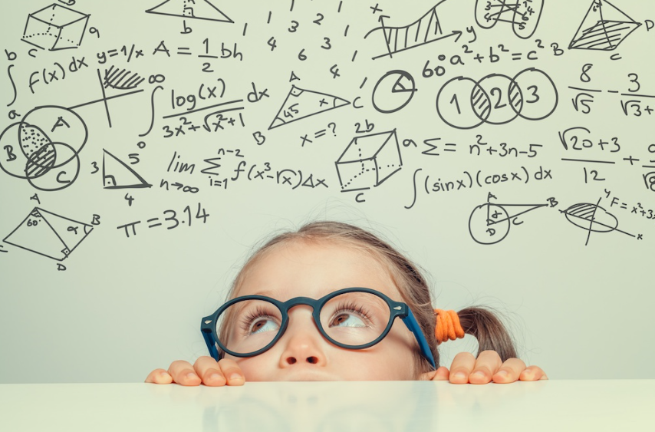 (Balance, 2023)
What could we have?
We need pupils to understand the relevance of numeracy in all aspects of the world we live in. Of course, we need the basics first. In her ‘Essential Ingredients for Numeracy’, Scott presents 3 core elements for a new and simplified view, confidence, content, and context (Scott, 1999). We all need confidence to use a new tool to begin with and why shouldn’t this be true in numeracy (Vygotsky, 1978). The Literacy and Numeracy Framework (LNF) in Wales’s key aims are for learners to develop numerical reasoning and use number, measuring and data skills, mastering them by the age of 14 (Welsh Government, 2013). Now, I have been in many a Primary and Secondary setting where the teacher is moving on to a different element of Maths when several pupils hadn’t mastered what they were doing in the previous objective, so how are these pupils supposed to remember what they haven’t learned to build on it next time?
Differentiation is a good way to start, back to basics, can the pupil write the numbers down in the correct order and in the correct column? Has it been demonstrated or are they expected to just know? Have books with larger squares been provided to assist with it? Do they have the tools to help them gain confidence such as a multiplication table or Numicon? Once a pupil learns to use these tools, they will be learning the mathematics and strategies and as confidence grows, start to ‘grow out’ of them. In younger students it may be worth providing them with different stimulus like using sticks outside or allowing older students to run a tuck shop in school (Froebel, 1903). These are just small examples of little things that could make a big difference. If the child isn’t learning it, teach it a different way!
If you’d like to join the debate subscribe here: theoverthinkingteacher.com

References
Balance, B., 2023. Math Learning Disabilities Explained. [Art].
Cockcroft, D. W. H., 1981. The Cockcroft Report, s.l.: s.n.
Froebel, F., 1903. The Education of Man. New York: D.Appleton and Company.
jobcrusher.com, 2023. smart girl having an idea. [Art].
Lisa O'Keefe, K. P., 2019. Re-highlighting the potential of critical numeracy. Mathematisc Education Research Journal, 33(2), pp. p285-299 (2021).
National Numeracy, 2022. Nation turns to numeracy to help count the cost of living this winter. [Online]
Available at: https://www.nationalnumeracy.org.uk/news/numeracy-help-cost-living-winter
Scott, D., 1999. Essential Ingredients for Numeracy. Australian Primary Mathematics Classroom, 4(1), pp. p4-8.
Vygotsky, L., 1978. Mind in Society. London: Harvard University Press.
Welsh Government, 2013. National Literacy and Numeracy Framework. [Online]
Available at: https://hwb.gov.wales/api/storage/64812b0e-3d20-4d10-94e8-68221e47a38d/to-support-schools-in-introducing-the-national-literacy-and-numeracy-framework.pdf

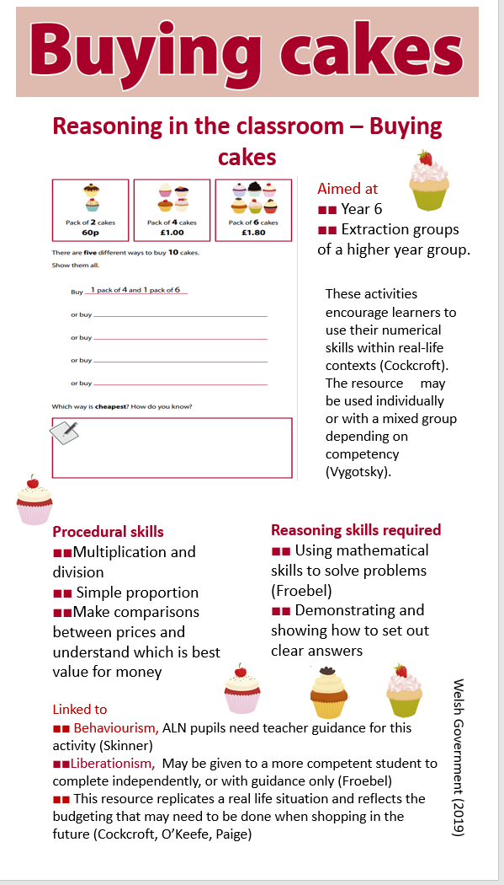

References
Cockcroft, D. W. H., 1981. The Cockcroft Report, s.l.: s.n.
Froebel, F., 1903. The Education of Man. New York: D.Appleton and Company.
Lisa O'Keefe, K. P., 2019. Re-highlighting the potential of critical numeracy. Mathematisc Education Research Journal, 33(2), pp. p285-299 (2021).
Skinner, B. F., 1984. The Evolution of Behaviour. The Journal of the Experimental Analysis of Behaviour, March.41(2).
Vygotsky, L., 1978. Mind in Society. London: Harvard University Press.
Welsh Government, 2019. Yera 6-Activities. Reasoning in the Classroon: Training Pack. [Online]
Available at: https://hwb.gov.wales/playlists/view/fe34f4fc-8149-40d6-9f9f-ffef01ff6e16/en/9?options=CNIQ39k7rbEp4zsz8OdGxip83XDxyAM%252BxyuNqUgoOrvEtxGXwma9Q0UtNK7LrNnQRo8G99LdOyi%252FaS6VMThAcJydjTw3aXD2wrzQJ3KIwW78dbgBIadplkyatZUq61ijjHrrZgIYiQqiJZ1ZHh6%252BMg%253D%
[Accessed 1 March 2023].

Video
https://clipchamp.com/watch/9Qr9t3g799f

Evaluation
For the requirement of the portfolio ‘Numbers Count’ an A4 resource sheet to be used by professionals to develop numeracy skills was to be included. Browsing the Literacy and Numeracy Framework shared resources in the workplace led me to resources that were developed by the Welsh Government. This is an evaluation on the resource selected.
Entitled ‘Buying Cakes’ there is diversity for the accessibility of differing abilities and opportunities to expand the exercise as the teacher sees fit (Welsh Government, 2019). The lesson asks the pupil/s to calculate the cheapest way to purchase 10 cakes which are sold in different pack sizes at different costs (Welsh Government, 2019). It is relevant to the recent cost of living crisis and the bright graphics are appealing (Welsh Government, 2019). The specification asked for an effective resource, and this lends itself to multiple mathematical numeracy disciplines and reasoning.
The resource covers thirteen out of the sixteen numeracy elements in the Literacy and Numeracy Framework (LNF) (Welsh Government, 2013) (Welsh Government, 2019). Firstly, the number system. To calculate the cost of one cake pupils would have to use the number system confidently, counting reliably to identify the number of cakes in the different packs (Welsh Government, 2013) (Welsh Government, 2019). Relationships within the number system are demonstrated by using halves in context to money and pack sizes (Welsh Government, 2013) (Welsh Government, 2019). The use of calculation to combine the pack sizes to find the five ways to make up ten cakes demonstrates progression step 2 in this area by adding, subtracting, multiplying, and dividing (Welsh Government, 2013) (Welsh Government, 2019). The financial literacy element is given with the calculation of money to identify the cheapest way to purchase the cakes (Welsh Government, 2013) (Welsh Government, 2019). This covers an understanding of the numeracy strand representing and comparing relationships between numbers and quantities and comprehension of the number system (Welsh Government, 2013) (Welsh Government, 2019). By drawing a conclusion as to which pack of cakes was the cheapest the pupil/s demonstrate/s the ability to collect and interpret data and represent data by arranging their ‘workings out’ in a legible manner as required in the LNF strand of probability models to help make inferences and decisions when using statistics (Welsh Government, 2013) (Welsh Government, 2019). Learning how measurements relate to the real world is indicative of the economy of finding the cheapest deal for an item which could relate to any purchase being made and is particularly relevant in the current cost of living crisis (National Numeracy, 2022) (Welsh Government, 2013). All elements of the strand containing the components of developing mathematical proficiency are also used in this resource (Welsh Government, 2013) (Welsh Government, 2019). Conceptual understanding and logical reasoning where the pupil can use this method of calculation when using money and affordability in many life situations such as finance and budgeting are present (Welsh Government, 2013) (Welsh Government, 2019). Fluency and communication with symbols are needed in order to calculate cake cost and strategy competence in order to work out the cheapest (Welsh Government, 2013) (Welsh Government, 2019). The resource is easy to mark and has skills transferable to the numerical and reasoning skills in the national tests (Welsh Government, 2020). Progression may be monitored by how much help the pupil requires to complete the task successfully.
The resource can be linked to educational theorists. From the age of 3 and in some areas earlier, due to the Flying Start scheme, children are legally required to attend an institute of education. Most schools will have similar and predictable routines. The same can be said for the way in which children are taught to approach numerical problems. Due to the National Curriculum and LNF, Math specialists in Secondary schools and Primary school teachers are given a specific criterion to follow to teach children the numerical literacy required (Welsh Government, 2020). We could argue that schools adopt the theory of operant conditioning through the repetition and training of the child’s brain in patterns that lead to solving an equation (Skinner, 1984). To examine the resource and answer the first questions, the child must identify that addition is needed to work out the five ways to buy ten cakes. They will have been taught addition using single digits at first before progressing to column addition (Welsh Government, 2020). Teachers use repetition to allow the mathematical processes to be stored into the long-term memory, which creates an automatic behaviour in the child of how to select and operate the formula (Skinner, 1984). The activity itself may be delivered and controlled completely by the teacher, particularly if it is being used for small, extracted groups (Skinner, 1984). It is however versatile. In larger groups, for example, instances where a class has a mixed year intake, the older (or more confident) students may be used to guide the younger or less able students which itself has proven to consolidate the peer teachers existing knowledge (Vygotsky, 1978). Vygotsky’s social constructivist approach promotes the use of mixed ability groups to solve problems, which lead to the development of negotiation skills and respectful communication (Vygotsky, 1978). More able and talented (MAT) students may access this resource as a plenary activity as it can be completed independently, the teacher may be asked for guidance, but the resource explains the activity well and is uncomplicated (Froebel, 1903). Alternatively, real or pretend cakes may be used to provide a visual learning experience and ‘play’ or real money could be used in a shop role play activity (Froebel, 1903). This may work well for pupils with additional learning needs as learning will be ‘fun’ (Froebel, 1903).
Conversely, ALN pupils who are older may find role play too childish and may find the idea of packs of cakes has no appeal to them. In this instance perhaps multi packs of crips or some other snack that they enjoy could be substituted. Pupils may find the request to find five different ways to buy ten cakes an overwhelming task, they may benefit from the use of number blocks to provide a visual aid (Froebel, 1903).
To conclude, the resource is useful. Its ability to be adapted for proficient and less proficient learners makes it accessible for all (Vygotsky, 1978). The bright colours and images appeal to visual learners. The language is simple to allow pupils to read and complete the task independently (Vygotsky, 1978) (Skinner, 1984). The stages needed to complete the tasks are short and uncomplicated (Skinner, 1984). Only three elements of the LNF are not covered within this activity (Welsh Government, 2013)

References
Froebel, F., 1903. The Education of Man. New York: D.Appleton and Company.
National Numeracy, 2022. Nation turns to numeracy to help count the cost of living this winter. [Online]
Available at: https://www.nationalnumeracy.org.uk/news/numeracy-help-cost-living-winter
Skinner, B. F., 1984. The Evolution of Behaviour. The Journal of the Experimental Analysis of Behaviour, March.41(2).
Vygotsky, L., 1978. Mind in Society. London: Harvard University Press.
Welsh Government, 2013. National Literacy and Numeracy Framework. [Online]
Available at: https://hwb.gov.wales/api/storage/64812b0e-3d20-4d10-94e8-68221e47a38d/to-support-schools-in-introducing-the-national-literacy-and-numeracy-framework.pdf
Welsh Government, 2019. Yera 6-Activities. Reasoning in the Classroon: Training Pack. [Online]
Available at: https://hwb.gov.wales/playlists/view/fe34f4fc-8149-40d6-9f9f-ffef01ff6e16/en/9?options=CNIQ39k7rbEp4zsz8OdGxip83XDxyAM%252BxyuNqUgoOrvEtxGXwma9Q0UtNK7LrNnQRo8G99LdOyi%252FaS6VMThAcJydjTw3aXD2wrzQJ3KIwW78dbgBIadplkyatZUq61ijjHrrZgIYiQqiJZ1ZHh6%252BMg%253D%
[Accessed 1 March 2023].
Welsh Government, 2020. Area of Learning and Experience: Mathematics and Numeracy. [Online]
Available at: https://hwb.gov.wales/curriculum-for-wales/mathematics-and-numeracy/
[Accessed 2023].

Reflection
For the first assignment for level 5 our cohort were asked to complete a portfolio containing the following elements, a blog explain why numeracy is important, another blog to explain the role of schools in developing numeracy skills, an A4 sized resource that teachers can use to develop numeracy, a video, showing the resource in use imbedded in the portfolio, an evaluation of the resource and a reflection on the module. I will use the Gibbs’ Reflective Cycle to critique my experience (The University of Edinburgh, 2023). I chose this six-stage model as I felt that it would provide a measured approach to each stage of the process (The University of Edinburgh, 2023).
During the first lecture, I realised how important numeracy is in our daily lives. Our lecturer recommended that we read a journal article that she provided, entitled, Re-highlighting the potential of critical numeracy by Lisa O’Keefe and Kathryn Paige (O'Keefe, 2019). This gave us an Australian perspective on their declining numeracy standards, the link of numeracy and digital competency, the link to creating global citizens and critical thinkers and the need to link this to ‘lifeworld’s’ (O'Keefe, 2019). We also discussed the Cockcroft report which was commissioned in 1978 in the United Kingdom to analyse the effectiveness of the current maths teaching and its relevance to employability and day to day life (Cockcroft, 1988).
Lecture two focused on the educational theorists who could be linked to our work. One which wasn’t familiar, connectivism. The most significant focus in this theory is the incorporation and acceptance of the influence and evolution of technology and its impact on pedagogy (Siemens, 2005). In lecture three another unfamiliar concept was introduced. Freire’s Pedagogy of the Oppressed (Feire, 1970). Using his experience in teaching adult literacy in Brazil, Freire discusses how the social status quo perpetuates class differences, access to education, and liberation (Feire, 1970). Our final lecture covered the effective writing of an evaluation and reflection.
This module raised mixed feelings as my relationship with numeracy is complicated. Having never learned my timestables in primary school, I struggled in secondary. A year or more ago I would have looked at the specification for this module with dread, but due to recent experiences my mind-set has changed. Due to Adverse Childhood Experiences, I found concentration difficult and was often absent at school which affected the continuity in my learning (Public Health Network Cymru, 2017) . Although common sense and logic helped with the Sciences and English, Maths proved difficult to grasp. Teachers at the time taught one method of calculation, unlike today where different strategies are shown and the pupil can choose to use whichever method suits them. My mind did not seem compatible with that of the teacher (Skinner, 1984). When asking for help, the teacher would explain it once in the same way and continue teaching the class. Voicing incomprehension would have drawn attention to my already self-concious self. Years later, when studying for a level 3 NVQ, a requirement for an application of number qualification was required to complete the course. I dreaded going to college, things being explained multiple times made me tearful and I felt as though a brick wall was erected to keep the answers just out of reach. So, using Vygotsky's MKO, I asked a maths teacher friend for help (L.S Vygotsky, 1978). With some coaching from her, percentages seemed to make sense and I could use multiple mathematical calculations to complete past GCSE exam papers. Reflecting on this time, it was more psychologically straining than leaving my daughter's father and having no job or home at the time.
At the beginning of this academic year, I undertook a college course for Maths GCSE, as my final goal will be to become a qualified teacher and Wales required a grade B or above for enrolment to the PGCE course. In preparation for this, past papers were acquired, and textbooks borrowed from the school where I work. I also had my own maths book to use in the lessons where I scribe for a pupil in year 10. My attitude started changing. In maths lectures I understood and could keep up with the lesson and in the school classes my confidence started to develop. Where I had previously assumed a self-diagnosis of dyscalculia the realisation of how much learning I had missed and the impact it had on my numeracy education hit me (Skinner, 1984). I developed confidence in work where numeracy was involved and sharing my knowledge consolidated my own skills (L.S Vygotsky, 1978). I saw a difference in how I managed finances at home and my shift in attitude towards it encouraged my daughter to ‘have a go’. Regretfully, a short time after starting the course, the Welsh Government announced a change in the grade requirement, lowering it to a C. This gave me mixed feelings. Firstly, relief, as two online lectures and working was tiring. Secondly, regret at not being able to see how far I had come on my journey with numbers.
Having a module focusing on numeracy has allowed me to communicate how my relationship with it has changed. I enjoy participating in a maths class and understanding what is being taught (Skinner, 1984). My ACES have often left feelings of disconnection and intense emotions that often link with maths for me (Public Health Network Cymru, 2017). Overcoming this mental hurdle has given me the resilience to go out of my comfort zone and ask for more information with no embarrassment attached. To let go of pre-existing barriers within myself and embrace new challenges with zeal. However, through all of this, my time management skills have been lacking during the process. My increased self-confidence has let me to become overconfident in the amount of time that it will take to research and write as thoroughly as possible. Subsequently, I find that I am rushing the latter part of the module again.
I originally recorded the video using my phone. The quality was excellent, and I intended to email it to myself and store it in my files from there. Unfortunately, the file was too large to send so I set about compressing it. I downloaded several apps to my phone which didn’t work. I saved it into my files, and it converted into a zip file which I thought had compressed it, but it hadn’t. After many failed attempts I used my laptop which worked well although there wasn’t any video editing software preinstalled. I searched the internet to find the best app and I used Microsoft video editor. It was very simple to use. I edited the video down to the required 3 minutes and the file was automatically compressed into MP4 format ready to embed into my portfolio. It was then a simple drop and drag to embed.
For the next module, I will endeavour to start early to give time for contemplation on newly learned concepts and to fine tune grammar and language. It may help develop the way that I use references more thoroughly. I realise that during the writing of this portfolio that I have taken my daughter on holiday and isolated and recovered from covid 19 and a chest infection which has affected the writing timeframe. The experience has taught me to be in good time to negate any adverse circumstances that arise unexpectedly.

References
Cockcroft, W. H., 1988. The Cockcroft Report (1988) Mathematics Counts, s.l.: s.n.
Feire, P., 1970. Pedagogy of the Oppressed. London: Penguin Books.
L.S Vygotsky, M. C., 1978. Mind in Society: Development of Higher Psychological Processes. Harvard: Harvard University Press.
O'Keefe, P., 2019. Re-highlighting the potential of critical numeracy. Mathematics Education Research Journal, Volume 33, pp. 285-299.
Public Health Network Cymru, 2017. Adverse Childhood Experiences (ACES), s.l.: YouTube.
Siemens, G., 2005. Connectivism: A Learning Theory for the Digital Age. International Journal of Instructional Technology & Distance Learning, Volume 2, pp. 3-10.
Skinner, B. F., 1984. The Evolution of Behaviour. The Journal of the Experimental Analysis of Behaviour, March.41(2).
The University of Edinburgh, 2023. Gibbs' Reflective cycle. [Online]
Available at: https://www.ed.ac.uk/reflection/reflectors-toolkit/reflecting-on-experience/gibbs-reflective-cycle

