Using Information in Human Resources

Report Title: Developing Professional Practice

Name: Lauren Baldwin

CIPD Membership Number: 53306594

Date: 24/10/2018

Word count (max: 2500 words): XXXX

I declare that this assignment is my own work and that any information obtained from books and other sources have been appropriately referenced.

Signed LBaldwin Date 14/11/2018

Table of Contents
1. What it means to be a HR Professional 2
1.1 The CIPD HR Map 2
1.2 Examples of skills/behaviours and why they are important to HR Professionals and their organisations 3
2. Group Dynamics & Conflict Resolution 4
2.1 Tuckman’s Model 1965/1977 4
2.2 Conflict Resolution Methods 6
3. Project Management, Problem Solving, Influencing, Persuading and Negotiating 8
3.1 Applying project management techniques 8
3.2 Apply problem-solving techniques 8
3.3 Apply a range of methods for influencing, persuading and negotiating with others 8
References 9

What it means to be a HR Professional

The CIPD HR Map

The best way to explain what a HR Professional is, is by referring to the Profession Map created by the CIPD.

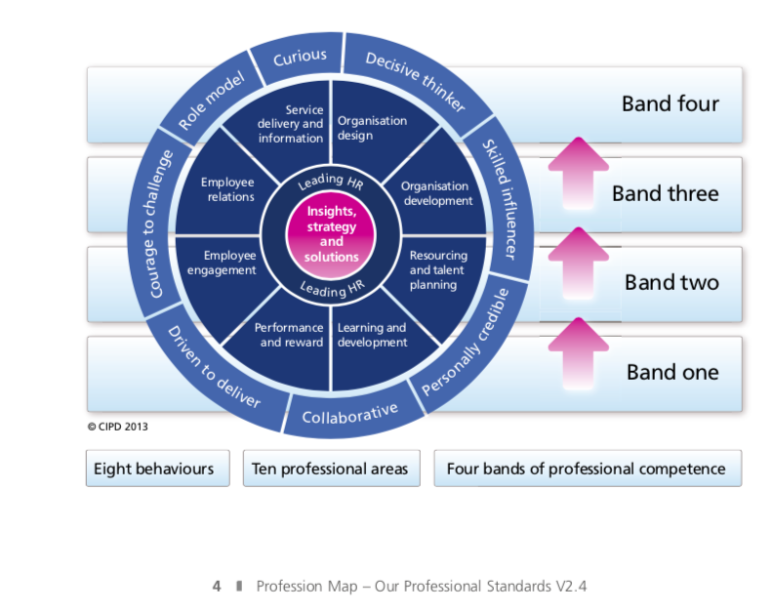
Figure 1-My HR Map
(Chartered Institute of Personnel and Development, 2018)

The HR map was developed by the CIPD by HR professionals for HR professionals, created by both specialists and generalists working in different sectors and countries in order to pull together something that any person working in, or studying HR can use and refer to. It is designed to describe what is expected of a HR professional and what you should know in order to carry out your HR role efficiently and exactly how to achieve that within each professional area depending on your own professional competence. This includes looking at behaviours and the technical parts of being a HR professional, organised by area of competence as opposed to job levels or roles. It is adaptable to every type and size of organisation in any stage of the HR process and can be used by just focusing in on certain behaviours or key areas individually or referred to as a whole map, spanning out from the key core areas that are relevant to all organisations. The map is made up of ten professional areas, and eight behaviours in four bands (Chartered Institute of Personnel and Development, 2018).

Professional areas
• Describes what you need to do (activities) and what you need to know for each area of the HR profession at four bands of professional competence.
Behaviours
• Describes the behaviours and HR professional needs to carry out their activities. Each behaviour is described across four bands of professional competence.
Bands and transitions
• Describes the four bands of professional competence and the transition challenges faced when moving from one band to the next. How their contribution and success is measured.

Examples of skills/behaviours and why they are important to HR Professionals and their organisations

Being a Successful Role Model
The CIPD Map (2016) refers to the behaviour of a role model as a HR professional who consistently leads by example. This person acts with integrity, impartiality and independence, balancing personal, organisation and legal parameters (Chartered Institute of Personnel and Development, 2018). The CIPD also has a code of professional conduct (2018) which states that members should exhibit personal leadership as a role model for maintaining the highest standards of ethical conduct (Chartered Institute of Personnel and Development, 2018). The CIPD expects you to be a ‘change-ready employee’ by being flexible and constructive.
It is important to be a good role model, as your actions and decisions are on display every day. It is not only employees learning from your behaviour, but also customers, visitors, even contractors. Other employees will look up to you as a HR Professional and can learn from or even copy your behaviour, so you should be showing ‘good practice’ at all times (Jaya Dass, 2016).

Decisive Thinker
The CIPD Map (2016) refers to the behaviour of a decisive thinker as a HR professional as someone who exhibits the capability to analyse and recognise data and information quickly. Somebody who uses information, and knowledge in a structured way to comprehend and ascertain options, make recommendations and make sound, defendable decisions (Chartered Institute of Personnel and Development, 2018).

In order to be an effective and efficient HR professional; being decisive in your thinking process is paramount. You often come across robust people decisions and will often find yourself having to analyse information and or data and arrive at a structured, coherent conclusion. When this is not done proficiently and in an organised manner you often encounter further problems. Therefore, this is a fundamental behaviour to display and act on (Jaya Dass, 2016)

Courage to Challenge
As shown on The CIPD Map (2016), a HR professional should be showing courage and confidence to speak up skilfully, challenging others even when confronted with resistance or unfamiliar circumstances (Chartered Institute of Personnel and Development, 2018).
HR exists to function as a secondary part of a business or organisation. When a HR professional is courageous, this means they are not afraid to challenge even the highest authority in the business and make sound credible decisions and debates. You should have courage in your opinions and be able to act on them objectively, professionally and in a clear and concise way. In HR, having the courage to challenge behaviour focused on short-term business goals which are detrimental to the organisations people and its long-term success is key (Chartered Institute of Personnel and Development, 2018).

Group Dynamics & Conflict Resolution

In the early 1940s, Kurt Lewin, a social psychologist noted that people often take on different roles and behaviours when they work in a group. Group dynamics is the effects of roles and behaviours surrounding group interactions of other group members as well as on the whole group.

A better understanding of what motivates teams, and the sort of people that make up successful teams can positively affect HR decision-making and assist the organisation in creating a more successful workforce.

Tuckman’s Model 1965/1977

The below model is referred to as the Tuckman model created by Bruce Tuckman, it can be used to address the different stages of team development. He evaluated more than 50 studies of group development and produced the things they had in common by creating the well-known model we as HR professionals frequently refer to today (Tuckman, 1965).
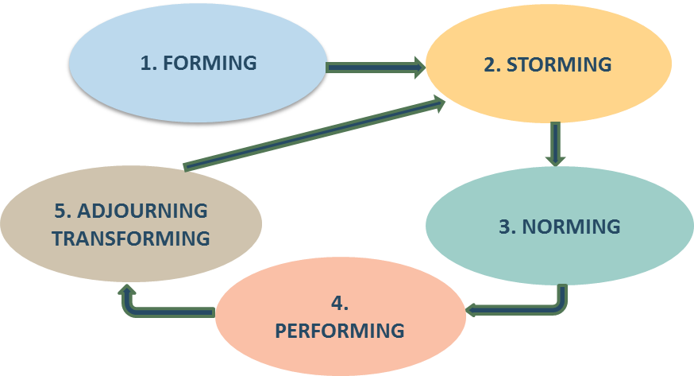
Figure 2-Tuckman Model
(Office of Childcare, n.d.)

His theory notes that there are five stages that a group of people will move through. Four stages were initially introduced to the model, until later in 1977 when he conducted a new set of studies and reviewed and amended it to include the newly discovered stage (Tuckman, 1977). During the above stages to the model, team/group members will encounter and address numerous issues. The way they go about resolving these issues determines the fate of the group as to whether they will succeed in completing the tasks assigned to them.

The below goes into more detail about each of the stages:

- Forming
This is the first stage in the model in which the team/group members are new to the group and new to each other. Team members tend to experience a range of emotions during this stage, e.g. two opposite emotions could be excitement and uncertainty. Some personalities will respond to the task set with a positive emotion like excitement, whereas other types of people could respond with more of a negative response e.g. uncertainty towards the task set – do they fully understand the task, and do they feel comfortable with the new group of people? At this stage, the goals and leadership of the team are yet to be determined (Luthans, 2011).

Subsequently, forming is an orientation period when members familiarise themselves with one another and share expectations about the group, as well as the rules to be followed. Development of trust and openness is essential at this stage and therefore it should not be rushed (Barnett & Weidenfeller, 2016) .

- Storming
In this stage, the group is likely to discover the highest level of disagreement and conflict, as individuals will often challenge group goals and often compete for the leadership position. If the team are not able to resolve these conflicts, then the group will often split or remain in existence but will be unsuccessful and not advance to the next stages (Barnett & Weidenfeller, 2016).

- Norming
At this stage the group members will begin to develop a feeling of unity and identity. Cooperative effort should begin to produce results and some responsibilities are divided among members and the group can decide how it will evaluate progress (Barnett, 2016).

- Performing
This stage occurs when the group has developed and achieves a feeling of cohesiveness. During this stage of development, individuals accept one another, and conflicts are resolved through a group discussion. Team members make decisions through a logical process that is focused on pertinent goals rather than emotional issues (Barnett & Weidenfeller, 2016).

- Adjourning
Not all groups will experience this stage as some groups are relatively permanent. This stage only happens when the group splits up – normally due to being unable to achieve the task or certain individuals deciding to go their own direction. (Luthans, 2011).

Conflict Resolution Methods

Causes of conflict
- Different points of view
  - See a situation differently
  - Want different outcomes
  - Different idea of what to do
- Multiple/conflicting priorities
- Personalities
- Background, culture, gender
- Changes (too many, too fast)
- Strong feelings / frustration

Thomas Kilmann – Conflict Mode Instrument
The purpose of the Thomas Kilmann questionnaire is to identify your preferred mode, along with its pros and cons, then seek positive outcomes through your best conflict-handling techniques, therefore expanding your range of conflict management skills.

The five common modes for handling conflict according to Kilmann are:

  - Competing
  - Collaborating
  - Compromising
  - Avoiding
  - Accommodating

The Thomas Kilmann model states that an individual’s behaviour has two basic dimensions as shown on the axis in the chart below:

Assertiveness
The extent to which the individual attempts to satisfy his/her own concerns

Co-operativeness
The extent to which the individual attempts to satisfy the other person’s concerns

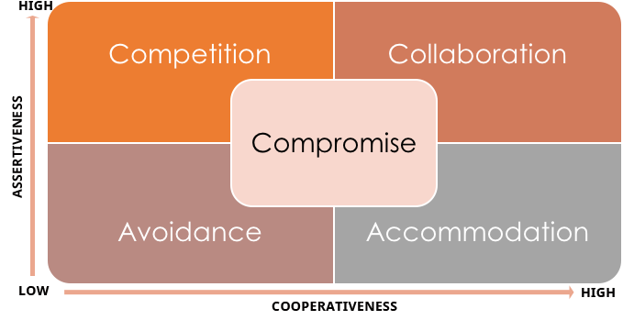
Figure 3-Thomas Kilmann Model
(Chancy, 2017)

Please see appendix for Figure 4-My results (Kilmann). I took the Thomas Kilmann questionnaire myself, in order to enhance my understanding as to how I approach conflict and resolve conflicts within my workplace.

The results of the questionnaire showed that I scored fairly high on two of the conflict resolution methods – competing and collaborating.

Competing

Competing is useful when decisive action is vital and a quick decision is required e.g. in an emergency or when looking at important issues where things need implementing that may not be very popular among a team of colleagues e.g. discipline or cost-cutting. It also comes in useful when you have other strong personalities in a team who look out the ‘weaker’ non-competitive members of the team in order to gain an upper-hand.

Pros | Cons
Other strong, competitive team members may give up trying to influence you with their opinions/ideas | Could isolate yourself from the team and sharing information as people may not want to share their ideas
Helpful trait to have in situations where decisive action is vital | Over-confident – unable to ask others for their opinion/information
Able to implement unfavourable rules/policies without emotional connection | Less able to learn from others

Collaborating

Collaborating comes in useful when the objective is to learn or understand other’s views on matters and for finding a solution to something where both concerns are not to be compromised. Collaborating between two persons might take the form of exploring a disagreement to learn from each other’s insights, concluding to resolve a situation which would otherwise have them competing for something or confrontation. It is also a useful trait to have in order to gain commitment from others by incorporating their views into a decision.

Pros | Cons
Both assertive and cooperative behaviour | Over-use can waste time, resources and energy that could otherwise be spent elsewhere
Find an alternative which meets both parties’ concerns – pleasing both individuals | Trust and openness could be abused
Gaining commitment and improving relationships

Project Management, Problem Solving, Influencing, Persuading and Negotiating

Applying project management techniques

A project I’ve been working on recently at my workplace is being in-charge of organising the work Christmas meal. This project involved sourcing a venue for us to have our meal at – this includes costing and ensuring it is in a good location close to our office in order for us to leave and get there in a timely manner and won’t require transport (cost effective). It is important for us to keep the costs at a minimum as we are still a small company. There are currently 12 employees including Managing Directors. The directors would like to fund the meal and any costs involved through the company, however because of this it is important for me to try and keep expense to a minimum.

[Evidence TBC]

Apply problem-solving techniques

[Evidence TBC]

Apply a range of methods for influencing, persuading and negotiating with others

[Evidence TBC]

Ran out of time. Requires re-submission & re-work

References
Barnett, R. C. & Weidenfeller, N. K., 2016. Shared Leadership and Team Performance. Advances in Developing Human Resources, 18(3), pp. 334-351.
Chancy, S., 2017. The Thomas Kilmann Conflict Mode Instrument (TKI) for addressing conflicts. [Online]
Available at: http://ascenditur.no/blog/2017/04/30/managing-workplace-conflicts/
[Accessed 14 November 2018].
Chartered Institute of Personnel and Development, 2018. Code of Professional Conduct | CIPD. [Online]
Available at: https://www.cipd.co.uk/about/what-we-do/professional-standards/code
[Accessed 13 November 2018].
Chartered Institute of Personnel and Development, 2018. The 2013 Profession Map for HR and L&D. [Online]
Available at: https://www.cipd.co.uk/learn/career/profession-map/2013-profession-map
[Accessed 12th November 2018].
Jaya Dass, 2016. Eight Behavioural Traits That Every HR Professional Needs | Randstad Singapore. [Online]
Available at: https://www.randstad.com.sg/workforce360/archives/jaya-dass-eight-behavioural-traits-every-hrd-needs_94/
[Accessed 13 November 2018].
Luthans, F., 2011. Organizational Behavior: An Evidence-Based Approach. 12th ed. Boston: McGraw-Hill.
Office of Childcare, n.d. Teams and Change | Systems Building Resource Guide. [Online]
Available at: https://childcareta.acf.hhs.gov/systemsbuilding/systems-guides/leadership/teams-and-change
[Accessed 14 November 2018].
Tuckman, B. W., 1965. Developmental sequence in small groups. Psychological Bulletin, Issue 63, pp. 384-399.
Tuckman, B. W., 1977. Stages of small group development revisited. Group and Organization Studies, Volume 2, pp. 419-427.

