27/03/2026
Assessment 1
Project Proposal Report

Module NaMe: Changemakers, Creativity and Value creation
Module Code: ACCA 5033
Student NAME: Adriano Antonio Donda
Student ID: 2428051
Lecturer: Dr. Fahad Ahmad
Trinity saint david University of Wales (London Campus)

Table of Contents
Introduction 2
Task 1: Ideation and Innovation 3
Task 2: Aim, Objectives and Research Area 6
Task 3: Research Strategies 8
Conclusion 10
References 11
Appendix A: Pilot Tool and Feedback 13

Introduction

Artificial intelligence (AI) is increasingly transforming higher education through its application in teaching, learning, assessment and academic support. One important application of AI is the use of chatbots, which can provide immediate answers, guidance and support to students. First-year computing students often require frequent academic support as they adjust to university life and new academic expectations, but this support may not always be available when needed. This project proposes the design of an AI-powered academic support chatbot to improve access to academic support for first-year computing students. The report explores innovation and ideation, defines the project aim and objectives, and presents suitable research and development strategies for the proposed solution.

Task 1: Ideation and Innovation

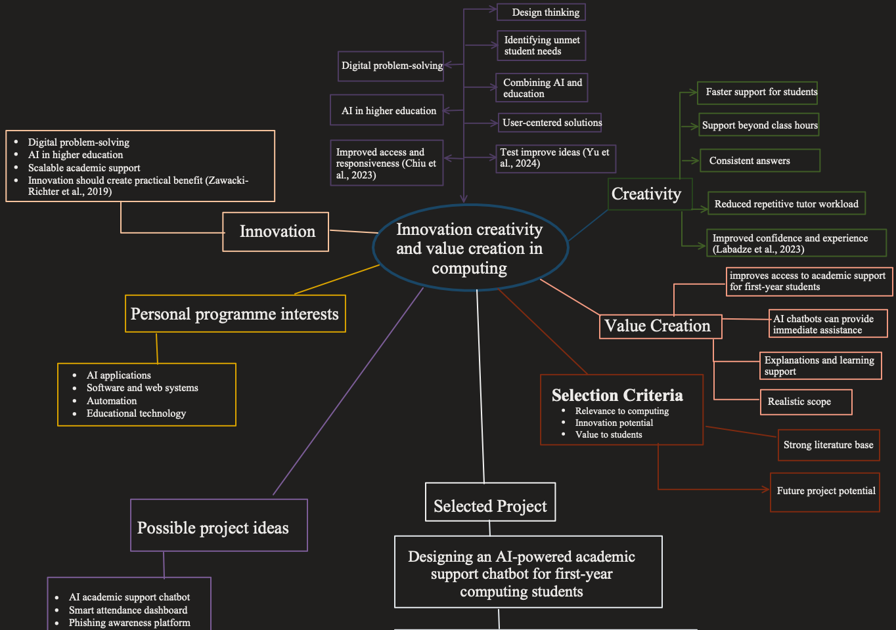

References:

Chiu, T.K., Xia, Q., Zhou, X., Chai, C.S. and Cheng, M., 2023. https://doi.org/10.1016/j.caeai.2022.100118.
Essel, H.B., Vlachopoulos, D., Tachie-Menson, A., Johnson, E.E. and Baah, P.K., 2022. https://doi.org/10.1186/s41239-022-00362-6.
Labadze, L., Grigolia, M. and Machaidze, L. (2023) https://doi.org/10.1186/s41239-023-00426-1.
Page, L.C. and Gehlbach, H. (2017) https://doi.org/10.1177/2332858417749220.
Yu, Q., Yu, K. and Lin, R. (2024) https://doi.org/10.1057/s41599-024-03237-5.
Zawacki-Richter, O., Marín, V.I., Bond, M. and Gouverneur, F., 2019. https://doi.org/10.1186/s41239-019-0171-0.

The following mind map addresses how an effective computing project can be influenced by innovation, creativity and value creation and help to develop a research idea that is relevant. The main theme, Innovation, Creativity and Value Creation in Computing, indicates the perspective that not just any technology should be used in successful projects, but they must also be aimed at addressing genuine issues in an able and socially valuable way. Innovation in this case is taken to refer to the practical implementation of an idea to enhance the existing system, service or experience. Artificial intelligence has become a significant innovation in the context of higher education, as it is currently finding application in teaching, learning, assessment and academic support. Recent sources indicate that AI applications, such as chatbots, have gained increased prominence in the educational setting since they can enhance responsiveness, access to information and effectiveness of support services (Chiu et al., 2023; Zawacki-Richter et al., 2019).

The innovation branch of the mind map is concerned with digital resolution of problems, AI in higher education, academic support to scale and enhanced access and responsiveness. These concepts play a vital role since innovation in computing does not necessarily involve creating something informal but rather creating something useful, efficient and pertinent. The suggested chatbot in this context is a creative solution to the issue that the first-year students usually require to receive academic assistance, but are not necessarily available at any time. This renders the project viable and up-to-date with the contemporary trends in educational technology.

Another significant aspect of the map is creativity, since creative thinking aids in developing an idea of a project out of a broad problem. In this section, the mind map comprises design thinking, finding the needs that students have not met, integrating AI and education, user-centred solutions, and testing and improving solutions. These ideas demonstrate that creativity cannot be a haphazard generation of ideas, but it is an organised process of getting to know the users and developing solutions that suit the needs of the users. This can be said to be pertinent in the area of Computing most notably because technical projects tend to be more powerful when they are informed by the experiences of real users. The studies of the design thinking propose that the process can also empower problem-solving, innovation and meaningful development of solutions in education (Yu et al., 2024).

The value creation branch demonstrates the worth of the chosen project. The suggested chatbot might be valuable in the sense that it would be quicker in supporting students, be available to assist them outside of classes, give more reliable responses to frequently asked academic enquiries, lower the number of cases of repetitive work that tutors would get, and boost student confidence. It might enhance the provision of academic assistance to first-year students. As they are usually acclimating to new academic demands and might require assistance at inconvenient hours. This is because the project is beneficial not only to individual learners but also to tutors and institutions. Research on AI chatbots in education suggests that such systems could support learning, enhance access to information and develop more efficient support processes when implemented properly (Essel et al., 2022; Labadze et al., 2023).

There are personal and programme-related interests, which are also arranged on the map, including AI applications, software and web systems, automation, and educational technology. These interests are significant since the brief demands that the project ideas be related to the field of study of the student. Some potential project ideas were taken into consideration, such as an AI academic support chatbot, a phishing awareness platform, a smart attendance dashboard and a student productivity app. These possibilities were then weighed against selection criteria such as relevance to computing, possibilities of innovation, value to students, realism, availability of literature and prospects of future projects.

According to these criteria, the chosen project is designing an AI-powered academic support chatbot for first-year computing students. This concept has been selected as it solves a well-defined support gap, as it has a high fit with software and AI, is feasible and studyable, and adds value to students and staff members. In general, the mind map illustrates a logical flow of ideas about innovation and creativity to a narrowed project concept that is justified by existing literature and has a definite practical application (Chiu et al., 2023; Labadze et al., 2023).

Task 2: Aim, Objectives and Research Area

Project title: Designing an AI-powered academic support chatbot for first-year computing students
AI has become more popular in the education sector, and existing reviews show that artificial intelligence is being utilised in education, teaching, learning, evaluation and management. Chatbots have subsequently undergone a considerable degree of particular attention as they are also capable of responding to questions and providing feedback and quick responses to learners. This makes them relevant to the context of higher education, where they often demand first-year students, but they do not necessarily receive immediate staff support. The concept of an academic support chatbot that will operate on the basis of AI is, therefore, a suitable and novel project idea as it combines the software development and value-creation within a real-life applied environment (Chiu et al., 2023; Labadze et al., 2023).

Aim
This project is designed to explore how an AI-based academic support chatbot could improve access to academic support among first-year Computing students.

Objectives
The initial aim is to determine the key academic support issues among the first-year computing students. The second purpose is to investigate the students' attitudes towards chatbot-based academic support in higher education. The third goal is to analyse the possible advantages and shortcomings of an AI-based academic support chatbot. The fourth goal is to find out the main design features that would render such a chatbot helpful, reachable, and relevant to first-year students (Chiu et al., 2023; Labadze et al., 2023).

Research Philosophy
Pragmatism is the best research philosophy to apply in this project. The most crucial question in this project is not whether or not students have some opinion about AI, but whether a chatbot can also be used as a real-life support tool in a higher education environment. A pragmatist approach is hence apt since it enables the project to be outcome-based in nature, useful and of applied value. It also helps to add other types of evidence, including student perceptions, usage expectations and design requirements, when necessary in subsequent parts of the project (Kaushik and Walsh, 2019).
Search tool and databases
To find the literature that would be of interest, I would combine the use of broad academic search tools and more specific databases. Initially, Google Scholar would be utilised since it is a very broad search tool and can be used to find journal articles, conference papers and related citations. I would also rely on IEEE Xplore and the ACM Digital Library since the offered project falls within computing and educational technology. Moreover, I would resort to Scopus or Web of Science, which are accessible at the university, and find peer-reviewed research and follow influential resources. The multi-database approach is also more effective than working on one platform since extensive searching is generally more effective when it is done on multiple platforms, with Google Scholar being a notable complementary database to other platforms rather than a direct replacement (Martin-Martin et al., 2018; Justesen et al., 2021).

Search strategy
My search strategy would be the identification of the major project concepts. The latter includes the AI chatbot technology, higher education, student support and first-year students. Then I would look at identifying similar words to every thought and combining them using Boolean operators such as AND and OR. E.g. AND (AI chatbot/conversational agent/virtual assistant) AND (higher education/university) AND (academic support/student support/advising) AND (first-year student/undergraduate). I would also use the quotation marks in case of exact phrases and truncation where there is a need to improve the search. I would also go through the reference list of literature review articles that are significant to find other more useful sources (MacFarlane et al., 2022; Justesen et al., 2021).

Task 3: Research Strategies

A small-scale mixed-method exploration design would be suitable in this project since data on student attitudes (structured) and brief qualitative remarks on their expectations and worries about an AI-based academic support chatbot (qualitative) are required in the study. An online questionnaire that will be distributed to first-year students of the computing course will be the primary means of data collection. This is appropriate since it is feasible, cheap and in tandem with an online project subject. The questionnaire would also have some Likert-type questions of a closed type to assess attitudes such as usefulness, accessibility and trust, and two open-ended questions to get suggestions and concerns (Bolarinwa, 2015). A safe online application, such as Microsoft Forms or Qualtrids would also assist in the efficient and systematic gathering of the information.
The questionnaire should be connected to the project's aim and objectives in order to make the instrument measure the intended issues and not irrelevant opinions and increase validity. The ambiguity would be lowered by using clear language, brief questions and fixed answer choices. The pilot stage would be used to find out items that are confusing in their widest use (Byrne, 2021). Moreover, one should note the content validity, i.e., the questionnaire should include the primary areas of interest, such as present support problems, readiness to work with a chatbot, anticipated features and perceived constraints. The significance of these steps is that validity and reliability require special attention to the development of instruments and their initial testing.
To enhance reliability, a similar questionnaire is supposed to be administered to the participants in one and the same format and in the same order. Consistency would be enhanced by using standardised words and one response scale. Had the end sample been large, internal consistency might subsequently be verified by some measure of reliability like Cronbach's alpha of the Likert-type items (Eldridge et al., 2016). The concept of reliability in this project is therefore based on the application of a stable instrument such that the phrasing is not inconsistent and that repeated or overlapping questions are avoided.
Less generalisability would occur. Since this would be a small research project involving one group of students in a single programme, the results would not be able to be statistically generalised to all students in the university. Nevertheless, the research may yield valuable information about comparable first-year computing situations (Roberts and Allen, 2015). The goal in this proposal is not the generalisation in a broad sense, but a local knowledge of a local problem that can still be used with a high degree of caution in a similar environment.
Informed consent, voluntary participation, anonymity, confidentiality, and secure data storage should be employed ethically in the project. The participants must be informed of the study purpose; they have the right to withdraw before submission, and the answers obtained will be used strictly for academic research. Since this is a learning environment, students should not be pressured to join in as well (Tiersma et al., 2022). When the questionnaire is conducted online, the issues of privacy and data security should be taken into account, such as the utilisation of secure software and the elimination of direct identifiers. This is of particular concern to online educational research, where consent, confidentiality and data quality should be actively managed as opposed to being assumed.
It would be a short questionnaire of approximately eight questions that would be the pilot method of data collection. It would be initially tested on three students to ensure that it is clear, it is not too long, and it is relevant. Based on pilot feedback, a single word could be paraphrased, and one repeated question could be deleted and replaced with an open-ended one on preferred features of chatbots. Appendix A should contain this pilot with a short comment on the main body that the pilot questionnaire and feedback summary are presented in the appendix. The purpose of pilot work is advantageous as it is beneficial to narrow down feasibility and aim of the main data collection period.
To perform a quantitative analysis, descriptive statistics (frequency, percentages and average response scores) would be used to analyse the closed questionnaire items. This would assist in determining trends in the usefulness, trustworthiness or even accessibility which useful students hold about the chatbot. To extract some theme, the open-ended responses need to be coded and classified based on the themes, e.g. anticipated benefits, desired features and concerns. A reflexive thematic analysis model would be appropriate since it would give a definite procedure of delineating tendencies in short textual information even though student opinions can still be interpreted.

Conclusion

This project proposal has explored the development of an AI-powered academic support chatbot for first-year computing students, demonstrating how innovation, creativity and value creation can be applied to address a real-world problem in higher education. The study identified a clear gap in the availability of timely academic support, particularly for first-year students who are adapting to new academic demands and often require assistance outside scheduled teaching hours.
Through the ideation process, the chatbot concept was selected as a practical and relevant solution, supported by current research on artificial intelligence in education. The project aims and objectives were clearly defined to guide the investigation into student needs, attitudes and expectations, as well as the potential benefits and limitations of chatbot-based support. The proposed research strategy, based on a mixed-methods approach, ensures that both quantitative and qualitative insights can be gathered to inform the design of an effective system.
Furthermore, the proposal outlined appropriate research tools, technologies and development methods, highlighting the suitability of an agile approach for iterative design and improvement. Consideration was also given to ethical issues, reliability, validity and potential risks, ensuring that the project is both feasible and academically robust.
Overall, the proposed chatbot has the potential to enhance accessibility, improve student confidence and reduce the workload of academic staff. By integrating AI into student support systems, this project contributes to the ongoing digital transformation of higher education and provides a foundation for future development and implementation of intelligent support solutions.

References

Bolarinwa, O. (2015) 'Principles and methods of validity and reliability testing of questionnaires used in social and health science researches,' Nigerian Postgraduate Medical Journal, 22(4), p. 195. https://doi.org/10.4103/1117-1936.173959.
Byrne, D. (2021) 'A worked example of Braun and Clarke’s approach to reflexive thematic analysis,' Quality & Quantity, 56(3), pp. 1391–1412. https://doi.org/10.1007/s11135-021-01182-y.
Chiu, T.K., Xia, Q., Zhou, X., Chai, C.S. and Cheng, M., 2023. Systematic literature review on opportunities, challenges, and future research recommendations of artificial intelligence in education. Computers and Education: Artificial Intelligence, 4, p.100118. https://doi.org/10.1016/j.caeai.2022.100118.
Eldridge, S.M., Chan, C.L., Campbell, M.J., Bond, C.M., Hopewell, S., Thabane, L. and Lancaster, G.A., 2016. CONSORT 2010 statement: extension to randomised pilot and feasibility trials. bmj, 355. https://doi.org/10.1136/bmj.i5239.
Essel, H.B., Vlachopoulos, D., Tachie-Menson, A., Johnson, E.E. and Baah, P.K., 2022. The impact of a virtual teaching assistant (chatbot) on students' learning in Ghanaian higher education. International Journal of Educational Technology in Higher Education, 19(1), p.57. https://doi.org/10.1186/s41239-022-00362-6.
Justesen, T., Freyberg, J. and Schultz, A.N.Ø. (2021) 'Database selection and data gathering methods in systematic reviews of qualitative research regarding diabetes mellitus - an explorative study,' BMC Medical Research Methodology, 21(1), p. 94. https://doi.org/10.1186/s12874-021-01281-2.
Kaushik, V. and Walsh, C.A. (2019) 'Pragmatism as a research paradigm and its implications for social work research,' Social Sciences, 8(9), p. 255. https://doi.org/10.3390/socsci8090255.
Labadze, L., Grigolia, M. and Machaidze, L. (2023) 'Role of AI chatbots in education: systematic literature review,' International Journal of Educational Technology in Higher Education, 20(1). https://doi.org/10.1186/s41239-023-00426-1.
MacFarlane, A., Russell-Rose, T. and Shokraneh, F. (2022) 'Search strategy formulation for systematic reviews: Issues, challenges and opportunities,' Intelligent Systems With Applications, 15, p. 200091. https://doi.org/10.1016/j.iswa.2022.200091.
Martín-Martín, A., Orduna-Malea, E., Thelwall, M. and López-Cózar, E.D., 2018. Google Scholar, Web of Science, and Scopus: A systematic comparison of citations in 252 subject categories. Journal of informetrics, 12(4), pp.1160-1177. https://doi.org/10.1016/j.joi.2018.09.002
Page, L.C. and Gehlbach, H. (2017) 'How an artificially intelligent virtual assistant helps students navigate the road to college,' AERA Open, 3(4). https://doi.org/10.1177/2332858417749220.
Roberts, L.D. and Allen, P.J. (2015) 'Exploring ethical issues associated with using online surveys in educational research,' Educational Research and Evaluation, 21(2), pp. 95–108. https://doi.org/10.1080/13803611.2015.1024421.
Tiersma, K., Reichman, M., Popok, P.J., Nelson, Z., Barry, M., Elwy, A.R., Flores, E.J., Irwin, K.E. and Vranceanu, A.M., 2022. The strategies for quantitative and qualitative remote data collection: lessons from the COVID-19 pandemic. JMIR formative research, 6(4), p.e30055. https://doi.org/10.2196/30055.
Yu, Q., Yu, K. and Lin, R. (2024) 'A meta-analysis of the effects of design thinking on student learning,' Humanities and Social Sciences Communications, 11(1). https://doi.org/10.1057/s41599-024-03237-5.
Zawacki-Richter, O., Marín, V.I., Bond, M. and Gouverneur, F., 2019. Systematic review of research on artificial intelligence applications in higher education–where are the educators?. International journal of educational technology in higher education, 16(1), p.39. https://doi.org/10.1186/s41239-019-0171-0.

Appendix A: Pilot Tool and Feedback

Purpose of the pilot testing
This pilot was meant to test the relevance, clarity and structure of the proposed data collection tool to the project entitled Designing an AI-powered academic support chatbot for first-year Computing students. The pilot was aimed at verifying the comprehensibility of the questionnaire items, their proper focus and appropriateness to explore the students’ opinions about the possibility of using an AI-based chatbot to acquire academic assistance.

Pilot method overview
A short online questionnaire was the pilot method of data collection. It was to be tested on the wording, relevance and the order of the questionnaire items to be used later. Both a combination of closed and open-ended questions was incorporated in the questionnaire because it was necessary to collect short structured answers and short unstructured qualitative remarks. Vitality was also sought by seeking responses on the clarity, length, repetition and general appropriateness of the questions to the project topic.

Pilot participants: 3 students with a background in Computing related studies.
Pilot format: Web-based questionnaire.
Purpose: To enhance consistency, significance, focus and sequence.

Pilot questionnaire
- What year of study are you in?
- What is your frequency of academic support after class?
- Is the accessibility of academic support as and when required?
- Do you apply an AI-based chatbot to academic support?
- Which kind of academic questions will the chatbot be useful for?
- What would you be worried about with regard to using an AI chatbot as an academic support tool?
- What is the functionality of the chatbot that would be helpful to first-year Computing students?
- Any other remarks or recommendations?
Pilot feedback summary
According to the pilot feedback, the questionnaire was topical in regard to the project topic though improvements were required. One of the questions was too broad and was paraphrased to make it narrower. It was also noticed that, two items were overlapping to a small degree hence one was simplified to eliminate repetition. Additionally, the answer revealed that a question on useful chatbot features was important because it would help in enhancing the focus on design in the proposed project.

Changes to be made on the basis of feedback.
In accordance with the pilot, there were a few minor alterations to the questionnaire to enhance it. One ambiguous item was simplified, one of the duplicated ideas was minimised, and the sequence of questions was changed in a way that the questionnaire proceeded more successfully to the general support needs to opinions, concerns and suggested features. Such amendments enhanced the general concentration of the tool and gave it better applicability to the gathering of data concerning the project aim and objectives.

