

ASSIGNMENT 1

NAME: YOANNA MIHAYLOVA
NUMBER: 1818183
SUBJECT: ACCOUNTING FUNDAMENTALS (LCBB4001)
TOPIC: ASSIGNMENT 1
LECTURER: REXON NTING

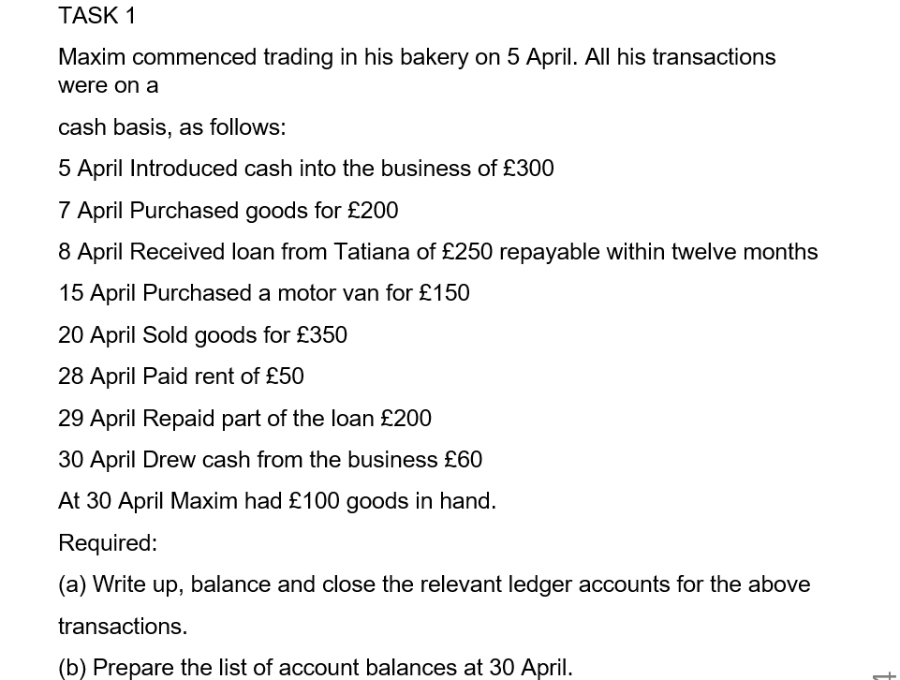
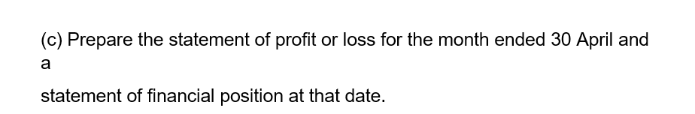

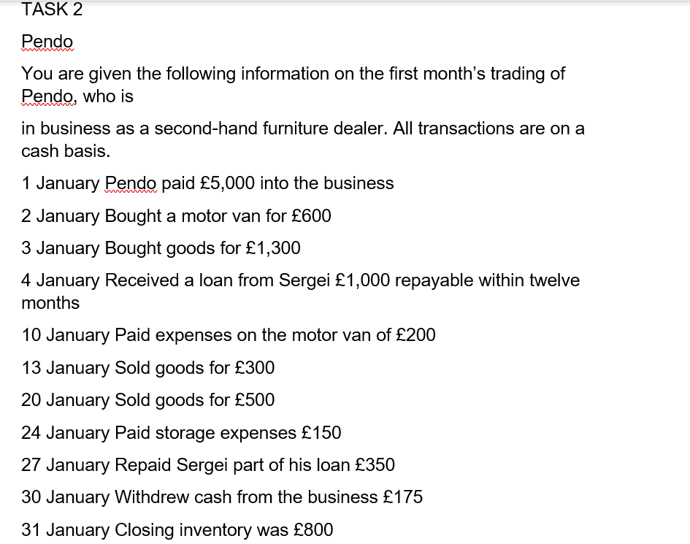
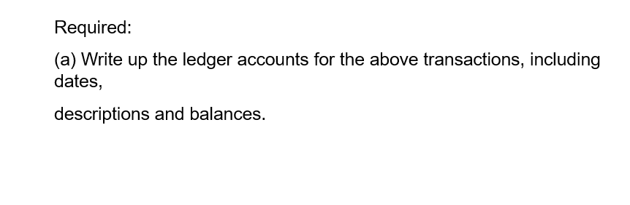
(b) Prepare the trial balance at 31 January.
(c) Prepare the statement of profit or loss for the month ended 31 January and a statement of financial position at that date.

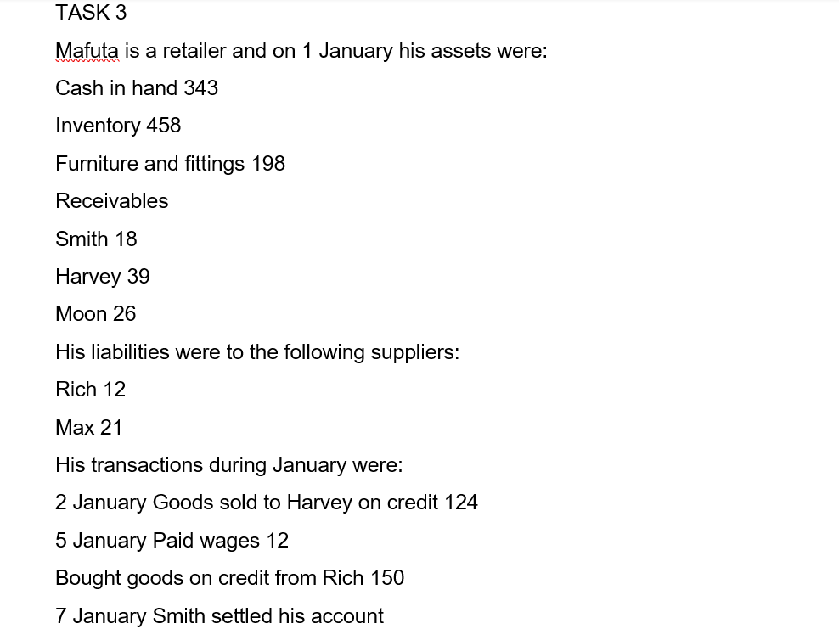

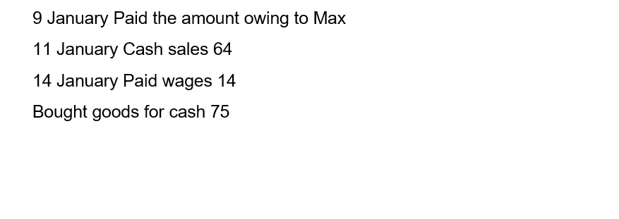
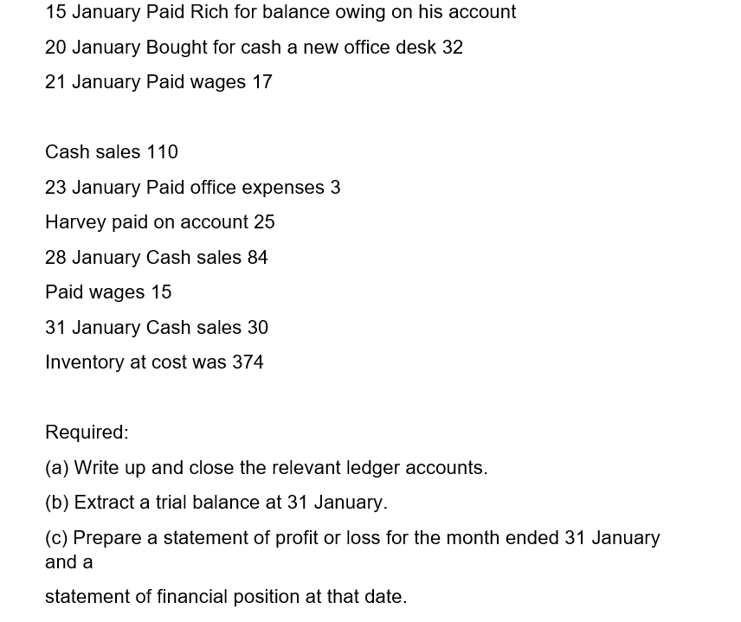

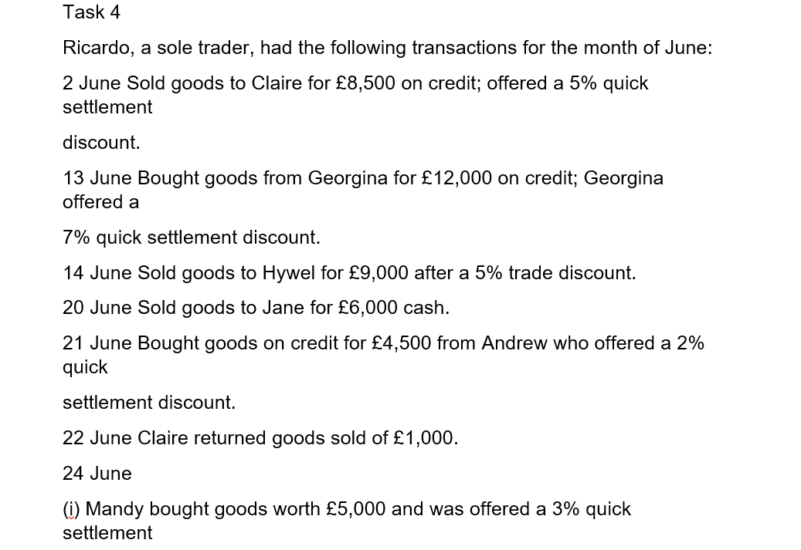

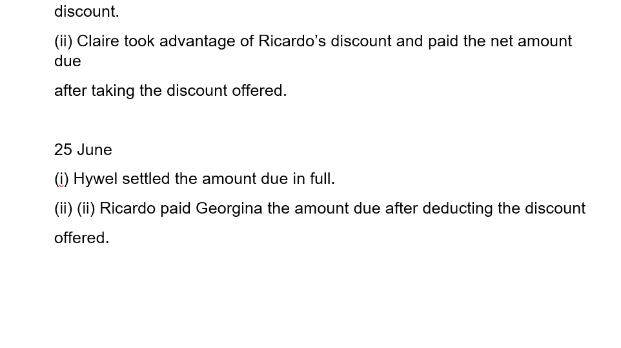
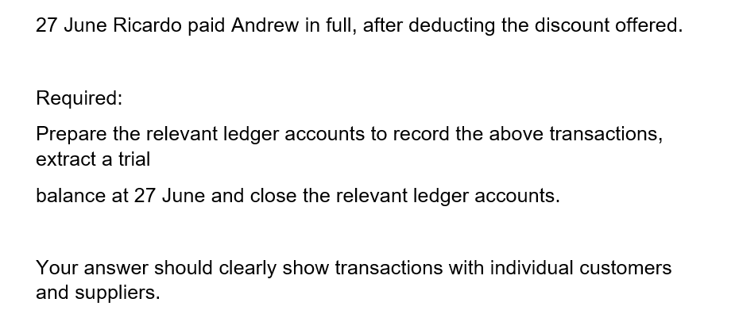

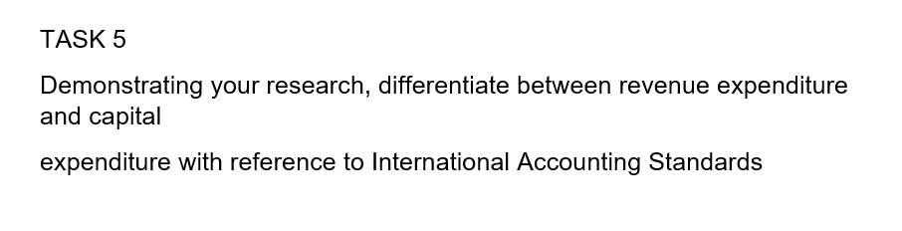

Revenue Expenditure is the cost, which will be an expense in the accounting period until the expenditure takes place. The revenue expenditures are known as a fixed assets. They start to be used behind a fixed asset is put in service and just keep the assets in operation order. Amount that is spent to purchase a fixed asset is proposed as a capital expenditure. The rate of the capital expenditure is going to be written down as an asset. After that is going to be changed to the income statement like amortization expense during the years of the assets useful life.
Example of Revenue Expenditure:
If we assume, that a company have made a capital expenditure of £ 600 000 to install a high productive machine. The new machine needs repairing of £ 3000 every month. This £ 3000 is a Revenue Expenditure, since it will be reported on the monthly statement. Like this is being matched with the month’s revenues. Usual maintenance of the machine are also revenue expenditures, since the expenditure doesn’t make the machine more than it was and it doesn’t extend the machine’s useful life. In a result, the normal maintenance is going to be reported on the income statement as well, like an expenditure in the accounting period when the report is made.
The Capital Expenditures present important investments of fund, that a company makes to support or to enlarge its business and produce further profits. Capital expenditures are for the procurement of longtime assets, like facilities and producing installation. Assets like this supply income generating value for organization for period of years. The organizations are not allowed to reduce the full cost of the asset in the year the expenses are entered. They have to bring back the cost through year-by-year depreciation over the good life of asset. Companies very often apply debt financing or enquiry financing to overlay material costs involved in acquiring important assets for enlarging their business. (Maverick, 2019)
Examples of Capital Expenditures
Involve the amounts spent to better assets like land, buildings, equipment, furnishing, fixtures, vehicles. The whole amount spent on Capital Expenduring an bookkeeping year is read under investment activities on the statement of cash flows.
Capital Expenditures are for fixed assets, that are expected to be productive assets for a long period of time. Revenue Expenditures are for costs, that are related to specific revenue transactions, like the cost of goods sold or maintenance expense. The differences between these kinds of expenditures are:
- Timing – Capital expenditures are rated to expense little by little via depreciation. Revenue expenditures are rated to expense in the current period.
- Consumption – capital expenditure is assumed to be consumed over the useful life of the related fixed asset. Revenue expenditure is assumed to be consumed in a very short period of time.
- Size – Capital expenditure involve large financial amounts than revenue expenditure.
References:
www.accountingcoach.com
www.accountingtools.com
www.investopedia.com

