

Programme: Master of Business Administration
Module: International Marketing: Principles and Practices
Student Name : Gungun Gehija
Module code: LCMB7026
Chosen Company: BMW
Country A: UK
Country B: India
Supervisor Name: Muhammad Tariq

Table of contents

1. Introduction 3
2. Brand overview 3
3. Comparison of the Socio-cultural Context of the UK and India 5
4. Comparison of Brand’s STP strategies in the UK and India 9
5. Comparison of Marketing Mix Strategies in the UK and India 15
6. Evaluation of the Performance of Marketing Strategies 18
7. Evaluation of Marketing Ethics Practice 20
8. Recommendation & Conclusion 23
References 26

1. Introduction
This report is a critical analysis of the international marketing contexts in BMW in the UK and India, two different markets that have a different socio-cultural, economic and regulatory environment. It focuses on how BMW can change its brand positioning, segmentation strategies and 7Ps marketing mix to suit the macroenvironment in any country. The strategies are also measured by the effectiveness based on market performance measures (sales growth, brand presence and customer engagement). The ethical considerations that exist in the marketing practice of BMW are evaluated with the aim of determining what could be wrong. Lastly, the recommendations are suggested based on evidence and can be implemented to improve the future BMW international marketing strategy in both markets.

2. Brand overview
The BMW Group is one of the premium cars automobile manufacturers in the world that competes in passenger cars, motorcycles and mobility services; it has BMW, MINI and Rolls-Royce brands as well as financial services and aftersales. As of 31 December 2023, the Group has an international workforce of approximately 154,950 employees, and in 2023 revenues of €155.5 billion and a profit before tax of 17.1 billion demonstrate the presence of large-scale operations on a global scale (Statista, 2024). BMW produced about 2.2 million vehicles globally in 2024 and it is speeding up its electrification campaign - BEV sales were over c.426,600 vehicles (yoy growth at +13.5%).
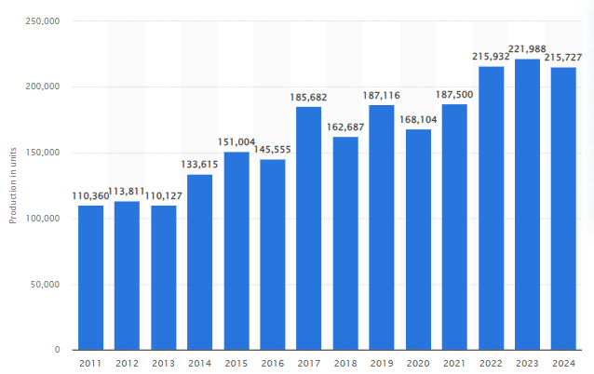
Figure 1: BMW Group’s Global Production
(Source: Statista, 2024)
BMW has a strategic presence in the UK, some of which include manufacturing, research and brand representation: the UK itself is one of the few examples where BMW,MINI and Rolls-Royce have operations in, and the Group itself has approximately 8,000 employees there with a 147-strong network of retailers underlining the operational significance and local value-chain relevance of the market (BMW Group, 2024). There is also a high level of uptake of the electric BMW models in the UK market in the high end segment.
In India, BMW Group has continued to grow since it began its local operations, with the latest annual car deliveries of 15,721 cars (BMW and MINI) representing an 11 percent growth, as of 2024, and driven by the desire to more cars in premium and long-wheelbase models and the continued rise in the adoption of EVs (‌BMW Group Press Club, 2024). BMW India has a dealer and service network in the major metropolitan centres and uses local initiatives such as training centres, parts logistics to scale distribution and aftersales. The performance in the region in India has contributed to the double-digit growth in the recent past and is a major growth market in India of the Group.
All in all, BMW takes a strong position through its global size, strong profit base, large employee base, and explicit EV development opportunities, whereas its operational presence in the UK and India is differentiated in the areas of manufacturing and retail penetration in the UK and sales growth and network development in India, respectively.

3. Comparison of the Socio-cultural Context of the UK and India
The respective socio-cultural environment in the United Kingdom and India is incredibly different and has provided the varying consumer expectation, brand meaning and marketing practice of premium automakers like BMW. The six dimensions used by Hofstede indicate differences in orientations at the national culture level. The UK has a high score of Individualism and Indulgence and a low score of Power Distance and Uncertainty Avoidance, indicating that the culture is highly autonomous and immediate and tolerant of ambiguity; India, on the other hand, has high Power Distance and Long-Term Orientation but is characterized by a more collectivist, hierarchical culture (Geert Hofstede, 2025). The implication of these differences is that British consumers would intercept BMW communication in terms of personal accomplishment and lifestyle, whilst Indian consumers tend to interpret premium purchases in terms of status, family pressures and pro-social signalling, which is the consideration in positioning, promotional appeals and dealership relationships. The patterns of cultural scores hence suggest that varying communication approaches be adopted in aspirational, lifestyle-based campaigns in the UK and status-and-heritage stories, in conjunction with relationship management and trust cues in India.
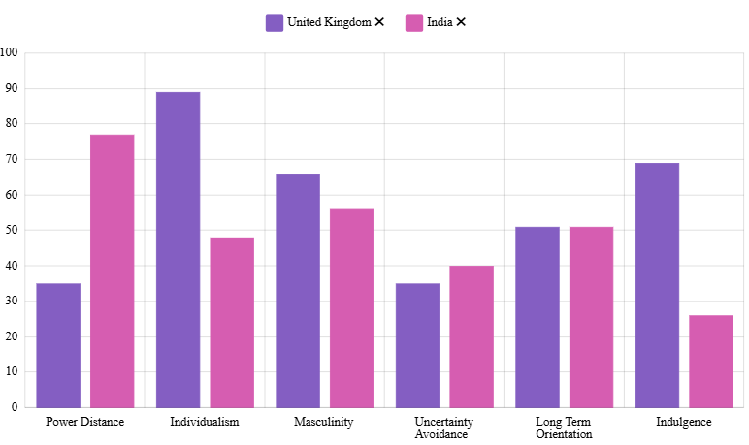
Figure 2: Comparison between the UK and India
(Source: Geert Hofstede, 2025)
The UK is a mature, stable economy with well-established regulatory bodies, politically, with policy changes and variations in taxation or EV incentives, which influence the dynamics of the automotive market and investment planning on a regular basis. The political environment in India can be described as featuring an active industrial policy such as Make in India and incentive towards local manufacturing, a complex system of federal regulation and a governance framework that can serve to protect local industry but open market access to well-balanced foreign OEMs (Geert Hofstede, 2025). In the case of an international company such as BMW it would imply that the UK will provide regulatory predictability, but at the expense of increased compliance and labour expenses, whilst India will provide growth incentives, but necessitate management to tread a fine line and follow state-driven rules and localisation requirements.
The UK is a high income market with a relatively mature demand and high purchasing power per-capita; it has a relatively low growth, and the focus is on share retention, premium market and services (finance, subscriptions). India is a market with high growth rates and pockets of growth in the two digits and a huge and young population; the GDP growth and the increasing disposable incomes in cities are creating demand for aspirational premium products. Product strategy of BMW should hence focus on high margin models, Mobility services and UK retention offers whereas in India it should focus on affordable premium derivatives, long wheelbase/india specific versions and scalable after sales to tap into the emerging upper-income brackets (‌BMW Group Press Club, 2024). The GDP and the macro growth differentials highlight the fact that the UK has a stable but low growth rate and India has a higher growth rate with the implication being that investment should be prioritised.
Demographics and urbanisation influence the potential of the market and consumer behaviour socially. The elderly demographic and high urbanisation of the UK population, as well as the developed luxury consumption behaviour, prefers smaller model SUVs, electrified models and experience-based ownership (service bundles, subscriptions) models (BMW UK, 2025). The demographic dividend of India, the increasing urban middle and upper classes and the high power of family in purchase decision making have provided consumers with aspiration cars whose characteristics to be both status, space and value; premium EVs are taking root among the early adopters in the big cities. India is experiencing an increase in its number of cars at a slower pace but a faster pace which means that the luxury ladder is shifting and that BMW can use this as an opportunity to run specific financing and demonstrator experiences in Tier-1 and Tier-2 cities (RushLane, 2025). Patterns of EV adoption exemplify this difference: battery electric vehicle registration and market infrastructure are growing fast both in the UK, and the market share of BEVs is rapidly increasing year on year; the EV market in India is also growing fast, particularly in two-wheelers and a nascent premium passenger EV market, although the quantity and density of infrastructure vary between the two nations. Such trends impact on product mix choices (EV models, charging solutions, PHEV/BEV mixes), as well as aftersales investments.
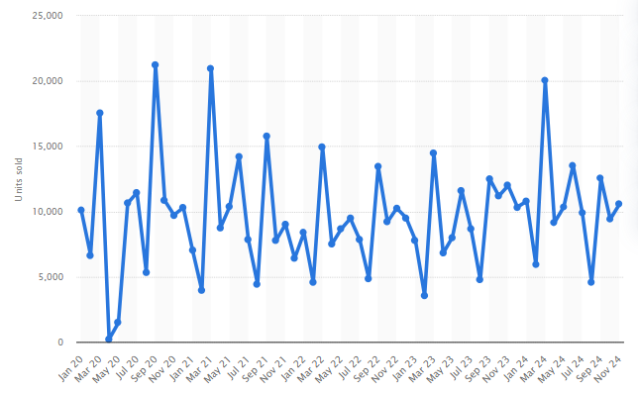
Figure 3: BMW’s Monthly Sales in the UK
(Source: Statista, 2024)
While they’re digitally connected, the level of consumer digital maturity and service expectations differs. People in the UK want online experiences to be simple, easy and quick to use right here right now. Consumers in India are moving quickly to use digital channels for search and purchase in a leapfrog manner; however, there is a heavy reliance on dealerships for high-value purchases. Hence localized digital finance and mobile-first vernacular content are critical. UK's stringent consumer protection, emissions and safety regulations mandate complete compliance and limit quick product variation. In contrast, India’s evolving standards and incentives open up opportunities for differentiated launches backed by local homologation strategy.
The UK strategy towards zero net and policy measures such as incentives, potential changes in road-use tax and seeding in charging infrastructure is still very pro-electrification. In India, the balance between pollution control and continuous industrial growth is carefully calibrated. Recent policy and subsidy measures have accelerated EV uptake in the country. However, challenges remain in electric vehicle manufacturing infrastructure and grid usage. For BMW, this entails, in the UK, investing in charging partnerships and lifecycle communications, and in India designing integrated value propositions that link electrified products with financing, localized service and education to overcome infrastructure constraints.
In summary, the socio-cultures and macroenvironments impacting the UK and India are vastly different. As a result, BMW would have to implement differentiated market strategies: in the UK focus on individuality, digital ease and full electrification; and in India on status, VFM variants, relationship-oriented channels and phased electrification strategies. Making these changes will help the other company to connect with the culture and the Working conditions laws in place.

4. Comparison of Brand’s STP strategies in the UK and India
BMW has a diversified portfolio in the UK, starting with entry-level hatchbacks and small SUVs, and going to premium electric-powered models and luxury sedans, serving a wide range of clients, starting with young professionals and ending with well-to-do families. On its online configurator, it lists 1-Series and X1 (compact) models all the way up to EVs and luxury SUVs - with petrol, diesel, hybrid, plug-in, and fully electric power options.
In India, meanwhile, the segmentation and targeting of the brand is more skewed towards premium and aspirational consumers with affluent professionals, entrepreneurs, well-established families and status-sensitive buyers. This is seen in the number of models sold that have been based on high-end sedans, SUVs, long-wheelbase models and a rapidly developing EV line-up. BMW India recorded the highest annual sales in its history of 15,721 cars (BMW + MINI) in 2024, indicating a vigorous penetration into the rising luxury market of the Indians, who constitute the high mobility category (ONS, 2021).
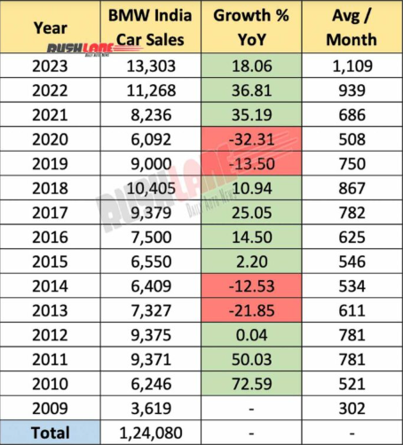
Figure 4: BMW’s Sales in India
(Source: RushLane, 2025)
In India, BMW seems to appeal to other sub-segments as well: compact premium against younger demographics such as SAV/compact SUVs), long-wheelbase sedans or flagship SUVs against older luxury segments and EV adopters against status-conscious consumers of the future. This strategy of segmentation is reinforced by the fact that the Luxury Class such as flagship sedans/SUVs and SUV segments have grown.
Therefore, in the UK BMW adopts a mass-premium approach that includes numerous segments of the customers, in India, the company focuses on fewer segments, namely, the premium, aspirational, and status-based ones.
Product Strategy and Positioning: Adapting to the Market Requirement: BMW has a very comprehensive offering in the UK: all the active models in the UK include internal combustion engines, hybrid, plug-in hybrid and fully electric. As an example, the UK iteration of the BMW iX has up to 426 miles of range, and it is packaged distinctly, as a luxury-electric SUV aimed at the high-end, but green customer segment (IMF, 2025). It focuses on flexibility, decision-making, and contemporary mobility - taking up cutting-edge technology, convenience like home charging, online configurators and a large assortment.
BMW has a local product strategy in India, adapted to the local circumstances, tastes, and legal restrictions. As an example, there are models that are being sold such as long-wheelbase sedans and SUVs - indicating a desire to have space, comfort (particularly to be chauffeured around), and status among high-end Indian consumers (‌SMMT, 2025). When entering India, as mentioned in larger research, companies such as BMW tend to fine-tune their models on the global plans: at times by raising ground clearance, by tuning the suspension to handle bumpy roads, by installing filters in the cabin protecting the cabin against dust, and other Indian-driving-related functions.
India has a stronger shift in the product mix, with more of their vehicles based on SUVs, SAVs (Sports Activity Vehicles) and long-wheelbase body styles, indicating that BMW focuses on those features more associated with the perceived value of luxury in India: roominess, comfort, presence and status. It is true that the Luxury Class product and SUV-SAV category of BMW India registered high volumes in 2024.
In this way, the product positioning of BMW in the UK is closer to the versatility, technology, sustainability and mobility choice, whereas in India, it is closer to the status, comfort, exclusivity and aspirational value.
Pricing Strategy Market Conditions and Regulatory Impact: BMW pricing in UK is based on a developed market with VAT, being lower than the market could be with the very high luxury importation taxes found in most emerging economies; as a result, the pricing of the BMW is more competitive in relation to income levels and the market structure. The UK configurator displays the base model price of a large variety of vehicles, including smaller SUVs, luxury and electric cars.
Duties on imports, taxes and domestic regulation play a major role in determining the prices in India. Historically several of the high-end cars (particularly imported ones) were subject to high taxes. As an illustration, automobiles imported in the form of completely built-up (CBU) attracted enormous custom penalties. This added a significant amount of final prices over the original factory price which affected the affordability and influenced the targeting strategy of BMW (NITI AAYOG‌, 2025). As a reaction, BMW India has focused on locally assembling / CKD / SKD where feasible to balance the prices, yet most of the high-end models are still imports.
Understanding this, BMW India has recently adopted a price-protection policy of a fully imported model (MINI Cooper S) bought before the projected tariff reductions in the new trade agreement with the UK - an indicator of their receptiveness to regulatory changes and price awareness in the minds of the Indian buyers.
This distinction highlights the fact that, whereas the UK consumers can enjoy the global competitive prices, the Indian consumers have an increased cost barrier, and this is addressed by BMW through selective localization, local demand-oriented variants and price/promotion strategies.
Communications, Branding and Image: Advertising and Market Positioning: The brand communication used by BMW in the UK builds on the association of the brand with luxury-performance-innovation and fosters sustainability and the future movement using its electric and hybrid models. The digital visibility (configurator, digital showroom, EV options) indicates that the emphasis is put on the digital, convenience-driven, customer-centric experience conforming to the expectations of European consumers (BMW UK, 2025a).
In India, on the contrary, the communications BMW uses, including press releases, dealer campaigns, and market launches, focus on prestige, luxury, status and exclusivity. To illustrate, after reaching record sales in the year 2024, BMW India emphasized its greatest product assault in the luxury vehicle section, customized client involvement, and development of services and supremacy in SUV, Luxury Class, and EV segments (India Today, 2025). This implies that the brand image relayed in India is more aspirational, status quo, exclusive and long term value oriented than merely performance and technological contemporary. This positioning is supported by the focus on the long-wheelbase models, SUVs, and high-end versions.
Furthermore, the marketing mix of BMW in India must also have more dealer networks, customer experience, relationship selling as it is based on the social and cultural norms concerning luxury purchases in India, such as status and trust. This is in line with existing relationship marketing tactics in the luxury car industry.
Applicability of Global vs Local Strategy: Strategic Implications: The dissimilar STP strategies of BMW in the UK and India can be explained by the conscious glocalization strategy: retaining its global brand image and adjusting to the local socio-economic, regulatory and cultural conditions.
In the UK, BMW is enjoying a market where demand is mature, infrastructure is established, regulations are well-articulated, and digital penetration is high which allows them to provide a wide variety of flexible product mixes, such as EVs, hybrids, SUVs, sedans and even compact urban vehicles (BMW UK, 2025b). Its segmentation is broad, covering both urbanists and families to environment-friendly consumers - covering as much of the market as possible.
High import taxes, immature, but rising luxury demand, diversified consumer expectations, and infrastructural issues (to charge EVs, road conditions, services etc.) in India require a more focused, high-end, aspirational segmented strategy. BMW emphasis on long-wheelbase vehicles, SUVs, selective EVs, selective localization or pricing, and premium positioning is indicative of a precise strategy to get all possible returns on investment, control expenses, and develop brand cachet among high-income consumers.
The implementation of price-protection of the import-duty modifications (of MINI), and selective product localization/adaptation to the conditions of the Indian market, proves that BMW is sensitive to changing macro environment and regulatory conditions in India.
Key Similarities and Strategic Consistencies
Irrespective of the differences, BMW has similarities in both markets:
- Same brand: identity performance, luxury, quality, and technological sophistication is still preserved. In the UK or in India, BMW is a luxury, aspirational brand based on providing luxury, performance, and brand status.
- Innovation and product diversification: in both markets BMW sells electric, hybrid, and conventional engines; the EV-charge is obvious worldwide. To illustrate an example, the BMW iX and other electric vehicle models are included in the line-up in the UK, and in India, BMW is also advertising electric vehicles and registering an increasing sales in that sector (Business Standard ‌India, 2025).
- The dealer networks, financing service and after sales services, which are necessary in both cases, but more vital in India to establish trust and offer after sales services. Research papers on BMW global marketing strategy emphasize relationship-based marketing and integrated communications as the norms of its marketing strategy (Moneycontrol, 2024).
Strategic Issues and Adaptation: Why STP is Differing across Countries
The step deviation in STP is largely caused by the market form, regulation cost, customer economy, and culture. High importation duty and taxes in India increase the retail price and make it unaffordable to many potential customers, therefore forcing BMW to target segments with great amounts of money. The complicated regulatory and taxation will also imply that product mix and prices have to be well taken care of.
The luxury car buyers in India tend to cherish status, social signaling, space (family car or chauffeur), and long-term value more than fuel efficiency or performance, so BMW had to focus on SUVs, long-wheelbase sedans, and luxury SUVs. In the meantime, in the UK, the dynamics of the mature market, the environmental legislation, and the evolving customer values like EVs, to sustainability enable BMW to focus on technology, EV-readiness, flexibility and mobility as the elements of everyday luxury ownership.
Besides, one global model may be more feasible or applicable in one of the markets than the other due to the differences in infrastructure (charging network, road conditions, service coverage) and this is being adjusted by BMW. According to the scholarly debate, automobile manufacturers worldwide tend to alter the product characteristics, such as the use of suspension, robustness, ground clearance, etc., to accommodate the application in India.
Therefore, the STP strategies implemented by BMW represent a sensible compromise between international brand equity and local adaptability - to make sure that it is relevant, profitable, and powerful in the UK and India.

5. Comparison of Marketing Mix Strategies in the UK and India
Product: In the UK BMW offers a wide, choice-based product portfolio comprising compact models, performance sedans, premium SUVs, plug-in hybrids and a rapidly expanding range of BEVs such as iX, i4. Product design focuses on technological attributes like connected services, advanced driver assistance, high-end finish, and options that would please the personal preferences such as sizes, engines, trim and personalization options. The UK product is based on a saturated, high-demand market where electrification and emissions regulation are major-buying motivations (‌Mint, 2025). BMW product mix in India is intentionally directed towards the larger SUVs, Luxury Class sedans (including long-wheelbase models) and carefully selective BEVs. Indian products are localized to local tastes (focus on space, presence, comfort in which chauffeurs can be used) and regulatory/tax realities; BMW also localizes where economical (CKD/assembly) to control prices. In India the focus on the product is thus aspiration models that express status whereas in the UK it balances sustainability, technology and lifestyle (‌The Financial Express, 2025).
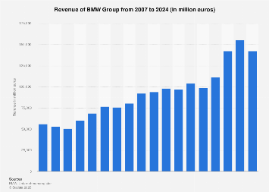
Figure 5: BMW Group Sales
(Source: ‌Statista, 2025)
Price: UK pricing represents a civilized market with both VAT and established competition but less penal import tariffs, meaning that BMW is able to place models in a wider price range (entry-premium to ultra-luxury) as well as to employ pricing plus service packages and subscription arrangements (‌Nikbin et al. 2022). In India, greater import duty, taxation and logistics expenses substantially raise retail prices on fully imported models; BMW counters this by local assembly selectively, more focus on financing/lease facilities and specific promotions (e.g. price-protection policies on particular imports) to save demand (BMW GROUP, 2023). Those structural variations imply that BMW can potentially embark on a process of pursuing a margin-diverse approach in the UK but should focus on high-margin, high-status models and pricing strategies in India, to continue being profitable and deal with the issue of affordability.
Place (Distribution): The UK has a dense distribution network that is digitally seamless: there is an established system of retailers, well-developed services/aftercare network, and an expanding omnichannel sales experience (online configurators, click-to-collect, home delivery and charger deals) (The Economic Times, 2025). BMW has a number of thousand employees in the UK directly and has a network of 130147 retailers across the country, assisting the urban and regional markets. In India BMW distribution focuses on Tier-1 and Tier-2 city premium that has flagship showrooms, experience centres and dealer-led high touch sales. Trust building in India is more about dealer relationship and brand experience; aftersale growth (service centres, parts logistics) is of priority to maintain the ownership and resale value. In India, spatial emphasis is more discriminative and clustered-luxury based than in the expansive UK.
Promotion: The UK is focused on innovation, sustainability and driving performance with promotional strategies which include digital campaigns, experiential EV show, and integrated content marketing in accordance with the environmental policy and consumer preference towards digital convenience. Influencer partnerships, social media, and configurators are extremely popular. Promotion in India is more status and relationship-based; product launches, lavish experiences in the dealership, celebrity endorsements, and custom ownership programmes which are indicators of exclusivity (Hailu, Workneh and Kahissay, 2021). Digital marketing also matters in India, but it is accompanied by high-contact seller communications and dealership events to transform aspirational buyers. This can be reflected in the social metrics: the official channels of BMW UK have a high level of national interaction (e.g., c.378k followers on Instagram), and those of BMW India demonstrate very significant local activity (c.2.0M Instagram followers), which means that there is a high level of brand resonance and digital interaction in the aspirational segments of India.
Evaluation of Marketing Success: Evidence and Outcomes:
The market-specific 4Ps of BMW are working in both markets though the concept of “success” varies. In the UK, BMW Group exceeded 2024 expectations Premium category leader 125,265 registrations (BMW alone) – but with overall premium segment leadership 172,240 registrations, premium entry vehicles made a limited contribution; EVs and luxury class were primary drivers, indicating effectiveness of promotional positioning with broad distribution reach. The UK success demonstrates the ability to hold and expand market share in a mature premium category, and to convert its EV and digital strategies into tangible registrations (Syarifuddin et al. 2021).
In 2014, BMW Group India sold a record 15721 cars, which is an increase of 11 % (YoY). The Germans have reported especially great success in the SUV segment. According to the data, BMW’s selling and distribution strategy is doing a great job in luring more customers and converting aspirers into buyers. BMW India’s growth in the SUV and luxury segments coupled with rising EV activity suggests high strategic relevance and market traction.
Other performance indicators support these conclusions. BMW, operating as a brand within the BMW Group, reported revenues of affected two brands. Globally, the BMW Group reported large revenues and scale (Group revenues €155.5bn, workforce ~154,950 as of 2023) and large vehicle volumes (over 2.45 million vehicles in 2024) (Moneycontrol, 2024). As a result, the BMW Group possesses robust capabilities in the global marketplace, which can be very handy for local BMW strategies. With global 43M followers on Instagram and large local followings, strong brand awareness and social media stature aid distribution and promotion, although local engagement patterns vary.
Limitations and challenges: The UK is facing challenges such as increasingly strong rivals in the EV sector, stricter emissions legislation, and limited overall market growth, which will require the development of innovative products and services. Charging infrastructure for BEVs is uneven, as are deficiencies; dealer network scalability; import duties; and high price sensitivity outside the affluent cohort. BMW minimizes their impact through local assembly, targeted financing and selective dealer expansion but suffers from infrastructure and policy changes.
The UK version of BMW’s 4Ps is focused on breadth, technology and sustainability that has led to leadership in the premium segment and adoption metrics of EVs. The 4Ps in India emphasize desirable product lines, premium pricing and high touch distribution which has driven record sales and growth in luxury segments. Each of these strategies is successful through the logic of local market factors: the UK strategy secures market leadership and EV momentum, while the India strategy builds brand cachet and profitable growth with an expanding base of luxury consumers. To remain successful, India must continue to refine EV infrastructure partnerships and calibrate localisation in both areas.

6. Evaluation of the Performance of Marketing Strategies
BMW in the UK:
BMW has shown significant market success in the UK market, especially in the high-end section. This year the company registered 125,265 cars of the BMW brand alone, and the total premium market consisted of 172,240 cars. The main motivation behind it is a high focus on luxury electric vehicles (EVs) and a rise in popularity of the high-end models such as the BMW iX and i4 (Al Thaqafi, 2023).. The range, sustainability capability and innovative technology make these vehicles more desirable as they match the growing demand of electrified and environment-friendly cars in the UK.
Annual Sales and Market Share:
The general performance of BMW in the UK has been good as it has kept leading in the premium vehicle market segment. The market share of the company in the premium sector in the UK shows that the company has a good brand presence in the market. Nevertheless, the presence of competitors such as Tesla remains a threat to the competitive position of the company due to its growing popularity in the market. The success of EVs in the market in 2024 can be seen as a sign of BMW being able to take advantage of the increasing popularity of green mobility and still remain one of the leaders in luxury cars. It has enjoyed a consistent presence in the UK market( Statista, 2025).
Social media and brand awareness:
BMW UK is highly engaged with its target audience as it has 378,000 followers on Instagram. The emphasis on online marketing, EV events, and collaboration with influencers has been well-received by the tech-savvy audience, especially the ones that value sustainability. This has increased awareness of the brand and created a solid online presence, which is essential in an ever more digital market.
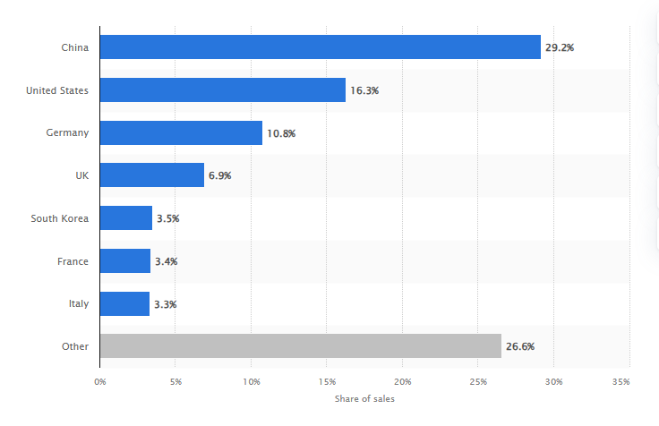
Figure 6: BMW Group's key automobile markets 2024
(Source: Statista, 2025)
BMW in India:
In India, BMW has recorded the highest sales of 15,721 cars in 2024, which is an 11% growth over a year. This growth has been fuelled by the concentrate on SUVs, luxury sedans, including long-wheelbase models, where they fit the desires of consumers in status, comfort and space. The rising need and demand of expensive cars coupled with the fast-growing upper-middle-income group in India have also made BMW successful in this region (Li, 2025).
Sales and Market Share:
The sales performance of BMW India, especially in the luxury market and the SUV market is an indication of the success of its marketing strategy. As the affluence and aspirations of Indian consumers have been on the upswing, it has been able to tap into these sentiments to position itself as a source of exclusivity and prestige (Press.bmwgroup, 2025). Nonetheless, issues like the expensive importation tariffs and immature EV network still affect the pricing and distribution policies.
Social Media and Brand Awareness:
BMW India has significantly more subscribers on social media, as it has approximately 2 million subscribers at Instagram (Ackodrive, 2025). The local presence of the brand is excellent and it connects with aspirational consumers through digital marketing, with celebrities and unique dealership experiences. Such a high degree of social media activity is useful in positioning BMW as a luxury brand as well as helps to generate awareness and consumer interest.
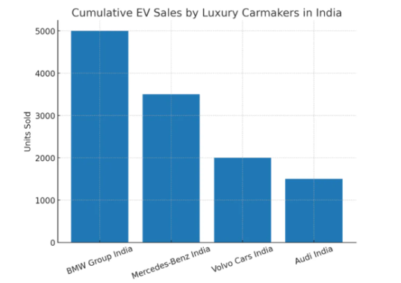

Figure 7: Leading position of BMW
(Source: Ackodrive, 2025)

7. Evaluation of Marketing Ethics Practice
Ethical Issues in the UK:
Sustainability and Greenwashing: In its marketing mix of electric vehicles (EV) in the UK, BMW focuses on the theme of sustainability, as it is considered a pioneer in ensuring the shift towards more eco-friendly transportation. Nevertheless, issues concerning the greenwashing have been raised, especially as the energy use and emission of carbon in the production of EVs are high, especially where the electricity is not fully renewable. Although the idea to electrify BMW is praiseworthy, the marketing might be criticized as the brand is being promoted as more environmentally friendly than it might be, which may lead to confusion of the consumers who care about the environment about the overall environmental effects of its vehicles (Rausch-Phan, and Siegfried, 2022)..
Pricing and Accessibility: BMW uses a premium pricing approach in the UK which is consistent with its luxury positioning, but may be considered to be exclusionary. BMW is relatively expensive, and this might exclude many consumers, which implies a moral issue concerning the availability of the vehicles to a multicultural society. Although the brand provides financing opportunities, the high cost of the product is still a major concern still, which may lead to inequality in the acquisition of luxury products (Ghadge et al., 2022).
Digital Marketing and Data privacy: BMW UK uses digital marketing and personalized experiences along with high levels of social media interactions, and these approaches cast ethical doubts on the issue of privacy of information. Consumer data use in targeted advertising is controversial, though it is legal, unless it is very transparent. The collection, storage, and utilization of the consumer data by the company raise certain ethical issues, particularly because it is not effectively communicated to the consumers how their data are collected, stored, and utilized.
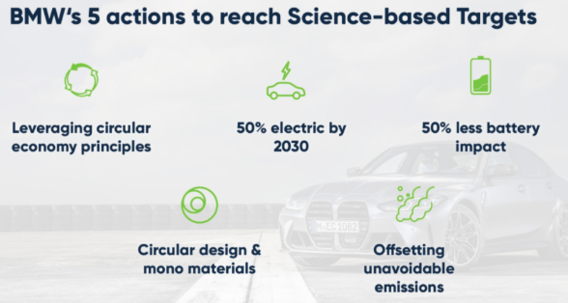

Figure 8: Sustainability targets of BMW
(Source: Ecochain, 2025)
Ethical Concerns in India:
Cultural Sensitivity and Aspirational Messaging: In India, BMW marketing strategy places a lot of focus on aspirational marketing in which the same way that one owns a BMW means that he or she is a social status. Although this will ensure that the Indian market wants to associate with a prestigious image, the ethical consequences of consumerism and cultivating materialistic principles, in particular among younger generations, will arise. The belief that a BMW car is a symbol of success might unintentionally increase social injustice as it encourages people to think that the only way to be a successful person is by owning a material product, other than personal or social accomplishments (Ecochain, 2025)
Exclusivity and Availability: In India, the pricing approach of BMW is dictated by the high importation taxes and local production to make the vehicles more affordable to the wealthy population. Nevertheless, even after the attempts of localization of part of production, most of the premium models are still costly and luxurious which arguably may contribute to increasing economic inequality ((Mahiban and Emimal, 2023). The fact that the brand targets cars of high status, e.g., SUVs and long-wheelbase models, and the aspirational market, makes it questionable whether it ought to be ethically responsible towards marketing more inclusive and socially responsible luxury products.
Environmental Impact and EV Adoption: The penetration of the electric vehicles of BMW in India is good news, but the EV infrastructure in India is still in its infancy, and the environmental advantages of EVs in India are dubious because of the fact that the country uses coal as its electrifying material (Rozenšteina and Bormane, 2024). The marketing of EVs by BMW, in the market where the infrastructure is underdeveloped, can also be regarded as ethically dubious, as it can generate false hopes of the consumers about the environmental advantages of having an EV, as there are local issues with the infrastructure of charging and renewable energy.
Dealer Network and Ethical Sales Practices: BMW in India depends largely on its dealer network to make sales and the high-touch sales model is based on the principle of establishing close personal relations with the customers. Although this relationship-based selling model is typical in the luxury sector, it might be considered manipulative when the salespeople force the consumers into buying that which they might not afford or need. There are also ethical issues related to the fact that there is a chance of taking advantage of consumer aspirations and impacting their buying behaviors by using emotive appeals and status marketing.
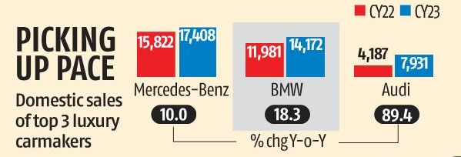
Figure 9: Sale of BMW in India
(Source: Business-standard, 2025)

8. Recommendation & Conclusion
Conclusion
All in all, BMW has achieved strong international marketing performance in the UK and India that shows a balance of global brand. BMW's wide product mix that includes Electric Vehicles and extensive digital engagement has helped it to maintain its leadership in an already developed premium market in the UK. In comparison, India’s premium positioning strategy, end focus on SUVs and long-wheelbase models, distribution through significant dealers has resulted in record sales and increasing brand aspiration. Evidence indicates that BMW's differentiated strategies are effectively aligned with each country's socio-cultural and macroenvironmental conditions while ethical considerations, pricing barriers and EV infrastructure challenges remain.
Recommendations
Marketing to Sustainability in the UK:
BMW should increase its efforts on sustainability through the improvement of the visibility of environmental impact. Although the company has made big milestones in the electric vehicle (EV) sector, its sustainability story can be further enhanced by expressing the overall life cycle effects of its products, which also include how the materials are sourced, manufacturing processes, and recycling of the products at the end of their lifecycle (Rozenšteina and Bormane, 2024). BMW may collaborate with third parties who may independently engage in life-cycle assessment and also publicly report the findings, as this will indicate to the society that BMW is indeed determined to minimize its carbon footprint.
Grow EV Partnership Infrastructure in the UK:
With the UK market moving towards EVs, BMW ought to cooperate with other providers of charging infrastructure to increase the number of fast-charging stations. This would help solve one of the biggest consumer-related issues surrounding EV implementation range anxiety and contribute to the increased sales of BMW electric vehicles. Also, BMW may want to consider some new services, including charging homes or becoming a member of charging stations to serve as an added incentive to consumers to switch to the electric cars (Mahiban and Emimal, 2023). This would make BMW a holistic solution provider of sustainable mobility, and not an EV manufacturer.
Localization of Marketing Content in India:
BMW should go on adjusting its marketing messages to suit the local cultures and desires in India. The fact that the brand targets status is right but it must also consider more socially conscious messages, including family mobility and safety as well (Gode et al., 2021). As they focus on such attributes as long-wheelbase models that suit family comfort or cutting-edge safety features, BMW can meet the cultural expectations of Indian families and provide comfort and safety, and at the same time remain highly aspirational. This would be more in line with the aspirational but pragmatic thinking of Indian consumers where luxury and functionality are in balance.
Enhance EV Strategy in India:
BMW needs to invest in the development of EV infrastructure in India to facilitate the increased demand of electric cars. The company would collaborate with local governments, charging providers and real estate developers to assist in increasing the deployment of EV charging stations.. Moreover, BMW will have an opportunity to enlighten the Indian consumers on the eco- and cost-related advantages of EVs, which would help overcome the obstacles of low awareness and infrastructure. These barriers may be overcome by providing incentives like subsidized home charging units, or long-term service packages.
Affordability through Product Diversification in India:
Even though BMW has the luxury positioning in India as its strong point, still it can be good to introduce more cheaper premium variants that can attract the new rich. The company can go for the compact premium models or hybrids with the lesser price helping them to reach a larger market consisting of the middle-class people. Besides that, BMW can offer financial schemes targeting young, aspirational customers with the provision of more affordable installments and lease plans. This way, the company will be able to reach out to a bigger audience without compromising the image of the luxurious brand.
Strengthening Relationship Marketing in India:
Customer relationships are to be strengthened more in the Indian market and it is a very important thing to do. BMW is to be a dealer-driven brand and differentiate its selling by close-by and high-quality service. Apart from that, the company can award certain privileges to its customers through exclusive loyalty programs and organizing special events like testing of cars, golf tournaments, or networking with celebrities, which would strengthen.

References
Ackodrive, (2025). BMW Group India Crosses 5,000 EV Deliveries, Widens Lead Over Rivals. Available at: https://ackodrive.com/news/bmw-group-india-crosses-5-000-ev-deliveries-widens-lead-over-rivals/ [Accessed on 5.12.25]
Al Thaqafi, T., (2023). Cultivating sustainable supply chain Practises in electric vehicle manufacturing: a MCDM approach to assessing GSCM performance. World Electric Vehicle Journal, 14(10), p.290.https://www.mdpi.com/2032-6653/14/10/290
‌BMW Group Press Club, (2024). BMW Group UK Leads the Premium Segment in 2024 with Strong Electric Growth. Available at: https://www.press.bmwgroup.com/united-kingdom/article/detail/T0447261EN_GB/bmw-group-uk-leads-the-premium-segment-in-2024-with-strong-electric-growth [Accessed on 05.12.2025].
BMW GROUP, (2023). DRIVING THE NEXT ERA‌ - BMW GROUP REPORT 2023. Available at: ttps://www.bmwgroup.com/en/report/2023/downloads/BMW-Group-Report-2023-en.pdf [Accessed on 05.12.2025].
BMW Group, (2024). Home - BMW Group Report 2024. Available at: https://www.bmwgroup.com/en/report/2024/index.html [Accessed on 05.12.2025].
BMW UK, (2025). About us - Experience BMW. Available at: https://www.bmw.co.uk/en/footer/experience-bmw/about-us.html [Accessed on 05.12.2025].
BMW UK, (2025a). BMW Range of New Cars - View All Current BMW Models. Available at: https://www.bmw.co.uk/en/all-models.html [Accessed on 05.12.2025].
BMW UK, (2025b). BMW iX. Available at: https://www.bmw.co.uk/en/all-models/bmw-i/ix/bmw-ix.html [Accessed on 05.12.2025].
Business Standard ‌India, (2025). BMW India Guarantees Price Protection for UK-Imported MINI Cooper S. Available at: https://www.business-standard.com/industry/auto/bmw-india-guarantees-price-protection-for-uk-imported-mini-cooper-s-125052300383_1.html [Accessed on 05.12.2025].
Business-standard, (2025). BMW Group India races to new peak in record year for luxury car sales. Available at: https://www.business-standard.com/companies/news/bmw-group-s-domestic-car-sales-jump-by-18-in-2023-amid-rising-demand-124011100738_1.html [Accessed on 5.12.25]
Ecochain, (2025). How BMW Group Is Embracing Science-Based Targets To Avoid 200 Million Tons of CO₂. available at: https://ecochain.com/blog/bmw-and-sustainability/ [Accessed on 5.12.25]
Geert Hofstede, (2025). Country Comparison Bar Charts. Available at: https://geerthofstede.com/country-comparison-bar-charts [Accessed on 05.12.2025].
Ghadge, A., Mogale, D.G., Bourlakis, M., Maiyar, L.M. and Moradlou, H., (2022). Link between Industry 4.0 and green supply chain management: Evidence from the automotive industry. Computers & Industrial Engineering, 169, p.108303.https://www.sciencedirect.com/science/article/pii/S036083522200362X
Gode, P., Bieker, G. and Bandivadekar, A., (2021). Battery capacity needed to power electric vehicles in India from 2020 to 2035. Int. Counc. Clean Transp, pp.1-16. https://theicct.org/wp-content/uploads/2021/06/Battery-capacity-ev-india-feb2021.pdf
Hailu, A.D., Workneh, B.D. and Kahissay, M.H., (2021). Influence of pharmaceutical marketing mix strategies on physicians’ prescribing behaviors in public and private hospitals, Dessie, Ethiopia: a mixed study design. BMC public health, 21(1), p.65. Available at: https://link.springer.com/content/pdf/10.1186/s12889-020-10063-2.pdf
IMF, (2025). INDIA 2025 ARTICLE IV CONSULTATION-PRESS RELEASE; STAFF REPORT; STAFF STATEMENT; AND STATEMENT BY THE EXECUTIVE DIRECTOR FOR INDIA. Available at: https://www.imf.org/-/media/files/publications/cr/2025/english/1indea2025003-source-pdf [Accessed on 05.12.2025].
India Today, (2025). India-UK FTA: Fillip to luxury car segment? Here is what experts think. Available at: https://www.indiatoday.in/auto/latest-auto-news/story/india-uk-fta-fillip-to-luxury-car-segment-here-is-what-experts-think-2721084-2025-05-07 [Accessed on 05.12.2025].
Li, S., (2025), June. BMW Electric Vehicles Transition and Future Market. In 2025 3rd International Conference on Digital Economy and Management Science (CDEMS 2025) (pp. 723-733). Atlantis Press.https://www.atlantis-press.com/proceedings/cdems-25/126012755
Mahiban, L.N. and Emimal, M., (2023). Longevity of electric vehicle operations. Qeios. doi, 10. https://qeios-uploads.s3.eu-west-1.amazonaws.com/publication-ancillary-files/AJ94WO/zapc232-recenzija.pdf
Medhekar, A.A.M., Deshmukh, A.A. and Rahul, S., (2022). Customer Relationship Building Through Relationship Marketing Philosophy. International Journal of Humanities, Law and Social Sciences, 23, pp.140-154. https://arihantmbainstitute.ac.in/wp-content/uploads/2024/04/3.2.1.pdf
‌Mint, (2025). BMW closes in on Mercedes in India. It’s a tight race, but on different roads. Available at: https://www.livemint.com/auto-news/bmw-mercedes-benz-india-luxury-car-market-race-11760345025527.html [Accessed on 05.12.2025].
Moneycontrol, (2024). BMW India against preferential treatment to any brand or tech, seeks duty rationalisation on imported models. Available at: https://www.moneycontrol.com/news/business/bmw-india-against-preferential-treatment-to-any-brand-or-tech-seeks-duty-rationalisation-on-imported-models-12036471.html [Accessed on 05.12.2025].
‌Nikbin, D., Iranmanesh, M., Ghobakhloo, M. and Foroughi, B., (2022). Marketing mix strategies during and after COVID-19 pandemic and recession: a systematic review. Asia-Pacific Journal of Business Administration, 14(4), pp.405-420. Available at: https://www.researchgate.net/profile/Mohammad-Iranmanesh-2/publication/355185224_Marketing_mix_strategies_during_and_after_COVID-19_pandemic_and_recession_a_systematic_review/links/616569c4ae47db4e57cc441e/Marketing-mix-strategies-during-and-after-COVID-19-pandemic-and-recession-a-systematic-review.pdf
NITI AAYOG‌, (2025). Electric Vehicles in India Unlocking a $200 Billion Opportunity. Available at: https://www.niti.gov.in/sites/default/files/2025-08/Electric-Vehicles-WEB-LOW-Report.pdf [Accessed on 05.12.2025].
ONS, (2021). Gross Domestic Product (GDP). Available at: https://www.ons.gov.uk/economy/grossdomesticproductgdp [Accessed on 05.12.2025].
Press.bmwgroup, (2025). BMW Group India continues its trailblazing performance. Highest-ever annual car sales of 15,721 units with +11% growth.. Available at: https://www.press.bmwgroup.com/india/article/detail/T0447350EN/bmw-group-india-continues-its-trailblazing-performance-highest-ever-annual-car-sales-of-15-721-units-with-11-growth?language=en [Accessed on 5.12.25]
Rausch-Phan, M.T. and Siegfried, P., (2022). Green Supply Chain Management. In Sustainable Supply Chain Management: Learning from the German Automotive Industry (pp. 47-90). Cham: Springer International Publishing.https://link.springer.com/chapter/10.1007/978-3-030-92156-9_4
Rozenšteina, D. and Bormane, S., (2024). Sustainable Marketing: Challenges and opportunities in context of consumer behaviour. In Annual 30th International Scientific Conference “Research for Rural Development (2024) (Vol. 39, pp. 179-186). https://lbtufb.lbtu.lv/conference/Research-for-Rural-Development/2024/LBTU_LatviaResRuralDev_30th_2024-179-186.pdf
RushLane, (2025). BMW India Sales 2024 Growth, MINI and Motorrad Decline. Available at: https://www.rushlane.com/bmw-india-sales-2024-growth-12515388.html [Accessed on 05.12.2025].
‌SMMT, (2025). Electric Vehicle (EV) Data - UK Electric Vehicle Registration Statistics. Available at: https://www.smmt.co.uk/vehicle-data/electric-vehicle-registrations [Accessed on 05.12.2025].
Statista, (2024). BMW Group motorcycle production 2024. Available at: https://www.statista.com/statistics/267249/motorcycle-production-of-bmw-group-since-2006/?srsltid=AfmBOoreP9ys6kwb2DjaeAZ7UQ8cMNt0aoUJYk40Tv0q7nedk3hIDIBO [Accessed on 05.12.2025].
Statista, (2024). UK: BMW monthly sales volume. Available at: https://www.statista.com/statistics/300405/bmw-car-sales-in-the-united-kingdom/?srsltid=AfmBOopH-zS2uM7T52HQpPTIgsvL8X2I0zsFz8uzd3GhSCTitNmIxWnc [Accessed on 05.12.2025].
‌Statista, (2025). BMW Group revenue 2024. Available at: https://www.statista.com/statistics/264340/global-revenue-of-bmw-group/?srsltid=AfmBOoo9XHWnRGjVqT7ykCR7nhlnt16s-L-8U4-ZRsuU6izBRdDe_0Bx [Accessed on 05.12.2025].
statista, (2025). Breakdown of BMW Group's worldwide automobile sales in FY 2024, by region. Available at:https://www.statista.com/statistics/267252/key-automobile-markets-of-bmw-group/?srsltid=AfmBOopWzSEkzrKakIKcdMGE--g7ZHq8LpFeExfYjvfaoKQ5pvefPKuQ [Accessed on 5.12.25]
Syarifuddin, A.D.I., Basalamah, S., Sinring, B. and Mas’ud, M., (2021). The Effect of Marketing Mix on Consumer Purchase Intention and Decisions on Frozen Food in Makassar, Indonesia. Am J Humanit Soc Sci Res, 5(4), pp.32-40. Available at: https://www.academia.edu/download/66793140/E21543240.pdf
The Economic Times, (2025). How BMW, Mercedes & Audi stack up and what their strategies are. Available at: https://m.economictimes.com/how-bmw-mercedes-audi-stack-up-and-what-their-strategies-are/articleshow/12395542.cms [Accessed on 05.12.2025].
‌The Financial Express, (2025). FTA opens India’s doors to British luxury cars. Available at: https://www.financialexpress.com/policy/economy/fta-opens-indias-doors-to-british-luxury-cars/3836494 [Accessed on 05.12.2025].

