

Masters of Business Administration
Dissertation - Proposal
Module code: LCMB7035

The impact of brand image and product design on consumer behavior and perception of luxury brands by different classes of people: A study of Nike

Student Name: Md Mohaiminul Islam Bappy
Student ID: 2431568
Submission Date: 17/07/2026
Supervisor Name: Amir Homayounfard

Table of Contents
1. INTRODUCTION 2
2. RATIONAL OF THE STUDY 2
3. RESEARCH AIM 2
4. OBJECTIVES 2
5. RESEARCH QUESTIONS 3
6. LITERATURE OVERVIEW 3
6.1 Introduction to Brand Image 3
6.2 Brand Image Strategies in Luxury Context 3
6.3 Product Design and Brand Perception 4
6.4 Nike's Brand Positioning and Consumer Behaviour 4
6.5 The Customer-Based Brand Equity Framework 4
7. RESEARCH METHODOLOGY 5
Research Method 5
Research Onion 6
CHOICES 7
Data Collection and Data Analysis 7
Data Collection Method 8
References 10

1. INTRODUCTION

Luxury brands are increasingly recognised for shaping consumer identity, social status, and purchasing behaviour beyond product functionality. Nike has evolved from a sportswear manufacturer into a globally recognised lifestyle brand through emotional branding, innovative product design, and strong customer engagement (Wu, 2022; Anttonen, 2015). Previous studies have demonstrated that branding strategies, public relations, and emotional marketing positively influence consumer perceptions and brand equity (Neupane, 2022). However, limited research has examined how brand image and product design influence luxury brand perception across different social classes. Therefore, this study investigates these relationships using Nike as a case study.

2. RATIONAL OF THE STUDY

This research is undertaken to examine how brand image and product design influence consumer behaviour towards luxury brands across different social classes, using Nike as a case study. Although Nike has successfully established a strong global brand through emotional branding, innovation, and lifestyle marketing, limited research has explored how these factors affect consumers from different socioeconomic backgrounds (Neupane, 2022). The findings will assist Nike in understanding consumer expectations, strengthening its brand image, refining product design, and developing targeted marketing strategies for diverse customer segments. The study will also provide insights into enhancing customer satisfaction, brand loyalty, and competitive advantage through products that better reflect consumer preferences and luxury perceptions (Anttonen, 2015; Flynn, 2015). Furthermore, the research will contribute to academic knowledge by explaining how brand image and product design jointly shape consumer behaviour, purchase intentions, and perceptions of luxury within increasingly competitive global markets (Stoeva, 2017).

3. RESEARCH AIM

This research aims ‘to investigate how brand image and product design influence consumer behavior and perception of luxury brands across different social classes, using Nike as a case study’.

4. OBJECTIVES

The proposed study intends to achieve the following objectives:
- To examine the concept of brand image and its dimensions within the context of luxury brands, specifically focusing on Nike's brand positioning strategies.
- To identify how brand image strategies differentially impact consumer behavior, purchase intentions, and brand loyalty among different social classes.
- To develop recommendations for luxury brand strategies that effectively engage consumers across diverse socioeconomic segments.

5. RESEARCH QUESTIONS

The proposed research will address the following questions:
- How does Nike's brand image influence consumer perceptions of luxury across different social classes?
- What are the differential effects of Nike's brand image strategies on consumer behavior and brand loyalty among diverse socioeconomic segments, and what strategic recommendations can be derived for accessible luxury brand management?

6. LITERATURE OVERVIEW

6.1 Introduction to Brand Image

Brand image is defined as the collection of consumer perceptions, associations, and beliefs regarding a brand, encompassing functional, symbolic, and experiential attributes that influence purchasing behaviour (Keller, 1993). According to Keller's Customer-Based Brand Equity (CBBE) framework, brand awareness, perceived quality, brand associations, and brand loyalty collectively strengthen brand value and consumer responses (Neupane, 2022). Nike has established a distinctive brand image through innovation, athletic excellence, and inspirational marketing, particularly the "Just Do It" campaign, which symbolises determination and self-improvement (Stoeva, 2017). Consequently, Nike has been recognised as a lifestyle brand that promotes aspirations, identity, and personal achievement rather than merely selling sports products (Anttonen, 2015).

6.2 Brand Image Strategies in Luxury Context

Luxury brands strengthen their brand image through emotional branding, lifestyle positioning, and celebrity endorsements to build lasting consumer relationships. Nike has successfully adopted these strategies by creating emotional connections through inspirational storytelling, community engagement, and consistent brand messaging across digital platforms (Stoeva, 2017). Its use of athlete endorsements, including Michael Jordan and LeBron James, alongside innovative marketing, has reinforced brand loyalty and established Nike as a symbol of sportsmanship, aspiration, and self-transcendence, thereby enhancing consumer engagement and competitive advantage (Wu, 2022; Flynn, 2015).

6.3 Product Design and Brand Perception

Product design plays a vital role in shaping consumer perceptions by integrating aesthetic, functional, and symbolic attributes that enhance brand value and quality. In luxury branding, innovative design differentiates products while supporting individuality and brand identity (Wu, 2022). Nike has achieved this through technologies such as Air cushioning, Flyknit, and Nike+, creating products associated with superior performance and innovation. Furthermore, product design serves as a status symbol, reflecting consumers' social identity and cultural values (Flynn, 2015). Combined with inspirational marketing, athlete endorsements, community engagement, and consistent brand messaging, Nike's innovative product strategy has strengthened consumer appeal, with 84% of surveyed respondents owning Nike products (Anttonen, 2015).

6.4 Nike's Brand Positioning and Consumer Behaviour

Nike's brand positioning successfully combines emotional branding, lifestyle marketing, innovative product design, and corporate responsibility to strengthen consumer relationships and brand equity. Public relations strategies have been found to positively influence customer-based brand equity, with 76% of customers agreeing that Nike's PR activities are effective and significantly enhance brand perceptions (Neupane, 2022). Moreover, emotional branding has encouraged positive consumer responses, with 62% of respondents reporting changes in product opinions and all participants recognising Nike as the leading sports brand (Stoeva, 2017). Nike has also enhanced its brand image by integrating sustainability and corporate social responsibility into its long-term strategy, reinforcing consumer trust and supporting sustainable brand growth (Valjakka, 2013).

6.5 The Customer-Based Brand Equity Framework

Customer-Based Brand Equity (CBBE) framework is a conceptual model that provides the theoretical foundation for this study by explaining how consumers develop strong relationships with a brand through four sequential stages: brand salience, brand meaning, brand response, and brand resonance (Keller,1993). The framework is particularly appropriate for analysing Nike’s brand image because it incorporates both functional and symbolic brand attributes that shape consumer behaviour and perceptions of luxury across different social classes (Neupane, 2022). It also supports the examination of variations in consumer responses based on socioeconomic backgrounds, thereby addressing the study’s research objectives and hypotheses (Anttonen, 2015; Wu, 2022).

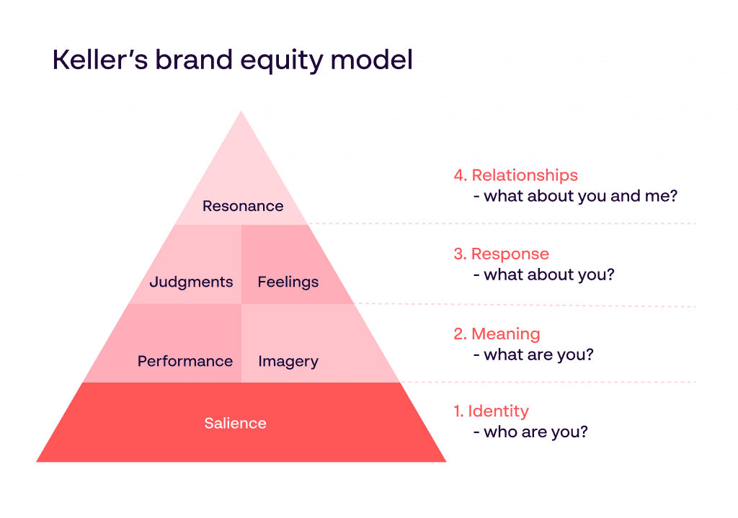

Fig: 01 Customer-Based Brand Equity (CBBE) model, (Keller,1993)

Advantages of Using Keller's CBBE Framework
- Provides a complete understanding of brand equity, from awareness to brand loyalty and relationships (Keller, 1993).
- Examines both product performance and symbolic brand meanings, making it suitable for luxury brand research (Wu, 2022; Flynn, 2015).
- A widely validated model that offers strong theoretical support and enables comparison with previous studies (Neupane, 2022; Stoeva, 2017).
Disadvantages of Using Keller's CBBE Framework
- Does not directly consider social class, requiring modification for this study (Bourdieu, 1984).
- Assumes consumers follow a fixed sequence, which may not reflect actual purchasing behaviour.
- Does not treat product design as a separate construct, requiring additional adaptation (Flynn, 2015).

7. RESEARCH METHODOLOGY

Research Method
Research methodology provides a systematic approach for planning, conducting, and evaluating research to generate reliable and valid findings. It involves selecting appropriate research designs, data collection methods, and analytical techniques to address research questions and test hypotheses effectively, ensuring the credibility and accuracy of the study (Saunders et.al, 2023). This chapter presents the methodological framework adopted to examine the influence of brand image and product design on consumer behaviour and luxury brand perception across different social classes, using Nike as a case study. The research follows the Research Onion model proposed by Saunders et al. (2019) to ensure a structured and comprehensive research process.

Research Onion
The Research Onion provides a structured framework for planning and conducting research systematically. It guides researchers through six interconnected layers: research philosophy, research approach, methodological choice, research strategy, time horizon, and data collection techniques. By following these stages, researchers can ensure a rigorous and well-organised research process. In this study, the Research Onion supports the systematic investigation of how brand image and product design influence consumer behaviour and luxury brand perception across different social classes (Saunders et al., 2023).
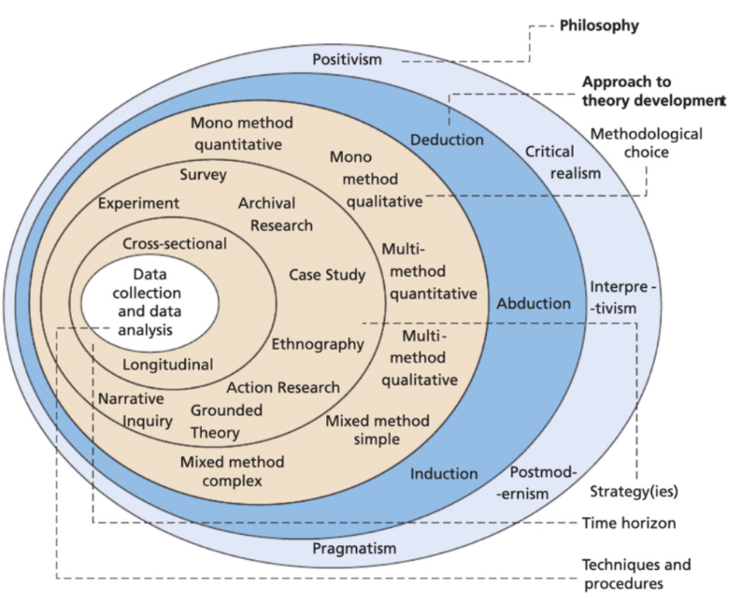

Fig:02 The Research Onion, (Saunders et al., 2023)

CHOICES

Quantitative Research
Quantitative research focuses on collecting and analysing numerical data to examine relationships between variables, test hypotheses, and identify meaningful patterns. It uses structured data collection methods and statistical techniques to produce reliable findings that can be generalised to a wider population. Quantitative data may be obtained from both primary and secondary sources, but its value depends on careful analysis and interpretation to generate valid research outcomes (Saunders et al., 2023).

Mono Method Quantitative
For this research, a mono method quantitative approach will be used, which encompasses methodology that exclusively relies on quantitative data and analytical techniques for investigation (Creswell, 2014). Within the field of brand management and consumer behaviour research, this strategy entails utilising a range of quantitative methods, including surveys, statistical analysis, and hypothesis testing, to evaluate the influence of brand image and product design on consumer behaviour and perception of luxury brands across different social classes (Creswell, 2014).
Time Horizons-Cross Sectional
A cross-sectional research design involves collecting data from a sample of individuals at a single point in time to examine relationships, differences, and trends among variables (Creswell, 2014). This approach enables researchers to capture participants' attitudes and behaviours efficiently without requiring long-term observation. In studies of brand management and consumer behaviour, cross-sectional research is useful for assessing consumer perceptions, brand awareness, and purchasing behaviour at a specific time. It also provides valuable insights for understanding market trends and supporting marketing decision-making (Ligaraba et.al, 2024).

Data Collection and Data Analysis
Sampling
Sampling refers to the process of selecting a representative subset of participants from a target population to draw conclusions about the entire population. Appropriate sampling improves the reliability and generalisability of research findings by ensuring the selected sample accurately reflects the characteristics of the wider population (Saunders et al., 2023).

Size
This research will involve 100 students from the University of Wales Trinity Saint David as participants. The sample size is considered appropriate for quantitative analysis and will provide sufficient data to examine the relationships between brand image, product design, and consumer behaviour using statistical techniques.
Type
The study will recruit 100 participants from the University of Wales Trinity Saint David who are aged 18 years or above, reside in the United Kingdom, and have purchased or considered purchasing Nike products. Participants must also be willing to take part in the online survey. Individuals who are under 18 years of age, do not reside in the UK, or have never purchased or considered purchasing Nike products will be excluded from the study. These inclusion and exclusion criteria will ensure that the collected data are relevant to the research objectives and suitable for quantitative analysis.
Sampling Method
The present study will employ probability sampling, specifically stratified random sampling, to ensure representation across different social classes. According to Saunders et al. (2023), in probability sampling, a sample is selected so that every individual in the population has a known, nonzero probability of being included. Research findings can be extrapolated to a larger population because this method ensures that every member of the population has an equal chance of being selected. Alternatively, Stratified sampling is a methodology in which the larger population is subdivided into strata (subgroups), such as social class categories, and a random sample is drawn from each stratum proportionate to its size in the population. This technique ensures that all subgroups are adequately represented in the sample, enabling meaningful comparison across social classes.

Data Collection Method
The collection of data will involve the use of online questionnaires that have been created with the assistance of Microsoft Forms. There will be a total of ten closed-ended questions for which participants will have approximately 05-10 minutes to complete.
Analysis of Data
To be able to conduct a comprehensive analysis, both quantitative data and software tools, such as Microsoft Excel, will be utilised to create visual representations. Quantitative data analysis involves the utilisation of statistical methods to interpret numerical data. Microsoft Excel is a widely utilised software application for performing statistical analysis on numerical data, providing a variety of functions and tools that enable researchers to effectively manipulate, analyse, and visualise quantitative data.
Research Ethics
Research ethics encompasses the principles and standards that guide the ethical behaviour in research, aimed at safeguarding the rights, welfare, and safety of individuals participating in research endeavours. This encompasses a collection of guidelines and regulations that researchers are anticipated to follow to uphold integrity, credibility, and dignity in their research work (Smith & Johnson, 2015). In connection with this study, the student will ensure that all primary data gathered will be safeguarded and maintained as private and confidential throughout the research process.

Resources and Planning
The Gantt progress chart allows the researcher to maintain visibility on commitments, focus on overcoming challenges and preventing delays, and provide timely communication in cases where commitments cannot be met (Geraldi, 2012).
To enhance the structure of the research concerning the impact of brand image and product design on consumer behaviour and perception of luxury brands across different social classes, a Gantt Chart was developed to visually illustrate the project's timeline and facilitate effective task coordination.

Fig: 03 Personal Gantt Chart (Self Created, 2026)

References
Aaker, D.A. (2009). Managing Brand Equity: Capitalizing on the value of a brand name. Journal of Marketing.
Anttonen, S. (2015). Branding a lifestyle: Case Nike. Bachelor's Thesis. Helsinki Metropolia University of Applied Sciences.
Baalbaki, S.S. (2012). Consumer Perception of Brand Equity Measurement: A New Scale. Dissertation of Doctor of Philosophy. University of North Texas.
Creswell, J. W. (2014). Research Design: Qualitative, Quantitative, and Mixed Methods Approaches. Sage Publications.
Eisenhardt, K. (1989). Building theories from case study research. Academy of Management Review, 14(4), 532-550.
Eusebius, S. (2019). Customer-Based Brand equity in a Digital Age: An Analysis of Brand associations in User-generated Social Media Content. New Zealand University of Otago.
Flynn, P. (2015). Nike Marketing Strategy: A Company to Imitate. Honors Thesis. University at Albany, State University of New York.
Geraldi, J. and Lechter, T., 2012. Gantt charts revisited: A critical analysis of its roots and implications to the management of projects today. International Journal of Managing Projects in Business, 5(4), pp.578-594.
Ho, A. (2017). Explore the Categories on Different Emotional Branding Experience for Optimising the Brand Design Process. Vancouver: Springer International Publishing.
Keller, K.L. (2001). Building Customer-Based Brand Equity: A Blueprint for Creating Strong Brand. Marketing Science Institute.
Keller, K. L. (1993). Conceptualizing, measuring, and managing customer-based brand equity. Journal of Marketing, 57(1), 1-22.
Keller, K.L. (2003). Strategic Brand Management. 2nd edition. Upper Saddle River, NJ: Prentice Hall.
Keller, K.L. (2013). Strategic Brand Management. 4th edition. Pearson.
Ligaraba, N., Cheng, J., Ndungwane, N.F. and Nyagadza, B., 2024. Brand authenticity influence on young adults’ luxury sneakers brand preference: the mediating role of brand image. Future Business Journal, 10(1), p.33.
Magids, S., Zorfas, A., & Leemon, D. (2015). The New Science of Customer Emotions. Harvard Business Review.
Marazza, A. (2013). A Survival Guide For Symbolic And Lifestyle Brands. Forbes.
Neupane, R. (2022). Analysis of the Impact of Public Relations Strategies on Customer-Based Brand Equity: A Study of Nike Customers in the UK. Granthaalayah, 10(14).
Saunders, M. N. K., Lewis, Philip,; Thornhill, Adrian, (2023). Research Methods for Business Students. Ninth edition., Harlow, England :, Pearson Education Limited.
Sadeghi, M., Fakharyan, M., & Co. (2015). Investigating the Effect of Rational and Emotional Advertising Appeals of Hamrahe Aval Mobile Operator on Attitude Towards Advertising and Brand Attitude. International Journal of Asian Social Science, 5(4), 233-244.
Smith, J., & Johnson, R. (2015). Understanding Research Ethics: A Comprehensive Guide. Harvard University Press.
Solomon, M., Bamossy, S., Askegaard, S., & Hogg, M. (2006). Consumer Behaviour: A European Perspective. England: Pearson Education Limited.
Stoeva, M. (2017). Emotional Branding Online: Case Study Nike. Bachelor's Thesis. Helsinki Metropolia University of Applied Sciences.
Valjakka, M. (2013). Corporate Social Responsibility and Reputation Management: A Case Study of Nike. Bachelor's Thesis. Helsinki Metropolia University of Applied Sciences.
Vazquez, R., Del Rio, Belen A., & Iglesias, V. (2002). Consumer-based brand equity: development and validation of a measurement instrument. Journal of Marketing Management, 18(1-2), 27-48.
Wu, G. (2022). The brand analysis of Nike based on its emotional branding and marketing strategies. The Hainan University-Arizona State University Joint International Tourism College, Hainan University.
Yin, R.K. (2018). Case Study Research and Applications: Design and Methods. 6th edition. Sage Publications.

