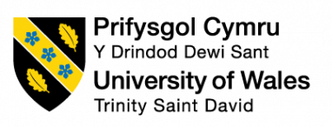

Reflective writing

Student Name: Oksana Klepailo
Student Number: 1912613
Moodle Title: Academic and Employability
skills BMSW4001
Lecturer’s Name: Anita Nan

08/08/2020
Table of contents
Introduction…………………………………………………………….…... 3
Time management……………………………………………………….... 3
Paraphrasing……………………………………………………….……... 4
CV writing…………………………………………………………………. 5
Giving PowerPoint Presentation……………………………………. ….. 6
Referencing………………………………………………………………. 7
Conclusion…………………………………………………………………. 8
References………………………………………………………………….9
Appendices…………………………………………………………………10

Introduction
I am a student at the University of Wales Trinity Saint David (UWTSD). I am studying a course called Skills for the Workplace and as a student, I had been asking to write this report about reflective writing. In my report, I want to share with you my experience and feelings about the learning process and results. I would like to say more about Time management, Paraphrasing, and Referencing that I had learned in Term 1. In addition to that, I will also reflect on subjects I had studied in Term 2 such as CV writing and giving a PowerPoint Presentation. In Appendices 1 and 2 attached below are my reflecting writing exercises from the classes in Term 2. During writing my report I will use Driscoll’s Model (1994) which is one of the common frameworks of reflection and it consists of 3 stages (What? So what? Now what?) This model will help me to build my report correctly and structurally.

Time management
What?
First of all, I want to start with the Time management subject learned in Term 1. In class I considered the Eisenhower Matrix, which is the main body of time management, the matrix gives a good knowledge about how effectively focus the attention on important things to save more time. This matrix uncovers concept what are important things, what are urgent, or not urgent, and not important. (Expert Program Management, 2017)
So what?
I am so satisfied with the learning of Time management, the lessons I visited were well-structure, clear and explanation of the materials was very understandable. I am very thankful to the lecturer Timothy Hopkins. To consider my previous understanding of time management I can say it was not clear and I did not know how to allocate my time with benefits. However, in the class the lecturer gave to me the best knowledge of Time management, he explained how right I need to manage and plan my tasks and activities without spending a lot of time because time is priceless. I really enjoyed listening to this class. Furthermore, I had searched in university literature about time management and I found out another time management matrix developed by Covey (1989). This matrix gave me the ability to understand time management deeper, I can strongly say that both mentioned matrixes are very useful and important for me. I took knowledge about which things or tasks I can attribute to the urgent and important and which are not urgent and not important for me. I believe It was a good experience of learning this subject for me.
Now what?
This knowledge of time management helped me to accomplish my tasks without wasting time. All information from the lessons of Time management that I have taken from my studying is very important to me because for now, I know how to use my time efficiently and rationally, and I also believe it will help me to manage the tasks in time in my routines and at my future job as well. I am confident that special this knowledge gave me a lot of advantages.

Paraphrasing
What?
In the last term, I studied another topic as well which called Paraphrasing. Paraphrasing is writing skills that allow to express someone’s words or ideas by using your own words. Paraphrasing is using to avoid plagiarism and to make the work more unique and attractive for reading. I had learned several techniques such as using synonyms, changing word class, and word order which is really helping to paraphrase. (Bailey, 2011).
So what?
I can say that I really enjoyed the Paraphrasing subject and attended this class with pleasure. As for my previous knowledge about paraphrasing should say that was quite low and I did not have a good imagination how to paraphrase effectively and professionally. However, after that class, I took the chest of new knowledge of paraphrasing skills. In addition to that, I can say that paraphrasing is an important thing need to know, and I found it useful in my life, and it will help me at my future work and at the university as well. Paraphrasing gives me the ability to develop my vocabulary and ensures brain training. As far as for me this topic was very beneficial, it gave me useful knowledge and it definitely helped me to write my report in Term 1.
Now what?
The learning process of paraphrasing motivated me to study and search for more and more new words to improve better my vocabulary. In addition, I want to say that Paraphrasing I found it challenging to write but it is a worthy thing need to know, and it is really useful and helpful at my university and in my future work as well. I could learn better paraphrasing skills at my lessons, but I will keep going to do it better in further.
CV writing
What?
In Term 2 I discovered all aspects of writing a professional CV. CV writing is one of the most important subjects that need to know, is a consequence of a well-written CV the chance to get a good job will increase several times. CV is a kind of document which is using to apply for the different job positions. It allows to write all information about work experience, education, skills in a short and clear way to encourage a future employer. It includes contact details, personal profile, work experience, education, skills and achievements, interests, and references. (Smith, 2019)
So what?
Before I enter the lessons of Term 2, I had some knowledge about CV writing, but this knowledge was not so relevant and deep for writing an effective CV. I had some required information for my CV, but it does not make a good structure of CV and I did not have the part of personal profile writing. In Term 2, I attended classes of Anita Nat and I found it very helpful for me and every lesson gather me more and more. The lecturer had explained a lot of interesting information about CV writing that I did not know it before. I am very glad that CV writing subjects are present in my university course. Finally, I understood how to build my CV in a correct way, I learned how to write a personal profile which will help to attract my future employer and soon I can add it to my new CV. I also have learned that need to avoid a generic phrase, using email must be professional, check grammar and spelling mistakes, to write a personal address inside a CV is not relevant. It is very useful for me because it makes me be more confident. I believe the knowledge of CV writing will help me to apply and find the job of my desire.
Now what?
I can definitely say that I knowledgeable about writing an effective CV and able to present it in a professional way. I believe the knowledge that I took from my classes of CV writing will help me to reach my goal by finding a new good job position and to get success. I felt stimulated to complete my CV as I really want to take a nice job and attract my future employer by my professional looking CV.

Giving a PowerPoint Presentation
What?
In a class in Term 2, I acquired knowledge of a very interesting topic called Giving PowerPoint Presentation. This subject covers some technic of giving a presentation, some of them is speaking - need to speak loud, clear with medium temp; body language gives an understanding of neutral gestures, keep eye on the audience; time management teaches to finish the presentation in time. (UWTSD Moodle, 2020)
So what?
I really was satisfied with the learning material in the class. I found it very interesting, useful, clear and I am enjoyed listening to the explanation by a professional teacher. I can strongly say that this class brought me only positive emotions. The teacher Anita Nan explained the material very clearly and structurally. I learned how to encourage the audience during the presentation, how to use the right voice tone, gesture, and how to make eye contact with the audience. Unfortunately, my background knowledge about giving a PowerPoint Presentation was very poor, I knew the general steps how to present presentation, however, it was not enough to make it effectively and professionally. In consequence of this lesson I found out how to select the appropriate font, background, and color, I understood the differences between the white and dark color of using at the presentation, that the light colors are ideal for creating a presentation. I became more aware of slide preparation that each slide has to have a unique title, need to follow the recommended font size, to use maximum only 6 bullet points per slide. Furthermore, I took a new knowledge that time management is important during the presentation. I believe a giving a PowerPoint presentation skill will help me to achieve my goals and successfully present my work.
Now what?
The classes of giving a PowerPoint Presentation taught and helped me a lot to reduce my fear of public speaking. It is very important to be aware of how I need to talk to the audience, how I need to encourage their attention, how I need to be confident in my speaking skill. I am very interested in developing giving a PowerPoint Presentation skill in the future, and I wish to improve it for better and better results.

Referencing
What?
As for references, I can say for sure that attending this class was worth it. Referencing is the process of using people’s work in researches or assignments. Referencing gives the ability to the reader to find in a short way the information which was used and allows to verify the faith of arguments. Furthermore, referencing it is a good tool in academic writing to avoid plagiarism during the writing work. (Pears and Shields, 2019, p.1)
So what?
In the class, I had learned that referencing helps to avoid plagiarism in my report. Moreover, I have taken knowledge of how to show that is my opinion in writing the report and this is not mine. I understood that each time I want to write somebody’s else ideas in my work I must always reference it.
I am totally satisfied with listening to this class, the information provided by my lecturer was really grate and given exercises helped a lot for my better understanding of references writing. How to write references I had this skill before, I knew that I need to refer someone’s words or ideas, I knew that I need to write references in-text and also in the references list. However, my knowledge was not enough to write it professionally and how it demands by university standards. I can say that these lessons gave me a better understanding of referencing, the teacher explained how to use right the referencing guide, and he provided as an example, the Harvard referencing guide that can be used during writing my works.
The Harvard referencing guide is the best guidebook I have ever seen. This guide has a good structure, very nice planned, I could find step by step description of the way how to refer to information in-text and in referencing list. Furthermore, I was able to find how to refer e-books, books without an author, journals, and newspaper articles website links, internet resources, blog, and vlog. I am strongly believing that I am confident of getting better in writing references. (Harvard referencing handbook, 2020).
Now what?
The experience I have taken in my lessons about referencing helped me in writing my reports at the university, it allows me to avoid plagiarism. I took new knowledge and improved my writing referencing skills for what I am very proud and happy, and I believe this knowledge will be so useful for me for further as well.

Conclusion
All those topics mentioned above is very important to me and each of them brought some challenges in my life, some of them helped me to accomplish my tasks and achieve goals, some of them motived me and gave me more confidant. Driscoll’s Model of the three stages really helped me to complete my report in the right order to capture the attention of the reader. I would like to say that I gained valuable experience in reflective writing.

References:
Bailey, S. (2011) Academic writing for international business students. London: Routledge.
Expert Program Management (2017) The Eisenhower Matrix. [Online] Available at: https://expertprogrammanagement.com/2017/07/the-eisenhower-matrix/ (Accessed: 24 July 2020).
Morgan, P. (2017) The Business Student’s Guide to Study and Employability. London: SAGE Publication Ltd.
Pears, R. and Shields, G. (2019) Cite them Right: The Essential Referencing Guide. 11th edn. London: Red Globe Press.
Smith, J. (2019) ‘How to write a CV’, Prospects, March. [Online] Available at: https://www.prospects.ac.uk/careers-advice/cvs-and-cover-letters/how-to-write-a-cv (Accessed: 28 July 2020).
The University of Edinburgh (2020) Gibbs’ reflective cycle.[Online] Available at: https://www.ed.ac.uk/reflection/reflectors-toolkit/reflecting-on-experience/gibbs-reflective-cycle (Accessed: 08 August 2020).
UWTSD: Library and Learning Recourse (2020) Referencing Handbook Harvard. [Online] Available at:
https://uwtsd.ac.uk/media/uwtsd-website/content-assets/documents/library-and-learning-resources/infoskills/Harvard-eng_v.1.2.pdf (Accessed: 09 August 2020).
UWTSD Moodle (2020) Week 7. Giving PowerPoint Presentations. [Online] Available at: https://moodle.uwtsd.ac.uk/course/view.php?id=6958 (Accessed: 08 August 2020).

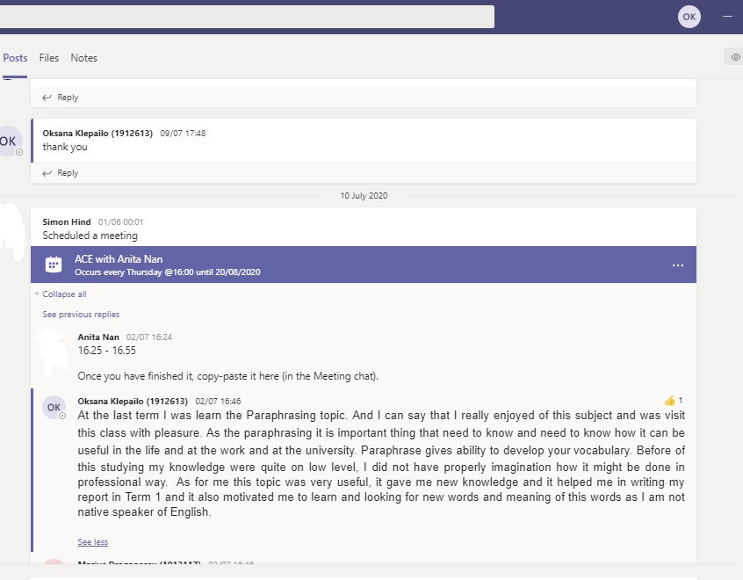
Appendix 1

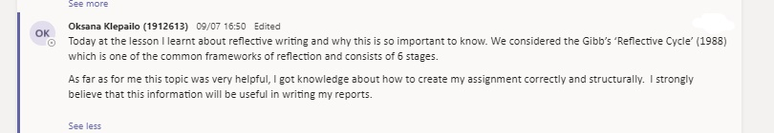
Appendix 2

