

365 Airport Transfers

EFFECTIVE TEAM WORKING and COMMUNICATION
BMSW4002
TABLE of CONTENTS

- INTRODUCTION ……………………….2

- COMMUNICATION (Definitions) ……………………2

- IMPORTANCE OF COMMUNICATION………….3

- IMPORTANCE OF EFFECTIVE COMMUNICATION………..3

- METHODS OF COMMUNICATION……………4

5.1 Verbal Communication…………….4

5.2 Non-verbal Communication………..4

6. THEORIES OF COMMUNICATION …………5
6.1. Shannon and Weaver Model of Communication………5
6.2. Schramm Model of Communication…………6
6.3. Berol’s Model of Communication………..8
6.4. My own justification about all the models discussed above…………9

7. COMMUNICATION AT MY WORK PLACE…………….. 10
8. CONCLUSION …………………10
9. REFERENCES…………………..11

- INTRODUCTION

In this assignment I will present some definitions for communication, the importance of communication and methods of communication. Also I will describe each theory of communication including my own explanation about the models from the theories of communication.
The next point but not the last in this assignment, it will be the communication at my work place, the way how I communicate with costumer and the importance of a good and clear communication.
Be the end of this assignment I will write my own conclusion.

- COMMUNICATION – Definitions

Communication is the process of sharing information between two persons. (Munna ET at 2020)

The communication is any “information related behaviour”. (Ruben.1984)
Communication is sharing of ideas and feelings in a mood of mutuality. (Dale, 1969)

Communication is a use of a verbal statements which is one of the most common way to communicate with each other. (Griffiths ET at, 2015)

Communication is a process by which information is exchanged between individuals through a common system of symbols, signs, or behaviour.

Communication is the way the sender send the message to the receiver.

- IMPORTANCE OF COMMUNICATION

Communication is important because it brings people together, closer to each other.
Communication also is good because it helps to understand people better, avoid misunderstanding and creating clarity of conversations. Communication also can educates people.
In any are of working activity, communication can obtain high productivity, safety and happy employees. The communication can be different any culture or environment, and that mean the messages can suffer any changes.

- IMPORTANCE OF EFFECTIVE COMMUNICATION

The communication would be more effective if the sender will use the correct words, phrases so that the information reaches the recipient correctly.
For example:
“I want water” is communication.
“I want a glass of cold water from the blue jug” is effective communication.
Effective communication in the workplace is an essential element for a business to have success; it improves relationships within the company and with clients, and it growths employee arrangement and the general efficiency of a team.
On the other way, when a team fail to communicate effectively, the consequences are damaging to the business. This could happen is communication is poor.
To prevent this “disaster” for the business, an effective communication is very important and for that the team should have clear instructions and conversations

- METHODS OF COMMUNICATION

  - Verbal Communication
The most common way to communicate with people is to use a verbal communication (using sounds and words to express yourself).
A team member can pass a message to the team leader by phone or by writing an email. Without a good verbal communication a business could slow down.
Verbal communication is the way to share information with other people use by using words. For that reason can contain both spoken and written communication. Many people are using the word to describe only oral communication. The verbal part of communication is about the words that you select, and how they are caught and understood.
The good communication is when we are able to speak clearly and listening.
  - Nonverbal communication
Any message that are sent without written words or speech is a nonverbal communication.
Nonverbal suggestion from a person such a smiling or eye contact could help the listener to interpret the message.
7% of the messages are communicated trough words, 38% by voice and 55% by facial expression. [Mehrabian.1981]
Nonverbal communication helps people to:
- Support or modify what is said in words
- Deliver information about their sensitive state
- Describe or support the relationship between people
- Deliver feedback to the other person
- Control the flow of communication
The clear method used is the written Communication and that involves: Messages, E-mails, Social media (Facebook, Instagram, Twitter, etc.), Books, News Papers and the Internet.

- THEORIES OF COMMUNICATION

  - Shannon and Weaver Model of Communication

Claude E. Shannon and Warren Weaver [1949] suggested that the model of communication to be a Mathematical Theory of Communication.
The Information source encodes the message and send it to the receiver through a telephone and telegraph. The sender converts the message into codes understandable to the machine. The message is sent in codes through a medium. (Fig.1)

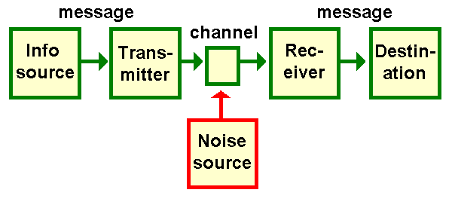

Fig.1

Shannon and Weaver Model of Communication come out with elements as: a transmitter, a receiver and a source of noise. Hardware is a transmitter and receiver in telecommunication, used by the sender and receiver in the act of communication.
This model shows to fit for telecommunication such as: radio and television.

The concepts in this model are:
- Sender is the person who prepare the message, select the channel and directs the message.
- Encoder is the sender who uses device, which adapts message into signals or double data.
- Channel is used to send the message.
- Receiver is the device used to convert signals or double data into message.
- Destination is the person who catches the message or the location where the message must reach.
- Noise is the environment which doesn’t let the message get into receiver as what it is sent.

The criticisms of Shannon Weaver Model:
- Shannon Weaver Model can be related more for interpersonal communication than a group communication and mass communication.
- Receiver plays the inactive part in the communication process as sender plays the main role that sends messages.

  - Schramm Model of Communication

Wilbur Schramm (1954) decided to study the communication as a depended discipline. Schramm discover some models to send different questions. His contribution was to consider that the fields of experience of the sender and receiver. If there is nothing common between the sender and the receiver in the range of experience, the communication cannot take place.
The feedback from the receiver to sender has been introduced by Schramm’s model.
This diagram represent the fields of knowledge of the sender to receiver.

Fig.2

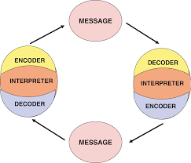

Information are useless until are carefully placed into words and transmitted to others.
Encoding is important because it introduces the process of communication by converting the idea into content.
Agreeing to the Schramm’s model, coding and decoding are the key for an effective communication.
Schramm Model affirm that the communication is incomplete until the sender gets a feedback from the receiver.
According to Schramm’s Model of communication when the sender pass the information to the receiver, the receiver must decode the information and give him the feedback or respond consequently.

  - Berol’s Model of Communication

Berol’s model of communication is an expanded model of linear communication of Shannon and Weaver model. This model describe all the elements of communication: sender- message-channel-receiver. Berol consider that for an effective, the sender and the receiver must be on the same "line", they must have some similarities in some characteristics as good communicators and good listeners.
Even if this model take in consideration much more than Shannon and Weaver model, still the effects of the message is not known. In the same time don't take in consideration the reality of life: the people are different, is improbable that in the people be on the same level.

The elements of Berlo’s Model of Communication are:

Sender which is the source of the communication or the person who makes the message.

Message is the constituent that is actuality sent by the sender to the receiver.

Channel is the average used to send the message.
Receiver is the person who catches the message sent in the process.
The criticism of Berlo’s model of communication:
- No feedback
- In this model is no mention about barriers to communication
- No area for noise
- It is a very complicated model

We can observe that this model omits the usage of the human capacity of thinking, analysing and understanding. (Fig.3)

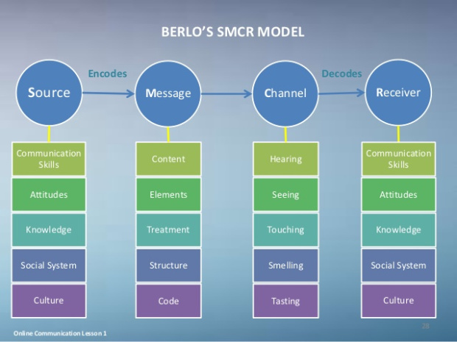
Fig.3

  - My own conclusion about the models of communication is that the sender and the receiver are perfect about what they would like to discuss.
I believe that every step in the cycle of Communication’s model is important, and it’s basically impossible to avoid any of them. I’m thinking if we will pay attention to every component, both the sender and recipient are able to communicate effectively, understand each other better and react to each other more vigorously.

- COMMUNICATION AT MY DESK (MY WORKPLACE)

I’m working as an operator for an Airport Transfers Company and communication with my team and with my costumer is very important.
One of the ways to improve the process of communication with an
organization and to remove the barriers to effective organizational
communication is by forming a positive attitude within the workplace
One of the ways to improve the process of communication with an
organization and to remove the barriers to effective organizational
communication is by forming a positive
Always I’m taking in consideration the barriers of communication. This barriers can involves words (language, unclear message, and ambiguity). By sending an email to my driver with booking details, contains an unclear message or incomplete details regarding that booking it can be a disaster. At my work place I’m using the written communication which contains letters, reports, documents, emails, messages. This is my way to have a clear and correct communication with my team.

- CONCLUSION

Writing this assignment I’ve understood that the effective communication at the work place and also in my life is very important. I have learned about the verbal communication and nonverbal communication. How a message can be interpretable if we are not using the correct words compare with a nonverbal communication when actually we are using – eye contact or just a simple smiley face.
I’ve been learning about the Shannon and Weaver Model of Communication, Schramm Model of Communication and Berol’s Model of Communication and I understood that over the years the researches give us some theories of communication and they try to explain us the way that a symbol is shared via different signs.

REFERENCES

Maund, A. (2017) Certificate in Higher Education: Skills for the Workplace, Student Yearbook.1st .SAGE, London.
Croft. R (copyright 2004) Communication Theory - printing paper from the Class
Webster M .(1828) Definition of communication [Online] Available at: https://www.merriam-webster.com/dictionary/communication. Accessed on: 05/04/2020 at 19:52.
Juneja. P (2015) - Reviewed By Management Study Guide Content Team. Delhi
Marchionni, G. (2015) Information Communication, Morgan & Claypool, University of North Carolina.
Thompson, N. (2018) Effective Communication: a guide for the people professions, Third edition. Hampshire
Adair, J. (2003) Effective Communication, Pan Macmillan Ltd, London:

