Ways of Perceiving
Word Count – 1317
Adam Higgins (1700155)
2018
Contextual Studies – Ways of Perceiving
Simplicity in Design

Introduction
The show is about the simplicity of products and how they are perceived to be so simple yet are far from it. Some of the most simple looking products, if you look at minimalism for example are some of the hardest products to create and manufacture today.

The average user don’t spend time on thinking how products are made, what manufacturing processes are used and all the little details which go into a product being made. The show will hopefully demonstrate this and give a different insight to products.

Context
Simplicity is something we don’t think about in detail. When the word simple comes to mind you instantly think of how something is easy or there’s not much to it. Within the design world things are far from simple. Its something only design minded or design conscious people really process. If a user is presented with a product in it’s final form they take it for what it is without any questions. The user fails to break down how this product has actually got to them in their hands, there’s a whole story behind the product.

Simplicity within a product is something which needs to be brought to eye and ‘simple looking’ products shouldn’t be seen as ‘simple’. If something complex is shown to you, you start to think of how it might have been made or how it works. There is a whole group of products which are underestimated.

I have decided to look at several designers which use a minimalism and modernisation hen designing as these sort of products are the ones which are being stereotypes as simple. All of these designers have things in common and incorporate to fit into the theme of simplicity.

So why is it that we think things are simple yet when broken down are the opposite?
There are many factors which can come into play when we think about this.

Minimalism is something which has become very popular within design recently. Lots of designers around the world are using basic shapes and geometry to make the foundations of a product. Minimalistic products tend to influence the users not to think about the absence within a product.

Advertising is also a massive factor when it comes to branding a product simple or easy to use. Clever branding can manipulate the user to think a certain way about a product. The users are almost brainwashed to think a certain way. Companies such as apple are a great example of this, after one look at their adverts you already know how to use the phone advertising.

Modernisation is also something which can influences the idea that something is simple. As design goes there’s been a huge shift in the style of design. From more traditional old designs styles to modern and minimal. So if you’re brought up today this is what you see and wont think of anything else.

The way we see products is also a massive factor. ‘They way in which we are brought up to see things a certain way, seeing becomes before words. So although you see something which is simple, the knowledge or understanding never fits the sight’ according to (Berger, 1972). This is such a relevant statement for this topic and fits into perfectly to the message of not everything is as simple as it seems.

(Berger, 1972) also goes on to explain that when an ‘image is presented as a work of art, the way people look at it is affected by a whole series of learnt assumptions about art.’ So for example beauty, truth, civilization, form, status, taste. This statement links directly into how people make assumptions about products. A product may be give a persona of being simple due to its form or beauty.

Artists and Artworks
My imagined exhibition will contain the following designers work and will be displayed in the mission gallery. The four products will have details of the product but then a screen behind displaying a break down of the products, shows that there are many process and problems you need to overcome before reaching the final outcome. In short, it will show the story of a product not just the end.

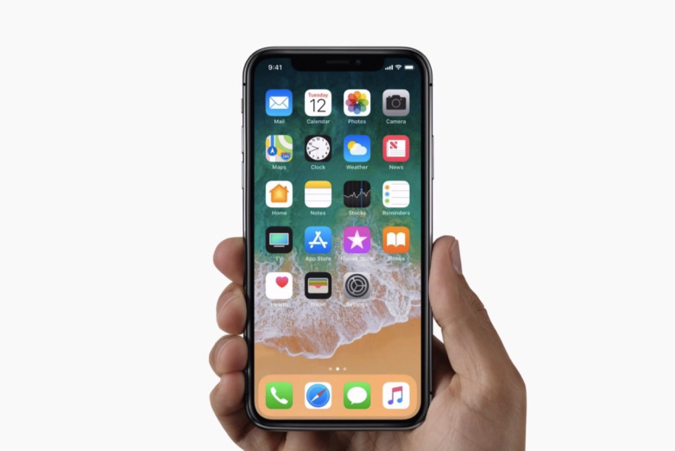
Jonathan Ive – iPhone X

My first designer Jonathan Ive is the creator of the iPhone of many generations. Its know for its simplistic and user friendly interface. As the product is intuitive to use many users would jump to the conclusion that the whole product is simple and wouldn’t think of the complexity gone into the phone.
This is a product which is taken for granted users don’t realise the little things like when you press an application the phone a whole lot of process within are taken in order for the app to open.
The work of Jonathan Ive creates the user to think they are using a simple product but it is created by the interface due and the lack of buttons and components within the product, the true complexity lies within the phone which you cant see. Which links me back to the way we perceive a product, if you were around before mobile phones were popular then you would understand a iPhone is very complex.


John Pawson – Cutlery

My second designer is John Pawson, John Pawson is a British designer which is know for his minimalistic designs. Minimalism is a form of simplicity, order and harmony. When designing you’re designing for less.

This product made by John Pawson is a cutlery set which has a very visible minimalistic theme throughout the set. There is very little use of many materials and designs/patterns which is what makes it minimal. Minimalism has this word ‘simple’ stuck to it, because it doesn’t contain much, its’s instantly seen as simple. This product has been created in an era here modernisation and minimalism is very present which can be one of the main causes of a product being given a wrong name to it.

Naoto Fukasawa – Aboutwater Tap


My third designer is a famous Japanese industrial designer, Naoto Fukasawa. Naoto also designs around the idea of simplicity and minimalism. Many of his products are plain and have a very clean and featureless aurora around them.

The product in question here, The simple ‘3 piece component tap’ well that was is perceived in the image. People look at that image and product and immediately think that’s all to it. They forget that underneath the counter there are many more components which make the tap function. Product such as this have a stereotype around them, a statement made by (Stuart, 1997) states that “A stereotype isolates ‘typical’ characteristics of a particular group and places them at the centre of representation, disregarding individual qualities within the social group.”
Products these days can be grouped in to certain named groups, ‘simple’, ‘futuristic’ and many more. My point is that stereotyping can give the wrong name to a product solely based on the looks of it.

Verner Panton – Panton Chair

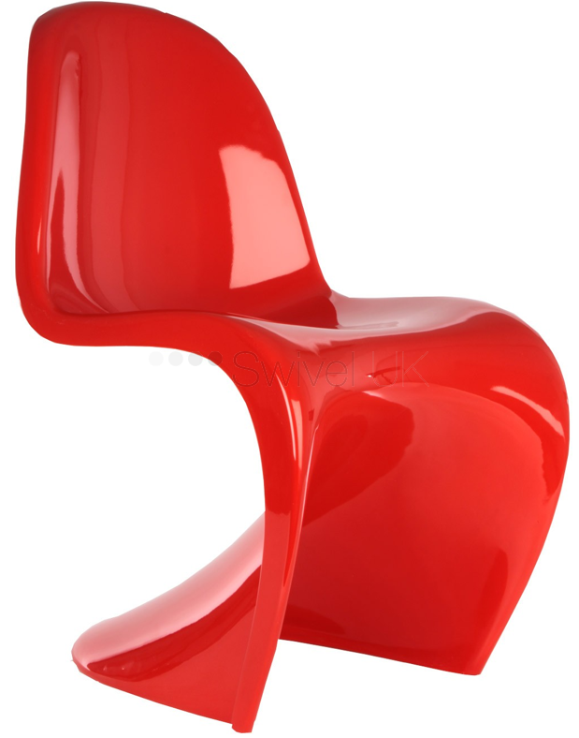

My Fourth Designer is Verner Panton, he is a well know designer and especially known for his Panton Chair. The chair is a iconic product in todays world due to its form and method of manufacture.

Due to the clever designing and manufacture of the product, it can again like the other products I am looking at, can be seen as ‘simple’. There is only one component in this chair and the support of the chair is based solely on the bottom of the chair.

My point of this product is that it would have taken ages to get the point where this chair was possible to sit on. Hours of designing, testing and reworking would have been put in to make it possible, many problems would have occurred and been over overcome.

Bibliography
Aboutwater, 2017. Aboutwater. [Online]
Available at: http://www.naotofukasawa.com/INDEX/index_02.html
[Accessed 23rd April 2018].
Berger, J., 1972. Ways of Seeing. 3rd ed. London : British Broadcasting Corporation/Penguin Books .
Fronzoni, A., 2001. AG Fronzoni. [Online]
Available at: http://agfronzoni.com/
[Accessed 23rd April 2018].
Hall, S., 1997. Representation & The Media. First Edition ed. Amherst(Massachusetts ): Sut Jhally.
Morris, R., 2018. Tate. [Online]
Available at: http://www.tate.org.uk/art/art-terms/m/minimalism
[Accessed 23rd April 2018].
Pawson, J., 2003. John Pawson. [Online]
Available at: http://www.johnpawson.com/works/steak-knife
[Accessed 23rd April 2018].
Stuart Representation – Cultural Representations and Signifying Practices. (London: Sage, 1997). p. 249.
Turner, L., 2009. Metamodernism. [Online]
Available at: http://www.metamodernism.com/2015/06/03/misunderstandings-and-clarifications/
[Accessed 23rd April 2018].
Verpan, 2015. Verpan. [Online]
Available at: https://www.verpan.com/verner-panton
[Accessed 23rd April 2018].

