Student Name: Ruth lynn Parino Talavera
Student Number: 2316908
Lecturer Name: Richard Ashaye

BA (Hons) Leadership and Management Skills for the Workplace Organisational Culture LCLM 5005
Table of Contents
1. Introduction 2
2. Organisational Culture, Ethos, and Values of Emirates Airlines 2
3. Organisational Culture Analysis Using Relevant Tools 4
3.1 Culture Model of Deal and Kennedy applied to Emirates Airlines (Deal & Kennedy, 1983). 4
3.2. Harrison and Stokes’ Four Culture Dimensions 5
4. Influence of Organisational Culture on Structure and Decision-Making 5
5. How is the Emirates Airline applying the Influence of Organisational Culture to the External environment. 6
Using Organisational Culture to Adapt 8
6. Is Organisational Culture a Barrier to Effective Functioning at Emirates Airlines? 9
7. Establishing a Culture of Sustainability in the Workplace 12
7.1 Corporate Social Responsibility (CSR) 13
7. 2. Business Ethics and Code of Conduct 14
7.3. Environmental Responsibility 14
8. Using Organisational Health Index (Financial and Non-financial performance) to measure the effectiveness of Emirates Airlines 15
9. Recommendations for Improvement Using OHI 16
10. Conclusion 17
11. References 17

1. Introduction
Organisational culture plays an integral and pivotal role in determining the success of an organization in its functioning and functionality in a rapidly evolving and competitive environment, such as the aviation sector. Emirates Airlines presents a great case in point in terms of the importance and significance of organisational culture in the provision of quality services and organisational decision-making and planning. Emirates Airlines began operations in the year 1985 with two aircraft leased from another airline and has since then evolved into one of the leading airlines in the global marketplace through Dubai’s strategic geographic point and focus on quality passenger services with 150 destinations across six continents employs multicultural employees representing 160 nacionalities.

This report will investigate the organisational culture and values of Emirates Airlines and how such factors affect its structure and responsiveness to pressure from the environment. Theories and elements such as the Deal and Kennedy model and the Harrison and Stokes dimensions of culture will be employed to assess the strengths and weakness of the organisation, as well as the effects of the CSR and Organisational Health Index.

2. Organisational Culture, Ethos, and Values of Emirates Airlines
The corporate philosophy of Emirates Airlines is based upon a number of values that form the driving factor in its operations and strategies. They include: Safety, Service Excellence, Innovation, People, Financial Strength. Its corporate philosophy has a number of tenets, the first of which is the “treating our customers as honored guests and our focus is to provide a constant level of quality regardless of the destinations and class of travel” (Emirates, n.d.; Nataraja & Al-Aali, 2011).
The leadership style in the airline is perceived to be highly democratic, creating a forum where employees are urged to share their ideas and views. The above style has the advantage of increasing employees’ commitment and efficiency and aligns well with the following attributes known to be present in an adhocracy corporate culture:
• Innovation and Risk Taking: Emirates promotes and supports innovation and a mindset of taking risks in order to improve its services.
• Attention to detail (Precision Orientation) - The highest standards in operations and services are maintained consistently.
• Outcome-based focus (achievement oriented) - The focus is upon the results through satisfaction, efficiency, and services.

Moreover, Emirates shows a considerable commitment to diversity and inclusion, a fact that is quite admirable in an area where diversity in the labour force is considered less common. Through incorporating diversity into its corporate identity and operations, it is able to offer its customers a differentiated experience in its services. This has been facilitated by the presence of some external elements, such as the government support and its ideal location.

The airline’s mission statement, vision, and values emphasize the company’s commitment to safety, a focus on services, reliability, and a customer-focus approach (Emirates, n.d.). Theoretical perspectives emphasize the need for ethics in business, developing leadership, working in teams, professionalism, employee development, and a focus on the customer, incorporating the basic elements of organisational behaviours for success in the aviation industry.

3. Organisational Culture Analysis Using Relevant Tools

3.1 Culture Model of Deal and Kennedy applied to Emirates Airlines (Deal & Kennedy, 1983).
1. Work Hard/Play Hard
The Emirates Airlines organization shows the work hard/play hard environment through initiatives and independence in decision-making for its employees. Employees are encouraged to remain enthusiastic and proactive in their work, especially in the areas of customer and sales services. The organization understands that success is a group effort and not an individual accomplishment in any way, and this promotes combined efforts in all other departments
2. Tough Guy/Macho
This culture, that promotes heroism and taking risks, is hardly compatible with the Emirates values and ethics founded in teamwork and shared responsibility, and in any case, the company discourages highly individualistic strategies that might undermine the employees’ motivation and increase staff turnover.
3. Process Culture
The Emirates Airlines model has nothing to do with the process culture because the process culture values a strict process and a slow feedback process, while Emirates promotes the taking of informed risks and offers the employees a rapid feedback process
4. Bet Your Company
The "bet your company" culture, where the decision holds risks in the long term and the results take a long time to emerge, is also not typical of the Emirates company. The company functions in a dynamic and competitive environment where immediate results and making frequent decisions in the presence of clients are required. This type of long-term and high-stakes decision-making is practiced in the fields of oil, gas, pharmaceuticals, and construction, where the results often take a long time to emerge

3.2. Harrison and Stokes’ Four Culture Dimensions
Harrison and Stokes (1992) propose a four-dimensional classification of organisational culture: 1. Power Orientation: The extent to which power is centralized or diffused. 2. Role Orientation - Focus upon rules, procedures, and structure. 3. Task Orientation: Goal achievement and performance are emphasized. 4. Person Orientation - Attention to individual needs and development.
Application to Emirates Airlines:

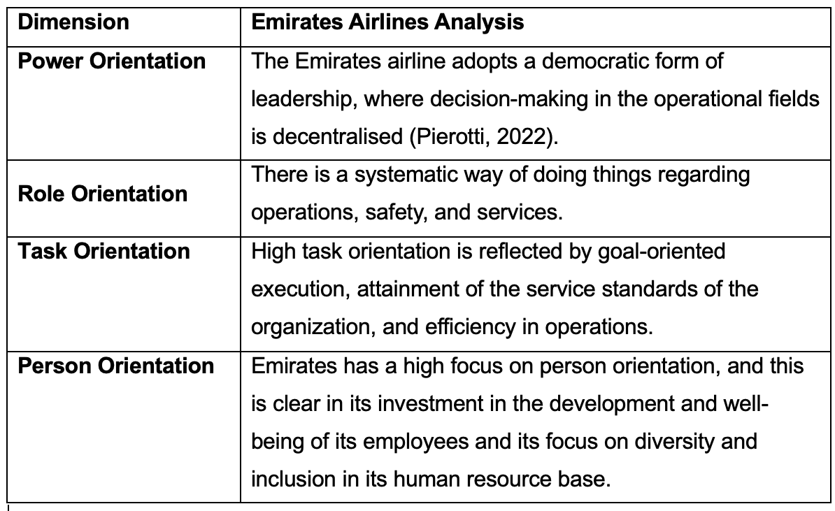
Emirates Airlines’ culture reflects a balance of task and person orientation, with high achievement focus combined with employee empowerment and inclusivity. This combination aligns with an adhocracy culture, promoting innovation, flexibility, and responsiveness to customer needs.

4. Influence of Organisational Culture on Structure and Decision-Making
The adhocracy corporate culture in Emirates that focuses on innovation, collaboration, and a people-driven approach to services deeply influences the structure and decision-making processes in the company. The corporate culture in the airline company promotes employee engagement, knowledge sharing and taking risks in order to facilitate the more organic elements in the structure of the company, especially decision-making at the SBUs (Mullins & Christy, 2016; Browaeys, Price, & Price, 2011).

Despite the presence of a participative environment, centralized decision-making remains important in the organization structure, where the Chairman of the Emirates Group is also the CEO of Emirates Airline, and key strategic decisions emanate from this source (Pierotti, 2021). Decisions related to operations, especially those in the realm of services and innovation in the ground and in-flight settings, remain relatively decentralized to facilitate fast action in addressing client demands (Cork, 2011; Deal, Deal & Prince, 2011).

This alignment of the company’s culture and structure guarantees that Emirates has a high standard of services, efficiency, and innovation in its operations, in line with its values of professionalism, teamwork, and excellence (Handy, 1985 and Prince, Hoppe and Prince, 2011). The company’s organisational culture thus allows for a combination of centralisation for strategic decisions and decentralisation for operational decisions in a highly competitive global environment for airlines.

5. How is the Emirates Airline applying the Influence of Organisational Culture to the External environment.

The Emirates Airline is applying the Influence of Organisational Culture to Emirates Airlines works in a complex and ever-changing global aviation sector environment. The airline has an organisational environment that is affected by a number of elements within its PESTLE and SWOT environment.

PESTLE Analysis
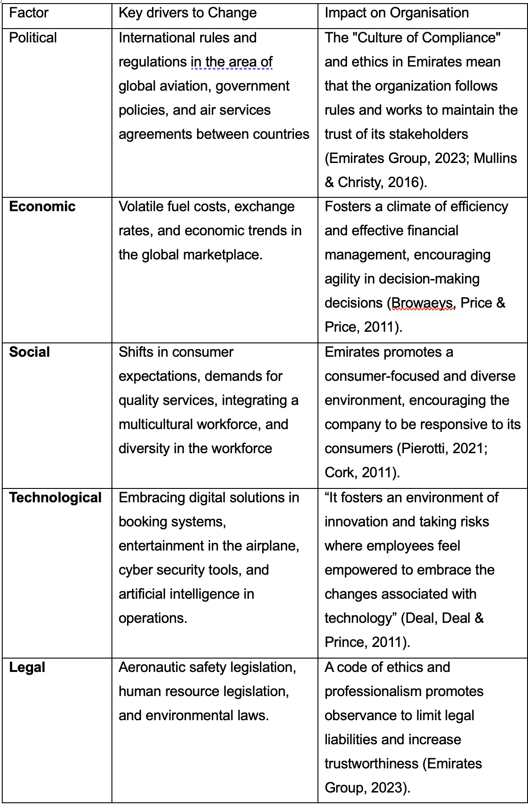

Using Organisational Culture to Adapt

The company utilizes its adhocrative corporate culture, marked by innovation, teamwork, and a focus on the customer, to meet satisfactorily the following driving forces:

- Innovation and Risk Taking: The employees are urged to make recommendations and introduce new technology to quickly adjust to changes in technology and the marketplace (Deal, Deal & Prince, 2011).
- Customer-Centric Approach – The service-focused environment allows the organization to implement changes in the trends in the social environment, for example, the need for personalized services (Cork, 2011).

- Ethical and Professional Standards – Emirates to the regulatory and legal obligations in an effective manner (Emirates Group, 2023).

- Diversity and Inclusion – Having a multicultural and inclusive environment helps Emirates adjust to the global marketplace and their consumer choice preferences in various regions (Pierotti, 2021 & Prince, Hoppe & Prince, 2011).

Thus, the organisational culture plays a strategic role in adjusting the internal processes and behaviours of the employees in Emirates to the demands of the rapidly changing external environment through the above mechanisms..

6. Is Organisational Culture a Barrier to Effective Functioning at Emirates Airlines?
Organisational culture plays a major part in the effectiveness of the operations in an organisation. For the Emirates Airlines organization, the prevailing culture appears to be one of high performance, a hierarchical form, discipline, and focus on consumer services. Though the culture presents a number of advantages, it also has the potential to present barriers to effective communication, innovation, employee motivation, and adaptability (Mullins & Christy, 2016).

Emirates Airlines organisational culture has been known to be of a high performance-driven, hierarchical, disciplined, and customer service-driven type, hierarchical, disciplined, and customer service oriented. Though the organisational culture of Emirates Airlines has numerous benefits, there are also certain constraints created by the same (Mullins & Christy, 2016).

1. Barriers to Effective Functioning in Emirates Airlines
1.1 Highly Centralised Decision-Making
Emirates Airlines maintains a highly centralised and hierarchical structure, with many strategic decisions made by senior executives and government stakeholders (Pierotti, 2021).
Barrier created:
- Slow decision-making
- Limited autonomy for managers
- Lack of flexibility in emergency situations
Example: For instance, airlines that formed relatively more decentralised teams in the COVID-19 scenario adapted quicker (IATA, 2021).

1.2 Pressure from High-Performance Culture
Emirates is known for its performance-driven, disciplined, and excellence-focused culture.
Barrier created:
- High levels of stress in the employees
- Fear of making mistakes
- Poor work-life balance
- Burn out risks
This is in line with the argument put forward by Mullins and Christy in 2016 that high demanding work environments may lower employee well-being and increase the rate of employee turnover.

1.3 Multicultural Workforce Challenges
With over 160 nationalities, Emirates’s diverse workforce creates communication and cultural challenges.
Barrier created:
- Misinterpretation of communication
- Variations in expectations regarding leadership and teamwork
- Possible conflict because of variations in cultural norms (Browaeys & Price, 2011)
Though diversity is an advantage, if intercultural communication competencies are lacking, diversity might instead decrease cohesiveness within a team.

1.4 Top-Down Communication
Despite the efforts to enhance the process, the communications in Emirates tend to be top-down and lack upward feedback (Pierotti, 2021).

Barrier created:
- Employees do not feel heard
- Reduced innovation
- Low psychological safety (Deal, Deal & Prince, 2011)

1.5 Strict Rules and Standardisation
Airlines need to follow rigorous processes in terms of safety, but too much standardization might be detrimental to their flexibility.

Barrier created:
• Employees face the challenge of coping with the demands of unpredictable customers
• Lack of innovation and creative solutions
• Lack of perceived empowerment
This aligns with the view expounded by Handy (1985) that role cultures will undermine innovation.

2. Is Organisational Culture a Barrier?
YES, organisational culture has the potential to be a partial hindrance, despite the fact that it has functioned as an element in the company’s success.

Why it is a barrier:
The centralized and hierarchical culture restricts empowerment
There is less autonomy for managers and employees, and the rate of response is delayed (Pierotti, 2021).

Expectations of high performance produce stress This will affect employee morale and employee retention (Mullins and Christy, 2016).
The absence of standardized cross-cultural training in an organization means that employees will Causes miscommunication and inefficiency (Browaeys & Price, 2011).

Limited bottom-up communication
Restricts innovation and continuous improvement processes
Despite this, it is not an effective barrier because:
• The company culture fosters excellence, customer services, and efficiency, making the brand stronger.
• Emirates focuses on employee development, cultural understanding, and management training.
• Its robust organisational identity fosters stability and global competitiveness.

Accordingly, culture proves to be both a weakness and a strength for the human species.
3. Ways to Overcome These Barriers
3.1 Increase Employee Empowerment
• Delegate more decision-making authority to frontline managers.
• Adopt elements of decentralisation to speed up responses.

3.2 Enhance Cross-Cultural Training
Offer mandatory cross-cultural communications training • Improve cultural intelligence in teams.
This reduces misunderstandings and enhances teamwork.

3.3 Encourage Two-Way Communication
- Create digital platforms for employee suggestions.
- Implement leadership “open door” communication programs.
- Promote psychological safety.

3.4 Promote Work–Life Balance
- Flexible scheduling for crew
- Mental health support
- Reduce excessive performance pressure
- Use employee workshops to produce new ideas for services.

3.5 Build an Innovation-Friendly Culture
- Recognise and reward creative problem-solving.
- Use employee workshops to generate new service ideas.
- Reduce the fear of failure by encouraging an experimentation mindset.

7. Creating a Culture of Sustainability in the Workplace

Emirates Airlines is aware of the importance of sustainability in the success of any organization. The company has combined corporate social responsibility, ethics, and sustainable environment practices to accommodate the interests of the societal and environmental communities (Mullins & Christy, 2016; Browaeys, Price & Price, 2011).

7.1 Corporate Social Responsibility (CSR) The Emirates Airlines company shows a clear commitment to social responsibility in its dealings with important stakeholders to the organization, incorporating ethics in its sustainable practices.
The duty of the airline to its employees is clear in its commitment to offering a safe working environment, competitive benefits programs, inclusion of diverse cultures, and employee development and training, according to the Emirates Group Business Code of Conduct.

Emirates promotes customer safety and trust through the application of effective safety procedures, quality consumer services, clear consumer pricing, and effective consumer data privacy and security protocols. The company also promotes supplier trust and satisfaction in its dealings with suppliers based on integrity, in a bid to establish long-term relationships and quality in the process of working with the suppliers.

Moreover, Emirates works in conjunction with governments and regulatory bodies to adhere to the laws and regulations of the global aviation sector, in addition to supporting initiatives related to economic and environmental projects such as fuel efficiency and carbon emissions. The company has formed partnerships in the transport sector to offer its services to a wider number of people and to

At last, the airline gives back to the community through philanthropic initiatives, supporting the youth, humanitarian initiatives across the globe, sponsoring events in the fields of culture and sports, and creating jobs. All these cumulatively demonstrate the company’s commitment to Corporate Social Responsibilities (CSR), ethics in business dealings, and Corporate Social and Environmental Responsibilities (CSER) initiatives

7. 2. Business Ethics and Code of Conduct
Emirates has a strict "Code of Conduct" to encourage the making of ethical decisions and honesty in the organisation at all levels. The Code of Conduct includes the following domains:
- Fair and transparent dealings with customers, suppliers, and stakeholders.
- Anti-corruption, anti-bribery, and compliance with laws and regulations.
- Respect for diversity and inclusion in the workplace

7.3. Environmental Responsibility
Emirates has taken a number of initiatives to accommodate the concerns of the environment. For instance, the organization has undertaken the implementation of fuel-efficient and environmentally friendly aircraft and aviation technologies in addition to those related to the minimization and recycling of waste in both the working environment and the flights.

7.4. Corporate Social and Environmental Responsibility (CSER)
Company decisions take into account both social and environmental impacts. It encompasses sustainability in planning, employee behavior, and the way in which customers are engaged.
The company environment inspires employees to apply the principles of CSER in their work, creating a shared responsibility (Mullins & Christy, 2016; Cork, 2011). By incorporating the values of CSER into their company culture and values, Emirates connects ethics and Corporate Social Responsibilities to Company objectives and a competitive advantage in order to satisfy the expectations of its stakeholders.

8. Using Organisational Health Index (Financial and Non-financial performance) to measure the effectiveness of Emirates Airlines

Financial Performance of Emirates — Evidence of Strong Outcomes
Emirates has demonstrated strong financial performance in recent years: in fiscal year 2024-25, it reported a profit after tax of AED 19.1 billion (US$ 5.2 billion) with a profit margin of 14.9% (Emirates, 2025). The airline carried 53.7 million passengers, representing a 3% increase, and increased seat capacity by 4% (Emirates, 2025). Investments in premium customer services, including lounges and “Chauffeur-Drive” expansions, show commitment to strategic execution (Emirates, 2025). Such strong financial indicators suggest effective execution and operational resilience, which are key dimensions in the OHI framework (McKinsey & Company, n.d.-b).

Non-Financial / Organisational-Culture Considerations for Emirates
Non-Financial/ Organizational Culture Factors for Emirates Besides the monetary factor, OHI focuses on the importance of culture and the sense of feeling that employees experience in the organization. The strengths of OHI include:

- There is a clear link between the premium service approach and the performance of the team, demonstrated through effective operations and excellent customer service (McKinsey & Company, n.d.-a).

- Capabilities to handle growth and the management of resources as the company grows, demonstrating effective coordination and competencies.

Possible risks include:

- The workload and stress might also influence the welfare, motivation, and employee retention, which OHI considers essential to the long-term success of the organization.

- Innovation and Change: Innovation and renewal processes perhaps receive less importance if the spotlight remains solely on keeping things running well (McKinsey & Company, n.d.-b).

- The presence of global growth and several divisions in the organization might cause alignment and communications issues, thereby resulting in the development of silos in the organization

A formal OHI assessment would help identify these cultural gaps, offering a “leading indicator” for long-term performance beyond financial metrics.

9. Recommendations for Improvement Using OHI

- Conduct a formal OHI diagnostic
The organization should undertake a survey of its employees to assess the effectiveness of the organization’s leadership, people alignment, motivation levels, preparedness to implement innovation, and the work environment (McKinsey & Company, n.d.-b).
- Address cultural and structural gaps Focus on employee well-being, internal communication, innovation capacity, engagement, and turnover risk (Charoghchian Khorasani et al., 2023). Interventions could include training, feedback loops, workload balancing, and recognition programs.
- Integrate OHI into strategic planning
Leverage OHI results to provide a forecaster for the sustainability goal, and make the results available to ensure means-based decisions and strategic services.
- Monitor both financial and non-financial metrics
Track both financial and non-financial indicators Besides the financial side, it is important to measure other areas such as employee engagement, employee retention, service output, and innovation output (Haywood Mann, 2022).
- Encourage Open Leadership and Communicate Effectively
Engage in Open Leadership and Communications leaders should communicate the strategic vision and expectations clearly while promoting upward communications in order to improve employee engagement and collaboration (McKinsey & Company, n.d.-b).

10. Conclusion
Emirates Airlines has a focus on tasks combined with a people-centric mindset, encouraging innovation, empowerment, and diversity. Its adhocracy-style organization allows the company to rapidly react to consumers and their needs while demonstrating tight operational control. The organization applies a mixed model: strategic control centralized and operations decentralized, realizing excellent services, efficiency, and a competitive advantage for the company. Though size and global presence introduce their share of complexities to the organization, active work with the company culture and its management mitigates any barriers to success. The Organizational Health Index allows Emirates to systematically evaluate its company culture and improve its alignment to maintain a high level of innovation and employee well-being.

11. References
Browaeys, M., Price, M. & Price, R. (2011) Understanding Cross-Cultural Management. 2nd edn. Harlow: Financial Times Prentice Hall.
Cork, T. (2011) ‘Unlocking great workplace culture’, Canadian HR Reporter, 24(19), p. 34.
Deal, P., Deal, J. & Prince, D.W. (2011) Developing Cultural Adaptability: How to Work Across Differences. Hoboken: Wiley.
Deal, T.E. & Kennedy, A.A. (1983) Corporate Cultures: The Rites and Rituals of Corporate Life. Reading, MA: Addison-Wesley.
Emirates (no date) About us – Timeline. Available at: https://www.emirates.com/uk/english/about-us/timeline/ (Accessed: 8 December 2025).
Emirates Group (2021) The Emirates Group Business Code of Conduct. Available at: https://c.ekstatic.net/ecl/documents/responsible-business/the-emirates-group-business-code-of-conduct.pdf?h=TZZCWlWzlZr3RJWN8o3Ueg (Accessed: 8 December 2025).
Emirates Group (2023) The Emirates Group Business Code of Conduct. Available at: https://c.ekstatic.net/ecl/documents/responsible-business/the-emirates-group-business-code-of-conduct.pdf?h=TZZCWlWzlZr3RJWN8o3Ueg (Accessed: 8 December 2025).
Handy, C.B. (1985) Understanding Organizations. 3rd edn. Harmondsworth: Penguin.
IATA (2021) COVID-19 Adaptation in Global Airlines. IATA Publications.
IvyPanda (2021) Organizational behavior of Emirates Airlines. Available at: https://ivypanda.com/ (Accessed: [insert access date if required]).
McKinsey & Company (n.d.-a) ‘Organizational Health Index – What is the OHI?’ Available at: https://www.mckinsey.com/ (Accessed: 9 December 2025).
McKinsey & Company (n.d.-b) ‘The power of organizational health’. Available at: https://www.mckinsey.com/ (Accessed: 9 December 2025).
Mullins, L. & Christy, G. (2016) Management & Organisational Behaviour. 11th edn. London: Always Learning.
Nataraja, B. & Al-Aali, A. (2011) [Title not provided]. Cited in: IvyPanda (2021) Organizational behavior of Emirates Airlines. IvyPanda.
Pierotti, M. (2021) ‘A Review of the Organisational Structure of the Emirates Group’. Available at: https://www.researchgate.net/publication/358139927_A_Review_of_the_Organisational_Structure_of_the_Emirates_Group (Accessed: 8 December 2025).
Prince, D.W., Hoppe, D. & Prince, R. (2011) Communicating Across Cultures. Greensboro: Wiley.

