

Student name: Marcia Marques

Student ID: 2246784

Module name: BSc (Hons) Health and Social Care

Module code: BMHP6020

Lecturer’s name: Jolly Nwankwo

“Project Timeline (Gantt Chart)”  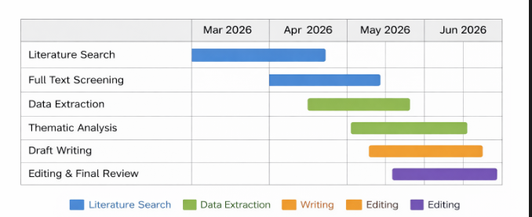 |  | Functional Neurological Disorder: A Multidimensional Review of Causes, Diagnosis, and Therapeutic Strategies in the UK  Aim  This study aims to critically examine evidence in the UK of the etiology, diagnostic models, and treatment approaches of the Functional Neurological Disorder (FND) in order to assess the prevailing practice and to suggest how to enhance health and social care services.  Methods for Data Collection and Analysis  Transparency and rigour will be achieved by conducting a structured review of the literature using PRISMA principles. Peer-reviewed journal articles will be used to collect the data, which will be synthesised using the thematic analysis. |  | “Integrated Neurobiological and Biopsychosocial Framework of FND”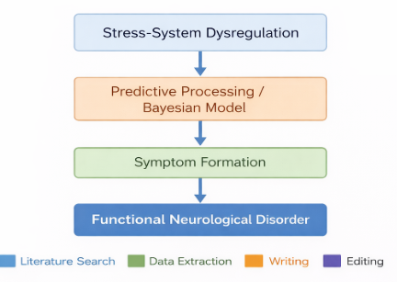
Methodology  The study utilizes the qualitative research method of secondary research, thereby taking a structured literature review design. Searches will be done on electronic databases such as PubMed, CINAHL, PsycINFO, Cochrane Library and Google Scholar.  Search/key terms will include: “Functional Neurological Disorder” OR “FND” AND “United Kingdom” OR “UK” AND “etiology,” “diagnosis,” “treatment,” and “multidisciplinary.” Boolean operators will refine searches.  Inclusion criteria:  - Peer-reviewed articles  - Published 2014–2024  - UK-based studies  - Adult populations (18+)  - Focus on causes, diagnosis, treatment, or service delivery  Exclusion criteria:  - Non-UK studies  - Grey literature  - Opinion pieces  - Case reports without broader analysis  Such a systematic methodology will help to be relevant to clinical scenarios in the UK, where the problem of variability in diagnoses and service inconsistencies remains acute (Varley, 2023; Russell et al., 2022). |  |  |  | Data Analysis  Information will be summarized into a structured table with authors, year, the study design, sample characteristics, major findings, and limitations. Thematic analysis approach will then be practiced in order to determine patterns and conceptual associations across studies.  Themes are expected to include:  - Neurobiological and stress-related mechanisms (Weber, 2022)  - Predictive processing and Bayesian models (Pagnini et al., 2023)  - Diagnostic complexity and subtype variation (Kola & LaFaver, 2022)  - Multidisciplinary treatment pathways within UK services (Russell et al., 2022)  - Outcome measurement limitations (Nicholson et al., 2020)  - Service-user experiences and stigma (Foley et al., 2024)  Themes will be critically synthesised to highlight research gaps and implications for UK health service development.  Ethical Consideration  The research is a secondary analysis of peer-reviewed articles openly available on the Internet and does not include human participants. Hence, it does not need formal NHS ethical approval. Cheating will be avoided by proper referencing and following up the university research procedures. The work with the data will be conducted in a responsible and transparent way, and it will be in line with PRISMA reporting standards.

Data Collection
The collection of data will involve systematic database searches and title and abstract screening in accordance to the prepared inclusion and exclusion parameters. Eligibility of the articles will be carried out through review of full text. Only good peer-reviewed articles pertaining to practice in the UK will be used. This is a systematic method, which improves reliability and decreases selection bias.

References

Foley, C., Kirkby, A. and Eccles, F.J., 2024. A meta-ethnographic synthesis of the experiences of stigma amongst people with functional neurological disorder. Disability and Rehabilitation, 46(1), pp.1–12.
Kola, S. and LaFaver, K., 2022. Functional movement disorder and functional seizures: What have we learned from different subtypes of functional neurological disorders? Epilepsy & Behavior Reports, 18, p.100510.
Nicholson, T.R., Carson, A., Edwards, M.J., Goldstein, L.H., Hallett, M., Mildon, B., Nielsen, G., Nicholson, C., Perez, D.L., Pick, S. and Stone, J., 2020. Outcome measures for functional neurological disorder: A review of the theoretical complexities. The Journal of Neuropsychiatry and Clinical Neurosciences, 32(1), pp.33–42.
Pagnini, F., Barbiani, D., Cavalera, C., Volpato, E., Grosso, F., Minazzi, G.A., Vailati Riboni, F., Graziano, F., Di Tella, S., Manzoni, G.M. and Silveri, M.C., 2023. Placebo and nocebo effects as Bayesian-brain phenomena: The overlooked role of likelihood and attention. Perspectives on Psychological Science, 18(5), pp.1217–1229.
Russell, L., Butler, L., Lovegrove, C., Owens, C., Roberts, L., Yates, P., Carrick, R., Amoako, A. and Price, C., 2022. Developing a multidisciplinary pathway for functional neurological disorders in a UK National Health Service: The Exeter model. ACNR: Advances in Clinical Neuroscience and Rehabilitation.
Varley, D., 2023. The clinical management of functional neurological disorder in UK health services: A mixed-methods study of diagnostic assessments, treatments, experiences and perspectives.
Weber, S., 2022. The role of stress in neuropathophysiological mechanisms of functional neurological disorders. Doctoral dissertation. University of Zurich.

