Boycho Nikolov
Student ID: 2115531

Netwotk Programmability (ACCA5029_LON)
Assessment 1
Boycho Nikolov
2115531@student.uwtsd.ac.uk

Contents
Netwotk Programmability (ACCA5029_LON) 0
Introduction: 2
Task Description: 3
Analysis and evaluation of Infrastructure as Code (IaC). 3
Configuration management and orchestration tools, Chef, Ansible, Salt stack, Terraform. 4
1. Ansible 4
2. Chef: 5
3.Terraform: 6
Key scripting languages for network programmability, e.g., Python, JavaScript, Bash, PowerShell 7
Python: 7
JavaScript: 7
Bash: 7
Necessary auxiliary technologies for network programmability, e.g., Linux, JSON, YAML and relationship with DevOps. 7
Linux 8
YAML 8
API programming and networking automation 8
Conclusion: 8
Bibliography 9

Introduction:

Network programmability is the ability to automate network configuration and management tasks using programming languages and tools. This approach to network management has become increasingly important due to the growing complexity of modern networks, the need for faster deployment of new services, and the demand for more agile and flexible network infrastructure.

Studying network programmability can help individuals and organizations to
Increase operational efficiency: By automating routine tasks such as network device configuration and monitoring, network programmability can reduce the time and effort required to manage networks, freeing up IT staff to focus on more strategic projects.

It also will Improve network agility: Programmable networks can quickly adapt to changing business needs and enable faster deployment of new services, applications, and infrastructure.

It’s important to study because Automation can help to ensure consistent network configurations and enforce security policies across the entire network, reducing the risk of misconfigurations and security breaches.

Learning Future-proof network infrastructure As new technologies and trends emerge, programmable networks can easily integrate new features and capabilities, making it easier to stay ahead of the curve and avoid costly network upgrades.

Overall, studying network programmability can help individuals and organizations to build more efficient, agile, secure, and future-proof networks.

Task Description:
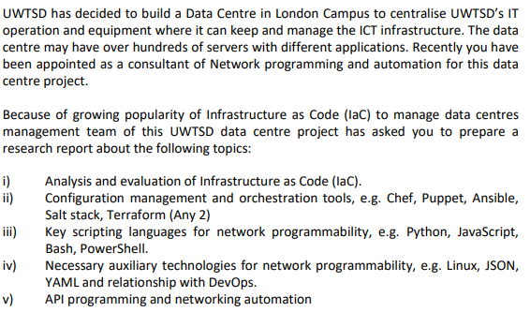

Analysis and evaluation of Infrastructure as Code (IaC).

Infrastructure is an important part of the software development process as it is directly responsible for the smooth running of the software application. Servers, load balancers, firewalls, databases, and complex container clusters are examples of infrastructure.
Because infrastructure difficulties permeate the entire development process, they are relevant outside of production situations as well.
These include CI/CD platforms, staging environments, and testing tools, among other things.
As software product complexity increases, these infrastructure challenges become increasingly critical. The traditional technique of manually managing infrastructure is quickly becoming a non-scalable solution to meet the aspirations of today's DevOps-based rapid software development cycles.
As a result, Infrastructure as Code (IaC) has become the de facto development solution today. Infrastructure as Code (IaC) allows you to scale and track infrastructure changes as they occur.
We'll take a closer look at infrastructure as code in this instalment, including its benefits, why it's vital, and more details.
What Is Infrastructure as Code?
Infrastructure as code could be called the process of deploying and using code, rather than manually configuring the appropriate devices and systems. Developers run scripts after defining code parameters, and the IaC platform automatically generates the infrastructure. Such automated IT configurations allow teams to quickly build the necessary cloud setup to test and launch their product. Infrastructure as code will allow any developers to create any infrastructure component needed, for example, databases, virtual machines, or different connection types.
In layman's terms, it's the process of delivering and managing infrastructure defined using code, not by hand. IaC is also an important DevOps technique that is required for a fast software delivery lifecycle.

Configuration management and orchestration tools, Chef, Ansible, Terraform.

Infrastructure as Code, or IaC, has revolutionized the way IT infrastructure is built and maintained since its debut more than a decade ago.
Creating a new infrastructure used to arrange physical servers, establish network connections, and store equipment in a data centre. The software can now be used to create an infrastructure that is more efficient, cost-effective, and secure.
In addition, thanks to the move away from historical change management, teams can now deploy widely vetted but fully uncontrolled new processes in minutes, not days, by following standard procedures for provisioning and updating systems, as well as their configuration.
In this article, we'll look at the top three infrastructure-as-code products that have great reputations for automating complex and time-consuming operations like device configuration, provisioning, and deployment at scale.[1]

Here is the most popular Orchestration Tools:

1. Ansible
Ansible was created by RedHat with the goal of promoting simplicity. It contributes to IT modernization and helps DevOps teams deploy applications faster, more reliably and more coordinated.
Without worrying about meeting compliance standards, you can easily create multiple identical setups with security baselines. From a business perspective, Ansible provides a competitive advantage by freeing up the organization's time to implement innovation and strategy, as well as align IT with business requirements.
Ansible uses YAML-based configuration modules called "Playbooks" to set the planned end state of your infrastructure as an IaC tool. Ansible allows you to develop your own modules and plugins if you encounter a problem that the default modules can't solve.
It is believed to be the simplest method to automate the provisioning, setup and maintenance of applications and IT infrastructure.[1]
Why Ansible is good:
- In terms of implementation, configuration, and ease of use, it's a simple tool.
- It configures the servers and runs them correctly.
- Custom modules allow Ansible to be fully customized. There is also now a large official repository of extensions and add-on modules.
- Any machine-level tasks you need to perform to set up an environment should be automated.
- For testing, verifying, and configuring VMs and container images, Ansible works incredibly well with Jenkins in a CI pipeline.
- Since Ansible is agentless, all activities are done via SSH. This means you won't need to install any software on the server running Ansible.[2]

Cons:
- Ansible has a hard time handling large and complex inventories. Improvements in inventory handling can make a significant difference.
- Community Edition lacks built-in scheduling.
- Ansible's free training and tutorials don't provide the same level of detail and ease of use for first-time users.
- YAML syntax can be difficult to understand. It can be difficult to determine the exact location of a syntax error.

2. Chef:
Chef is another one of the most well-known IaC tools in business. Chef uses a procedural style language in which the user must write code and determine how to achieve the desired state step by step. It is up to the user to choose the best deployment method.
Chef lets will let anyone developer create recipes and cookbooks and start using Ruby-based DSL.
These recipes and cookbooks detail the processes required to configure your applications and utilities on existing servers to your liking. Its complete flexibility, along with built-in drift minimization and the ability to define policies as code, makes it scalable and applicable in any CI/CD pipeline.
This infrastructure management solution is designed to help you implement and model a scalable and secure infrastructure automation process in any environment.
Why Chef is Good:

- Chef has pre-packaged templates that make it easy to manage infrastructure ranging from low to significant complexity.
- Chef is easy to work with. Many Chef materials follow similar principles, making it very easy to construct basic cookbooks from scratch.
- Chef is working hard to equip Chef Automate with significant integrations that will allow it to reach its full potential.
- Cookbooks are one of Chef's best features because they allow for quick adoption.
- There is a wealth of material to help you achieve almost any goal with Chef.
Cons:

- Domain-specific language is powerful but takes some practice.
- The variety of tools can be confusing.
- At first, the chef may seem intimidating.

3.Terraform:

The most widely used and open-source infrastructure automation tool is HashiCorp Terraform. It supports infrastructure such as code configuration, provisioning, and management.
Terraform makes things very easy to create and build IaC across multiple infrastructure providers using a single process. The required infrastructure is defined as code using the declarative technique. Before upgrading or provisioning infrastructure, terraform allows users to perform a pre-implementation check to see if the settings satisfy the expected results.
Through a simple and consistent CLI procedure, you can have the architecture of your choice across multiple cloud providers.
It also supports various providers including Digital Ocean, GitHub, Cloudflare and others. Terraform also has a source control feature that allows resource destruction. When working with hybrid clouds, this functionality is critical because plans can be generated across multiple cloud providers and infrastructures using the same process.

Why is good:

- Many infrastructure providers are supported/integrated, this includes AWS, Google Cloud, Datadog, GitLab, Heroku, and SignalFx.
- Rapidly deploy infrastructure as code. It's easy to set up the environment and get started, developing quickly.
- It simplifies cloud state management much more than native solutions provided by service providers.

Cons:
- Lacks a graphical user interface, which would make it much easier to use.
- Refactoring infrastructure code can be time-consuming and often requires the creation of new resources (such as renaming resources)
- Terraform has its own DSL, HashiCorp's configuration language, which takes some time to learn.

Key scripting languages for network programmability, e.g., Python, JavaScript, Bash, PowerShell

In this research, it will be will briefly introduce most popular programming languages, relating them to web development and the ability to create web applications and websites with them.

But before that, see how the popularity of programming languages is determined. Because it turns out that this is very difficult and only somewhat possible, based on a wide range of data, rankings, and measurements.

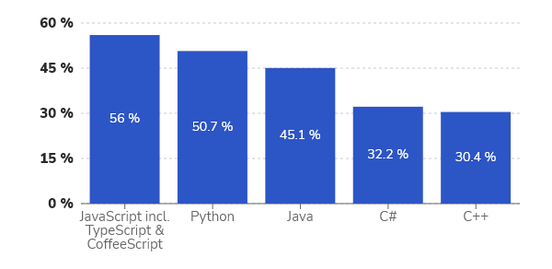
Figure 1
If there is one programming language that can be said to be the most popular and most used, it is JavaScript. It is an essential component in front-end web application development. For the ninth year in a row, it is in first place in the ranking of the most used programming language on StackOverflow (the most famous portal for developers). Figure 1.

Pros of the three languages listed by the developers at Figure 2, source:
www. stackshare.io.[3]
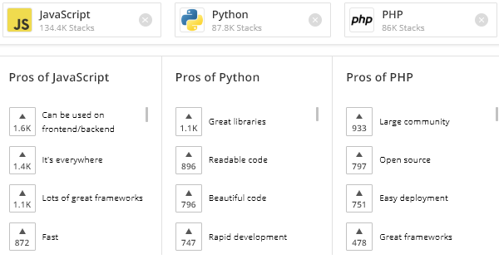
Figure 2

Python:

What is Python used for and what are its benefits?
Python is one of the most popular programming languages, which is used in many different fields - from the development of web applications and those for the desktop environment, to data analysis and management of training models for machine learning (machine learning).

Python is a programming language invented by Guido van Rossum in 1990. Python is a general-purpose programming language, unlike, for example, PHP, which is primarily intended for use on the web. Python is much easier to learn compared to other programming languages. Applications written in Python are compact and easy-to-read code for developers, and are often shorter than their equivalents written in, for example, C/C++.
Python is installed on most GNU/Linux distributions.

The creator of Python is a fan of the British comedy group 'Monty Python'. And in her honour, he named his programming language Python.

Python has following benefits:
- Readable and beautiful Python code
Python code looks very close to the way people think. This means a high-level language - the details that the "machine" understands like memory management, pointers, etc. are hidden behind words, and the utterance resembles the use of human language.
Sample Python and C++ code with the same goal, Figure 3.
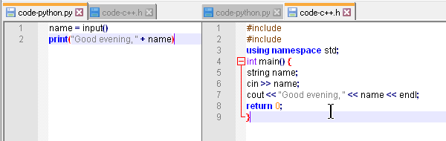
Figure 3
Python's syntax is simple and allows for more to be achieved with fewer lines of code compared to other programming languages.[4]
- Open Source and great libraries
Python is open source and has a large community of enthusiasts, programmers, developers, and data experts.
Python has a modular design – it has a single core that has no preference for the purposes or environment in which it will be used. Modules or libraries can be added to the kernel that make it suitable for different environments and purposes.

Since the language is open source and of a decent age, many modules have been created for it, which expand the scope of its use. The large community has also generated many modules and language improvements.
These modules can be installed through the pip package manager.

For example, if you want to install Django, you can use, Figure 4:
Figure 4

- Wide application
Python is used for a variety of purposes - web applications, machine learning, desktop applications, specific software tools and system scripts, image processing, graphic design, and more. He is everywhere![5]

Python could be used for:

- GUI based desktop applications.
- image processing and graphic design.
- Games.
- web applications, web sites, web software frameworks.
- Corporate and business applications.
- Network applications and operations.
- Scientific purposes - research and computing and data science.
- Prototypes of software products

- Python for the web
Although Python was not created with the thought or purpose of being used specifically for the web, there are many modules built into it that can be used to create web applications and sites.
- Python for Data Science
Python's widespread adoption in scientific circles is due to the extensive and mature collection of tools for mathematical functions and statistics, as well as the ease of use of the language. As a result, Python has become the language of choice for programming and developing systems for machine learning, modelling, and Big Data analysis.

In Conclusion with Python, developers "code" faster, which optimizes product development time. At the same time, the code is easier to maintain due to its easy readability. Thanks to the large number of great Python libraries, developers do not have to create everything from scratch and use already created tools.

If you need a programming language that is easy, and you have big data to analyse, and apart from that you operate on the web, then your first choice will be Python. This is of course the optimal combination of needs, but even if you don't need it for big data.

JavaScript:

JavaScript is one of the main components of the web along with HTML and CSS. It is used in the development of websites, web applications, games, and mobile applications.
In 1995, Netscape (the company created by the developers of the first web browser with a graphical interface - Mosaic) decided to expand the capabilities of its new web browser, Netscape Navigator, by adding support for a scripting language. After initial attempts to embed the Java and Scheme programming languages, Brendan Icke came up with an entirely new interpreted programming language, which he called Live Script. When the new version of the browser was released in December 1995, the language was renamed to JavaScript. As it was later understood, Netscape's choice of the name was influenced by the popularity of Java at the time and the possibility that the new scripting language would thus attract more attention.
JavaScript should not be confused with Java; they are two separate technologies. Java is a programming language whose programs are compiled before being executed, while JavaScript is a scripting language that is executed by an interpreter (JavaScript engine). Such an interpreter is available in web browsers and in the Node.js server platform.[6]
Until the advent of JavaScript, websites were static pages containing only text and images. With the addition of JavaScript, pages are animated by using various functionalities such as:
Changing the appearance of objects - resizing, moving, showing, hiding.
Validation of data entered in form fields.
Loading new content without the need to reload the page (Ajax).
Tracking visitor behaviour (for analytics, personalization) and more.

Here are the most distinctive features of JavaScript:

- It can be used in Front-end and Back-end development.
- JavaScript is everywhere.
- There are many great frameworks out there.
- Others: fast, light, flexible, nowadays there is no device that does not support it.

Necessary auxiliary technologies for network programmability: Linux, JSON, YAML and relationship with DevOps.

Linux:

JSON:

To understand the utility and importance of JSON, we need to understand a little about the history of interactivity on the Internet. In the early 2000s, website interactivity began to change. At that time, the browser only served to display information, and the web server did all the work of preparing the content for display. When the user pressed the button in the browser, the request was sent to the server, where the HTML page was assembled and sent ready for display. This mechanism was slow and ineffective. This required the browser to re-render everything on the page, even if only a small portion of the data changed.

At that time, transfer billing was based on the amount of data transferred, so developers realized that reloading an entire page was very expensive and considered new technologies to improve the user interface. After that, the ability to create background web requests that was added to Internet Explorer 5 turned out to be quite a viable approach to loading data in stages for display. Instead of reloading the page, clicking the button will simply execute a web request that will run in the background. Content will be updated as soon as it is loaded. It can be controlled using JavaScript, the universal programming language for browsers.

Originally, the data was transferred in XML format, which was difficult to use in JavaScript. JavaScript already had objects that were used to represent data in the language, so Douglas Crockford took the JS object syntax and used it as a specification for a new data exchange format called JSON. This format was much easier to read and parse in a JavaScript browser. Soon developers started using JSON instead of XML.

Fast data exchange JSON is now the de facto standard for transferring data between server and client. mobile applications and even internal system services.
On Figure 5 could be seen JSON file:
The JSON format is commonly used to handle (store and use) service information. This is usually a staff table that neither the developer nor the audience of the web resource should see.[7]

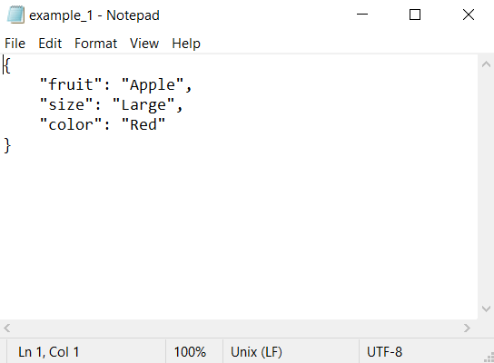
Figure 5
While JSON is a relatively short and flexible data format that is easy to work with in many programming languages, it has some drawbacks. Here are some limitations:

- There is no structure. On the one hand, this means that you have complete flexibility to present your data in any way you want. On the other hand, you can easily store unstructured data.
- Only one number type. IEEE-754 double-precision floating-point format is supported. That's pretty good, but you can't use the variety of numeric types that other languages have.
- There is no date type. developers must use string representations of dates, which can lead to formatting inconsistencies. Alternatively, use the number of milliseconds since the start of the Unix era (January 1, 1970) as the date.
- No comments yet - you won't be able to comment fields that require it right in the code.
- Verbosity - although JSON is less verbose than XML, it is not the shortest format for data exchange. For high-performance or specialized services, you'll want to use more efficient formats.
In conclusion, JSON is a data format mainly aimed at sending data between web servers and browsers or mobile applications. The format is simple in design and flexibility, easy to read and understand, and easy to work with in most programming languages. The lack of a strict schema provides flexibility in format, but this flexibility sometimes makes the data difficult to read and understand.

You may find JSON difficult to work with in strongly typed languages like Scala or Elm, but the format's wide adoption means there are utilities and libraries to help with even complex problems.

YAML:

YAML stands for "YAML Ain't Markup Language." It is a human-readable data serialization format that is often used for configuration files in network programmability. YAML files use a syntax that is designed to be easy to read and write by humans, making them an ideal choice for configuration files that may need to be modified frequently.
YAML is important for network programmability for several reasons:
It is lightweight: YAML files are smaller than other data serialization formats like XML, which makes them faster to parse and easier to transmit over the network.
It is easy to read and write: YAML syntax is designed to be easy for humans to read and write, which makes it more accessible to network engineers and developers who may not have extensive programming experience.
It supports complex data structures: YAML supports complex data structures such as arrays and nested dictionaries, which makes it ideal for storing network configuration data that may have multiple layers and dependencies.
It is language-agnostic: YAML is not tied to any specific programming language or platform, which makes it a versatile choice for storing and transmitting data between different systems.
Overall, YAML is an important tool for network programmability because it provides an easy-to-read and easy-to-write format for storing and transmitting network configuration data. By using YAML files to store configuration data, network engineers and developers can automate network management tasks more easily and efficiently, leading to faster deployment of new services and a more agile and flexible network infrastructure.[8]

API programming and networking automation:

Conclusion:

In conclusion, studying network programmability is crucial for individuals and organizations who want to keep pace with the rapidly changing networking landscape. By leveraging programming languages and tools to automate network configuration and management tasks, network programmability can improve operational efficiency, network agility, security, and futureproofing of network infrastructure. Therefore, individuals who want to enhance their skills in network management and stay competitive in the industry should consider studying network programmability.

Bibliography

[1] “IT Automation with Ansible.” https://www.ansible.com/overview/it-automation (accessed May 07, 2023).
[2] D. Hall, “Ansible configuration management : leverage the power of Ansible to manage your infrastructure efficiently”.
[3] “JavaScript vs PHP vs Python 2023 Comparison of Languages.” https://stackshare.io/stackups/javascript-vs-php-vs-python (accessed May 07, 2023).
[4] “About PythonTM | Python.org.” https://www.python.org/about/ (accessed May 07, 2023).
[5] “Python Machine Learning - Sebastian Raschka - Google Books.” https://books.google.co.uk/books?hl=en&lr=&id=GOVOCwAAQBAJ&oi=fnd&pg=PP1&dq=Python&ots=NdfyLfQTYL&sig=OGpF58l2gaIka4shsIcsb33UI5E&redir_esc=y#v=onepage&q=Python&f=false (accessed May 07, 2023).
[6] “Beginning JavaScript - Paul Wilton - Google Books.” https://books.google.co.uk/books?hl=en&lr=&id=-mp4J3nVS6MC&oi=fnd&pg=PR6&dq=JavaScript&ots=izImHaQJTe&sig=qvBkumvidpPsUAsphZmdfr23ny8&redir_esc=y#v=onepage&q=JavaScript&f=false (accessed May 07, 2023).
[7] “Comparison between JSON and YAML for data serialization”.
[8] “YAML Ain’t Markup Language (YAMLTM) revision 1.2.2.” https://yaml.org/spec/1.2.2/ (accessed May 07, 2023).

