

Academic Skills Report

Name of the university: University of Wales Trinity Saint David (London Campus)
Student Name: Cherelle Egan
Student ID: 2443051
Module Code: LCLM4001
Module: Academic Skills
Lecturer: Timothy Hopkins

Table of Contents
- Introduction……………………………………………….
- Description of experiences……………………………
- Personal Reflection/Evaluation……………………………………...
- Analysis…………………………………………………….
- Conclusion………………………………………………...
- References………………………………………………...

Introduction

This is a reflective report about some of the things I have learnt this far during my Academic skills module. Reflection is important as it helps refresh your memory. Reflection is also important part of learning through experience.

This term in Academic kills I learnt about something new each week. In The first week i had an introduction to the module and learnt about which academic skills we would need throughout our business studies. We were also shown different techniques about how to use our time efficiently when learning.

We were not only introduced to the module but also who we could go to if we needed help. Lizeta Demetriou who is the general manager of the programme, she organises any events or student activities and is also there to help with any queries related to the course. Naomi Doerge is the Deputy Programme manager and is there Offering support/guidance to students on matters concerning attendance, engagement, and academic support.

Description Of Experiences

There are many methods to help students with time management, two of which are The Pomodoro Technique and The Eisenhower Matrix.
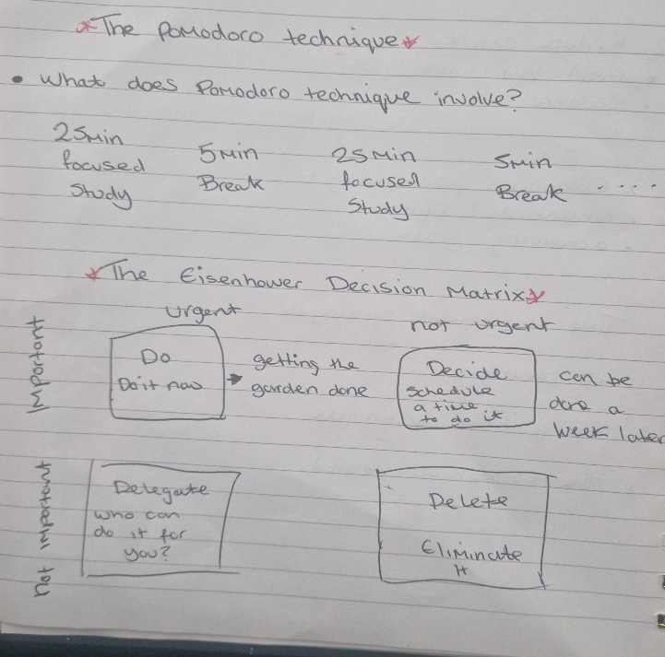
Source (Author)
These methods really made me think about how I can improve on my time management not only for my studies but in my day-to-day life.
The Pomodoro Technique is a time management method that involves working in focused intervals of 25 minutes, called "Pomodoros," followed by short breaks to enhance productivity and reduce burnout.
The Eisenhower Matrix, also known as the Eisenhower Box or Urgent-Important Matrix, is a time management tool that helps individuals prioritize tasks based on their urgency and importance. It divides tasks into four quadrants.
In class we were asked to draw our own Eisenhower Matrix, inputting things we my do in our lives at home that are Important, not important, urgent and not urgent. This was so we knew how to use it when doing any course work in the future. (as shown in picture above)
The Pomodoro Technique has especially helped as I get easily distracted, so the short breaks in-between studying allowed me to regain focus. I feel the Eisenhower Matrix has also been beneficial, not only in class but in my day to life.

Personal Reflection

Looking at what I have learnt so far, I am excited for the next term. I do think I have been able to do the work at hand well, but I get easily distracted. I will continue to use the techniques I have spoken about to help me stay focused and organised. As I said previously these methods have helped me in class and in day to do tasks. These are methods I wish I had been shown before.

Analysis

The two methods I have focused on in this report have both worked for me for different reasons. The Poromodo technique worked for the times I was studying as it gave me short breaks in-between. Doing this ensured I I kept my focus and didn’t get too tired. The Eisenhower also worked in the same kind of way helping me organise what I should make priority. |
Even though these methods have been helpful, I still get easily distracted and can still be a little unorganised in some aspects of my studies and day to day life. I think that if I use these methods more often, I will be able to have a more successful next term.
I will also try other techniques we have be shown, and this will help me decide what works best for me in the future.
Practicing mindfulness means maintaining moment-to-moment awareness of where you are and what you’re doing — which is great news when trying to stay focused. By being mindful and recognizing when your attention starts to drift, you can quickly bring your focus back to where it needs to be.

Conclusion

My Overall conclusion is that with out proper time management and understanding of whichever course or activity you are taking part in, it can make it difficult to complete. The methods I have learnt will help me with my course going forward. And if they do not work for some parts I know that there are other techniques, I can investigate practicing. Always try a variety of methods to find the ones that work for you.

References

Page 1: Tile: Week 1- Introduction to the Module and Time Management | Academic Skills (LCLM4001_LON) | Home

Page 2: https://www.todoist.com/productivity-methods/pomodoro-technique
https://www.bing.com/search?q=the+pomodoro+technique+explained&FORM=HDRSC1&daf1=1

https://www.bing.com/search?q=images+of+insert+tab&cvid=6df3111b577042eeb1546acc552633ac&gs_lcrp=EgRlZGdlKgYIABBFGDkyBggAEEUYOTIGCAEQABhAMgYIAhAAGEAyBggDEAAYQDIGCAQQABhAMgYIBRAAGEAyBggGEAAYQDIGCAcQABhA0gEJNjc2NjNqMGo5qAIIsAIB&FORM=ANAB01&DAF1=1&PC=LCTS

Page 4: https://www.healthline.com/health/mental-health/how-to-stay-focused#set-a-smart-goal

