

Student Name : Goodwin Zigona
Student Number : 2425307
Module Name : Change Makers: Creativity and Value Creation
Module Code : BMHP5014
Lecturer : Zara Ahmed

Component 2
Written Assignment
Change Makers: Creativity and Value Creation

Table of Contents
Written Assignment 3
Pitch 4
References 7

Written Assignment
References
Jane Osareme, O., Muonde, M., Maduka, C.P., Olorunsogo, T.O. and Omotayo, O., (2024). Demographic shifts and healthcare: A review of aging populations and systemic challenges. Int J Sci Res Arch, 11(1), pp.383-95.
Masterson, D., Areskoug Josefsson, K., Robert, G., Nylander, E. and Kjellström, S., (2022). Mapping definitions of co‐production and co‐design in health and social care: a systematic scoping review providing lessons for the future. Health Expectations, 25(3), pp.902-913.
Satpathy, S., Khalaf, O., Kumar Shukla, D., Chowdhary, M. and Algburi, S., (2024). A collective review of Terahertz technology integrated with a newly proposed split learningbased algorithm for healthcare system.
Wood, R.M., Fox, S.S., Morgan, L.E. and Walton, N.S., (2025). The NHS waiting list in England must halve to reach waiting time targets. Future Healthcare Journal, p.100478.
Grandviewresearch, (2026). UK healthcheckup market.[Online]. < https://www.grandviewresearch.com/industry-analysis/uk-health-check-up-market-report>. [Accessed on: 13 June, 2026]
Statista, (2026). Share of problems.[Online]. < https://www.statista.com/statistics/1274307/problems-with-national-health-care-system-in-great-britain/?srsltid=AfmBOopdcJoKum2VDIRIceifL9Niv6tKkyOdBXwZmKoGJQ63wLtwCONd>. [Accessed on: 13 June, 2026]

i) Conclusion
Based on the above analysis or key points, it is concluded that Mobile Health Pods are significant or valuable for improving the well-being of individuals, especially the ageing population in the UK, while travelling from one place to another. The product can help handle emergency situations in many public places where people often visit for various reasons, which defines the need for its adoption. The appropriate development of a timeline can help complete the implementation of Mobile Health Pods within one year.
h) Dissemination
How the innovation will be promoted and disseminated
The innovation can be promoted by selecting effective and useful methods. It can include campaigns, and digital platforms such as social media. Thus, the main objective will be to inform communities and local people about accessibility, benefits and availability of Mobile Health Pods. The innovation will also be disseminated to stakeholders, including healthcare professionals, relevant institutions and the public through professional training workshops, healthcare conferences and social media campaigns.
g) Technology integration
Technology integration
Technological integration is the seamless incorporation of advanced systems and digital tools into day to day activities, routines and operations (Satpathy et.al 2024). Use of apps, data or AI security systems can be integrated into the innovation in an appropriate manner as technology is at the core of the new product or innovation, will enable the delivery of accessible, patient centered and efficient healthcare services in public places. Any form of technology can be implemented through telemedicine, mobile applications and AI connected diagnostic devices.
How technological aspect enhance effectiveness
The above technological aspects can enhance the effectiveness of the solution by providing required and time effective services.


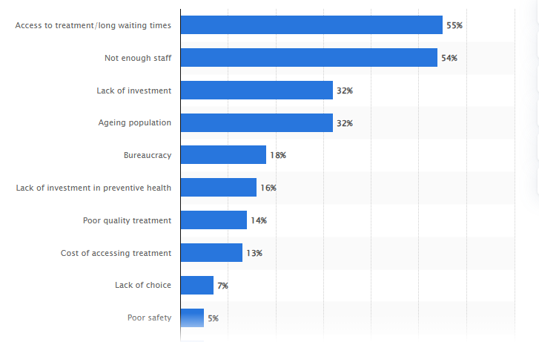
Access to healthcare and accessibility is key problem in UK (Statista, 2026)
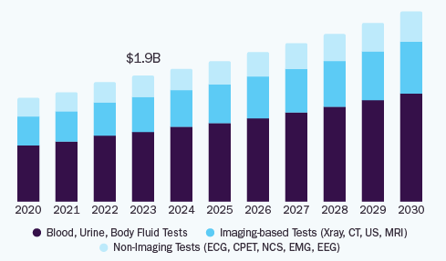
Healthcare checkup market is growing so introducing new services in sector may be useful (Grandviewresearch, 2026).
f) Development and regulations
Relevant regulations and standards
The innovation must comply with several relevant healthcare regulations and standards. For example, to ensure effective and safe operation within the UK health and social care sector, Mobile Health Pods must comply with the Health and Social Care Act 2008. It establishes the regulatory term or framework for H&S care services in England (Masterson et.al 2022). It can also comply with Care Quality Commission regulations, which regulate H&S care services in the UK. The innovation provider must obtain CQC registration when providing regulated activities, such as remote clinical consultation. They should follow key standards such as safe care, safeguarding service users and staffing competency. The Data Protection Act 2018 must be complied with to handle personal data.

e) Timeline
Concise timeline

Months | Rollout phases | Activities
Months 1-2 | Needs assessment, site selection and planning | Determine healthcare access gaps, community groups and consult NHS stakeholders and healthcare professionals.
Months 3-4 | Design and development | Design Mobile Health Pod infrastructure, diagnostic equipment, install telemedicine systems and digital health records.
Months 5-6 | Prototype testing | Conduct technical testing, train staff, ensure compliance with NHS standards and perform pilot simulation.
Months 7-8 | Pilot deployment | Launch mobile health pods in chosen public locations such as airports, shopping centers’ and train stations, along with underserved communities.
Months 9-10 | Monitoring and evaluation | Gather data on patient usage, healthcare results and satisfaction.
Months 11-12 | Full rollout and integration | Expand deployment to additional place and integrate services with NHS primary care.

c) Target Audience and Impact
Demographic
Demographics are the characteristics of a population recognized by distinct criteria (Jane et.al 2024). The primary beneficiaries of the new product will be individuals who face barriers to accessing traditional healthcare services within the UK. For example, the key demographics who will benefit from the innovation are older adults’ aged 65+, people living in remote and rural areas, and low-income populations.
How innovation improve the health and well-being
The innovation can improve the health and well-being of this group and impact positively as it can contribute to the common good by increasing access to promptly and preventative healthcare services. The pods can provide consistent access to blood pressure, glucose, and oxygen saturation analysis.

d) Implementation
Where, whom and how
The innovation can be implemented or located in train stations, shopping centers and airports, along with other community based public locations where individuals can conveniently access healthcare services without waiting for too long. The implementation of Mobile Health Pods will include collaboration between different stakeholders within the UK H&S care sector. The list of stakeholders will include NHS integrated care systems, healthcare experts, local authorities, community and voluntary firms and technology and medical device providers. The innovation can also be implemented by following the six phases, including planning and site selection, design and development, prototype testing, pilot deployment and others.

b) The issue/gaps in health and social care
Why the innovation is needed and evidence
Innovation in the form of Mobile Health Pods in public areas across the UK is needed due to the growing demand for healthcare services. Thus, it is determined that the UK’s healthcare system is experiencing unexpected demand due to an ageing population, increased healthcare use, demand for better services, and rising chronic disease prevalence. According to NHS England, waiting lists for elective care exceeded 7 million patients, while demand for GP appointments continues to increase yearly (Wood et.al 2025). Long waiting times for treatment and appointments, and delays in intervention and diagnosis are key identified gaps, defining the need for an innovative solution or product in the country. Moreover, the Mobile Health Pods are needed in the UK due to the lack of self-service stations and their limited availability. The developed innovative solution can provide routine health assessments, blood pressure, oxygen saturation, and glucose and telehealth consultations.

a) Title and innovative overview
Proposed innovation
Product- Mobile Health Pods in Public Places
The proposed innovative solution that can help to enhance the health and social (H&S) care experience of service users, patients or health and social care professionals in the UK is Mobile Health Pods, a product. The best thing about this product is that it can support a health and social care cause: the provision of insufficient self-service stations in the UK for healthcare in public areas, including airports, shopping centers’, and train stations. Mobile health pods are autonomous, self-contained micro clinics that will be placed in high-traffic public areas.

Written Assignment

Pitch
The first main point is an issue in health and social care; access to timely and preventive healthcare remains a significant issue. Modern healthcare systems are facing a perfect storm of demographic shifts and rising patient expectations (Bansal et.al 2022). An ageing population requires longer hospital stays and complex, specialised care. Systematic barriers like long wait times and knowledge gaps lead to delayed care. This led to worse symptoms and costly conditions. Patients with low levels of education and people living farther from healthcare settings experience delayed appointments. Additionally, long waiting times and diagnosis delays can severely impact health outcomes and disease progression.
Another major issue is insufficient access to preventative healthcare, which drives up health inequities in health and social care. Moreover, barriers like high costs, lack of health insurance, geographical isolation, and physician shortages prevent early detection and holistic disease management (Whittaker et.al 2022). Also, delaying care until symptoms become severe allows silent conditions like hypertension, diabetes, and certain cancers to progress unchecked. This lack of preventive screening leads to late-stage diagnoses, which are more expensive and less responsive to treatment compared to early interventions. Health inequalities are another significant issue which affect health and social care outcomes (Bansal et.al 2022). This is mostly experienced by the rural population because of prohibitive out-of-pocket costs, severe shortages of rural providers, and a lack of transportation. This results in delayed treatment and heavier reliance on emergency services. Patients with low income are not able to take treatment because of high medical expenses and inadequate insurance coverage.
Another main point is target the audience and impact; the older adults aged 65 will gain benefits from Mobile Health Pods. This innovation will remove barriers to care by bringing preventative healthcare within the community. By placing these convenient screening kiosks in high-traffic areas like malls, transport hubs, and community centres, the chosen demographic can easily gain access to treatment. Mobile health pods will be integrated with IoT sensors, which help in measuring important signs like glucose, blood pressure and oxygen saturation quickly. The innovation will provide appointment-free screening, which makes representative healthcare more accessible in public spaces. This can allow telehealth consultations to immediately connect patients with professional advice, removing barriers like long travel times and clinic waitlists. Additionally, virtual services reduce logistic barriers helps in making care accessible for patients in rural areas (Angyal et.al 2022).
Similarly, Mobile Health Pods can also eliminate geographical and logistical barriers to care, bringing essential screenings and routine diagnostics directly to local neighbourhoods. This proactive innovation can ensure early detection of chronic conditions, ultimately preventing severe, costly medical emergencies. Furthermore, early detection is a powerful preventive tool that empowers patients to address health risks before they progress into life-altering emergencies (Nyashanu et.al 2022). This innovation will decentralize healthcare by bringing consultation directly within communities. This model will also reduce wait times, prevent issues and mitigate healthcare costs for the chosen demographic. This creates a patient-centric ecosystem which aims to balance public health access with economic and environmental sustainability.
Another point is implementation that can improve the health and well-being of the demographic or have a positive impact on their physical, emotional, and cognitive well-being. Thus, the implementation of Mobile Health Pots will be supported by healthcare professionals and experts, as well as by technical expertise. Shopping centres, train stations, and other locations will be selected because they are highly accessible, especially for people who have difficulty accessing hospitals and medical services in emergency situations. NHS integrated care systems can integrate pod services with existing NHS services and local authorities can determine suitable community places and facilitate partnerships with local organisations. Healthcare professionals and staff can receive training on operating pod technologies, referral pathways, data management, and privacy procedures.
Along with the above three elements discussed in poster, the timeline is also considered a main point introduced in the poster and elaborated in detail. Thus, an appropriate, concise timeline is developed to show the major development and rollout phases of the innovation that will be introduced in the UK for everyone. A timeline can play an important role in completing a project or a set of tasks (Leong et.al 2023). Thus, it can help satisfy the needs of the target audience by providing timely, comfortable services without wasting their time. The service provider's initiative can also conduct an appropriate analysis to identify the extent to which people need Mobile Health Pods.
Development and regulations are key points that will support the implementation of innovation in an effective manner. Thus, the initiatives will be taken into account to have a positive impact on well-being and health of the demographic or targeted people. Current policy and legislation such as Health and Social Care Act 2008, Care Quality Commission regulations and Data Protection Act 2018 will be taken into account to conduct ethical practices and actions that can provide people assurance and build trust.
Technology Integration is the key process or point that will be considered to implement the innovation. Thus, it can focuses on enhancing results and increasing the effectiveness of the product. It can drive the attention of experts and service providers ahead integrating technologies such as AI and data security systems by taking suggestions from experts or technical expertise, with skills that they can use to provide expected outcomes. Technological aspects can enhance efficiency by reducing the need for travel to healthcare settings and provide quicker access to treatment and healthcare suggestion. It can also reduce pressure on emergency services.
Dissemination is another point, according to which Instagram, Twitter and YouTube will be used as digital marketing platforms to promote the innovation from the national to the global level. Mobile Health Pods will be disseminated through a multi channel approach tailored to different stakeholder groups. Experts can be engaged through conference and communication networks to reach the public. This tactic can promote awareness, support integration of innovation and encourage adoption into the UK H&S care system. The strategy can also enhance the performance and usefulness of the product in the market.

References
Angyal, A., Longet, S., Moore, S.C., Payne, R.P., Harding, A., Tipton, T., Rongkard, P., Ali, M., Hering, L.M., Meardon, N. and Austin, J., (2022). T-cell and antibody responses to first BNT162b2 vaccine dose in previously infected and SARS-CoV-2-naive UK health-care workers: a multicentre prospective cohort study. The Lancet Microbe, 3(1), pp.e21-e31.
Bansal, N., Karlsen, S., Sashidharan, S.P., Cohen, R., Chew-Graham, C.A. and Malpass, A., (2022). Understanding ethnic inequalities in mental healthcare in the UK: A meta-ethnography. PLoS Medicine, 19(12), p.e1004139.Code
Leong, J., May Yee, K., Baitsegi, O., Palanisamy, L. and Ramasamy, R.K., (2023). Hybrid project management between traditional software development lifecycle and agile based product development for future sustainability. Sustainability, 15(2), p.1121.
Nyashanu, M., Pfende, F. and Ekpenyong, M.S., (2022). Triggers of mental health problems among frontline healthcare workers during the COVID‐19 pandemic in private care homes and domiciliary care agencies: Lived experiences of care workers in the Midlands region, UK. Health & social care in the community, 30(2), pp.e370-e376.
Whittaker, H., Rubino, A., Müllerová, H., Morris, T., Varghese, P., Xu, Y., De Nigris, E. and Quint, J.K., (2022). Frequency and severity of exacerbations of COPD associated with future risk of exacerbations and mortality: a UK routine health care data study. International journal of chronic obstructive pulmonary disease, pp.427-437.

