NAME: KENNEDY NGANGA KAMAU
PROGRAMME: LEADERSHIP AND MANAGEMENT SKILLS FOR THE WORKPLACE
STUDENT NUMBER: 2018117
MODULE: WORKPLACE CULTURE AND ITS IMPACT ON ORGANISATION EFFICIENCY
MODULE CODE: BMSW 5105
LECTURERS NAME: NADEEM MIZRA
ASSIGNMENT TITLE: PART 1-INDIVIDUAL WRITTEN REPORT
: PART 2-INDIVIDUAL REFLECTIVE ESSAY

PART 1. INDIVIDUAL REPORT.

This report will be looking at how broader external environmental factors along with covid-19 and ethical dilemmas affect Barclays banks culture and its performance
Barclays bank is a British multinational universal bank headquartered in London, England. Built over centuries it traces its origin from two goldsmith bankers John Freame and Thomas Gould in 1690. It has experienced growth against the backdrop of challenges like financial crises, industrial and technological revolutions, international conflicts to name but a few. It has achieved notable milestones in the banking industry being the first bank in the world to deploy a cash dispenser in 1967 and launching the first credit card in the United Kingdom in 1966.
As one of the main successful banks, Barclays offers a wide range of products and services to individuals, partnerships, charity, organisations, and governments. From savings to mortgages, investment management, lending options, trust and bonds, insurance, wealth protection, Tailored investment solutions, to easy and flexible banking.
It is one of the largest banks in the United Kingdom coming second to Lloyds banking group. It has employed about 47686 thousand people operating in about 1600 branches around the country as of 2021, In October 2021 the customer satisfaction with the current account service provided by Barclays was ay 65 percent. (Statista, 2021)
Barclays has various operating markets which provides institutions and secondary market clients with execution services, market insights, risk management and financial solutions.

BARCLAYS MARKET SHARE
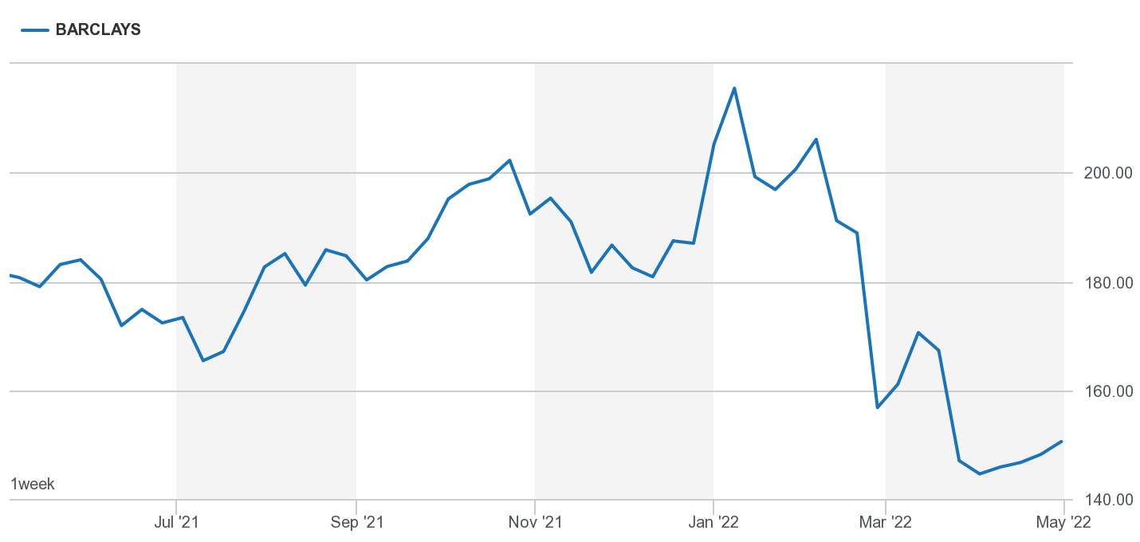
Diagram 1 (Anon, 2022)

From the above image we can see that Barclays market shares are selling at a good price though they have dropped significantly from over 200 at the beginning of the year to 150 this financial year 2022 due to some of the external environmental factors we shall be looking at in this report.

In this report I will focus on using several environmental analysis tools and techniques to expound how these factors affect organisational culture of Barclays and its performance.
I will use the PESTEL Analysis which is a tool or framework used to analyse and monitor the external marketing environment factors which impact an organisation. It focuses on the political, economic, social, technological, environmental, and legal factors. It is mainly used to determine the threats and weaknesses used in SWOT analysis.
The Porters five forces model will also be used for assessing and evaluating the position of Barclays bank in the banking industry and their current competitive position. This model explains the five forces that that drive the aggressiveness intensity and attractiveness of the market. It identifies where the power lies in Barclays and will help us understand Barclays current competitive position. The five forces are supplier power, buyer power, competitive rivalry, threat of substitution, and threat of new entrant.
We shall also look at the cultural web of Barclays, as this is what influences how work gets done, who is credible to do which work and how to do it, it also sets up the frame of mind people in the company should have. This usually have a major impact on the organisations work output and environment. The cultural web model was developed in 1992 by Kevan Scholes and Gerry Johnson and has six elements, stories, rituals and routines, symbols, organisational structure, control systems, and power structures. This will help us in uncovering cultural assumptions and practises in Barclays.
BARCLAYS PESTEL ANALYSIS
1.POLITICAL FACTORS
This are influences that the government has put in place that Barclays must observe to carry out business. They are mostly positive for the smooth running of business though at time they are negative and restrictive in nature. Normally politics keep changing as well as politicians and this streams down to policy changes in governance hence policy changes in banks, customers, and economies of operation.
Political stability
This is when the politics in the country are not chaotic and provide a secure and favourable environment for business which in turn bring market growth and security. Political instability hinders investors and maltreat stakeholders thus affecting the growth and stability of business.
For example, The vote to leave the European Union (Brexit) by UK affected the banks trade with the EU single market in a negative way because it led to a loss with EU customers.
Tax
The government also regulates the corporation taxes which the bank need to pay the government on the profit made and this streams down to the customers who are the source of revenue thus impacts on profits. They also impose and regulate the Value added tax on product and services or tax on the properties the bank operates.

2.ECONOMIC FACTORS
This are mainly factors that influence production, consumption and dealing of products and services.
Interest rates
When the interest rates are high people and businesses often borrow less and invest less because of high payments in premiums and durations of pay. Though they receive more interest on the money saved in the bank, it lowers the profits for the bank. When the interest rates are low people and businesses borrow and invest more thus increasing the profits for the bank.
Inflation.
This occurs when price of commodities go up and the purchasing value of money goes down. This forces the customers from spending on luxury goods and concentrate on the essentials.
Unemployment
With the outbreak of covid-19 and all the restrictions and lockdowns that were put in place, people opted to spend less and save the money they had as security of the uncertain times that we were going through. There were also a lot of business closures and people losing jobs. This had direct impact on the banks profits as transaction saw a great decline from the normal.
Exchange rates
This is the value of our currency for the reason of converting it to another currency. This being one of the services offered by the bank, a rise and fall in the exchange rate affects the profits of the bank.
For example, When the exchange rate of the pound falls in value it becomes weak, this makes UK good and services cheaper to sell abroad, this reduces the profits for business and the effect is felt in the banking sector. When businesses need to purchase goods, service and materials from abroad the weak pound buys less thus increasing the cost of production, again the cost is passed on to customer.

3.SOCIAL FACTORS
This are mainly trends that affect spending and habits of people.
Lifestyles
This is the way people live and it keeps changing depending on various aspects like fashion, market trends, financial status etc. customers today want tailor made services to suit their lifestyle
For example, Barclays partner finance allows the customer to buy a product of their choice by making the payment easy for them by spreading the cost with finance. And this is available from various retailers.
Demographics
This relates to different sections of the population in the country. This has influences change in the culture of providing services and changing with the trends.
For example, The bank has to find ways of reaching out to younger customers who have no experience or exposure to the old way of banking by acquiring dynamic fintech. On the other hand they have to manage the aging customer base who high percentage has not embraced technology yet some have no idea of how to use it.
4.TECHNOLOGICAL FACTORS
Information Technology
This are factor relating to the use of technology. With consumers valuing more of their time there is desire to own devices that connect marketing application with financial ones. Customers want to control their finances from their gadgets at the comfort of their homes or offices. With the outbreak of covid-19 we have witnessed a new way of doing things like working from home and buying online.
Customer have embraced new technology purchasing from search results and using mobile devices for the whole purchasing process. The bank has been forced to adapt to the emerging changes by developing better advanced digital solutions and easy to use banking applicating and mobile banking.
Automation
which refers to work that was previously done by people now being done by machines has seen the bank shift from the traditional way of doing things like filling of paperwork in files and shelves to investing in computers for storing information and creating cloud storage technology that does not require physical space.
This has also influenced the way research is being done especially in reaching out to people and delivering information. With the diminishing of paperwork questionnaires are being replaced by online digital forms which give feedback at the press of a button. While at the same time embracing online bank statements.
This has forced Barclays to transition from the old ways of Banking though still in use in moderation to embracing the modern ways, this has made them invest heavily in technology and innovation to meet customers demands.
E-commerce
The world has become one global village by embracing technology, more and more firms are turning to online. This has forced Barclays to partner with other financial institution to provide some services like withdrawing money using other credit and debit cards from other financial institutions using Barclay bank ATM machines. This increases the customer base while lowering some cost of providing service, it is however very competitive.

5.ENVIROMENTAL FACTORS
This involve the external surrounding conditions. Famous economist “Kotler” says, “Business environment means such type of surrounding situation or influencing power that influences an organization’s activities, operations, and decisions.”
With climate change being a threat to sustainable development Barclays as a financial institution has got itself adjusting to change and putting up regulations especially in financing organisations that are degrading the environment.
The bank of England has put in place regulations that reduce carbon emissions produced by the cash system forcing the bank to invest in greener methods like electric cars to do their transportation. A UK cash industry charter has been launched, committing Barclays to reduce single use plastic, adapt renewable energy, and achieve net zero. This charter focuses on energy, plastic, and carbon to deliver a sustainable future.
Barclays has developed sustainable green solutions which focus is on aiding companies tackle environmental and sustainability issues . They do this by offering flexible financing and deposits to aid in the companies green ideas.

6.LEGAL FACTORS
Barclays operates within the jurisdiction of various governments, which may refer to a national, provincial or any authority that is able to make laws, rules, and regulations. This involves various area which the law regulates for the smooth running of business.
We have equality law;
This protects against unlawful discrimination when giving out financial services. There is always difference in connection to sex, disability, gender, pregnancy, and maternity. Religion and beliefs also differ. It is therefore vital that Barclays take these protected attributes into consideration when making decisions and strategies. For example, when deciding benefits and premiums for insurance and loans.
These laws should be observed irrespective of the nature of service, whether free or paid for. It is there important to avoid presumption about people that may lead to discrimination because of a guarded attribute.
For example: A disabled person who is a long-term patient in a psychiatric hospital wishes to open a bank account. The bank incorrectly assumes that because they are in a hospital, they cannot manage their own affairs. It refuses to open an account unless it is provided with an enduring power of attorney. The bank continues with its refusal despite being provided with good evidence that the person has full capacity to manage her own affairs. This is the wrong approach. It is probably direct discrimination because of disability. A better approach is to accept the evidence that has been given (Equalityhumanrights.com, 2019)
The consumer protection laws;
this aims to protect the consumers from inadequate/bad quality of products and services. They also make sure the bank meets the safety standards when providing services and products. They are laws that outline the consumer rights and the responsibility the bank has in the event of an argument. Barclays in adherence to this must provide accurate information in all its communications pertaining their services and products to avoid confusing consumers, while also ensuring satisfactory quality.
The Financial Conduct Authority (FCA)
which main objective is to protect consumers form any financial suffering that may be caused by financial institutions and to maintain integrity in the United Kingdom’s financial system and enhance competition.
For example, “The FCA has continued to act to protect and enhance the integrity of the UK financial system, early this month NatWest was fined £264m, in the FCA’s first ever criminal prosecution under anti-money laundering legislation.” (FCA, 2021)
This kind of monitoring and prosecution put Barclays management in place with the law when making strategies and decisions.
We also have the privacy and date protection laws which prohibits the bank from sharing customer personal details with other agents and organisations. This is mainly to prevent criminal elements like phishing, fraud and identity theft.
The key driver to change.
From the PESTEL analysis we can conclude the the key driver for change at Barclays bank is Technology factors.
Technology seems to be the major player joining all the other factors in one way or another, it also keeps changing and updating with time and preference and is the connecting point and centre of communication between the internal and external factors.
With proper investing on fintech and up to date gadgets and equipment’s, Barclays has been able to navigate through the covid-19 pandemic while maintaining it performance in the market.

BARCLAYS PORTERS FIVE FRAMEWORK ANALYSIS

Diagram showing the Porters five forces

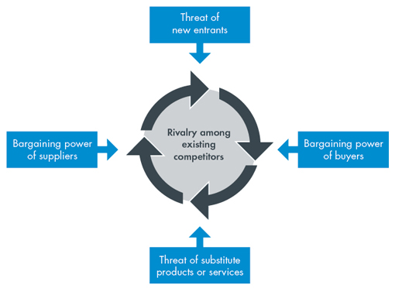

Diagram 2 (CGMA, 2013)
- Supplier power.
Barclays aim is to do business with innovative, responsible, cost competitive and diverse suppliers ensuring integrity and equality in their selection. Thus buy their raw materials from several suppliers. Commanding suppliers in the market use their bargaining power to charge high price for their goods and services and this impacts by lowering the profits of the bank.
- Buyer power.
Customers always want to buy the best quality service and product while spending the least amount possible. If the customer base is small, the more power they will have in demanding more discounts and offers. This pressure is felt in the profit.
- Competitive rivalry.
The rivalry in the banking industry is intense because of few payers dealing with the same products. This normally causes prices of service to drop leading to lower or decrease in profits. This has caused Barclays to cooperate with competitors to enlarge the market base.
- Threat of substitution
This normally occurs when a service or product satisfies the customers’ needs in a different way. With the embracing of technology and flexibility of doing business, this has forced Barclays to change it culture of doing many things like requesting for a minimum balance in the account to maintain it while competitors are not requesting for any amount.
Barclays has resorted to enforcing switching charges and focusing more on the needs of the customer as compared to customers wants.
- Threat of new entrant.
This comes with fintech, innovative, and modern ways of doing business. They also come with reduced costs for services to win more customer base and give very good offer for services. This forces Barclays to change in various strategies to maintain business without incurring losses.
The key driver to change.
From the porters five analysis we conclude that threat of new entrants is the key driver for change. Barclays must lower prices, reduce cost, and add value by innovating new products and service to remain relevant in the market.

THE CULTURAL WEB OF BARCLAYS

Elements of the cultural web
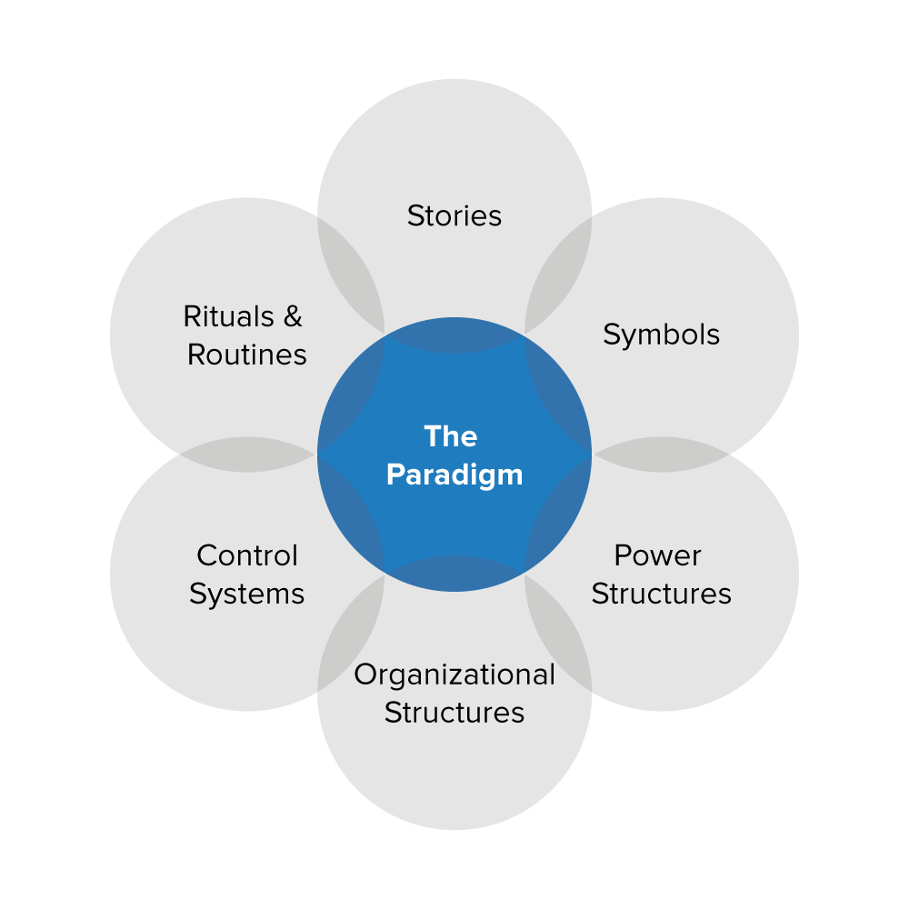
Diagram 3 (Mindtools.com, 2012)

THE PARADIGM

- STORIES
-one of the oldest banks
-It is a respected institution
-Household name in UK
-The eagle logo symbolises pride, strength, and elegance of the bank.

- SYMBOLS
-Executive offices
-The eagle logo
-Sharply dressed staff in navy blue suits

- POWER STRUCTURES
-Board of directors sets strategy and oversee its implementation by the executive committee.
-Executive committee is headed by the CEO
-Decentralised power structure

- ORGANISATIONAL STRUCTURES
-Divided into three, Personal banking, business banking, and Barclaycard consumer
-Each branch is headed by the branch manager

- CONTROL SYSTEMS
-High degree of organisational awareness
-High satisfying rewards

- RITUALS AND ROUTINES
-Excellence in service
-Lots of training to keep staff UpToDate with systems
-customers expect someone to receive them when they enter the banking hall

Based on the evaluations we realise the covid-19 has changed the way we do business, The work from home policy has proved that work can still be done away from the office and achieve same or more results. By changing the policy of having to go to the office for work and permanently coming up with a strategy that will allow staff work from home and only go to the office when necessary. Barclays can minimise on the acquisition of large offices and reduce on already what they have, and this would increase the profits from saved rents and leases and expenses associated running of offices.

ETHICAL DILEMMAS

This involves scenarios where hard decisions have to be made between two direction of action, the choice mainly breaching a moral principle. This mainly happens when the only decision required is a critical one to save face of the current situation.

Ethical dilemmas at Barclays.

1.Climate change

Despite making some notable progress in reducing their carbon print as discussed earlier, Barclays is associated to the fracking industry through ownership of third energy and are on record to funding the coal mining industry to a tune of billions of pounds. This means that banking with Barclays could be funding these toxic industries without our knowledge

2. Tax Avoidance

Barclays has branches located in “tax haven” like Monaco, Guernsey, and Isle of man. It is thought that they do this to avoid paying the required tax to maximise profits. It can be assumed after they were involved in the libor rate fixing scandal and were fined £290 by UK and US regulators, and mis-selling irrelevant payment protection insurance (PPI) to mortgage borrowers.

CONCLUSION

Barclays must put into consideration its external marketing environmental factors while making their strategic plan. This is because of the presence of competitors, substitutes, and threats from new entrants

RECOMMENDATION

A detailed environmental analysis of the external factors will need to be carried with more emphasis on the future of banking. The foundation of the PESTEL analysis should rely on current information to put in place methods to counter the threats or utilise the opportunities they find.

TASK 2. REFLECTIVE ESSAY.

I enrolled for level 5 at the University of Wales Trinity Saint David term one class taking BA in Leadership and Management Skills in the workplace. One of the modules I just completed is Workplace Culture and its impact on Organisational Efficiency. I began by induction into the module in the week one class and got to learn what an organisation is. I thought it was going to be an easy task like level four, but it turned out to be very detailed and complex.

I learnt about the organisation and its environment in week one and two. Types of organisations, how they are run, external, and internal factors and how they influence the running of organisations. I did not know that external environmental factors play a major role while making strategies for business while at the same time affecting the main internal functions of the business.

I was introduced to tools of analysing the environmental factors like the Porters Five forces and the PESTEL analysis. I previously did not know about these tools but I can now be able to use them given the chance by any organisation, and give recommendations using the same.

In week three I studied about organisational structures. I had not known there are so many of them and got know why they are needed. I only knew the traditional structure but after this study I learnt about hoe the structures have evolved and they are used to run different organisations. I also know that culture is a major determinant of organisational structure something I had no clue about.

Week four was about organisational culture and I got to know the reason why I distinguish organisations from others though at times dealing in the same commodity is because of the culture of the organisation of individual organisation. Am now able to note and use elements of an organisation culture like innovation, team orientation, and outcome orientation to achieve organisational goals.

In week five and six I studied on how to create an ethical and sustainable culture and determinant of making it successful. I now know how to create culture in an organisation and how I can teach employees to learn it. I also learnt how to analyse organisational culture using the cultural WEB model and with this I can be able to clarify convictions and assumptions within any organisation.

Week seven was a bit hard as the barriers to the effective functioning of the organisation involved lots of theories, tools and tables used for analysis. In the end I was able to learn how to overcome the barriers especially through understanding of Beers model. I can also track organisational elements that drive performance in an organisation using the organisation health index.
I finished the module in week seven and eight learning about global implications on an organisations culture. I got the opportunity to study how different cultures run organisations. For example I learnt that the Chinese build strong networks of relationships while in India they value family employment to maintain and enhance fortunes. This has made me respected and value people differently while embracing different cultures to achieve organisational goals.
In conclusion, I have changed my way of thinking and approach to culture within an organisation. And gained enough knowledge to deliver positive change using different cultures the organisation, while achieving the goal and objectives of the organisation.

REFFERENCES:
- Home.barclays. (2022). Barclays Our Story and History | Barclays. [online] Available at: https://home.barclays/who-we-are/our-history/ [Accessed 4 May 2022].
- Barclays.co.uk. (2022). Our products and services | Wealth Management | Barclays. [online] Available at: https://www.barclays.co.uk/wealth-management/why-barclays/our-products-and-services/ [Accessed 4 May 2022].
- Statista. (2021). Barclays: employment numbers by country 2021 | Statista. [online] Available at: https://www.statista.com/statistics/441855/barclays-group-employees-by-country-worldwide/ [Accessed 4 May 2022].
- Anon, (2022). Stock. [online] Available at: https://www.londonstockexchange.com/stock/BARC/barclays-plc/company-page [Accessed 4 May 2022].
- CGMA. (2013). Porter’s Five Forces of Competitive Position Analysis. [online] Available at: https://www.cgma.org/resources/tools/essential-tools/porters-five-forces.html [Accessed 4 May 2022].
- All Answers Ltd (2021). Barclays PEST Analysis and Strategy. [online] Ukessays.com. Available at: https://www.ukessays.com/essays/banking/barclays.php [Accessed 5 May 2022].
- Professionalacademy.com. (2022). Marketing Theories – PESTEL Analysis. [online] Available at: https://www.professionalacademy.com/blogs/marketing-theories-pestel-analysis/ [Accessed 4 May 2022].
- Mindtools.com. (2012). The Cultural Web: Aligning Your Organization’s Culture With Strategy. [online] Available at: https://www.mindtools.com/pages/article/newSTR_90.htm [Accessed 4 May 2022].
- Banking Laws and Regulations | United Kingdom | GLI. (2022). GLI - Global Legal Insights - International legal business solutions. [online] doi:https://www.globallegalinsights.com.
- Equalityhumanrights.com. (2019). Equality law - Banks and other financial services providers | Equality and Human Rights Commission. [online] Available at: https://www.equalityhumanrights.com/en/advice-and-guidance/equality-law-banks-and-other-financial-services-providers [Accessed 5 May 2022].
- BBC Bitesize. (2022). Political factors - External factors - National 5 Business management Revision - BBC Bitesize. [online] Available at: https://www.bbc.co.uk/bitesize/guides/zgfrpbk/revision/2 [Accessed 6 May 2022].
- CGMA. (2013). Porter’s Five Forces of Competitive Position Analysis. [online] Available at: https://www.cgma.org/resources/tools/essential-tools/porters-five-forces.html [Accessed 6 May 2022].
- Fern Fort University. (2022). Barclays PLC Porter Five (5) Forces & Industry Analysis [Strategy]. [online] Available at: http://fernfortuniversity.com/term-papers/porter5/analysis/963-barclays-plc.php [Accessed 6 May 2022].
- Barclays.co.uk. (2022). Cultural awareness | Barclays. [online] Available at: https://www.barclays.co.uk/business-banking/business-insight/cultural-awareness/ [Accessed 6 May 2022].
- BBC News. (2013). Timeline: Libor-fixing scandal. [online] Available at: https://www.bbc.co.uk/news/business-18671255 [Accessed 6 May 2022].

‌

‌
‌

‌
‌
‌

‌
‌

‌
‌
‌

‌

