
Mitsa Carla Lima Goncalves
2515320

mock interview

Cert HE Business Skills for the Workplace

Name: Employability and Career Development
Module: LCLM4005_LON
Student Name: Mitsa Carla Lima Goncalves
Student ID: 2515320
Assignment Title: Mock Interview
Lecturer: Sukhpreet Grewal

- OVERVIEW

This mock interview will simulate a recruitment process for a Salon Manager position, based on a job posting on the Indeed platform. The objective of this simulation is to demonstrate the skills and qualifications required for the role, as well as to apply communication and performance techniques in a job interview context.

Throughout the interview, questions related to professional experience, leadership skills, team management, customer service, problem-solving, and the organization of daily salon operations will be addressed. This activity aims to highlight the importance of adequate preparation for a job interview and how a candidate can present their skills clearly, confidently, and professionally.

- Job Description

This is a Salon Manager position at Radio Hair Salon & Gallery, an award-winning salon in London. The role involves managing the salon's daily operations, leading the team, and ensuring excellent customer service.

The ideal candidate should possess strong communication, leadership, and organizational skills, and be able to work in a dynamic environment. The company is looking for someone focused on providing a positive customer experience and maintaining high quality standards.
This is a full-time position with a starting salary of £33,000 per year, including benefits such as employee discounts and a pension plan.
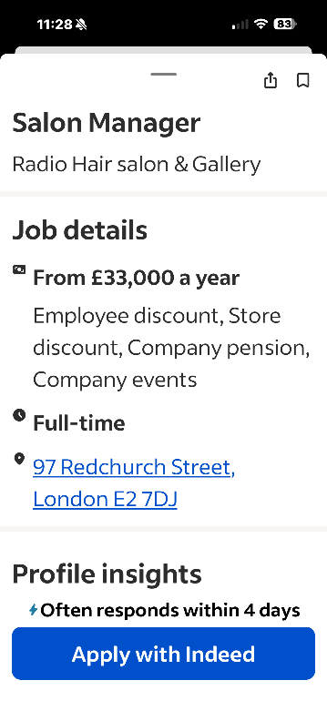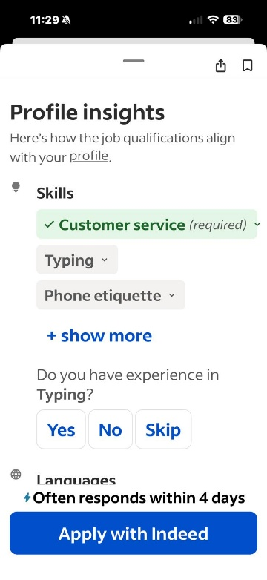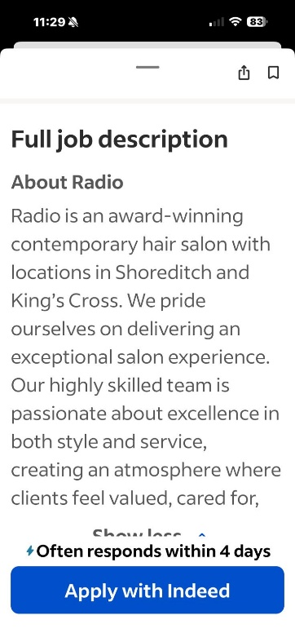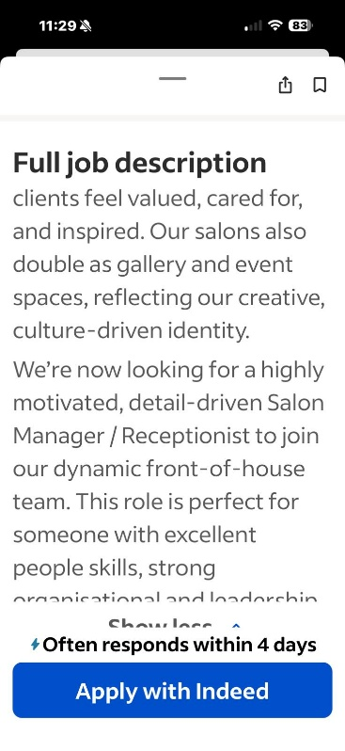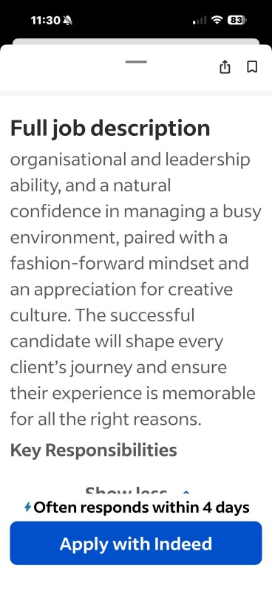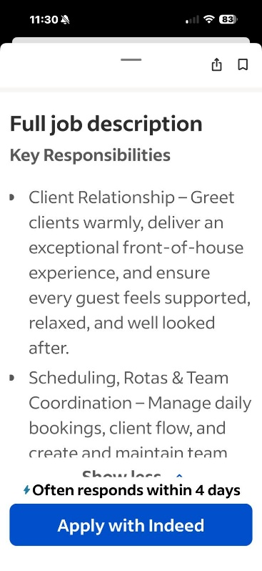
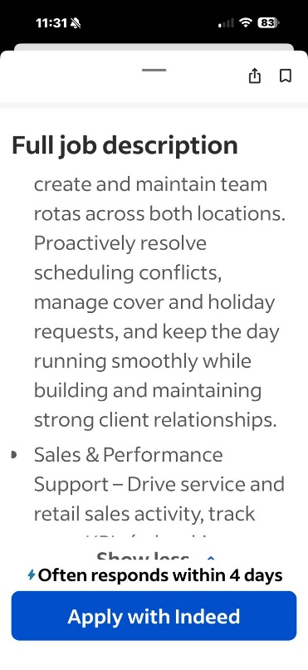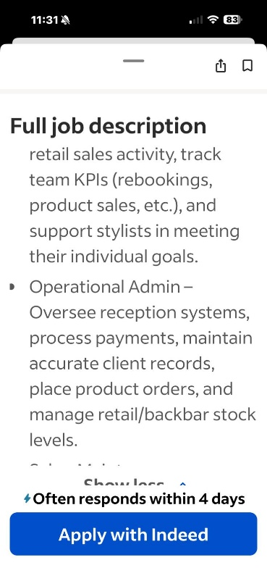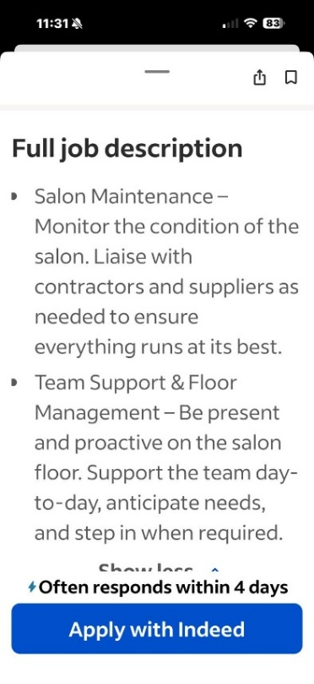
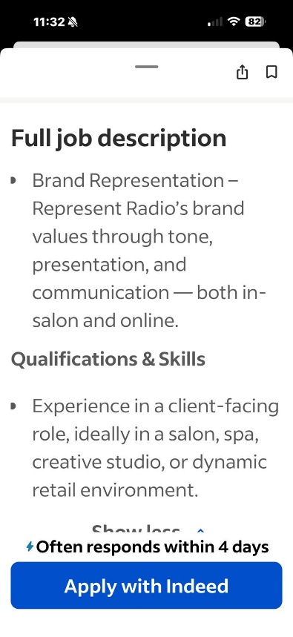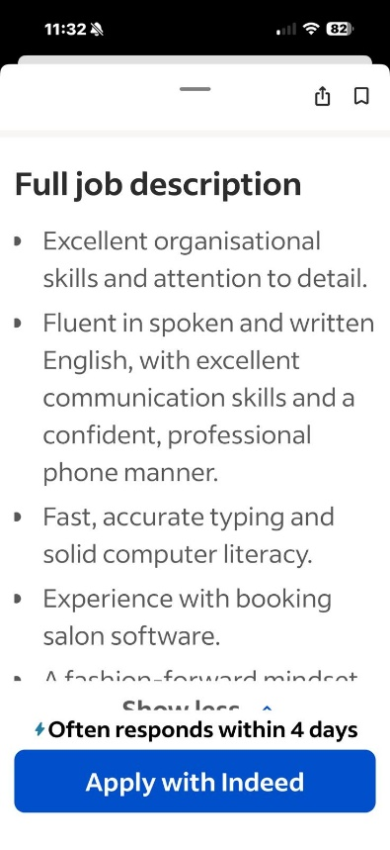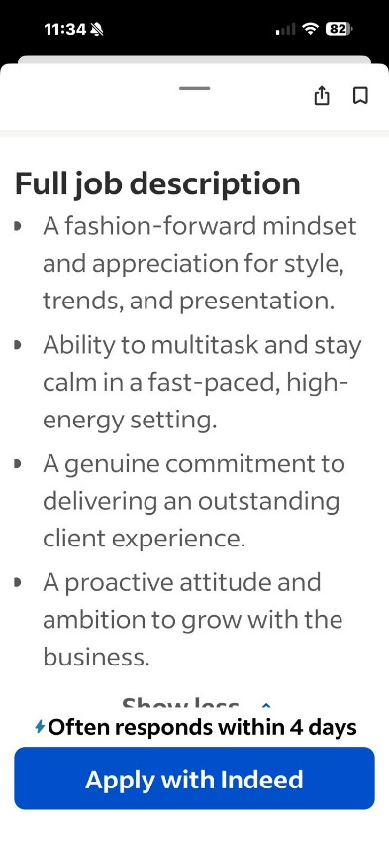

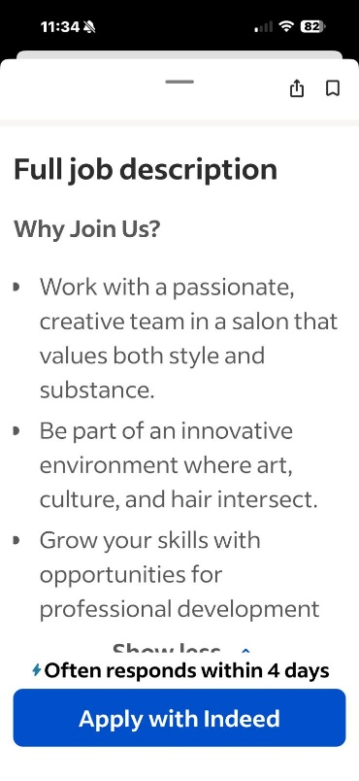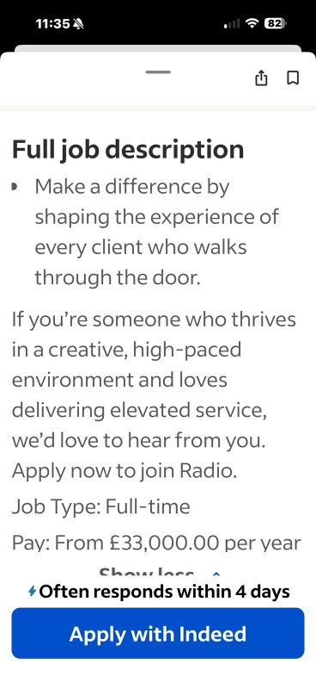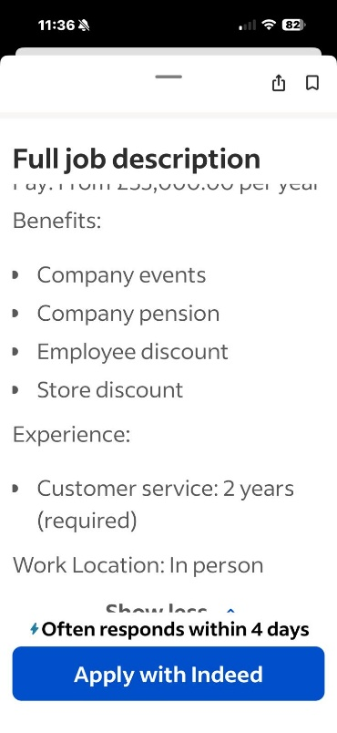

3. Application
Next, I will present my cover letter and curriculum vitae (CV), prepared specifically for the Salon Manager position. These documents highlight my professional experience, skills, and qualifications relevant to the role.

4.Cover Letter
Mitsa Carla Lima Goncalves
2515320@student.uwtsd.as.uk
Radio Hair salon &Gallery
97nRedchurch Street, London E27DJ
04 July 2026
Dear Hiring Manager
I wish to apply for the role of Salon Manager, currently being advertised on Indeed. Please find enclosed my CV for your consideration.
With over 20 years of experience in the beauty industry as an aesthetician and almost 10 years of successfully owning and managing my own hair salon, I have developed the leadership, organisational, and customer service skills required to manage a busy and successful salon.
During my career, I have been responsible for check and control the daily operations and managing appointments, supervising team staff, maintaining stock levels, make sure that we give standards of customer service, and creating a welcoming environment for both client and teamwork. Running own salon has shown me the importance of a strong leadership, effective communication, and delivering exceptional client experience while achieving business goals.
I am passionate about beauty industry and enjoy building good relationships with clients and helping my team to their best. I am a reliable, hardworking, and enjoy leading a team by example while delivering excellent customer service.
I am excited about the opportunity to bring my experience and enthusiasm to your team and would welcome the chance to discuss how I can contribute to the continued success of your company.
Thank you for considering my application. I look forward to hearing from you.
Yours faithfully
Mitsa Goncalves

5.Curriculum Vitea (CV)
Mitsa Carla Lima Goncalves
2515320@student.uwtsd.ac.uk

Personal Profile:
I believe to be a very ambitious individual. I am capable of responsibilities with the different jobs that I have worked throughout my years. With great communication skills, I am able to aid when someone needs help. I am punctual, with the dislike of arriving late to areas of which I am committed to travel to, work being the main commitment. I also believe to be a very positive individual. I enjoy making others smile and laugh, however, I can also maintain a professional and subtle perspective when necessary. I am keen to learning new skills and experiences throughout my daily life every day and would take in every detail during whichever opportunity I am given. Strong leadership and management skills, with the ability to organise daily operations, motivate teams, and deliver excellent customer service. Confident in building positive relationships with clients, resolving issues professionally, and working effectively in fast-paced environments.

Skills:
- Punctual
- Hardworking
- Great communication
- Great team worker
- Friendly
- Deadline achiever
- Multitasking
- Management and leadership skills
- Portuguese – Fluent
- Creole – Fluent
- Spanish – Intermediate
- Inglish - Fluent
- Team management and motivation

Work Experience History

- Expresso Coffee Shop 1999-2001
During my time at expresso coffee shop, I worked as a barista. It was fast paced and very busy most of the time. I enjoyed working at such a fast pace. I was able to complete many different tasks that were given to me and made sure to complete them within given deadline.
- Cupido Bakery 2001-2003
Working at Cupido Bakery I was a customer advisor. I would work the till and serve as a cashier along with help with baking when my colleagues were in need of help.
- HEL Nails 2003-2006
Working as a beginner nail technician in Hel Nails, I was able to complete a course during that time to learn how to become professional in this specific area. I was trained to serve customers’ needs in terms of what they required and was able to complete them according to their requests without problems.
- Flare & Glare - beautician 2006-2009
Working as a beautician, I worked with a variety of people. Constantly learning new experiences, whether it be communication, customer service, service handling and so forth. Working as a beautician, it allowed me to become more interactive with customers, and this allowed me to gain my own personal customers.
- Onix Mani-pedi spa – Angola 2010-2012
During this time, I had moved to Angola. There I worked as a manager of a 5-star spa. During my time there, I organised schedules, employee management and many more. I also contacted events organisations and made plans for their activities during the times that they requested.
- L&M Studios (own Business) 2012-2020

-The Dark Room Vegan Nail Shop – London
From April 2021 to May 2023, I work as Nail technician doing Hard gel, Manicure, Pedicure, Acrylic, Après Nails, shellac, and Salon Supervisor.

-Manager - Nail Technician
Dzyer Vegan Salon – London
From May 2023 to September Managed the daily operations of the salon, scheduled appointments, supervised staff, and provided professional nail services. Delivered excellent customer service while maintaining high standards of hygiene and client satisfaction.
Warehouse Operative Crosswear Lda |- London September 2024 – Present
Responsible for preparing and dispatching party goods orders, managing stock, providing customer service, and operating the cash register. Ensure efficient warehouse operations, accurate order processing, and a high standard of customer service while supporting the day-to-day running of the business
Education / certifications
Olin Fashion
Gel Nail certification, Manicure, Pedicure, Waxing and Intimate Waxing
LOREAL Portugal
Hair & Beauty Colour Correction
Lia Cardozo Make
Make-up Master class
Equi Estetica
Laser Hair Removal
LAB -London Academy of Beauty
Nail Technology
Cert HE Business Skills for the Workplace (Currently studying)
University of Wales Trinity Saint David (UWTSD) | 2025 – Present

Personal Interests
I enjoy extending my vocabulary, so reading is a hobby that I enjoy a lot of the time. Being able to learn new things everyday allows me to develop more personal skills that I wasn’t aware I had. In terms of communication, that is one of the most important skills that I continue to change and update as there are always challenges that are willing to test your experience.
I believe myself to be a bubbly person, continuously having a smile on my face and a social butterfly. Meeting new people is something I look forward to. Learning different ways of dealing with challenges in fundamental stages to achieve the highest possible which is something to constantly look forward to.

Mock Interview

1. Can you tell me about your previous skills and experience?
Answer: I have over 20 years of experience in the beauty, customer service, and management fields. I have worked as a nail technician, salon manager, and currently work as a warehouse operator at Crosswear. Throughout my career, I have developed skills in leadership, organization, communication, customer service, and team management. I began my professional journey as a beautician at the age of 23. I fell in love with the profession and made it my career. I took several courses over the years, such as gel nails, manicure/pedicure, acrylic nails, gel polish, waxing, laser hair removal, makeup, facial cleansing, and fungal treatments. For several years I worked in various beauty studios and gained experience in dealing with colleagues and solving day-to-day problems, such as scheduling and rescheduling appointments, ordering products, and covering for absent colleagues. Sometime later I was offered a position as team supervisor, which gave me the confidence to accept an offer for a manager position at a hand and foot spa that was about to open in Angola. I moved to the country and managed that spa for 3 years, providing training in the beauty area, managing a team of 16 employees consisting of nail technicians, cleaning staff, a receptionist, and a driver. During that time, I managed to build a great team, providing excellent work for the company, both in terms of customer service and teamwork what motivated me to open my own business, which I ran successfully for 10 years. I am currently studying the Cert HE Business Skills for the Workplace UWTSD And my goal is to continue my studies. I intend to go on to... Level 5 e Level 6 do BA Leadership and Management Skills for the Workplace Because I want to further develop my management and leadership skills.

2. Can you tell me what are your strengths and weaknesses?
Answer: I'm an organized, responsible person who enjoys working. I also learn quickly and get along well with colleagues and clients. I consider myself a very calm and confident person in my work. I am very curious and enjoy accepting challenges, which has helped me develop my skills considerably. I really enjoy learning new things, technologies, and new ways of working. I can work under pressure to meet deadlines and deliver the service as requested by the client. I am very punctual at work, and I don't like to be absent unless it is necessary. I consider myself a very organized person. I always take care to check my schedule before starting my workday, to see how many clients I will have, how long each service will take, what services have been requested, and then organize all my work materials and my service area.
My weakness is that I like to do everything myself because I'm quite a perfectionist and I like the service to be very well done and for the client to be satisfied with the quality of the service provided. But over time I realized that teamwork is very important for the smooth operation of the company, both in customer service and in company maintenance. From then on, I started teaching my team the techniques I had as a beautician, as well as my experience in dealing with clients, and with that I managed to provide the complete package for the company's success

3. Can you describe a time when you had to meet a tight deadline?
Answer: In my work at Crosswear, we do delivery next day and especially during peak seasons, we have many orders to prepare and ship on the same day. During these times, I organize my work, stay calm, and work with my colleagues to ensure everything is delivered on time, also I always try to do the most urgent and then the rest making sure that everything is within company standards. Among the many situations I've encountered in my current job, one that happened during the Christmas period stands out. We received a delivery of several pallets of Christmas cards, and we had to check them all and put them outside into the shelves and give them their locations into the system so that the pickers could collect them for delivery to customers who had made online purchases. Because it was a very big shipment, I suggested to my colleague who is my partner in my department that we could divide the work into two groups: one would handle checking and placing them on the shelves, and the other would handle entering the locations. She accepted my suggestion, and we did it that way, which helped us a lot to make the most of our time and have everything ready for the pickers to complete the orders and send them to customers on time. Everything went as planned and as I suggested. Later, we were congratulated by our manager because this challenge was successfully overcome, and at the end of the day there were no complaints from either part neither from the pickers, as they found everything, they needed to complete the orders, not from the customers, as we didn’t have any delays on the delivery’s .

4. Can you tell me about a difficult situation you faced at work and how you dealt with it?
Answer: Dealing with clients is a big challenge every day, because we are different people, with different tastes and opinions, and different languages. I remember once, at the salon where I worked, a colleague was attending to a client who wanted a specific nail art design. The client wasn't satisfied because the result wasn't what she had requested, and I noticed that my colleague was getting a little frustrated with the situation because she didn't understand or speak English as well as I did, and therefore her understanding was more limited. So, I asked if I could help. I spoke calmly with the client, listened carefully to what she wanted, asked some questions such as if she had any reference photos, what colours she had in mind, and managed to get an idea of ​​what the client had in mind. I showed the client some photos and videos of what I understood about her request, then did the nail art the way she had imagined it. To show that we valued client satisfaction, we decided not to charge for the nail art, and the client only paid for the gel nail service. In the end, she left very satisfied and thanked us for how we resolved the situation. For me, it was an example of how remaining calm, listening to the client, and finding a solution can transform a negative experience into a positive one. As for my colleague, she wasn't upset by my intervention because she felt she wouldn't be able to provide a quality service and satisfy the client. She thanked me for my help and felt more at ease. Soon after, I suggested she take a short course on the type of nail art the client had requested, which she readily accepted.

5. Can you tell me about a time when you demonstrated good leadership?
Answer: As the manager of the Dzyer salon, I was responsible for organizing schedules, supervising the staff, and ensuring the salon works smoothly. I always try to motivate employees and help when someone needed support, and I always tried to listen to my team to get to know each person and understand their needs. In my team, I had a situation that caught my attention. I had an employee who was a very good professional, but for some reason, she started to show signs of instability at work, arriving late, losing focus, and not delivering the good service she was used to delivering to clients. One day, I called her aside to talk and understand what was happening to her that was affecting her work performance. She told me that she was having problems with the person she shared a house with and that she needed to leave that house urgently. So, I offered to help her find an apartment. I did online research on websites and asked some friends, as well as some commercial establishments that advertise rentals, and I was able to help her hopefully I find a way to help her and with that, she managed to rent a place for herself. Her personal problem was affecting her work performance, which was unusual, and I was able to notice it in time to help. Communicating with and listening to my staff has always been my main policy, as it allows me to understand and help in time to ensure the smooth operation of the company.

6. Can you give an example of when you provided excellent customer service?
Answer: As beautician, I have always maintained a respectful and attentive relationship with my clients, always paying attention to their needs and preferences, as well as their emotional state. I have always tried to have a light and relaxed relationship, but at the same time very professional, making clients feel comfortable and always returning. Once I had a bride who was getting married and wasn't quite sure what she wanted because she was a somewhat uncertain client. She was a mature woman with dark skin, who had never been married before, and wasn't very familiar with the internet for research. We talked a lot, I asked many questions, did a lot of research online, from hairstyles, nail length and type, various types of makeup for dark and mature skin. I also did research for her bridesmaids, prepared a file with all the necessary information and presented it to her. We made some changes according to her tastes and desires, did some trials, and managed to reach a consensus on the final day, which made her very satisfied and happy. The wedding day was a perfect day for her, just as she had dreamed. Although it was naturally a day full of emotions and nervousness, I tried to convey my calm and professionalism to her.
7. Can you tell me about a time when you worked successfully as part of a team?
Answer: At Crosswear, we work as a team, helping each other towards the same goal: preparing orders, organizing the warehouse, and meeting shipping deadlines. Communication and cooperation among everyone are fundamental for efficient work. That's the same at my university. I really enjoy working in teams, including at my university where I'm doing my degree. I'm always ready to help and to ask for help when necessary. We had a group project where we had to create a PowerPoint presentation. I wasn't the team leader, but I always kept myself informed of everything that was happening. I even remember that our team leader confused the deadlines for uploading the project, and I remembered to ask in the group chat if it had already been submitted. That's when he realized he had missed the deadline. He automatically submitted it, and I offered to send an email to the professor to ask if we would have any problems or if we would be penalized for the delay. He replied later saying that we might get less marks on our grades because of the delay, but fortunately our work was so good that we weren't penalized for this detail, and we all passed with merit.

