

How does exposure to traumatic incidents impact the mental health of police officers and are current interventions effective in mitigating long term psychological harm?

School: UWTSD
Degree: Professional Policing Practise
Due Date: 06th October 2025
Word Count: 7305

Acknowledgement
I would like to thank my mother and father for their unwavering support, encouragement and belief in me, which has been a constant source of strength during this process. I would also like to express my gratitude to my sister, Rio-Alice for her generously sharing her knowledge and experience throughout this dissertation. The time and help she gave me is something I will always be grateful for.
Finally, I would like to thank my Granch, I would like to thank him for always pushing me to stay focused and priorities my university studies, whose guidance and encouragement has been invaluable. Reminding me of the importance of education.

Abstract
Police officers are regularly exposed to traumatic incidents as part of their occupational duties, putting them at risk of developing psychological distress and long-term mental health issues. This study investigates the impact of repeat exposure to traumatic incidents on the mental health of police officers and evaluates the perceived effectiveness of current interventions such as Trauma Risk Management (TRiM).
The primary research within this study was a survey method, to gather quantitative data from serving Gwent Police officers regarding their experiences of trauma exposure, mental health and engagement with available interventions.
Findings suggest that exposure to traumatic incidents can have a significant impact on officers’ mental health, while majority of respondents were aware of existing interventions such as TRiM, fewer than half reported using them following a traumatic event. Among those who have completed the TRiM process, some participants found the interventions beneficial, whereas others reported that they did not find it effective. These findings suggest that even though interventions are available and generally recognised within Gwent Police, the utilisation and sustained effectiveness remains inconsistent. These results highlight the need for ongoing evaluation and adaptation of psychological support strategies to ensure that they effectively meet the long-term mental health needs of police officers.

Declaration
This work has not previously been accepted in substance for any degree and is not being concurrently submitted in candidature for any degree.
Signed: Skye-Marie Roberts
Date: 06/10/25

Statement 1:
This dissertation is being submitted in partial fulfilment of the requirements for the degree of BSc Policing Practise.
Signed: Skye-Marie Roberts
Date: 06/10/25

Statement 2:
This dissertation is the result of my own independent work/investigation, except where otherwise stated. Other sources are acknowledged by footnotes giving explicit references. A bibliography is appended.
Signed: Skye-Marie Roberts
Date: 06/10/25

Statement 3:
I hereby give consent for my dissertation, if accepted, to be available for photocopying and for interlibrary loan, and for the title and summary to be made available to outside organisations.
Signed: Skye-Marie Roberts
Date: 06/10/25

Statement 4:
I hereby give consent for my dissertation, if accepted, to be available on the university’s IT system to those who have consent to use the system.
Signed: Skye-Marie Roberts
Date: 06/10/25

Table of Contents
Chapter One: Introduction 7
1.1 Introduction 7
1.2 Background 7
1.3 Research Objectives 7
1.4 Research Structure 7
1.5 Conclusion 8
Chapter Two: Literature Review 9
2.1 Introduction 9
2.2 Exposure to Trauma in Policing 9
2.3 Psychological Impacts 10
2.4 Organisational Stressors 11
2.5 Trauma Risk Management (TRiM) 12
2.6 TRiM compared to other interventions 13
2.7 Gaps in The Research 14
2.8 Conclusion 14
Chapter Three: Research Methodology 16
3.1 Introduction 16
3.2 Research 16
3.3 Research Onion Method 17
3.4 Research strategy and choice 17
3.5 Data Collection and Analysis 18
3.6 Ethical Considerations 18
3.7 Limitations & Problems 19
3.8 Conclusion 19
Chapter Four: Data Analysis 20
4.1 Introduction 20
4.2 Demographics Statistics 20
4.3 Questionnaire Findings 21
21
4.4 Conclusion 23
Chapter Five: Findings and Conclusions 24
5.1 Introduction 24
5.2 Main Findings 24
5.3 Limitations 25
5.4 Recommendations 26
5.5 Conclusion 26
References 28
Appendices 31
Appendix A – Blank survey questions 31
Appendix B: Survey of Results 34

Chapter One: Introduction

Introduction
The Purpose of this dissertation is to investigate how does exposure to traumatic incidents impact the mental health of police officers and if interventions are effective in mitigating long term psychological harm. This chapter of the dissertation will provide a background of this topic and it will outline the aims and objectives of the research.

Background
Policing is a profession that is marked by frequent exposure to high-stress and traumatic incidents. Unlike many other occupations, police officers repeatedly encounter and deal with high-risk and traumatic events. This is likely to make them more susceptible to mental health conditions. Research had increasingly highlighted mental health challenges that police officers face, such as Post Traumatic Stress Disorder (PTSD), depression, anxiety, and burnout reported at higher levels than in the general population (Phythian , et al., 2022).

Research Objectives
- Explore the link between repeat exposure to traumatic incidents and the development of mental health issues within police officers.
- Assess the effectiveness of current interventions such as TRiM in mitigating long-term psychological harm.
- To understand if officers utilise interventions after experiencing a traumatic incident in work.

Research Structure
This dissertation has five chapters. The first chapter introduces that officers deal with traumatic incidents often and explains that officers vulnerable to mental health issues due to this. It presents the question that this research is based around and what objectives of the research.
Chapter two consists of a review of literature which already exists in the field of research. The literature review confirms that there is a link between traumatic incidents and poor mental health within police officers. It also highlights the gaps within the research and the issues of underreporting.
Chapter three explains the research methodology and what primary research will be used within this study.
Chapter four presents the data analysis from the selected primary research method. It will show the quantitative results with statistical findings and have visual representations by presenting bar graphs of results found in this study.
The final chapter will include the main findings and conclusions from the research project. It will also look at the limitations to the study and recommendations for further research.

Conclusion
This chapter has outlined this study’s objectives and the reason for this research. It provides a brief background of the topic, the next chapter will go into more detail about this through a literature review.

Chapter Two: Literature Review

2.1 Introduction
Police officers experience traumatic incidents, this is expected part of their role when working in a high-stress environment. Police officers attend a range of incidents which involve violence, fatalities, domestic abuse, delivering death messages and sexual abuse. Due to this, police officers are more at risk of developing mental health conditions. This includes, Post traumatic stress disorder (PTSD), anxiety, depression and burnout.
This literature review aims to look into how exposure to traumatic incidents can effect officers and their mental health. It will evaluate the effectiveness of interventions that have been put into place to mitigate the long-term psychological harm. The review will critically compare studies, organisational reports, and evidence-based practices. It will highlight the current knowledge of this subject and look at the gaps that are within the current research.

2.2 Exposure to Trauma in Policing
Multiple studies have found that police officers attend a high number of traumatic incidents within their role. Purda & Demou (2019), conducted a systematic review which shows that police officers in the United Kingdom (UK) consistently reported that they have been repeatedly exposed to traumatic incidents. This study tells us policing is one of the top three most stressful careers and can lead to mental health issues due to the frequent exposure to dangerous situations. Likewise, Garbarino et al (2013), found that police officers often face a large number of incidents in one week which could be seen as having a high impact on officer mental health. This study found that attending traumatic incidents was one of the most common operational stressors in police officers which led to mental health issues in the future.
Other studies highlight a contrast between specialist roles and general duties. An example of this is a study conducted by Bell & Eski (2016), by completing qualitative interviews with police officers that work within the child sexual exploitation unit. This found that there was a high rate of emotional distress due to being exposed to disturbing contents for a period of time. Whereas Brewin et al (2020) used as quantitative method which highlighted that collective trauma was the most significant precursor of PTSD symptoms, regardless of the type of trauma that was experienced. This difference in findings may be credited to the method which was used to measure the results. Bell and Eski focused on subjective emotional responses through thematic coding, while Brewin et al used diagnostic symptom thresholds.
Furthermore, vicarious trauma has also been researched in recent years. Tehrani (2018) conducted research around police officers which work within cybercrime and online child abuse units. These results shows that officers experience second hand trauma even with minimal physical risk. This study challenges earlier models of trauma exposure which focus on officers being in physical danger as a key factor of trauma. This study does also acknowledge that officers in response roles constantly are exposed to unpredictable trauma, which can lead to mental health issues such as stress and requires high psychological demand. Although the literature does consistently support a link between police officers and being exposed to trauma, methodological limitations still remain. There is a lack of comparison to other high-risk professions, which makes it difficult to determine whether policing presents unique risk or has similarities to other professions such as health care or other emergency responses.

2.3 Psychological Impacts
When looking at the psychological impacts, the most commonly studied outcomes of police officers being exposed to trauma are conditions such as PTSD, depression, anxiety and work burnout. Brewin et al (2020), conducted a study of 40 police officers in the UK and found that approximately 20 percent of officers met the criteria for PTSD, with 90 percent experiencing multiple traumatic incidents within their role. This percentage being significantly higher than in the general UK population, this suggests that there is a profession specific vulnerability. PTSD is not the only concern. Purda and Demou (2019) also found that there are high rates of depression and anxiety, where a lot of police officers are showing symptoms of impaired functioning due to this. Burnout can also be seen by emotional exhaustion and detachment, this showed higher rates in officers who are in leadership roles.
There are contradictions in literature regarding gender, Houdmont et al (2016) reported that there was no gender disparity in PTSD rates, the results that they had gathered showed no significant differences between male and female officers when looking at PTSD. However, Brown et al (2022) found that female police officers reported to have higher levels of anxiety and organisational stress. These differences could reflect biases or different expectations around emotional expression across genders.
Within the police force, stigma around mental health and wellbeing still seems to be a barrier when police officers are in need of mental health support. A large number of studies, including the Police Federation (2024) national survey found that police officers regularly avoid seeking help for their mental health. This can be for reasons such as fear of being perceived weak or their career being jeopardised in any way. Qualitative work was completed by Karaffa & Koch (2016) which supports these findings. Their study illustrates how police culture can lead to hyper-masculinity and stoicism, stopping officers from reporting psychological stress. It reports that it is difficult to change this culture due to help-seeking stigma being seen as a sign of weakness within the police.

2.4 Organisational Stressors
According to Pruba and Demou (2019) organisational stressors such as shift work, officer workload, lack of independence, conflict between colleagues and insufficient support can have an effect on officer mental health. Brough & Biggs (2015) believe that organisational culture could be a stronger factor in poor mental health within police officers. However, Houdmont et al (2016) believes that role-specific exposure to trauma has an effect on officer mental health before accounting for the organisational stress they deal with. However, the findings are limited and the suggestions seem uncertain due to this.
Personal resilience is also a factor to be considered. Arble et al (2018) completed a study which showed that officers that had a higher resilience score were not as likely to develop mental health conditions such as PTSD following exposure to traumatic incident. However, resilience can be often ill-defined and measured inconsistently which limits the finding accuracy.

2.5 Trauma Risk Management (TRiM)
When looking at interventions that are used to mitigate the risk of long term psychological harm, Trauma Risk Management, also known as TRiM is one of the most used interventions in UK policing and emergency services. This intervention was first developed by UK military and since been adapted for first responders. It was designed to change from compulsory psychological debriefing to a peer lead and and evidence-informed process that identifies risk level to each individual developing psychological distress after experiencing an traumatic incident (Greenberg et al 2003). TRiM is delivered by trained officers, it is a psychological risk assessment process. The model of TRiM highlights the normality of stress reactions, identifying early warning signs of psychological difficulties and facilitating access to professional help where necessary (Whybrow et al, 2015).
Research into the effectiveness of TRiM within police is growing, though still limited compared to military or healthcare setting. Greenberg et al (2010) conducted one of the first empirical evaluations of TRiM in the United Kingdom. His findings suggests that TRiM improved early identification of trauma-related symptoms and increased officers developing help seeking behaviour. It is explained individuals who received TRiM intervention were more likely to seek help for their mental health compared to other who have not. This study suggests that TRiM intervention is effective in helping officers deal with their mental health, with lower rates of long-term psychological morbidity. Hunt et al (2013) evaluated the implementation of TRiM within Cumbria Constabulary and found officers who received TRiM support had lower rates of sickness absence compared to those who did not. Suggesting improved psychological well-being and early help-seeking. These results are supported by King's College London (2020) which noted that TRiM trained organisations often demonstrate reduced stigma around mental health and greater openness to seeking support among staff.
A recent evaluation by Oscar Kilo (2023) supports these findings, showing the positive feedback from officers who are TRiM trained across multiple police forces. It also shares the same opinion regarding the effectiveness of TRiM intervention in early identification of Trauma and how it assists in promoting police officers to seek help for their mental health after attending a traumatic incident.
However, contrasting findings highlight variability in outcomes depending on how the intervention is implemented. Roberts (2019) in a multi-force evaluation questions TRiM’s long-term effectiveness due to finding no statistics which suggest that there is a significant reduction in PTSD after six months post TRiM implementation. They suggest that inconsistent training standards and the lack of follow up sessions weakens the model’s impact. Another factor of this could be all police forces delivering the training and recording outcomes differently. Also mentioned, the TRiM process relying on peer support where areas of stigma still remains high, this may undermine the process.

2.6 TRiM compared to other interventions
Critical Incident Stress Debriefing (CISD) is a model which is criticised for potentially retraumatising individuals who take part within this intervention TRiM avoided enforced group disclosure and rather focuses on confidential one to one assessments that are voluntary. This shift is supported by evidence suggesting that early formal debriefing may interfere with natural recovery process (Rose et al, 2002).
When looking at Employee Assistance Programmes (EAPs), it often involves delayed access to professional counselling. This may discourage engagement among officers wary of stigma (Houdmont et al, 2016). TRiM differs by leveraging peer relationships and immediate accessibility. TRiM practitioners being peers, helps to bridge cultural divide between operational staff and clinical services, encouraging trust and early disclosure (Jones et al, 2017).
A key strength of TRiM is its potential to reshape police culture. Noted by Sharp et al (2015), embedding TRiM into standard operational practice signals an institutional commitment to mental health. Challenging the norms of stigma and emotional suppression within policing. When TRiM is properly implemented, it contributes to psychological literacy, a shared language and understanding of stress response across different ranks. This can help normalise conversations about mental health, reducing stigma and encouraging officers to seek help earlier. Despite TRiM being used by police forces within the United Kingdom, empirical evidence based in policing remains underdeveloped. Most published studies are small-scale evaluations or rely on self-reported outcomes rather than longitudinal or randomised designs. There is limited evidence on whether TRiM reduces long term PTSD, improves retention, or enhances over wellbeing. Additionally, little is known about it’s effectiveness across different police roles. Emerging research suggests the need for hybrid models, integrating TRiM with structured psychological screening and digital follow up. The College of Policing, (2023) has advocated for combining peer-based support with professional oversight, ensuring that officers identified high-risk receive timely clinical referrals. The integrative approach may enhance accountability and consistency.

2.7 Gaps in The Research
Despite the growing body of research on trauma and mental health in UK policing, there are still gaps within this research. Firstly, the literature is dominated by cross-sectional and self-reported designs, which limit causal inference and are vulnerable to bias from stigma and underreporting (Purba & Demou 2019) and (Brewin et al, 2020). There is a clear lack of longitudinal studies tracking officers over time to understand how repeated trauma exposure affects them. Also, while TRiM is widely implemented, few studies provide robust empirical evaluations using control groups or standardised outcome measures (Roberts et al, 2019). This limits the ability to determine whether observed improvements are due to the intervention itself or broader organisational factors. Thirdly, existing research often treats the police force as the same group, overlooking intersectional factors such as gender, ethnicity, rank and specialised roles. These factors may influence both exposure and coping mechanisms (Brown et al, 2022).

2.8 Conclusion
In summary, the literature overwhelmingly supports a link between trauma exposure and adverse mental health outcomes among police officers in the UK. PSTD, depression, anxiety and burnout are commonly reported, with cumulative trauma, organisational stressors and cultural stigma acting as key contributing factors. TRiM and related peer-support frameworks represent the most promising current interventions, offering identification, stigma reduction, and cultural change. Studies also show that TRiM is the most structured and culturally compatible framework currently implemented within UK policing. Studies have shown that TRim can enhance peer support, reduce stigma and promote early identification of psychological distress. However, evidence of their long-term effects remain inconclusive due to methodological weaknesses and variable implementation.
Overall, the literature points to a need for systemic and evidence-based approaches to trauma management in policing. Future research should adopt a longitudinal and mixed-method design to access both immediate and enduring effects of trauma exposure. In conclusion, while awareness of psychological harm within UK policing has improved significantly, the research remains at an early stage of development and evaluating sustainable, evidence-based strategies to protect officers mental health for their careers long term.

Chapter Three: Research Methodology

3.1 Introduction
Within this chapter, it will discuss the research methodology that will be used to during this research to ascertain how traumatic incidents that effect police officers and if interventions that are currently in place are effective. The methodology is structured using the Research Onion Model which was developed by Saunders et al (2019), this provides a systematic guide for developing a coherent research design.
It will highlight the nature and purpose of research within social science. It looks at the research approach and strategy that will be used within this research. It will detail the data collection and analysis procedures, along with what limitations there are when completing this study. This study will gather data from serving police officers in Gwent Police and enables the identification of statistical relationships between trauma exposure and mental health outcomes. It will be an assessment of officer’s perception of intervention effectiveness.
By following this structured and transparent methodology, the research aims to produce valid and reliable findings that can inform evidence-based policies and mental health practices within police organisations.

3.2 Research
Research is a systematic process of enquiry that intends to generate new knowledge and strengthen existing theories. According to Saunders et al (2019) research in social science does often include the study of human behaviours, attitudes and perceptions. Within this study it will explore the psychological impacts of trauma on police officers.
This study will have a positivist research philosophy, which is considered by the belief that reality is objective and measurable (Maretha, 2023). By the researcher maintaining an independent role, observing without influencing the subject (Park et al, 2019). Deductive research will be applied by hypotheses or propositions derived from existing theory and tested through empirical observation and data collection (Soiferman, 2010).

3.3 Research Onion Method
Within social science, by using a structured and systematic approach it allows the results to have clarity, coherence and rigor. The Research Onion method was developed by Saunders, Lewis and Thornhill (2007), this model uses a layered framework. 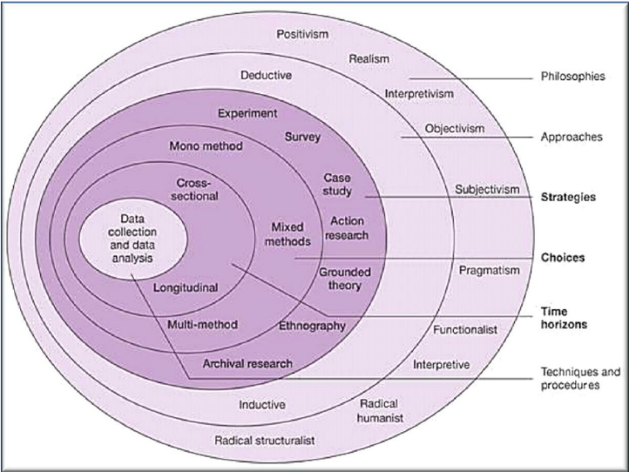
Figure 1: Research Onion
(Dublin, 2016)
The chart above demonstrates a visual representation of The Research Onion method, this contains an outer layer which shows the beginning of the research and then working through the other layers of Philosophies, Approaches, Strategies, Choices and Time Horizons to reach the final layer of Techniques and procedures which allows data collection and analysis.

3.4 Research strategy and choice
Quantitative research is a type of research that’s main objective is collecting data and analysing this. It uses numerical data which allows patterns to be identified, to test hypotheses and make predictions from these patterns. Qualitative research looks at people’s experiences, behaviours and perspectives exploring these and making efforts to understand them. It does not look at numbers like Quantitative research, it focuses on how people feel, think and interpret situations (Lakshman et al, 2000).
This study aims to understand if officer’s mental health is affected by attending traumatic incidents and if they feel the interventions in place are effective in helping with their personal mental health. A survey method will be used within this study. The survey will be disseminated to police officers who are currently working on front line policing and officers who have previously worked in the response department. This approach enables the collection of data to be from a sample of police officers within a limited time frame. The aim is to establish patterns and potential correlations between the frequency of exposure to trauma and various mental health outcomes, as well as officers’ perceptions of interventions which aim to tackle mental health.
This study will adopt a cross-sectional time horizon, meaning that data will be collected at one point rather than over a extended period of time (Rindfleisch et al, 2008). This approach is appropriate for examining currently mental health outcomes in police officers and identifying patterns or associations between exposure to traumatic incidents and perceived effectiveness of interventions.

3.5 Data Collection and Analysis
This research will collect numerical data which relates to the frequency and nature of traumatic the officers have been exposed to. It will look at reported psychological symptoms they have experienced and perceived effectiveness of mental health interventions which are available to them. This study aims to obtain at least 60 responses to the survey from police officers. the results of this study will be analysed by charts and graphs.

3.6 Ethical Considerations
Within this survey, participants will be made aware that they will be able to opt out of the survey at anytime. They will also be informed that none of their personal information will be used or shared, and that their participation will remain anonymous. By having an awareness that the survey may be upsetting due to the nature of this study, this has been taken into consideration. Due to the sensitivity of this topic, there will also be signposting information around mental health support on the opening page of the survey.

3.7 Limitations & Problems
While this research project will provide valuable information and results when looking at the psychological effects of trauma exposure and the perceived effectiveness of interventions there are limitations which must be considered. Participants will be employees of Gwent Police, which is a small police force. Due to this, it may not be a true representation of all police officers’ opinions and views on this matter. Another limitation that must be highlighted is self-report bias due to officers who complete the survey underreporting their mental health being affected due to stigma in police forces (Edwards & Kotera, 2020). Looking at this issue, the survey will be anonymous which may encourage officers to be honest with their answers and allowing them to speak freely.

3.8 Conclusion
In summary, this chapter has outlined the methodological framework that will be used within this study. The use of the survey method was justified as the most suitable approach to gather quantifiable data which aligns with the research objectives. The nature of the traumatic instances which the officers have been exposed to is sensitive, therefore, mental health awareness will be a key theme throughout the survey.
Consideration was also given to the limitations and challenges is also acknowledged and will be considered when researching this subject. Overall, the chosen methodology of the survey provides a foundation for analysis, ensuring that the research outcomes are both credible and relevant.

Chapter Four: Data Analysis

4.1 Introduction
This chapter presents the findings from the survey that was completed by 55 surveying police officers, this survey was shared within Gwent Police. Focusing on their exposure to traumatic incidents, the psychological effects of these experiences, their awareness and use of mental health interventions and the effectiveness of interventions such as TRiM. The data provides an insight into the extent to which traumatic experience impact officers mental wellbeing, as well as how supported they feel by their organisation.

4.2 Demographics Statistics
Understanding the demographics of sample population is important when contextualising data. Out of the 55 officers who completed the survey, the largest age group was 25 to 34 years old, accounting for 47% (26) of participants. This was followed by the 35 to 44 age group at 29% (16), with younger officers aged 18 to 24 making up 15% (8). The smallest age group being 45 to 54 at just 9% (5). This age distribution suggests that the sample consists primarily of early to mid-career officers, which may influence the way they experience and interpret exposure to trauma, as well as their openness to seeking support. When looking at the participants gender, this revealed that majority of respondents identified as male at 65% (36), while 33% (18) identified as female. One participant, preferred not to disclose their gender and no respondent answered ‘other’. This gender breakdown aligns with broader demographic trends within UK police forces, where male officers remain the majority. Almost half at 47% (26) had served between 2 to 5 years, and a significant portion with 42% of participants had been in the professions for more than 5 years. Only 11% (6) of respondents had severed fewer than 2 years as a police officer.

4.3 Questionnaire Findings

4.3.1 Traumatic incidents
Figure 2
Bar chart of the results of question “On average, how often do you attend a traumatic incident?

As seen in the graph above, officers were asked to report how frequently they attended incidents that they considered as traumatic. With only a small portion (7%) answering that they attend traumatic incident daily, 38% (21) answered that they encounter them on a weekly basis. A further 31% (17) reported monthly exposure and 24% (13) said that they rarely attend traumatic incidents. When looking at these results, it shows that a large number experience trauma weekly, reinforcing that trauma is a routine and expected part of policing.

4.3.2 Mental health
When asked how frequently traumatic incidents affect their mental health, responses varied throughout the 55 participants. Only one officer indicated that traumatic exposure always impacted their mental health. However, 16% (9) stated that they are sometimes affected and an additional 36% (20) stated that they were rarely affected. Only 7% (4) claim that they are never affected by traumatic incidents. These figures indicate that 56% (30) of participants experience at least intermittent mental health consequences from traumatic incidents.

4.3.3 TRiM
One of the most revealing findings from the survey related to officers’ awareness of available mental health interventions. A large majority of 82% (24) were aware of some form of supported provided by their organisation, while 9% were unaware and another 9% were unsure. This would suggest that communication about support services is relatively effective, however awareness does not appear to equate to engagement.
When asked whether they had ever completed a TRiM intervention, only 42% of participants answered “yes”, while 58% said “no”. This would mean that a substantial portion of the sample had never directly engaged with TRiM, despite frequent trauma exposure. This disconnection may indicate logistical barriers, lack of trust in this intervention or perceived stigma in seeking formal support.

Figure 3
Bar chart of the results of question “How effective did you find completing a TRiM in relation to your mental health?”

Among those who completed a TRiM, perceptions of its effectiveness were mixed. Notably, no participant rated it as ‘very effective’. However, 45% of respondents who have completed a TRiM found it ‘somewhat effective’ and 41% felt that it was neither effective or ineffective. Three respondents reported that it was ‘very ineffective’. These results suggest that while TRiM may offer some benefit, it may not be viewed as a successful tool. The lack of strong positive feedback may reflect concerns about follow-up care, deliver method or the timing of the intervention.
Participants who have completed a TRiM were asked whether the traumatic incident in question continued to affect them afterwards. Responses were split, 36% stated that they were still affected, while 45% said that they were no longer affected and 23% answered ‘maybe’, these figures indicate that even when interventions are used, they do not guarantee resolution of psychological distress.
In addition to TRiM, officers were also asked if they had ever received support through other interventions. 80% stated that they had not and 20% said that they have received support through other interventions. Only 2 participants elaborate on this and stated that they received counselling through their organisation. This does raise concern about the availability of alternative mental health resources due to such a high number not given the opportunity to complete other interventions. It also suggests that many officers who experience trauma may not pursue formal support at all, this could potentially link to stigma, lack of time and insufficient resources.

4.4 Conclusion
The data reveals patterns regarding the psychological impact of trauma and the use of mental health interventions in policing. First, traumatic incidents are a routine part of most police officers professional experience, with over 75% reporting monthly or more frequent exposure. Secondly, more than half these officers acknowledged that these incidents had a negative impact on their mental wellbeing at least some of the time. Despite these findings, fewer officers had engaged with formal interventions such as TRiM and the ones who had, the intervention was perceived as moderate at best. While awareness of interventions are high, actual engagement is low within officers.
These findings show a significant gap between need and response. They raise critical questions about whether existing support systems such as TRiM are adequately tailored to realities of modern policing and if further investment, training and cultural change is required to address long-term psychological harm among officers. This will be explored in the next chapter.

Chapter Five: Findings and Conclusions

5.1 Introduction
This chapter presents the findings and conclusions of this study, by outlining the key findings and drawing the main conclusions of the research. In line with this study’s objective this chapter first reports police officer’s exposure of traumatic incidents and the effect on their mental health. Followed by the effectiveness of the current interventions in mitigating the long-term psychological harm and identifying the most used interventions.
Section 5.3 of this chapter will consider the limitations to this study and in section 5.4 will discuss what recommendations were found based on the findings of this study. The final section 5.5, it will summaries all of the findings within this study.

5.2 Main Findings
Analysis revealed that officers who has experienced exposure to traumatic incidents can develop mental health issues due to this. Within this study, the highest percentage (38%) of officers, 21 out of 55 reported that they attended traumatic incidents on a weekly basis. This coincides with other studies conducted that were highlighted in chapter 2. Garbatina et al (2020) also reported that officers are exposed to a high number on traumatic incidents in a week.
However, within this study less that quarter of participants admitted that they are sometimes affected by these experiences. With only one officer out of 55 (2%) stating that they are always affected by these incidents. Less than 10% of officers who completed the survey, stated that they were never affected after attending a traumatic incident. As seen in chapter two, Karaffa & Koch’s (2016) study shows that there are factors to police officers not reporting psychological stress, such as policing culture and stoicism. It is unknown if this is shown within this studies findings, as seen above a low number a officers reported that they were effected by traumatic incidents and it cannot be determined by this study.
In relation to the interventions that are available to police officers through their organisation. A large majority of officers who took part in this study stated that they are aware of support that is available to them. The survey focused on the TRiM intervention, less than half of the participants reported that they had completed this process within their organisation. This shows that a large proportion of officers have not directly used TRiM despite the large number of officers which reported that they attend traumatic incidence weekly. Some of the officers that completed the TRiM process reported that they were still affected by the traumatic incident that they completed a TRiM for. Whereas others stated that they were no longer affected. Showing that interventions may not be effective and cannot guarantee successful results. These findings are different to other study’s findings in section two. Greenberg et al (2010) findings suggest TRiM had a positive effect on trauma-related symptoms within in officers who participated in their study. Reporting that TRiM is effective in relation to helping police officers with their mental health.
Officers were also able to share what other interventions they have used in relation to their mental health. Less than quarter of participants reported they they have used other interventions through their organisation. Only two participants stated that they received counselling.

5.3 Limitations
This study does have limitations that must be acknowledged. The research focused on surveying police officers from Gwent Police which limits the number of varied participants. Policing culture may differ across police forces. Also, the number of participants, while sufficient for analysis, it does not capture the full diversity of the police workforce. Variables such as gender, rank and length of services could influence mental health outcomes and responses to interventions. These differences could not be fully explored within this study. However, he survey was disseminated on a platform where all of Gwent Police officers are able to see it, however still only a low number of officers participated.
Another limitation that should be highlighted, the sensitivity around the topic of this study may influence participants responses. The data realised on self-reported accounts through the survey, while this is valuable there is risk of bias, such as under-reporting due to stigma, over-reporting due to current stress or memory recall limitations. A questionnaire was used within this study, interview was considered however would not be as effective for this study due to needing several participants for meaningful results. Also, due to the nature of this study participants may not answer honestly due to stigma and and not being able to be anonymous. Participants may be more likely to answer honestly knowing that they can answer anonymously.

5.4 Recommendations
Based on the findings of this study, it is clear that while police officers are frequently exposed to traumatic incidents and often experience psychological impacts as a result, existing organisational interventions such as TRiM are not consistently perceived as effective.
There should be a greater focus early intervention and proactive wellbeing strategies, this ensures that support is offered before symptoms escalate into long-term psychological harm.
Also, training and awareness programmes should be developed and implemented to reduce stigma around seeking support for mental health, particularly in policing culture where resilience is often seen as emotional suppression. As seen in similar studies by Purba & Demous(2019) and Brewin (2020), both are likely to see stigma and underreporting.
Finally, leadership within policing organisations should encourage the development of a culture of openness and accountability in relation to wellbeing. By ensuring that officers are not only aware of the resources available to them but also feel encouraged and supported to use them.
These recommendations aim to create a more comprehensive and responsive system of mental health support which is tailored to the unique challenges of policing.

5.5 Conclusion
This study set out to explore how exposure to traumatic incidents impact the mental health of police officers and to assess the effectiveness of current interventions in mitigating long-term psychological harm. The aim of this research was to provide an understanding of the impacts of traumatic incidents and the best intervention available to police officers when looking at their mental health. The findings aimed to be useful to upgrade policy, mental health professionals and police organisations on police officer well-being after dealing with traumatic incidents.
The findings provide clear evidence that trauma is not a rare occurrence in policing, but rather a routine part of the profession. Nearly three quarters of participants reported attending traumatic incidents monthly. These high levels of exposure show the likelihood of psychological strain within the policing role.
The survey data showed that experiencing trauma affects officers differently, with majority reporting at least some negative impact on their mental health. Only a small number reporting no impact at all. In terms of organisation response, awareness of available interventions were high but engagement was limited. Fewer than half of participants reported that they had completed a TRiM and some officers found it ‘somewhat effective’, while none found it ‘very effective’. Furthermore, a significant number of officers reported that the traumatic incident in question still affected them after they completed TRiM. These findings show that while TRiM may provide short-term relief, it does not consistently prevent longer-term psychological harm.
Also, the low use of other mental health interventions, with only one in five officers reporting that they used alternative forms of support. This suggests that organisational reliance on TRiM may leave gaps in care.
In conclusion, this study reinforces the argument that police organisations must do more than simply provide interventions on paper. They must ensure that all interventions are accessible, trusted and capable of addressing both immediate and long-term psychological needs of their workforce. Only through a proactive approach can the policing profession begin to mitigate the long-term psychological risks to police officers.

References
- Arble, E., Daugherty, A., & Arnetz, B. (2018). Models of resilience: Developing critical incident response strategies for law enforcement. Journal of Police and Criminal Psychology , 345-356.
- Bell, S., & Eski, Y. (2016). Break a leg - Not a spirit! Police mental health and "negative" coping strategies: An interpretative phenomenological analysis. Policing: A Journal of Policy and Practise, 109-121.
- Brewin, C., Miller, J., Soffia, M., Peart, A., & Burchell, B. (2020). Post traumatic Stress Disorder and Complex Post traumatic Stress Disorder in U.K Police Officers. Occupational Medicine , 104-110.
- Brough, P., & Biggs, A. (2015). Job demands x control interactions and psychological strain in police officers . International Journal of Stress Management, 1-23.
- Brown, J., Copper, C., & Campbell, E. (2022). Gender, trauma exposure and mental health outcomes in UK policing: Understanding differential vulnerability . Policing and Society, 801-819.
- College of Policing. (2023). Wellbeing and Trauma management in Policing. London: College of Policing.
- Dublin, G. (2016). Proceedings of ARCOM Doctoral Workshop on Rese. Dublin Insistute of Technology , 1-74.
- Edwards, A., & Kotera, Y. (2020). Mental Health in the UK Police Force: a Qualitative Investigation into Stigma with Mental Illness . International Journal of Mental Health and Addiction , 116 -1134.
- Garbarino, S., Cuomo, G., Chiorri, C., & Magnavita, N. (2013). Association of work-related stress with mental health problems in a special police force unit. BMJ Open, 2791.
- Greenberg, N., Henderson, A., Langston, V., Iversen, A., & Wessely, S. (2010). A cluster randomized controlled trail to determaine the efficacy of TRiM (Trauma Risk Management) in a military population. Journal of Tramatic Stress , 184 - 189.
- Houdmont, J., Elliott-Davies, M., & Donnelly, J. (2016). Police stress and wellbeing in the UK: a national overview. Policing: A journal of Policy and Practice, 142-152.
- Hunt, E., Jones, N., Hastings, V., & Greenberg, N. (2013). TRIM: An organisational response to traumatic events in Cumbria Constabulary . Occupational Medicine, 549-555.
- Hunt, E., Jones, N., Hastings, V., & Greenberg, N. (2013). TRIM: an organizational response to traumatic events in Cumbria Constabulary. Organisational Medicine, 549-555.
- Jones, N., Burdett, H., Green, K., & Greenberg, N. (2017). Trauma risk management (TRIM): promoting help seeking for mental health problems among Combat-Exposed UK military personnel. Psychiatry, 236-251.
- Jones, N., Roberts, P., & Greenberg, N. (2003). Peer-group risk assessment: A post-traumatic management strategy for hierarchical organization . Occopational Medicine, 469-475.
- Karaffa, K., & Koch, J. (2016). Stigma pluralistic ignorance, and attitudes towards seeking mental health services amoung police officers. Criminal Justice and Behaviour, 759-777.
- King's College London. (2020). The mental health and wellbeing of emergency responders in the UK. London: King's College London. Retrieved from King's College London.
- Lakshman, M., Sinha, L., Biswas, M., Charles, M., & Arora, N. (2000). Quantitative Vs Qualitative Reaseach Methods. Indian Journal of Pediatrics, 369 - 377.
- Maretha, C. (2023). Postivism in Philosophical Studies. Journal of Innovation in Teaching and Instructional Media, 2775-4537.
- Oscar Kilo. (2023). National Police Wellbeing Service Annual Review. London: College of Policing.
- Oscar Kilo. (2023). Oscar Kilo award winners 2023. Retrieved from Oscar Kilo: https://www.oscarkilo.org.uk/resources/oscar-kilo-awards/winners-2023
- Park, Y., Konge, L., & Artion, A. (2019). The Positivism Paradigm of Research. Philosophy of Science, 690 - 694.
- Papazoglou, K., & Tuttle, B. (2018). Fighting Police Trauma: Practical Approaches to Addressing Psychological Needs of Officers. Sage Open, 596.
- Phythian , R., Birdsall, N., Boulton, L., Cooper, E., Posner, Z., & Kirby , S. (2022). Developments in UK police wellbeing: A review of blue light wellbeing frameworks. The Police Journal, 24-40.
- Police Federation. (2024). Mental Health. Police Federation. Retrieved from Police Federation.
- Phythian , R., Birdsall, N., Boulton, L., Cooper, E., Posner, Z., & Kirby , S. (2022). Developments in UK police wellbeing: A review of blue light wellbeing frameworks. The Police Journal, 24-40.
- Purba, A., & Demou, E. (2019). The relationship between organisational stressors and mental wellbeing within police officers: a systematic review. BMC Public Health , 1-21.
- Rindfleisch, A., Malter, A., Ganesan, S., & Moorman, C. (2008). Cross-Sectional Versus Longitudinal Survey Research: Consepts, Findings, and Guildlines . Journal of Marketing Reseach , 261-279.
- Roberts, N. (2019). Evaluating peer-support interventions in policing: A multi-force study TRiM effectiveness. Psychological Services, 595-603.
- Rose, S., Bisson, J., Churchill, R., & Wessely, S. (2002). Psychological debriefing for preventing post traumatic stress disorder (PTSD) (Review). Cochrane Library, 1-39.
- Sharp, M., Fear, N., Rona, R., Wessely, S., Greenberg, N., Jones, N., & Goodwin, L. (2015). Stigma as a barrier to seeking health care among military personnel with mental health problems . Epidemiologic Reviews, 144-162.
- Saunders , M., Lewis , P., & Thornhill, A. (2019). Research Method for Buisness Students. New York: Pearsons.
- Soiferman, K. (2010). Compare and Contrast Inductive and Deductive . Inductive and Deductive Research Approaches, 1-23.
- Tehrani, N. (2018). Secondary trauma and moral injury in UK police officers. Occupational Medicine, 482-487.
- Whybrow, N., Jones, N., & Greenberg, N. (2015). Promoting organizational well-being: a comprehensive review of Trauma Risk Management. Occupational Medicine, 331-336.

Appendices

Appendix A – Blank survey questions
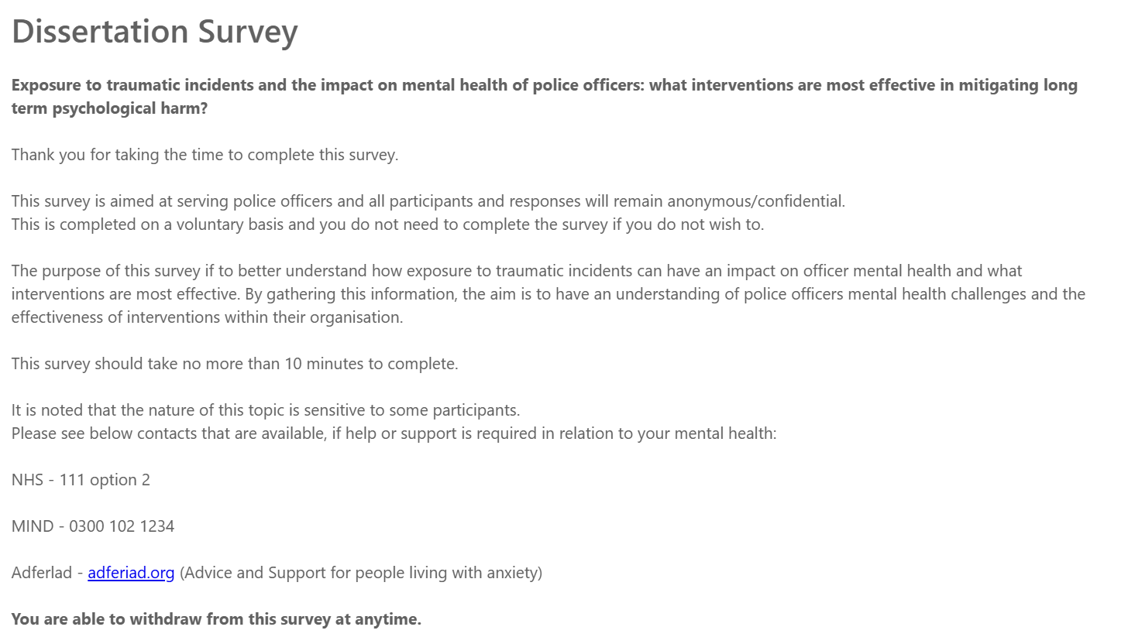

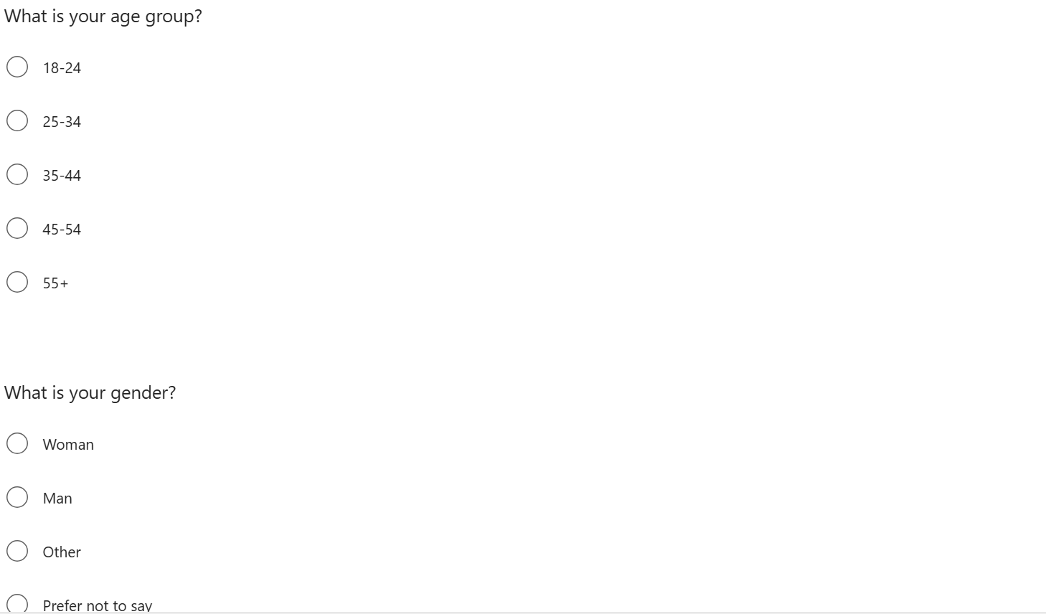

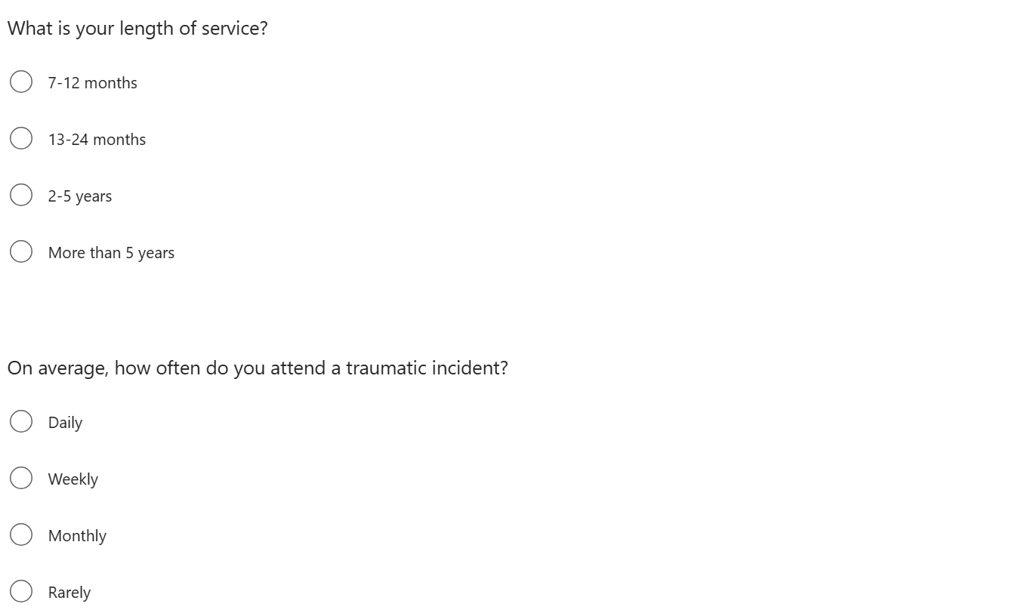
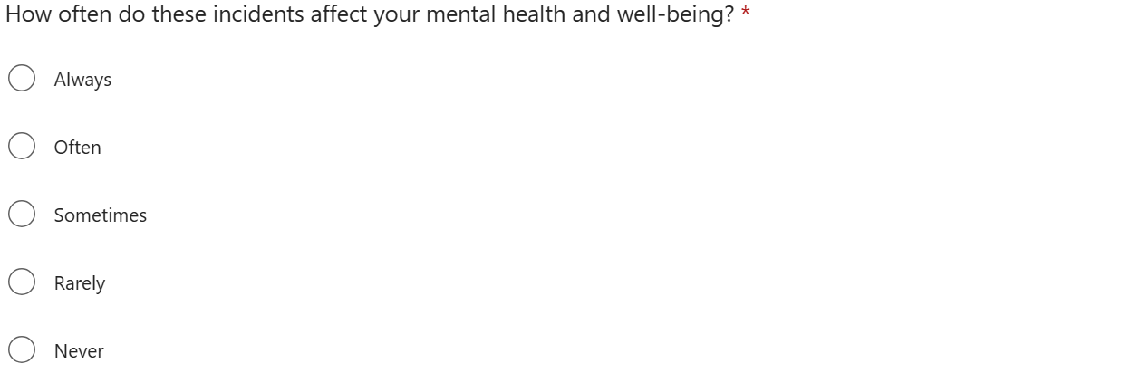
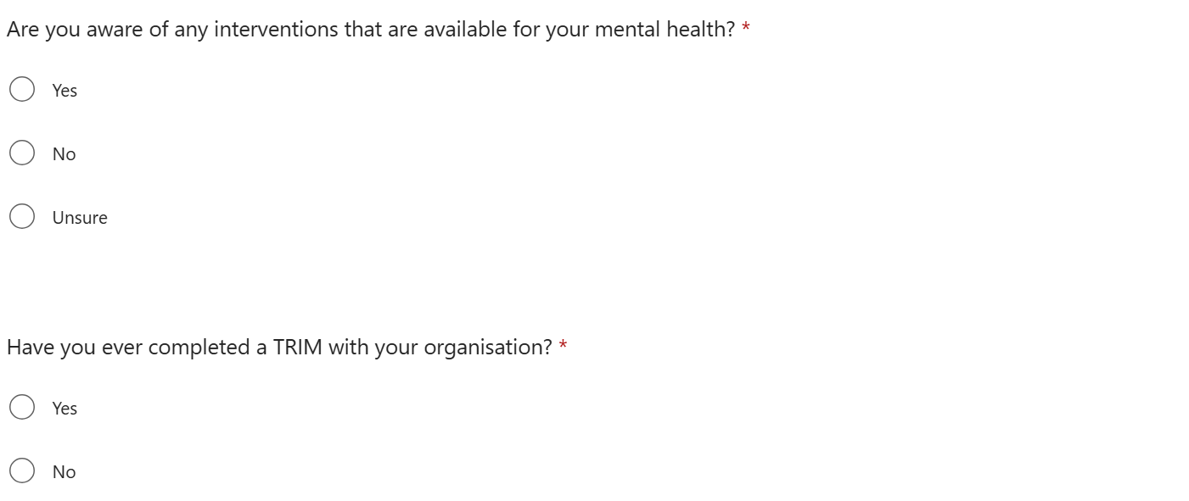

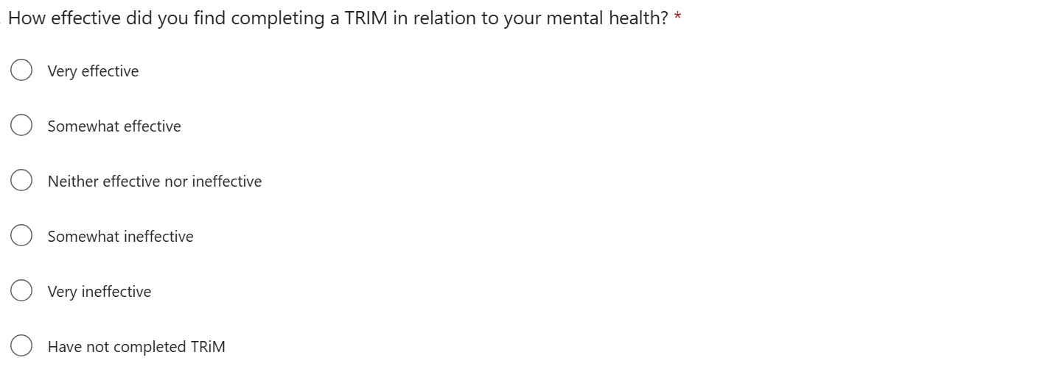
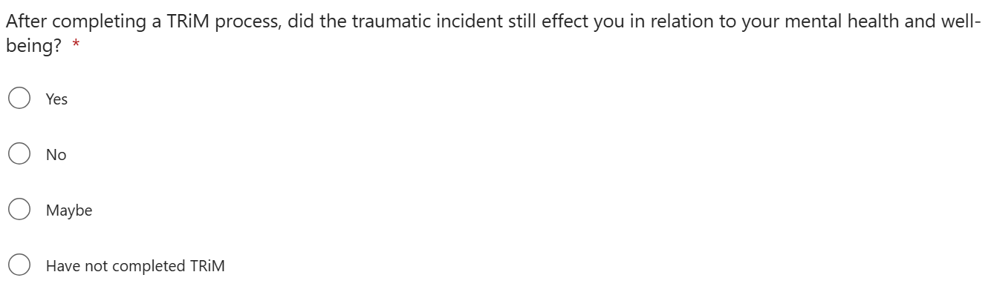
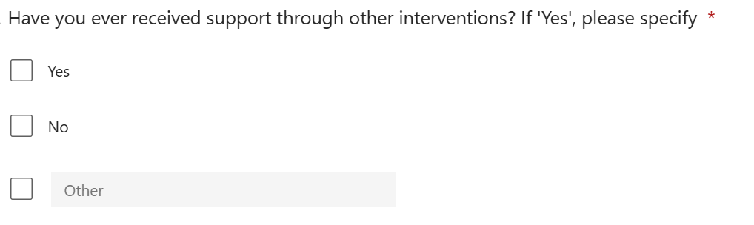

Appendix B: Survey of Results
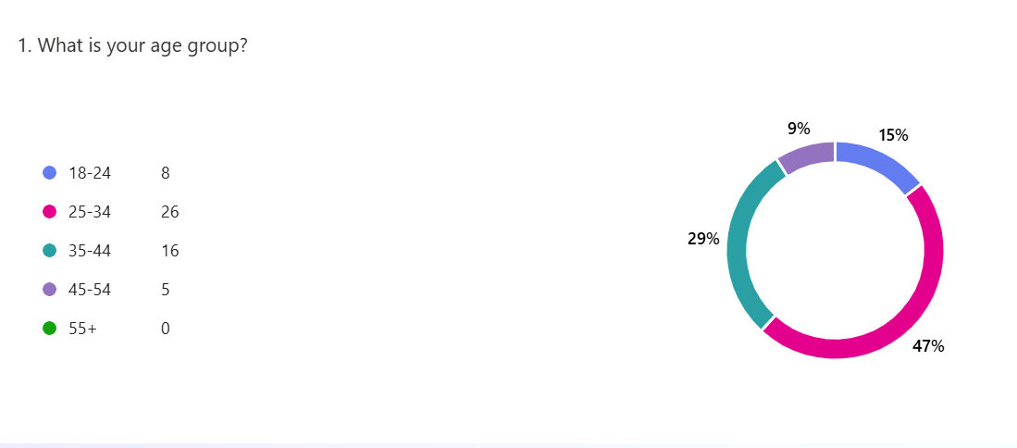

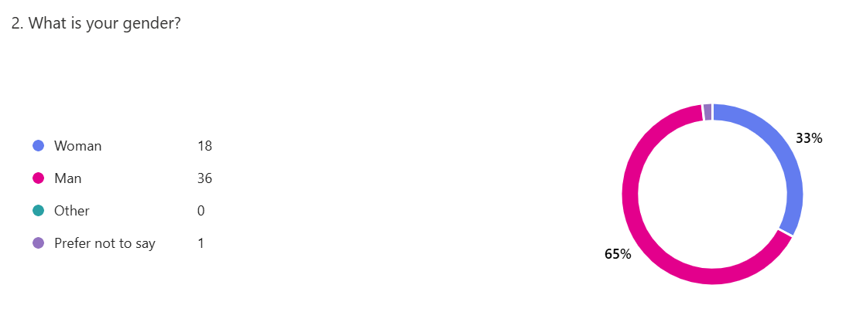

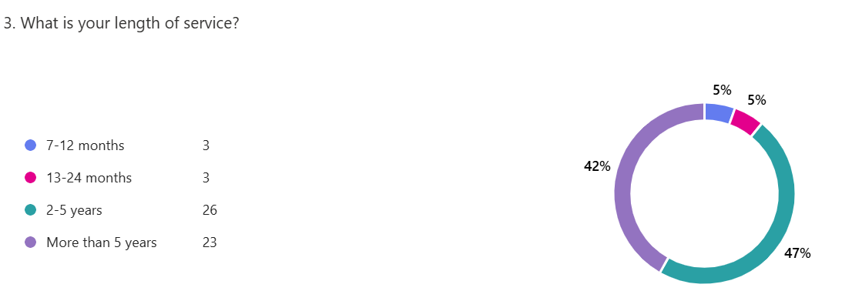

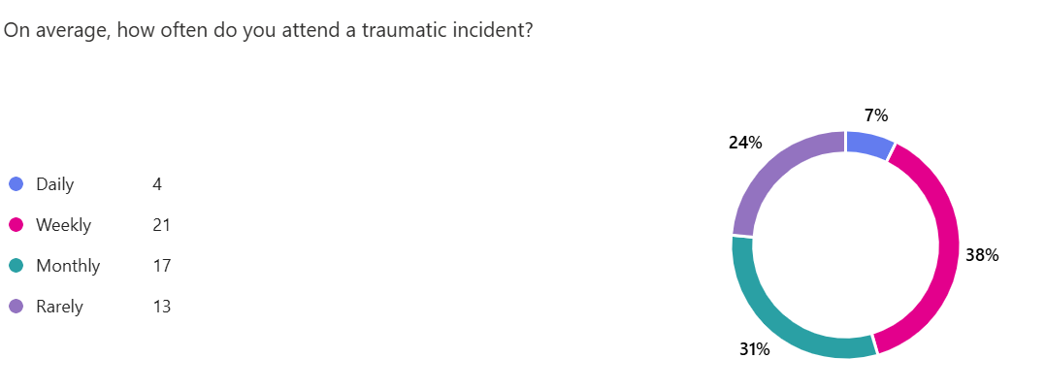
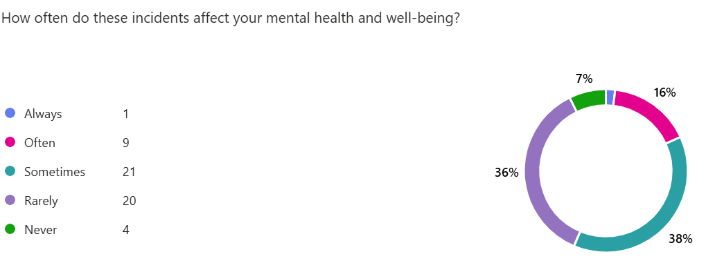
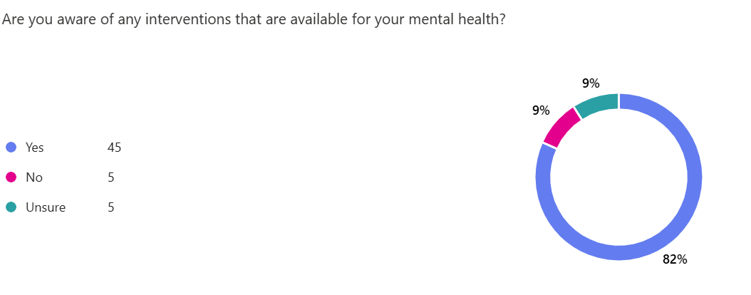
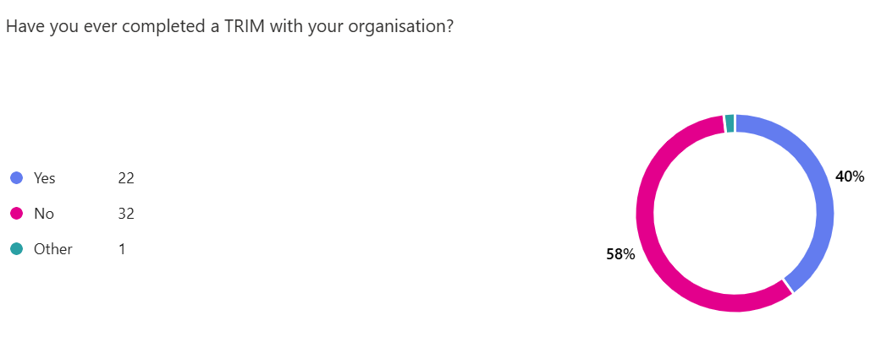
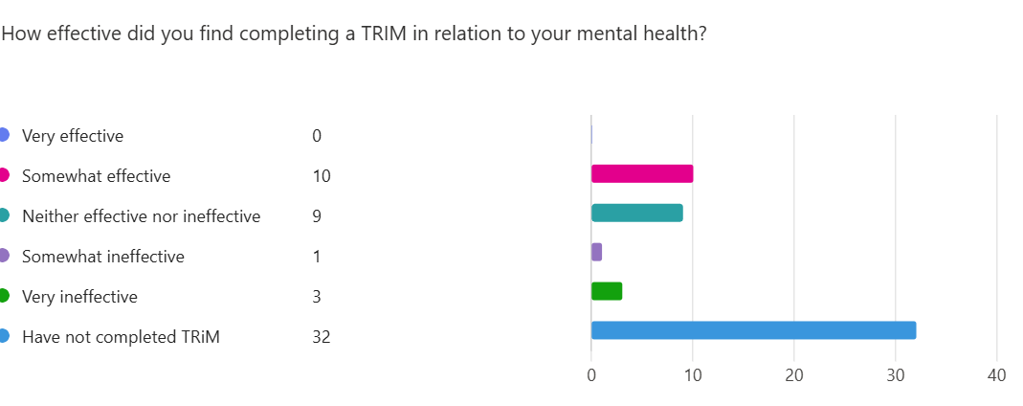
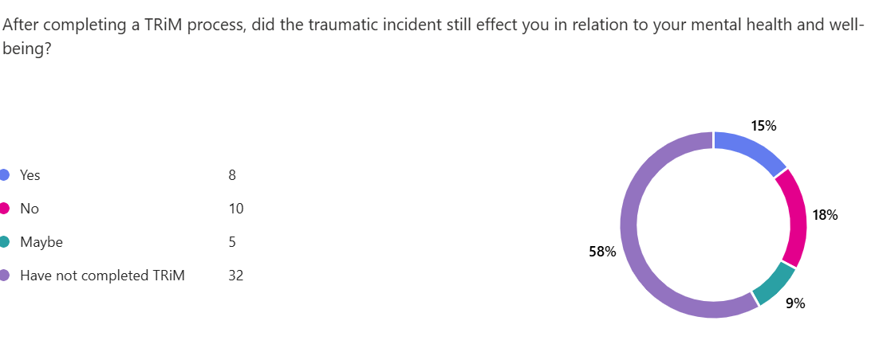
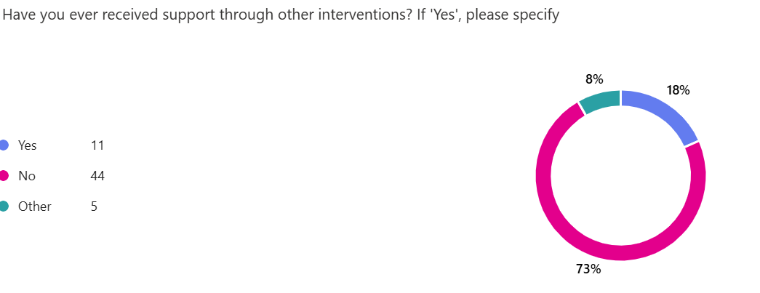

Appendix C – Application For Ethical Approval
PG2_Application_for_Ethical_Approval.docx

Appendix D – Research Proposal Sheet
Research Proposal Sheet (3).docx

Appendix E – Figure 1
Dublin, G. (2016). Proceedings of ARCOM Doctoral Workshop on Rese. Dublin Insistute of Technology , 1-74.

