Service Improvement Report: Enhancing Quality and Patient Safety in Leeds Teaching Hospitals NHS Trust Maternity Services

Module Code and Title: LCHS7006 - Quality Assurance and Service Improvements
Student Name: MD Nasir Uddin Nahid
Student ID: 2432642
Programme: MSc Public Health and Social Care in Practice
Assignment Component: Component 2 - Service Improvement Report

Executive Summary

The given report critically addresses the problem concerning the quality and patient safety in the maternity services at Leeds Teaching Hospitals NHS Trust. This review identifies several issues, such as staffing issues, poor governance and organisational culture constraints, that lead to the decline in quality of care and jeopardise maternal and neonatal well-being.
In the report, the typical theoretical foundation, such as the Donabedian model and the root cause analysis tools, is used to analyse the role of structural and process inefficiency in the development of the appalling healthcare outcomes. The systems-based approach proposes that the lack of these needs does not arise in a vacuum since the circumstance is precipitated by the entangled nature of the workforce strain, policy strain and failure of reporting systems.
In this connection, the report suggests various evidence-based suggestions which may be adopted to improve the service quality and patient safety. These are reinforcing the capacity of the workforce, improving incident reporting mechanisms, better governance and leadership practices and the establishment of systematic quality improvement strategies like the PDSA cycle and Lean strategies.
On the whole, the report highlights the need to implement an all-inclusive and systematic approach towards service enhancement. A complex intervention to change the underlying causes of quality failure can help healthcare organisations to produce sustainable change and secure quality maternity care that is both safe, effective and patient-centred.
Table of Contents
Executive Summary 2
1. Introduction 5
1.1 Background of the Case 5
1.2 Defining the Quality Problem 5
1.3 Public Health Significance 5
1.4 Aim of the Report 5
2. Analysis of Quality and Patient Safety Issues 7
2.1 Theoretical Frameworks for Quality Management 7
2.1.1 Donabedian Model 7
2.1.2 Systems Thinking and Patient Safety 8
2.2 Root Cause Analysis 8
2.2.1 Fishbone Analysis 8
2.2.2 5 Whys Analysis 9
2.2.3 Culture and Reporting Failures 9
2.3 Policy and System-Level Analysis 10
2.3.1 Workforce Pressures 10
2.3.2 Governance and Regulation 10
2.3.3 Digital and Service Challenges 10
2.4 SWOT Analysis 11
2.5 Synthesis 11
3. Recommendations 13
3.1 Workforce Improvement Strategies 13
3.2 Strengthening Incident Reporting Systems 13
3.3 Enhancing Governance and Leadership 13
3.4 Implementation Using PDSA Cycle 14
3.5 Lean and Continuous Improvement Approaches 15
4. Conclusion 16
References 17

1. Introduction

1.1 Background of the Case
Leeds Teaching Hospitals NHS Trust is a healthcare provider with the largest scope of services in England, which is affected by a great variety of maternity and neonatal services offered to a heterogeneous population (Leeds Teaching Hospitals NHS Trust, 2025). The latest regulatory investigations have shown that there is a strong concern over the quality and safety of care in these services (Department of Health and Social Care, 2025a). These issues are a lack of sufficient staffing, governance structure weaknesses and inability to keep clinical environments safe (NHS England, 2024b). These problems mirror the larger systemic problems in the National Health Service, specifically the problem of workforce deficit and the growing demand for services (Allen et al., 2024).

1.2 Defining the Quality Problem
The major quality concern in this case is associated with the failures related to patient safety caused by the organisational and system-level flaws in the maternity services (NICE, 2021). The presence of ineffective incident reporting systems and ineffective communication processes undermines the process of risk identification and adverse events learning in healthcare organisations (Van Dael et al., 2021). Moreover, insufficient openness and transparency in healthcare facilities may also lead to underreporting of safety issues and hinder the process of improvement (Martin et al., 2023). The combined effects of these factors are the deterioration of effective, safe, and patient-centred care delivery.

1.3 Public Health Significance
Patient safety is one of the priorities of public health because maternity services are essential to safeguard the well-being and health of both mothers and newborns (NHS England, 2021). Maternity care failures may result in avoidable harm, chronic health issues, and great emotional trauma for families (Taylor et al., 2022). Moreover, these failures may lower the confidence rates of the population in healthcare systems and exert an extra burden on the already limited resources (Widdows et al., 2025). To improve the outcomes of healthcare and provide equal access to safe and effective maternity services, these quality issues should, therefore, be addressed.

1.4 Aim of the Report
The purpose of the report is to critically examine the quality concerns in the identified area of Leeds maternity services through applying theoretical frameworks and tools of root cause analysis. It will also consider policy and system-level factors that impact the delivery of services and make evidence-based suggestions to improve the delivery of the service. Moreover, the report aims to show how it is possible to implement quality improvement methodologies into practice to facilitate sustainable organisational change and improve patient safety outcomes across maternity services.

2. Analysis of Quality and Patient Safety Issues

2.1 Theoretical Frameworks for Quality Management

2.1.1 Donabedian Model
Another model, the Donabedian model, is a fairly popular method of assessing the quality of healthcare based on the interrelated aspects of structure, process, and outcomes (Anderson et al., 2022). When applied to Leeds Teaching Hospitals NHS Trust, the organisational structure, including staffing levels, resource allocation, and infrastructure, impacts the quality of care delivery (McGowan et al., 2023). Lack of sufficient staff and resources can impose limitations on clinical operations, such as decision-making, communication, and patient monitoring (Drennan et al., 2021).
Poor compliance with clinical protocols and reporting of incidents contributes to process-related failures that further diminish the quality of provided care to patients (Santos, Ajayi-Obe and Aurelio, 2025). These shortcomings eventually result in adverse consequences, such as greater risks to maternal and neonatal safety (Widdows et al., 2025). The Donabedian framework thus illustrates how the organisational structure weaknesses can trickle down to process failures and poor patient outcomes. By means of the Donabedian framework, the relationship between the structure, process, and outcomes of Leeds maternity services can be depicted (Figure 1).
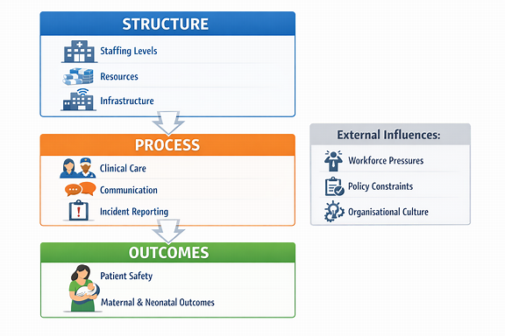
Figure 1: Application of the Donabedian Model to Leeds Maternity Services (Created with CO-Pilot by Author)
This chart shows that organisational structure deficiencies have a direct impact on care processes and result in unfavourable patient outcomes in the maternity services eventually (Anderson et al., 2022).

2.1.2 Systems Thinking and Patient Safety
Systems thinking offers healthcare quality with a holistic view by acknowledging that patient safety is a complex relationship within organisational systems (Aunger et al., 2022). Instead of blaming the failures on the individual practitioners, such an approach focuses on systemic drivers of failures, including organisational culture, leadership, and communication processes (Payne et al., 2023).
In the Leeds maternity case, several failures at the system level are possible, such as a lack of coordination between teams and an ineffective system of governance (Coleridge et al., 2022; Edwards et al., 2021). All these issues are related, which makes it more prone to errors that will go unaddressed (Van Dael et al., 2021). The system thinking thus points out the necessity to deal with the underlying weaknesses within organisations in order to achieve better patient safety outcomes.

2.2 Root Cause Analysis

2.2.1 Fishbone Analysis
The Fishbone diagram is an effective method of determining the underlying cause of quality issues because it classifies factors that cause them into major areas (Crawford, 2025). In this instance, the problem of staffing shortages belongs to the category of people and restricts the possibility of healthcare professionals to provide safe and effective care (Allen et al., 2024). The growing use of locum personnel only exacerbates both continuity of care and team cohesion (Ferguson et al., 2024).
The factors related to processes involve the presence of ineffective systems of incident reporting, as a result of which healthcare organisations can not recognise the patterns of harm and take corrective measures (Santos, Ajayi-Obe and Aurelio, 2025). Additional factors that add to patient risk are environmental, including improper infection control and unclean clinical environments (Camacho et al., 2024).
The inability to hold anyone accountable and supervise is further complicated by management-related factors, such as poor leadership and inadequate governance (Martin et al., 2023). These interrelationships explain the way that several organisational shortcomings work together to generate massive quality failures in maternity services. Table 1 categorizes factors that contribute to service quality, and their direct impact in order to have a more analytical break down of underlying causes.
Table 1: Categorised Root Causes and Their Impact on Maternity Service Quality (Author Made)
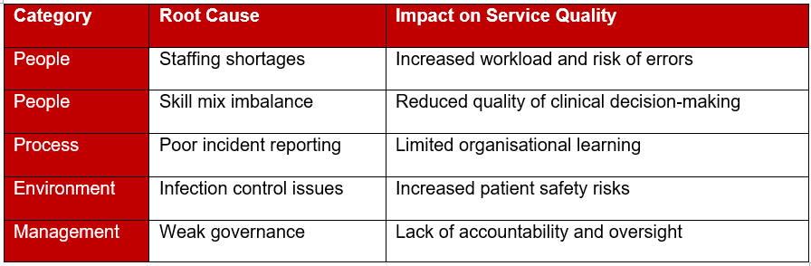

2.2.2 5 Whys Analysis
The 5 Whys method facilitates a more in-depth investigation into the roots of the problem by posing repetitive questions about the causes of why something happens (Crawford, 2025). Indicatively, improper patient outcomes could be associated with ineffective care delivery, which could be attributed to overwork among health care workers (Drennan et al., 2021).
This staffing pressure can be a result of staffing minimisation, often affected by higher workforce planning issues in the NHS (Department of Health and Social Care, 2025b). Policy-level constraints, such as funding available and rising demand for services, further influence these challenges (Allen et al., 2024). 5 Whys analysis then indicates that immediate clinical failures are based on bigger systemic and policy-related problems. The 5 Whys approach can be used to further investigate the underlying causes of the identified quality problem, as illustrated in Table 2.
Table 2: 5 Whys Analysis of Patient Safety Failures (Author Made)
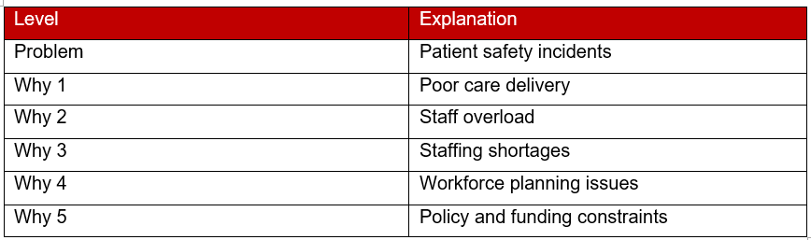

2.2.3 Culture and Reporting Failures
The role of organisational culture in determining patient safety outcomes in healthcare facilities is vital (Adams et al., 2024). The absence of openness and transparency may dishearten the staff, preventing them from reporting cases and consequently restricting learning and improvement opportunities (Van Dael et al., 2021).
Studies show that an adequate reporting system is crucial to detect risks and avert subsequent damage (Santos, Ajayi-Obe and Aurelio, 2025). In the Leeds maternity case, blame culture could lead to the underreporting of safety issues and the barriers to the enactment of remedial measures (Martin et al., 2023). Consideration of such cultural barriers is thus critical towards enhancing quality and safety in healthcare organisations.

2.3 Policy and System-Level Analysis

2.3.1 Workforce Pressures
The problem of a workforce shortage also continues to be a critical issue in the NHS, especially in those sectors with high demand, like maternity services (Allen et al., 2024). The growing use of temporary workers emphasises the challenges of having a stable workforce and quality of care (Ferguson et al., 2024).
The existing workforce issues are further exacerbated by the growing patient demand and reduced resources, which impose further strain on the healthcare professionals (Department of Health and Social Care, 2025a). This can lead to burnout and diminished ability to provide safe care by staff.

2.3.2 Governance and Regulation
Proper governance and regulatory structures are paramount in the promotion of high standards of healthcare quality and safety (NHS England, 2024a). Nevertheless, these frameworks may be somewhat less effective in practice due to gaps in their implementation and oversight (Department of Health and Social Care, 2025b).
The NHS Patient Safety Strategy emphasises the importance of continuous improvement and organisational learning (NHS England, 2024b). Nevertheless, issues of policy in practice can reduce the effectiveness of such programs. This shows that policy frameworks cannot work without competent local implementation, and there is no link between national strategy and frontline practice.

2.3.3 Digital and Service Challenges
The adoption of digital technologies in healthcare services poses challenges and prospects to patient safety (Hinton et al., 2022). Although digital systems are capable of enhancing efficiency and sharing information, they can also create new problems concerning communication and data accuracy (Camacho et al., 2024).
The introduction of remote care and digital monitoring in the maternity services would have to be implemented with strong measures to ensure that patient safety is not endangered.

2.4 SWOT Analysis
SWOT analysis offers a systematic method of analysing both internal and external forces that determine the quality of healthcare services (Atkins et al., 2023).
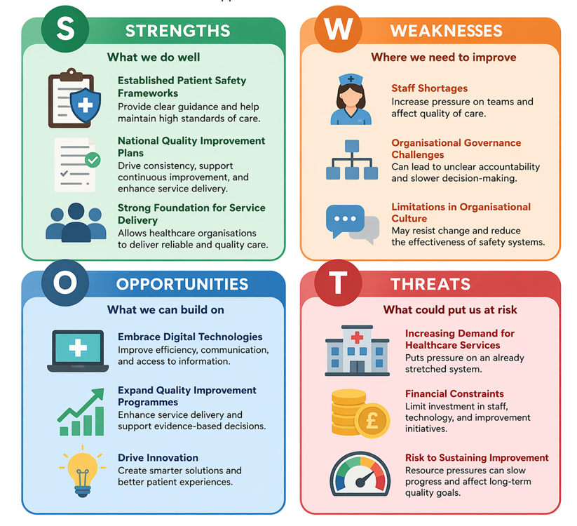
Figure 2: SWOT Analysis of Healthcare Service Quality in Maternity Care (Created with CO-Pilot by Author)
Strengths
The NHS has a number of strengths, such as established patient safety frameworks and national quality improvement plans, which help to consistently deliver services (NHS England, 2021). These frameworks provide a road map that can be used to maintain standards and improve ongoing improvement throughout the healthcare organisations.
Weaknesses
Despite such advantages, there are also serious drawbacks, in this case, with staff shortage, organisational governance, and limitations of organisational culture (Martin et al., 2023). These factors decrease safety system effectiveness and have adverse effects on patient outcomes of maternity care.
Opportunities
The potential areas to enhance are embracing digital technologies and increasing the number of quality improvement programs focused on improving service delivery (Lavallee et al., 2024). The strategies could encourage productivity, better communication, and engage in evidence-based decision-making in medical institutions.
Threats
External threats encompass mounting pressure on the already limited resources due to the growing demand for healthcare services and financial limitations (Department of Health and Social Care, 2025a). These issues might restrict the organisation's capacity to adopt and maintain quality improvement efforts.
This discussion indicates that despite the NHS having good structural pillars, chronic weaknesses and external factors can cause the success of improvement efforts to fail unless that is done comprehensively.

2.5 Synthesis
The qualitative analysis demonstrates that the quality breakdowns in the Leeds maternity services are not isolated but rather a multitude of factors in the system. Workforce shortage poses operational burdens that have a direct effect on care delivery and the possibility of a safety event (Atkins et al., 2023). These pressures are undermined by the governance weaknesses, which limit effective oversight of the organisation and reduce its ability to manage the arising risks.
A significant factor is also the organisational culture, where the absence of openness is a limitation to reporting incidents and learning from errors. When quality improvement endeavours are supported by leadership of good quality and a culture encouraging life-long learning and collaboration, it will be more effective (Lavallee et al., 2024). It shows that individual considerations are not likely to yield any significant change unless it is a combined system-wide effort.
Policy-wise national strategies provide a guide on how to improve patient safety, and their effectiveness is shown in the effective implementation on the local level. Combining the theoretical framework with practical improvement measures will prove that structural, cultural, and governance-related aspects need to be taken into consideration to bring about sustainable change (Phillips et al., 2025).

3. Recommendations

3.1 Workforce Improvement Strategies
In order to address the quality issues uncovered in the Leeds maternity services, the workforce capacity needs to be enhanced. The workload stress can be mitigated with the help of staffing improvement and grant health providers more opportunities to deliver safer and more effective care (Drennan et al., 2021). The workforce planning strategies should focus on the recruitment process, retention of the workers, and establishment of more clinical jobs to improve service delivery (Allen et al., 2024).
The reduction in the number of locum workers is also crucial, and the persistence of care is closely linked with patient safety and quality outcomes (Ferguson et al., 2024). Investment in staff training and professional development can enhance clinical competence and improve the performance of staff in maternity services (Taylor et al., 2022). Also, staff wellbeing can be enhanced by providing them with supportive working conditions and can decrease burnout, as well as increase the retention rates and ensure a steady level of service quality (Winnifrith et al., 2024).

3.2 Strengthening Incident Reporting Systems
In order to improve organisational learning and patient safety, there is an imperative to develop effective incident reporting systems. It is recommended that healthcare organisations embrace a systematic reporting system that will help to encourage employees to report safety concerns without the fear of being accused (Adams et al., 2024).
The kinds of culture that can be encouraged to facilitate risk detection and ongoing quality improvement are openness and transparency (Martin et al., 2023). It is suggested that, with appropriate reporting systems, health care organisations are able to systemically analyse the events and even develop targeted interventions to prevent the events (Santos, Ajayi-Obe and Aurelio, 2025). Also, the incorporation of patient feedback into reporting systems might also be used to achieve additional information on safety issues and enhance overall quality of care (Van Dael et al., 2021).

3.3 Enhancing Governance and Leadership
To improve accountability and boost decision-making in healthcare organisations, strengthening systems of governance is crucial. Leadership is needed to instil the spirit of safety and maintain the level of quality at all times (McGowan et al., 2023).
The healthcare leaders should also strive to improve communication, staff support, and ensure that the policies are translated into practice (NHS England, 2024a). Well-developed governance systems could help to track down the performance and promote the provision of quality care (Department of Health and Social Care, 2025b). Moreover, managers can be provided with the skills to manage complex healthcare settings and promote sustainable change with the help of leadership development programmes (Atkins et al., 2023).
Furthermore, constant employee involvement and feedback systems must be included in the improvement plans so that experiences on the frontline should guide the decision-making process. Incorporating quality improvement initiatives among healthcare professionals can facilitate ownership and accountability, which is vital in supporting the long-term organisational change and enhancing the overall service performance (Atkins et al., 2023).

3.4 Implementation Using PDSA Cycle
The Plan-Do-Study-Act cycle is a systematic approach to applying and evaluating quality improvement programs in health care facilities. Some of the key issues that should be correctly identified and prioritised during the planning phase include staffing shortage and reporting failure (Boot et al., 2023). The PDSA cycle presented in Table 4 can be used to summarise the proposed implementation strategy.
Table 4: PDSA Cycle for Service Improvement Implementation (Author Made)
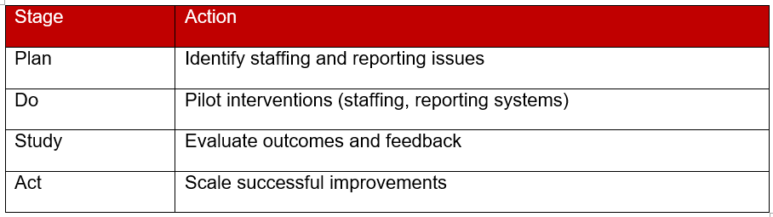
Pilot interventions during the implementation stage may be implemented, e.g. better staffing models or better reporting systems, to see how effective they are (Britton, 2023). The research phase will involve the assessment of the outcomes in terms of performance and feedback of medical workers to identify the impact of such interventions (Winnifrith et al., 2024).
Lastly, the action stage aims at perfecting effective strategies and magnifying them throughout the organisation to effect long-term change. The evaluation and monitoring process should be ongoing to ensure that the results are sustained. A greater degree of adaptability and responsiveness to the arising challenges can be further enhanced by introducing feedback loops in the PDSA cycle (Phillips et al., 2025).

3.5 Lean and Continuous Improvement Approaches
The lean methodologies may be used to assist in eradicating inefficiencies and increasing the flow of patients in maternity services. Organisations can promote efficiency and patient outcomes by detecting waste and removing it in the process of healthcare (Dallow et al., 2024).
The approaches of continuous improvement, including Lean and Six Sigma, aid in the creation of sustainable quality improvement strategies as they emphasise the utilisation of data-driven decisions and process optimisation (Stone, Pope and Proudlove, 2025). These strategies also encourage multidisciplinary cooperation, which will be required to address more complex healthcare concerns and enhance service in the long term (Lavallee et al., 2024). The effectiveness of these interventions, however, relies on successful implementation, engagement of the staff and ongoing evaluation of the strategies in complex healthcare settings.

4. Conclusion
The case study of Leeds Teaching Hospitals NHS Trust maternity services shows that interdependency among the system-level factors, such as workforce shortages, weaknesses in governance, and organisational culture, is the main cause of quality failures. The impacts of these issues are severe to patient safety and reduced efficiency of health care delivery, particularly in high-risk settings, such as maternity care.
The theoretical models, such as the Donabedian model and root cause analysis tools, are used to inform about the role of structural and process deficiencies in poor patient outcomes. These paradigms provide an excellent understanding of how the weaknesses of the healthcare systems may lead to failures in providing care and patient safety. The answers to such predicaments should be multi-layered and interwoven to enhance organisational systems rather than people playing the blame game.
The proposed strategies based on quality improvement strategies, such as but not limited to the use of PDSA and Lean strategies, are a systematic approach to implementing sustainable change in healthcare organisations. These methods focus on the value of ongoing observation, assessment, and adjustment of the importance of the relevance of the improvements as effective and responsive to the changing healthcare needs. Moreover, effective implementation should rely on robust leadership, a good level of communication and involvement of all levels of healthcare professionals.
Lastly, a system-wide change process must be implemented to help improve the quality of maternity services with a policy, leadership and safety culture. By mitigating risks through a focus on the root issues of quality failures, healthcare organisations will be able to improve patient outcomes and provide safe, effective, and equitable care.

References
Adams, M., Sanford, N., Bevan, C., Hartley, J., Heazell, A.E., Montgomery, E., Sanford, N., Treadwell, M., Sandall, J. and Booker, M. (2024). Strengthening open disclosure in maternity services in the English NHS: the DISCERN realist evaluation study. Health and Social Care Delivery Research, pp.1–159. doi:https://doi.org/10.3310/ytdf8015.
Allen, T., Ashcroft, D., Ferguson, J., Grigoroglou, C., Kontopantelis, E., Stringer, G. and Walshe, K. (2024). The use of locum doctors in the NHS: understanding and improving the quality and safety of care. Health and Social Care Delivery Research, 12(37), pp.1–266. doi:https://doi.org/10.3310/cxmk4017.
Anderson, M., Molloy, A., Maynou, L., Kyriopoulos, I., McGuire, A. and Mossialos, E. (2022). Evaluation of the NHS England evidence-based interventions programme: a difference-in-difference analysis. BMJ Quality & Safety, 32(2). doi:https://doi.org/10.1136/bmjqs-2021-014478.
Atkins, E., Birmpili, P., Glidewell, L., Li, Q., Johal, A.S., Waton, S., Boyle, J.R., Pherwani, A.D., Chetter, I. and Cromwell, D.A. (2023). Effectiveness of quality improvement collaboratives in UK surgical settings and barriers and facilitators influencing their implementation: a systematic review and evidence synthesis. BMJ Open Quality, 12(2), p.e002241. doi:https://doi.org/10.1136/bmjoq-2022-002241.
Aunger, J.A., Millar, R., Rafferty, A.M. and Mannion, R. (2022). Collaboration over competition? Regulatory reform and inter-organisational relations in the NHS amidst the COVID-19 pandemic: a qualitative study. BMC Health Services Research, 22(1). doi:https://doi.org/10.1186/s12913-022-08059-2.
Boot, M., Allison, J., Maguire, J. and O’Driscoll, G. (2023). QI initiative to reduce the number of inpatient falls in an acute hospital Trust. BMJ Open Quality, 12(1), p.e002102. doi:https://doi.org/10.1136/bmjoq-2022-002102.
Britton, H.E. (2023). Increasing staff time for patient facing care on an inpatient geriatric unit through modification of multidisciplinary board rounds: a quality improvement project. BMJ open quality, 12(4), pp.e002405–e002405. doi:https://doi.org/10.1136/bmjoq-2023-002405.
Camacho, E.M., Gavan, S., Keers, R.N., Chuter, A. and Elliott, R.A. (2024). Estimating the impact on patient safety of enabling the digital transfer of patients’ prescription information in the English NHS. BMJ Quality & Safety, 33(11). doi:https://doi.org/10.1136/bmjqs-2023-016675.
Coleridge, S.L., Wiggans, A., Nelissen, E., Bethune, R., Blackwell, R., Bryant, A. and Morrison, J. (2022). Improving the uptake of cervical screening in pregnant and recently postnatal women: a quality improvement project. BMJ Open Quality, 11(2), p.e001709. doi:https://doi.org/10.1136/bmjoq-2021-001709.
Crawford, M. (2025). Quality improvement project to reduce length of stay for patients with urinary tract infections in an NHS hospital trust. BMJ Open Quality, 14(3), pp.e002998–e002998. doi:https://doi.org/10.1136/bmjoq-2024-002998.
Dallow, A., Goldthorpe, K., Murphy, P., Phipps, D. and Rostami, P. (2024). Formative qualitative evaluation of an improvement programme delivered in an English hospital trust to reduce harm from pressure ulcers. BMJ Open Quality, 13(3), pp.e002532–e002532. doi:https://doi.org/10.1136/bmjoq-2023-002532.
Department of Health and Social Care (2025a). Performance of the health service in England: Secretary of State for Health and Social Care annual report 2022 to 2023. [online] GOV.UK. Available at: https://www.gov.uk/government/publications/performance-of-the-health-service-in-england-secretary-of-state-for-health-and-social-care-annual-report-2022-to-2023/performance-of-the-health-service-in-england-secretary-of-state-for-health-and-social-care-annual-report-2022-to-2023 [Accessed 12 Apr. 2026].
Department of Health and Social Care (2025b). Review of patient safety across the health and care landscape. [online] GOV.UK. Available at: https://www.gov.uk/government/publications/review-of-patient-safety-across-the-health-and-care-landscape/review-of-patient-safety-across-the-health-and-care-landscape [Accessed 12 Apr. 2026].
Drennan, V.M., Collins, L., Allan, H., Brimblecombe, N., Halter, M. and Taylor, F. (2021). Are advanced clinical practice roles in England’s National Health Service a remedy for workforce problems? A qualitative study of senior staff perspectives. Journal of Health Services Research & Policy, 27(2), p.135581962110367. doi:https://doi.org/10.1177/13558196211036727.
Edwards, H., Redaniel, M.T., Opmeer, B., Peters, T., Margelyte, R., Rejon, C.S., Hollingworth, W., Craggs, P., Hill, E., Redwood, S., Donovan, J. and Luyt, K. (2021). Evaluating an enhanced quality improvement intervention in maternity units: PReCePT trial protocol. BMJ Open Quality, 10(2), p.e001204. doi:https://doi.org/10.1136/bmjoq-2020-001204.
Ferguson, J., Stringer, G., Walshe, K., Allen, T., Grigoroglou, C., Ashcroft, D.M. and Kontopantelis, E. (2024). Locum doctor working and quality and safety: A qualitative study in english primary and secondary care. BMJ Quality & Safety, 33(6), p.bmjqs-016699. doi:https://doi.org/10.1136/bmjqs-2023-016699.
Hinton, L., Dakin, F.H., Kuberska, K., Boydell, N., Willars, J., Draycott, T., Winter, C., McManus, R.J., Chappell, L.C., Chakrabarti, S., Howland, E., George, J., Leach, B. and Dixon-Woods, M. (2022). Quality framework for remote antenatal care: qualitative study with women, healthcare professionals and system-level stakeholders. BMJ Quality & Safety, 33(5). doi:https://doi.org/10.1136/bmjqs-2021-014329.
Lavallee, L., Roman, C., Brace, E., Mackillop, L., Yang, Y., Cairns, A., Dockree, S., Tarassenko, L., McManus, R.J., Wilson, H. and Tucker, K. (2024). Rapid implementation of blood pressure self-monitoring in pregnancy at a UK NHS Trust during the COVID-19 pandemic: a quality improvement evaluation. BMJ Open Quality, 13(2), pp.e002383–e002383. doi:https://doi.org/10.1136/bmjoq-2023-002383.
Leeds Teaching Hospitals NHS Trust (2025). Leeds Teaching Hospitals commits to improvements following CQC reports on maternity and neonatal services - Leeds Teaching Hospitals NHS Trust. [online] Leeds Teaching Hospitals NHS Trust. Available at: https://www.leedsth.nhs.uk/news/leeds-teaching-hospitals-commits-to-improvements-following-cqc-reports-on-maternity-and-neonatal-services/ [Accessed 12 Apr. 2026].
Martin, G., Chew, S., McCarthy, I., Dawson, J. and Dixon-Woods, M. (2023). Encouraging openness in health care: Policy and practice implications of a mixed-methods study in the English National Health Service. [online] THIS Institute - The Healthcare Improvement Studies Institute. Available at: https://www.thisinstitute.cam.ac.uk/research/outputs/encouraging-openness-in-health-care-policy-and-practice-implications-of-a-mixed-methods-study-in-the-english-national-health-service/ [Accessed 12 Apr. 2026].
McGowan, J., Attal, B., Kuhn, I., Hinton, L., Draycott, T., Martin, G. and Dixon‐Woods, M. (2023). Quality and reporting of large-scale improvement programmes: a review of maternity initiatives in the English NHS, 2010–2023. BMJ Quality & Safety, 33(11), p.bmjqs-016606. doi:https://doi.org/10.1136/bmjqs-2023-016606.
NHS England (2021). The National Patient Safety Improvement Programmes. [online] Available at: https://www.england.nhs.uk/patient-safety/patient-safety-improvement-programmes/ [Accessed 12 Apr. 2026].
NHS England (2024a). Quality and outcomes framework guidance for 2023/24. [online] www.england.nhs.uk. Available at: https://www.england.nhs.uk/long-read/quality-and-outcomes-framework-guidance-for-2023-24/ [Accessed 12 Apr. 2026].
NHS England (2024b). The NHS Patient Safety Strategy. [online] NHS England. Available at: https://www.england.nhs.uk/patient-safety/the-nhs-patient-safety-strategy/.
NICE (2021). Patient safety. [online] NICE website: The National Institute for Health and Care Excellence. Available at: https://www.nice.org.uk/patient-safety [Accessed 12 Apr. 2026].
Payne, R., Clarke, A., Swann, N., Dael, J. van, Brenman, N., Rosen, R., Mackridge, A., Moore, L., Kalin, A., Ladds, E., Hemmings, N., Rybczynska-Bunt, S., Faulkner, S., Hanson, I., Spitters, S., Wieringa, S., Dakin, F.H., Shaw, S.E., Wherton, J. and Byng, R. (2023). Patient safety in remote primary care encounters: multimethod qualitative study combining Safety I and Safety II analysis. BMJ Quality & Safety, 33(9). doi:https://doi.org/10.1136/bmjqs-2023-016674.
Phillips, A.J., Bowen, R., Wells, M., McNeish, I. and Sundar, S. (2025). Key clinical findings from the IMPROVE-UK quality improvement projects: an overview. BMJ open quality, 14(Suppl 1), p.e002902. doi:https://doi.org/10.1136/bmjoq-2024-002902.
Santos, C., Ajayi-Obe, A. and Aurelio, M. (2025). Using Quality Improvement to improve serious incident reporting in the English NHS. BMJ Open Quality, 14(3). doi:https://doi.org/10.1136/bmjoq-2024-003234.
Stone, M., Pope, C. and Proudlove, N. (2025). Quality improvement project to reduce beta-D-glucan turnaround times in an NHS pathology network. BMJ Open Quality, 14(2), p.e003210. doi:https://doi.org/10.1136/bmjoq-2024-003210.
Taylor, B., Hewison, A., Cross-Sudworth, F. and Morrell, K. (2022). Transformational Change in maternity services in England: a longitudinal qualitative study of a national transformation programme ‘Early Adopter’. BMC Health Services Research, [online] 22(1). doi:https://doi.org/10.1186/s12913-021-07375-3.
Van Dael, J., Gillespie, A., Reader, T., Smalley, K., Papadimitriou, D., Glampson, B., Marshall, D. and Mayer, E. (2021). Getting the whole story: Integrating patient complaints and staff reports of unsafe care. Journal of Health Services Research & Policy, 27(1), pp.41–49. doi:https://doi.org/10.1177/13558196211029323.
Widdows, K., Reid, H., Smith, D.M., Wood-Harper, R., Camacho, E., Roberts, S.A. and Heazell, A.E.P. (2025). Evaluating the implementation of the Saving Babies Lives Care Bundle Version 2 from service user and healthcare professionals’ perspectives: a questionnaire study. BMJ Open Quality, 14(3), p.e003456. doi:https://doi.org/10.1136/bmjoq-2025-003456.
Winnifrith, T., Millington-Sanders, C., Husbands, E., Haros, J. and Ballinger, H. (2024). Proactive advance care planning conversations in general practice: a quality improvement project. BMJ Open Quality, 13(3), pp.e002679–e002679. doi:https://doi.org/10.1136/bmjoq-2023-002679.

