MARIUS TIPA 2011920
ZOOS ROLE IN CONSERVATION

TABLE OF CONTENTS:
INTRODUCTION
HISTORY AND EVOLUTION
ZOOS and CONSERVATION WORK
SUCCESSFUL REINTRODUCTION PROGRAMMES
EX-SITU BREEDING
THE CRITICISMS
CONCLUSIONS

INTRODUCTION
This report examines zoos’ mixed heritage and assesses the role zoos have to play in the future of conservation Worldwide, in the context of the Anthropocene biodiversity crises. The author will highlight case studies and look at the evidence for the impact zoos have on wildlife conservation.
The rapid loss of natural habitat is causing an increased rate of extinction, well above naturally occurring levels (IPBES, 2023). This calls for a more proactive and coordinated response from the global conservation community. Despite their historical popularity as entertainment venues, in recent times zoos have undergone considerable change and have become part of this effort to protect and restore species and their habitats. While remaining attractive places of entertainment, today zoos also emphasise their contribution to wildlife conservation. Far beyond keeping animals alive in captivity for public entertainment, many zoos have become strongly proactive in conserving wild animals, reintroducing endangered species and restoring habitats (Tribe, 2006).
Critics argue that the role of zoos in conservation has been widely exaggerated and in reality zoos try to justify their existence by claiming that keeping wild animals in captivity contributes to conservation and education (BornFree, 2023).

ZOOS: HISTORY and EVOLUTION
A zoo (zoological park) is a place where animals live in captivity and are put on display for people to view. The first zoos were created as private collections of the wealthy and were called menageries. There is evidence to suggest that rulers in ancient Egypt and Mesopotamia created such menageries as early as 2500BC. They left records, in the form of wall carvings, of expeditions to distant places to bring back exotic animals such as giraffes, elephants, bears, dolphins and birds (National Geographic, 2023).
The model of the modern public zoo appeared in 18th century, when the scientific focus of the Age of Enlightenment began to extend to zoology (Vienna, Paris, Madrid). During this time, many of the private collections, often royal menageries, became public zoos. Later, in 1826, London Zoo was established as a study collection for the fellows of the Zoological Society, but within a few years it opened to the public.
The conditions were poor, with animals being kept in cages or small, barren enclosures. The knowledge about their biology, diets and habitats was very limited. Hence most animals had a short lifespan (Rothfels, 2002). The situation only improved towards the end of the 19th century, when Carl Hagenbeck revolutionised the way animals were displayed: doing away with cages, he created landscaped enclosures surrounded by moats, where animals were seen as people would expect to see them in the wild. Using this design, in 1907 he built Hagenbeck’s Tierpark, Hamburg. His zoo embodied many of the principles that zoos use to this day: open enclosures without barred cages (Rothfels, 2002).
Hagenbeck’s ideas were used throughout the 20th century, eventually leading to a reinvention of zoo dsign in the 1970s, 80s and 90s. During this time, scientists were gaining valuable knowledge on animal behaviour, social biology and ecology. These studies help to design new exhibits that were much more appropriate for the animals and allowed them to express more of their natural behaviour. The enclosures became larger and more complex, with extensive vegetation and an enriched environment for the animals (Rothfels, 2002). Despite these improvements, critics point out that many animals suffer in captivity, as zoos can never recreate the complex environment they are adapted to live in (BornFree, 2022).

ZOOS and CONSERVATION WORK
Zoos evolution over time was not only reflected in improved exhibit design, but also in the different ideas regarding the purpose of zoos and the relationship between the public and animals. In recent times, alongside recreation, science and education, zoos became preoccupied with conservation. 'I think. According to Phillips (2015), quoting Professor Ben Minteer, an environmental ethicist and conservation scholar at Arizona State University, “the concern for naturalism in zoo exhibits was sucked up into a larger concern for ecology and conservation” (Phillips, 2015).
Another reason was the ever-increasing pressure from the animal rights campaigners and the public at large, who became more aware and involved in the cause of the animals in captivity and demanded improvements in their welfare. Zoos had to react and attempt to present themselves increasingly as organisations with a significant role to play in wildlife conservation (Phillips, 2015).
According to the UN, almost 50% of world’s population lives in urban environments, disconnected from nature to a large degree. Therefore, for a large proportion of people, visiting zoos and aquariums represent the main type of interaction they have with wildlife. This offers a great opportunity to win public support for wildlife preservation, through raising awareness and education about animals, their behaviour, habitat, population changes, and why they need to be conserved.
Zoos and aquariums recognised the opportunity to transform themselves from traditional animal displays to entertaining, interactive conservation centres. And they moved fast to capitalise on this opportunity: a study by Patrick et al. (2007) confirms that conservation and education are key elements in the mission statements of zoos. Also significant, a survey conducted by AZA (Association of Zoos and Aquariums), reveals that the public think conservation and education are the most important roles of zoos (Fraser and Sickler, 2008).
Their major contribution comes through zoos ex-situ actions: education programs, captive breeding and management of wildlife. However, recently, zoos have also become more involved with government authorities and local communities, carrying out in-situ conservation, predominantly recovery programs for endangered species (Tribe, 2006). But, according to Tribe (2006), given the high costs of these activities, zoos must strike a balance between commercial success and professional conservation credibility.
Data from the International Species Information System (ISIS) shows that zoos hold approximately 15% of the total threatened species in the world (Conde et al. 2011). The same study carried out by Conde et al. (2011) shows that most ISIS affiliated zoos are in the temperate region, while most of the threatened species are tropical. This indicates a mismatch between areas where the captive species are being held and their natural habitats. It also suggests that most zoos in the tropical areas with high biodiversity are not participating in conservation programs (Conde et al. 2011).
The British and Irish Association of Zoos and Aquariums came up with a list of the most endangered animals, to highlight their work in securing a future for these species:

- Blue-crowned laughing thrush (Garrulax courtoisi).

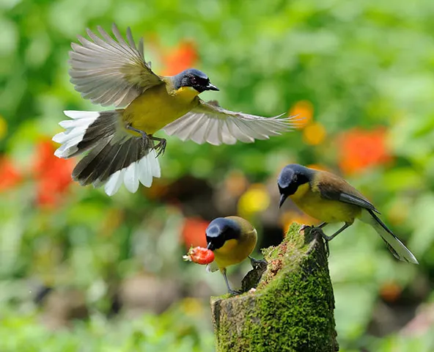
Trapping for the bird trade is a major cause of its decline. In the wild, a small population of around 300 birds exist in south-eastern China (WAZA, 2023)
The Forestry Bureau of Wuyuan County (FBWC) supports the protection of key breeding sites and monitors the population, with financial and technical support from London Zoo (WAZA, 2023).
There are 290 birds in zoos around the world, an increase of 163% from 2008 levels, through Global Species Management Plan (WAZA, 2023).

- The mountain chicken frog (Leptodactylus fallax).

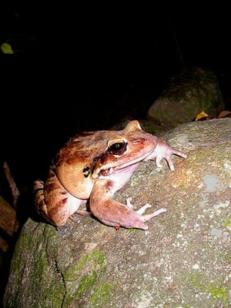
One common throughout the Caribbean Islands, since 2002 their wild population has plummeted, mainly due to the rapid spread of the chytrid fungus. Hunting, invasive species and habitat destruction are the other causes (Natural History Museum, 2023).
With an estimated wild population of under 200 individuals (Dominica, Monserrat), safeguarding in captivity, breeding and releasing is vital for the survival of this species (Natural History Museum, 2023).

- White-clawed crayfish (Austropotamobius pallipes).
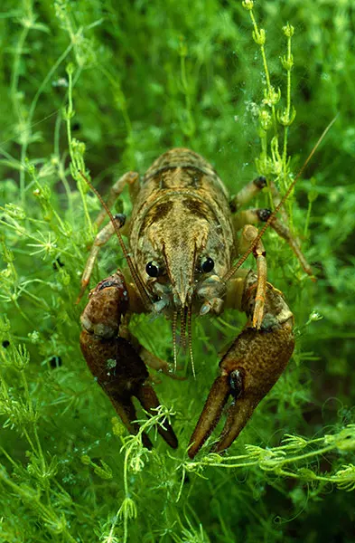
In Britain, 95% have disappeared as a result of the introduction of American crayfish, disease and pollution.
In 2008, the South West Crayfish Partnership was set up and included Bristol Zoological Society. In an attempt to hold the decline, they established 17 ark sites and captive-bred more than 4000 crayfish. These were released as river supplementation.
Together with the invasive crayfish control programme, this had led to a 75% increase of the white-clawed crayfish in the South West (Bristol Zoological Society, 2023).

- Amur leopards (Panthera pardus orientalis).

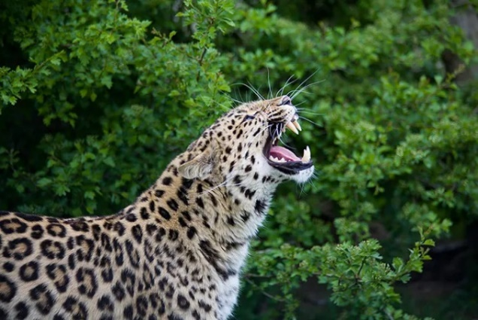
In 2017 there were only around 100 individuals left in the wild (Russia and China). It is the most endangered species of big cat in the world. Retaliatory killings, poaching and habitat loss are the main threats (Zoological Society of London, 2023).
217 animals are held in captivity. UK zoos take part WAZA’s Global Species Management Plan (Twycross Zoo, Dartmoor Zoo) of ex-situ breeding, with reintroduction currently in planning (WAZA, 2023).

- Potosi pupfish.

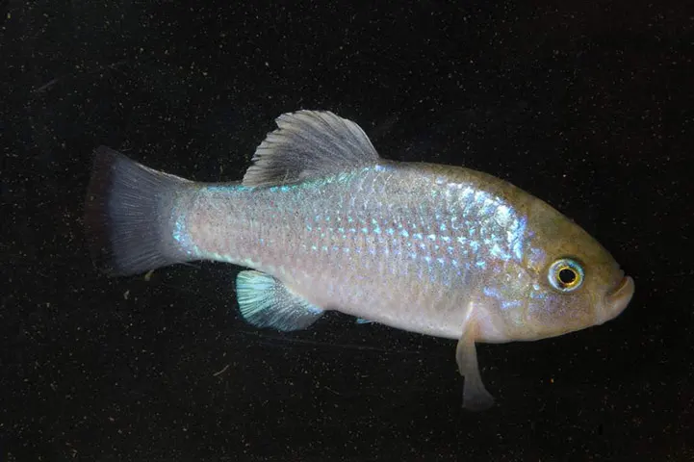
Originating in Mexico, now extinct in the wild, mainly because of climate change and pollution. Bristol Zoo and London Zoo are the only organisations associated with ISIS (Species 360) to have these species (around 400 fish). Some also exist with a few private breeders in Spain, Mexico and the US (BBC News, 2009).

- Partula snails.
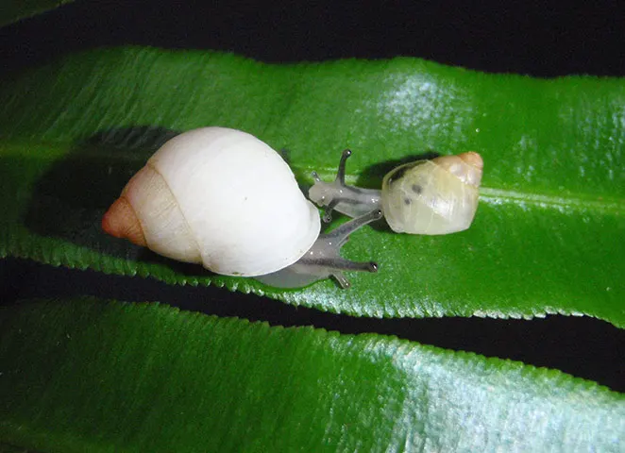
Polynesian tree snail. IUCN considers it extinct in the wild. Its demise happened as a result of a misguided biological pest control programme.
London Zoological Society, together with the French Polynesian government and other zoos, have run a reintroduction programme. ZSL coordinates the global collaboration between 16 zoos and conservation organisations.
The reintroduction programme has seen 15,000 snails make the journey back to the Islands since its beginning in the 1990s (ZSL, 2023).

- Blue-eyed black lemur (Eulemur flavifrons).
Native to Madagascar, there are fewer than 1,000 individuals remaining in the wild. The destruction of their tropical forest habitat led to them becoming the most endangered primate species in the world (The Guardian, 2022).
In October 2021 EAZA had 24 captive animals as part of their Ex-situ Programme (EAZA, 2023). Mulhouse Zoo (Alsace, France) leads a consortium of European Zoological Gardens, who have joined forces to carry out conservation and research projects on this species (EAZA, 2023).
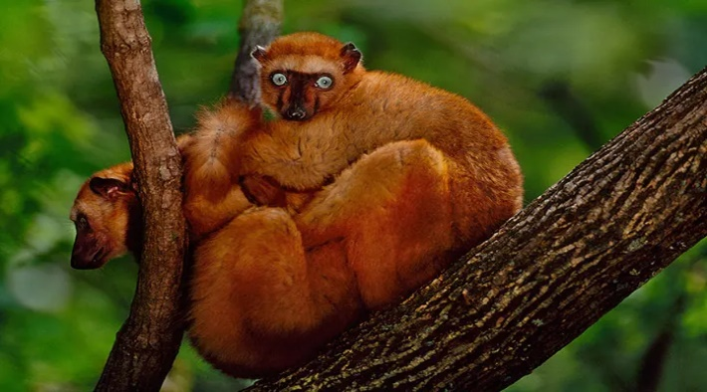

- Ploughshare tortoise (Astrochelys yniphora)
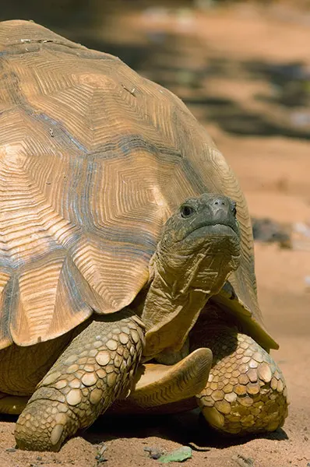
The wild population is thought to be less than 600 adults (Baly Bay National Park, Madagascar). Poaching for pet trade is the main threat, but also bush fires.
The ex-situ zoo population provides veterinary research opportunities to support health management in the Madagascar breeding centres.
Durrell Wildlife Conservation Trust is maintaining a large captive breeding colony in Madagascar, which serves as the last stronghold for the species (EAZA, 2023).

- Scimitar-horned oryx (Oryx dammah).

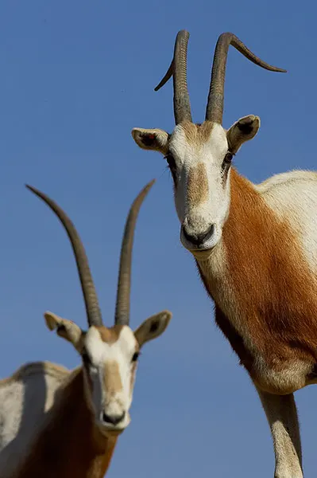
Once distributed across most of North Africa, it is now considered extinct in the wild due to overhunting, habitat loss and persistent drought. Zoological Society of London together with the Environmental Agency - Abu Dhabi, the Sahara Conservation Fund and the Smithsonian Conservation Ecology Center (CEC) work with the government of Chad and other zoos to return oryx to the Ouadi Rimé-Ouadi Achim Game Reserve (Smithsonian National Zoo and Conservation Ecology Center, 2023).

Zoos’ role in wildlife conservation was strengthened over recent years by scientific bodies. In October 2010 the Convention on Biological Diversity (CBD) in Nagoya, Japan, recognised that given the gravity of the situation, in-situ conservation actions will need to be combined with ex-situ approaches, such as captive breeding in zoos and aquariums (Conde et al. 2011).
In 2021 a report produced by a group of UK zoos shows that the fate of 29 native species rests in the hands of just seven zoos and aquariums, and that at least 76 native species in total are being restored by the work of zoos. All the major conservation successes from bison to beavers have had good zoos involved. It also shows that BIAZA members are engaged in 800 conservation projects in 105 countries (The Guardian, 2022). The same report identified nine species in the British Overseas Territories that would face significant declines without the action of zoos. In Montserrat, Chester Zoo is working with the Durrell Wildlife Trust and ZSL London Zoo to restore the critically endangered mountain chicken frog which only exist in Montserrat in special enclosures set up by the zoos. Without their work the enigmatic frog would face extinction (In our hands: The British and UKOT species that Large Charitable Zoos & Aquariums are holding back from extinction)
BIAZA highlights the involvement of ZSL Whipsnade Zoo in the conservation of the corncrake. Over 1000 birds have been bred at the zoo and released in Nene Washes in Cambridgeshire. Whipsnade is providing expert advice on the risk of diseases to the health of these rare birds. Also, they say the expertise of ZSL London and Whipsnade zoos is also important to the recovery of other species, like harbour seals and sea eagles.
Despite the commitment and investment zoos have a mixed track record when it comes to the success of conservation projects. They are responsible for only 16 successful reintroduction in the wild programmes, out of 145 attempted (wildwelfare.org, 2021).
Oded Berger-Tal (2020) researching Global reintroduction perspectives: 2018 (IUCN Species Survival Commission), concluded that failures often follow patterns that could be avoided in order to improve success rates and came up with a list of most common reasons for failure (Berger-Tal 2020):
- Poor practice
- Difficulties monitoring after release, lack of funding to monitor the outcome
- Insufficient stakeholder engagement, lack of public support (arabian oryx, Oman)
- Habitat availability and quality
- Influx of invasive species
- Wars, civil unrest, political instability
Berger-Tal, a researcher at Ben Gurion University specialising in application of animal behaviour research to conservation and management, also suggests that there are a lot of hidden failures, as biologists are reluctant to make public failed reintroduction efforts, due to political implications that could affect future funding. But despite this, all projects yield important lessons and scientists must be able to discuss the results, positive or otherwise (Berger-Tal, 2020).

SUCCESSFUL REINTRODUCTION PROGRAMMES
Bison (Netherlands and Romania)
Dutch and Romanian European bison reintroduction programmes were declared successful after several years of conservation efforts. Their presence has been deemed of great environmental importance, the grazing led to a consequent flourishing of flora and fauna. (The Guardian, 2022). According to the Foundation for Conservation Carpathia, in Romania this is not only a matter of repairing past environmental mistakes through modern biodiversity conservation, but it is also a great example of how nature conservation can help local communities thrive by developing ecotourism programmes (The Guardian, 2022).
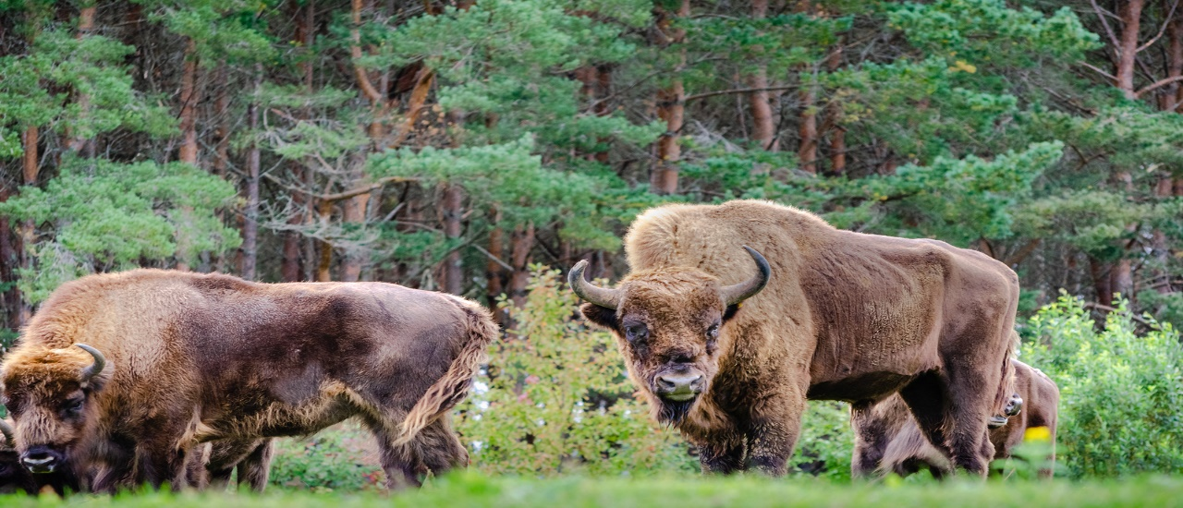

Grey wolf, US
Yellowstone wolves are probably the most well-known and controversial case of wildlife reintroduction. This project was initiated to control elk overpopulation. In 1995, 14 Canadian wolves were relocated to Yellowstone National Park. In 2016, there were 106 and the population was considered stable.
Although the project faced considerable local opposition, mainly because of the perceived effect on livestock and game in the area (Bath, 2008), there is evidence to suggest that wolves are causing a trophic cascade of ecological change (National Geographic, 2022), including helping to increase beaver populations and bring back vegetation, in particular aspen (Yellowstone National Park, 2023).

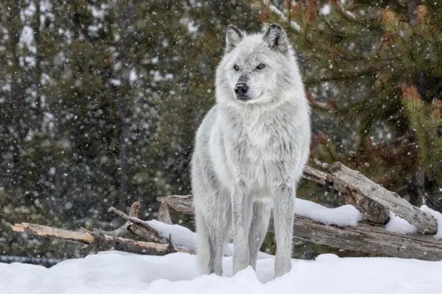

Eurasian Beaver, UK
The beaver is a keystone species and one of nature’s ecological engineers. Through building dams and digging canals, beavers create and maintain habitats where an abundance and diversity of life can flourish. Dams prevent soil eroded from fields from being lost to the sea. Carbon and nutrients are trapped, improving water quality downstream. The flow of water is slowed, helping to ameliorate flooding.
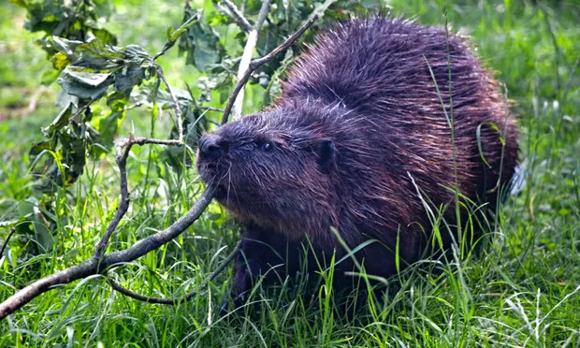

Giant tortoise, Galápagos Islands
Since the 16th century, hunters and invasive species decimated the population. The number dropped from around 5000 to only 15 in 1970. After the eradication of rats and other pests, the tortoises were reintroduced. In 2010, a survey carried out on the island of Espanola revealed that there were 1500 specimens.
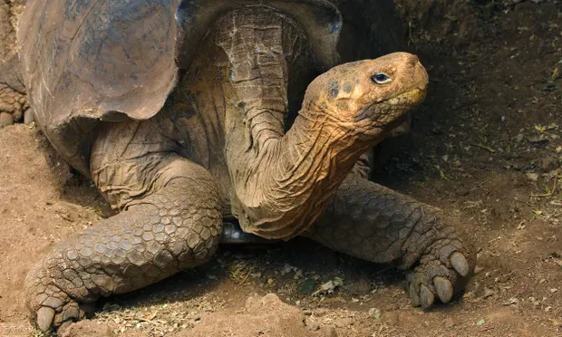

EX-SITU BREEDING
Although habitat protection and ecosystem health should be the conservation priority, captive breeding can play a vital role in saving animals from extinction ( Przewalski’s wild horse, blackfooted ferret, California condor). It has the potential to maintain populations as an “insurance policy” against various threats (disease, invasive species,etc) until reintroduction is possible (Conde et al 2011). Through captive breeding programmes, Zoos help restoring population of threatened species and offer shelter to species losing their habitats. They can maintain numbers and genetic diversity through periodic releases, and also carry out research on captive populations in order to formulate new strategies for conserving wild species. This increases knowledge of animal biology, genetics, behaviour, interactions, food habits etc. (Wildwelfare, 2023).
The negatives of captive breeding are the high costs involved, the risk of inbreeding, and the fact that only a limited portion of the gene pool is being conserved (Wildwelfare, 2023). Conde, 2011 also highlights these risks and argues that because of these factors, ex-situ breeding is only one tool and it should be considered when the species has reached the point of no return (Conde et al, 2011).

THE CRITICISMS
While conceding that some zoos have become more proactive their efforts and more in tune with the plight of wild animals, critics still feel that most zoos still display animals for mainly commercial purposes. They point out that in the US alone, out of 2,400 animal enclosures licensed by the U.S. Department of Agriculture, only 212 are under regulatory umbrella of the American Zoo and Aquarium Association (National Geographic, 2003). Others claim that zoos are inherently cruel and all animals should be released back into the wild (Born Free, 2023). They see the zoos claim that they help preserve endangered species as a poor justification for keeping wild animals suffering in captivity, with the main purpose being the display for commercial purposes (PETA UK, 2018).
Talkin to Laura Fravel in an interview for National Geographic, David Hancocks, a former zoo director, estimates that less than 3 percent of the budgets of these accredited zoos in the US goes into wildlife conservation, while many zoos not affiliated with the AZA spend nothing on conservation. He believes that zoos’ role in conservation has been widely overstated and "Zoos have painted themselves as saviors of the wild," (Fravel, 2003). He also suggests that this could have a detrimental effect on the public attitude towards species conservation: "I fear this has instilled a false sense of security in the public mind. Many people now believe they don't have to worry about saving animals, because zoos are doing the job." (Fravel, 2003).
Benjamin Beck, a former associate director of biological programs at the National Zoo in Washington, D.C. argues that in the last century, only 16 of 145 reintroduction programs worldwide were actually successful in restoring animal populations to the wild. Of those, most were carried out by government agencies, not zoos (Fravel, 2003).

CONCLUSIONS
Zoos and aquariums can play an important role in the global efforts to protect endangered species and bring back species already extinct. Through education and raising awareness they can inspire the public to support important projects and attract funding. They can offer refuge to animals that have lost their natural habitat or have suffered drastic declines due to overhunting, poaching, competition from invasive species, disease, etc.
Although some critics argue the zoos role in conservation is overstated and that their success rate is poor, there is evidence to suggest that zoos and aquariums have played a vital part in rescuing a number of species from the brink of extinction. And while not all the conservation and reintroduction programmes have been successful, they argue that important lessons have been learned as a result, and that the knowledge and expertise built up within the zoos will increase the rate of success of future projects.

REFERENCES
Intergovernmental Science-Policy Platform on Biodiversity and Ecosystem Services (IPBES), 2023, bit.ly/IPBESReport , accessed 28/03/2023

Tribe, A., 2006, Assessing the Role of Zoos in Wildlife Conservation,
Human Dimensions of Wildlife, Taylor& Francis Online, https://doi.org/10.1080/10871200390180163

National Geographic, 2023, https://education.nationalgeographic.org/resource/zoo/, viewed 27/03/2023.

Rothfels, N., 2002, Savages and Beasts: The birth of the modern zoo, John Hopkins University Press.

BornFree, 2022, Are Zoos Ethical?, https://www.bornfree.org.uk/blog/are-zoos-ethical?, accessed 28/03/2023.

Phillips, K., 2015, The ethical evolution of zoos, ABC, Australia, https://www.abc.net.au/radionational/programs/rearvision/the-ethical-history-of-zoos, accessed 28/03/2023

Patrick P., Mathews C., Ayers D., Tunnicliffe S., 2007, Conservation and Education: Prominent Themes in Zoo Mission Statements, The Journal of Environmental Education, DOI:10.3200/JOEE.38.3.53-60, accessed 29/03/2023.

Fraser J., Sickler J., 2008, Why-Zoos-and-Aquariums-Matter, Fraser.Sickler.2008, Why-Zoos-and-Aquariums-Matter-Handbook.pdf, accessed 29/03/2023.

Conde D., Flesness N., Colchero F., Jones O., Scheuerlein A., 2011, An Emerging Role of Zoos to Conserve Biodiversity, Science, https://www.science.org/doi/10.1126/science.1200674.

The Guardian, 2012, Top 10 species fighting extinction with the help of zoos – in pictures, https://www.theguardian.com/environment/gallery/2012/aug/15/top-10-species-extinction-zoos-in-pictures.

Soorae , Pritpal S., Global reintroduction perspectives : 2018. Case studies from around the globe,
https://doi.org/10.2305/IUCN.CH.2018.08.en, accessed 29/03/2023.

Berger‐Tal O, Blumstein D, Swaisgood R, 2020, Conservation translocations: a review of common difficulties and promising directions, Animal Conservation, Vol 23.

Yellowstone National Park, https://www.yellowstonepark.com/things-to-do/wildlife/wolf-reintroduction-changes-ecosystem/, accessed 29/03/2023

National Geographic, 2022, Wolves of Yellowstone, https://education.nationalgeographic.org/resource/wolves-yellowstone/

Bath A. 2008, The public and wolf reintroduction in Yellowstone National Park, Taylor& Francis Online, https://doi.org/10.1080/08941928909380693

World Association of Zoos and Aquaria, 2023, https://www.waza.org/priorities/conservation/conservation-breeding-programmes/global-species-management-plans/blue-crowned-laughingthrush/, accessed 29/03/2023.

Natural History Museum, 2023, Mountain chickens: how we almost lost the Caribbean's largest frogs, https://www.nhm.ac.uk/discover/mountain-chicken-how-we-almost-lost-the-caribbeans-largest-frog.html

BBC News, 2009, Zoo breeds “extinct” fish species, http://news.bbc.co.uk/1/hi/england/bristol/8164244.stm, accessed 29/03/2023.

Zoological Society of London, 2023, Restoring Polynesian heritage, Partula snail conservation,
https://www.zsl.org/what-we-do/projects/partula-snail-conservation

Wildwelfare, 2023, https://wildwelfare.org/the-conservation-mission-of-zoos

The Guardian, 2022, Zoos play a vital role in animal conservation across the world, https://www.theguardian.com/world/2022/oct/18/zoos-play-a-vital-role-in-animal-conservation-across-the-world

In our hands: The British and UKOT species that Large Charitable Zoos & Aquariums are holding back from extinction.
Fravel L., 2003, Critics Question Zoos' Commitment to Conservation, National Geographic, https://www.nationalgeographic.com/animals/article/news-zoo-commitment-conservation-critic

PETA UK, 2018, 9 reasons not to visit zoos, https://www.peta.org.uk/blog/9-reasons-not-to-visit-zoos, accessed 28/03/2023.

