John Hughes
1708241
Networking & Cybersecurity

Apply the Principles and Practices of Data security, Governance and Compliance Based on a Given Scenario.

2023/2024 Semester One
Data Security, Governance and Compliance
ACCA7028
Munyaradzi Murira

Submission Date: 16th January 2024
Word Count: 3000
Internal Verifier: Dr Nitheesh Murugan Kaliyamurthy

Table of Contents

Table of figures 2
Table of Tables 3
List of Acronyms 3
1. IT Security Frameworks & Models 4
1.1 The CIA Triad 4
1.2 Information Technology Infrastructure Library (ITIL) 6
1.2.1 ITIL Creation 6
1.2.2 ITIL V3 6
1.2.3 ITIL V4 7
1.3 Information Security Management Systems (ISMS) 9
1.3.1 ISO/IEC 27000 Series 9
1.3.2 ISO/IEC 27001 9
2. Nature Garden Scenario 12
2.1 Applying ITIL Framework to Nature Garden’s Challenges 12
2.2 Creating an ISMS with ISO/IEC 27001 Standards 13
2.3 Updating Regulatory Requirements and Standards 18
References 19

Table of figures

Figure 1 Classical CIA triad, adapted from [1] 3
Figure 2 CIA Triad Availability, adapted from [1] 4
Figure 3 ITIL V3 Service lifecycle, adapted from [6] 5
Figure 4 ITIL V4 SVS, adapted from [8] 6
Figure 5 ITIL The four dimensional model, adapted from [9] 6
Figure 6 ITIL Service Value Chain, adapted from [8] 7
Figure 7 PDCA cycle, adapted from [14] 10
Figure 8 ITIL Service strategy and design flowchart, adapted from [15] 11
Figure 9 ITIL demand management flowchart, adapted from [16] 12
Figure 10 NG Hierarchical flow staff structure 13
Figure 11 Compliance flowchart 16

Table of Tables

Table 1 Risk assessment based on NG's requirements 13
Table 2, asset management inventory 14
Table 3 Operations security checklist 15
Table 4 Communications security checklist 15

List of Acronyms

B
BAB, British Assessment Bureau
BYOD, Bring Your Own Device
C
CCTA, Central Communications and Telecommunications Agency
CIA, Confidentiality, Integrity and Availability
CMMC, Cybersecurity Maturity Model Certification
D
DoD, Department of Defence
G
GDPR, General Data Protection Regulation
H
HIPAA, Health Insurance Portability and Accountability Act
I
IAF International Accreditation Forum
IS information security
ISMS Information Security Management System
ITIL Information Technology Infrastructure Library
N
NG Nature Garden
P
PECR Electronic Communications Regulations
PII Personally Identifiable Information
PIPEDA Personal Information Protection and Electronic Documents Act
POPIA , Protection of Personal Information Act
S
SVS Service Value System

IT Security Frameworks & Models

The CIA Triad

Data is a pivotal asset that is transferred between entities in increasing quantities. Consequently, modern organisations are now required to align their operations with data security, governance & compliance standards. This necessity is critical in safeguarding the Confidentiality, Integrity and Availability (CIA) of data, which comprise the core principles of the CIA triad.

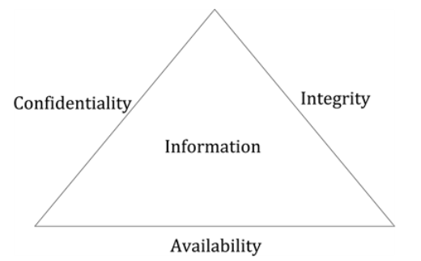
Figure 1 Classical CIA triad, adapted from [1]

Author David Coss describes the CIA triad as an emblematic model in Information Security (IS) governance. It takes a holistic approach to the protection of data by covering the fundamental requirements of IS [2].
Confidentiality – This principle covers the safeguarding of sensitive information, ensuring access is only permitted to authorised personnel, guarding against unauthorised disclosure of data. This is essential for protecting intellectual property contained within the information. Additionally, data should be categorised by its level of sensitivity. Personally Identifiable Information (PII) is at the highest level of security, maintaining privacy and protecting individuals [3].
Integrity – To ensure the reliability of data, information must be protected from modification during transit or storage, unless the modifications are made by authorised entities adhering to controlled processes. This protection must cover both unauthorised access by malicious entities and accidental modifications by authorised users. Regarding modern day IS, integrity should also feature non-repudiation, using technologies such as hash-keys and digital signatures to prevent denial of responsibility [4].
Availability – This principle involves providing reliable and convenient access to data and information by authorised users. The IT system must provide adequate access to software, hardware and network assets for reliable availability of data [1].
It is argued by Suhail Quadri that availability is the most important aspect of the CIA triad, as the previous two principles are directly dependant on it. He states that we can have availability even without confidentiality and integrity, but we cannot have confidentiality and integrity without availability of information [1]. Whilst it is understandable that information is required for the first two principles, Quadri appears to have overlooked the fact that all three components are critical to IS situations and in particular, when developing IS management systems within organisations [4].

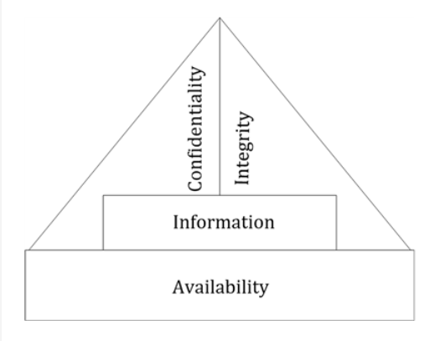
Figure 2 CIA Triad Availability, adapted from [1]

In conclusion, the CIA triad is not just a theoretical construct, but a set of principles that can be applied to all aspects of IS. By ensuring confidentiality of data, organisations protect themselves from unauthorised access. Upholding data integrity ensures the reliability of information, whilst maintaining availability results in both data and system resources being available when needed. When these three principles are upheld, IS frameworks are more effective and robust when facing the challenges of safeguarding digital assets.

Information Technology Infrastructure Library (ITIL)

ITIL Creation

Since its initial release in 1989 by the UK government’s Central Communications and Telecommunications Agency (CCTA), ITIL has undergone several transformations to address the evolving field of IT service management. Its first iteration released as a series of books that offer guidance and recommendations for clients and businesses. This was streamlined in 2000, with version 2 comprising of 9 core volumes that focused on different aspects of services, applications and IT management [5].

ITIL V3

ITIL version 3 was released in 2007 to address a life-cycle based approach to service management, consisting of 5 key-stages outlined as follows from IBM [5]:

- Service Strategy – Focusing on the ITIL service life cycle, this stage offers guidance on design, development and implementation of service management. It provides recommendations for defining and documenting a portfolio of IT services, including budgeting for financial management, forecasting future demand and feedback analysis to improve business relationships.
- Service Design – Designing the processes of services involves the development of a catalogue of available services and policies to ensure they meet current standards. This stage covers security, availability, design coordination and continuity management.
- Service Transition – This volume explains how to move from development to operation whilst providing balance between services. The stage covers planning and support for new or modified existing services by codifying the lifecycles of IT service updates. It also offers guidance on testing and validation to monitor the impact of new or modified services before they are deployed.
- Service Operation – Focusing on general management, this volume offers guidance on access controls and service requests as well as dealing with a triage of events, incidents and problems to identify and resolve issues.
- Continual Service Improvement (CSI ) – This stage provides guidance in alignment of services as the organisation experiences operational changes. This aim is achieved through gathering, processing and analysing data for presentation of information used for improvements.

Figure 3 ITIL V3 Service lifecycle, adapted from [6]

ITIL V4

ITIL V4 was introduced in February 2019 as a significant update to the existing framework. It reorganises the volumes with an increased emphasis on value, cost and risk. The latest volumes according to Derrick Berger in his conference paper - Using ITIL V4 in Security Management, are as follows [7]:
- Service Value System (SVS) – This module is central to ITIL V4 and one of the most significant updates. The previously used service lifecycle is now refined into a new model known as the Service Value Chain and placed at the core of the SVS. This is to represent a holistic approach by representing all the components working together to create value of IT enabled services.
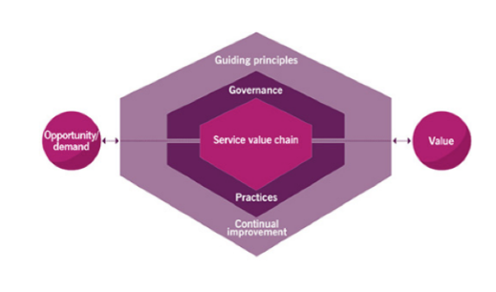
Figure 4 ITIL V4 SVS, adapted from [8]
- The Four-Dimensional Model – This volume provides information on a balanced approach to service management by addressing what is commonly known as the 4 P’s – People, Products, Partners and Processes. It emphasises the assessment of cost, value, impact and risk of each of the 4 P’s [7].
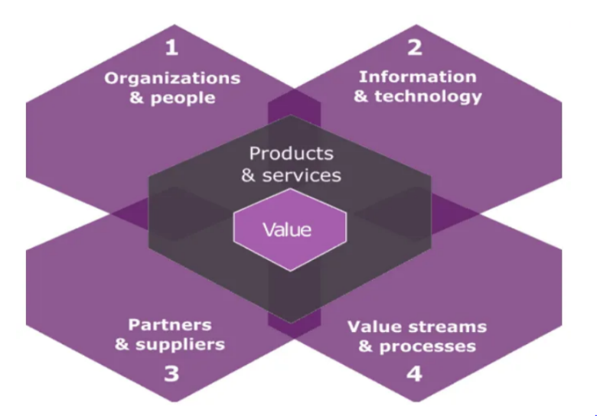
Figure 5 ITIL The four dimensional model, adapted from [9]
- Guiding Principles – The 7 guiding principles were introduced to help organisations adopt best practices for service management. These principles are:

1 - To focus on value through effective management.
2 - Start where you are. Do not abandon existing systems.
3 - Progress iteratively through feedback. Making measured changes to avoid setbacks.
4 - Collaborate and promote visibility. Transparency between different entities promotes collaboration.
5 - Think and work holistically. Promote compatibility amongst different aspects of the SVS.
6 - Keep it simple and practical. This principle addresses the need for processes and resources to match an organisation’s needs.
7 - Optimise and automate. As manual processes can be problematic, automation should be promoted to optimise efficiency.

- ITIL Service Value Chain – This volume provides a flexible model for creating, delivering and maintaining service through the following key activities: Plan, Improve, Engage, Design & Transition, Obtain and Build, and Deliver & Support.
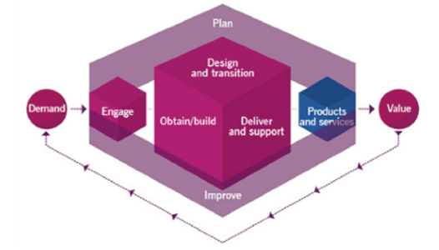
Figure 6 ITIL Service Value Chain, adapted from [8]
- Practises – ITIL V4 increases the number of practices from 26 (known as processes in V3), to 34 divided into three areas. General management contains 14 practices, service management consists of 17 and technical management consists of 3. Some of the most critical areas are IS management, risk management and relationship management.

In conclusion of ITIL framework, it provides a comprehensive approach towards managing IT services that aligns closely with the business objectives of organisations of all sizes. The frameworks emphasis on structured processes and best practices establishes a strong platform for success.
The ITIL service management practices seem versatile and compatible with any IS model or framework to combine into a potentially well-rounded approach to Information Security.

Information Security Management Systems (ISMS)

ISO/IEC 27000 Series

In the current digital era, information is both an asset and a potential vulnerability. Organisations are faced with cybersecurity and privacy protection challenges throughout all aspects of their operations. A fundamental requirement for mitigating this challenge is to adopt an Information Security Management System (ISMS) that adheres to industry recognised standards. The ISO/IEC 27000 family of standards is designed to provide guidance for adopting a robust ISMS capable of providing security for all kinds of digital information within organisations of any size. The latest version, ISO/IEC 27000:2018 is due for replacement in 2024 with the ISO/IEC WD 27000 currently under development [10].

ISO/IEC 27001

Of the existing standards on the series, ISO/IEC 27001 stands out as the most widely recognised. The latest statistics released by the International Organization for Standardisation (ISO) suggest that over 58,000 organisations are actively certified in ISO/IEC 27001, with many more potentially using the standards without certification. Although any organisation can utilise the ISO/IEC 27001 framework for an ISMS without certification, accreditation is granted by International Accreditation Forum (IAF) bodies, providing assurance to stakeholders and clients over the organisation's commitment to maintaining the highest standards of information security [11].
Implementing ISO/IEC 27001 begins with defining the scope of the ISMS to match the specific needs of the organisation. This must, according to IAF accreditors the British Assessment Bureau (BAB), identify the types of the organisation’s products and services, and the geographical region in which they operate. BAB state that in many cases, the ISMS will apply to the entirety of the organisation. However, a well defined scope will identify any circumstances where that is not possible [12].
Another early stage of the ISO 27001 is the need to clarify the ISMS policy and objectives. This policy provides a statement of how the organisation intends to process and store information in a manner that complies with both legal and ethical obligations [12].
Essential to a successful ISMS is a risk assessment and management plan. Author Colin Calder explains in his book, that the assessment should document a method for identifying risks, a plan for mitigating them and a means for addressing them in the event of such risks being realised. Calder states that manual risk assessments are time consuming and error-prone. Therefore automated risk assessment should be chosen, typically involving a purpose built software tool [13].
Asset management will be required to classify information regarding both value and sensitivity. BAB recommend an inventory of assets that covers all hardware, cloud infrastructure, physical documents and digital data. It is stated that for large scale organisations this can be one of the largest tasks associated with ISO/IEC 27001, but also one of the most important as it is fundamental to an ISMS [12].
Additionally, establishing guidelines for acceptable use of assets is essential. Central to this practice is the implementation of an access control policy, which governs the use of both hardware and software resources. The policy should specify the criteria for granting access to individuals, outlining the necessary qualifications for such access and the procedures for its regular review and monitoring [12].
Further requirements of an ISMS are stated by Georg Disterer in his journal, ISO/IEC 27000, 27001 and 27002 for Information Security Management. Communications and operating procedures for IT management are also advised for business areas involving sensitive information. Disterer states these areas need to be identified in the risk assessment and should cover financial accounts, software development, customer and supplier management and protect the transfer of information across networks [14].
Disterer also highlights the need for system acquisition, development and maintenance procedures to ensure that security is at the heart of information systems across the entire lifecycle. This should cover security for information systems, system files, applications and software [14].
Business continuity procedures should be established and documented to ensure that it can continue to operate with minimal disruption in the event of a security incident. This principle should establish criteria for escalating and reporting incidents to regulatory authorities and independent bodies necessary for improving the industry as a whole [12].
A mandatory requirement of an ISMS will be the legal, regulatory and contractual compliance for an organisation to adhere to. All three of these requirements must be met and documented to demonstrate awareness of them to clients and employees. This document should provide clarification what is legal, regulatory, or contractual and how each aspect impacts the information security processes [12].
As stated by Calder, ISO/IEC 27001 promotes continual improvement in stability, adequacy and effectiveness of the ISMS. This is achieved through an effective auditing process to ensure conformity across the organisation. A record of the audit results is necessary to demonstrate compliance, as well as any opportunities for improvement. additionally, non-conformities should be documented along with the action taken to address the issues and identify any individuals responsible. The internal criteria should be regularly reviewed to maximise the effectiveness of the ISMS and minimise any interference from the auditing process [13].
BAB states that with all relevant policies in place, the organisation should be prepared for certification if desired. It is also noted that not all documents are needed before the accreditation process begins, but are desirable to display a willingness to implement them as necessary during the progression of ISMS implementation [12].

Figure 7 PDCA cycle, adapted from [14]

Nature Garden Scenario

Nature Garden (NG) finds itself in a complex and challenging situation of maintaining their reputation as a sought-after health and well-being brand, whilst adapting to the evolving landscape of emerging technologies and customer demands.
The lack of an established IS policy jeopardises not only its brand image, but its entire operations, indicating a need for a comprehensive approach to its information security concerns. It is recommended that NG utilises the ITIL framework to address its IT service management, combined with a new ISMS based on the ISO/IEC 27001 standards. In instances where ITIL and ISO/IEC 27001 share common principles, a single most suitable solution will be chosen to meet the needs of the organisation.

Applying ITIL Framework to Nature Garden’s Challenges

SERVICE STRATEGY AND DESIGN
Based on the challenges experienced by NG, an effective service strategy and design is required for aligning the organisation’s IT services with its business goals. This approach should begin with a market analysis to understand the organisation’s customer needs. This information can help shape their objectives, such as enhancing customer experience and expanding their market reach.
The service design phase needs to consider NG’s reliance on cloud services and wireless networks. Both technologies offer efficiency and scalability. however, risk management must be considered. The organisation’s large-scale operations must also consider its legal and regulatory environments.
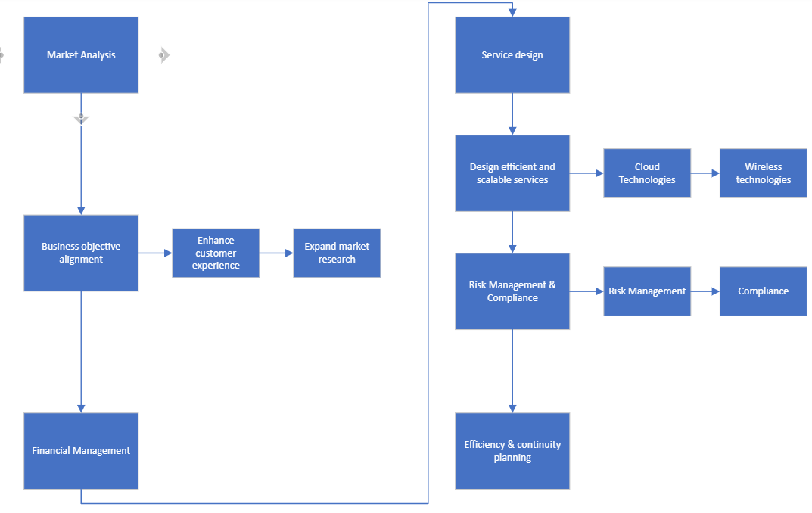
Figure 8 ITIL Service strategy and design flowchart, adapted from [15]

DEMAND MANAGEMENT PRACTICES
Given NG’s extensive use of cloud services and wireless networks, demand management is crucial in maintaining uninterrupted services to both employees and clients. This can be achieved through analysing usage patterns and customer behaviours to predict periods of demand. Strategies such as off-peak incentives could be used to mitigate peak demand and differentiated service levels to manage user behaviour. These approaches should help the organisation mitigate the risks of service congestion and network degradation.
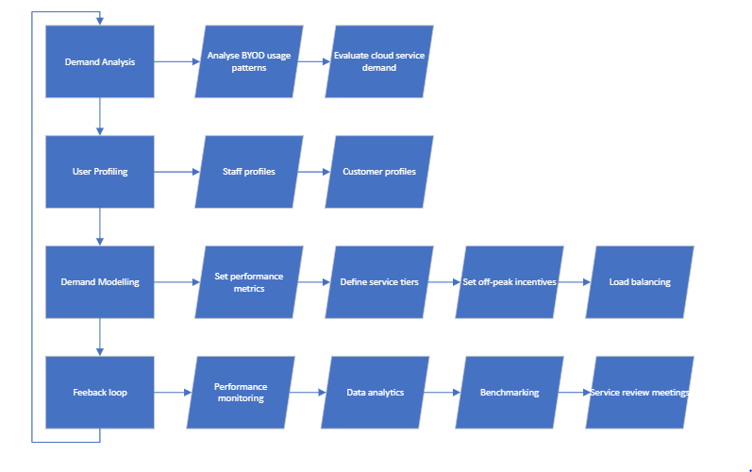
Figure 9 ITIL demand management flowchart, adapted from [16]

Creating an ISMS with ISO/IEC 27001 Standards

CLAUSE 4.3 ISO/IEC 27001 - SCOPE
NG must define the scope of its ISMS based on its operational requirements. Its key issues are recommended, but not limited to the following:
- Operating internationally, NG must comply with data protection and privacy laws across different regions. Particular attention is needed for regulations such as The General Data Protection Regulation (GDPR) in EU regions, Protection of Personal Information Act (POPIA) in South Africa and Personal Information Protection and Electronic Documents Act (PIPEDA) in Canada.
- Considering NG’s extensive use of cloud services, it must address the safe storage of sensitive data as well as adequate encryption standards for its 95% wireless-based networks to address the security concerns of such technologies.
- A Bring Your Own Device policy (BYOD) is required to address the challenges posed by personal device usage.
- The organisation’s online presence and extensive social media activity requires cybersecurity measures to mitigate the risks posed by cyber-threats.
- Data storage and access control must be considered to protect sensitive data such as Personal Identifiable Information (PII) and intellectual property.

CLAUSE 5.1 LEADERSHIP AND COMMITMENT
ISO/IEC 27001 requires a hierarchical flow of leadership and commitment to the ISMS. This principle emphasises a need for top level management to support the plan, thereby fostering a culture of security and awareness throughout the organisation [17].

Figure 10 NG Hierarchical flow staff structure

CLAUSE 6.1 RISK ASSESSMENT AND TREATMENT
A fundamental requirement to any ISMS is a risk assessment and treatment plan. This should evaluate the specific characteristics of the organisation’s operations. NG’s risk assessment is outlined in table 1 [18]:
Table 1 Risk assessment based on NG's requirements
RISK AREA | POTENTIAL THREATS | MITIGATION MEASURES
Cloud Services | Data breaches, unauthorised access | Encryption, access control
Wireless Networks | Intrusion, data interception | Secure WI-FI protocols, network monitoring
BYOD Policy | Device loss/theft, malware | Secure device management, user training policy
Online Presence | Website hacking, data leaks | Implement SSL certificates, maintain security audits
Social Media Activities | Account hijacking, misinformation, reputational damage | Strong password policy, awareness and monitoring of activities
Data Storage | Unauthorised access, accidental data loss | Identify sensitive data, access control, regular backups
Regulatory Compliance | Legal action, non-compliance, penalties, fines | Regional compliance audits, adherence to data protection standards, ISO 27001 certification

CLAUSE 5.2 SECURITY POLICY
In the context of NG’s requirements, the security policy needs to address the scope of the ISMS as a high-level document that sets out the approach to managing the relevant IS risks. Such a document may be expected by potential customers and backed by evidence of its functionality by accreditation. The security policy should therefore avoid generic information, instead focusing on NG’s unique operational landscape involving wireless and cloud based technologies across an international marketplace [19].
ANNEX A CLAUSE 8.1 ORGANISATIONAL ASSET MANAGEMENT
In alignment with clause 8.1 of ISO/IEC 27001, a comprehensive asset management process should feature an inventory of assets. As NG is primarily cloud based, this will comprise a digital asset base. An example of which is provided in table 2, illustrating its asset categories and risk levels to assist the management process [20]:
Table 2, asset management inventory
ASSET CATEGORY | SPECIFIC ASSETS | RISK CLASSIFICATION | RISK CONSEQUENCES
Customer Data | Personally Identifiable Information, payment information | High | Legal issues, loss of customer trust
Intellectual Property | Health products, formulas, designs | High | Financial damage, competitive losses
Digital Media | Marketing materials, social media content | Medium | Reputational damage, marketing disruption
IT Infrastructure | Servers, network devices, cloud storage | High | Data breaches, operational disruption
Personal Devices (BYOD) | Staff smartphones, laptops, tablets | Medium | Security breaches, data leakage

ANNEX A.9 ACCESS CONTROL
Considering NG’s operational landscape, a suitable access control system is required. This system needs to be dynamic in its operation to provide scalability and address different regional laws and regulations. The access control must cover the following issues:
- User Authentication – Multi-factor authentication. Strong password policies.
- Authorisation Mechanisms – Role-based access control. Regular review of privileges.
- BYOD Policy Compliance – Develop clear device usage guidelines. Protect corporate data.
- Physical Access – Secure physical access to IT infrastructure. Utilise key-card access and CCTV surveillance.
- Monitoring and Logging – implement anomaly detection. Monitor and log actions and incidents.
- Data Protection Compliance – Align access with regional regulations. Incorporate necessary controls.
- Access Audits – Conduct regular audits. Analyse audit-trails to investigate incidents.
- Training & Awareness – Educate employees about policies and procedures. Highlight the need for awareness of issues like tailgating, shoulder-surfing and password sharing.
ANNEX A.12 OPERATIONS SECURITY
This aspect is crucial for NG’s IS needs. The following checklist covers the key security requirements for the organisation’s operations procedure:
Table 3 Operations security checklist
OPERATIONS SECURITY ASPECT | DESCRIPTION OF MEASURES
Malware Protection | Anti-virus/malware software. Regular scanning & updates
Data Encryption | Encrypt sensitive data in transit & storage using Advanced Encryption Standards (AES)
Network Security | Implement firewalls, intrusion detection and secure WI-FI protocols
Incident Response | Establish efficient response plan. Run training and drills
Backup & Recovery | Regular backups. Established recovery procedures. Regular testing
Patch Management | Application of software updates. Apply suitable patches and test for adverse effects.
Physical Security | Secure access to physical premises and infrastructure
User Account Management | Regular review of user access rights. Apply least privileged principle
Operational procedure Documentation | Maintain updated documentation of procedures

ANNEX A.13 COMMUNICATIONS SECURITY
As communications are fundamental to any organisation, this clause is critical for any modern ISMS. The following checklist provides comprehensive coverage of NG’s needs [21]:

Table 4 Communications security checklist
Communications Security Aspect | Security Measures for NG
Email | Use email encryption & anti-phishing measures
Secure Network Transmissions | Implement VPN’s and TSL/SSL for data transmission security
Social Media | Enforce strong authentication. Monitor for unauthorised activities.
Mobile Communications | Secure mobile communications with encryption. Secure apps
Voice and Video Calls | Use encrypted communication platforms for sensitive discussions.
WI-FI | Provide guidelines against the use of unsecured public Wi-Fi.
Incident Response | Establish protocols for responding to communication security incidents.

ANNEX A.18.1 COMPLIANCE
To ensure that Nature Garden adheres to the compliance requirements, the following flowchart has been designed to illustrate the steps required to maintain the standards of annex A.18.1 [22]:
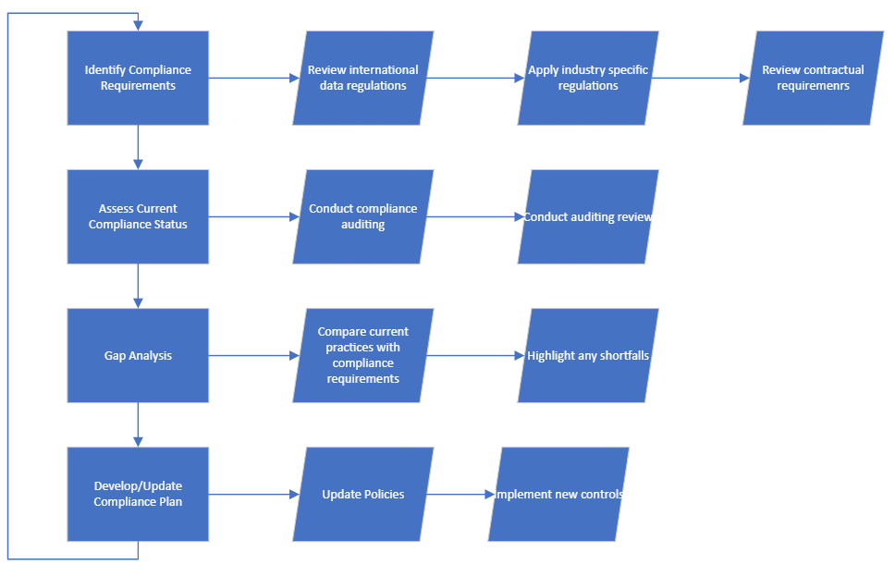
Figure 11 Compliance flowchart

Updating Regulatory Requirements and Standards

Due to the rapidly progressing evolution of technology and global business, the continuous updating of regulations and standards is not only beneficial, but necessary to keep up with the latest developments. As new technologies emerge, new challenges are posed by issues such as cybersecurity, business ethics and practices. In the peer-reviewed journal by Shalinka Jayatilleke, it is stated that requirements tend to change over time in response to the needs of the work environment [23].
The following list provides a timeline of examples of regulatory changes due to technology, business or cybersecurity events:

- 2013 - The Health Insurance Portability and Accountability Act (HIPAA) Omnibus Rule – As the US healthcare system became digitally integrated, problems arose with frequent data breaches, typically amongst business associates of healthcare providers. In response to this issue, the HIPAA omnibus rule was established to strengthen patient privacy, preventing subcontractors from accessing private information [24].
- 2018 - The General Data Protection Regulation (GDPR) and the Privacy and Electronic Communications Regulations (PECR) – On 25th May 2018, the EU’s GDPR regulations came into effect. In response to a growing concern over electronic privacy, data tracking and profiling, a significant change in regulations resulted in new requirements for online companies using cookies. Websites must now request consent, provide clear information of cookie usage, allow easy withdrawal of consent, and document user consent. For EU and UK websites, adhering to these new regulations is mandatory to ensure compliance and avoid legal penalties [25].
- 2020 - The Cybersecurity Maturity Model Certification (CMMC) – The disparate thefts of data and information, often seemingly small and irrelevant but accumulatively significant, led to an increase in cybersecurity incidents within the defence industry. In response, CMMC was established to standardise and elevate cybersecurity practices amongst US defence contractors. This standard now requires defence contractors to obtain mandatory cybersecurity certification to work with the US Department of Defence (DoD) [26].

In conclusion, the need for continuous monitoring and evaluation of regulations is required to protect the needs of individuals, businesses and national interests. Each new technological advancement brings its own set of challenges, and whilst this causes problems for businesses and organisations, it is necessary to protect the evolving fabric of society.

References

[1] S. Qadir and S. M. K. Quadri, ‘Information availability: An insight into the most important attribute of information security’, J. Inf. Secur., vol. 7, no. 3, pp. 185–194, 2016.
[2] S. Samonas and D. Coss, ‘The CIA strikes back: Redefining confidentiality, integrity and availability in security.’, J. Inf. Syst. Secur., vol. 10, no. 3, 2014.
[3] E. McCallister, Guide to protecting the confidentiality of personally identifiable information, vol. 800, no. 122. Diane Publishing, 2010.
[4] A. Kaufmann, ‘CIA Triad’. Fortinet, Jul. 2023. Accessed: Jan. 02, 2024. [Online]. Available: https://www.fortinet.com/resources/cyberglossary/cia-triad
[5] ‘What is IT Infrastructure Library (ITIL)?’ IBM. Accessed: Jan. 02, 2024. [Online]. Available: https://www.ibm.com/topics/it-infrastructure-library
[6] M. Van Zweden, ‘DON’T FORGET THE SERVICE LIFECYCLE’, itil.org. Accessed: Jan. 04, 2024. [Online]. Available: https://blog.itil.org/2012/05/dont-forget-the-service-lifecycle/
[7] D. Berger, N. Shashidhar, and C. Varol, ‘Using ITIL 4 in security management’, in 2020 8th International Symposium on Digital Forensics and Security (ISDFS), IEEE, 2020, pp. 1–6.
[8] A. Limited, ITIL foundation: ITIL 4 edition. TSO (The Stationery Office), ein Unternehmen von Williams Lea, 2019.
[9] ‘ITIL® 4 Foundation’. Accessed: Jan. 04, 2024. [Online]. Available: https://www.axelos.com/certifications/itil-service-management/itil-4-foundation
[10] ISO, ‘ISO/IEC 27000:2018 Information technology Security techniques Information security management systems’. ISO. Accessed: Jan. 04, 2024. [Online]. Available: https://www.iso.org/standard/73906.html
[11] ‘The ISO Survey’. Dec. 31, 2022. [Online]. Available: https://www.iso.org/the-iso-survey.html
[12] ‘What are the ISO 27001 requirements?’ Oct. 24, 2019. Accessed: Jan. 05, 2024. [Online]. Available: https://www.british-assessment.co.uk/insights/what-are-the-iso-27001-requirements/
[13] A. Calder, Nine Steps to Success: An ISO27001: 2013 Implementation Overview. IT Governance Ltd, 2016.
[14] G. Disterer, ‘ISO/IEC 27000, 27001 and 27002 for Information Security Management’. Journal of Information Security, 2013. Accessed: Jan. 05, 2024. [Online]. Available: https://serwiss.bib.hs-hannover.de/frontdoor/deliver/index/docId/938/file/ISOIEC_27000_27001_and_27002_for_Information_Security_Management.pdf
[15] ‘ITIL Service Strategy’. Accessed: Jan. 07, 2024. [Online]. Available: https://wiki.en.it-processmaps.com/index.php/ITIL_Service_Strategy
[16] ‘ITIL Demand Management’. Accessed: Jan. 08, 2024. [Online]. Available: https://wiki.en.it-processmaps.com/index.php/ITIL_Demand_Management
[17] M. Sharron, ‘ISO 27001 Requirement 5.1 – Leadership and Commitment’. Dec. 14, 2023. Accessed: Jan. 08, 2024. [Online]. Available: https://www.isms.online/iso-27001/leadership-commitment/
[18] C. Biscoe, ‘7 Steps to a Successful ISO 27001 Risk Assessment’. Jun. 18, 2020. [Online]. Available: https://www.itgovernance.co.uk/blog/7-steps-to-a-successful-iso-27001-risk-assessment
[19] M. Sharron, ‘ISO 27001 Requirement 5.2 – Information Security Policy’. ISMS.online, Dec. 14, 2023. Accessed: Jan. 08, 2024. [Online]. Available: https://www.isms.online/iso-27001/information-security-policy/
[20] M. Edwards, ‘ISO 27001 – Annex A.8: Asset Management’. Dec. 14, 2023. Accessed: Jan. 08, 2024. [Online]. Available: https://www.isms.online/iso-27001/annex-a-8-asset-management/
[21] M. Edwards, ‘ISO 27001 – Annex A.13: Communications Security’. Dec. 14, 2023. Accessed: Jan. 08, 2023. [Online]. Available: https://www.isms.online/iso-27001/annex-a-13-communications-security/
[22] M. Edwards, ‘ISO 27001 – Annex A.18: Compliance’. Dec. 14, 2023. Accessed: Jan. 08, 2023. [Online]. Available: https://www.isms.online/iso-27001/annex-a-18-compliance/
[23] S. Jayatilleke and R. Lai, ‘A systematic review of requirements change management’, Inf. Softw. Technol., vol. 93, pp. 163–185, 2018.
[24] N. Yaraghi and R. D. Gopal, ‘The role of HIPAA omnibus rules in reducing the frequency of medical data breaches: Insights from an empirical study’, Milbank Q., vol. 96, no. 1, pp. 144–166, 2018.
[25] M. Degeling, C. Utz, C. Lentzsch, H. Hosseini, F. Schaub, and T. Holz, ‘We value your privacy... now take some cookies: Measuring the GDPR’s impact on web privacy’, ArXiv Prepr. ArXiv180805096, 2018.
[26] H. Strohmier, G. Stoker, M. Vanajakumari, U. Clark, J. Cummings, and M. Modaresnezhad, ‘Cybersecurity maturity model certification initial impact on the defense industrial base’, J. Inf. Syst. Appl. Res., 2022.

