Transdisciplinary Exploration Behind UX:
A Case Study of the Virtual Museum Project

Introduction
This project focuses on the field of Virtual Reality (VR), aiming to explore the possibilities of intelligent interaction design in virtual spaces from a transdisciplinary perspective（Sundar.2015）. By integrating data science, artificial intelligence, and user experience research , it seeks to address the challenge of effectively combining theories and methodologies from different disciplines to create user-friendly virtual environments（Lee, Hyunae.2020）.
As technology advances rapidly, VR has become a crucial platform for connecting knowledge across various domains (Simpson, Andrew.2014). However, constructing an optimal virtual environment that harmonizes technical efficiency and user experience remains a pressing issue. This study adopts a data-driven approach, collecting and analyzing user interaction data in virtual environments, such as behavior trajectories, preferences, and emotional feedback. (Elgewely, Eiman, and Willeke Z. Wendrich.2021) These datasets are modeled using machine learning algorithms to uncover user needs, behavioral patterns, and their relationships with the virtual space(Garrett, Peter.2003). Building upon this, the project integrates knowledge from cognitive psychology, human-computer interaction, and information design to optimize the UX design process, ensuring virtual environments are both intelligent and human-centric.
In terms of research strategy, this project emphasizes interdisciplinary collaboration. Data science provides technical support for developing accurate predictive models of user behavior. ( Wheelock, Brenda.2001) Design disciplines focus on creatively optimizing interactive interfaces. Sociology examines the relationship between user behavior and cultural or social contexts, ensuring the design is globally usable and adaptable(Taylor, Paul Michael.2005).
The structure of this paper is divided into three main sections. The first section centers on UX research, addressing its transdisciplinary, multidisciplinary, and interdisciplinary aspects, and illustrating the significance of each discipline in enhancing user experience. Examples will be provided to demonstrate how cross-disciplinary integration is applied. The second section delves into three primary domains involved in UX research across fields, exploring how they contribute to the establishment of the discipline from various perspectives. Finally, the third section presents practical applications, analyzing three specific case studies. These examples highlight the research and collaborative elements in the projects and demonstrate how UX research contributes to their overall success and completion.

1 The Application of Transdisciplinary, Multidisciplinary, and Interdisciplinary Approaches in User Experience
User experience design, as an emerging discipline, inherently involves transdisciplinary elements. For example, in the construction of virtual museums, UX designers must collaborate with engineers to translate user insights into actionable information. Beyond this, designers are also tasked with evaluating the usability of related devices, which requires collaboration with marketing and other relevant teams. This is because an outstanding product must align with market demands(Colbert, Edwin Harris.2021).
However, this raises a key question: is UX research limited to transdisciplinary approaches? Can multidisciplinary and interdisciplinary methodologies also be identified within this field? And how can examples be used to illustrate the differences among these three approaches?

1.1 Comparing the Differences Among Transdisciplinary, Multidisciplinary, and Interdisciplinary Approaches in UX Design
First, does UX design embody transdisciplinary, multidisciplinary, and interdisciplinary characteristics? If so, how do these concepts manifest in practice?
Transdisciplinary, multidisciplinary, and interdisciplinary are relatively recent concepts, proposed to meet the evolving demands of academic research and teaching. Below is a detailed explanation of these concepts and their application in UX design Transdisciplinary refers to a methodology or mindset that transcends the boundaries of a single discipline to solve specific problems by integrating knowledge and methods from various fields.( Grinberg, Daniel.2017) This approach fosters innovation by broadening research perspectives and problem-solving capabilities.
Grinberg.D once said transdisciplinary approaches require researchers to possess analytical skills and the ability to collect user data using diverse methodologies such as qualitative and quantitative research, usability testing, and diary studies. Designers must not only have foundational knowledge in their field but also understand relevant mathematical applications, programming skills, and other cross-domain competencies (Thilmany, Jean2004). This integration allows designers to address complex challenges by leveraging common knowledge and methodologies across disciplines(Saromines-Ganne.2014).
Multidisciplinary fields also share a similar degree, multidisciplinary approaches involve the application of knowledge, skills, and methods from several disciplines to address a problem, ensuring the utilization of expertise from different fields without necessarily integrating or merging them. In UX design research, this could mean working with teams from engineering, psychology, marketing, and business to ensure that the product meets functional, user-centered, and market-oriented requirements. Each discipline contributes its specialized knowledge independently while collaborating toward a shared goal(Lehrer, Erica.2023).
Interdisciplinary methods go beyond mere collaboration among disciplines, striving for deeper integration to create a unified approach(Rakesh, R.2024). This involves blending knowledge, tools, and perspectives from various fields to form a coherent framework for addressing complex challenges. In UX design, interdisciplinary efforts may involve combining cognitive psychology theories with interaction design principles and data science algorithms to create intuitive and user-friendly systems. This approach not only ensures usability but also enhances user satisfaction by addressing psychological, aesthetic, and functional dimensions.( Preziosi, Donal.2019)
By exploring these three approaches in UX design, we can see how they contribute uniquely and collaboratively to enhancing research, development, and innovation.

1.2 The Inherent Interdisciplinary Nature of Design Studies
Herbert A. Simon first introduced the concept of "artifacts" into the context of artificial sciences in his 1969 work, The Sciences of the Artificial. At the turn of the century, Nigel Cross systematically explored the fundamental question of whether design should be regarded as a discipline or a science from a historical perspective. In 2013, Craig Bremner and Paul Rodgers theoretically proposed the "non-disciplinary" or "alternative-disciplinary" nature of design.
In response to the ambiguous disciplinary positioning of design studies, one of the authors derived the concept of "interdisciplinarity". in 2018, inspired by the notion of "interculturality" from cultural anthropology. This concept aims to describe the intersection of natural sciences, humanities, and social sciences within design studies, emphasizing its fluidity and flexibility as these disciplines interact, compete, and merge over time. The recent classification of "Design Studies" as an interdisciplinary category, moving it from the realm of arts to a more integrative disciplinary directory, reflects academic recognition of these explorations.
Design studies are now validated as a discipline that combines cutting-edge elements of art and industry, while serving as a platform where multidisciplinary knowledge converges, collides, and is reconstructed(Santagati, F. M. C.2019).

1.3The Evolution of Design Studies
Another characteristic of design studies is the constant emergence of frontier fields. In the era of mass media and print culture, architectural design, landscape design, industrial design, and graphic design were prominent disciplines. ( Lassalle, Y. M.1997) With the rise of internet technology, new domains such as interaction design, information design, visualization design, and interface design have emerged.
Today, design is shifting from a purely commercial focus to broader societal applications (Geoghegan, H.,2010). Social innovation design, service design, and intelligent design—fields aimed at addressing societal challenges at national and regional levels—are leading the development of design studies.
These emerging fields introduce more diverse reference frameworks to traditional design discussions, enriching and deepening the discipline’s connotation.Contemporary design is gradually breaking away from the modernist ideologies defined by the Industrial Revolution, liberating itself from the constraints of instrumental rationality and functionalism(Jung, T., tom Dieck.2016). As a result, it is increasingly presenting itself as a more comprehensive discipline.

2 Interdisciplinary Factors in This Project
In the field of user experience research, interdisciplinary factors are an unavoidable topic. As discussed in the first section, interdisciplinarity, multidisciplinarity, and transdisciplinarity are interconnected concepts.( Jung, T., tom Dieck, M.C.2016) However, as seen in the challenges arising from the virtual museum project, interdisciplinarity inevitably introduces new questions. For instance, how do we define the boundaries of a discipline? Can all disciplines engage in interdisciplinary research, or is it limited to specific fields?
In other words, how can we validate the application of interdisciplinarity? Taking this project’s research on virtual museums as an example, what is the specific definition of interdisciplinarity within the context of user experience research? This question requires not only a theoretical exploration but also practical examination of how disciplines intersect and collaborate to achieve meaningful outcomes.

2.1 Interdisciplinary Factors in Virtual Museums
Virtual museum spaces have had a significant impact on traditional museums, particularly in terms of exhibition and dissemination strategies. The focus of museum communication has always been on visitors as the primary subjects of interest and the digital formats used for museum dissemination(Hooper-Greenhill, E., 2013). At the same time, the aforementioned digitization processes and projects are transforming traditional museum spaces and shifting communication strategies into the digital/virtual realm, creating a "public museum ecosystem." Whether in traditional museum spaces or their modified forms, they differ fundamentally from virtual spaces because the two generate entirely distinct perceptions. Consequently, the physical spatial experience in traditional museums, which is evidently absent in virtual museums, must be configured as an extended experience within the virtual space—and vice versa(Collier, R., 2009).
Thus, virtual museums require an extended approach based on classic museology theories and digital humanities to define the missions and impacts of museums within virtual spaces. From a scientific perspective, these new challenges give rise to interdisciplinary fields of discourse situated between museology and digital humanities as well as information technology. Accordingly, the characteristics and standards of virtual museums are becoming interdisciplinary research subjects, necessitating examination in the context of current projects alongside cutting-edge virtual museums(Wood, S.L, 1958).
When debating virtual museums within the interdisciplinary discourse between digital humanities and museology, it is crucial to understand the specific characteristics of museum objects—rather than texts. From the perspective of museology, texts are archives of thought whose value largely depends on the informational content they convey (Waidacher,1999b). In contrast, museum objects are unique artifacts or selected natural items (Pomian,1988), carriers of symbols, and, more precisely, bearers of feelings and meanings (Waidacher,1998). The value of museum objects is inseparable from their contextual information and unique histories, often defined by their documented “object biographies.” As such, museum archives define an object not only based on its materiality (according to primary documentation) but also as tangible evidence of specific events or environments (according to secondary documentation), reflecting the intangible aspects of the archived museum object.
Within this framework, a critical issue arises, how to describe the characteristics of virtual museums and define their appearance from an interdisciplinary perspective.? The challenge for interdisciplinarity lies in bridging the gap between real and virtual museum spaces, rather than replacing one with the other, akin to Plato's "allegory of the cave."(Vázquez, D., Fernández-Balbuena.2020) For example, video calls can facilitate connection and information exchange but cannot replace physical interaction—an understanding affirmed and experienced during the COVID-19 crisis. After all, a photograph or hologram is not a real person but merely a (virtual) representation of them. The challenges of authenticity and space are central to this discussion(Roberts, L.C., 2014).
In this sense, several questions emerge from the perspective of digital humanities（Song, M., Elias.2003）. The challenges identified under this problem awareness involve extending traditional museum spaces into virtual spaces by enhancing visitor experiences. Such enhanced experiences are created by communicating the unique projects of museum institutions, which are based on the attributes of museum objects，carriers of feelings and meanings and expressions of museum. This is why the fundamental goal of virtualizing physical museum spaces is to use digital humanities methods and tools to present museum objects, hidden stories, and contexts in ways traditional museums cannot achieve.
Consequently, the challenges faced by digital humanities in the field of virtual museums primarily involve modeling metadata for objects to enable their presentation and visualization in both physical and virtual spaces.(Carrozzino, M.2021)From a museology perspective, these challenges pertain to the circulation of museum objects during the process of compiling or collecting metadata. This process corresponds to registering, inventorying, and cataloging objects while gathering data related to their complete histories, including intangible aspects, within the context of their “biographies.”(Suzuki, A. 2015) From the applied museology perspective, these processes are operated through museum management systems, such as databases. In digital methodologies, this involves information modeling, description, standardization and normalization of metadata, as well as knowledge management and organization.
The fundamental task of collecting basic data about museum collections—referred to as primary documentation from a museology perspective—entails recording data related to an object’s materiality, such as its material, form, technique, dimensions, etc. ( Cohen, E.H., 2011). Educational dark tourism at an in populo site. Primary documentation also involves gathering original event-related information about the object, such as its creators, developers, artists, or historical users. Museum curators, exhibition designers, and museum staff act as “instances of the museum,” a concept corresponding to the interpretive authority of museums in most traditional museum spaces from a scientific perspective. In subsequent steps, all collected data is modeled, and the object and its data are described as metadata. In summary, this process uses digital methods for managing and organizing knowledge(Reiche, I., Eveno, M., de Mecquenem, C., Calligaro, T., Laval, E., Pillay, R., Ravaud, E., Etgens, V., Mösl, K. and Alfeld, M., 2022).
From this, we can see that the disciplinary characteristics of virtual museums are primarily built upon their continuous evolution in digitization and humanization, encompassing fields such as computer science, data management, and even archival studies. These factors ultimately shape the experience of virtual museums, inherently making it a multidisciplinary concept.

3. Interdisciplinary Fields Led by User Experience Research
In the first section, this paper primarily discussed the differences between interdisciplinary, multidisciplinary, and cross-domain approaches within the field of user experience, using examples to illustrate these distinctions. The second section focused on identifying specific interdisciplinary factors involved in virtual museum user experiences—in other words, highlighting prominent features at the technical level.
However, this raises new questions: What other disciplinary backgrounds are reflected in these technical aspects? And why do they ultimately coalesce into user experience research?
This chapter, therefore, will analyze the evolutionary process of user experience research from the perspectives of economics, management science, and engineering, exploring how these disciplines have contributed to its development.

3.1 The Economic Context for the Emergence of User Experience Research
User experience (UX) research, as a branch of service-oriented disciplines shaped by market dynamics, has a historical and temporal background that underpins its continuous development. According to historical studies, the earliest establishment of concepts related to this discipline can be traced back to William Petty, a classical political economist from Britain. In his 1662 publication Treatise of Taxes and Contributions, Petty argued that in the initial stages of commodity exchange, services (such as user research) were primarily ancillary to production and exchange activities. Over time, however, services gradually evolved into a specialized industry model.
In 1776, British economist Adam Smith further advanced this notion in The Wealth of Nations, where he defined services as a new form of social production. He introduced the idea that "consumption is the sole end and purpose of all production." Building upon this foundation, in 1850, French economist and philosopher Frédéric Bastiat asserted in his work Economic Harmonies that "all production—whether tangible or intangible—relies on exchange and service."
From this point onward, the recognition of the service industry began to solidify.
Modern discussions of the service industry were propelled by American economist Allan Fisher, who proposed the concept of the "tertiary sector." In his 1935 work The Clash of Progress and Security, Fisher used a classical framework to articulate the abstract concept of the tertiary sector. This concept was later refined by American economist Victor Fuchs, who, in 1968, formally introduced the term "service economy," marking a paradigmatic shift from the abstract concept of classical services to the modern service economy.
In contemporary times, this evolution has been further detailed by Swedish scholar Jan Owen Jansson in his 2006 book The Economics of Services: Development and Policy. Jansson emphasized the increasing inclusion of various fields within the service economy system due to technological advancements. These fields include knowledge economy, network economy, information economy, digital economy, experience economy, and sharing economy.
In summary, from the perspective of economics, UX design’s conceptual foundation in artistic design theory is rooted in the service economy. Historically, it has evolved from being a subsidiary concept within economic activities to becoming a distinct service industry, eventually transforming into the modern concept of the service economy in contemporary times.

3.2 The Emergence of Management Disciplines in User Experience Research
If the economic field serves as the foundational premise for the emergence of user experience (UX) research, its application level cannot be separated from the support of management and engineering techniques. Notably, the earliest instance of integrating services with marketing in UX research dates back to the publication of the first specialized book on service sales, A Concise Service Marketing Management, in 1964. This work fundamentally established a "human-centered, service-oriented theoretical framework." Subsequently, foundational theories such as the Nordic School's customer perception, service quality, and relationship marketing theories have provided significant theoretical support to service marketing.
In 1984, Groth introduced a complete conceptual and model framework for customer relationships and lifecycle in his work Strategic Management and Marketing in the Service Sector. He argued that the core of UX lies in customer perception and the extension of service quality. Groth also emphasized that service quality encompasses both the technical aspects of service outcomes and the entire service process. His perspective underscored that service quality plays a decisive role in the success of a product. Of particular note is his proposed "Five Dimensions" model, which forms the foundation of the SERVQUAL (Service Quality) scale widely used today. These five dimensions are Tangibility、Security、Reliability、Responsiveness and Empathy.
In the same year, Normann published Service Management: Strategy and Leadership in Service Enterprises, introducing a novel approach to managing service organizations, which is regarded as the inception of "service management." He introduced the concept of "Moments of Truth" to service management theory, which was later expanded in 1986 by Carlzon. Carlzon identified "service encounters" as manifestations of these critical moments, focusing on interactions between service providers and recipients (i.e., customers). This includes studying the collaborative relationships between frontline service personnel and customers, the role of customer participation in service production, and the impact of tangible evidence on customer perceptions of service quality.
In 1984, Rosenberg and Czepiel introduced role theory from sociology, positing that both customers and service personnel assume specific roles during face-to-face service interactions. This perspective was further developed in 1985 by Solomon and colleagues in their paper Role Theory and Dyadic Interactions: Service Encounters, which highlighted that customer satisfaction is determined by the interaction between service providers and customers.
In 1989, Bateson brought the psychological concept of personal control into the discussion, suggesting that both service personnel and customers desire to control the service process and its outcomes. This cumulative body of work underscores the multidisciplinary roots of UX research, particularly its reliance on management science to understand and optimize the interactions, processes, and outcomes inherent in service delivery.
In conclusion, the foundational influence of management studies has significantly contributed to the emergence of user experience research. Even within the framework of management studies, its evolution has undergone considerable changes to reach its current state. User experience inherently incorporates elements of management studies, which also constitutes one of its multidisciplinary backgrounds.

3.3 The Engineering Background for the Emergence of User Experience Research
The disciplinary background of user experience (UX) research is not limited to economics and management; engineering plays a crucial role as a foundational condition for the realization of UX research. From its inception, UX research has been intricately linked with science and technology.
In the field of technology, the earliest emergence of the concept of "user experience" was proposed by Palumisa in 1992, who introduced the concept of "service science" and pointed out the future societal trend of "service innovation."
In the early 1990s, Louis Gerstner, Chairman and CEO of IBM, initiated a significant strategic shift for the company, integrating hardware, software, and services to offer customers comprehensive solutions. His successor, Samuel Palmisano, introduced "Service-Oriented Modeling and Architecture" and a series of practices related to "Software as a Service" (SAAS), such as SAAS storage services and the "Smart Planet" initiative, which successfully facilitated IBM's transformation into a service-oriented company.
In 2002, IBM's Almaden Research Center, in collaboration with Henry Chesbrough of the University of California, Berkeley, began researching services from the perspective of social engineering systems. It was clear that the leadership of these companies attached great importance to the experiences and perceptions of their customers with respect to both software and hardware components.
The year 2004 marked the "birth of service science." In April of that year, IBM held a conference in San Jose, California, called "Business in the Global Scalable Enterprise Era," where Professor Chesbrough initiated a special session with several professors to discuss the concept of "service science." Most of the attendees were skeptical. In May of the same year, IBM's Research Department held a conference in Yorktown Heights, New York, called "Architecture of Demand Business," where IBM's Research Department head Paul Horn and head of IBM's Service Business Consulting Research Institute Ginni Rometty presented the need for service science as the keynote topic. This meeting resulted in a white paper titled "Service Science." In November 2004, another conference called "Service Innovation for the 21st Century" was held at IBM’s Almaden Research Center in San Jose, California, where researchers and educators from relevant disciplines discussed special topics and educational directions related to service innovation.
The scope of service science eventually expanded to include engineering and management fields. This gave rise to a more comprehensive term: Service Science, Management, and Engineering (SSME), which combined service science, service management, and service engineering, forming an independent discipline known as "service science." Service was then defined as the process of interaction and behavior between providers and customers to collaboratively create and capture value.
From an engineering perspective, the development of user experience research undoubtedly involves the continuous advancement of engineering disciplines, such as ergonomics, mechanical engineering, and particularly data science. Many of the concepts and knowledge in these areas are still in use today.

4. Coherent Case Analysis and the Application of Interdisciplinary Knowledge in Virtual Museums
The first three sections explain the interdisciplinary applications, multidisciplinary content, and the connections between different fields within user experience research. The second section mainly focuses on how technological applications in virtual museums reflect interdisciplinary fields, while the third section outlines the disciplinary structure behind user experience research. The aim is to analyze why user experience research is capable of conducting interdisciplinary studies from a disciplinary background perspective.
In this section, the paper will present complete specific cases, and the analysis of these cases will mainly showcase how various factors from intersecting disciplines are involved.

4.1 Case Analysis of the New Museum for Contemporary Art in New York
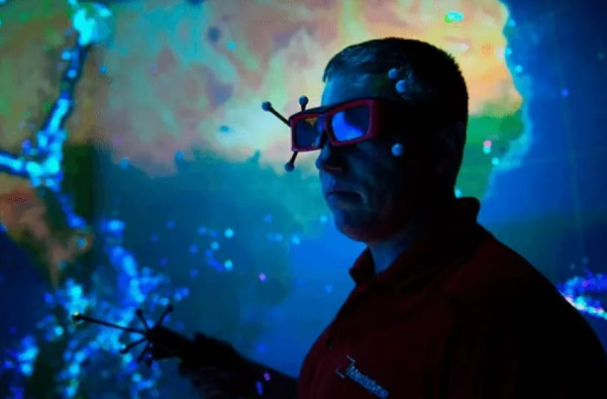
(Source from https://www.darts.cn/article/article_info/key/MTIwMjA5NDU2MTaDz3llsJykcw.htm)
In the virtual reality exhibition at the New Museum for Contemporary Art in New York City, artist Daniel Steegmann Mangrané collaborated with the ScanLAB project to use OptiTrack motion capture technology by Leard Group's virtual motion point division. This technology immersed viewers in the virtual scene of the "rapidly disappearing Brazilian tropical rainforest."
Leard Group, along with its subsidiaries Lifeng Culture, BlueShuo Technology, and Virtual Motion Point, has participated in over 100 influential exhibition projects. Leveraging innovative technologies and solutions like LED displays, holographic imaging, VR/AR/XR virtual reality, naked-eye 3D projections, immersive environmental interaction, and panoramic multi-channel sound, these projects aim to create a cultural core centered on the exhibition industry. They consider visitor experience, spatial flow, and post-exhibition operations comprehensively. By combining innovative cultural products and services, they merge time-based and spatial art, creating a new model for public cultural services in museums to meet the diverse cultural consumption needs of the public.
As OptiTrack tracks the visitors' movements throughout the exhibition space, they can explore the stunningly detailed virtual tropical rainforest. Visitors can move between branches, crouch down to feel the ground of the rainforest, truly experiencing being in this magical world and interacting with it, creating a personalized, instantaneous, and ubiquitous viewing experience.

4.2 VR Project of the Hunan Provincial Museum
Additionally, the VR experience project "National Treasure Mystery" created by Virtual Motion Point in collaboration with Virtual Realm Technology for the Hunan Provincial Museum marks an important milestone in the exhibition methods of domestic history museums. The project uses 66 Opti Track motion capture cameras and incorporates 14 sets of customized cultural relic props to create a real-life version of "Night at the Museum" through VR interaction.
Since the pandemic, museums across the country have been focusing on development concepts, technological means, and business model innovation. They have explored a series of new forms of museum innovation, including "cloud exhibitions," "XR immersive exhibitions," "digital collections," and "archaeological blind boxes." Museums have evolved from being traditional spaces filled with "historical memories" to becoming vibrant and energetic industries bursting with innovation. They have turned fields like cultural relics and archaeology into hot topics in the public cultural sphere, and museums have become trendy destinations favored by the younger generation for social media check-ins.
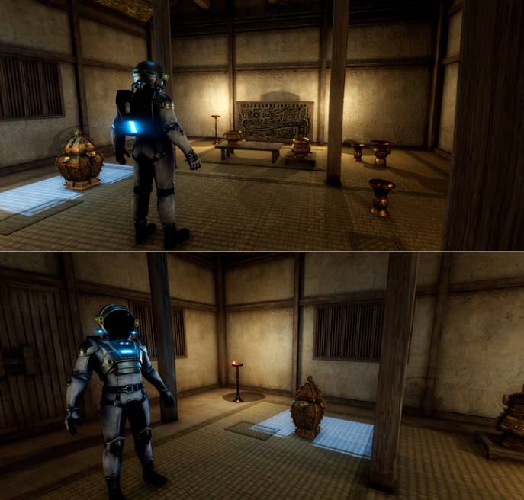
(Source from https://www.urbanlight.cn/newsdetail/57dc962b-85fa-f639-f86a-830336719cc0)
4.3 Virtual Project of the Beijing Palace Museum
The "Panoramic Palace Museum" and "V Palace Museum" modules in the Beijing Palace Museum’s mini-program present differences between real and virtual scenes. Simple touch-screen operations allow the exhibition items and scenes to change freely, breaking the spatial and temporal barriers between people and exhibits. This helps visitors engage in deep learning and understanding of the virtual museum's displayed content from different perspectives.
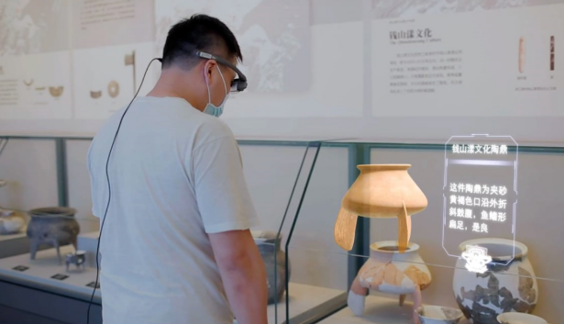
(Source from https://www.urbanlight.cn/newsdetail/57dc962b-85fa-f639-f86a-830336719cc0)

While the development direction of the digital Palace Museum is influenced by factors such as technological pursuits and the digital divide, there has been a lack of clear exploration regarding its future development. Previous research indicates that virtual museums now exist independently from physical museums but with a mutually supportive relationship. It highlights the independence and unique value of virtual museum online exhibitions and suggests that the focus of virtual museums should be on the online exhibition itself rather than merely replicating physical exhibitions.

4.4 Virtual Museum in the Dunhuang Caves
The Dunhuang Caves are a crystallization of ancient civilization exchange, rich in historical, artistic, technological, and social value. At the beginning of 2020, due to the impact of the COVID-19 pandemic, the six caves under the administration of the Dunhuang Academy were temporarily closed. To enrich the spiritual and cultural lives of the people during the pandemic, the Dunhuang Academy accelerated the promotion of digital exhibitions and communication, creating the first WeChat mini-program "Cloud Tour Dunhuang," which integrates functions such as exploration, touring, and preservation of the Dunhuang caves.
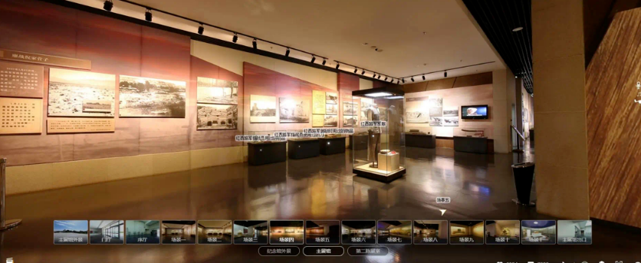
(Source from http://www.sanyamuseum.com/a/chenliexuanjiao/2023/1016/3967.html)

"Cloud Tour Dunhuang" utilizes multimedia, networking, and digital technologies to break the constraints of time and space, enabling the digital dissemination of Dunhuang treasures. At the same time, it leverages the "new cultural and creative" strategy to stimulate content innovation, popularizing and disseminating Dunhuang culture to the public. The program offers cultural services such as appreciation, touring, and research. It also allows for customized personalized content presentation, where users can gain knowledge through interactive experiences and access a "touchable" online Dunhuang Cave at any time and place. By empowering culture with technology, it brings traditional culture to the youth, promoting the industry's movement toward a broader "smart cultural tourism" future and further advancing cultural exchanges along the Silk Road.

Conclusion
It can be seen that future user experience research will inevitably involve deep interdisciplinary integration. This is particularly significant in the field of virtual museums, where such integration plays a crucial role. As a novel cultural medium that deeply combines culture, technology, and art, virtual museums offer vast application scenarios and exploration opportunities for user experience research.
In conclusion, user experience research in virtual museums requires not only the integration of knowledge from economics, management, and engineering but also the rich heritage of humanities and the cutting-edge advancements of STEM disciplines. In the future, such interdisciplinary integration will deepen further, driving virtual museums to become pivotal tools for cultural dissemination and public education, while also providing user experience research with richer practical scenarios and innovative momentum.

Reference:

The Holocaust Museum in Jerusalem. Annals of tourism research, 38 (1), pp.193-209
Grinberg, D., 2017. A Tour of the Tactical Subjunctive: Virtually Visiting the Guantanamo Bay Museum of Art and History.
Thilmany, J., 2004. Museum Virtually Unwrapped. Mechanical Engineering, 126(9), pp.20-20.
Rakesh, R. and Nithya, M., 2024, October. Zooviz–Unveiling Anatomy Virtually. In 2024 International Conference on Power, Energy, Control and Transmission Systems (ICPECTS) (pp. 1-5). IEEE.
Simon, H.A., 1955. A behavioral model of rational choice. The quarterly journal of economics, pp.99-118.
Rodgers, P. and Bremner, J., 2017. The concept of the design discipline. Dialectic, 1(1), pp.19-38.
Matthews, L., 2020. virtually unseen: new digital understandings of reclaimed space. idea journal.
Brinkmann, T., 2003. Ruth Ellen Gruber, Virtually Jewish: Reinventing Jewish Culture in Europe, Berkeley/Los Angeles/London:: University of California Press 2002. Comparativ, 13(1), pp.139-144.
Duncan, C., 2012. Art museums and the ritual of citizenship. In Interpreting objects and collections (pp. 279-286). Routledge.
Hooper-Greenhill, E., 2013. Museum, media, message. Routledge.
Weil, S.E., 1990. Rethinking the museum and other meditations. Smithsonian Institution.
Greenhill, E.H., 1992. Museums and the Shaping of Knowledge. Routledge.
James, S., 1998. Virtually New, Creating the Digital Collection:: A Review of Digitisation Projects in Local Authority Libraries and Archives. Reference Reviews, 12(8), pp.7-8.
Caulton, T., 2006. Hands-on exhibitions: Managing interactive museums and science centres. Routledge.
Hyde, G., 2003. Virtually Missouri. College and Research Libraries News, 64(1), pp.42-42.
Chatterjee, H. and Noble, G., 2016. Museums, health and well-being. Routledge.
McCormick, T., 2009. William Petty: and the ambitions of political arithmetic. Oxford University Press, USA.
Smith, A., 1987. The Essential Adam Smith. WW Norton & Company.
Bastiat, F., 2015. Frédéric Bastiat. The Standards: Klassisch liberale Aufsätze neu interpretiert, p.131.
Arndt, P., 1938. The Clash of Progress and Security.
Fuchs, V.R., 1996. Economics, values, and health care reform. American Economic Review, 86(1), pp.1-24.
HENK, L.K., 2010. The Economics of Services: Development and Policy.
KELKAR, S., 2011. IT SERVICE MANAGEMENT: A CONCISE STUDY. PHI Learning Pvt. Ltd.
Grönroos, C., 1990. Service management and marketing (Vol. 27). Lexington, MA: Lexington books.
Elliott, R., 1991. Five dimensions of therapy process. Psychotherapy Research, 1(2), pp.92-103.
Murray, A.J. and Greenes, K.A., 2006. New leadership strategies for the enterprise of the future. VINE, 36(4), pp.358-370.
Rosenberg, L.J. and Czepiel, J.A., 1984. A marketing approach for customer retention. Journal of consumer marketing, 1(2), pp.45-51.
Solomon, M.R., Surprenant, C., Czepiel, J.A. and Gutman, E.G., 1985. A role theory perspective on dyadic interactions: the service encounter. Journal of marketing, 49(1), pp.99-111.
Bateson, G. and Rieber, R.W. eds., 1989. The individual, communication, and society: Essays in memory of Gregory Bateson. Cambridge University Press.
Cao Lei, Li Wanqiang, Liu Yuhao, Li Renjie, and Hu Fei, 2021. Research on the Engineering Application of Service Design for Service-Oriented Manufacturing. Packaging Engineering Art Edition, 42(12), pp. 59-69.
Palmisano, S., 2004. Leading change when business is good. Interview by Paul Hemp and Thomas A. Stewart. Harvard Business Review, 82(12), pp.60-70.
Malozemoff, A.P. and Grant, P.M., 1987. High temperature superconductivity research at the IBM thomas J. Watson and Almaden research centers. Zeitschrift für Physik B Condensed Matter, 67(3), pp.275-283.
Johnson, E., Seyi-Lande, O.B., Adeleke, G.S., Amajuoyi, C.P. and Simpson, B.D., 2024. Developing scalable data solutions for small and medium enterprises: Challenges and best practices. International Journal of Management & Entrepreneurship Research, 6(6), pp.1910-1935.

