Lab – Understanding Ethernet Cable Standards
Topology
Addressing Table
Device | Interface | IP Address | Subnet Mask | Default Gateway
PC-A | NIC | 192.168.10.1 | 255.255.255.0 | N/A
PC-B | NIC | 192.168.10.2 | 255.255.255.0 | N/A
Objectives
Part 1: Analyze Ethernet Cabling Standards and Pinouts
Part 2: Build an Ethernet Crossover Cable
Part 3: Test an Ethernet Crossover Cable
Background / Scenario
In this lab, you will build and terminate an Ethernet crossover cable and test it by connecting two PCs together and pinging between them. You will first analyze the Telecommunications Industry Association/Electronic Industries Association (TIA/EIA) 568-A and 568-B standards and how they apply to Ethernet cables. You will then construct an Ethernet crossover cable and test it. Finally, you will use the cable you just constructed to connect two PCs together and test it by pinging between them.
Note: With autosensing capabilities available on many devices, such as the Cisco 1941 Integrated Services Router (ISR) switch, you may see straight-through cables connecting like devices.
Required Resources
- One length of cable, either Category 5 or 5e. Cable length should be 0.6 to 0.9m (2 to 3 ft.)
- 2 RJ-45 connectors
- RJ-45 crimping tool
- Wire cutter
- Wire stripper
- Ethernet cable tester (optional)
- 2 PCs (Windows 7 or 8)
- Analyze Ethernet Cabling Standards and Pinouts
The TIA/EIA has specified unshielded twisted pair (UTP) cabling standards for use in LAN cabling environments. TIA/EIA 568-A and 568-B stipulates the commercial cabling standards for LAN installations; these are the standards most commonly used in LAN cabling for organizations and they determine which color wire is used on each pin.
With a crossover cable, the second and third pairs on the RJ-45 connector at one end of the cable are reversed at the other end, which reverses the send and receive pairs. The cable pinouts are the 568-A standard on one end and the 568-B standard on the other end. Crossover cables are normally used to connect hubs to hubs or switches to switches, but they can also be used to directly connect two hosts to create a simple network.
  - Analyze diagrams and tables for the TIA/EIA 568-A standard Ethernet cable.
The following table and diagrams display the color scheme and pinouts, as well as the function of the four pairs of wires used for the 568-A standard.
Note: In LAN installations using 100Base-T (100 Mb/s), only two pairs out of the four are used.
568-A 10/100/1000Base-TX Ethernet
Pin Number | Pair Number | Wire Color | 10Base-T Signal  100Base-TX Signal | 1000Base-T Signal
1 | 2 | White/Green | Transmit | BI_DA+
2 | 2 | Green | Transmit | BI_DA-
3 | 3 | White/Orange | Receive | BI_DB+
4 | 1 | Blue | Not Used | BI_DC+
5 | 1 | White/Blue | Not Used | BI_DC-
6 | 3 | Orange | Receive | BI_DB-
7 | 4 | White/Brown | Not Used | BI_DD+
8 | 4 | Brown | Not Used | BI_DD-

The following diagrams display how the wire color and pinouts align with an RJ-45 jack for the 568-A standard.
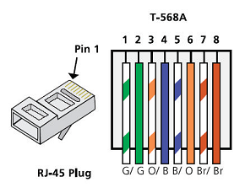
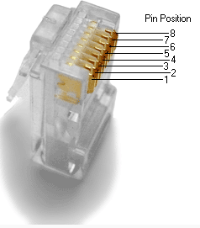
  - Analyze diagrams and tables for the TIA/EIA 568-B standard Ethernet cable.
The following table and diagram display the color scheme and pinouts for the 568-B standard.
568-B 10/100/1000-BaseTX Ethernet
Pin Number | Pair Number | Wire Color | 10Base-T Signal  100Base-TX Signal | 1000Base-T Signal
1 | 2 | White/Orange | Transmit | BI_DA+
2 | 2 | Orange | Transmit | BI_DA-
3 | 3 | White/Green | Receive | BI_DB+
4 | 1 | Blue | Not Used | BI_DC+
5 | 1 | White/Blue | Not Used | BI_DC-
6 | 3 | Green | Receive | BI_DB-
7 | 4 | White/Brown | Not Used | BI_DD+
8 | 4 | Brown | Not Used | BI_DD-
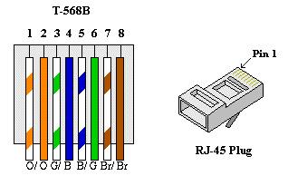

- Build an Ethernet Crossover Cable
A crossover cable has the second and third pairs on the RJ-45 connector at one end, reversed at the other end (refer to the table in Part 1, Step 2). The cable pinouts are the 568-A standard on one end and the 568-B standard on the other end. The two following diagrams illustrate this concept.
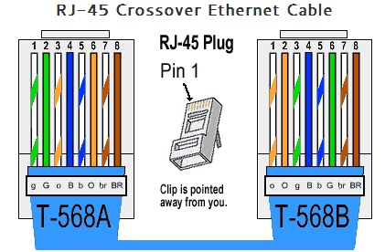
  - Build and terminate a TIA/EIA 568-A cable end.
    - Determine the cable length required. (Your instructor will let you know the cable length you should make.)
Note: If you were making a cable in a production environment, the general guideline is to add another 12 in. (30.48 cm) to the length.
    - Cut off a piece of cable to the desired length and using your wire stripper, remove 5.08 cm (2 in.) of the cable jacket from both ends.
    - Hold the four pairs of twisted cables tightly where the jacket was cut away. Reorganize the cable pairs into the order of the 568-A wiring standard. Refer to the diagrams, if necessary. Take as much care as possible to maintain the twists in the cable; this provides noise cancellation.
    - Flatten, straighten, and line up the wires using your thumb and forefinger.
    - Ensure that the cable wires are still in the correct order for the 568-A standard. Using your wire cutters, trim the four pairs in a straight line to within 1.25 to 1.9 cm (1/2 to 3/4 in.).
    - Place an RJ-45 connector on the end of your cable, with the prong on the underside pointing downward. Firmly insert the wires into the RJ-45 connector. All wires should be seen at the end of the connector in their proper positions. If the wires are not extending to the end of the connector, take the cable out, rearrange the wires as necessary, and reinsert the wires back into the RJ-45 connector.
    - If everything is correct, insert the RJ-45 connector with cable into the crimper. Crimp down hard enough to force the contacts on the RJ-45 connector through the insulation on the wires, thus completing the conducting path. See the following diagram for an example.
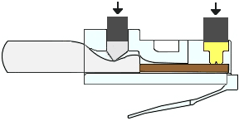
  - Build and terminate a TIA/EIA 568-B cable end.
Repeat steps 1a to 1g using the 568-B color wiring scheme for the other end.
- Test an Ethernet Crossover Cable
  - Test the cable.
Many cable testers will test for length and mapping of wires. If the cable tester has a wire map feature, it verifies which pins on one end of the cable are connected to which pins on the other end.
If your instructor has a cable tester, test the crossover cable for functionality. If it fails, check with your instructor first as to whether you should re-cable the ends and re-test.
  - Connect two PCs together via NICs using your Ethernet crossover cable.
    - Working with a lab partner, set your PC to one of the IP addresses shown in the Addressing Table (see page 1). For example, if your PC is PC-A, your IP address should be set to 192.168.10.1 with a 24-bit subnet mask. You partner’s IP address should be 192.168.10.2. The default gateway address can be left empty.
    - Using the crossover cable you made, connect the two PCs together via their NICs.
    - On the PC-A command prompt, ping the PC-B IP address.
Note: The Windows firewall may have to be temporarily disabled for pings to be successful. If the firewall is disabled, make sure you re-enable it at the conclusion of this lab.
    - Repeat the process and ping from PC-B to PC-A.
Assuming IP addressing and firewall are not issues, your pings should be successful if the cables were properly made.
Reflection
  - Which part of making cables did you find the most difficult?
I found that when attempting to straighten out the cables to insert into the RJ-45 connector very hard, this is most likely due to my hands being large and unable to correctly place them within the connector.

Why do you have to learn how to make a cable if you can easily buy pre-made cables?
Having the ability to cut and create cables will allow you to craft cables to your desired length. most cables from third party providers will be in a variety of lengths such as 1metre 3 meters, 5 meters and 10 meters etc.
As such there will be slack when attempting to implement cables into ports, having the ability to create the cables will reduce the slack and overall need for cable management.

Reflection:
Write a research report (Max word count 600) on Cat 5e and 6 Ethernet cable standards.

Introduction

The purpose of the following report is to define and expand on the standards of Cat5E and Cat 6 ethernet cable standards by covering the following topics; Bandwidth, speed and crosstalk. The report will be using figure 1 as a reference through the report.
Table 1 - CAT5e & CAT6 Standards
 | CAT5e | CAT6
Release date | 1999 | 2002
Bandwidth | 100Mhz | 250-500Mhz
Speed | 1 Gigabit Per Second | 10 Gigabit Per Second
Crosstalk | Minimum Protection | Strong Protection

1.1 Standards of CAT5e & CAT6

Bandwidth:
Cat5e and CAT6 can maintain speeds of up to a Gigabit per second. The main difference within the standards is that the frequencies that the cables are able to maintain. CAT6 can provide frequencies of up to 250Mhz
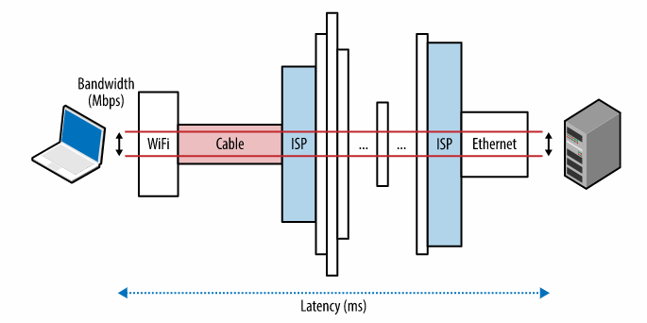
while CATe5 can only go to 100Mhz; Having more frequency enables a cable to process more information at any given time, this information being, voice, data, television and so forth. [1]
Figure 1 - Bandwidth Diagram [2]

Speed:
The differences within the speed of the cable standards are vastly different in the fact that CAT5e can support speeds from 0-1000Mbps at distances of 50 meters; while CAT6 can support a variety of speeds up to 10000Mbps at a maximum distance of 55 meters. [2]

Crosstalk
Crosstalk is the issue caused by electrical signals interfering with other Electrical signals that are within a close proximity, this can cause damage to data as it is being transmitted over a cable.
CAT5e offers a low amount of crosstalk due to its enhanced standards from the standard CAT5 cable. CAT5e also reduces the crosstalk between the different pairs of wires within the cable which in turn offers better performance.CAT6 offers this as well as an interior separator which isolates the different pairs of wires further increasing the performance the cables are able to achieve.

Conclusion

Though the two ethernet cable standards vary in performance areas such as bandwidth, speed, distance and crosstalk, each standard has its own place within the world. While CAT6 standards are far above of that which CAT5e can deliver, the variety of tasks it can perform based on its current standards is not to be misjudge. Many organizations do not utilize gigabit speeds to its end’s users; gigabit is reserved for data centers and internet service providers. CAT6 and CAT5e can be used in a variety of situations, dependent on the needs of the user.

Bibliography

[1] | M. Meyers, "All-in-one is all you need," in Network + Exam N10-006, Mc Graw Hill education, 2015, p. 767.
[2] | M. Meyers, "All-in-One is all you need," in Network +, N/A, Mc Graw Hill Education, 2015, p. 109.
[3] | I. Grigorik, "Primer on Latency and Bandwidth," O'Reilly Media, N/A N/A N/A. [Online]. Available: https://hpbn.co/primer-on-latency-and-bandwidth/. [Accessed 12 December 2019].

