
UNIVERSITY OF WALES TRINITY SAINT DAVID

Name: Mariam Jamil - 2541507
Module Code: ACCA4025
Program: CertHE Computing Skills for Workplace
Lecturers: Martin Svejda, Malik Mehmood
Learning in the Digital Era

JULY 2026
Professional Development Plan (PDP)
Table of Contents
Task 1 – Self Evaluation 2
Task 2 – PDP 3
Task 3 – Unit 4 Topic Summary 4
Task 4 – Video Presentation 5

Task 1 – Self Evaluation
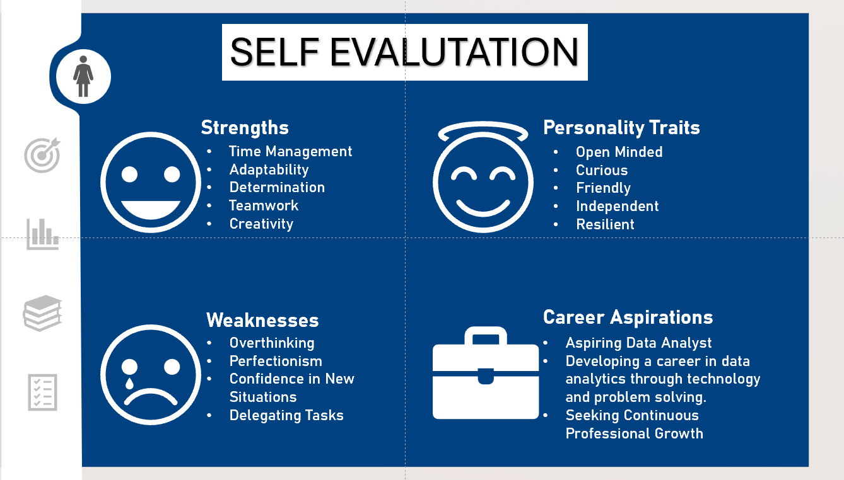
Figure 1: Screenshot of the completed self-evaluation, summarising strengths, weaknesses, personality traits and future career aspirations.

Task 2 – PDP
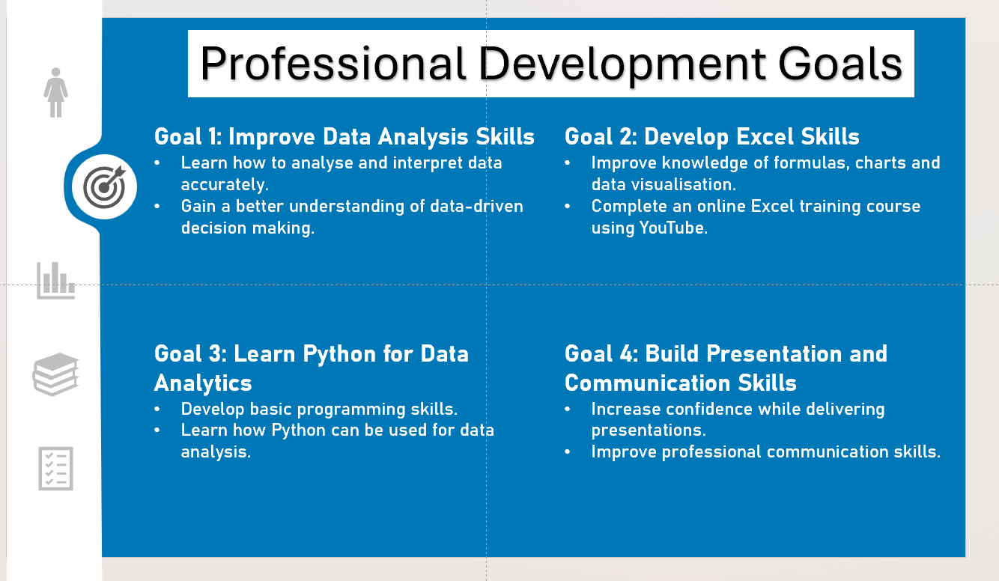
Figure 2: Screenshot of Professional Development Plan (PDP), outlining four SMART goals to support academic, personal and professional growth.
Link to PDP: assignment 2 Professional Development Plan (PDP).pptx
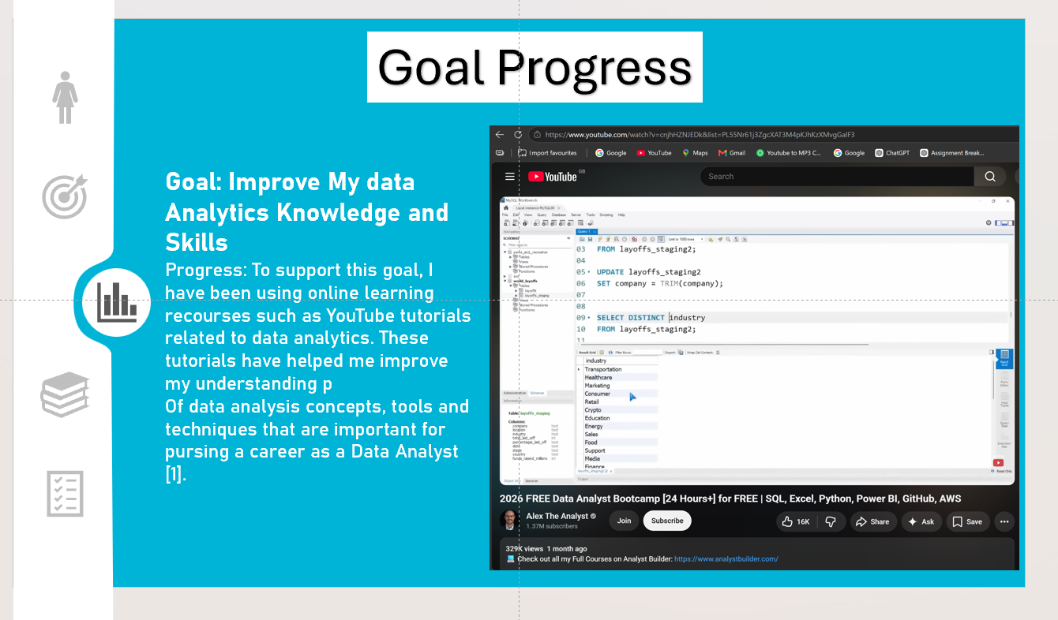
Figure 3: Screenshot of evidence of progress towards data analytics goal through engagement with an online Data Analyst training course.

Task 3 – Unit 4 Topic Summary
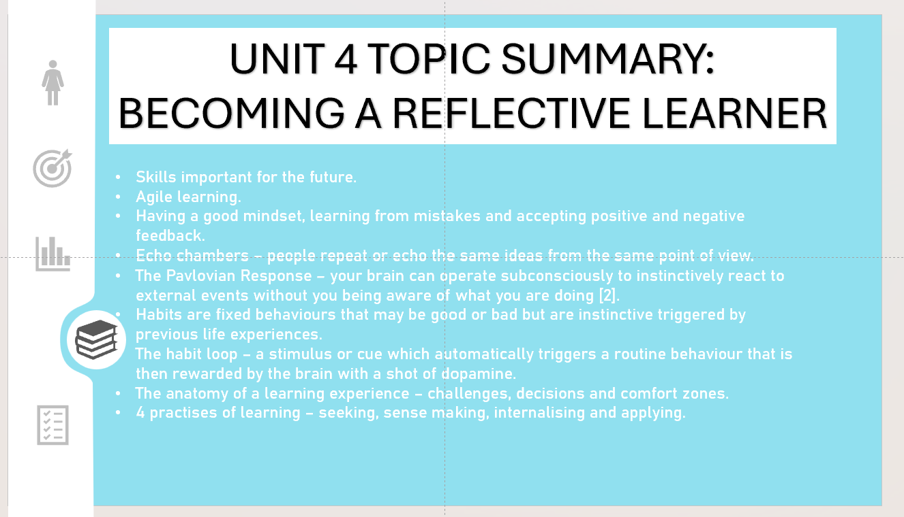
Figure 4: Screenshot summarising the main concepts covered in the Moodle Unit 4 Becoming a Reflective Learned topic 1, Learning to Learn.

Task 4 – Video Presentation
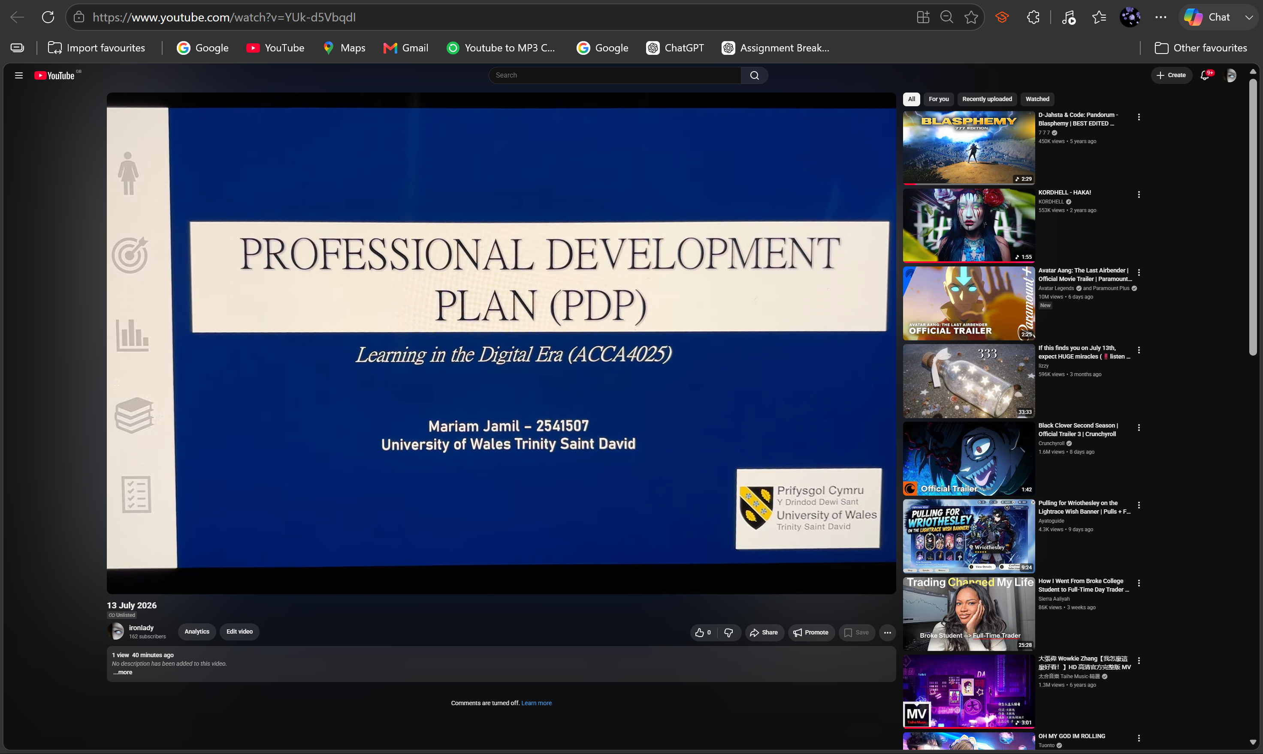
Figure 5: Screenshot of uploaded video presentation, demonstrating successful publication to online platform YouTube for assessment.
YouTube video link: https://youtu.be/YUk-d5VbqdI
PowerPoint presentation link: assignment 2 Professional Development Plan (PDP).pptx

