Introduction to Character Animation
Rigging a Digital Character & Demonstrating the 12 Principles of Animation
Elodie Gipson
2305469
BA Computer Games Design

YouTube link: https://youtu.be/bY33nlC5TMA

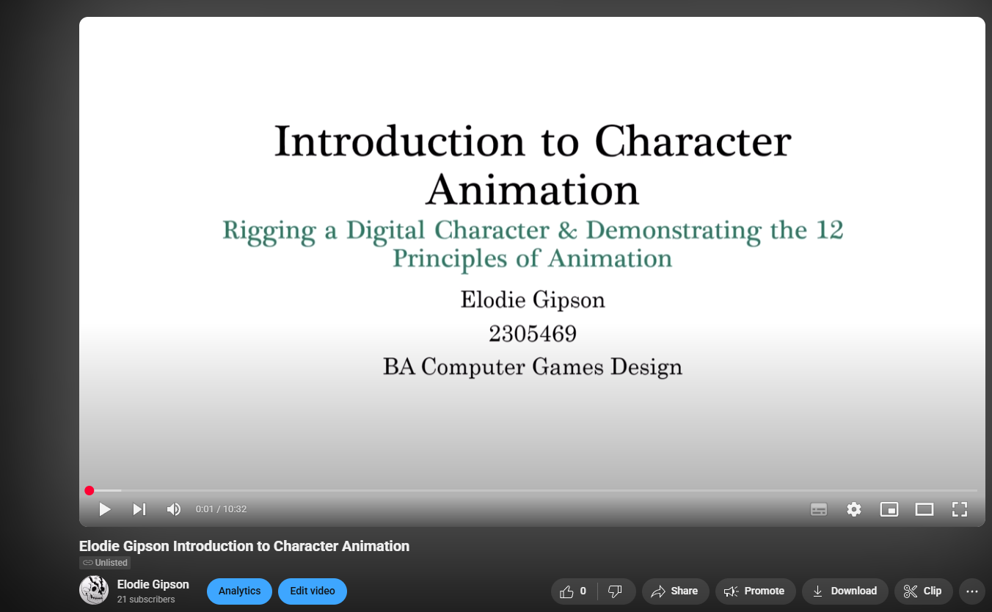

PowerPoint link: Elodie Gipson Introduction to Character Animation.pptx

