Module: Digital Skills and Research Methods
The Use of Technology in the Modern Healthcare Workplace
The Case of Care Homes in the UK

Academic Year 2022-2023

Module Code: LCHS4002_LON
Student name: Victoria Oltean
Student iD:2212115
Module Leader: Suneth Fernando

Table of Contents
- Introduction........................................................................................................................3
  - Background of the Study........................................................................................4
  - Statement of the Problem.......................................................................................4
  - Research Rationale................................................................................................5
  - Research Aim and Objectives................................................................................5
- Literature Review
  - Technology.............................................................................................................6
  - Types of Technology.............................................................................................7
  - Benefits of Modern Technology..............................................................................7
  - Barriers of Modern Technology..............................................................................8
  - Improving Use of Modern Technology in Care Homes..........................................8
3.0 Research design and methodology ...................................................................................6
4.0 Data Analysis and Findings................................................................................................7
5.0 Conclusion and Recommendations...................................................................................8
5.1 Research Limitations..............................................................................................9
5.2 Recommendations.................................................................................................9
5.3 Conclusion............................................................................................................10
References.............................................................................................................................11

1.0 Introduction
In order to conduct valid and reliable research, students must understand the basic methods and tools in the completion of it. In this paper, we will discuss the use of technology in care homes and will engage with reliable sources that would support the research topic. Firstly, the title of the research explains clearly its objective, but we will also look at the design of it, the rationale, the research questions, and finally, the reliability of sources used.
1.1 Background of the Study
Technology is healthcare facilities is a very discussed topic among professionals and there are multiple sources available that could aid this report. The implementation of technology has seen a massive expansion during the last decade, and the UK is currently one of the top countries in the world to implement technology into the healthcare system. Care homes and other medical settings are well understaffed at the moment, and technological innovations, such as wearable devices or robots are much required by these institutions to help with the workload. The most difficult period for healthcare practitioners was during the Covid-19 pandemic, especially in care homes, where the risk of infection was very high.
1.2 Statement of the Problem
The need for technology to be implemented more widely in care homes is a must for both patients and care givers in the present context and society.
Kydd et al. (2015) have researched the adaptability of staff to technology and discovered that while a high percentage of care homes have access to internet and digital health records, not all staff is able to use computers or other devices. This is caused by the age of the staff, as many older workers don’t feel comfortable using technology in general. The same study describes the benefits of technology in care homes, where residents are using technology (touch screens, tablets, large print keyboards, or trackball mice) to improve their knowledge but also to overcome some effects of arthritis and tremor.
Fisk (2015), conducted a survey that involved 12,237 residents, care home staff, and family members in order to understand their perception about surveillance inside the resident’s bedrooms and communal areas. Residents and family members were willing to have the cameras installed in both areas, while staff was against them, especially in the communal areas (with only 21 percent agreeing to it). The aim of this survey was to support previous reports of poor care and abuse in care homes across the UK. Of course the implementation of audio devices or cameras should be agreed with the residents as this is their right to privacy.

1.3 Research Rationale
Choosing a subject for research can be a time-consuming task, especially for students conducting research for the first time. Topic selection can develop in many different ways as the researcher might have different reasons behind it, such as personal experiences, their state of knowledge in the field, personal values, or even curiosity on a certain subject (Neumann, 1994).
During the recent pandemic, healthcare settings have understood better the importance of technology, especially when working with high risk individuals, such as elderly residents in care homes or other vulnerable categories. At present, care homes in the UK are using some digital tools, including telehealth or telemedicine. These tools are not nearly enough for the times we live in, where technology is present almost everywhere in our day to day life. In independent living facilities, NHS also uses Telecare – a technology that monitors residents so they can receive help in cases of falls or other incidents (NHS, 2020).
1.4 Research Aim and Objectives
The main objective of the care homes is to offer residents the opportunity to have a normal life while being closely monitored by professionals for their own protection. The living conditions should be decent and accommodate their needs while in care. For example, care workers are checking on residents during night time, an action that can disturb their sleep, but this can be avoided by installing acoustic listening devices in the rooms or wearable devices, such as smart watches that can monitor their sleep patterns and health condition (SCIE, 2017).
Locke et al. (1993) state that research questions emerge from three sources mainly: logic, practicality, and accident. The research questions of this paper have the aim to understand the real need of technology in care homes and how could technology aid healthcare professionals with their workload.
- What technology is currently implemented in care homes across the UK?
- Is there proof that technology is improving the well-being of patients?
- How could technology ease the work of healthcare professionals?
Answering these questions, we will have a better understanding on the benefits of technology and digital tools in healthcare facilities.

2.0 Literature Review
This study will present all the data collected in an organised manner and make an attempt of answering the research questions as accurate as possible, only by analysing secondary data. Not all sources can be trusted while researching data for academic work. A reliable source will be collected from a trustworthy source, even from physical publications, online, or from interviews with professionals in the field. The internet allows everyone to publish their work, this is why sources found online must be updated, credible, and accurate. Also, sources older than ten years old should not be used as these are outdated.
A good literature review will not only show findings in the field, but also gaps that need to be filled. The literature associated with the research topic is very broad, mainly incorporated in annual statistics and reports created by NHS or other healthcare organisations. However, during the past few years, there is a lack in literature, and many reports have not been published due to the pandemic. Current data can have a great value in the present research, as technology is constantly advancing and the need for it has been mainly introduced in care homes very recently.
2.1 Technology
Globally, the overall elderly population was 12 percent in 2015, but it is estimated to rise to 22 percent by 2050. The UK is one of the countries with rapidly growing elderly population, with over 11 million people aged 65 and over, while half a million are over 90. This is a drastic increase since the last Census in 2011. During Covid-19, about 40,000 deaths were reported in care homes across the UK. This made families worry about their relatives placed in these facilities and the number of residents saw a decline over the past years (Munson, 2022).
2.2 Types of Technology
Technology in care homes is seen as a massive innovation in healthcare, and health and social care professionals have now access to a wide range of devices that help them in their work, but also improve the quality of life of residents in these facilities. For instance, carers have access to electronic health records for each resident, which can be updated and monitored constantly. During the pandemic, the government has intervened by funding the acquisition of electronic devices for residents in care homes, so they can communicate with their loved ones, without actual physical contact. Additionally, care homes use devices such as Person-centred Technology that allows them to plan, record, and monitor the care of residents, which can be also shared with NHS or pharmacies. On technology highly approved in many healthcare systems is the PainCheck system, which can inform healthcare professionals about discomfort or pain in patients, only by analysing signs of pain and facial cues for individuals unable to communicate (Handsale, 2021).
2.3 Benefits of Technology
There are an estimated 5,057 nursing homes and 12,022 residential homes in the UK which have about 408,371 residents, including older and disabled adults. Over 70 percent of the care home residents have dementia or other severe memory issues (LaingBuisson, 2014).
Wu et al. (2022) describe the correlation between safety and technology in care homes and independent living facilities for older individuals. The study highlights the importance of smart technology in their day to day life, such as sensor systems that adjust air ventilation levels, communication devices, or smart networks.
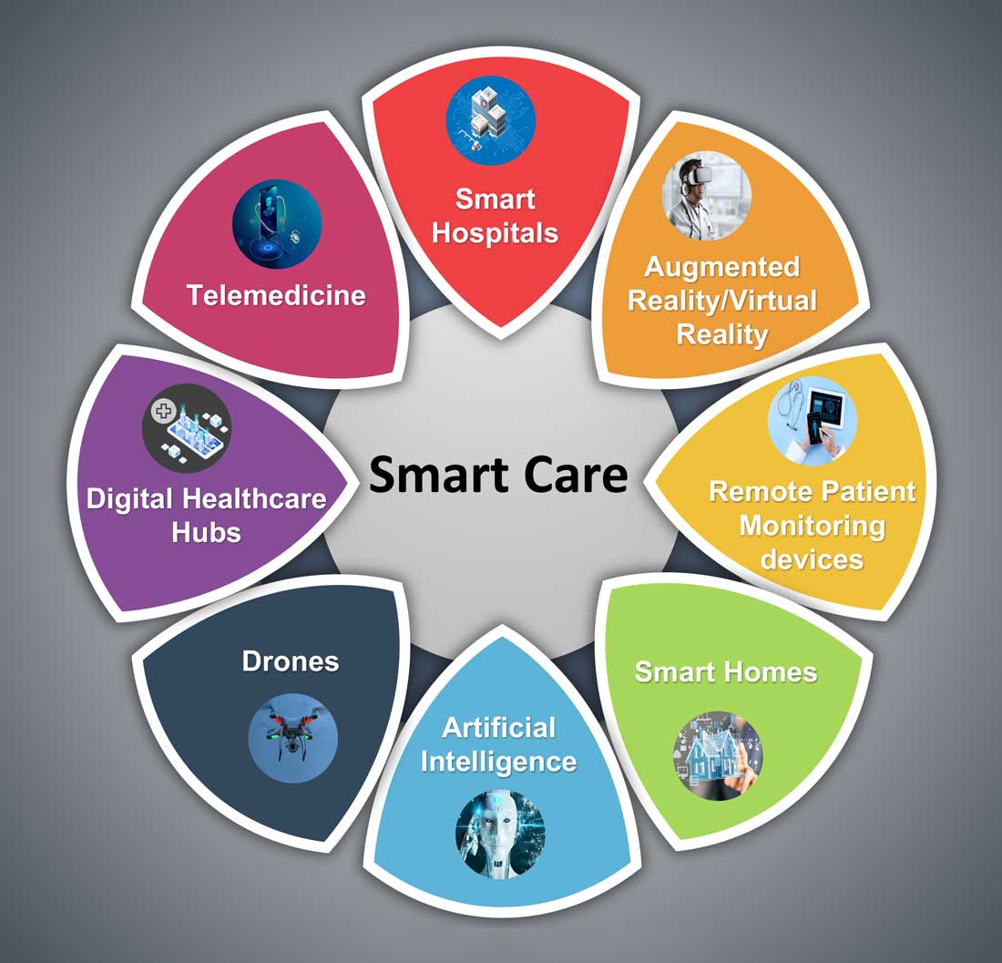
Obayashi et al. (2020) reports great feedback on Socially Assistive Robots (SARs) in care homes and describes the positive impact these have on the well-being of old people. The robots are offering communication and emotional support to residents, while connecting them with their families via video calls. The study has been conducted in dementia based care homes and the results were positive towards SARs implementation amongst the residents.
Figure 1. Smart Care Tools (Zia, 2021).
2.4 Barriers of Modern Technology
For technology to be used efficiently, staff in care homes must receive the proper training and work as trained at all times. Carayon et al (2019) state that the main barriers in technology use are the limited access to information or even inadequate information, limited usefulness and usability of the technologies, challenges associated with using multiple health IT systems, and technical problems. Other barriers would involve disabilities, mental or physical illnesses of the residents and their inability to use digital devices.
3.0 Research Design and Methodology
The design of a research includes five main areas: the framework, the strategy to be followed, the sample from which data will be collected, the tools and methods for collecting the data, and data processing (Punch, 2006).
This paper will analyse the importance of technology and digital tools in care homes by conducting secondary data research. Secondary data is information already published by other authors, which means the researcher will not use primary data in order to answer the questions proposed. Research design is what glues all the elements of the research into one piece, presenting logical decisions regarding data collection, analysis, and processing.
Qualitative data will be used via a literature review, as the researcher will collect information from several sources already published. Case studies and field research will be used in the research, as these will complement and support each other. The aim behind this is to understand the correlation between primary data and theory in the healthcare environment. A case study is a research strategy that focuses on in-context study of the case, while using multiple sources of data.
The study will not have a sample as secondary data is used for the findings and the researcher is the instrument used for data collection. The results of the study might be limited as the researcher has no control over the samples or variables of the primary data. Secondary data has already been measured and processed, but the sources can be much wider than research conducted with primary data only.

4.0 Data Analysis and Findings
This paper will understand the current use of technology in care homes and the reasons behind the lack of it. The researched literature and recent studies show the benefits of technology in healthcare facilities, and even if there is a limited range of physical evidence regarding to care homes, other medical settings have seen the pros and cons of it. Of course, many of the variables can be applied to care homes easily, as the main objective all the healthcare system is the quality of life of patients.
Valid data for social research can be collected from research journals, conference papers and proceedings, dissertations, or specialised books from the field. While identifying relevant literature, the researcher must consult a wide range of sources, identify abstract information and extract important parts of it, and locate the relationship between their study and literature in general. A descriptive study is when the researchers gathers data, organises, and summarise it in a simple way, in order to draw a picture of the topic studied, explain the development of actions, and maybe show correlations between events, situations, or even individuals ( Punch, 2006).

5.0 Conclusion and Recommendations
It is forecasted that technology will expand to even more fields in the years to come and avoiding the implementation of it will be impossible at a certain point. However it is vital to implement it in areas that would benefit the most from it. Other healthcare facilities have already made the important step and benefit from its advantages. Only a few care homes in the UK have introduced digital devices to residents or discussed the possibility with their families.
5.1 Research Limitations
The main disadvantage of secondary data is that data is collected from past sources and it cannot be processed in real time as primary data. Updated information could offer more insight to the current issues and the research question would receive more accurate answers. The lack of accuracy of secondary data can create an issue when published as well. However, collecting secondary data is much easier compared with primary data and no ethical approval is required, which is an important advantage for researchers in social sciences.
5.2 Recommendations
As many of the barriers found in using technology in care homes relate to the training received by staff and their adaptability to technology, this must be one of the main focuses of organisations when implementing any digital innovation. This can lead to more qualified healthcare professionals and improve the quality of life of the service users.
5.3 Conclusion
One concern that has been discussed in literature is the need for healthcare professionals once more technology is implemented in care homes. However, the technology introduced to these settings is still far from replacing human connection, as one of the main issues is isolation and the prevalence of depression in residents. Robots and other aids are implemented in order to ease the workload of staff, to help monitor the care of residents, and also to provide a safe space for everyone in the facilities.

References
Carayon, P., Hundt, A.S. and Hoonakker, P. (2019). Technology barriers and strategies in coordinating care for chronically ill patients. Applied Ergonomics, 78, pp.240–247. doi:https://doi.org/10.1016/j.apergo.2019.03.009.
Fisk, M., J. (2015). Surveillance Technologies in Care Homes. Seven Principles for their Use. Working with Older People. Volume 19, Issue 2, pp 51-59.
Handsale (2021). Understanding the Use of Technology in Care Homes. [online] Priesty Fields Care Home. Available at: https://handsale.co.uk/priestyfields/2021/08/technology-care-homes/ [Accessed 28 Mar. 2023].
Kydd, A., Wild, D. and Szczepura, A. (2015). Implementing digital skills training in care homes: a literature review. [online] journals.rcni.com. Available at: https://journals.rcni.com/nursing-older-people/implementing-digital-skills-training-in-care-homes-a-literature-review-nop.28.4.26.s22 [Accessed 21 Nov. 2022].
LaingBuisson (2014). Care of older People. UK Market Report. Twenty-Seventh Edition.
Locke, L., F., Spirduso, W., W. and Silverman S., J. (1993). Proposals that Work. Third Edition. Newbury Park, Sage Publications.
Munson, S. (2022). Care Home Stats. Number of Settings, Population, and Workforce. Available at: https://www.carehome.co.uk/advice/care-home-stats-number-of-settings-population-workforce [Accessed 22 Nov. 2022].
Neumann, W., L. (1994). Social Research Methods. Qualitative and Quantitative Approaches. Second Edition. Boston. Allyn and Bacon.
NHS (2020). The Framework for Enhanced Health in Care Homes. Issue 2, NHS England and NHS Improvement.
Obayashi, K., Kodate, N. and Masuyama, S. (2020). Measuring the impact of age, gender and dementia on communication‐robot interventions in residential care homes. Geriatrics & Gerontology International, Volume 20, Issue 4, pp.373–378. doi:10.1111/ggi.13890.
Punch, K., F. (2006). Developing Effective Research Proposals. Second Edition. Sage Publications.
SCIE (2017). Dementia: Technology in care homes - SCIE. [online] Social Care Institute for Excellence (SCIE). Available at: https://www.scie.org.uk/dementia/support/technology/care-homes [Accessed 23 Nov. 2022].
Wu, H-W., Kumar, P., Yu, K., W., and Cao, S-J. (2022). A Global Challenge for Smart and Healthy Care Homes for the Elderly. Indoor and Built Environment, pp 1-5.
Zia, S. (2021). Hospital medicine and the future of smart care. [online] The Hospitalist. Available at: https://www.the-hospitalist.org/hospitalist/article/242968/mixed-topics/hospital-medicine-and-future-smart-care [Accessed 23 Nov. 2022].

